Howard University
College of Engineering and Architecture
Department of Electrical Engineering & Computer Science

Large Scale Programming
Fall 2024

Midterm Exam – Part I
October 17, 2024

Part I: 50 pts. (essay questions)

Instructions:
- Submit completed exam to your github repository under package org.howard.edu.lsp.midterm

Verify that the commit(s) completed successfully

- OPEN BOOK, OPEN NOTES. THERE IS NO COLLABORATION ON THIS EXAM
- Site any and ALL references for anything obtained off the internet.

Question 1. (10 pts.)

You are reviewing the following class in a Fitness Tracking System. The class is intended to manage various aspects of a user’s fitness activities.

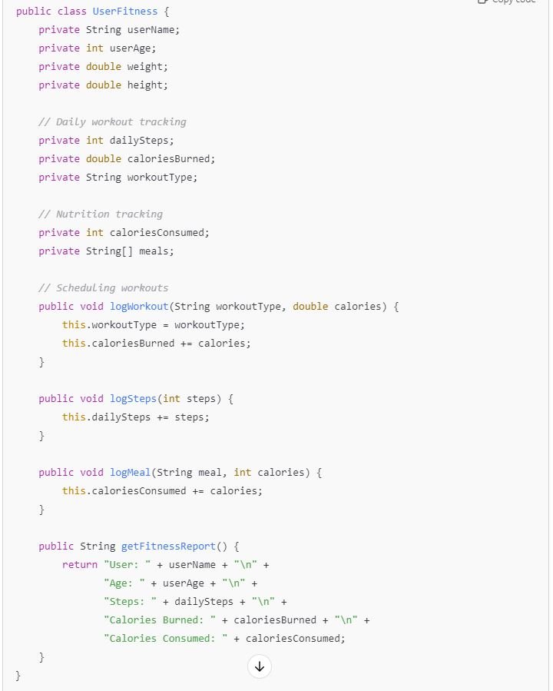

Tasks:
- Analyze the UserFitness class. Explain why this class has low cohesion. (5 pts.)
The UserFitness class has low cohesion because the class handles multiple activities. This class deals with various aspects of a user’s fitness like storing a user’s information, tracking their workouts, meal plans, and generating a fitness report.

- Describe, in general, how you would split the UserFitness class into more cohesive classes. Your answer should not be a complete design. (5 pts.)
To improve the cohesion, I would split the class based on its responsibilities. The class would be split into class that handles the user profile, one for workout tracking, one for meal tracking, and one to generate a user’s fitness report.

Question 2. (5 pts.)
Given the following, answer the below questions.

A university manages its students using a program that has a class Student with subclasses FirstYear, SecondYear, and ThirdYear for year-specific state and behaviors. The program has a List that contains all Students.

Should Student be a class, an abstract class or an interface? Explain your answer
Student should be an abstract class because it will have characteristics that are shared by its subclasses. Generic student information like studentID will be inherited by all the subclasses but the year-specific states and behaviors will be reserved to those subclasses.

- At the end of each year, the third-year students graduate and must be removed. This is done by passing the list to the following method:

void removeThirdYears(List<Students> students) {
for (Student student : students) {
try {
ThirdYear = (ThirdYear) student;
students.remove(thirdyear);
}
}
}

Why is the above method flawed? Hint: Another Arthur Riel heuristic (5 pts.)

Question 3. (5 pts.)
Given the following, answer the below questions.

public class BankAccount {
public String accountHolderName;
public String accountNumber;
public double balance;
public double interestRate;

public BankAccount(
String accountHolderName,
String accountNumber,
double initialDeposit,
double interestRate) {
this.accountHolderName = accountHolderName;
this.accountNumber = accountNumber;
this.balance = initialDeposit;
this.interestRate = interestRate;
}

// Exposed implementation for adding interest
public void addInterest() {
double interest = balance * (interestRate / 100);
balance += interest;
}

// Exposed implementation for deposits
public void deposit(double amount) {
balance += amount;
}

// Exposed implementation for withdrawals
public void withdraw(double amount) {
balance -= amount;
}
}

- Is BankAccount well-encapsulated? Why or why not? If so, describe what changes you would make to the class. Otherwise, state nothing. (5 pts.)
BankAccount is not well-encapsulated because several data members of the class are public. accountHoulderName, accountNumber, balance, interestRate are all public, allowing direct access and modification to these variables from outside the class. To improve encapsulation for this class, the variables should be set to private and should only be accessed using proper methods within the class to modify the data.

Question 4. (10 pts.)
Given the following, answer the below questions.

Given:
A car manufacturer uses Java software to track current vehicles being built. The UML diagram below shows an excerpt of the current software structure. You should assume the presence of other appropriate fields and methods

Car
getTrimLevel()
Engine
accelerate()
getFuelLevel()
Base
Sports
Luxury
Electric
Petrol

Each car can be built to one of three trim levels: Base, Luxury or Sport. They can also be configured with an electric or petrol engine. At various points in the manufacturing process the customer can choose to change the trim level.

Task:
- Explain in detail why the current structure does not support this. (5 pts.)
The current structure does not support this because since base, sports, and luxury are subclasses of Car, once a car object is created, the type is fixed at runtime. Currently the structure hold a static inheritance hierarchy, so you are unable to dynamically change the trim level without destroying the original object and creating a new one.

- Describe how to refactor the structure to allow trim-level change for a car to dynamically change. Hint: How would you modify Car to use composition to solve the problem? (5 pts.)
The structure would have to be refactored to use composition rather than inheritance. Instead of having separate classes for the trim levels, the Car class can be have a trim level object allowing that to change without destroying the object.

Question 5. (5 pts.)
Suppose you are about to code a particular class and find that you have written another class with nearly the functionality that you now are developing. This means that the two classes in large parts contain the same code, but in smaller parts have different code. Explain in detail why this may be a problem and how to solve it. Give your answer in terms of Arthur Riel’s design heuristics.
With two classes sharing large parts of the same code, this opens up the risk of errors due to redundant code. Same logic is repeated in multiple places, meaning bugs found in code may be represented in both classes and changes to one class will need to be represented in the other. The classes should have focus on one key abstraction, this design structure mixes together multiple abstractions which is advised against in Arthur Riel’s design heuristics. To fix this, refactoring the code using inheritance will help with the functionality of the classes. If the classes are related in a hierarchical way, they can be split into a parent class, holding the shared functionality, and child classes handling the differences in their code.

Question 6. (5 pts.)
Suppose we need to store instances of the classes Car and BankAccount in a database. To obtain low coupling it may seem as if the functionality to save an instance should be in precisely those classes, since they have the information that shall be saved. Why is it unwise to place the database calls there?
It would be unwise to have the Car and BankAccount classes store instances of themselves to a database because that gives the classes more responsibilities to handle. Having the database calls here actually causes tight coupling because the classes are now dependent on the database structure.

Question 7. (5 pts.)
Given a set of requirements, what conditions must be met to make it appropriate to create a new class hierarchy using inheritance? Neither superclass nor subclass exist before, the question is about designing a new class hierarchy.
The following conditions must be met: there is a clear “is-a” relationship.

Question 8. (2.5 pts.)
Describe the difference between inheritance and composition why would you choose one over the other.
Inheritance is when a subclass derives behavior and properties from a superclass, modeling an “is-a” relationship. Composition, on the other hand, is where one class is composed of objects of another class, modeling a “has-a” relationship. Inheritance is typically better when you need to reuse behavior from a superclass that is common to all subclasses. Composition should be use when you need the flexibility to swap between behaviors dynamically.

Question 9. (2.5 pts.)
Explain the meaning of cohesion and describe whether low or high cohesion is better.
Cohesion refers to how closely related the responsibilities of a class are. High cohesion means the responsibilities of the class are all closely related, meaning the class has a single responsibility, and all the functions within that class are related to that one task. A class with low cohesion means it has several unrelated responsibilities. A class with high cohesion is better because it is easier to understand and has better usability because all of its functions are for one task.

