131092 - IT4946E - ITSS Embedded Linux

Exercise 8.1 & 8.2

**Program 8.1.3.**

Make programs that communicate inter processes by using the shared memory and confirm the memory can be shared inter processes.

The made program is 2 and implement the following functions.

Program1: Output information on the shared memory to the console.

Program2: Write information in the shared memory.

**In the 8.1_shm_server.c** 🡺 **Write information in the shared memory**

I wrote in the shared memory: **abcdef** in this below code

And the console also displays the shared memory

**In the 8.1_shm_client.c** 🡺 **Output the information in shared memory**

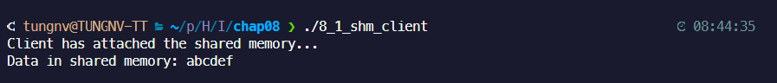

**Program 8.2.4**.

Executes the “ls -l” command in the child process.  
Remodel the child process to execute the command by using the arbitrary command option passed from the parent process

* Using the arbitrary command option passed from the parent process to input the directory
* Input the path to the current folder => It show how many files in the folder

Ex: There are 2 children in /home/tungnv/projects

