

HANOI UNIVERSITY OF SCIENCE AND TECHNOLOGY
SCHOL OF INFORMATION TECHNOLOGY AND COMMUNICATION
----------



AI PROJECT REPORT

Project name: Fire detection system

Supervisor Assoc. Prof. Phạm Văn Hải
Student names : Group 16

Hà Nôi, 8/ 2021

Hà Nội, tháng 10 năm 2012

AI Project name:
Hybrid Louvain-Clustering Model using Knowledge Graph for Improvement of Clustering User’s behavior on Social Networks
Student name: Student A 1 and Dong Nguyen Tien^{1,2}
¹ Class ICT Global xxx, Hanoi University of Science and Technology, No1. Dai Co Viet st., Hanoi, Vietnam
²
Abstract. Summary about 200 words. Recently, social networks play significant roles in real-time content analysis. Many studies have investigated social networks by analysis of contents based on users. However, these studies have some limitations of social network analysis while clustering contents based on users’ behavior. The research report has presented the Hybrid Louvain-Clustering model using a knowledge graph to cluster contents based on user behaviors in a social network. In the proposed model, all multi-dimensional user relationships represent in a knowledge graph while clustering contents based on user behaviors in real-time on social networks. The experiment demonstrated that the proposed method for a large-scale social network and reached efficient clustering content based on user’s behaviors. Additionally, experimental results show that the proposed algorithm enhances the performance of clustering contents based on user’s behavior of a social network analysis.
Notes: Length of the research report is round 15-20 pages.
Keywords: Knowledge graph, data analysis, social network analysis, clustering facebook page.
- Introduction / Overview of System/ Background
You can make several paragraphs as your statements
Recently, there are many studies related to social networks focusing on the investigations of the theory and applications of social networks [1]. Some studies have investigated approaches in social network analysis such as Attacking Similarity-Based Link Prediction in Social Networks [2], Clustering Social Networks [3], Maping Users Across Social Networks integrated with Network Embedding [4] and Online profiling and clustering of Facebook users [5], and Grouping Facebook Users Based On The Similarity Of Their Interests [6,8]. All of the related result works have some limitations in clustering contents/users without weights among relationships of nodes so that the problems in clustering with multi-dimensional in social networks.
In Subreddit Recommendations within Reddit Communities [6] done by Vishnu Sundaresan, et all. in Stanford University, the researchers have proposed method to assume the weight among shared users between subreddits, performed by Louvain algorithm to clusters of subreddit to cluster content-based users in the recommendation of social network analysis. Louvain method provides clustering contents/ users in large social networks [6]. However, the method uses to clustering in fully connected nodes which is poor results. These results were limited to use for doing marketings, advertisements using Louvain algorithm to real-world problems on social networks.

Main ideas of the proposed project
The research report has presented the Hybrid Louvain-Clustering model using a knowledge graph to cluster contents based on user behavior. All multi-dimensional relationships based on knowledge graph to clustering Facebook Pages are based on user’s behavior with these interactions in real-time on social networks. The proposed model presents two algorithms. The first algorithm called relationship user behaviors and content weights is a path directed relationships from user to pages by calculating the interactions of a users’ behaviors and contents. The second algorithm called relationship content-page weights is calculated by the total numbers of interaction relationship of users’ behavior that divided by the total the number of users. In the experiments, the proposed model has been validated tests in real-time on Facebook using real-time data collections and open data source [7].

- PRELIMINARIES / LITERATURE REVIEW/ BACK GROUND / THEORIES ….
  - Knowledge graph
A graph consists of two features: nodes and relationships. Each node has an entity (a person, thing, , place, category and other attributes of data) as shown in Figure 1. A relationship among nodes represent how nodes are connected. Unlike other databases, "Relationship" is a top priority in the graph database.
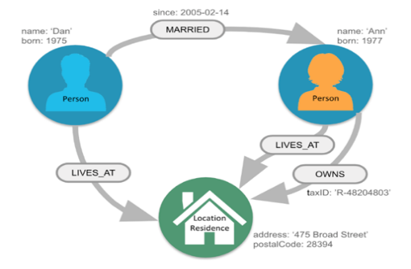
Fig. 1. The Person as nodes in location, having relationship connected with its Location node [6]
Knowledge graphs (KGs) provide an a structure information in information retrieval with question responses including Freebase, YAGO and DBpedia. A regular KG is usually represented as multi-relational data with large triple facts such as head entity, relation, and tail entity [6,8]. The social network Facebook, where there are many objects and types of relationships, all interact with each other in a multi-dimensional relationship and show the interactions in real life.
  - Facebook social network
Social networking is mostly based on Internet-based social sites to connect with friends, colleagues, family, or clients, customers. Social networking as a social purpose, givent in a business purpose [8]. Facebook represents a social network modeled as a graph, including typical types of nodes, groups and relationships. Each node represent an individual, page, group, or entity that contains various attributes such as name, gender, interest, location, image, content, and time [9].
The nodes contain user behaviors such as Page, Group, Place. Louvain Algorithm to social networks. The Louvain method is to apply detecting communities using networks [6]. The Louvain algorithm represents modularity-based algorithms dealing with large graphs. The Louvain algorithm has been recommended Reddit users in order to find optimal subreddits, based on the user behavior. The Louvain algorithm was applied to cluster topics from online social networks, such as Twitter and YouTube. While clustering of conventional Louvain algorithm, the results of clustering nodes of the algorithm are not high because of fully connected nodes.
- The proposed model / Algorithm / Steps of the Algorithm / System
The proposed model called Hybrid Louvain-Clustering model using a knowledge graph to cluster contents based on user behaviors is depicted in five steps, as shown in Figure 2.

Step 1. Collect data sets from Facebook
Scrapy tool is to get automatically data from Facebook.

Step 2: Present a social network to knowledge graph.
This step is to send a request from Facebook data sets, then detect entities from Responses. Each entity in a sets of entities $V≔\{U,P,G,S,I,A,C,R$}.
Let $G=\left(V,E,ω\right)$ be a social network where $V≔\{U,P,G,S,I,A,C,R$} is the set type of nodes in Facebook knowledge graph and $E≔\{\left(v_{i},v_{j}\right)\}$ is the set of directed edges representing the relations.
From raw data obtained from Facebook, the raw data extracts field data from HTML to build Relationships that show the level of connection between nodes in the graph.

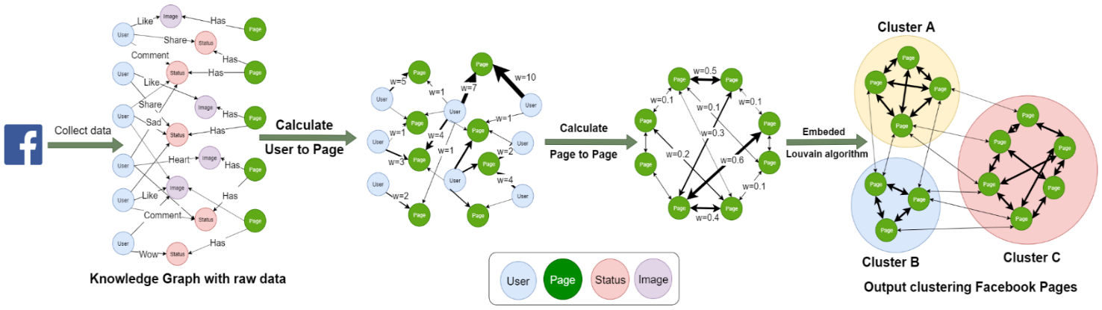
Fig. 2. The proposed model to clustering pages based on user

Step 3. Calculate weights from User behavior to a Page

ALGORITHM 1: Relationship User behavior and content weights
Goals: Calculate weights from relationship user behavior and contents that is a path directed relationships from user to pages by calculating the interactions of a users’ behavior and contents.
- Input: Knowledge graph with raw data.
- Output: Weighted relationships from User to Page
1 | Foreach status in list_status_or_images
2 | P ← Get page of status
3 | List_R ← Get list reactions of status
4 | Foreach r in List_R
5 | U ← Get User of reaction
6 | U_interact_P ← Get relationship interact from user to page
7 | If exist U_interact_P:
8 | weight ← Get weight of relationship user to page
9 | Else:
10 | is_like ← Get relationship user like page
11 | If exist is_like:
12 | weight ← 1
13 | Else:
14 | weight ← 0
15 | weight += reaction→type→weight
16 | Return relationship_U_interact_P ← {weight: weight}

Step 4. Calculate weights from Pages to Pages

Calculate relationship content-page weights is calculated by the total numbers of interaction relationship of users’ behavior that divided by the total the number of users to get weighted relationships among pages

Step 5. Transform weights to embedding Louvain algorithm
The outputs of algorithm 2 are weights that automatically embedded to input variable values using Louvain algorithm.
The experiments of the model validate how the mode performance done successfully as shown in Section 4.
- Experiments and results / Evaluation
  - Dataset
The experiments of the proposed model has been tested in data sets, getting from Facebook stored at the link [7]: https://www.kaggle.com/dongnguyentien/facebook-neo4j-dataset
  - Experimental results
The experimental results in the proposed model show the best case for the highest accuracy ($threshold=0.148,precision=0.86,recall=0.72$) also show five categories called clustering content nodes including "E-commerce & Shop", "Sports, Entertainment, News, Music", "Tourism, cuisine", "Technology and entertainment", “Military and history”
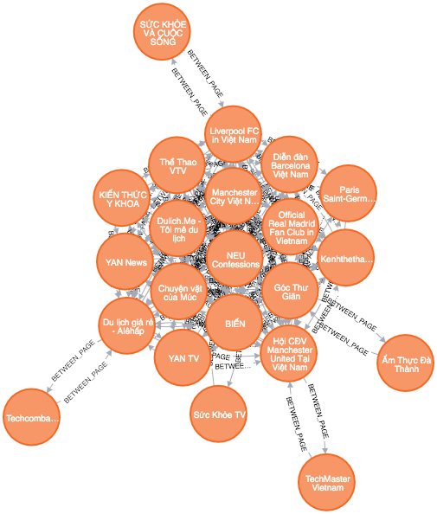
Fig. 3. Pages belong to clustering content node
In the experiments, the results of proposed model showed the relationships among Pages and Scored relationship among pages as shown in Figures 3 and 4.

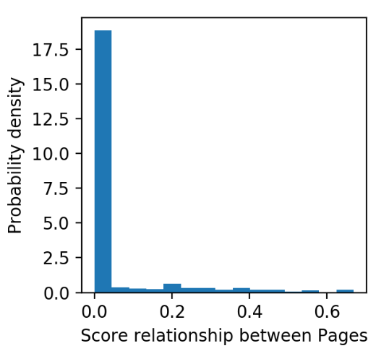
Fig. 4. Score of relationship between Pages, $w=\left(0,0.669\right)$
Most of relationship are weaken linkage relations, with the centralized value under 0.01.
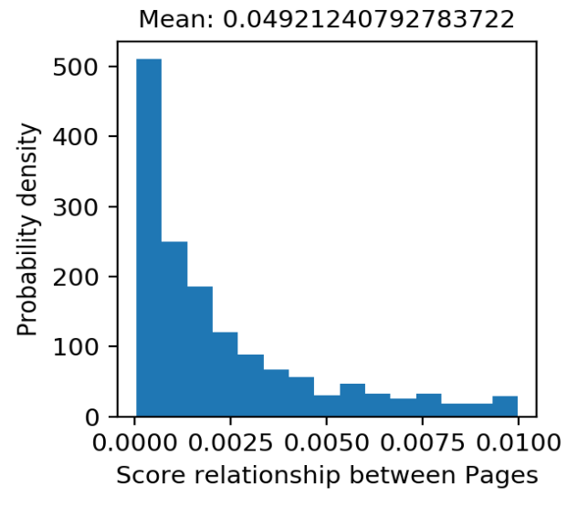
Fig. 5. Scored relationship among pages under 0.01
To control links based on nodes’s weights, we adjusted the parameter as threshold when running the Louvain algorithm, calculating the relationships with its condition $w≥threshold$. In order to evaluate the threshold, The dataset was sorted by contents of categories regarding to $tourism=\left[Page1,Page2,…\right]$.
The evaluation formula is defined by True Positive (TP), False Positive (FP), True Negative (TN), False Negative (FN) [10] of the following:
$Presicion=\frac{TP}{TP+FP}$ (1)
$Recall\left(truepositiverate\right)=\frac{TP}{TP+FN}$ (1)
$Falsepositiverate=\frac{FP}{TP+FP}$ (1)
To adjust parameters of the proposed models, the proposed model in experiments showed the best case when $threshold=0.148,precision=0.86,recall=0.72$ in the average, as shown in Figures 5 and 6, respectively.
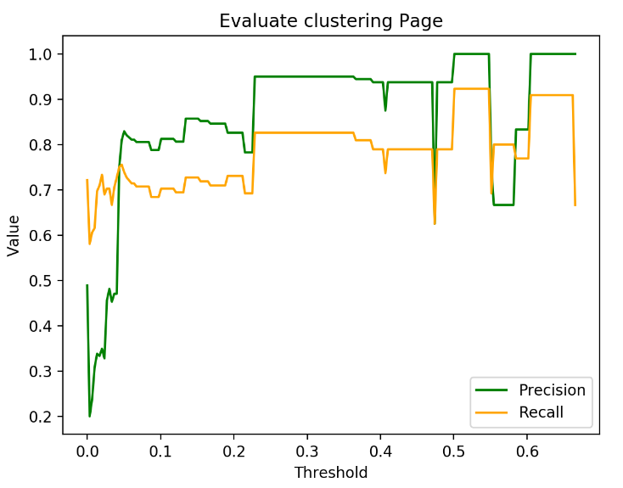
Fig. 6. Precision and recall rate while setting the threshold from 0 to 0.669
In further experiments, the experimental data consists of thousands of nodes in real-time Facebook and static data sets obtained from Scrappy tool in data source [18]. We carried out the experiments and compared the performance of the proposed approach and Louvain method through experimental results as summarized in Table 1. Average accuracy performance in evaluation of the proposed model has been calculated as shown in Table 1. The experimental results consistently show that the proposed approach achieved accuracy in terms of clustering nodes, precision, and recall.
Table 2. Comparison performance of the proposed model and Louvain method
Evaluation formula | The proposed model | Louvain
Clustering nodes | 5 | 2
Precision | 0.86 | 1
Recall | 0.72 | 0.5
The performance average of all experiments with analysis expert surveys in experiments was calculated for both static data sets and real-time Facebook social network obtained at 120.000 nodes from the period of January to October 2019 [18]. The experimental results in clustering contents based on users’ behavior demonstrate clearly that the proposed approach far outperforms the Louvain method.
- Conclusion
The investigation in this paper presented the Hybrid Louvain-Clustering model using a knowledge graph to cluster contents based on user behaviors. The experiment demonstrated that the proposed method for a large-scale social network and reached efficient clustering content based on user’s behavior. It is indicated that the proposed algorithm enhances the performance of clustering user-based contents for improvement of social network analysis. For further investigations, the proposed model will be applied in huge data sets of social networks, to dealing with dynamic environment of the Facebook.

References
- P. V. Marsden and N. E. Friedkin, “Network Studies of Social Influence,” Sociol. Methods Res., vol. 22, no. 1, pp. 127–151, 1993, doi: 10.1177/0049124193022001006./
- K.Zhou.2018, Attacking Similarity-Based Link Prediction in Social Networks, pages 1-9, 31 Dec 2018.
- Nina Mishra.2017, Clustering Social Networks, In Algorithms and models for the web-graph, pages 55-67 , December 2017.
- Li Liu.2016, Aligning Users Across Social Networks Using Network Embedding, IJCAI-16, July 2016.
- Mark Needham.2019, Neo4j. DOI = https://neo4j.com/ blog/graph-algorithms-neo4j-louvain-modularity.
- Guilherme Sakaji Kido.2016, Topic Modeling based on Louvain method in Online Social, In Conference: XII Brazilian Symposium on Information Systems.
- Scrapy data source link https://www.kaggle.com/dongnguyentien/facebook-neo4j-dataset
- Hai Pham, Khang Tran and Philip Moore. Context matching with reasoning and decision support using hedge algebra with Kansei evaluation. Proc. of the Fifth Symposium on Information and Communication Technology, pp. 202–210, 2014.
- Thai Nguyen, Hai Van Pham, A Novel Approach using Context Matching Algorithm and Knowledge Inference for User Identification in Social Networks, Proc. Of 4th International Conference on Machine Learning and Soft Computing (ICMLSC 2020), pp.149-153, 2020
- Xuan Truong Dinh and Hai Pham, A Proposal of Deep Learning Model for Classifying User Interests on Social Networks, Proc, of the 4th International Conference on Machine Learning and Soft Computing (ICMLSC 2020), pp. 10-14, 2020

