

**School of Information Technology**

**ICT582 LAB DECLARATION**

**Surname:** Moktan **Given Names:** Ngawang Tashi

**Student Number:** 34959761

**Due Date:** Saturday 9th March 2024, 10 PM **Date Submitted:** Friday 8th March 2024

**Lab Numbers:** 1 **Tutor's name**: A S M Hassan

**Your weekly lab should meet the following requirements. Please confirm this (by ticking boxes) before submitting your assignment.**

* The work included in this submission is completed independently by myself.
* I have read and understood ICT582 Lab Instructions.
* **This submission is compliant to ICT582 Lab Instructions.**
* I have kept another copy of this submission and associated programs and files in a safe place.
* I confirm that the work included in this submission is my own independent work.
* The test evidence for each exercise (including copies of terminal outputs or screenshots) in this submission is provided in the following pages of this document.

**Please make your declaration for each question or exercise in each weekly lab by writing YES in the last column if the question or exercise is fully completed and all relevant files for the question are included in this submission. Otherwise, write NO.**

|  |  |  |
| --- | --- | --- |
| **Lab Number** | **Question/Exercise Number** | **Fully Completed (Yes/No)** |
| 1 | 1 | Yes |
| 1 | 2 | Yes |
| 1 | 3 | Yes |
| 1 | 4 | Yes |
| 1 | 5 | Yes |

Test evidence of the exercises are in the following pages

**Test Evidence for the Exercises**

**Exercise 1:** After installing the required python version, I opened the command prompt to verify the installed version as shown in the figure below.

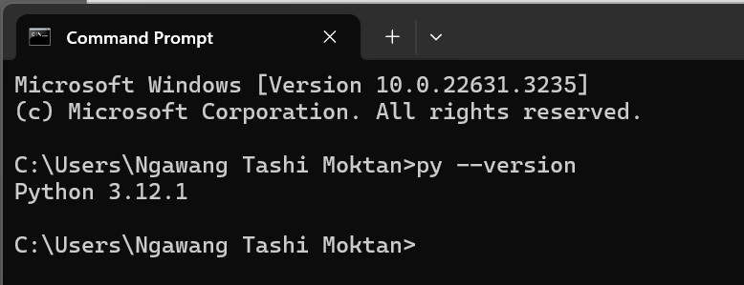

**Exercise 2:** Create a folder lab01 for lab 1. Then using Idle3 created a Python program to report my name, the city I am from and the course I am studying at Murdoch. Named the program file ex2.py.

Program with the output window.

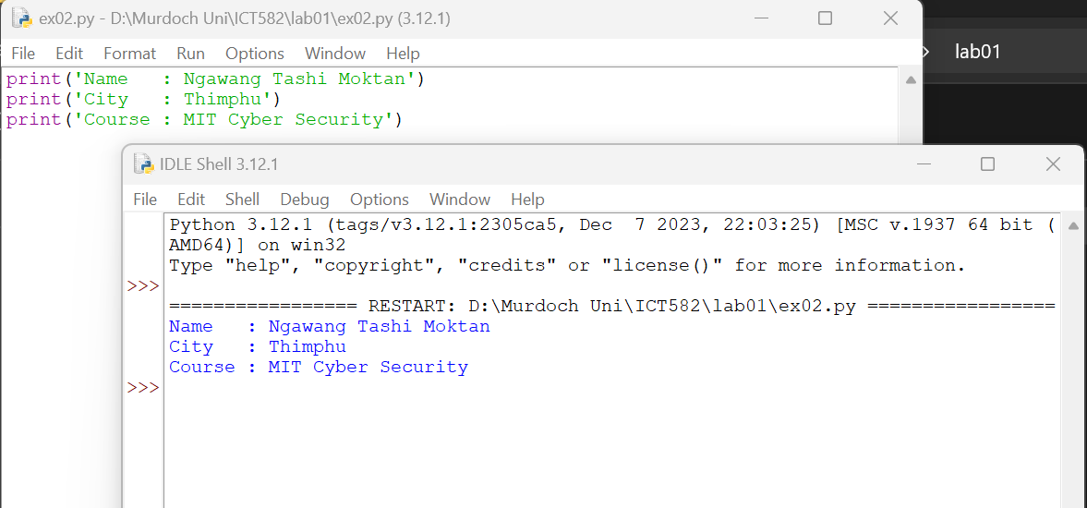

**Exercise 3:** Created another python file called ex3.py and copied the program from ex2.py with additional lines of code to print the codes name of unit I am enrolled in Murdoch university.

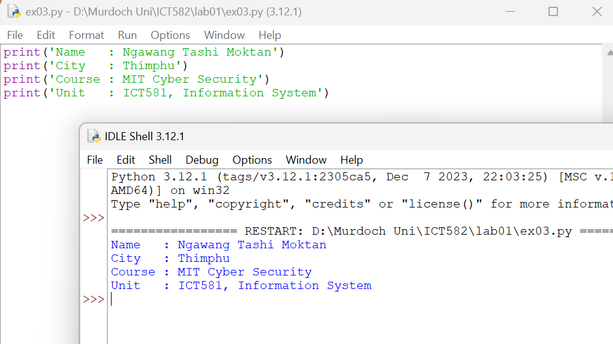

**Exercise 4:** Using command prompt, I change the directory folder lab0. Then using “copy” statement I copied program form Exercise 3 (ex03.py) new file ex4.py. Then using python3 from the command line to I run the program (python ex4.py).

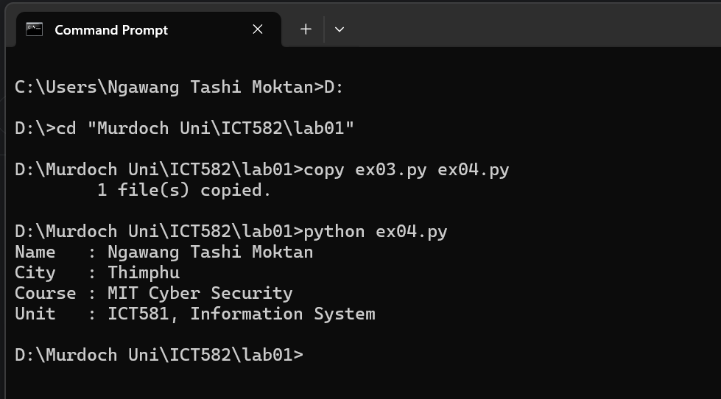

**Exercise 5:** For this exercise I created a python file ex05.py to convert temperature values from Fahrenheit to Celsius using the following formula: (Fahrenheit - 32) x 5 / 9.

Program:

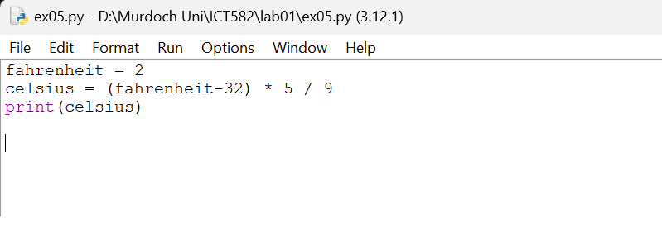

In this program, the variable fahrenheit is used to store temperatures in Fahrenheit and the variable celsius is used to compute the temperature in Celsius. Finally, a print statement is used to display the computation output.

Following are the test executions done to check the program:

