

**School of Information Technology**

**ICT582 LAB DECLARATION**

**Surname:** Moktan **Given Names:** Ngawang Tashi

**Student Number:** 34959761

**Due Date:** Saturday 16th March 2024, 10 PM **Date Submitted:** Saturday 16th March 2024

**Lab Numbers:** 2 **Tutor's name**: A S M Hassan

**Your weekly lab should meet the following requirements. Please confirm this (by ticking boxes) before submitting your assignment.**

* The work included in this submission is completed independently by myself.
* I have read and understood ICT582 Lab Instructions.
* **This submission is compliant to ICT582 Lab Instructions.**
* I have kept another copy of this submission and associated programs and files in a safe place.
* I confirm that the work included in this submission is my own independent work.
* The test evidence for each exercise (including copies of terminal outputs or screenshots) in this submission is provided in the following pages of this document.

**Please make your declaration for each question or exercise in each weekly lab by writing YES in the last column if the question or exercise is fully completed and all relevant files for the question are included in this submission. Otherwise, write NO.**

|  |  |  |
| --- | --- | --- |
| **Lab Number** | **Question/Exercise Number** | **Fully Completed (Yes/No)** |
| 2 | 3 | Yes |
| 2 | 4 | Yes |
| 2 | 7 | Yes |

Test evidence of the exercises are in the following pages

**Test Evidence for the Exercises**

**Exercise 3:** A program file called ex3.py was created and declared a variable called a message to store part of the message to reduce duplication or typing the same message at multiple locations. Furthermore, the program prompts the user to input a number between 1-7 and displays the day of the week accordingly, Monday being 1 and Sunday being 7. Additionally, if the user inputs any number that is out of the range, then the program alerts the user that the input is invalid and exits.

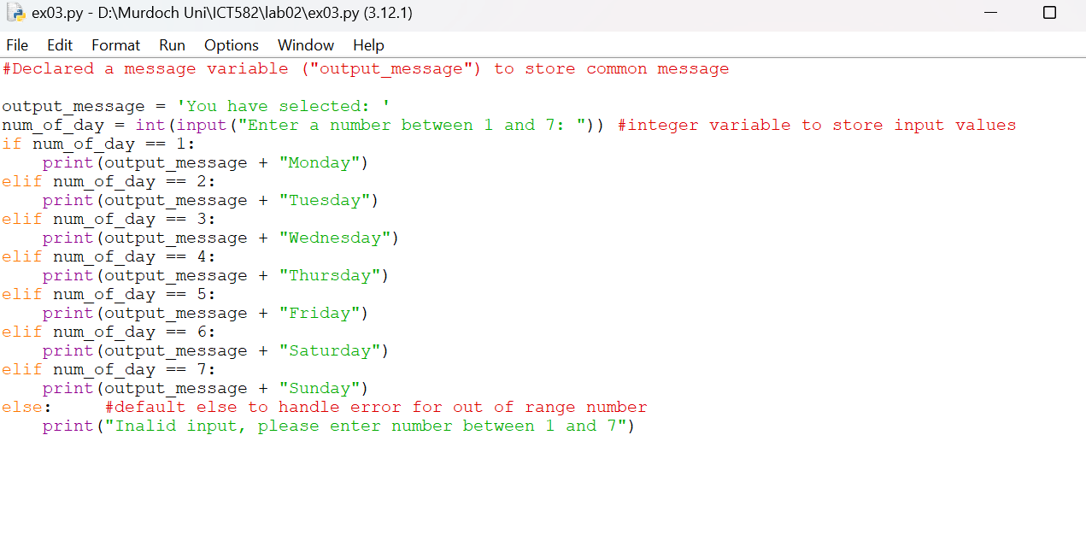Program:

Output:

**Exercise 4:** A program file called ex4.py was created using if-elif-else statements that simulates the fines issued to drivers based on speeds recorded by a police radar gun. The program reads the speed input from the user and print the message “Speeding” if the speed exceeds 60 km/h or “Not speeding” if the speed is 60 km/h or less.

The program will also calculate the fine and print the following output accordingly.

|  |  |  |
| --- | --- | --- |
| speed (km/h) | speed message | Fine message |
| speed less than 0 | Vehicle speed cannot be a less then 0 |  |
| 0 - 60 | Not Speeding |  |
| 61 - 65 | Speeding | Warning |
| 66 – 70 | Speeding | Your speeding fine is: $100 |
| 71 – 80 | Speeding | Your speeding fine is: $200 |
| 81 and more | Speeding | Your speeding fine is: $500 |

Program.

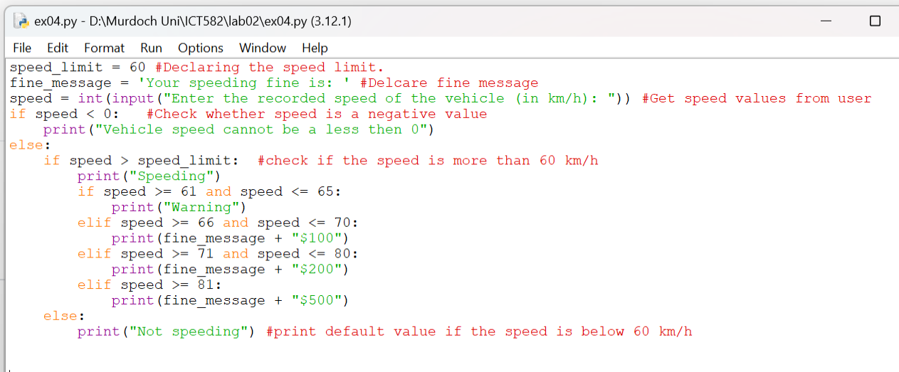

Output window.

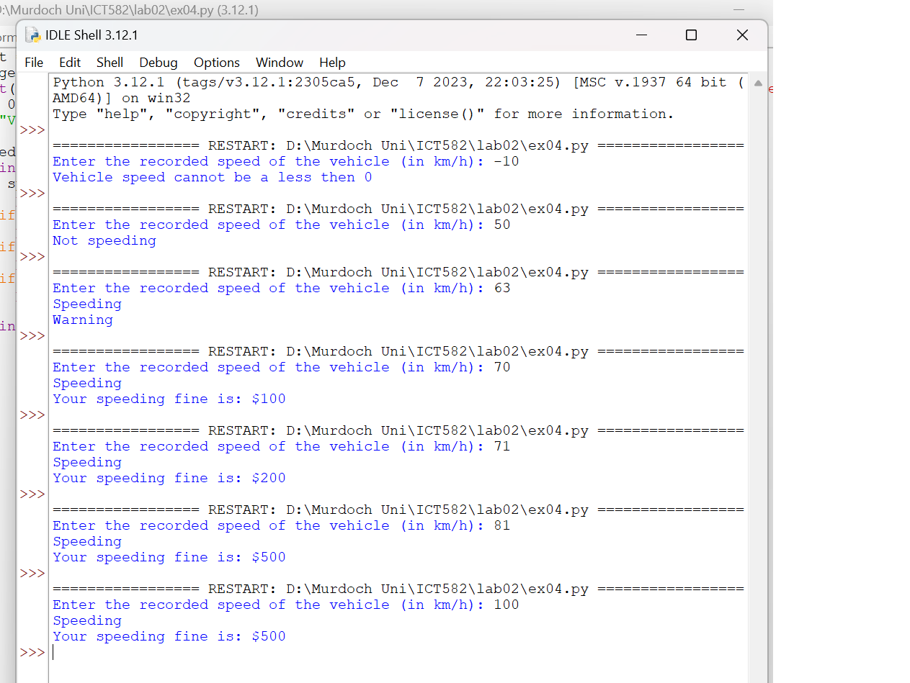

**Exercise 7:** Created python program file ex7.py to calculate the sum of all even numbers between two numbers. The program reads the two numbers (ie start_no and end_no) from the users and checks whether the ‘start_no’ is less than ‘start_no’. If the input is correct, it will calculate the sum if all even numbers within the range. Initially the sum of even number (ie sum_of_even_numbers) is assigned to zero. The program use a for loop to iterate through the range and add the even number to the sum.

Program.

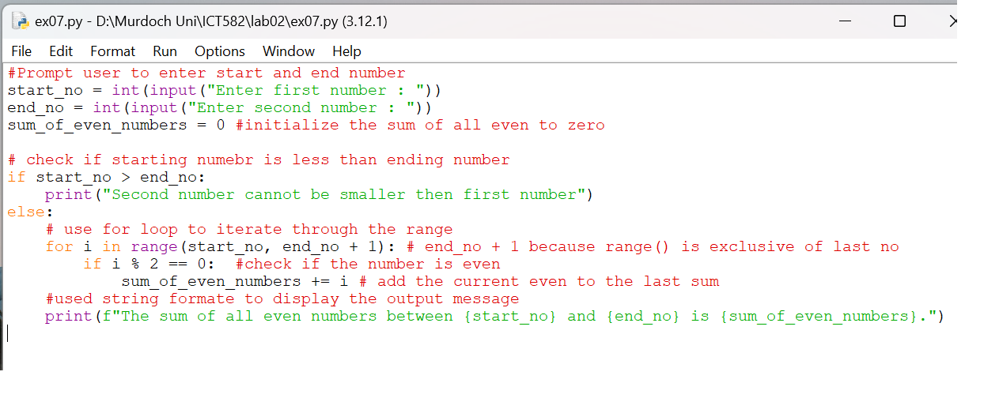

Output.

