

**School of Information Technology**

**ICT582 LAB DECLARATION**

**Surname:** Moktan **Given Names:** Ngawang Tashi

**Student Number:** 34959761

**Due Date:** Saturday, 30th March 2024, 10 PM **Date Submitted:** Saturday, 30th March 2024

**Lab Numbers:** 4 **Tutor's name**: A S M Hassan

**Your weekly lab should meet the following requirements. Please confirm this (by ticking boxes) before submitting your assignment.**

* The work included in this submission is completed independently by myself.
* I have read and understood ICT582 Lab Instructions.
* **This submission is compliant to ICT582 Lab Instructions.**
* I have kept another copy of this submission and associated programs and files in a safe place.
* I confirm that the work included in this submission is my own independent work.
* The test evidence for each exercise (including copies of terminal outputs or screenshots) in this submission is provided in the following pages of this document.

**Please make your declaration for each question or exercise in each weekly lab by writing YES in the last column if the question or exercise is fully completed and all relevant files for the question are included in this submission. Otherwise, write NO.**

|  |  |  |
| --- | --- | --- |
| **Lab Number** | **Question/Exercise Number** | **Fully Completed (Yes/No)** |
| 4 | 2 | Yes |
| 4 | 7 | Yes |
| 4 | 8 | Yes |

Test evidence of the exercises are in the following pages

**Test Evidence for the Exercises**

**Exercise 2:** The python program file ex2.py reads sequence of number and find the largest number. The main program calls the function “find_largest_number()” to find the largest number from the given sequence. The program will terminate if the user enters ‘stop’. The function takes in the user input sequence of number and checks if the user input is number or not, and then compare the number with next number to check which is largest. The functions return the largest number from the sequence and print it.

Program:

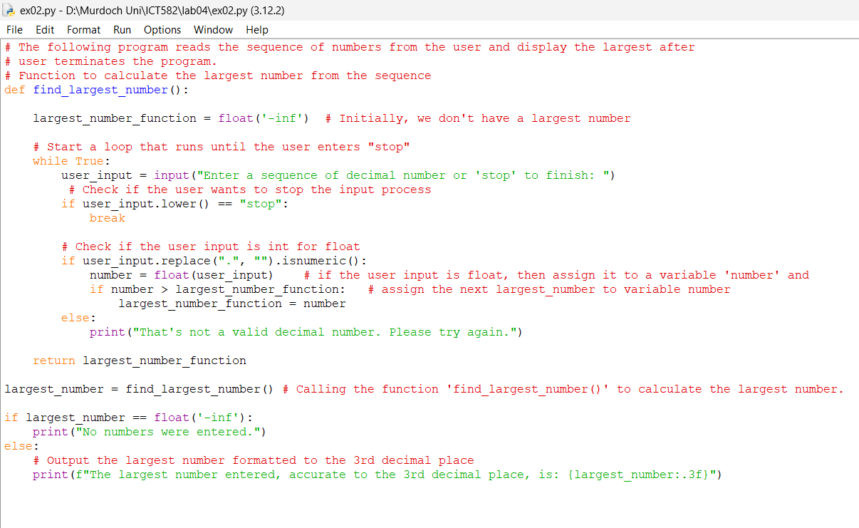

Output:

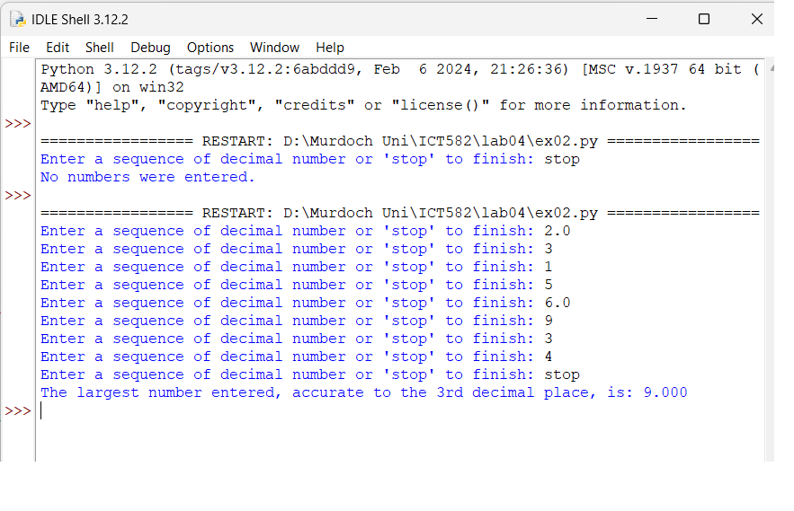

**Exercise 7:** The python program file ex07.py takes a string as input and returns a new string where each character is shifted by one position in the alphabetical order. The main program reads a string from user and calls ‘shift_string()’ function. The function takes in the user input string from main function as parameter and iterate through string using ‘for’ loop. The function treats ‘z/Z’ as special character and change it to ‘a/A’. The program terminates if the user types in ‘stop’.

Program.

Output window.

**Exercise 8:** The python program ex08.py reads the user input in integer and call’s the function ‘print_triangle()’ in triangle.py program. Here the main program imports function from another python script using ‘import’ keyword and the file name without the .py extension. In the following main program, I have used * to call the function from triangle.py. ‘*’ means making all the attributes of imported module visible in our code. We can also use ‘from triangle import print_triangle’ to make only a specific module visible.

Program ex08.py (main).

Program triangle.py (triangle function)

The ‘print_triangle()’ inside the triangle.py takes in the integer as parameter and prints the desire output. The output is represented in next output image.

Output.

