

**School of Information Technology**

**ICT582 LAB DECLARATION**

**Surname:** Moktan **Given Names:** Ngawang Tashi

**Student Number:** 34959761

**Due Date:** Saturday, 6th April 2024, 10 PM **Date Submitted:** Saturday, 6th April 2024

**Lab Numbers:** 5 **Tutor's name**: A S M Hassan

**Your weekly lab should meet the following requirements. Please confirm this (by ticking boxes) before submitting your assignment.**

* The work included in this submission is completed independently by myself.
* I have read and understood ICT582 Lab Instructions.
* **This submission is compliant to ICT582 Lab Instructions.**
* I have kept another copy of this submission and associated programs and files in a safe place.
* I confirm that the work included in this submission is my own independent work.
* The test evidence for each exercise (including copies of terminal outputs or screenshots) in this submission is provided in the following pages of this document.

**Please make your declaration for each question or exercise in each weekly lab by writing YES in the last column if the question or exercise is fully completed and all relevant files for the question are included in this submission. Otherwise, write NO.**

|  |  |  |
| --- | --- | --- |
| **Lab Number** | **Question/Exercise Number** | **Fully Completed (Yes/No)** |
| 5 | 2 | Yes |
| 5 | 5 | Yes |
| 5 | 7 | Yes |

Test evidence of the exercises are in the following pages

**Test Evidence for the Exercises**

**Exercise 2:** The python program file ex2.py a function called countUnique() which receives a list from the main program and returns a tuple with the unique count and the unique elements in a list. The function makes use of a for loop to iterate through the list and check whether the element is already present in a new list; if not, then the program adds the element to the list and, finally, returns the unique count and the unique list back to the main program. The main program continuously iterates and requests the user to enter the data into the list unless the user terminate the program by typing ‘stop’.

Program:

Output:

**Exercise 5:** The python program file ex05.py the function takes in list of words as input and stores it in a empty list capitalized_list. Using the loop it use word.capitalize() method to capitalize the first letter of each words. This function is designed without side effects. It creates a new list capitalized_list to store the capitalized versions and returns it.

Program:

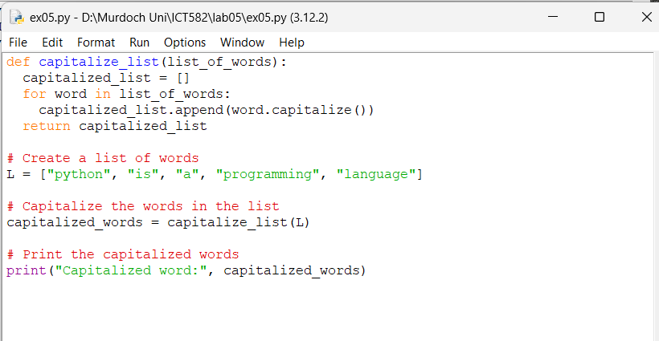

Output:

**Exercise 7:** The python program file ex07.py takes the marks of student and display the data in the list. The very first function (ie. validate_mark()) get the marks from the user and validate whether is marks in a whole number between 0 to 100. A loop is initiated with while True to continue unless return with the loop body, that is to keep asking user for valid input.

The second function just use if else statement to assign the letter grade according to the marks of student. The third function use the list data to calculate total marks, average mark, highest and lowest mark, number of student failed and highest archiving student.

Program (All function).

Program (Main method).

The main method checks whether the student id is 0 or not. The program will terminate if the student id is 0 and display the list and other data. A empty list is initialized to store each student data. The main method use while true loop to repeatedly execute the function unless it is broken. The main methos also prompt user to enter the student marks and append the data to the list.

Output.

