

**School of Information Technology**

**ICT582 LAB DECLARATION**

**Surname:** Moktan **Given Names:** Ngawang Tashi

**Student Number:** 34959761

**Due Date:** Saturday, 20th April 2024, 10 PM **Date Submitted:** Saturday, 20th April 2024

**Lab Numbers:** 6 **Tutor's name**: A S M Hassan

**Your weekly lab should meet the following requirements. Please confirm this (by ticking boxes) before submitting your assignment.**

* The work included in this submission is completed independently by myself.
* I have read and understood ICT582 Lab Instructions.
* **This submission is compliant to ICT582 Lab Instructions.**
* I have kept another copy of this submission and associated programs and files in a safe place.
* I confirm that the work included in this submission is my own independent work.
* The test evidence for each exercise (including copies of terminal outputs or screenshots) in this submission is provided in the following pages of this document.

**Please make your declaration for each question or exercise in each weekly lab by writing YES in the last column if the question or exercise is fully completed and all relevant files for the question are included in this submission. Otherwise, write NO.**

|  |  |  |
| --- | --- | --- |
| **Lab Number** | **Question/Exercise Number** | **Fully Completed (Yes/No)** |
| 6 | 1 | Yes |
| 6 | 2 | Yes |
| 6 | 4 | Yes |

Test evidence of the exercises are in the following pages

**Test Evidence for the Exercises**

**Exercise 1:** The python program file ex1.py creates a students dictionary and adds all the student marks details into the dictionary for each students and returns it back to the main program. Finally, the main program iterates through the dictionary and prints all the student marks details.

Program:

Output:

**Exercise 2:**

Program: The python program file ex2.py is the extension of ex01.py with additional function to display the average, highest and lowest mark. It also display the name and ID of all the students who got the highest grade and the lowest grade, total number of students failed in the unit.

Program:

Output:

**Exercise 4:** The program ex04.py reads the input lyric and displays the list of words with the highest frequency and the list of words with the lowest frequency.

Program.

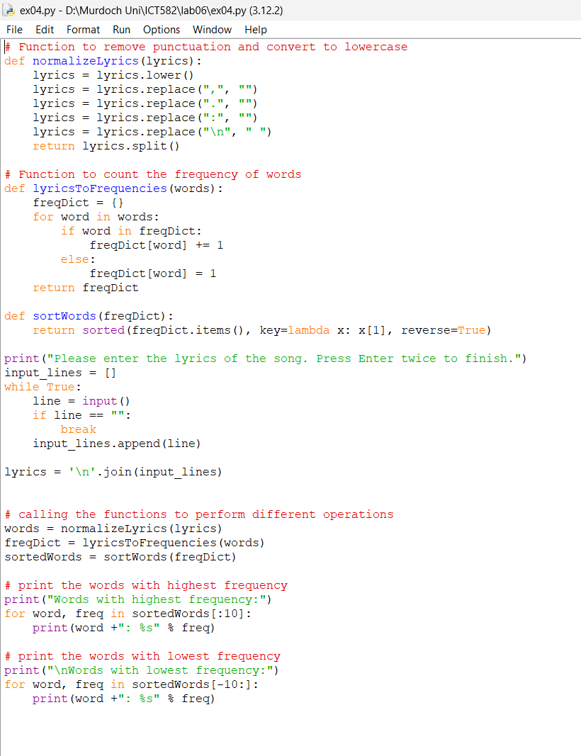

Output.

