

**School of Information Technology**

**ICT582 LAB DECLARATION**

**Surname:** Moktan **Given Names:** Ngawang Tashi

**Student Number:** 34959761

**Due Date:** Saturday, 27th April 2024, 10 PM **Date Submitted:** Saturday, 27th April 2024

**Lab Numbers:** 7 **Tutor's name**: A S M Hassan

**Your weekly lab should meet the following requirements. Please confirm this (by ticking boxes) before submitting your assignment.**

* The work included in this submission is completed independently by myself.
* I have read and understood ICT582 Lab Instructions.
* **This submission is compliant to ICT582 Lab Instructions.**
* I have kept another copy of this submission and associated programs and files in a safe place.
* I confirm that the work included in this submission is my own independent work.
* The test evidence for each exercise (including copies of terminal outputs or screenshots) in this submission is provided in the following pages of this document.

**Please make your declaration for each question or exercise in each weekly lab by writing YES in the last column if the question or exercise is fully completed and all relevant files for the question are included in this submission. Otherwise, write NO.**

|  |  |  |
| --- | --- | --- |
| **Lab Number** | **Question/Exercise Number** | **Fully Completed (Yes/No)** |
| 7 | 3 | Yes |
| 7 | 4 | Yes |
| 7 | 5 | Yes |

Test evidence of the exercises are in the following pages

**Test Evidence for the Exercises**

**Exercise 3:** The python program file ex03.py manipulates the file and get the initial and current size. The function get_file_size() returns the size of file in bytes. It uses os.path.getsize() which is a method from the os.path module that retrieves the size of a file. The function append_to_file() read the contents of the file and append first two line and append it to the file. The function read_three_line() reads the first three line after excuting the append_to_file() function. After modifying the file, function get_new_size() is called to calculate and display new file size.

Program:

Content of ex03.txt before excuting program.

Output:

Content of ex03.txt after excuting program.

**Exercise 4:**

Program: The python program file ex4.py processes a CSV file named "staff.csv" and prints specific details (Name and Address) for each row in the file. It uses Python's built-in csv module for parsing CSV files, and the os module to check for the file's existence. The program use next(reader) to skip the first row of the CSV file which is the header in our case..

Content of staff.csv

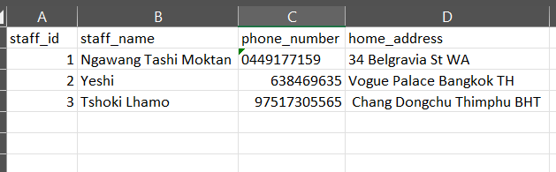

Program:

Output:

**Exercise 5:** The program ex05.py manages adding new entries to a CSV file named staff.csv located at a specified path. It utilizes Python's csv module for handling CSV operations and os module to check file existence. The add_staff() function will add append the new staff deatil to the csv file. The display_menu() function will display the user choise to add or stop the program.

Content of staff.csv before adding new staff.

Program.

Output.

Content of staff.csv after adding new staff.

