

**School of Information Technology**

**ICT582 LAB DECLARATION**

**Surname:** Moktan **Given Names:** Ngawang Tashi

**Student Number:** 34959761

**Due Date:** Saturday, 11th May 2024, 10 PM **Date Submitted:** Saturday, 5th May 2024

**Lab Numbers:** 8 **Tutor's name**: A S M Hassan

**Your weekly lab should meet the following requirements. Please confirm this (by ticking boxes) before submitting your assignment.**

* The work included in this submission is completed independently by myself.
* I have read and understood ICT582 Lab Instructions.
* **This submission is compliant to ICT582 Lab Instructions.**
* I have kept another copy of this submission and associated programs and files in a safe place.
* I confirm that the work included in this submission is my own independent work.
* The test evidence for each exercise (including copies of terminal outputs or screenshots) in this submission is provided in the following pages of this document.

**Please make your declaration for each question or exercise in each weekly lab by writing YES in the last column if the question or exercise is fully completed and all relevant files for the question are included in this submission. Otherwise, write NO.**

|  |  |  |
| --- | --- | --- |
| **Lab Number** | **Question/Exercise Number** | **Fully Completed (Yes/No)** |
| 8 | 3 | Yes |
| 8 | 4 | Yes |
| 8 | 5 | Yes |

Test evidence of the exercises are in the following pages

**Test Evidence for the Exercises**

**Exercise 3:** The program ex03.py use function ‘copy_file’ to copy the contents of one file (source_file) to another file (destination_file). The function also use error handling to try and catch exception when potential issues arise. The program handles FileNotFoundError when the program cannot locate the source file, IOError – which catch the input/output errors and one general purpose error handling.

Program:

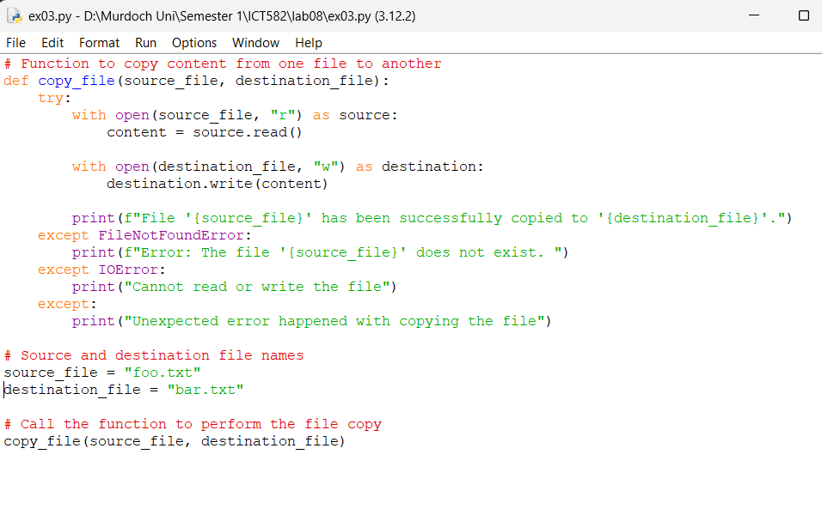

Content of Source File (foo.txt)

Content of destination file (bar.txt) before copying the content.

Output:

1. Error when source file is not found.

1. Error when source file is not in write mode.

1. Output when the program run without error

Output when copying content from source to destination file.

**Exercise 4:** The program ex04.py is designed to read data from a CSV file named ‘staff.csv’ and process each row to extract and display the information. The program imports csv module to read and write data in CSV. The main TRY block attempts to open and read csv file. A nested TRY CATCH is used within the main TRY block to throw exception for missing staff_id. Other exceptions handling are FileNotFoundError, IOError and general purpose error.

Program:

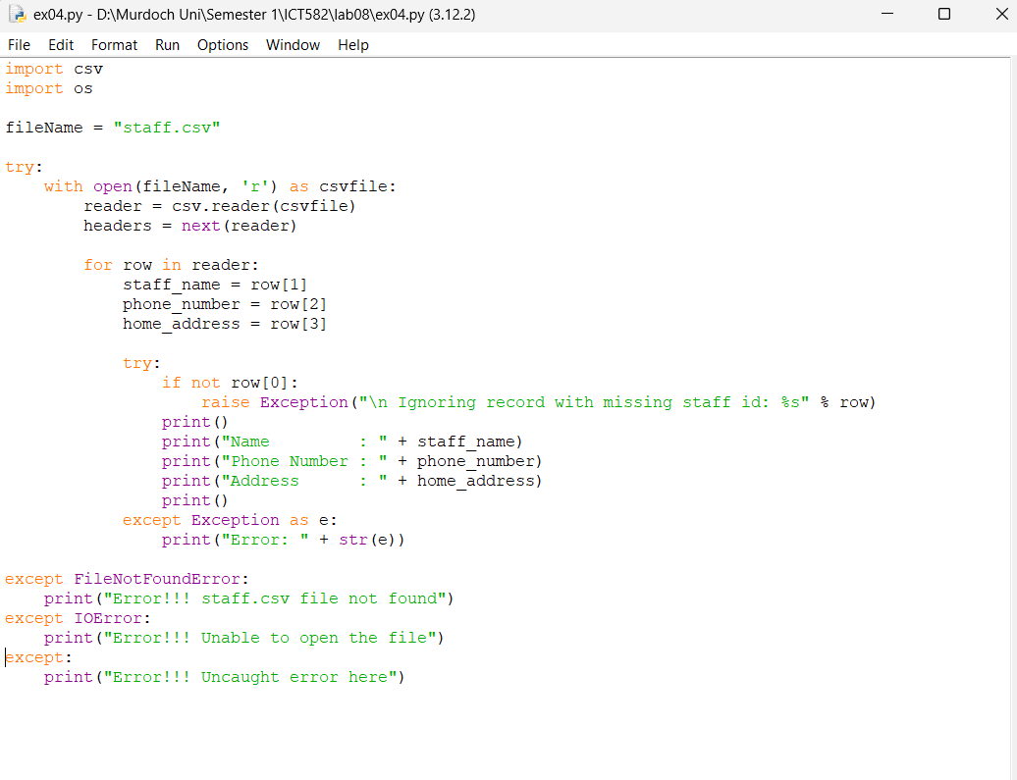

Output:

1. FileNotFoundError exception handling.

1. IOError exceptional handling.

1. General purpose error handling – happened when the file is empty.

1. Nested exceptional handling. Here, the second row has missing staff id, so we get the error and printing of that particular row is ignored.

**Exercise 5:** The program ex05.py defines a function ‘print_triangle(n)’, that prints a numerical triangle bases on the positive integer ‘n’. The program use assertion to ensure that ‘n’ is an integer within the specified range (1-9). If ‘n’ is not an integer or falls outside the range, the program will raises an ‘AssertionError’ with the message provided.

Program.

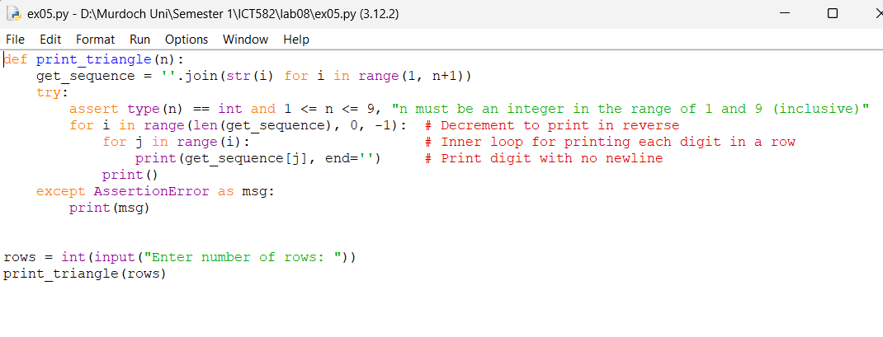

Output.

1. Throwing the assertion exception

1. Printing triangle with desired range.

