

**School of Information Technology**

**ICT582 LAB DECLARATION**

**Surname:** Moktan **Given Names:** Ngawang Tashi

**Student Number:** 34959761

**Due Date:** Saturday, 18th May 2024, 10 PM **Date Submitted:** Saturday, 18th May 2024

**Lab Numbers:** 9 **Tutor's name**: A S M Hassan

**Your weekly lab should meet the following requirements. Please confirm this (by ticking boxes) before submitting your assignment.**

* The work included in this submission is completed independently by myself.
* I have read and understood ICT582 Lab Instructions.
* **This submission is compliant to ICT582 Lab Instructions.**
* I have kept another copy of this submission and associated programs and files in a safe place.
* I confirm that the work included in this submission is my own independent work.
* The test evidence for each exercise (including copies of terminal outputs or screenshots) in this submission is provided in the following pages of this document.

**Please make your declaration for each question or exercise in each weekly lab by writing YES in the last column if the question or exercise is fully completed and all relevant files for the question are included in this submission. Otherwise, write NO.**

|  |  |  |
| --- | --- | --- |
| **Lab Number** | **Question/Exercise Number** | **Fully Completed (Yes/No)** |
| 9 | 1 | Yes |
| 9 | 2 | Yes |
| 9 | 3 | Yes |

Test evidence of the exercises are in the following pages

**Test Evidence for the Exercises**

**Exercise 1:** The program ex01.py modifies the lecture note by adding added three new functions namely: to_float(), _truediv_(), and invert().

Program:

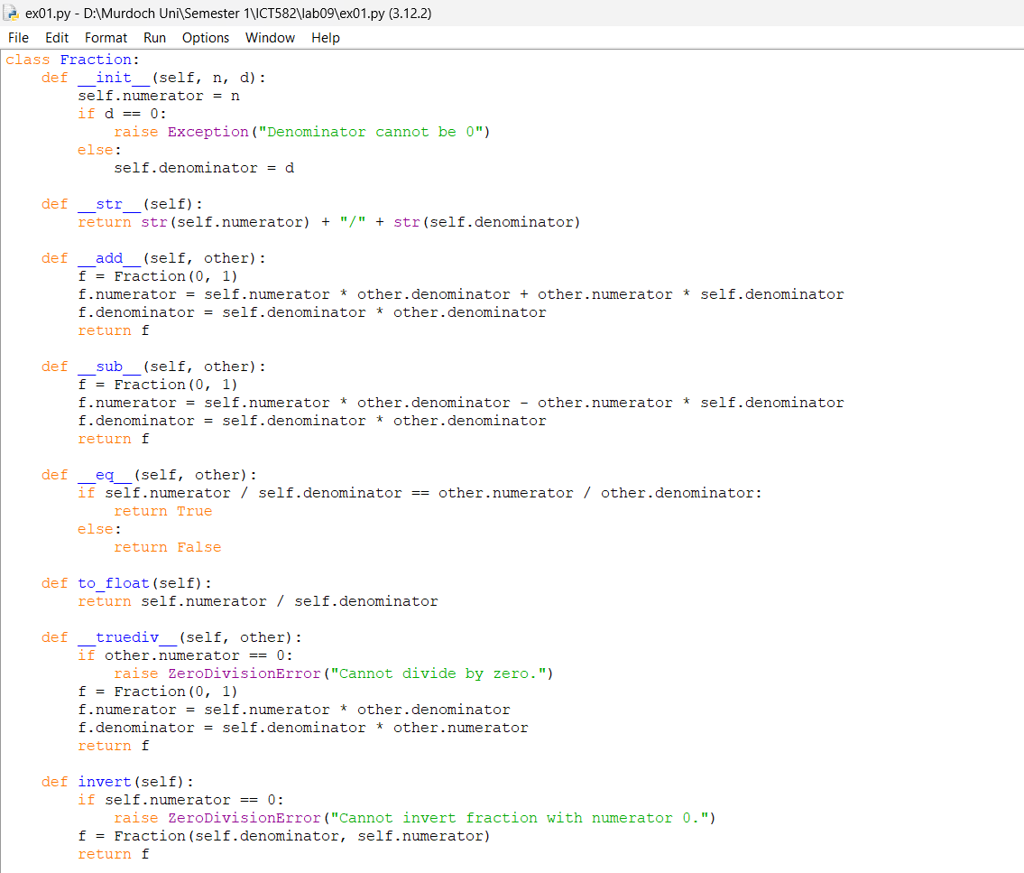

Output:

**Exercise 2:** The program ex02.py is TicketMachine class developed with all the required functions.

Program:

Output:

**Exercise 3:** The program ex03.py is also a TicketMachineSystem class developed to perform the operations like addMachine(), removeMachine(), getTotalMachine(), and getTotalSales().

Program.

Output.

