

ASsignment

Introduction to Server Environments and Architectures



Student Name: Nga Zong Li

Student Id: 35753736

Date: 6 July 2025

Github link  
Video link

Contents

Introduction 2

Day 1: Setting up and Exploring Linux 3

Morning Session 3

Lab - Sign up for a Github account 3

Lab - Obtaining Linux on PC – Install Ubuntu using VirtualBox. 4

Lab - Familiarity with Ubuntu Linux – Basic command line navigation and utilities. 5

Afternoon Session 8

Lab - Linux Services 8

Linux Permissions 13

# Introduction

This journal reflects my learning journey and hands-on experience during the BRG-27: *Introduction to Server Environments and Architectures* intensive workshop. The workshop was spread over four days, and I completed a wide range of lab activities focused on building, configuring, and managing Linux servers both locally and in the cloud. A final video demonstration was also prepared as part of the fifth deliverable.

Throughout this project, I learned how to install Ubuntu on a virtual machine, use basic and advanced Linux commands, manage services and file permissions, automate tasks with scripts, compare on-prem vs cloud costs using TCO analysis, and deploy cloud servers on AWS. I also configured DNS for a domain and secured the server with a free SSL certificate from Let’s Encrypt.

The journal is organised by day, as follows:

* **Day 1** – Set up GitHub for documentation, installed Ubuntu via VirtualBox, and practiced Linux terminal commands
* **Day 2** – Explored Linux services, file permissions, search utilities, cost comparison (TCO), cloud deployment, and bash scripting
* **Day 3** – Set up DNS with a registered domain and secured the site with an SSL certificate
* **Day 4** – Automated Linux tasks using bash scripts and cron jobs, and prepared for the final consultation
* **Day 5** – Recorded a 15-minute video demo showing my lab work, reflections, challenges, and walkthrough of an additional server service

This journal includes screenshots, key commands, problem-solving steps, and personal reflections. It also explains how these technical skills are relevant to real-world IT roles such as system administrator, DevOps engineer, or IT consultant. GitHub was used throughout the workshop to track changes and store my progress. The final video demonstration summarises everything I worked on and learned.

# Day 1: Setting up and Exploring Linux

## Morning Session

### Lab - Sign up for a Github account

Create a new repository and add a README.md and start documenting

Clone the repository to the local machine using Git.

### Lab - Obtaining Linux on PC – Install Ubuntu using VirtualBox.

Download Ubuntu ISO from the official website.

Install VirtualBox and create a new virtual machine

Configure VM settings

Mount ISO and install Ubuntu through guided installer.

I am using VMware Workstation

### Lab - Familiarity with Ubuntu Linux

Open Terminal and try out the lab practice by typing command

Trying up whoami command and understanding for Super User

Viewing the hosts file

Check for Computer Hardware info, export to file and remove it

Installing from source code and compile code from source.

#### I started by creating a GitHub account and set up a new repository called brg27-labs to store all my lab work. I learned how to clone the repository to my local machine and created a README.md file to start documenting my progress. Once Ubuntu was installed, I practiced using basic Linux commands in the terminal. I used pwd, ls, cd, mkdir, and touch to move around the file system, create directories, and create files. I also used the man command to check the manual pages for different commands. I explored folders like /etc, /home, and /var to get a better idea of how Linux organizes system files. This session helped me set up everything I needed to start the labs and gave me a solid introduction to Linux. I now understand the importance of using GitHub for documentation and version control, and I feel more confident using the Linux terminal. Installing and using Ubuntu in a virtual machine was a great way to get hands-on experience without needing a separate computer. These are all essential skills for anyone working in server environments

## Afternoon Session

### Lab - Linux Services

After install apache2, nmap and openssh-server

I made some change to the html (tittle and replace some word in pargaraph)

Without using sudo command, there is no permission to edit the html.

The html be like this

After remove apache2 the port 80 was no longer listed

Reinstall apache2 the port 80 is reappeared.

I created a new user with sudo adduser jaychou and saw the /etc/passwd file update to include the new account.

I SSH’d into the machine using:  
ssh user@ip, then exited using exit.

I downloaded three eBooks using wget

Moved them into a books directory, and created a tar archive

The result was smaller books.tar.bz2 file, showing good compression.

I then decompressed it using bunzip2 and extracted with tar -xvf.

### Lab - Linux Permissions

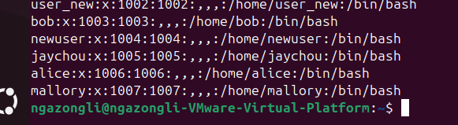

I began by creating three new users : alice, bob, Mallory

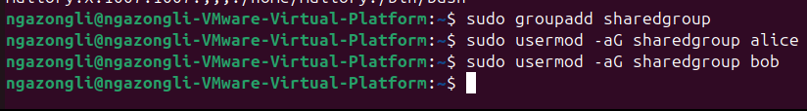

Then I created a new group called sharedgroup, and I added alice and bob to the group

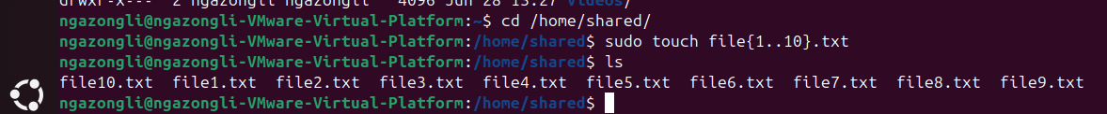

I created the shared folder and 10 files

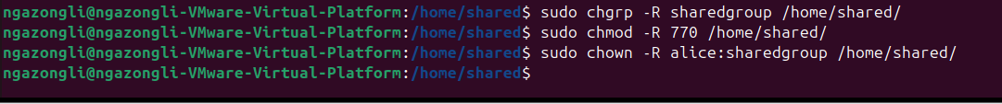

Then I assigned the group to the folder and its content

Used chmod to set and I changed the ownership of the files to alice

Owner alice is able to access and write to the file

Group bob is able to write to the file as i set the chmod 770

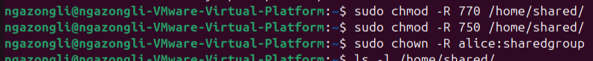

After I chmod to 750

Now Bob can read file and execute file but can’t write on it

User Mallory couldn’t access the folder at all.

I set up a shared folder where Alice had full access, Bob could only read and execute, and Mallory had no access. I used group permissions to control this by creating a sharedgroup, assigning Alice and Bob to it, and setting permissions with chmod 750. At first, Bob could write because the group had write access. I fixed this by reducing the group permissions to r-x only. Testing with su and whoami confirmed that Alice could write, Bob could read but not write, and Mallory couldn’t access the folder at all. This exercise helped me understand how to properly use chmod, chown, and group membership to manage file access securely.

### Lab – Searching filesystems