# Homework #1

Name: Nicolas GOMEZ BUSTAMANTE

Unit 1 Homework: Kickstart My Chart

## Assignment

### Given the provided data, what are three conclusions we can draw about Kickstarter campaigns?

Conclusion #1: “Theater” had the highest number of projects and the largest amount of successful projects but “Music” was the most efficient campaign

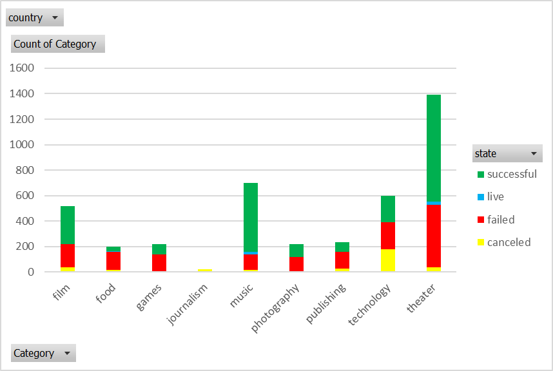

Conclusion #2: “Plays” was the subcategory with the largest number of projects and largest number of successful projects, followed by “rock” subcategory

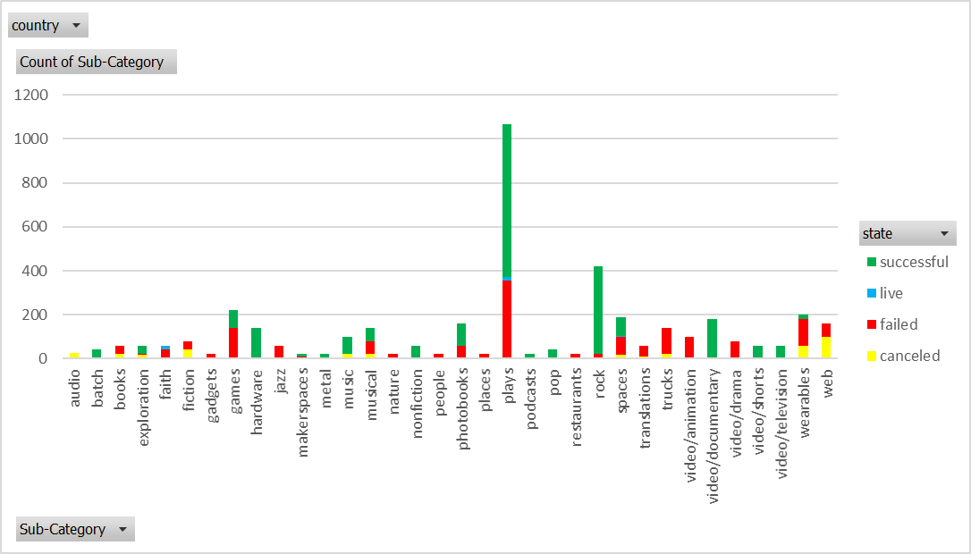

Conclusion #3: Projects launched in May had a higher successful rate, whereas projects created in Jan, Jun, Jul and Oct had a higher failure rate.

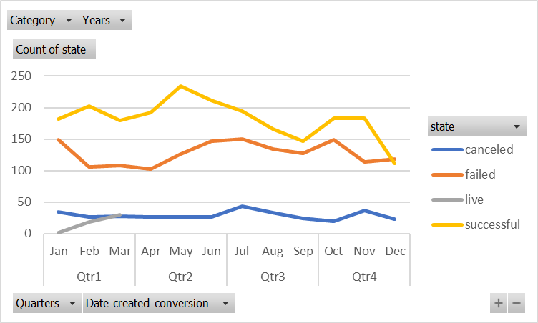

### What are some limitations of this dataset?

Some of limitations are:

* It’s not up to date. The last recorded value was from 2017 (representativity)
* Availability of main reasons (e.g. top 3) for cancellation or failure (learn from the past)
* Availability of main reasons (e.g. top 3) of success (to apply in the future)
* Information about backers (public, private, individuals, etc)

### What are some other possible tables and/or graphs that we could create?

Some additional tables and/or graphs that could be created include:

* Number of projects per country (e.g. most of the projects were executed in the US, followed by GB
* Weighted average of successful projects (percent funded x pledged), to identify the best projects (top 10), for all the projects and per category
* Weighted average of failed projects (percent funded x pledged), to identify worst projects (bottom 10), for all the projects and per category
* Pie chart of top 3 successful categories (film, music, theatre)  
  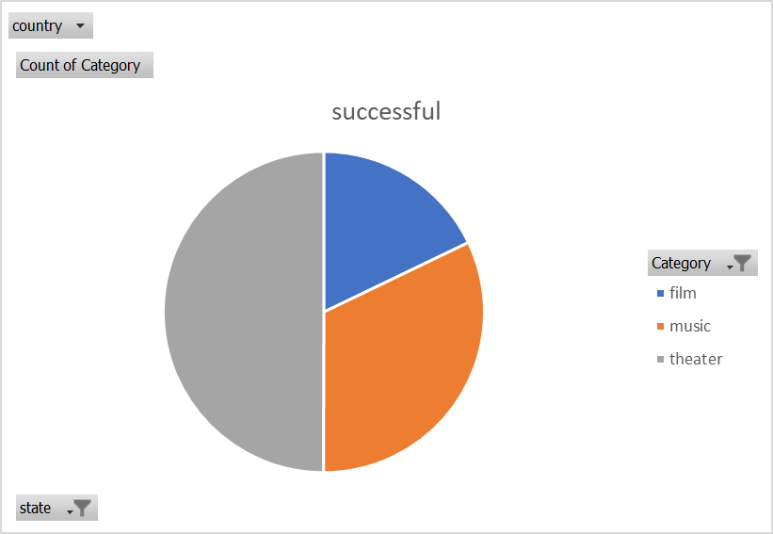
* Pie chart of top failed categories (film, technology, theatre)

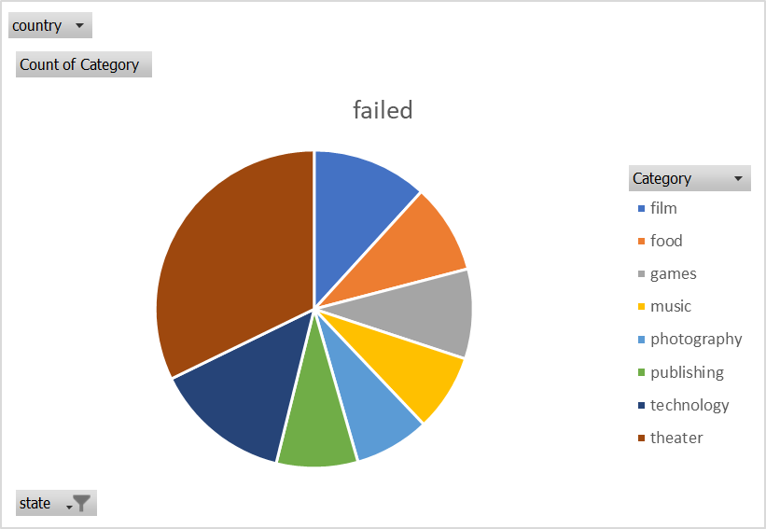

## Bonus

### Create a line chart that graphs the relationship between a goal's amount and its chances at success, failure, or cancellation

70% of successful projects required goal of less than $1000, or it’s more likely to have success on least ambitious goals.

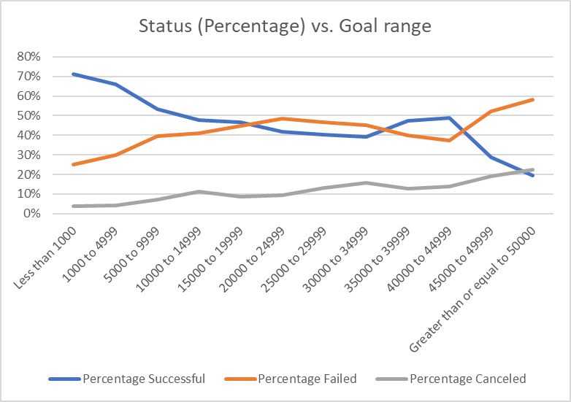

### Use your data to determine whether the mean or the median summarizes the data more meaningfully.

The mean (average) of backers of successful projects was 10 times higher than backers of failed projects (the higher the number of backers the higher likelihood of success)

|  |  |  |
| --- | --- | --- |
| STATS BACKERS_COUNT | | |
| STATS | SUCESSFUL | FAILED |
| AVERAGE | 194 | 18 |
| MEDIAN | 62 | 4 |
| MODE | 27 | 0 |
| MIN | 1 | 0 |
| MAX | 26457 | 1293 |
| VAR.P | 712841 | 3773 |
| VAR.S | 713167 | 3776 |
| STDEV.P | 844 | 61 |
| STDEV.S | 844 | 61 |