# Useful Recources

# 1.

**Link**: <https://www.gineersnow.com/engineering/software/new-computer-model-can-predict-delayed-flights-accurately-ever>

**Description**: It is an article for a PhD thesis with ANNs for this purpose. The paper is here: <http://ac.els-cdn.com/S1877050916324942/1-s2.0-S1877050916324942-main.pdf?_tid=4a044fb4-0443-11e7-8bd6-00000aab0f6c&acdnat=1489007450_558ca6ddcc996b5c1be5eecafc0eb130>

**Point made**: According to the U.S. Bureau of Transportation Statistics, the top five reasons for flight delays in the U.S. in 2014 are the following: **security**, which range from evacuation to reboarding; **extreme weather**, which include tornados, blizzards and hurricanes; **National Aviation System delays**, or a broad set of conditions including non-extreme weather, **airport operations**, **heavy traffic volume and air traffic control**; **air carrier delays**, which covers maintenance or crew problems, aircraft cleaning, baggage loading and fuelling; and late-arriving aircraft.

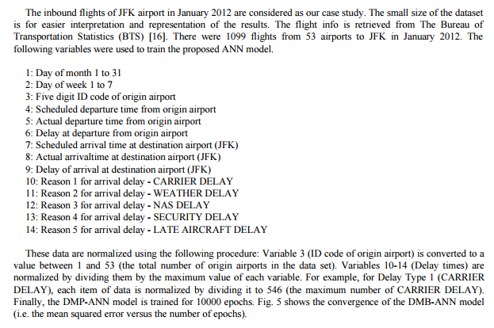

* They also identify 5 delay categories and try to classify with them.
* They normalize
* Only 14 variables (9 independent)!

# 2.

**Link**: <http://www.decisionsciencenews.com/2014/11/06/flight-delays/>

**Description**: Article with good plots about the reasons and the effect of the day and the month of the delays.

**Point made**: the reasons and the effect of the day and the month of the delays.

# 3.

**Link**: <https://flightdelaypredictor.wordpress.com>

**Description**: Just another view

**Point made**: suggest kNN or partitioning the data and DTs. Again only a few variables!

# 4.

**Link**: <https://jessesw.com/Air-Delays/>

**Description**: phd blog

**Point made**: Creating a New Feature: Number of Days to Holiday

# 5.

**Link**: <http://etd.fcla.edu/CF/CFE0001049/Bai_Yuqiong_200605_MS.pdf>

**Description**: Full phd thesis. Slightly moufa

**Point made**: ?

# 6.

**Link**: <http://www.jairm.org/index.php/jairm/article/view/22/63>

**Description**: Paper

**Point made**: Cycles across years

# 7.

**Link**: <http://cs229.stanford.edu/proj2012/CastilloLawson-PredictingFlightDelays.pdf>

**Description**: Paper

**Point made**: Techniques comparison (SVM, RFs, etc)

# 8.

**Link**: <http://www.mit.edu/~hamsa/pubs/RebolloBalakrishnanTRC2014.pdf>

**Description**: Paper

**Point made**: RFs

# 9.

**Link**: <http://cs229.stanford.edu/proj2012/BandyopadhyayGuerrero-PredictingFlightDelays.pdf>

**Description**: Paper (the one that we found)

**Point made**: Use LR to determine importance and then another technique. Firstly, estimate binary delay/no delay and then the magnitude.

# 10.

**Link**: <https://cseweb.ucsd.edu/~jmcauley/cse190/reports/fa15/037.pdf>

**Description**: Paper

**Point made**: Nice explanatory analysis and presentation. Removal or rows that do not help train a predictive model.

