**Manual Strategy Report**

**Summary**

Code is included in the submission. We look at the Best Possible Strategy (the biggest profit you can make if you can see the future) and compare it to performance of a Manual Strategy. The training set (“in-sample period”) spans trading days from January 1, 2008 to December 31, 2009. The test set (“out-of-sample period”) consists of trading days from January 1, 2010 to December 31, 2011.

**Part 1: Discussion of Technical Indicators**

1. **Simple Moving Average (20-day)**

The 20-day SMA is simply the average adjusted closing price in a 20 day rolling window, including the current day. In order to calculate the SMA on the first day of trading, we look up 20 days of data before the current date and perform the rolling calculation up to the first day of trading. I don’t directly use SMA to make decisions, but rather I include the SMA in the Bollinger Band calculation which I use to make the final buy or sell decision. A plot of the 20-Day SMA is included in the Bollinger Band plot (see below).

1. **Bollinger Bands**

The formula for Bollinger Bands is

bb_value[t] = (price[t] - SMA[t])/(2 * stdev[t])

Where price[t] is the current price, SMA[t] is the 20-day moving average on that day, and stdev[t] is the 20-day standard deviation of price on that day. Below is a chart showing the upper and lower Bollinger Band and 20-day SMA for JP Morgan over the in-sample period.

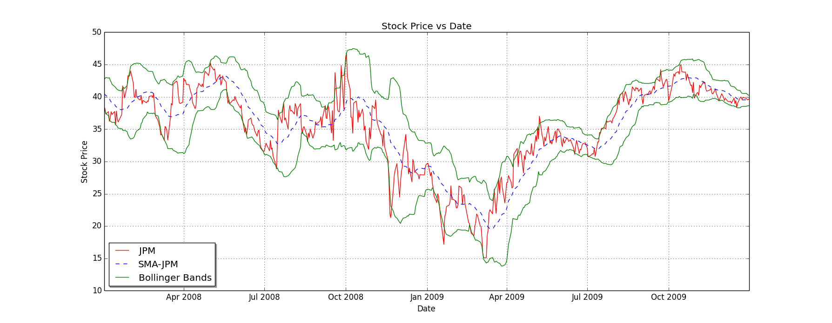

1. **Stochastic Oscillator**

The Stochastic Oscillator is a “momentum indicator comparing the closing price of a security to the range of its prices over a certain period of time” (Investopedia.com). The Stochastic Oscillator ranges from 0 to 100 (it is a percentage), and follows the formula:

%K[t] = (ClosingPrice[t] - LN)/(HN - LN)

Where ClosingPrice[t] is today’s closing price, LN is the *lowest* low in the last N days, and HN is the *highest* high in the last N days. Traders use different values of N depending on their trading goals. I found that a 14-day window worked very well.

We take the 3-day moving average of %K to create a “slow” version of the stochastic oscillator (let’s call this %D). This slower stochastic oscillator is used to make decisions. When %D is above 80, it suggests that the stock is overbought so a drop in price is imminent (selling opportunity). When %D is below 20, it suggests the stock is oversold and an increase in price is imminent (buying opportunity).

Here is a chart of %D and %K vs stock price over the in-sample period:

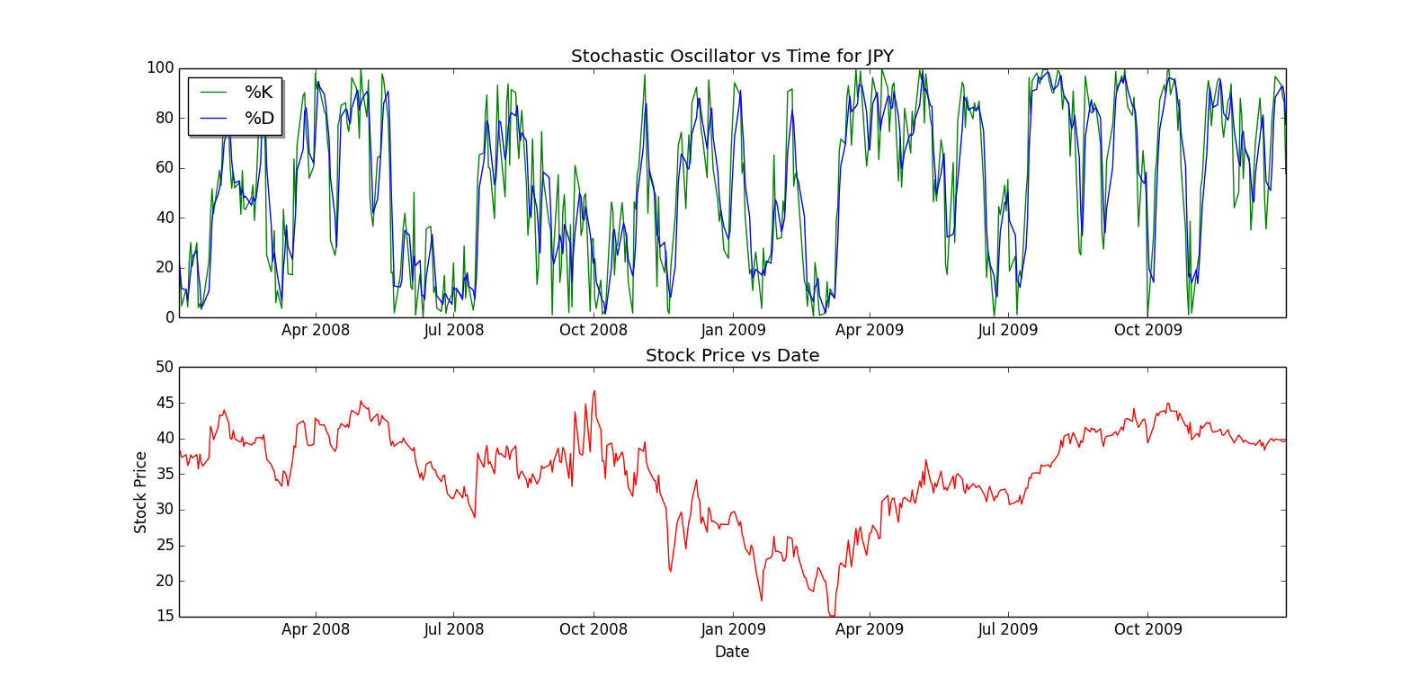

**Part 2: Discussion of Best Possible Strategy**

The Best Possible Strategy is to sell or short when you know the price is going to drop and to buy when you know the price will increase (only to sell or short it at the next drop). If you can do this with 0 transaction costs and 0 impact, you will have the theoretical maximum performance over that sample period. Our strategy is to be in a “short” position (-1000) when we know the stock will drop tomorrow and to be in a “long” position (+1000) when we know the stock will rise tomorrow. The Best Possible Trader operates on $0 commission and 0 impact per trade.

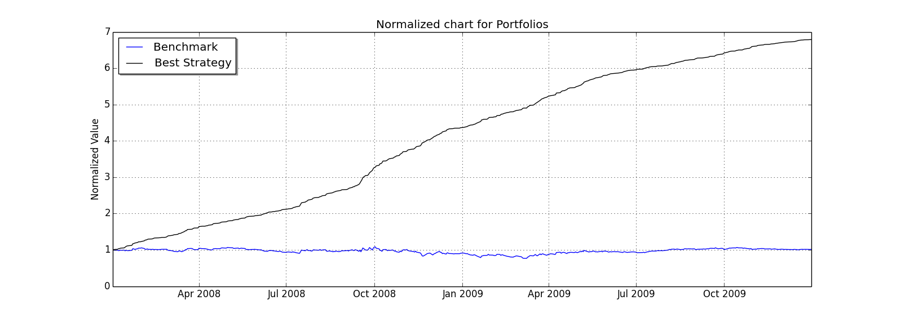

As you can see in the above chart, our Best Possible trader finishes the period at approximately 6.79X original value, while the Benchmark portfolio finishes at 1.01X original value.

Our statistics for the best possible trader are, as expected, insanely great. A Sharpe ratio of 13.3!

Sharpe Ratio of Best Possible Strategy: 13.3227698482

Sharpe Ratio of Benchmark: 0.156918406424

Sharpe Ratio of SPY : -0.137143508209

Cumulative Return of Best Possible Strategy: 5.7861

Cumulative Return of Benchmark: 0.0123

Cumulative Return of SPY : -0.194324631101

Standard Deviation of Best Possible Strategy: 0.00454782319791

Standard Deviation of Benchmark: 0.0170043662712

Standard Deviation of SPY : 0.0219321223021

Average Daily Return of Best Possible Strategy: 0.00381678615086

Average Daily Return of Benchmark: 0.000168086978191

Average Daily Return of SPY : -0.000189476626317

Final Portfolio Value: $678610

Final Benchmark Value: $101230

Final SPY Value: $80567.54

**Part 3: Discussion of Manual Strategy Trader**

My manual strategy trader outperforms the benchmark for in-sample. Here is the chart, with green lines representing entry into a LONG position, and red showing entry into a SHORT position. Note that there are periods where the trader exits a short position and holds a position of 0 while waiting for a better buying time. Exits from long or short positions are not shown –only entries into these positions are shown.

Manual Trader operates with $9.95 commission per trade and 0.005 impact on trade.

The Manual Strategy is as follows: I use Bollinger Bands and Stochastic Oscillator to “vote” on what state to be in. Should we be “long” (+1) or “short” (-1)? Both metrics have equal weight, so if they disagree the net result is to do nothing (0). Here is the voting scheme:

Bollinger Band Vote: +1 if Closing Price is less than bottom Band, -1 if Closing Price is greater than top Band

Stochastic Oscillator Vote: +1 if slow oscillator is < 20 (oversold), -1 if slow oscillator is > 80 (overbought)

End Vote = (Bollinger Band vote + Stochastic Oscillator vote) / 2

*Chart is on next page*

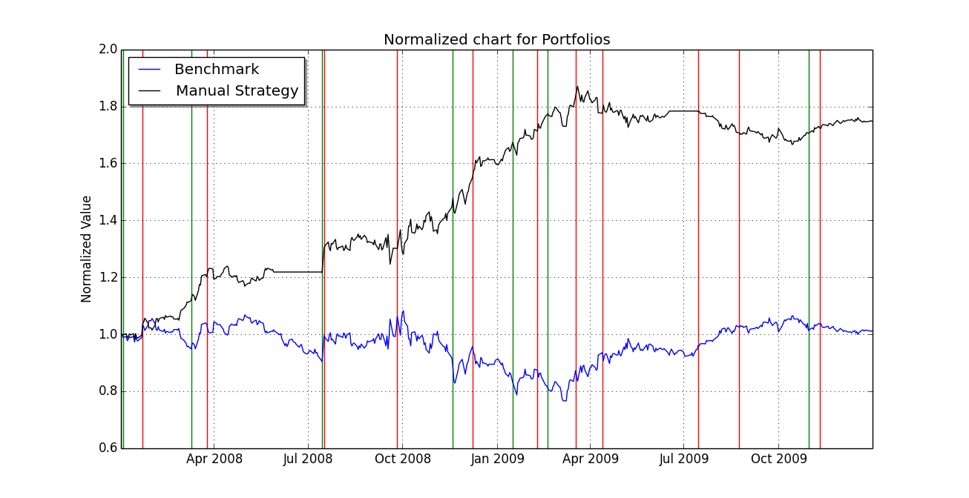

Sharpe Ratio of Fund: 1.70649716446

Sharpe Ratio of Benchmark: 0.156918406424

Sharpe Ratio of SPY : -0.137143508209

Cumulative Return of Fund: 0.7478105

Cumulative Return of Benchmark: 0.0123

Cumulative Return of SPY : -0.194324631101

Standard Deviation of Fund: 0.0108577745783

Standard Deviation of Benchmark: 0.0170043662712

Standard Deviation of SPY : 0.0219321223021

Average Daily Return of Fund: 0.00116720226454

Average Daily Return of Benchmark: 0.000168086978191

Average Daily Return of SPY : -0.000189476626317

Final Portfolio Value: $174781.05

Final Benchmark Value: $101230

Final SPY Value: $80567.54 (started with $100K of SPY)

**Part 4: Test Set Performance**

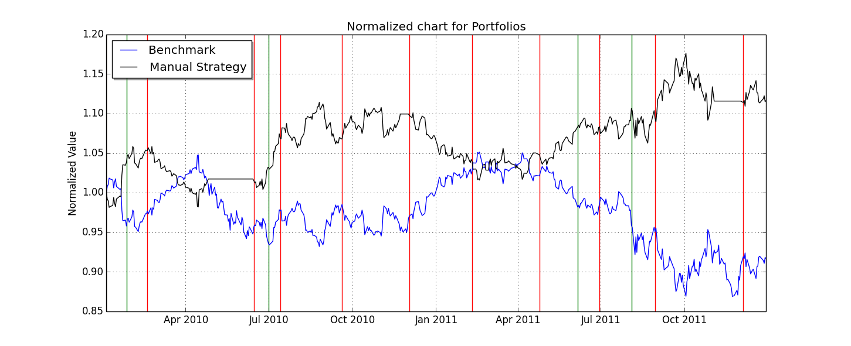

While we do outperform the buy-and-hold strategy for JPM over the out of sample period, it should be noted that SPY actually outperformed our fund over that period. Here is information about out of sample performance for Manual Trader (“Fund”). The SPY calculations assume you start with $100K of SPY.

We don’t perform as well as the in-sample period because JPM ends the out-of-sample period at a net decrease. In the in-sample period, JPM largely recovered from the Financial Crisis crash, so we were able to profit a lot from the recovery. In the out-of-sample period, there are fewer opportunities for massive profit, and the shorting opportunities are smaller. It also appears the stock is less volatile during the out-of-sample period, as the price leaves the Bollinger Band bracket fewer times as it did during our in-sample period. The out-of-sample Bollinger Band plot is included for comparison.

Sharpe Ratio of Fund: 0.57009306085

Sharpe Ratio of Benchmark: -0.256812960738

Sharpe Ratio of SPY : 0.439005682129

Cumulative Return of Fund: 0.1141765

Cumulative Return of Benchmark: -0.0834

Cumulative Return of SPY : 0.148148148148

Standard Deviation of Fund: 0.00673470605212

Standard Deviation of Benchmark: 0.0084810074988

Standard Deviation of SPY : 0.0129849753193

Average Daily Return of Fund: 0.000241860045016

Average Daily Return of Benchmark: -0.000137203160195

Average Daily Return of SPY : 0.000359096357221

Final Portfolio Value: $111417.65

Final Benchmark Value: $91660

Final SPY Value: $114814.81

