MKEL 1273: VLSI Design Automation

Semester: 2017/2018-1

Project 2

Group member:

GOH TA YANG

TIMOTHY TIAN ZHANG WAI

NG BOON KHAI

MICHEL HOH XIN JIE

**Objective**

The objective of this second part of the project is to develop algorithms to minimize the

floorplan area of terminal nodes in the ISP2005 benchmark circuits – Adaptec1 and Bigblue1.

we will build upon the profiler tool that you have developed in the first part of project. we are

free to implement (and modify) any placement algorithm we like. our task is to develop the

algorithm and show how we could iteratively minimize the total floorplan area. we will place

only the terminal cells (i.e. ignore non-terminal cells) and estimate the floorplan area.

**Design requirements**

The cells should be placed in a slicing fashion, i.e. the resulting floorplan must be a slicing

floorplan. For example, you can place the cells in rows or columns adjacent to each other. Each

cell should have a coordinate for location, with or without separation between rows/columns.

Figure 1 below shows an example. Total area is given by the dotted border of the floorplan.

Note that unoccupied space in the floorplan counts in the total area.

The cells should be placed in a way that you will obtain close to a square block. You will be

penalized if floorplan width/height or height/width ratio exceeds 1.2.

The placement should also be legal, i.e. no overlapping cells are allowed in the final floorplan.

**Algorithm**

We are using simple algorithm to minimize the floorplan as follow:

1. Load bench mark circuit
2. Extract terminal nodes and scale down the node to draw on the GUI
3. Sort the nodes according to their height from tall to short
4. Estimate possible area by adding all the area of the node (by multiplying height and width) and multiply the possible area by 10 as the floorplan should have larger area then the total area of the nodes
5. Estimate the width by square rooting (assuming the floorplan is a square) the estimated possible area
6. Enumerate the X and Y coordinate and push into array, for the 1st iteration, X and Y coordinates set to 0.
7. Estimated width = Estimated width / 1.2
8. For the next i iteration, X coordinate = previous nodes X coordinate + previous nodes width, totalRowWidth = totalRowWidth + CurrentNode Width
9. If totalRowWidth+ CurrentNodeWidth > Estimated Width then go to Step 8

Else

Y Coordinate = Previous y coordinate + Previous node height,

totalheight = totalheight + Current height

1. If totalWidth <totalRowWidth then totalWidth = totalRowWidth
2. If Ratio of height and width > 1.2 and Posible width >10 then go to step 7
3. Draw floor plan, print out total width height ration and area.

Start

Load Bench mark circuit

Extract terminal nodes

Scale down the area nodes

Sort nodes according to height

Estimated Possible Area= all (nodes width * nodes height)*10

Estimated width = $\sqrt{Estimated Possible Area}$

Estimated width = Estimated width / 1.2

Xcoordinate = PrevXcoordinate + Prevnodes Width  
totalRowWidth = totalRowWidth + CurrentWidth  
Push to Array

Xcoordinate = 0  
Ycoordinate = 0  
Push to Array

Ycoordinate = PrevYcoordinate + Prevnodes Height  
totalheight = totalheight + CurrentHeight  
Push to Array

totalWidth = totalRowWidth

totalRowWidth + CurrentWidth > Estimated width

totalRowWidth>totalWidth

Ratio of totalHeight and total Width > 1.2   
Possible total Width > 10

Draw Floor plan   
Print totalwidth, total height, ratio

End

No

Yes

No

Yes

Yes

No

**Instruction to build the program**

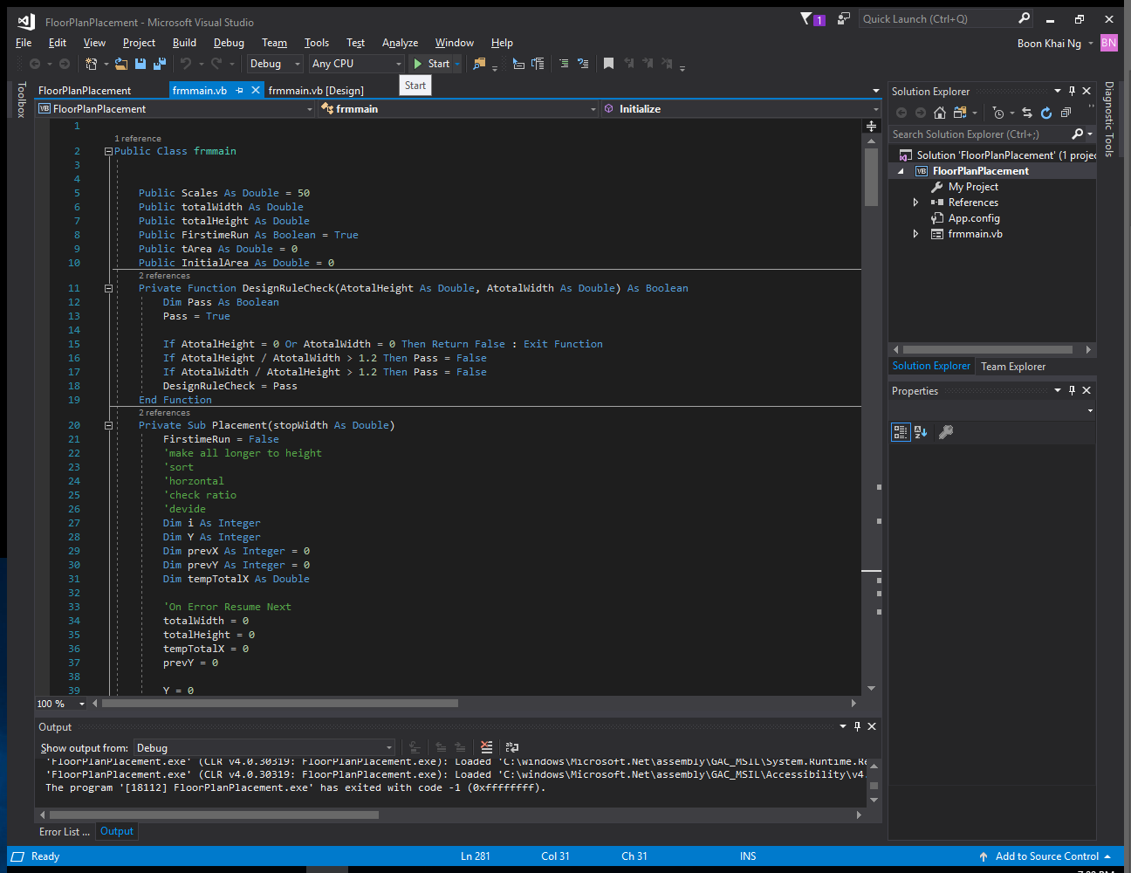

Using Microsoft Visual studio 2017 Open the floorplanplacement.sln and press the start button above to run the program, or build the program under the build menu build > Build solution. The output file will located at your project path bin/debug/floorplanplacement.exe.

**Instruction to Use the Floor plan minimization program**

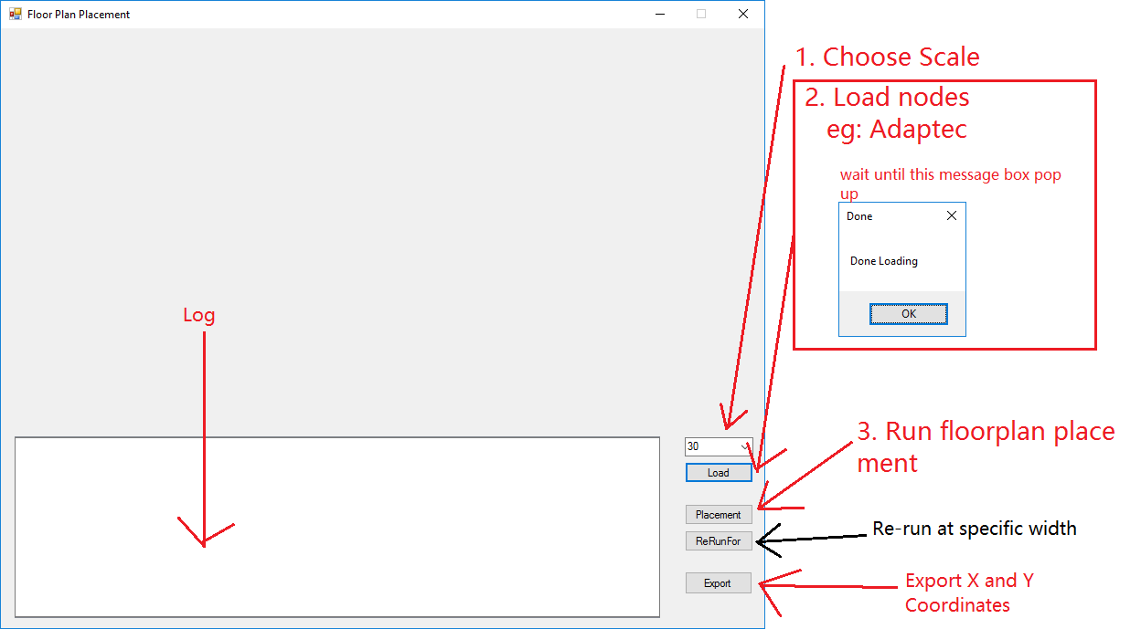

To use the program,

1. you need to select the scale, the reason for the scale is due to the size of the terminal nodes is way to big to fit inside the GUI, the optimal scale that can show perfectly on the GUI is 30.
2. Next you need to load the .nodes file and it will automatically grab the terminal nodes out from the file. Wait until the done loading message box before proceed to the next step
3. Next run the placement algorithm and the output is shown at the result
4. You can Re run the algorithm for specific width that you like to see the floor plan arrangement
5. You can export the X and Y coordinates by clicking the export button and specify the save file.

**Result**

Adaptec

It runs about six iterations to get the result

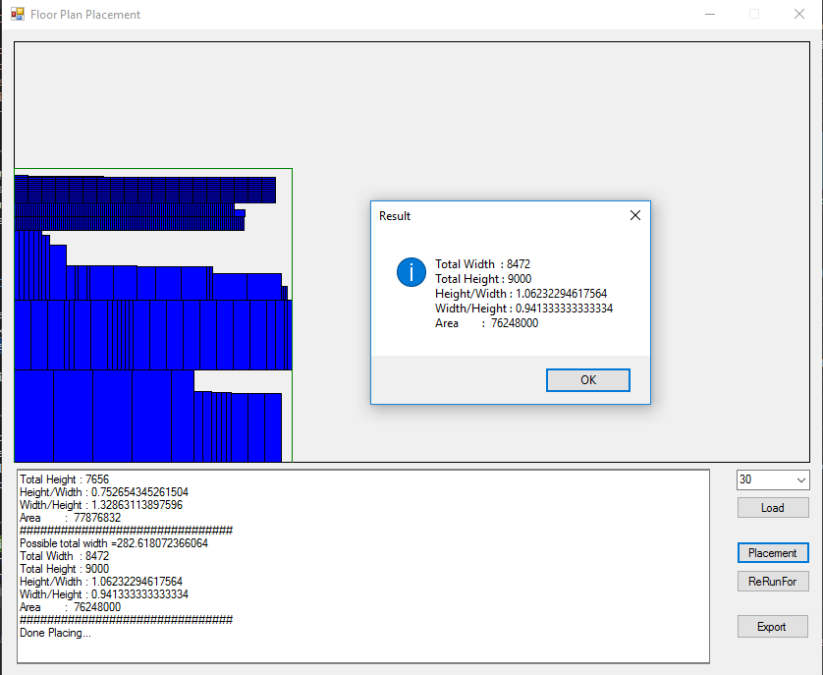

-Log-

Load file : C:\Users\boonkhai\Desktop\adaptec1\adaptec1.nodes

Estimated Initial Area: 64093992

Sorting the height

Sorted

Start Placing...

Possible total width =21097.3260548977

Total Width : 21076

Total Height : 4428

Height/Width : 0.210096792560258

Width/Height : 4.75971093044264

Area : 93324528

###############################

Possible total width =17581.1050457481

Total Width : 17520

Total Height : 5688

Height/Width : 0.324657534246575

Width/Height : 3.08016877637131

Area : 99653760

###############################

Possible total width =14650.9208714568

Total Width : 14629

Total Height : 6000

Height/Width : 0.410144234055643

Width/Height : 2.43816666666667

Area : 87774000

###############################

Possible total width =12209.100726214

Total Width : 12208

Total Height : 6888

Height/Width : 0.564220183486238

Width/Height : 1.77235772357724

Area : 84088704

###############################

Possible total width =10174.2506051783

Total Width : 10168

Total Height : 7644

Height/Width : 0.75177025963808

Width/Height : 1.3301936159079

Area : 77724192

###############################

Possible total width =8478.54217098192

Total Width : 8472

Total Height : 9000

Height/Width : 1.06232294617564

Width/Height : 0.941333333333333

Area : 76248000

###############################

Done Placing...

-X and Y Coordinates-

**(Refer to attachment)**

Bigblue

It runs about six iterations to get the result

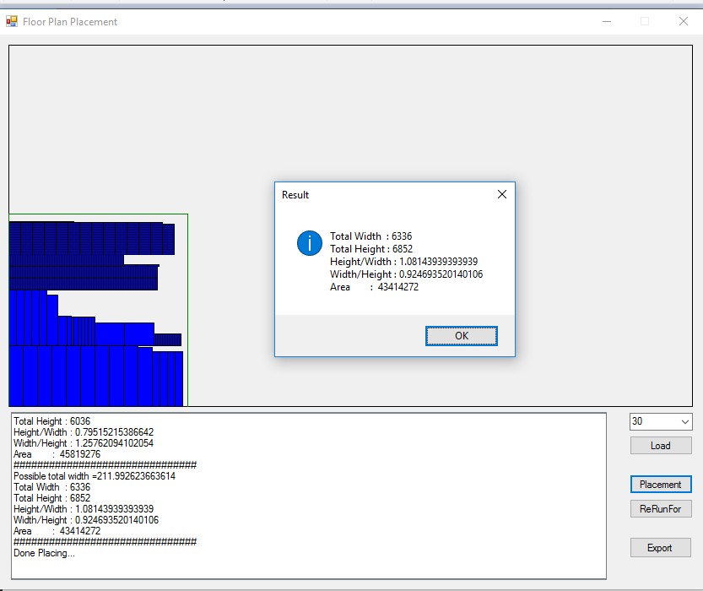

-Log-

Load file : C:\Users\boonkhai\Desktop\bigblue1\bigblue1.nodes

Estimated Initial Area: 36062760

Sorting the height

Sorted

Start Placing...

Possible total width =527.505485314643

Total Width : 15795

Total Height : 3204

Height/Width : 0.202849002849004

Width/Height : 4.92977528089886

Area : 50607180

###############################

Possible total width =439.587904428869

Total Width : 13176

Total Height : 3708

Height/Width : 0.281420765027323

Width/Height : 3.55339805825242

Area : 48856608

###############################

Possible total width =366.323253690724

Total Width : 10984

Total Height : 4236

Height/Width : 0.385651857246905

Width/Height : 2.59301227573182

Area : 46528224

###############################

Possible total width =305.269378075604

Total Width : 9144

Total Height : 5016

Height/Width : 0.548556430446194

Width/Height : 1.82296650717703

Area : 45866304

###############################

Possible total width =254.391148396336

Total Width : 7591

Total Height : 6036

Height/Width : 0.79515215386642

Width/Height : 1.25762094102054

Area : 45819276

###############################

Possible total width =211.992623663614

Total Width : 6336

Total Height : 6852

Height/Width : 1.08143939393939

Width/Height : 0.924693520140106

Area : 43414272

###############################

Done Placing...

-X and Y Coordinates-

**(Refer to attachment)**

**Attachment**

Source Code

Public Class frmmain

Public Scales As Double **=** **50**

Public totalWidth As Double

Public totalHeight As Double

Public FirstimeRun As Boolean **=** True

Public tArea As Double **=** **0**

Public InitialArea As Double **=** **0**

Private Function DesignRuleCheck**(**AtotalHeight As Double**,** AtotalWidth As Double**)** As Boolean

Dim Pass As Boolean

Pass **=** True

If AtotalHeight **=** **0** Or AtotalWidth **=** **0** Then Return False **:** Exit Function

If AtotalHeight **/** AtotalWidth **>** **1.2** Then Pass **=** False

If AtotalWidth **/** AtotalHeight **>** **1.2** Then Pass **=** False

DesignRuleCheck **=** Pass

End Function

Private Sub Placement**(**stopWidth As Double**)**

FirstimeRun **=** False

'make all longer to height

'sort

'horzontal

'check ratio

'devide

Dim i As Integer

Dim Y As Integer

Dim prevX As Integer **=** **0**

Dim prevY As Integer **=** **0**

Dim tempTotalX As Double

'On Error Resume Next

totalWidth **=** **0**

totalHeight **=** **0**

tempTotalX **=** **0**

prevY **=** **0**

Y **=** **0**

lstcordX.Items.Clear**()**

lstcordY.Items.Clear**()**

Logging**(**"Possible total width =" **+** CStr**(**stopWidth**))**

For i **=** **0** To lstNodeWidth.Items.Count **-** **1**

Application.DoEvents**()**

If **(**tempTotalX **+** CDbl**(**lstNodeWidth.Items**(**i**))** **<=** stopWidth Or tempTotalX **+** CDbl**(**lstNodeWidth.Items**(**i**))** **<=** totalWidth**)** Then

If i **=** **0** Then

prevY **=** i

'First Coordinate

lstcordX.Items.Add**(0)**

lstcordY.Items.Add**(**Y**)**

tempTotalX **=** tempTotalX **+** lstNodeWidth.Items**(**i**)** 'Use to calculate longest X

totalHeight **=** totalHeight **+** lstNodeHeight.Items**(**i**)**

Else

prevX **=** i **-** **1**

lstcordX.Items.Add**(**CStr**(**CInt**(**lstNodeWidth.Items**(**prevX**))** **+** CInt**(**lstcordX.Items**(**prevX**))))**

lstcordY.Items.Add**(**Y**)**

tempTotalX **=** tempTotalX **+** lstNodeWidth.Items**(**i**)** 'Use to calculate longest X

End If

Else

Y **=** Y **+** CInt**(**lstNodeHeight.Items**(**prevY**))**

prevY **=** i

totalHeight **=** totalHeight **+** lstNodeHeight.Items**(**prevY**)**

If tempTotalX **>** totalWidth Then totalWidth **=** tempTotalX

tempTotalX **=** **0**

lstcordX.Items.Add**(0)**

lstcordY.Items.Add**(**Y**)**

tempTotalX **=** tempTotalX **+** lstNodeWidth.Items**(**i**)** 'Use to calculate longest X

End If

Next

RefreshFloorPlan**()**

tArea **=** CDbl**(**totalHeight**)** **\*** CDbl**(**totalWidth**)**

tArea **=** tArea **\*** Scales **\*** Scales

Logging**(**"Total Width : " **&** CStr**(**CLng**(**totalWidth **\*** Scales**)))**

Logging**(**"Total Height : " **&** CStr**(**CLng**(**totalHeight **\*** Scales**)))**

Logging**(**"Height/Width : " **&** CStr**((**totalHeight **/** totalWidth**)))**

Logging**(**"Width/Height : " **&** CStr**((**totalWidth **/** totalHeight**)))**

Logging**(**"Area : " **&** CLng**(**tArea**))**

Logging**(**"###############################"**)**

End Sub

Public Sub RefreshFloorPlan**()**

picFloorPlan.Image **=** Nothing

picFloorPlan.Refresh**()**

For i **=** **0** To lstNodeWidth.Items.Count **-** **1**

DrawRectangle**(**CInt**(**lstcordX.Items**(**i**)),** CInt**(**lstcordY.Items**(**i**)),** CInt**(**lstNodeWidth.Items**(**i**)),** CInt**(**lstNodeHeight.Items**(**i**)))**

Next

End Sub

Private Sub SaveFile**()**

Dim FileName As String

Dim StrArray As New System.Text.StringBuilder**()**

Dim StrHeader As String **=** IIf**(**Scales **>** **1,** "Floorplan Scaled for " **+** CStr**(**Scales**)** **+** " smaller" **+** vbCr **+** vbLf**,** ""**)** **+** "Node name" **+** vbTab **+** "Width" **+** vbTab **+** "Height" **+** vbTab **+** "X" **+** vbTab **+** "Y"

Dim i As Integer

FileName **=** ""

cmOpendlg.FileName **=** ""

cmOpendlg.ShowDialog**()**

FileName **=** cmOpendlg.FileName

If FileName **=** "" Then Exit Sub

MsgBox**(**FileName**)**

StrArray.Append**(**StrHeader**)**

If lstcordX.Items.Count **=** **0** Then Exit Sub

For i **=** **0** To lstNodeName.Items.Count **-** **1**

StrArray.Append**(**vbCr **+** vbLf **+** CStr**(**lstNodeName.Items**(**i**))** **+** vbTab **+** CStr**(**CInt**(**lstNodeWidth.Items**(**i**)))** **+** vbTab **+** CStr**(**CInt**(**lstNodeHeight.Items**(**i**)))** **+** vbTab **+** CStr**(**lstcordX.Items**(**i**))** **+** vbTab **+** CStr**(**lstcordY.Items**(**i**)))**

Next

System.IO.File.WriteAllText**(**FileName**,** StrArray.ToString**())**

End Sub

Private Sub Loadfile**()**

Dim ReadSplit**()** As String

Dim FileName As String

Dim i As Integer

FileName **=** ""

InitialArea **=** **0**

cmdlg.FileName **=** ""

cmdlg.ShowDialog**()**

FileName **=** cmdlg.FileName

If **(**FileName **=** ""**)** Then Exit Sub

'FileName = "C:\Users\boonkhai\Desktop\adaptec1\adaptec.txt"

Logging**(**"Load file : " **&** FileName**)**

Dim lines**()** As String **=** IO.File.ReadAllLines**(**FileName**)**

'On Error GoTo Err

lstLoad.Items.AddRange**(**lines**)**

lstLoad.Items.Remove**(**""**)**

For i **=** **0** To lstLoad.Items.Count **-** **1**

If **(**CStr**(**lstLoad.Items**(**i**))).**Substring**(0,** **1)** **=** vbTab Then

If CStr**(**lstLoad.Items**(**i**)).**Length **>** **20** Then

If CStr**(**lstLoad.Items**(**i**)).**Substring**(**CStr**(**lstLoad.Items**(**i**)).**Length **-** **8,** **8)** **=** "terminal" Then

ReadSplit **=** Split**((**CStr**(**lstLoad.Items**(**i**))),** vbTab**)**

lstNodeName.Items.Add**(**ReadSplit**(1))**

lstUnscaledNodeWidth.Items.Add**(**CInt**(**ReadSplit**(2)))**

lstUnscaledNodeHeight.Items.Add**(**CInt**(**ReadSplit**(3)))**

lstNodeWidth.Items.Add**(**CInt**(**ReadSplit**(2))** **/** Scales**)**

lstNodeHeight.Items.Add**(**CInt**(**ReadSplit**(3))** **/** Scales**)**

InitialArea **=** InitialArea **+** **(**CDbl**(**ReadSplit**(2))** **\*** CDbl**(**ReadSplit**(3)))**

End If

End If

End If

Next

Logging**(**"Estimated Initial Area: " **+** CStr**(**InitialArea**))**

Sort**()**

MsgBox**(**"Done Loading"**,** vbYes **+** vbInformation**,** "Done"**)**

Exit Sub

Err**:**

MsgBox**(**"Error Readig file"**,** vbExclamation**,** "Error"**)**

End Sub

Public Function RoundUp**(**input As Double**)** As Integer

RoundUp **=** IIf**(**input **>** CInt**(**input**),** CInt**(**input**)** **+** **1,** CInt**(**input**))**

End Function

Private Sub Sort**()**

'Sort Height

Logging**(**"Sorting the height"**)**

Dim i As Integer

Dim j As Integer

Dim MaxLoc As Integer

Dim maxCount As Integer

Dim Max As Integer **=** **0**

maxCount **=** lstNodeHeight.Items.Count **-** **1**

For j **=** **0** To maxCount

For i **=** **0** To lstNodeHeight.Items.Count **-** **1**

If Max **<** CInt**(**lstNodeHeight.Items**(**i**))** Then Max **=** CInt**(**lstNodeHeight.Items**(**i**))** **:** MaxLoc **=** i

Next i

lstNodeNameSort.Items.Add**(**lstNodeName.Items**(**MaxLoc**))**

lstNodeWidthSort.Items.Add**(**lstNodeWidth.Items**(**MaxLoc**))**

lstNodeHeightSort.Items.Add**(**lstNodeHeight.Items**(**MaxLoc**))**

lstNodeHeight.Items.RemoveAt**(**MaxLoc**)**

lstNodeWidth.Items.RemoveAt**(**MaxLoc**)**

lstNodeName.Items.RemoveAt**(**MaxLoc**)**

Max **=** **0**

MaxLoc **=** **0**

Next j

For i **=** **0** To lstNodeNameSort.Items.Count **-** **1**

lstNodeName.Items.Add**(**lstNodeNameSort.Items**(**i**))**

lstNodeWidth.Items.Add**(**lstNodeWidthSort.Items**(**i**))**

lstNodeHeight.Items.Add**(**lstNodeHeightSort.Items**(**i**))**

Next

lstNodeHeightSort.Items.Clear**()**

lstNodeWidthSort.Items.Clear**()**

lstNodeNameSort.Items.Clear**()**

Logging**(**"Sorted"**)**

End Sub

Private Sub DrawRectangle**(**posX As Integer**,** posY As Integer**,** tWidth As Integer**,** tHeight As Integer**)**

Dim myGraphic As Graphics

Dim myRectangle As Rectangle

Dim myFrame As Rectangle

Dim myBorder As Rectangle

Dim myFloorPlan As Rectangle

Dim myPen As New Pen**(**Color.Black**)**

Dim myBrush As New SolidBrush**(**Color.Blue**)**

Dim myFloorPlanColor As New Pen**(**Color.Green**)**

posY **=** picFloorPlan.Height **-** posY **-** tHeight 'Calibrate left bottom as origin

myGraphic **=** Graphics.FromHwnd**(**picFloorPlan.Handle**)**

myFrame **=** New Rectangle**(**x**:=0,** y**:=0,** width**:=**picFloorPlan.Width **-** **1,** height**:=**picFloorPlan.Height **-** **1)**

myRectangle **=** New Rectangle**(**x**:=**posX**,** y**:=**posY**,** width**:=**tWidth**,** height**:=**tHeight**)**

myBorder **=** New Rectangle**(**x**:=**posX**,** y**:=**posY**,** width**:=**tWidth**,** height**:=**tHeight**)**

myFloorPlan **=** New Rectangle**(**x**:=0,** y**:=**picFloorPlan.Height **-** RoundUp**(**totalHeight**),** width**:=**RoundUp**(**totalWidth**),** height**:=**RoundUp**(**totalHeight**))**

myGraphic.FillRectangle**(**myBrush**,** myRectangle**)**

myGraphic.DrawRectangle**(**pen**:=**myPen**,** rect**:=**myBorder**)**

myGraphic.DrawRectangle**(**pen**:=**myPen**,** rect**:=**myFrame**)**

myGraphic.DrawRectangle**(**pen**:=**myFloorPlanColor**,** rect**:=**myFloorPlan**)**

End Sub

Private Sub cmdPlacement_Click**(**sender As Object**,** e As EventArgs**)** Handles cmdPlacement.Click

Logging**(**"Start Placing..."**)**

Dim PossibleArea As Double

Dim PossibletotalWidth As Double

'Get estimated Posible Area'

PossibleArea **=** InitialArea **\*** **10** **/** **(**Scales **\*** Scales**)**

PossibletotalWidth **=** PossibleArea **^** **(1** **/** **2)**

While **(**DesignRuleCheck**(**totalHeight**,** totalWidth**)** **=** False And PossibletotalWidth **>** **10)**

PossibletotalWidth **=** PossibletotalWidth **/** **1.2**

Placement**(**PossibletotalWidth**)**

End While

Logging**(**"Done Placing..."**)**

MsgBox**(**"Total Width : " **&** CStr**(**CLng**(**totalWidth **\*** Scales**))** **&** vbCr **+** vbLf **&**

"Total Height : " **&** CStr**(**CLng**(**totalHeight **\*** Scales**))** **&** vbCr **+** vbLf **&**

"Height/Width : " **&** CStr**((**totalHeight **/** totalWidth**))** **&** vbCr **+** vbLf **&**

"Width/Height : " **&** CStr**((**totalWidth **/** totalHeight**))** **&** vbCr **+** vbLf **&**

"Area : " **&** CStr**(**CLng**(**tArea**)),** vbInformation**,** "Result"**)**

End Sub

Private Sub cmdLoad_Click**(**sender As Object**,** e As EventArgs**)** Handles cmdLoad.Click

Dim msgAns As MessageBoxOptions

If FirstimeRun **=** False Then

msgAns **=** MsgBox**(**"Are you sure? All result will be cleared"**,** vbYesNo **+** vbInformation**,** "Load File?"**)**

End If

If msgAns **=** vbNo Then Exit Sub

Scales **=** CInt**(**cboScale.Text**)**

If Scales **<=** **0** Then MsgBox**(**"Scales must be positive integer"**)** **:** Exit Sub

lstlog.Items.Clear**()**

txtLog.Text **=** ""

Initialize**()**

Loadfile**()**

End Sub

Private Sub Logging**(**tdata As String**)**

lstlog.Items.Add**(**tdata**)**

lstlog.SelectedIndex **=** lstlog.Items.Count **-** **1**

txtLog.AppendText**(**tdata **+** vbCr **+** vbLf**)**

End Sub

Public Sub Initialize**()**

totalWidth **=** **0**

totalHeight **=** **0**

lstNodeHeight.Items.Clear**()**

lstNodeHeightSort.Items.Clear**()**

lstNodeWidth.Items.Clear**()**

lstNodeWidthSort.Items.Clear**()**

lstNodeName.Items.Clear**()**

lstNodeName.Items.Clear**()**

lstcordX.Items.Clear**()**

lstcordY.Items.Clear**()**

lstLoad.Items.Clear**()**

picFloorPlan.Image **=** Nothing

End Sub

Private Sub frmmain_Load**(**sender As Object**,** e As EventArgs**)** Handles MyBase.Load

Initialize**()**

cboScale.Text **=** "30"

For i **=** **1** To **10**

cboScale.Items.Add**(**i **\*** **10)**

Next

End Sub

Private Sub cmdRerun_Click**(**sender As Object**,** e As EventArgs**)** Handles cmdRerun.Click

Dim stopWidth As Double

stopWidth **=** CDbl**(**InputBox**(**"Please insert width"**))**

Placement**(**stopWidth**)**

MsgBox**(**"Total Width : " **&** CStr**(**CLng**(**totalWidth **\*** Scales**))** **&** vbCr **+** vbLf **&**

"Total Height : " **&** CStr**(**CLng**(**totalHeight **\*** Scales**))** **&** vbCr **+** vbLf **&**

"Height/Width : " **&** CStr**((**totalHeight **/** totalWidth**))** **&** vbCr **+** vbLf **&**

"Width/Height : " **&** CStr**((**totalWidth **/** totalHeight**))** **&** vbCr **+** vbLf **&**

"Area : " **&** CStr**(**CLng**(**tArea**)),** vbInformation**,** "Result"**)**

End Sub

Private Sub cmdExport_Click**(**sender As Object**,** e As EventArgs**)** Handles cmdExport.Click

SaveFile**()**

End Sub

End Class

X and Y Coordinates For Adaptec

Node name Width Height X Y

o210915 1206 2856 0 0

o210916 1206 2856 1206 0

o210917 1206 2856 2412 0

o210918 1206 2856 3618 0

o210927 701 2856 4824 0

o210920 276 2196 5525 0

o210922 276 2196 5801 0

o211414 140 2172 6077 0

o211416 140 2172 6217 0

o211418 140 2172 6357 0

o211420 140 2172 6497 0

o210904 500 2136 6637 0

o210905 500 2136 7137 0

o210906 500 2136 7637 0

o210907 500 2136 0 2856

o210908 500 2136 500 2856

o210909 500 2136 1000 2856

o210911 164 2136 1500 2856

o210912 164 2136 1664 2856

o210913 500 2136 1828 2856

o210914 500 2136 2328 2856

o210924 164 2136 2828 2856

o210925 164 2136 2992 2856

o211415 108 2136 3156 2856

o211417 108 2136 3264 2856

o211419 108 2136 3372 2856

o211421 108 2136 3480 2856

o211423 511 2136 3588 2856

o211424 511 2136 4099 2856

o211425 511 2136 4610 2856

o211426 511 2136 5121 2856

o211427 511 2136 5632 2856

o211428 511 2136 6143 2856

o211429 511 2136 6654 2856

o211430 511 2136 7165 2856

o211431 276 2136 7676 2856

o211432 276 2136 7952 2856

o211433 80 2136 8228 2856

o211435 164 2136 8308 2856

o211436 164 2136 0 4992

o211437 164 2136 164 4992

o211438 164 2136 328 4992

o211439 164 2136 492 4992

o211440 164 2136 656 4992

o211441 80 2136 820 4992

o210921 108 1968 900 4992

o210923 108 1968 1008 4992

o210930 516 1692 1116 4992

o211442 720 1056 1632 4992

o211443 720 1056 2352 4992

o210910 276 1044 3072 4992

o210919 80 1044 3348 4992

o210926 276 1044 3428 4992

o210931 80 1044 3704 4992

o211422 80 1020 3784 4992

o211434 80 1020 3864 4992

o210928 572 1008 3944 4992

o211412 792 1008 4516 4992

o211413 792 1008 5308 4992

o211444 1048 816 6100 4992

o211445 1048 816 7148 4992

o210932 72 432 8196 4992

o210933 72 432 8268 4992

o210934 72 432 8340 4992

o210935 72 432 0 7128

o210936 72 432 72 7128

o210937 72 432 144 7128

o210943 72 432 216 7128

o210955 72 432 288 7128

o210956 72 432 360 7128

o210957 72 432 432 7128

o210958 72 432 504 7128

o210960 72 432 576 7128

o211025 72 432 648 7128

o211026 72 432 720 7128

o211027 72 432 792 7128

o211028 72 432 864 7128

o211029 72 432 936 7128

o211030 72 432 1008 7128

o211031 72 432 1080 7128

o211032 72 432 1152 7128

o211033 72 432 1224 7128

o211034 72 432 1296 7128

o211035 72 432 1368 7128

o211036 72 432 1440 7128

o211037 72 432 1512 7128

o211038 72 432 1584 7128

o211039 72 432 1656 7128

o211040 72 432 1728 7128

o211041 72 432 1800 7128

o211042 72 432 1872 7128

o211043 72 432 1944 7128

o211044 72 432 2016 7128

o211045 72 432 2088 7128

o211047 72 432 2160 7128

o211048 72 432 2232 7128

o211049 72 432 2304 7128

o211051 72 432 2376 7128

o211052 72 432 2448 7128

o211054 72 432 2520 7128

o211057 72 432 2592 7128

o211122 72 432 2664 7128

o211123 72 432 2736 7128

o211125 72 432 2808 7128

o211126 72 432 2880 7128

o211127 72 432 2952 7128

o211129 72 432 3024 7128

o211130 72 432 3096 7128

o211131 72 432 3168 7128

o211132 72 432 3240 7128

o211133 72 432 3312 7128

o211134 72 432 3384 7128

o211135 72 432 3456 7128

o211136 72 432 3528 7128

o211137 72 432 3600 7128

o211138 72 432 3672 7128

o211139 72 432 3744 7128

o211140 72 432 3816 7128

o211141 72 432 3888 7128

o211142 72 432 3960 7128

o211143 72 432 4032 7128

o211144 72 432 4104 7128

o211145 72 432 4176 7128

o211146 72 432 4248 7128

o211147 72 432 4320 7128

o211148 72 432 4392 7128

o211149 72 432 4464 7128

o211150 72 432 4536 7128

o211151 72 432 4608 7128

o211152 72 432 4680 7128

o211156 72 432 4752 7128

o211157 72 432 4824 7128

o211158 72 432 4896 7128

o211159 72 432 4968 7128

o211160 72 432 5040 7128

o211162 72 432 5112 7128

o211163 72 432 5184 7128

o211165 72 432 5256 7128

o211167 72 432 5328 7128

o211168 72 432 5400 7128

o211169 72 432 5472 7128

o211170 72 432 5544 7128

o211171 72 432 5616 7128

o211172 72 432 5688 7128

o211175 72 432 5760 7128

o211183 72 432 5832 7128

o211187 72 432 5904 7128

o211190 72 432 5976 7128

o211191 72 432 6048 7128

o211192 72 432 6120 7128

o211193 72 432 6192 7128

o211194 72 432 6264 7128

o211195 72 432 6336 7128

o211196 72 432 6408 7128

o211198 72 432 6480 7128

o211199 72 432 6552 7128

o211201 72 432 6624 7128

o211203 72 432 6696 7128

o211204 72 432 6768 7128

o211205 72 432 6840 7128

o211216 72 432 6912 7128

o211217 72 432 6984 7128

o211218 72 432 7056 7128

o211219 72 432 7128 7128

o211220 72 432 7200 7128

o211221 72 432 7272 7128

o211222 72 432 7344 7128

o211223 72 432 7416 7128

o211224 72 432 7488 7128

o211225 72 432 7560 7128

o211226 72 432 7632 7128

o211227 72 432 7704 7128

o211228 72 432 7776 7128

o211229 72 432 7848 7128

o211230 72 432 7920 7128

o211231 72 432 7992 7128

o211232 72 432 8064 7128

o211233 72 432 8136 7128

o211234 72 432 8208 7128

o211235 72 432 8280 7128

o211236 72 432 8352 7128

o211237 72 432 0 7560

o211238 72 432 72 7560

o211239 72 432 144 7560

o211240 72 432 216 7560

o211241 72 432 288 7560

o211242 72 432 360 7560

o211243 72 432 432 7560

o211244 72 432 504 7560

o211245 72 432 576 7560

o211246 72 432 648 7560

o211247 72 432 720 7560

o211248 72 432 792 7560

o211249 72 432 864 7560

o211250 72 432 936 7560

o211251 72 432 1008 7560

o211252 72 432 1080 7560

o211253 72 432 1152 7560

o211254 72 432 1224 7560

o211255 72 432 1296 7560

o211256 72 432 1368 7560

o211257 72 432 1440 7560

o211258 72 432 1512 7560

o211259 72 432 1584 7560

o211260 72 432 1656 7560

o211261 72 432 1728 7560

o211262 72 432 1800 7560

o211263 72 432 1872 7560

o211264 72 432 1944 7560

o211265 72 432 2016 7560

o211266 72 432 2088 7560

o211267 72 432 2160 7560

o211268 72 432 2232 7560

o211269 72 432 2304 7560

o211270 72 432 2376 7560

o211271 72 432 2448 7560

o211272 72 432 2520 7560

o211273 72 432 2592 7560

o211274 72 432 2664 7560

o211275 72 432 2736 7560

o211276 72 432 2808 7560

o211277 72 432 2880 7560

o211278 72 432 2952 7560

o211279 72 432 3024 7560

o211280 72 432 3096 7560

o211281 72 432 3168 7560

o211282 72 432 3240 7560

o211283 72 432 3312 7560

o211284 72 432 3384 7560

o211285 72 432 3456 7560

o211286 72 432 3528 7560

o211287 72 432 3600 7560

o211288 72 432 3672 7560

o211289 72 432 3744 7560

o211290 72 432 3816 7560

o211291 72 432 3888 7560

o211292 72 432 3960 7560

o211293 72 432 4032 7560

o211294 72 432 4104 7560

o211295 72 432 4176 7560

o211298 72 432 4248 7560

o211299 72 432 4320 7560

o211300 72 432 4392 7560

o211301 72 432 4464 7560

o211306 72 432 4536 7560

o211307 72 432 4608 7560

o211308 72 432 4680 7560

o211309 72 432 4752 7560

o211312 72 432 4824 7560

o211315 72 432 4896 7560

o211316 72 432 4968 7560

o211317 72 432 5040 7560

o211318 72 432 5112 7560

o211319 72 432 5184 7560

o211320 72 432 5256 7560

o211321 72 432 5328 7560

o211322 72 432 5400 7560

o211323 72 432 5472 7560

o211326 72 432 5544 7560

o211329 72 432 5616 7560

o211330 72 432 5688 7560

o211331 72 432 5760 7560

o211347 72 432 5832 7560

o211350 72 432 5904 7560

o211359 72 432 5976 7560

o211360 72 432 6048 7560

o211362 72 432 6120 7560

o211363 72 432 6192 7560

o211370 72 432 6264 7560

o211374 72 432 6336 7560

o211376 72 432 6408 7560

o211377 72 432 6480 7560

o211378 72 432 6552 7560

o211379 72 432 6624 7560

o211381 72 432 6696 7560

o211382 72 432 6768 7560

o211383 72 432 6840 7560

o211384 72 432 6912 7560

o211385 72 432 6984 7560

o211386 72 432 7056 7560

o211387 72 432 7128 7560

o211389 72 432 7200 7560

o211390 72 432 7272 7560

o211391 72 432 7344 7560

o211392 72 432 7416 7560

o211393 72 432 7488 7560

o211394 72 432 7560 7560

o211395 72 432 7632 7560

o211396 72 432 7704 7560

o211398 72 432 7776 7560

o211399 72 432 7848 7560

o211400 72 432 7920 7560

o211401 72 432 7992 7560

o210929 340 204 8064 7560

o210938 432 72 0 7992

o210939 432 72 432 7992

o210940 432 72 864 7992

o210941 432 72 1296 7992

o210942 432 72 1728 7992

o210944 432 72 2160 7992

o210945 432 72 2592 7992

o210946 432 72 3024 7992

o210947 432 72 3456 7992

o210948 432 72 3888 7992

o210949 432 72 4320 7992

o210950 432 72 4752 7992

o210951 432 72 5184 7992

o210952 432 72 5616 7992

o210953 432 72 6048 7992

o210954 432 72 6480 7992

o210959 432 72 6912 7992

o210961 432 72 7344 7992

o210962 432 72 7776 7992

o210963 432 72 0 8064

o210964 432 72 432 8064

o210965 432 72 864 8064

o210966 432 72 1296 8064

o210967 432 72 1728 8064

o210968 432 72 2160 8064

o210969 432 72 2592 8064

o210970 432 72 3024 8064

o210971 432 72 3456 8064

o210972 432 72 3888 8064

o210973 432 72 4320 8064

o210974 432 72 4752 8064

o210975 432 72 5184 8064

o210976 432 72 5616 8064

o210977 432 72 6048 8064

o210978 432 72 6480 8064

o210979 432 72 6912 8064

o210980 432 72 7344 8064

o210981 432 72 7776 8064

o210982 432 72 0 8136

o210983 432 72 432 8136

o210984 432 72 864 8136

o210985 432 72 1296 8136

o210986 432 72 1728 8136

o210987 432 72 2160 8136

o210988 432 72 2592 8136

o210989 432 72 3024 8136

o210990 432 72 3456 8136

o210991 432 72 3888 8136

o210992 432 72 4320 8136

o210993 432 72 4752 8136

o210994 432 72 5184 8136

o210995 432 72 5616 8136

o210996 432 72 6048 8136

o210997 432 72 6480 8136

o210998 432 72 6912 8136

o210999 432 72 7344 8136

o211000 432 72 7776 8136

o211001 432 72 0 8208

o211002 432 72 432 8208

o211003 432 72 864 8208

o211004 432 72 1296 8208

o211005 432 72 1728 8208

o211006 432 72 2160 8208

o211007 432 72 2592 8208

o211008 432 72 3024 8208

o211009 432 72 3456 8208

o211010 432 72 3888 8208

o211011 432 72 4320 8208

o211012 432 72 4752 8208

o211013 432 72 5184 8208

o211014 432 72 5616 8208

o211015 432 72 6048 8208

o211016 432 72 6480 8208

o211017 432 72 6912 8208

o211018 432 72 7344 8208

o211019 432 72 7776 8208

o211020 432 72 0 8280

o211021 432 72 432 8280

o211022 432 72 864 8280

o211023 432 72 1296 8280

o211024 432 72 1728 8280

o211046 432 72 2160 8280

o211050 432 72 2592 8280

o211053 432 72 3024 8280

o211055 432 72 3456 8280

o211056 432 72 3888 8280

o211058 432 72 4320 8280

o211059 432 72 4752 8280

o211060 432 72 5184 8280

o211061 432 72 5616 8280

o211062 432 72 6048 8280

o211063 432 72 6480 8280

o211064 432 72 6912 8280

o211065 432 72 7344 8280

o211066 432 72 7776 8280

o211067 432 72 0 8352

o211068 432 72 432 8352

o211069 432 72 864 8352

o211070 432 72 1296 8352

o211071 432 72 1728 8352

o211072 432 72 2160 8352

o211073 432 72 2592 8352

o211074 432 72 3024 8352

o211075 432 72 3456 8352

o211076 432 72 3888 8352

o211077 432 72 4320 8352

o211078 432 72 4752 8352

o211079 432 72 5184 8352

o211080 432 72 5616 8352

o211081 432 72 6048 8352

o211082 432 72 6480 8352

o211083 432 72 6912 8352

o211084 432 72 7344 8352

o211085 432 72 7776 8352

o211086 432 72 0 8424

o211087 432 72 432 8424

o211088 432 72 864 8424

o211089 432 72 1296 8424

o211090 432 72 1728 8424

o211091 432 72 2160 8424

o211092 432 72 2592 8424

o211093 432 72 3024 8424

o211094 432 72 3456 8424

o211095 432 72 3888 8424

o211096 432 72 4320 8424

o211097 432 72 4752 8424

o211098 432 72 5184 8424

o211099 432 72 5616 8424

o211100 432 72 6048 8424

o211101 432 72 6480 8424

o211102 432 72 6912 8424

o211103 432 72 7344 8424

o211104 432 72 7776 8424

o211105 432 72 0 8496

o211106 432 72 432 8496

o211107 432 72 864 8496

o211108 432 72 1296 8496

o211109 432 72 1728 8496

o211110 432 72 2160 8496

o211111 432 72 2592 8496

o211112 432 72 3024 8496

o211113 432 72 3456 8496

o211114 432 72 3888 8496

o211115 432 72 4320 8496

o211116 432 72 4752 8496

o211117 432 72 5184 8496

o211118 432 72 5616 8496

o211119 432 72 6048 8496

o211120 432 72 6480 8496

o211121 432 72 6912 8496

o211124 432 72 7344 8496

o211128 432 72 7776 8496

o211153 432 72 0 8568

o211154 432 72 432 8568

o211155 432 72 864 8568

o211161 432 72 1296 8568

o211164 432 72 1728 8568

o211166 432 72 2160 8568

o211173 432 72 2592 8568

o211174 432 72 3024 8568

o211176 432 72 3456 8568

o211177 432 72 3888 8568

o211178 432 72 4320 8568

o211179 432 72 4752 8568

o211180 432 72 5184 8568

o211181 432 72 5616 8568

o211182 432 72 6048 8568

o211184 432 72 6480 8568

o211185 432 72 6912 8568

o211186 432 72 7344 8568

o211188 432 72 7776 8568

o211189 432 72 0 8640

o211197 432 72 432 8640

o211200 432 72 864 8640

o211202 432 72 1296 8640

o211206 432 72 1728 8640

o211207 432 72 2160 8640

o211208 432 72 2592 8640

o211209 432 72 3024 8640

o211210 432 72 3456 8640

o211211 432 72 3888 8640

o211212 432 72 4320 8640

o211213 432 72 4752 8640

o211214 432 72 5184 8640

o211215 432 72 5616 8640

o211296 432 72 6048 8640

o211297 432 72 6480 8640

o211302 432 72 6912 8640

o211303 432 72 7344 8640

o211304 432 72 7776 8640

o211305 432 72 0 8712

o211310 432 72 432 8712

o211311 432 72 864 8712

o211313 432 72 1296 8712

o211314 432 72 1728 8712

o211324 432 72 2160 8712

o211325 432 72 2592 8712

o211327 432 72 3024 8712

o211328 432 72 3456 8712

o211332 432 72 3888 8712

o211333 432 72 4320 8712

o211334 432 72 4752 8712

o211335 432 72 5184 8712

o211336 432 72 5616 8712

o211337 432 72 6048 8712

o211338 432 72 6480 8712

o211339 432 72 6912 8712

o211340 432 72 7344 8712

o211341 432 72 7776 8712

o211342 432 72 0 8784

o211343 432 72 432 8784

o211344 432 72 864 8784

o211345 432 72 1296 8784

o211346 432 72 1728 8784

o211348 432 72 2160 8784

o211349 432 72 2592 8784

o211351 432 72 3024 8784

o211352 432 72 3456 8784

o211353 432 72 3888 8784

o211354 432 72 4320 8784

o211355 432 72 4752 8784

o211356 432 72 5184 8784

o211357 432 72 5616 8784

o211358 432 72 6048 8784

o211361 432 72 6480 8784

o211364 432 72 6912 8784

o211365 432 72 7344 8784

o211366 432 72 7776 8784

o211367 432 72 0 8856

o211368 432 72 432 8856

o211369 432 72 864 8856

o211371 432 72 1296 8856

o211372 432 72 1728 8856

o211373 432 72 2160 8856

o211375 432 72 2592 8856

o211380 432 72 3024 8856

o211388 432 72 3456 8856

o211397 432 72 3888 8856

o211402 432 72 4320 8856

o211403 432 72 4752 8856

o211404 432 72 5184 8856

o211405 432 72 5616 8856

o211406 432 72 6048 8856

o211407 432 72 6480 8856

o211408 432 72 6912 8856

o211409 432 72 7344 8856

o211410 432 72 7776 8856

o211411 432 72 0 8928

o211446 2304 24 432 8928

X and Y Coordinates for Bigblue

Node name Width Height X Y

o278138 500 2196 0 0

o278139 500 2196 500 0

o278142 500 2196 1000 0

o278143 500 2196 1500 0

o278146 500 2196 2000 0

o278147 500 2196 2500 0

o278150 500 2196 3000 0

o278151 500 2196 3500 0

o278154 500 2196 4000 0

o278133 500 2136 4500 0

o278140 276 1968 5000 0

o278141 276 1968 5276 0

o278144 276 1968 5552 0

o278145 276 1968 5828 0

o278148 276 1968 0 2196

o278149 276 1968 276 2196

o278152 276 1968 552 2196

o278153 276 1968 828 2196

o278155 276 1968 1104 2196

o278134 399 1800 1380 2196

o278132 332 1044 1779 2196

o278135 164 1044 2111 2196

o278136 80 1020 2275 2196

o278137 164 1020 2355 2196

o278156 108 1020 2519 2196

o278157 108 1020 2627 2196

o278158 108 1020 2735 2196

o278159 108 1020 2843 2196

o278160 108 1020 2951 2196

o278161 1048 816 3059 2196

o278162 1048 816 4107 2196

o277604 72 432 5155 2196

o277605 72 432 5227 2196

o277606 72 432 5299 2196

o277607 72 432 5371 2196

o277608 72 432 5443 2196

o277609 72 432 5515 2196

o277612 72 432 5587 2196

o277615 72 432 5659 2196

o277618 72 432 5731 2196

o277619 72 432 5803 2196

o277623 72 432 5875 2196

o277624 72 432 5947 2196

o277627 72 432 6019 2196

o277628 72 432 6091 2196

o277629 72 432 6163 2196

o277632 72 432 6235 2196

o277633 72 432 0 4164

o277634 72 432 72 4164

o277637 72 432 144 4164

o277638 72 432 216 4164

o277647 72 432 288 4164

o277648 72 432 360 4164

o277649 72 432 432 4164

o277650 72 432 504 4164

o277653 72 432 576 4164

o277654 72 432 648 4164

o277655 72 432 720 4164

o277656 72 432 792 4164

o277665 72 432 864 4164

o277666 72 432 936 4164

o277667 72 432 1008 4164

o277668 72 432 1080 4164

o277669 72 432 1152 4164

o277670 72 432 1224 4164

o277671 72 432 1296 4164

o277672 72 432 1368 4164

o277673 72 432 1440 4164

o277674 72 432 1512 4164

o277675 72 432 1584 4164

o277676 72 432 1656 4164

o277677 72 432 1728 4164

o277678 72 432 1800 4164

o277679 72 432 1872 4164

o277680 72 432 1944 4164

o277681 72 432 2016 4164

o277682 72 432 2088 4164

o277683 72 432 2160 4164

o277684 72 432 2232 4164

o277685 72 432 2304 4164

o277686 72 432 2376 4164

o277687 72 432 2448 4164

o277688 72 432 2520 4164

o277689 72 432 2592 4164

o277690 72 432 2664 4164

o277691 72 432 2736 4164

o277692 72 432 2808 4164

o277693 72 432 2880 4164

o277694 72 432 2952 4164

o277695 72 432 3024 4164

o277696 72 432 3096 4164

o277697 72 432 3168 4164

o277698 72 432 3240 4164

o277699 72 432 3312 4164

o277700 72 432 3384 4164

o277701 72 432 3456 4164

o277702 72 432 3528 4164

o277703 72 432 3600 4164

o277704 72 432 3672 4164

o277705 72 432 3744 4164

o277706 72 432 3816 4164

o277707 72 432 3888 4164

o277708 72 432 3960 4164

o277709 72 432 4032 4164

o277710 72 432 4104 4164

o277711 72 432 4176 4164

o277712 72 432 4248 4164

o277713 72 432 4320 4164

o277714 72 432 4392 4164

o277715 72 432 4464 4164

o277716 72 432 4536 4164

o277717 72 432 4608 4164

o277718 72 432 4680 4164

o277719 72 432 4752 4164

o277720 72 432 4824 4164

o277721 72 432 4896 4164

o277722 72 432 4968 4164

o277723 72 432 5040 4164

o277724 72 432 5112 4164

o277726 72 432 5184 4164

o277727 72 432 5256 4164

o277728 72 432 5328 4164

o277729 72 432 5400 4164

o277730 72 432 5472 4164

o277731 72 432 5544 4164

o277732 72 432 5616 4164

o277743 72 432 5688 4164

o277744 72 432 5760 4164

o277745 72 432 5832 4164

o277746 72 432 5904 4164

o277747 72 432 5976 4164

o277751 72 432 6048 4164

o277752 72 432 6120 4164

o277754 72 432 6192 4164

o277756 72 432 6264 4164

o277757 72 432 0 4596

o277758 72 432 72 4596

o277759 72 432 144 4596

o277760 72 432 216 4596

o277761 72 432 288 4596

o277762 72 432 360 4596

o277763 72 432 432 4596

o277764 72 432 504 4596

o277765 72 432 576 4596

o277766 72 432 648 4596

o277767 72 432 720 4596

o277768 72 432 792 4596

o277769 72 432 864 4596

o277770 72 432 936 4596

o277771 72 432 1008 4596

o277772 72 432 1080 4596

o277773 72 432 1152 4596

o277774 72 432 1224 4596

o277775 72 432 1296 4596

o277776 72 432 1368 4596

o277777 72 432 1440 4596

o277778 72 432 1512 4596

o277779 72 432 1584 4596

o277817 72 432 1656 4596

o277821 72 432 1728 4596

o277823 72 432 1800 4596

o277825 72 432 1872 4596

o277827 72 432 1944 4596

o277829 72 432 2016 4596

o277831 72 432 2088 4596

o277833 72 432 2160 4596

o277835 72 432 2232 4596

o277837 72 432 2304 4596

o277838 72 432 2376 4596

o277840 72 432 2448 4596

o277842 72 432 2520 4596

o277844 72 432 2592 4596

o277847 72 432 2664 4596

o277849 72 432 2736 4596

o277853 72 432 2808 4596

o277854 72 432 2880 4596

o277855 72 432 2952 4596

o277857 72 432 3024 4596

o277864 72 432 3096 4596

o277891 72 432 3168 4596

o277892 72 432 3240 4596

o277893 72 432 3312 4596

o277894 72 432 3384 4596

o277895 72 432 3456 4596

o277896 72 432 3528 4596

o277897 72 432 3600 4596

o277898 72 432 3672 4596

o277899 72 432 3744 4596

o277900 72 432 3816 4596

o277901 72 432 3888 4596

o277902 72 432 3960 4596

o277903 72 432 4032 4596

o277904 72 432 4104 4596

o277905 72 432 4176 4596

o277906 72 432 4248 4596

o277907 72 432 4320 4596

o277908 72 432 4392 4596

o277909 72 432 4464 4596

o277910 72 432 4536 4596

o277911 72 432 4608 4596

o277912 72 432 4680 4596

o277913 72 432 4752 4596

o277914 72 432 4824 4596

o277915 72 432 4896 4596

o277916 72 432 4968 4596

o277917 72 432 5040 4596

o277918 72 432 5112 4596

o277919 72 432 5184 4596

o277920 72 432 5256 4596

o277921 72 432 5328 4596

o277922 72 432 5400 4596

o277923 72 432 5472 4596

o277924 72 432 5544 4596

o277925 72 432 5616 4596

o277926 72 432 5688 4596

o277927 72 432 5760 4596

o277928 72 432 5832 4596

o277929 72 432 5904 4596

o277930 72 432 5976 4596

o277931 72 432 6048 4596

o277932 72 432 6120 4596

o277933 72 432 6192 4596

o277934 72 432 6264 4596

o277935 72 432 0 5028

o277936 72 432 72 5028

o277937 72 432 144 5028

o277938 72 432 216 5028

o277939 72 432 288 5028

o277940 72 432 360 5028

o277941 72 432 432 5028

o277942 72 432 504 5028

o277943 72 432 576 5028

o277944 72 432 648 5028

o277945 72 432 720 5028

o277946 72 432 792 5028

o277947 72 432 864 5028

o277948 72 432 936 5028

o277949 72 432 1008 5028

o277950 72 432 1080 5028

o277951 72 432 1152 5028

o277953 72 432 1224 5028

o277954 72 432 1296 5028

o277956 72 432 1368 5028

o277961 72 432 1440 5028

o277965 72 432 1512 5028

o277966 72 432 1584 5028

o277967 72 432 1656 5028

o277969 72 432 1728 5028

o277970 72 432 1800 5028

o277974 72 432 1872 5028

o277977 72 432 1944 5028

o277978 72 432 2016 5028

o277979 72 432 2088 5028

o277980 72 432 2160 5028

o277981 72 432 2232 5028

o277982 72 432 2304 5028

o277984 72 432 2376 5028

o277985 72 432 2448 5028

o277989 72 432 2520 5028

o277990 72 432 2592 5028

o277993 72 432 2664 5028

o277994 72 432 2736 5028

o277995 72 432 2808 5028

o277996 72 432 2880 5028

o277998 72 432 2952 5028

o277999 72 432 3024 5028

o278000 72 432 3096 5028

o278001 72 432 3168 5028

o278002 72 432 3240 5028

o278003 72 432 3312 5028

o278004 72 432 3384 5028

o278005 72 432 3456 5028

o278006 72 432 3528 5028

o278007 72 432 3600 5028

o278008 72 432 3672 5028

o278009 72 432 3744 5028

o278010 72 432 3816 5028

o278011 72 432 3888 5028

o278021 72 432 3960 5028

o278022 72 432 4032 5028

o278023 72 432 4104 5028

o278024 72 432 4176 5028

o278025 72 432 4248 5028

o278026 72 432 4320 5028

o278027 72 432 4392 5028

o278028 72 432 4464 5028

o278029 72 432 4536 5028

o278030 72 432 4608 5028

o278031 72 432 4680 5028

o278032 72 432 4752 5028

o278043 72 432 4824 5028

o277610 432 72 4896 5028

o277611 432 72 5328 5028

o277613 432 72 5760 5028

o277614 432 72 0 5460

o277616 432 72 432 5460

o277617 432 72 864 5460

o277620 432 72 1296 5460

o277621 432 72 1728 5460

o277622 432 72 2160 5460

o277625 432 72 2592 5460

o277626 432 72 3024 5460

o277630 432 72 3456 5460

o277631 432 72 3888 5460

o277635 432 72 4320 5460

o277636 432 72 4752 5460

o277639 432 72 5184 5460

o277640 432 72 5616 5460

o277641 432 72 0 5532

o277642 432 72 432 5532

o277643 432 72 864 5532

o277644 432 72 1296 5532

o277645 432 72 1728 5532

o277646 432 72 2160 5532

o277651 432 72 2592 5532

o277652 432 72 3024 5532

o277657 432 72 3456 5532

o277658 432 72 3888 5532

o277659 432 72 4320 5532

o277660 432 72 4752 5532

o277661 432 72 5184 5532

o277662 432 72 5616 5532

o277663 432 72 0 5604

o277664 432 72 432 5604

o277725 432 72 864 5604

o277733 432 72 1296 5604

o277734 432 72 1728 5604

o277735 432 72 2160 5604

o277736 432 72 2592 5604

o277737 432 72 3024 5604

o277738 432 72 3456 5604

o277739 432 72 3888 5604

o277740 432 72 4320 5604

o277741 432 72 4752 5604

o277742 432 72 5184 5604

o277748 432 72 5616 5604

o277749 432 72 0 5676

o277750 432 72 432 5676

o277753 432 72 864 5676

o277755 432 72 1296 5676

o277780 432 72 1728 5676

o277781 432 72 2160 5676

o277782 432 72 2592 5676

o277783 432 72 3024 5676

o277784 432 72 3456 5676

o277785 432 72 3888 5676

o277786 432 72 4320 5676

o277787 432 72 4752 5676

o277788 432 72 5184 5676

o277789 432 72 5616 5676

o277790 432 72 0 5748

o277791 432 72 432 5748

o277792 432 72 864 5748

o277793 432 72 1296 5748

o277794 432 72 1728 5748

o277795 432 72 2160 5748

o277796 432 72 2592 5748

o277797 432 72 3024 5748

o277798 432 72 3456 5748

o277799 432 72 3888 5748

o277800 432 72 4320 5748

o277801 432 72 4752 5748

o277802 432 72 5184 5748

o277803 432 72 5616 5748

o277804 432 72 0 5820

o277805 432 72 432 5820

o277806 432 72 864 5820

o277807 432 72 1296 5820

o277808 432 72 1728 5820

o277809 432 72 2160 5820

o277810 432 72 2592 5820

o277811 432 72 3024 5820

o277812 432 72 3456 5820

o277813 432 72 3888 5820

o277814 432 72 4320 5820

o277815 432 72 4752 5820

o277816 432 72 5184 5820

o277818 432 72 5616 5820

o277819 432 72 0 5892

o277820 432 72 432 5892

o277822 432 72 864 5892

o277824 432 72 1296 5892

o277826 432 72 1728 5892

o277828 432 72 2160 5892

o277830 432 72 2592 5892

o277832 432 72 3024 5892

o277834 432 72 3456 5892

o277836 432 72 3888 5892

o277839 432 72 4320 5892

o277841 432 72 4752 5892

o277843 432 72 5184 5892

o277845 432 72 5616 5892

o277846 432 72 0 5964

o277848 432 72 432 5964

o277850 432 72 864 5964

o277851 432 72 1296 5964

o277852 432 72 1728 5964

o277856 432 72 2160 5964

o277858 432 72 2592 5964

o277859 432 72 3024 5964

o277860 432 72 3456 5964

o277861 432 72 3888 5964

o277862 432 72 4320 5964

o277863 432 72 4752 5964

o277865 432 72 5184 5964

o277866 432 72 5616 5964

o277867 432 72 0 6036

o277868 432 72 432 6036

o277869 432 72 864 6036

o277870 432 72 1296 6036

o277871 432 72 1728 6036

o277872 432 72 2160 6036

o277873 432 72 2592 6036

o277874 432 72 3024 6036

o277875 432 72 3456 6036

o277876 432 72 3888 6036

o277877 432 72 4320 6036

o277878 432 72 4752 6036

o277879 432 72 5184 6036

o277880 432 72 5616 6036

o277881 432 72 0 6108

o277882 432 72 432 6108

o277883 432 72 864 6108

o277884 432 72 1296 6108

o277885 432 72 1728 6108

o277886 432 72 2160 6108

o277887 432 72 2592 6108

o277888 432 72 3024 6108

o277889 432 72 3456 6108

o277890 432 72 3888 6108

o277952 432 72 4320 6108

o277955 432 72 4752 6108

o277957 432 72 5184 6108

o277958 432 72 5616 6108

o277959 432 72 0 6180

o277960 432 72 432 6180

o277962 432 72 864 6180

o277963 432 72 1296 6180

o277964 432 72 1728 6180

o277968 432 72 2160 6180

o277971 432 72 2592 6180

o277972 432 72 3024 6180

o277973 432 72 3456 6180

o277975 432 72 3888 6180

o277976 432 72 4320 6180

o277983 432 72 4752 6180

o277986 432 72 5184 6180

o277987 432 72 5616 6180

o277988 432 72 0 6252

o277991 432 72 432 6252

o277992 432 72 864 6252

o277997 432 72 1296 6252

o278012 432 72 1728 6252

o278013 432 72 2160 6252

o278014 432 72 2592 6252

o278015 432 72 3024 6252

o278016 432 72 3456 6252

o278017 432 72 3888 6252

o278018 432 72 4320 6252

o278019 432 72 4752 6252

o278020 432 72 5184 6252

o278033 432 72 5616 6252

o278034 432 72 0 6324

o278035 432 72 432 6324

o278036 432 72 864 6324

o278037 432 72 1296 6324

o278038 432 72 1728 6324

o278039 432 72 2160 6324

o278040 432 72 2592 6324

o278041 432 72 3024 6324

o278042 432 72 3456 6324

o278044 432 72 3888 6324

o278045 432 72 4320 6324

o278046 432 72 4752 6324

o278047 432 72 5184 6324

o278048 432 72 5616 6324

o278049 432 72 0 6396

o278050 432 72 432 6396

o278051 432 72 864 6396

o278052 432 72 1296 6396

o278053 432 72 1728 6396

o278054 432 72 2160 6396

o278055 432 72 2592 6396

o278056 432 72 3024 6396

o278057 432 72 3456 6396

o278058 432 72 3888 6396

o278059 432 72 4320 6396

o278060 432 72 4752 6396

o278061 432 72 5184 6396

o278062 432 72 5616 6396

o278063 432 72 0 6468

o278064 432 72 432 6468

o278065 432 72 864 6468

o278066 432 72 1296 6468

o278067 432 72 1728 6468

o278068 432 72 2160 6468

o278069 432 72 2592 6468

o278070 432 72 3024 6468

o278071 432 72 3456 6468

o278072 432 72 3888 6468

o278073 432 72 4320 6468

o278074 432 72 4752 6468

o278075 432 72 5184 6468

o278076 432 72 5616 6468

o278077 432 72 0 6540

o278078 432 72 432 6540

o278079 432 72 864 6540

o278080 432 72 1296 6540

o278081 432 72 1728 6540

o278082 432 72 2160 6540

o278083 432 72 2592 6540

o278084 432 72 3024 6540

o278085 432 72 3456 6540

o278086 432 72 3888 6540

o278087 432 72 4320 6540

o278088 432 72 4752 6540

o278089 432 72 5184 6540

o278090 432 72 5616 6540

o278091 432 72 0 6612

o278092 432 72 432 6612

o278093 432 72 864 6612

o278094 432 72 1296 6612

o278095 432 72 1728 6612

o278096 432 72 2160 6612

o278097 432 72 2592 6612

o278098 432 72 3024 6612

o278099 432 72 3456 6612

o278100 432 72 3888 6612

o278101 432 72 4320 6612

o278102 432 72 4752 6612

o278103 432 72 5184 6612

o278104 432 72 5616 6612

o278105 432 72 0 6684

o278106 432 72 432 6684

o278107 432 72 864 6684

o278108 432 72 1296 6684

o278109 432 72 1728 6684

o278110 432 72 2160 6684

o278111 432 72 2592 6684

o278112 432 72 3024 6684

o278113 432 72 3456 6684

o278114 432 72 3888 6684

o278115 432 72 4320 6684

o278116 432 72 4752 6684

o278117 432 72 5184 6684

o278118 432 72 5616 6684

o278119 432 72 0 6756

o278120 432 72 432 6756

o278121 432 72 864 6756

o278122 432 72 1296 6756

o278123 432 72 1728 6756

o278124 432 72 2160 6756

o278125 432 72 2592 6756

o278126 432 72 3024 6756

o278127 432 72 3456 6756

o278128 432 72 3888 6756

o278129 432 72 4320 6756

o278130 432 72 4752 6756

o278131 432 72 5184 6756

o278163 2304 24 0 6828