Bài 2
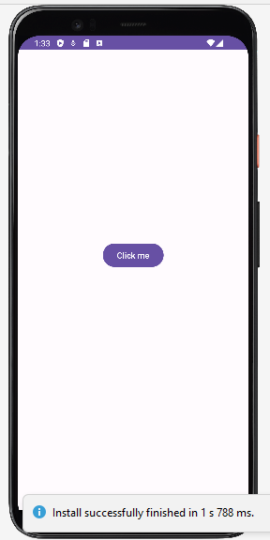
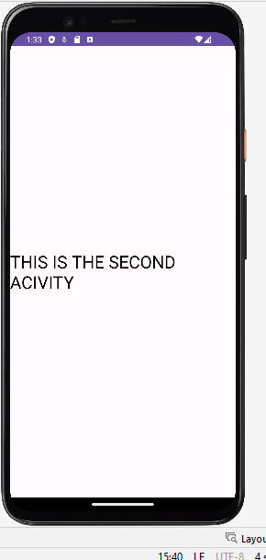
Tạo activity thứ 2: app javacom.example.bt_tuan2 new activity Empty Views Activity
Code trong MainActivity.java
package com.example.bt_tuan2;
import androidx.activity.result.contract.ActivityResultContracts;
import androidx.appcompat.app.AppCompatActivity;
import android.content.Intent;
import android.os.Bundle;
import android.view.View;
import android.widget.Button;
import com.google.android.material.bottomnavigation.BottomNavigationItemView;
public class MainActivity extends AppCompatActivity {
Button btn_Click;
@Override
protected void onCreate(Bundle savedInstanceState) {
super.onCreate(savedInstanceState);
setContentView(R.layout.activity_main);
btn_Click=findViewById(R.id.btn_Click);
btn_Click.setOnClickListener(new View.OnClickListener() {
@Override
public void onClick(View view) {
Intent a= new Intent(MainActivity.this,MainActivity2.class);
startActivity(a);
}
});
}
}

Bài 3
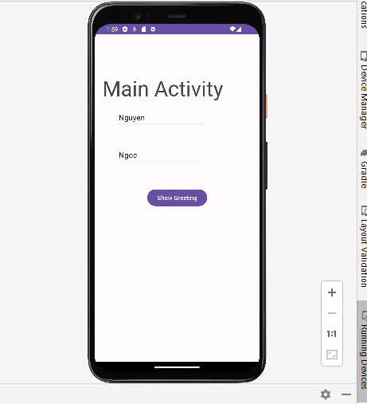
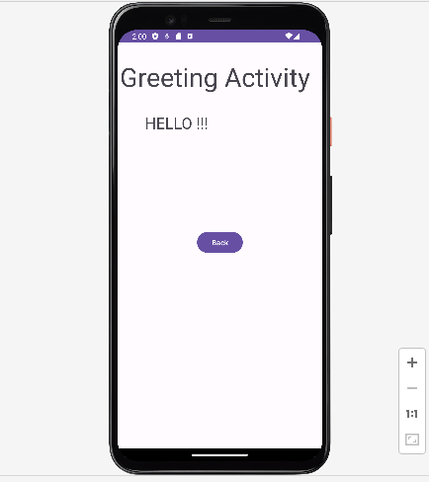
Bài 4
Tạo Fragment: Tạo activity thứ 2: app javacom.example.bt_tuan2 new Fragment Fragment (Blank)
Đóng thẻ trong Activity_Main đổi tên thẻ thành LinearLayout
Code trong activity_main.xml
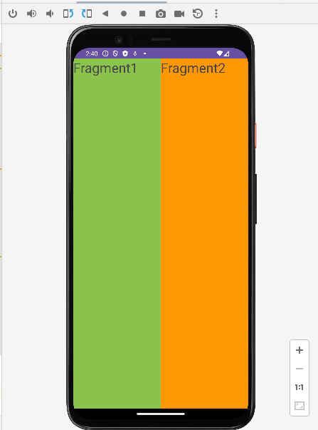
<?xml version="1.0" encoding="utf-8"?>
<LinearLayout xmlns:android="http://schemas.android.com/apk/res/android"
xmlns:app="http://schemas.android.com/apk/res-auto"
xmlns:tools="http://schemas.android.com/tools"
android:layout_width="match_parent"
android:layout_height="match_parent"
tools:context=".MainActivity"
tools:ignore="ExtraText"
android:weightSum="2">
<fragment
android:id="@+id/fr1"
class="com.example.bt2.Fragment1"
android:layout_width="wrap_content"
android:layout_height="match_parent"
android:layout_weight="1"/>
<fragment
android:id="@+id/fr2"
class="com.example.bt2.Fragment2"
android:layout_width="wrap_content"
android:layout_height="match_parent"
android:layout_weight="1"/>
</LinearLayout>

Bài 5
android:gravity="center" (điều chỉnh vị trí của chữ trong fragment)
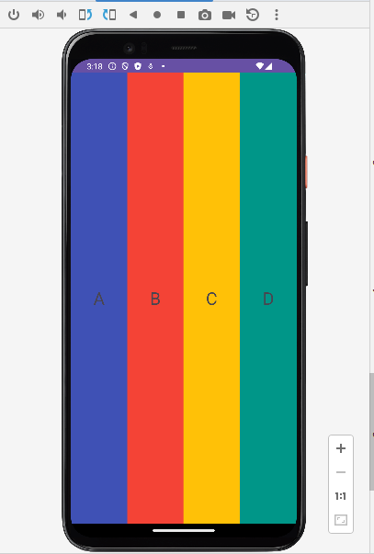

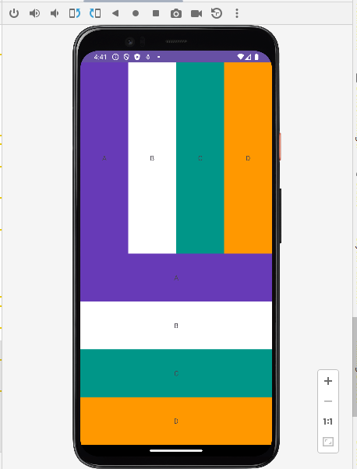
<?xml version="1.0" encoding="utf-8"?>
<LinearLayout xmlns:android="http://schemas.android.com/apk/res/android"
xmlns:app="http://schemas.android.com/apk/res-auto"
xmlns:tools="http://schemas.android.com/tools"
android:layout_width="match_parent"
android:layout_height="match_parent"
tools:context=".MainActivity"
android:orientation="vertical"
android:weightSum="2">
<LinearLayout
android:layout_width="match_parent"
android:layout_height="match_parent"
android:orientation="horizontal"
android:weightSum="4"
android:layout_weight="1">
<TextView
android:layout_width="match_parent"
android:layout_height="match_parent"
android:text="A"
android:background="#673AB7"
android:layout_weight="1"
android:gravity="center"/>
<TextView
android:layout_width="match_parent"
android:layout_height="match_parent"
android:text="B"
android:background="@color/white"
android:layout_weight="1"
android:gravity="center"/>
<TextView
android:layout_width="match_parent"
android:layout_height="match_parent"
android:text="C"
android:background="#009688"
android:layout_weight="1"
android:gravity="center"/>
<TextView
android:layout_width="match_parent"
android:layout_height="match_parent"
android:text="D"
android:background="#FF9800"
android:layout_weight="1"
android:gravity="center"/>
</LinearLayout>
<LinearLayout
android:layout_width="match_parent"
android:layout_height="match_parent"
android:orientation="vertical"
android:weightSum="4"
android:layout_weight="1">
<TextView
android:layout_width="match_parent"
android:layout_height="match_parent"
android:text="A"
android:background="#673AB7"
android:layout_weight="1"
android:gravity="center"/>
<TextView
android:layout_width="match_parent"
android:layout_height="match_parent"
android:text="B"
android:background="@color/white"
android:layout_weight="1"
android:gravity="center"/>
<TextView
android:layout_width="match_parent"
android:layout_height="match_parent"
android:text="C"
android:background="#009688"
android:layout_weight="1"
android:gravity="center"/>
<TextView
android:layout_width="match_parent"
android:layout_height="match_parent"
android:text="D"
android:background="#FF9800"
android:layout_weight="1"
android:gravity="center"/>
</LinearLayout>
</LinearLayout>

Bài 7
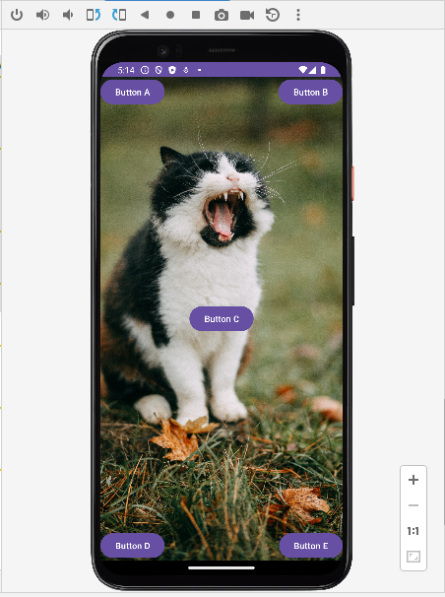
<?xml version="1.0" encoding="utf-8"?>
<FrameLayout xmlns:android="http://schemas.android.com/apk/res/android"
xmlns:app="http://schemas.android.com/apk/res-auto"
xmlns:tools="http://schemas.android.com/tools"
android:layout_width="match_parent"
android:layout_height="match_parent"
tools:context=".MainActivity"
>
<ImageView
android:layout_width="match_parent"
android:layout_height="match_parent"
android:scaleType="centerCrop"
android:src="@drawable/code" />
<Button
android:layout_width="wrap_content"
android:layout_height="wrap_content"
android:text="Button A"
/>
<Button
android:layout_width="wrap_content"
android:layout_height="wrap_content"
android:text="Button B"
android:layout_gravity="top|end"
/>
<Button
android:layout_width="wrap_content"
android:layout_height="wrap_content"
android:text="Button C"
android:layout_gravity="center"
/>
<Button
android:layout_width="wrap_content"
android:layout_height="wrap_content"
android:text="Button D"
android:layout_gravity="bottom|start"
/>
<Button
android:layout_width="wrap_content"
android:layout_height="wrap_content"
android:text="Button E"
android:layout_gravity="bottom|end"
/>
</FrameLayout>

