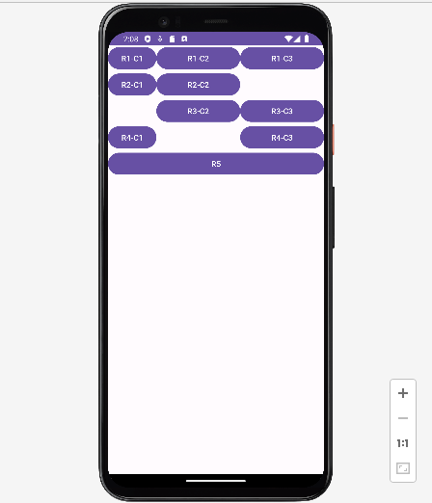
<?xml version="1.0" encoding="utf-8"?>
<TableLayout xmlns:android="http://schemas.android.com/apk/res/android"
xmlns:app="http://schemas.android.com/apk/res-auto"
xmlns:tools="http://schemas.android.com/tools"
android:layout_width="match_parent"
android:layout_height="match_parent"
tools:context=".MainActivity"
android:stretchColumns="1,2">
<TableRow>
<Button android:text="R1-C1"></Button>
<Button android:text="R1-C2"></Button>
<Button android:text="R1-C3"></Button>
</TableRow>
<TableRow>
<Button android:text="R2-C1"></Button>
<Button android:text="R2-C2"></Button>
</TableRow>
<TableRow>
<Button android:text="R3-C2" android:layout_column="1"></Button>
<Button android:text="R3-C3"></Button>
</TableRow>
<TableRow>
<Button android:text="R4-C1"></Button>
<Button android:text="R4-C3" android:layout_column="2"></Button>
</TableRow>
<TableRow>
<Button android:text="R5" android:layout_span="3"></Button>
</TableRow>
</TableLayout>

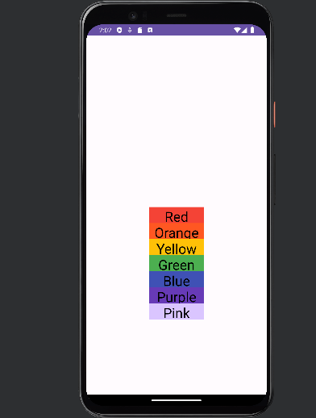
<?xml version="1.0" encoding="utf-8"?>
<RelativeLayout xmlns:android="http://schemas.android.com/apk/res/android"
xmlns:app="http://schemas.android.com/apk/res-auto"
xmlns:tools="http://schemas.android.com/tools"
android:layout_width="match_parent"
android:layout_height="match_parent"
tools:context=".MainActivity"
>
<TextView
android:layout_centerInParent="true"
android:layout_width="120dp"
android:layout_height="35dp"
android:textSize="30dp"
android:id="@+id/a"
android:text="Red"
android:gravity="center"
android:background="#F44336"
android:textColor="@color/black"
/>
<TextView
android:layout_centerInParent="true"
android:layout_width="120dp"
android:layout_height="35dp"
android:id="@+id/b"
android:text="Orange"
android:textSize="30dp"
android:gravity="center"
android:background="#FF5722"
android:layout_below="@id/a"
android:textColor="@color/black"
/>
<TextView
android:layout_centerInParent="true"
android:layout_width="120dp"
android:layout_height="35dp"
android:id="@+id/c"
android:text="Yellow"
android:textSize="30dp"
android:gravity="center"
android:background="#FFC107"
android:layout_below="@id/b"
android:textColor="@color/black"
/>
<TextView
android:layout_centerInParent="true"
android:layout_width="120dp"
android:layout_height="35dp"
android:id="@+id/d"
android:text="Green"
android:textSize="30dp"
android:gravity="center"
android:background="#4CAF50"
android:layout_below="@id/c"
android:textColor="@color/black"
/>
<TextView
android:layout_centerInParent="true"
android:layout_width="120dp"
android:layout_height="35dp"
android:id="@+id/e"
android:text="Blue"
android:textSize="30dp"
android:gravity="center"
android:background="#3F51B5"
android:layout_below="@id/d"
android:textColor="@color/black"
/>
<TextView
android:layout_centerInParent="true"
android:layout_width="120dp"
android:layout_height="35dp"
android:id="@+id/f"
android:text="Purple"
android:textSize="30dp"
android:gravity="center"
android:background="#673AB7"
android:layout_below="@id/e"
android:textColor="@color/black"
/>
<TextView
android:layout_centerInParent="true"
android:layout_width="120dp"
android:layout_height="35dp"
android:id="@+id/g"
android:text="Pink"
android:textSize="30dp"
android:gravity="center"
android:background="#EDD7C1FF"
android:layout_below="@id/f"
android:textColor="@color/black"
/>
</RelativeLayout>

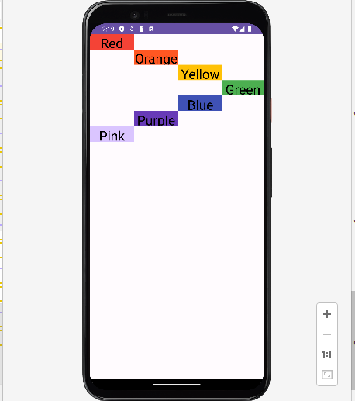
<?xml version="1.0" encoding="utf-8"?>
<RelativeLayout xmlns:android="http://schemas.android.com/apk/res/android"
xmlns:app="http://schemas.android.com/apk/res-auto"
xmlns:tools="http://schemas.android.com/tools"
android:layout_width="match_parent"
android:layout_height="match_parent"
tools:context=".MainActivity"
>
<TextView
android:layout_width="100dp"
android:layout_height="35dp"
android:textSize="30dp"
android:id="@+id/a"
android:text="Red"
android:gravity="center"
android:background="#F44336"
android:textColor="@color/black"
/>
<TextView
android:layout_width="100dp"
android:layout_height="35dp"
android:id="@+id/b"
android:text="Orange"
android:textSize="30dp"
android:gravity="center"
android:background="#FF5722"
android:layout_below="@id/a"
android:layout_toRightOf="@id/a"
android:textColor="@color/black"
/>
<TextView
android:layout_width="100dp"
android:layout_height="35dp"
android:id="@+id/c"
android:text="Yellow"
android:textSize="30dp"
android:gravity="center"
android:background="#FFC107"
android:layout_below="@id/b"
android:layout_toRightOf="@id/b"
android:textColor="@color/black"
/>
<TextView
android:layout_width="100dp"
android:layout_height="35dp"
android:id="@+id/d"
android:text="Green"
android:textSize="30dp"
android:gravity="center"
android:background="#4CAF50"
android:layout_below="@id/c"
android:layout_toRightOf="@id/c"
android:textColor="@color/black"
/>
<TextView
android:layout_width="100dp"
android:layout_height="35dp"
android:id="@+id/e"
android:text="Blue"
android:textSize="30dp"
android:gravity="center"
android:background="#3F51B5"
android:layout_below="@id/d"
android:layout_toLeftOf="@id/d"
android:textColor="@color/black"
/>
<TextView
android:layout_width="100dp"
android:layout_height="35dp"
android:id="@+id/f"
android:text="Purple"
android:textSize="30dp"
android:gravity="center"
android:background="#673AB7"
android:layout_below="@id/e"
android:layout_toLeftOf="@id/e"
android:textColor="@color/black"
/>
<TextView
android:layout_width="100dp"
android:layout_height="35dp"
android:id="@+id/g"
android:text="Pink"
android:textSize="30dp"
android:gravity="center"
android:background="#EDD7C1FF"
android:layout_below="@id/f"
android:layout_toLeftOf="@id/f"
android:textColor="@color/black"
/>
</RelativeLayout>

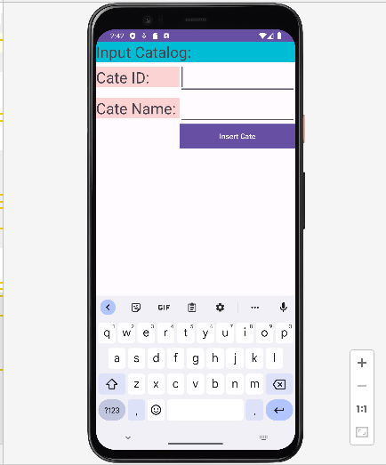
<?xml version="1.0" encoding="utf-8"?>
<TableLayout xmlns:android="http://schemas.android.com/apk/res/android"
xmlns:app="http://schemas.android.com/apk/res-auto"
xmlns:tools="http://schemas.android.com/tools"
android:layout_width="match_parent"
android:layout_height="match_parent"
tools:context=".MainActivity"
android:stretchColumns="1"
>
<TableRow>
<TextView
android:layout_height="wrap_content"
android:layout_width="match_parent"
android:text="Input Catalog: "
android:textSize="30dp"
android:background="#00BCD4"
android:layout_span="2"
/>
</TableRow>
<TableRow>
<TextView
android:layout_width="match_parent"
android:layout_height="wrap_content"
android:background="#FCD3D3"
android:text="Cate ID: "
android:textSize="30dp" />
<EditText
android:layout_width="match_parent"
android:layout_height="wrap_content"
android:textSize="30dp"/>
</TableRow>
<TableRow>
<TextView
android:layout_width="match_parent"
android:layout_height="wrap_content"
android:background="#FCD3D3"
android:text="Cate Name: "
android:textSize="30dp" />
<EditText
android:layout_width="match_parent"
android:layout_height="wrap_content"
android:textSize="30dp"/>
</TableRow>
<TableRow>
<Button
android:layout_height="match_parent"
android:layout_width="wrap_content"
android:background="#D2C5C5"
android:text="Insert Cate"
android:layout_column="1"/>
</TableRow>
</TableLayout>

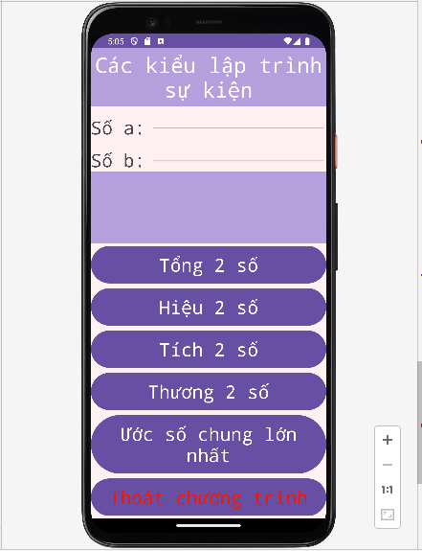
- MAIN ACTIVITY

package com.example.bt;
import androidx.appcompat.app.AppCompatActivity;
import android.os.Bundle;
import android.view.View;
import android.widget.Button;
import android.widget.EditText;
import android.widget.TextView;
//Nut Thoat
import android.app.AlertDialog;
import android.content.DialogInterface;
public class MainActivity extends AppCompatActivity {
TextView tv_kq;
EditText btn_a,btn_b;
Button tong,hieu,tich,thuong,uoc_chung,thoat;
@Override
protected void onCreate(Bundle savedInstanceState) {
super.onCreate(savedInstanceState);
setContentView(R.layout.activity_main);
tv_kq=findViewById(R.id.tv_kq);
btn_a=findViewById(R.id.btn_a);
btn_b=findViewById(R.id.btn_b);
tong=findViewById(R.id.tong);
hieu=findViewById(R.id.hieu);
tich=findViewById(R.id.tich);
thuong=findViewById(R.id.thuong);
uoc_chung=findViewById(R.id.uoc_chung);
thoat=findViewById(R.id.thoat);
tong.setOnClickListener(new View.OnClickListener(){
@Override
public void onClick(View view) {
float soa=Integer.parseInt(btn_a.getText().toString());
float sob=Integer.parseInt(btn_b.getText().toString());
float kq= soa+sob;
tv_kq.setText(kq+"");
}
});
hieu.setOnClickListener(new View.OnClickListener(){
@Override
public void onClick(View view) {
float soa=Integer.parseInt(btn_a.getText().toString());
float sob=Integer.parseInt(btn_b.getText().toString());
float kq= soa-sob;
tv_kq.setText(kq+"");
}
});
tich.setOnClickListener(new View.OnClickListener(){
@Override
public void onClick(View view) {
float soa=Integer.parseInt(btn_a.getText().toString());
float sob=Integer.parseInt(btn_b.getText().toString());
float kq= soa*sob;
tv_kq.setText(kq+"");
}
});
thuong.setOnClickListener(new View.OnClickListener(){
@Override
public void onClick(View view) {
float soa=Integer.parseInt(btn_a.getText().toString());
float sob=Integer.parseInt(btn_b.getText().toString());
float kq= soa/sob;
tv_kq.setText(kq+"");
}
});
uoc_chung.setOnClickListener(new View.OnClickListener(){
@Override
public void onClick(View view) {
int soa=Integer.parseInt(btn_a.getText().toString());
int sob=Integer.parseInt(btn_b.getText().toString());
tv_kq.setText(KT(soa,sob)+"");
}
});
thoat.setOnClickListener(new View.OnClickListener() {
@Override
public void onClick(View view) {
AlertDialog.Builder builder = new AlertDialog.Builder(MainActivity.this);
builder.setTitle("Thoát ứng dụng");
builder.setMessage("Bạn có chắc muốn thoát không?");
builder.setPositiveButton("Có", new DialogInterface.OnClickListener() {
@Override
public void onClick(DialogInterface dialogInterface, int i) {
finish();
}
});
builder.setNegativeButton("Không", new DialogInterface.OnClickListener() {
@Override
public void onClick(DialogInterface dialogInterface, int i) {
dialogInterface.cancel();
}
});
builder.show();
}
});
}
private int KT(int soa, int sob){
while (sob!=0) {
int temp = soa % sob;
soa = sob;
sob = temp;
}
return soa;
}
}

- XML

<?xml version="1.0" encoding="utf-8"?>
<LinearLayout xmlns:android="http://schemas.android.com/apk/res/android"
xmlns:app="http://schemas.android.com/apk/res-auto"
xmlns:tools="http://schemas.android.com/tools"
android:layout_width="match_parent"
android:layout_height="match_parent"
tools:context=".MainActivity"
android:orientation="vertical"
android:background="#FFF1F1">
<TextView
android:typeface="monospace"
android:layout_weight="1"
android:layout_width="match_parent"
android:layout_height="wrap_content"
android:gravity="center"
android:textSize="35dp"
android:textColor="@color/white"
android:text="Các kiểu lập trình sự kiện"
android:background="#B59FDC"/>
<LinearLayout
android:layout_weight="1"
android:layout_width="match_parent"
android:layout_height="wrap_content"
android:orientation="horizontal">
<TextView
android:typeface="monospace"
android:layout_width="100dp"
android:layout_height="45dp"
android:text="Số a:"
android:textSize="30dp" />
<EditText
android:typeface="monospace"
android:layout_width="match_parent"
android:layout_height="45dp"
android:textSize="35dp"
android:id="@+id/btn_a"/></LinearLayout>
<LinearLayout
android:layout_weight="1"
android:layout_width="match_parent"
android:layout_height="wrap_content"
android:orientation="horizontal">
<TextView
android:typeface="monospace"
android:layout_width="100dp"
android:layout_height="45dp"
android:text="Số b:"
android:textSize="30dp" />
<EditText
android:typeface="monospace"
android:layout_width="match_parent"
android:layout_height="45dp"
android:textSize="35dp"
android:id="@+id/btn_b"/></LinearLayout>
<TextView
android:id="@+id/tv_kq"
android:layout_width="match_parent"
android:layout_height="110dp"
android:layout_weight="1"
android:background="#B59FDC"
android:gravity="center"
android:textSize="35dp"
android:typeface="monospace" />
<Button
android:typeface="monospace"
android:layout_weight="1"
android:layout_width="match_parent"
android:layout_height="wrap_content"
android:gravity="center"
android:text="Tổng 2 số"
android:textSize="30dp"
android:id="@+id/tong"
/>
<Button
android:typeface="monospace"
android:layout_width="match_parent"
android:layout_height="wrap_content"
android:layout_weight="1"
android:gravity="center"
android:text="Hiệu 2 số"
android:textSize="30dp"
android:id="@+id/hieu"
/>
<Button
android:typeface="monospace"
android:layout_weight="1"
android:layout_width="match_parent"
android:layout_height="wrap_content"
android:gravity="center"
android:text="Tích 2 số"
android:textSize="30dp"
android:id="@+id/tich"
/>
<Button
android:typeface="monospace"
android:layout_weight="1"
android:layout_width="match_parent"
android:layout_height="wrap_content"
android:gravity="center"
android:text="Thương 2 số"
android:textSize="30dp"
android:id="@+id/thuong"
/>
<Button
android:typeface="monospace"
android:layout_weight="1"
android:layout_width="match_parent"
android:layout_height="wrap_content"
android:gravity="center"
android:text="Ước số chung lớn nhất"
android:textSize="30dp"
android:id="@+id/uoc_chung"
/>
<Button
android:typeface="monospace"
android:layout_weight="1"
android:layout_width="match_parent"
android:layout_height="wrap_content"
android:gravity="center"
android:text="Thoát chương trình"
android:textSize="30dp"
android:textColor="#FF1100"
android:id="@+id/thoat"
/>
</LinearLayout>

