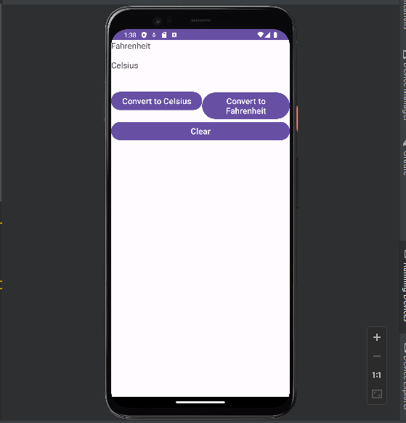
Main Activity
package com.example.bt_tuan4;
import androidx.appcompat.app.AppCompatActivity;
import android.os.Bundle;
import android.view.View;
import android.widget.Button;
import android.widget.EditText;
import android.widget.TextView;
public class MainActivity extends AppCompatActivity {
EditText nhap_f,nhap_c;
Button chuyenC,chuyenF,clear;
TextView tv_view;
// °F = (°C * 9/5) + 32
@Override
protected void onCreate(Bundle savedInstanceState) {
super.onCreate(savedInstanceState);
setContentView(R.layout.activity_main);
nhap_f=findViewById(R.id.nhap_f);
nhap_c=findViewById(R.id.nhap_c);
chuyenC=findViewById(R.id.chuyenC);
chuyenF=findViewById(R.id.chuyenF);
tv_view=findViewById(R.id.tv_view);
clear=findViewById(R.id.clear);
chuyenF.setOnClickListener(new View.OnClickListener() {
@Override
public void onClick(View view) {
float nhap= Float.parseFloat(nhap_c.getText().toString());
float kq= (nhap*9/5)+32;
tv_view.setText(kq+"");
}
});
chuyenC.setOnClickListener(new View.OnClickListener() {
@Override
public void onClick(View view) {
float nhap= Float.parseFloat(nhap_f.getText().toString());
float kq= (nhap-32)/(9/5);
tv_view.setText(kq+"");
}
});
clear.setOnClickListener(new View.OnClickListener() {
@Override
public void onClick(View view) {
tv_view.setText("");
nhap_c.setText("");
nhap_f.setText("");
}
});
}
}

- XML
<?xml version="1.0" encoding="utf-8"?>
<LinearLayout xmlns:android="http://schemas.android.com/apk/res/android"
xmlns:app="http://schemas.android.com/apk/res-auto"
xmlns:tools="http://schemas.android.com/tools"
android:layout_width="match_parent"
android:layout_height="wrap_content"
tools:context=".MainActivity"
android:orientation="vertical">
<LinearLayout
android:layout_width="match_parent"
android:layout_height="wrap_content"
android:orientation="vertical">
<TextView
android:layout_width="match_parent"
android:layout_height="wrap_content"
android:text="Fahrenheit"
android:textSize="50px"
/>
<EditText
android:layout_width="match_parent"
android:layout_height="50px"
android:id="@+id/nhap_f"
android:textSize="50px"
android:textColor="@color/black" />
</LinearLayout>
<LinearLayout
android:layout_width="match_parent"
android:layout_height="wrap_content"
android:orientation="vertical">
<TextView
android:layout_width="match_parent"
android:layout_height="wrap_content"
android:text="Celsius"
android:textSize="50px" />
<EditText
android:layout_width="match_parent"
android:layout_height="50px"
android:id="@+id/nhap_c"
android:textColor="@color/black"
android:textSize="50px"/>
<TextView
android:layout_width="match_parent"
android:layout_height="wrap_content"
android:textSize="50px"
android:textColor="@color/black"
android:gravity="center"
android:id="@+id/tv_view"/>
</LinearLayout>
<LinearLayout
android:layout_width="match_parent"
android:layout_height="wrap_content"
android:orientation="horizontal">
<Button
android:layout_width="wrap_content"
android:layout_height="wrap_content"
android:text="Convert to Celsius"
android:textSize="50px"
android:id="@+id/chuyenC"/>
<Button
android:layout_width="wrap_content"
android:layout_height="wrap_content"
android:text="Convert to Fahrenheit"
android:textSize="50px"
android:id="@+id/chuyenF"/>
</LinearLayout>
<Button
android:layout_width="match_parent"
android:layout_height="match_parent"
android:text="Clear"
android:textSize="50px"
android:id="@+id/clear"
/>
</LinearLayout>

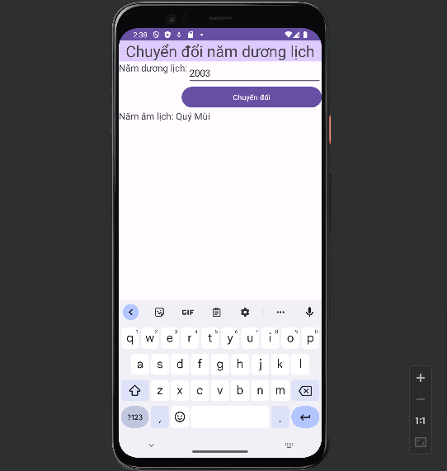

- Main Activity
package com.example.bt_tuan4;
import androidx.appcompat.app.AppCompatActivity;
import android.os.Bundle;
import android.view.View;
import android.widget.Button;
import android.widget.EditText;
import android.widget.TextView;
public class MainActivity extends AppCompatActivity {
EditText nhap_duong;
Button chuyen;
TextView tv_view;
@Override
protected void onCreate(Bundle savedInstanceState) {
super.onCreate(savedInstanceState);
setContentView(R.layout.activity_main);
nhap_duong=findViewById(R.id.nhap_duong);
tv_view=findViewById(R.id.tv_view);
chuyen=findViewById(R.id.chuyen);
chuyen.setOnClickListener(new View.OnClickListener() {
@Override
public void onClick(View view) {
int nhap= Integer.parseInt(nhap_duong.getText().toString());
String can="",chi="";
switch (nhap%10){
case 0: can="Canh" ;break;
case 1: can="Tân";break;
case 2: can="Nhâm";break;
case 3:can="Quý"; break;
case 4: can="Giáp";break;
case 5: can="Ất"; break;
case 6: can ="Bính"; break;
case 7: can="Đinh"; break;
case 8: can="Mậu";break;
case 9:can="Kỷ";break;
}
switch (nhap%12){
case 0: chi="Thân" ;break;
case 1: chi="Dậu";break;
case 2: chi="Tuất";break;
case 3:chi="Hợi"; break;
case 4: chi="Tí";break;
case 5: chi="Sửu"; break;
case 6: chi ="Dần"; break;
case 7: chi="Mẹo "; break;
case 8: chi="Thìn";break;
case 9:chi="Tỵ";break;
case 10:chi="Ngọ";break;
case 11:chi="Mùi";break;
}
tv_view.setText(can+" "+chi+" ");
}
});
}
}

- XML
<?xml version="1.0" encoding="utf-8"?>
<LinearLayout xmlns:android="http://schemas.android.com/apk/res/android"
xmlns:app="http://schemas.android.com/apk/res-auto"
xmlns:tools="http://schemas.android.com/tools"
android:layout_width="match_parent"
android:layout_height="wrap_content"
tools:context=".MainActivity"
android:orientation="vertical">
<TextView
android:layout_width="match_parent"
android:layout_height="wrap_content"
android:text="Chuyển đổi năm dương lịch"
android:textSize="30dp"
android:gravity="center"
android:background="#DDCBFD"
/>
<LinearLayout
android:layout_width="match_parent"
android:layout_height="wrap_content"
android:orientation="horizontal">
<TextView
android:layout_width="wrap_content"
android:layout_height="match_parent"
android:text="Năm dương lịch:"
android:textSize="50px"/>
<EditText
android:layout_width="match_parent"
android:layout_height="wrap_content"
android:id="@+id/nhap_duong"/>
</LinearLayout>
<Button
android:layout_width="271dp"
android:layout_height="wrap_content"
android:layout_gravity="end"
android:text="Chuyển đổi"
android:id="@+id/chuyen"/>
<LinearLayout
android:layout_width="match_parent"
android:layout_height="wrap_content"
android:orientation="horizontal">
<TextView
android:layout_width="wrap_content"
android:layout_height="match_parent"
android:text="Năm âm lịch: "
android:textSize="50px"/>
<TextView
android:layout_width="wrap_content"
android:layout_height="100px"
android:id="@+id/tv_view"
android:textSize="50px"
/>
</LinearLayout>
</LinearLayout>

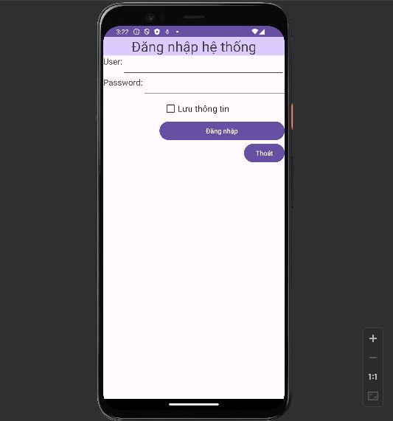
- Main Activity
- package com.example.bt_tuan4;
import androidx.appcompat.app.AppCompatActivity;
import android.os.Bundle;
import android.view.View;
import android.widget.Button;
import android.widget.CheckBox;
import android.widget.EditText;
import android.widget.TextView;
import android.widget.Toast;
//Nut Thoat
import android.app.AlertDialog;
import android.content.DialogInterface;
public class MainActivity extends AppCompatActivity {
EditText user,pass;
CheckBox luu;
Button btn_dn,btn_thoat;
@Override
protected void onCreate(Bundle savedInstanceState) {
super.onCreate(savedInstanceState);
setContentView(R.layout.activity_main);
user=findViewById(R.id.user);
pass=findViewById(R.id.pass);
luu=findViewById(R.id.luu);
btn_dn=findViewById(R.id.btn_dn);
btn_thoat=findViewById(R.id.btn_thoat);
btn_dn.setOnClickListener(new View.OnClickListener() {
@Override
public void onClick(View view) {
if(luu.isChecked()){
Toast.makeText(getApplicationContext(),"Đăng nhập thành công, thông tin đã được lưu",Toast.LENGTH_LONG).show();
}
else Toast.makeText(getApplicationContext(),"Đăng nhập thành công, thông tin không lưu lại cho lần sau",Toast.LENGTH_LONG).show();
}
});
btn_thoat.setOnClickListener(new View.OnClickListener() {
@Override
public void onClick(View view) {
AlertDialog.Builder builder = new AlertDialog.Builder(MainActivity.this);
builder.setTitle("Thoát ứng dụng");
builder.setMessage("Bạn có chắc muốn thoát không?");
builder.setPositiveButton("Có", new DialogInterface.OnClickListener() {
@Override
public void onClick(DialogInterface dialogInterface, int i) {
finish();
}
});
builder.setNegativeButton("Không", new DialogInterface.OnClickListener() {
@Override
public void onClick(DialogInterface dialogInterface, int i) {
dialogInterface.cancel();
}
});
builder.show();
}
});
}
}

XML
<?xml version="1.0" encoding="utf-8"?>
<LinearLayout xmlns:android="http://schemas.android.com/apk/res/android"
xmlns:app="http://schemas.android.com/apk/res-auto"
xmlns:tools="http://schemas.android.com/tools"
android:layout_width="match_parent"
android:layout_height="wrap_content"
tools:context=".MainActivity"
android:orientation="vertical">
<TextView
android:layout_width="match_parent"
android:layout_height="wrap_content"
android:text="Đăng nhập hệ thống"
android:textSize="30dp"
android:gravity="center"
android:background="#DDCBFD"
/>
<LinearLayout
android:layout_width="match_parent"
android:layout_height="wrap_content"
android:orientation="horizontal">
<TextView
android:layout_width="wrap_content"
android:layout_height="match_parent"
android:text="User:"
android:textSize="50px"/>
<EditText
android:layout_width="match_parent"
android:layout_height="wrap_content"
android:id="@+id/user"/>
</LinearLayout>
<LinearLayout
android:layout_width="match_parent"
android:layout_height="wrap_content"
android:orientation="horizontal">
<TextView
android:layout_width="wrap_content"
android:layout_height="match_parent"
android:text="Password:"
android:textSize="50px"/>
<EditText
android:id="@+id/pass"
android:layout_width="320dp"
android:layout_height="wrap_content"
android:layout_gravity="end"
android:inputType="textPassword" />
</LinearLayout>
<CheckBox
android:layout_width="263dp"
android:layout_height="match_parent"
android:layout_gravity="end"
android:text="Lưu thông tin"
android:textSize="50px"
android:id="@+id/luu"/>
<Button
android:layout_width="271dp"
android:layout_height="wrap_content"
android:layout_gravity="end"
android:text="Đăng nhập"
android:id="@+id/btn_dn"/>
<Button
android:id="@+id/btn_thoat"
android:layout_width="wrap_content"
android:layout_height="wrap_content"
android:layout_gravity="end"
android:text="Thoát" />
</LinearLayout>

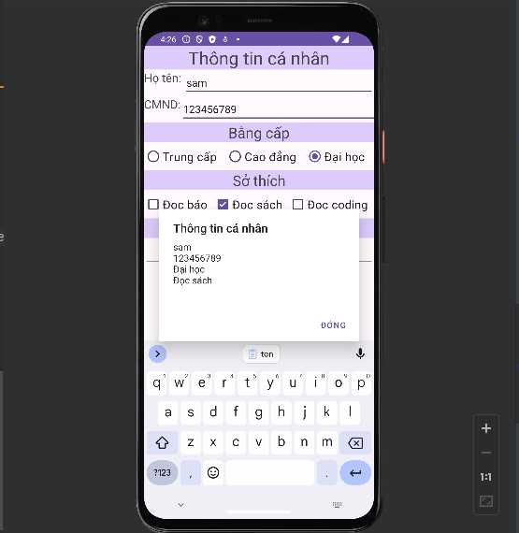

MAIN ACTIVITY
package com.example.bt_tuan4;
import androidx.appcompat.app.AppCompatActivity;
import android.os.Bundle;
import android.view.View;
import android.widget.Button;
import android.widget.CheckBox;
import android.widget.EditText;
import android.widget.RadioButton;
import android.widget.RadioGroup;
import android.widget.TextView;
import android.widget.Toast;
//Nut Thoat
import android.app.AlertDialog;
import android.content.DialogInterface;
public class MainActivity extends AppCompatActivity {
EditText ht,cmnd;
RadioGroup group;
CheckBox docbao,docsach,coding;
TextView tv_view;
Button btn_gui;
@Override
protected void onCreate(Bundle savedInstanceState) {
super.onCreate(savedInstanceState);
setContentView(R.layout.activity_main);
ht=findViewById(R.id.ht);
cmnd=findViewById(R.id.cmnd);
group=findViewById(R.id.group);
docbao=findViewById(R.id.docbao);
docsach=findViewById(R.id.docsach);
coding=findViewById(R.id.coding);
tv_view=findViewById(R.id.tv_view);
btn_gui=findViewById(R.id.btn_gui);
btn_gui.setOnClickListener(new View.OnClickListener() {
@Override
public void onClick(View view) {
String ten= ht.getText().toString();
if(ten.isEmpty()||ten.length()<3){
Toast.makeText(getApplicationContext(),"Tên không hợp lệ!",Toast.LENGTH_LONG).show();
return;
}
String chungminh=cmnd.getText().toString();
if(!chungminh.matches("\\d+")||chungminh.length()!=9){
Toast.makeText(getApplicationContext(),"CMND không hợp lệ!",Toast.LENGTH_LONG).show();
return;
}
if(!docbao.isChecked()&&!docsach.isChecked()&&!coding.isChecked()){
Toast.makeText(getApplicationContext(),"Sở thích phải chọn ít nhất 1 lựa chọn",Toast.LENGTH_LONG).show();
return;
}
String sothich="";
if(docsach.isChecked()){
sothich+="Đọc sách\n";
}
if(docbao.isChecked()){
sothich+="Đọc báo\n";
}
if(coding.isChecked()){
sothich+="Đọc coding\n";
}
int vitri=group.getCheckedRadioButtonId();
RadioButton a =findViewById(vitri);
String b=a.getText().toString();
new AlertDialog.Builder(MainActivity.this)
.setTitle("Thông tin cá nhân")
.setMessage(ten+"\n"+chungminh+"\n"+b+"\n"+sothich+"\n"+tv_view.getText().toString())
.setPositiveButton("Đóng",null)
.show();
}
});
}
}

XML
<?xml version="1.0" encoding="utf-8"?>
<LinearLayout xmlns:android="http://schemas.android.com/apk/res/android"
xmlns:app="http://schemas.android.com/apk/res-auto"
xmlns:tools="http://schemas.android.com/tools"
android:layout_width="match_parent"
android:layout_height="wrap_content"
tools:context=".MainActivity"
android:orientation="vertical">
<TextView
android:layout_width="match_parent"
android:layout_height="wrap_content"
android:text="Thông tin cá nhân"
android:textSize="30dp"
android:gravity="center"
android:background="#DDCBFD"
/>
<LinearLayout
android:layout_width="match_parent"
android:layout_height="wrap_content"
android:orientation="horizontal">
<TextView
android:layout_width="wrap_content"
android:layout_height="match_parent"
android:text="Họ tên: "
android:textSize="20dp"/>
<EditText
android:layout_width="match_parent"
android:layout_height="wrap_content"
android:id="@+id/ht"/>
</LinearLayout>
<LinearLayout
android:layout_width="match_parent"
android:layout_height="wrap_content"
android:orientation="horizontal">
<TextView
android:layout_width="wrap_content"
android:layout_height="match_parent"
android:text="CMND:"
android:textSize="20dp"/>
<EditText
android:id="@+id/cmnd"
android:layout_width="353dp"
android:layout_height="wrap_content" />
</LinearLayout>
<TextView
android:layout_width="match_parent"
android:layout_height="wrap_content"
android:text="Bằng cấp"
android:textSize="25dp"
android:gravity="center"
android:background="#DDCBFD"/>
<RadioGroup
android:layout_width="match_parent"
android:layout_height="wrap_content"
android:orientation="horizontal"
android:weightSum="3"
android:id="@+id/group">
<RadioButton
android:layout_width="wrap_content"
android:layout_height="wrap_content"
android:text="Trung cấp"
android:textSize="20dp"
android:id="@+id/trungcap"
android:layout_weight="1"/>
<RadioButton
android:layout_width="wrap_content"
android:layout_height="wrap_content"
android:text="Cao đẳng"
android:textSize="20dp"
android:id="@+id/caodang"
android:layout_weight="1"/>
<RadioButton
android:layout_width="wrap_content"
android:layout_height="wrap_content"
android:text="Đại học"
android:checked="true"
android:textSize="20dp"
android:id="@+id/daihoc"
android:layout_weight="1"/>
</RadioGroup>
<TextView
android:layout_width="match_parent"
android:layout_height="wrap_content"
android:text="Sở thích"
android:textSize="25dp"
android:gravity="center"
android:background="#DDCBFD"
/>
<LinearLayout
android:layout_width="match_parent"
android:layout_height="wrap_content"
android:orientation="horizontal"
android:weightSum="3">
<CheckBox
android:layout_width="wrap_content"
android:layout_height="wrap_content"
android:textSize="20dp"
android:text="Đọc báo"
android:id="@+id/docbao"
android:layout_weight="1"/>
<CheckBox
android:layout_width="wrap_content"
android:layout_height="wrap_content"
android:textSize="20dp"
android:text="Đọc sách"
android:id="@+id/docsach"
android:layout_weight="1"/>
<CheckBox
android:layout_width="wrap_content"
android:layout_height="wrap_content"
android:textSize="20dp"
android:text="Đọc coding"
android:id="@+id/coding"
android:layout_weight="1"/>
</LinearLayout>
<TextView
android:layout_width="match_parent"
android:layout_height="wrap_content"
android:text="Thông tin bổ sung"
android:textSize="25dp"
android:gravity="center"
android:background="#DDCBFD"/>
<EditText
android:layout_width="match_parent"
android:layout_height="wrap_content"
android:textSize="20dp"
android:id="@+id/tv_view"/>
<Button
android:layout_width="216dp"
android:layout_height="wrap_content"
android:layout_gravity="center"
android:text="Gửi thông tin"
android:textSize="20dp"
android:id="@+id/btn_gui"/>
</LinearLayout>

