
Mã Màu
(Hex Code)
#EEEEEE | #DDDDDD | #CCCCCC | #BBBBBB | #AAAAAA | #999999
#888888 | #777777 | #666666 | #555555 | #444444 | #333333
#222222 | #111111 | #000000 | #FF0000 | #EE0000 | #DD0000
#CC0000 | #BB0000 | #AA0000 | #990000 | #880000 | #770000
#660000 | #550000 | #440000 | #330000 | #220000 | #110000
#FFFFFF | #FFFFCC | #FFFF99 | #FFFF66 | #FFFF33 | #FFFF00
#CCFFFF | #CCFFCC | #CCFF99 | #CCFF66 | #CCFF33 | #CCFF00
#99FFFF | #99FFCC | #99FF99 | #99FF66 | #99FF33 | #99FF00
#66FFFF | #66FFCC | #66FF99 | #66FF66 | #66FF33 | #66FF00
#33FFFF | #33FFCC | #33FF99 | #33FF66 | #33FF33 | #33FF00
#00FFFF | #00FFCC | #00FF99 | #00FF66 | #00FF33 | #00FF00
#FFCCFF | #FFCCCC | #FFCC99 | #FFCC66 | #FFCC33 | #FFCC00
#CCCCFF | #CCCCCC | #CCCC99 | #CCCC66 | #CCCC33 | #CCCC00
#99CCFF | #99CCCC | #99CC99 | #99CC66 | #99CC33 | #99CC00
#66CCFF | #66CCCC | #66CC99 | #66CC66 | #66CC33 | #66CC00
#33CCFF | #33CCCC | #33CC99 | #33CC66 | #33CC33 | #33CC00
#00CCFF | #00CCCC | #33CC66 | #33CC33 | #00CC99 | #00CC66
#00CC33 | #00CC00 | #FF99FF | #FF99CC | #FF9999 | #FF9966
#FF9933 | #FF9900 | #CC99FF | #CC99CC | #CC9999 | #CC9966
#CC9933 | #CC9900 | #9999FF | #9999CC | #999999 | #999966
#999933 | #999900 | #6699FF | #6699CC | #669999 | #669966
#669933 | #669900 | #3399FF | #3399CC | #339999 | #339966
#339933 | #339900 | #0099FF | #0099CC | #009999 | #009966
#009933 | #009900 | #FF66FF | #FF66CC | #FF6699 | #FF6666
#FF6633 | #FF6600 | #CC66FF | #CC66CC | #CC6699 | #CC6666
#CC6633 | #CC6600 | #9966FF | #9966CC | #996699 | #996666
#996633 | #996600 | #6666FF | #6666CC | #666699 | #666666
#666633 | #666600 | #3366FF | #3366CC | #336699 | #336666
#336633 | #336600 | #0066FF | #0066CC | #006699 | #006666
#006633 | #006600 | #FF33FF | #FF33CC | #FF3399 | #FF3366
#FF3333 | #FF3300 | #CC33FF | #CC33CC | #CC3399 | #CC3366
#CC3333 | #CC3300 | #9933FF | #9933CC | #993399 | #993366
#993333 | #993300 | #6633FF | #6633CC | #663399 | #663366
#663333 | #663300 | #3333FF | #3333CC | #333399 | #333366
#333333 | #333300 | #0033FF | #FF3333 | #0033CC | #003399
#003366 | #003333 | #003300 | #FF00FF | #FF00CC | #FF0099
#FF0066 | #FF0033 | #FF0000 | #CC00FF | #CC00CC | #CC0099
#CC0066 | #CC0033 | #CC0000 | #9900FF | #9900CC | #990099
#990066 | #990033 | #990000 | #6600FF | #6600CC | #660099
#660066 | #660033 | #660000 | #3300FF | #3300CC | #330099
#330066 | #330033 | #330000 | #0000FF | #0000CC | #000099
#000066 | #000033 | #00FF00 | #00EE00 | #00DD00 | #00CC00
#00BB00 | #00AA00 | #009900 | #008800 | #007700 | #006600
#005500 | #004400 | #003300 | #002200 | #001100 | #0000FF
#0000EE | #0000DD | #0000CC | #0000BB | #0000AA | #000099
#000088 | #000077 | #000055 | #000044 | #000022 | #000011

Thao Tác:
Thêm 1 Activity:
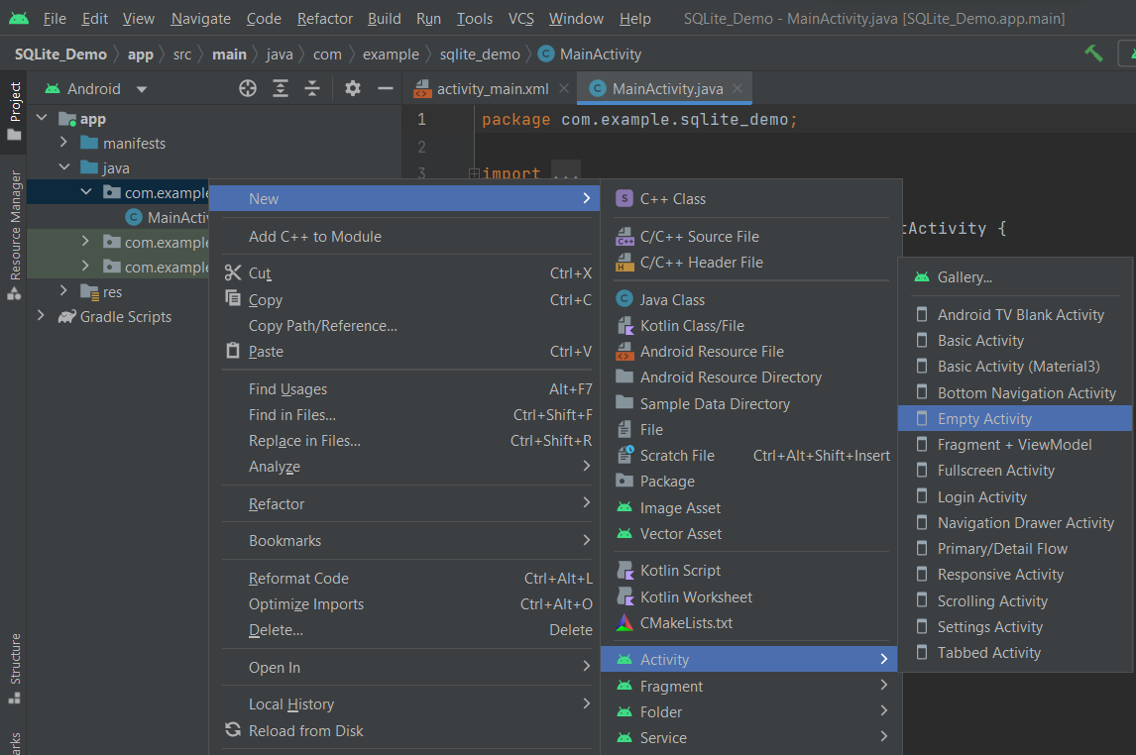

Thêm 1 XML:
: R_Mouse vào
Thêm 1 Class :
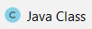
: R_Mouse vào <đặt tên> Class OK
Insert code: Ấn tổ hợp phím Alt + Ins trên bàn phím

Mục Lục
*****
BT4: Fragment. 1
BT5a: WeightSum. 4
BT5b: WeightSum, Orientation. 6
BT7: Chọn layout là FrameLayout, thiết kế như sau. 11
BT8: Sử dụng TableLayout thiết kế giao diện như sau: 12
BT9: Thiết kế giao diện và viết code điều khiển các chức năng như hình sau: 13
BT10: Viết chương trình đổi năm Dương lịch qua năm âm lịch (Năm dương lịch chỉ được nhập số >= 1900) 17
BT11: switch to temperature 20
BT12: Thiết kế giao diện đăng nhập. 24
BT13: Thiết kế form Thông tin cá nhân. 30
BT14: Position 39
BT15: ListView. 42
BT16: Thiết kế danh bạ. 46
BT17: Sắp sếp mảng, tăng dần và giảm dần. 52
KHIỂM TRA GIỮA KÌ LẦN 1: 55
KHIỂM TRA GIỮA KÌ LẦN 2: 70
BÀI TẬP VỀ SPINNER 82
Tạo spinner và hiển thị lên Toast. 82
Tạo spinner và hiển thị lên TextView. 83
BT18: Thiết kế album ảnh. 86
SQLite 95
BT19: Save và Update dữ liệu từ SQLite 95

BT4: Fragment.

Tạo thêm 1 Fragment:
: R_Mouse vào

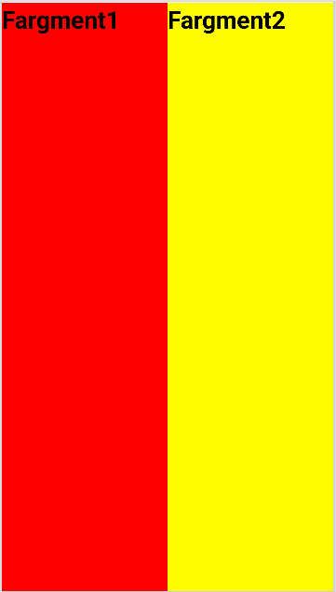

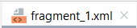
<?xml version="1.0" encoding="utf-8"?>
<FrameLayout xmlns:android="http://schemas.android.com/apk/res/android"
xmlns:tools="http://schemas.android.com/tools"
android:layout_width="match_parent"
android:layout_height="match_parent"
tools:context=".Fragment_1">
<!-- TODO: Update blank fragment layout -->
<TextView
android:layout_width="match_parent"
android:layout_height="match_parent"
android:background="#FF0000"
android:text="Fargment1"
android:textSize="30dp"
android:layout_gravity="center"
android:textStyle="bold"
android:textColor="@color/black"/>
</FrameLayout>

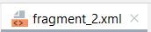

<?xml version="1.0" encoding="utf-8"?>
<FrameLayout xmlns:android="http://schemas.android.com/apk/res/android"
xmlns:tools="http://schemas.android.com/tools"
android:layout_width="match_parent"
android:layout_height="match_parent"
tools:context=".Fragment_2">
<!-- TODO: Update blank fragment layout -->
<TextView
android:layout_width="match_parent"
android:layout_height="match_parent"
android:background="#FFFC00"
android:text="Fargment2"
android:textColor="@color/black"
android:textSize="30dp"
android:textStyle="bold" />
</FrameLayout>

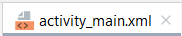

<?xml version="1.0" encoding="utf-8"?>
<LinearLayout
xmlns:android="http://schemas.android.com/apk/res/android"
xmlns:app="http://schemas.android.com/apk/res-auto"
xmlns:tools="http://schemas.android.com/tools"
android:layout_width="match_parent"
android:layout_height="match_parent"
tools:context=".MainActivity"
android:weightSum="2">
<fragment
android:layout_width="wrap_content"
android:layout_height="match_parent"
tools:layout="@layout/fragment_1"
android:layout_weight="1">
</fragment>
<fragment
android:layout_width="wrap_content"
android:layout_height="match_parent"
tools:layout="@layout/fragment_2"
android:layout_weight="1">
</fragment>
</LinearLayout>

BT5a: WeightSum.
android:weightSum="4"
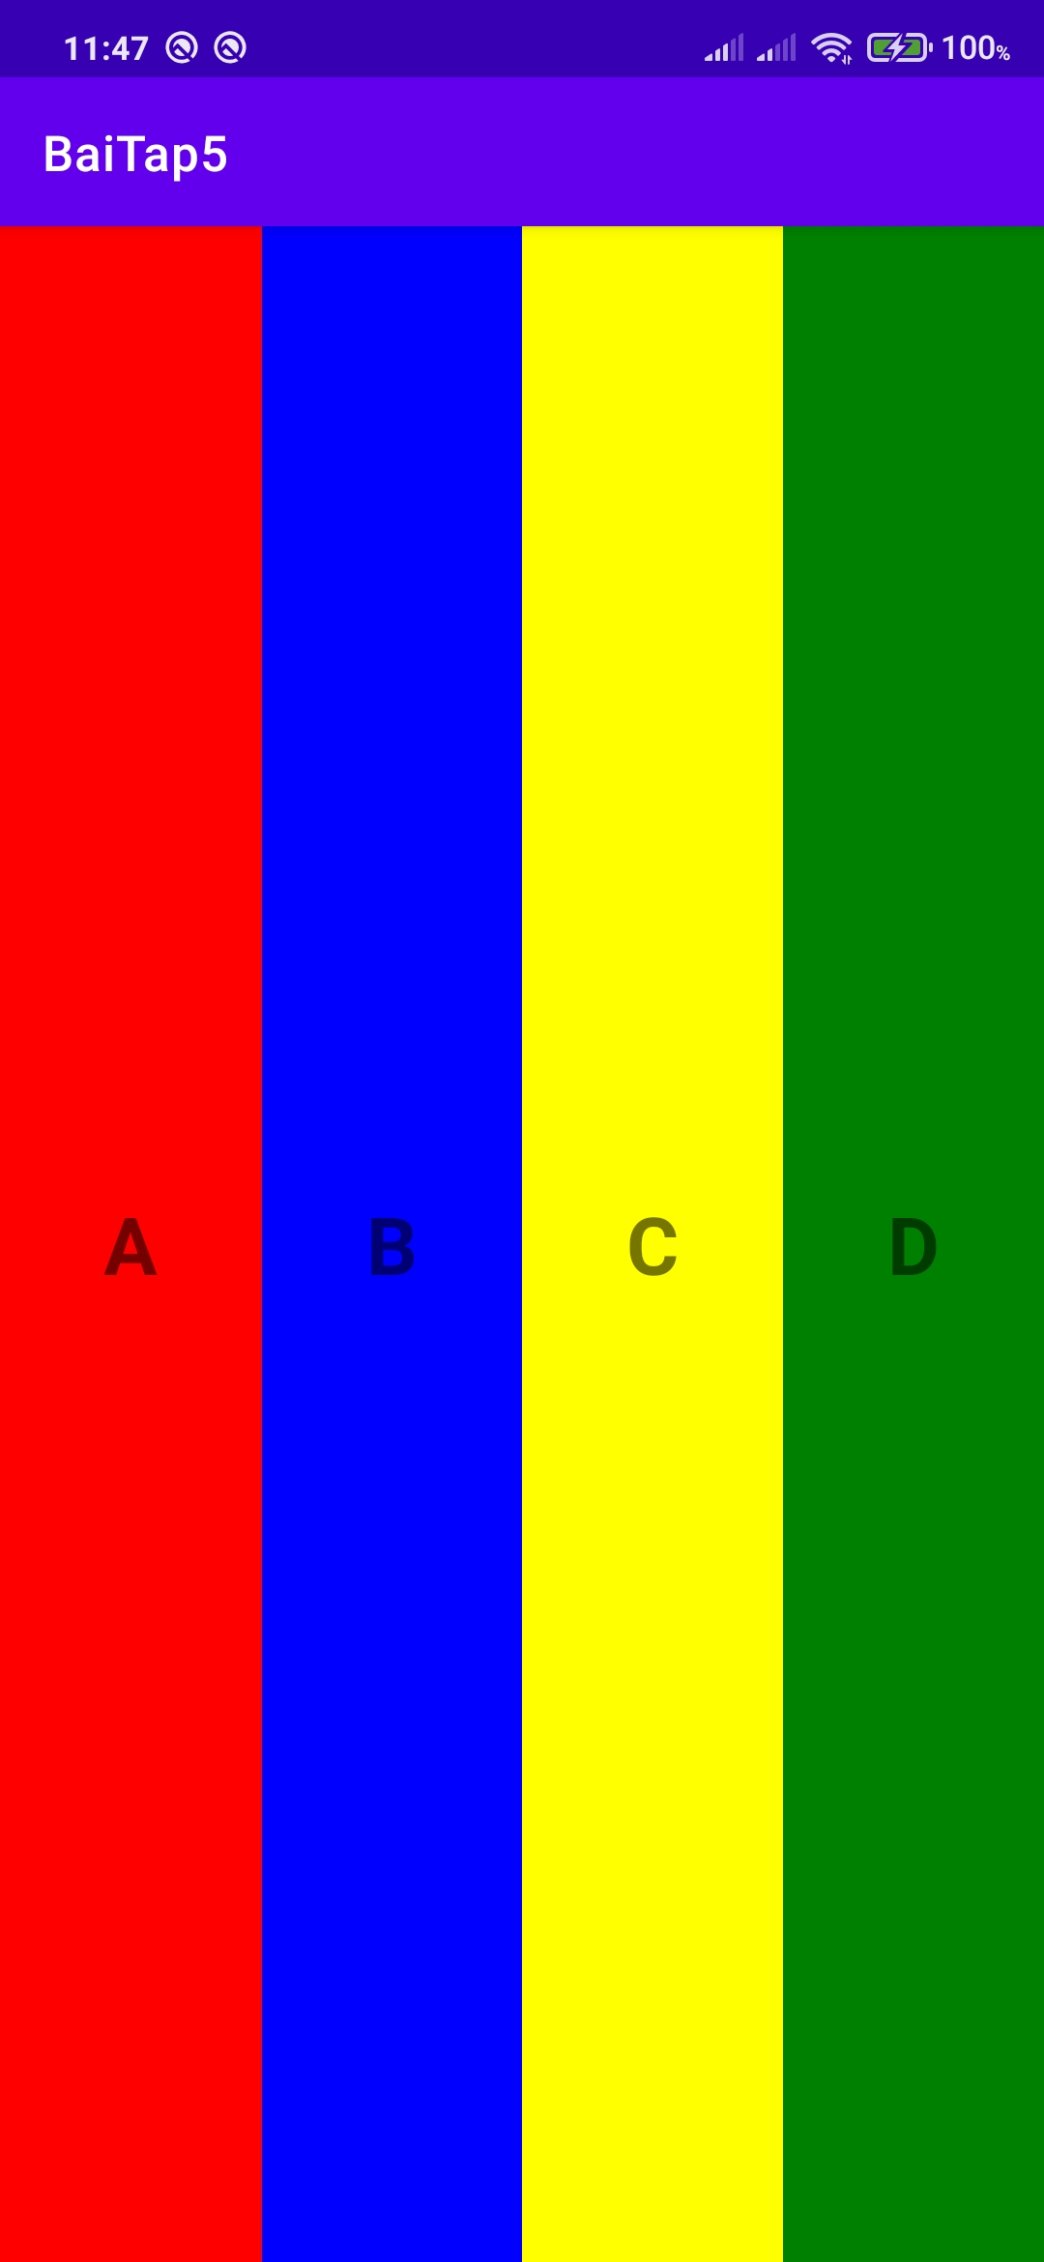

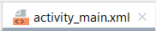
<?xml version="1.0" encoding="utf-8"?>
<LinearLayout xmlns:android="http://schemas.android.com/apk/res/android"
xmlns:app="http://schemas.android.com/apk/res-auto"
xmlns:tools="http://schemas.android.com/tools"
android:layout_width="match_parent"
android:layout_height="match_parent"
tools:context=".MainActivity"
android:weightSum="4">
<TextView
android:layout_width="wrap_content"
android:layout_height="match_parent"
android:layout_weight="1"
android:background="#FF0000"
android:text="A"
android:textSize="30dp"
android:textStyle="bold"
android:gravity="center">
</TextView>
<TextView
android:layout_width="wrap_content"
android:layout_height="match_parent"
android:layout_weight="1"
android:background="#0000FF"
android:text="B"
android:textSize="30dp"
android:textStyle="bold"
android:gravity="center">
</TextView>
<TextView
android:layout_width="wrap_content"
android:layout_height="match_parent"
android:layout_weight="1"
android:background="#FFFF00"
android:text="C"
android:textSize="30dp"
android:textStyle="bold"
android:gravity="center">
</TextView>
<TextView
android:layout_width="wrap_content"
android:layout_height="match_parent"
android:layout_weight="1"
android:background="#008000"
android:text="D"
android:textSize="30dp"
android:textStyle="bold"
android:gravity="center">
</TextView>
</LinearLayout>

BT5b: WeightSum, Orientation.
android:orientation="vertical"
android:weightSum="4"
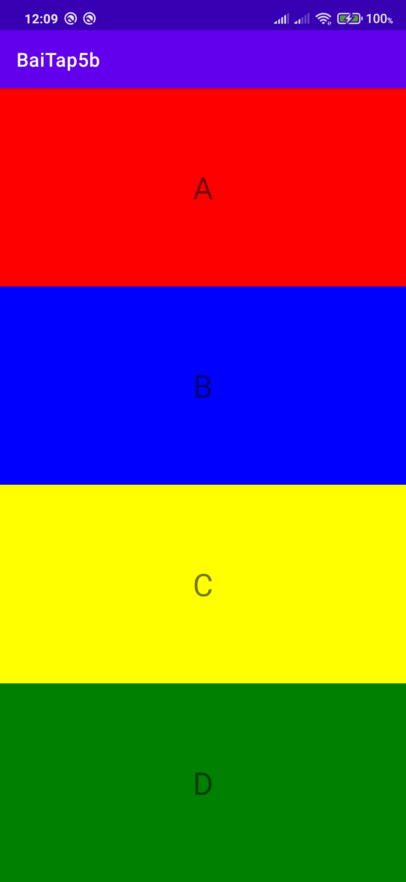

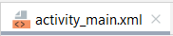

<?xml version="1.0" encoding="utf-8"?>
<LinearLayout xmlns:android="http://schemas.android.com/apk/res/android"
xmlns:app="http://schemas.android.com/apk/res-auto"
xmlns:tools="http://schemas.android.com/tools"
android:layout_width="match_parent"
android:layout_height="match_parent"
tools:context=".MainActivity"
android:orientation="vertical"
android:weightSum="4">
<TextView
android:layout_width="match_parent"
android:layout_height="wrap_content"
android:layout_weight="1"
android:background="#FF0000"
android:text="A"
android:textSize="30dp"
android:gravity="center">
</TextView>
<TextView
android:layout_width="match_parent"
android:layout_height="wrap_content"
android:layout_weight="1"
android:background="#0000FF"
android:text="B"
android:textSize="30dp"
android:gravity="center">
</TextView>
<TextView
android:layout_width="match_parent"
android:layout_height="wrap_content"
android:layout_weight="1"
android:background="#FFFF00"
android:text="C"
android:textSize="30dp"
android:gravity="center">
</TextView>
<TextView
android:layout_width="match_parent"
android:layout_height="wrap_content"
android:layout_weight="1"
android:background="#008000"
android:text="D"
android:textSize="30dp"
android:gravity="center">
</TextView>
</LinearLayout>
BT5c: Orientation.
android:orientation="vertical"

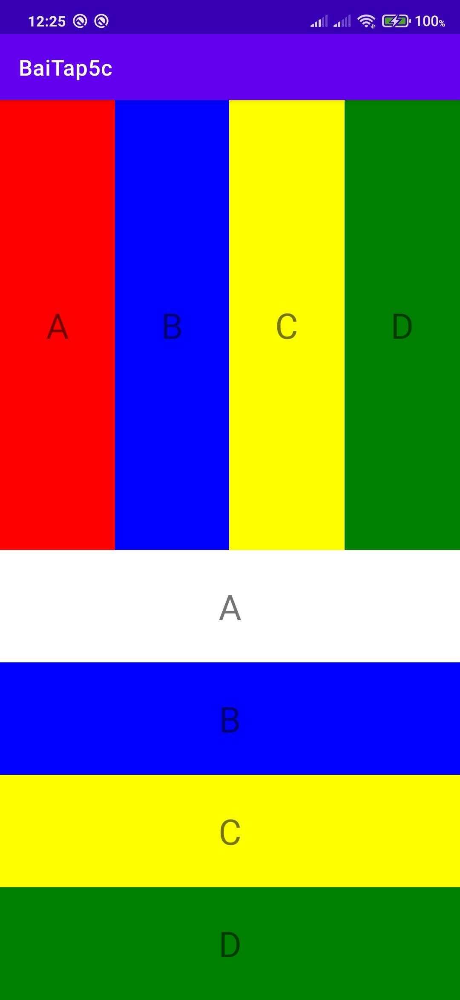
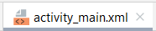
<?xml version="1.0" encoding="utf-8"?>
<LinearLayout xmlns:android="http://schemas.android.com/apk/res/android"
xmlns:app="http://schemas.android.com/apk/res-auto"
xmlns:tools="http://schemas.android.com/tools"
android:layout_width="match_parent"
android:layout_height="match_parent"
tools:context=".MainActivity"
android:orientation="vertical">
<LinearLayout
android:layout_width="match_parent"
android:layout_height="match_parent"
android:layout_weight="1"
>
<TextView
android:layout_width="wrap_content"
android:layout_height="match_parent"
android:text="A"
android:background="#FF0000"
android:textSize="30dp"
android:gravity="center"
android:layout_weight="1"/>
<TextView
android:layout_width="wrap_content"
android:layout_height="match_parent"
android:text="B"
android:background="#0000FF"
android:textSize="30dp"
android:gravity="center"
android:layout_weight="1"/>
<TextView
android:layout_width="wrap_content"
android:layout_height="match_parent"
android:text="C"
android:background="#FFFF00"
android:textSize="30dp"
android:gravity="center"
android:layout_weight="1"/>
<TextView
android:layout_width="wrap_content"
android:layout_height="match_parent"
android:text="D"
android:background="#008000"
android:textSize="30dp"
android:gravity="center"
android:layout_weight="1"/>
</LinearLayout>
<LinearLayout
android:layout_width="match_parent"
android:layout_height="match_parent"
android:orientation="vertical"
android:layout_weight="1">
<TextView
android:layout_width="match_parent"
android:layout_height="wrap_content"
android:text="A"
android:textSize="30dp"
android:gravity="center"
android:layout_weight="1"/>
<TextView
android:layout_width="match_parent"
android:layout_height="wrap_content"
android:text="B"
android:background="#0000FF"
android:textSize="30dp"
android:gravity="center"
android:layout_weight="1"/>
<TextView
android:layout_width="match_parent"
android:layout_height="wrap_content"
android:text="C"
android:background="#FFFF00"
android:textSize="30dp"
android:gravity="center"
android:layout_weight="1"/>
<TextView
android:layout_width="match_parent"
android:layout_height="wrap_content"
android:text="D"
android:background="#008000"
android:textSize="30dp"
android:gravity="center"
android:layout_weight="1"/>
</LinearLayout>
</LinearLayout>

BT7: Chọn layout là FrameLayout, thiết kế như sau.

BT8: Sử dụng TableLayout thiết kế giao diện như sau:

Chương 3: Xây dựng giao diện người dùng

BT9: Thiết kế giao diện và viết code điều khiển các chức năng như hình sau:
- Các thuộc tính: TextView, Plain Text, Button.

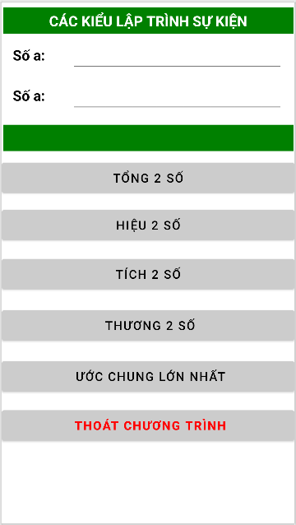

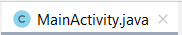

package com.example.baitap9;
import androidx.appcompat.app.AlertDialog;
import androidx.appcompat.app.AppCompatActivity;
import android.content.DialogInterface;
import android.os.Bundle;
import android.view.View;
import android.widget.Button;
import android.widget.TextView;
public class MainActivity extends AppCompatActivity {
TextView plaintxt_soa,plaintxt_sob,txt_ketqua;
Button btn_tong,btn_hieu,btn_tich,btn_thuong,btn_ucln,btn_thoat;
float soa,sob,tong,hieu,tich,thuong;
@Override
protected void onCreate(Bundle savedInstanceState) {
super.onCreate(savedInstanceState);
setContentView(R.layout.activity_main);
plaintxt_soa= (TextView) findViewById(R.id.plaintxt_soa);
plaintxt_sob=(TextView) findViewById(R.id.plaintxt_sob);
txt_ketqua=(TextView) findViewById(R.id.txt_ketqua);
btn_tong=(Button) findViewById(R.id.btn_tong);
btn_hieu=(Button) findViewById(R.id.btn_hieu);
btn_tich=(Button) findViewById(R.id.btn_tich);
btn_thuong=(Button) findViewById(R.id.btn_thuong);
btn_thoat=(Button) findViewById(R.id.btn_thoat);
// Phép cộng
btn_tong.setOnClickListener(new View.OnClickListener() {
@Override
public void onClick(View view) {
String st1,st2;
st1= plaintxt_soa.getText().toString();
soa= Float.parseFloat(st1);
st2= plaintxt_sob.getText().toString();
sob= Float.parseFloat(st2);
tong= soa + sob;
txt_ketqua.setText(String.valueOf(tong));
}
});
// Phép Trừ
btn_hieu.setOnClickListener(new View.OnClickListener() {
@Override
public void onClick(View view) {
String st1,st2;
st1= plaintxt_soa.getText().toString();
soa= Float.parseFloat(st1);
st2= plaintxt_sob.getText().toString();
sob= Float.parseFloat(st2);
hieu= soa - sob;
txt_ketqua.setText(String.valueOf(hieu));
}
});
// Phép nhân
btn_tich.setOnClickListener(new View.OnClickListener() {
@Override
public void onClick(View view) {
String st1,st2;
st1= plaintxt_soa.getText().toString();
soa= Float.parseFloat(st1);
st2= plaintxt_sob.getText().toString();
sob= Float.parseFloat(st2);
tich= soa * sob;
txt_ketqua.setText(String.valueOf(tich));
}
});
// Phép chia
btn_thuong.setOnClickListener(new View.OnClickListener() {
@Override
public void onClick(View view) {
String st1,st2;
st1= plaintxt_soa.getText().toString();
soa= Float.parseFloat(st1);
st2= plaintxt_sob.getText().toString();
sob= Float.parseFloat(st2);
if(sob == 0){
txt_ketqua.setText(String.valueOf("Không hợp lệ"));
}
else {
thuong = soa / sob;
txt_ketqua.setText(String.valueOf(thuong));
}
}
});
// Tìm ước chung lớn nhất
btn_ucln.setOnClickListener(new View.OnClickListener() {
@Override
public void onClick(View view) {
float max;
String st1, st2;
st1 = plaintxt_soa.getText().toString();
soa = Float.parseFloat(st1);
st2 = plaintxt_sob.getText().toString();
sob = Float.parseFloat(st2);
if (soa > sob) {
max = soa;
} else {
max = sob;
}
for (int i = 1; i <= max; i++) {
if (soa % i == 0 && sob % i == 0) {
txt_ketqua.setText(String.valueOf(i));
}
}
}
});
// Nút thoát
btn_thoat.setOnClickListener(new View.OnClickListener() {
@Override
public void onClick(View view) {
AlertDialog.Builder thoat= new AlertDialog.Builder(MainActivity.this);
thoat.setTitle("Thoát chương trình");
thoat.setMessage("Bạn có muốn thoát chương trình ?");
thoat.setPositiveButton("Thoát", new DialogInterface.OnClickListener() {
@Override
public void onClick(DialogInterface dialogInterface, int i) {
finish();
}
});
thoat.setNegativeButton("Không", new DialogInterface.OnClickListener() {
@Override
public void onClick(DialogInterface dialogInterface, int i) {
dialogInterface.cancel();
}
});
thoat.show();
}
});
}
}

BT10: Viết chương trình đổi năm Dương lịch qua năm âm lịch (Năm dương lịch chỉ được nhập số >= 1900)

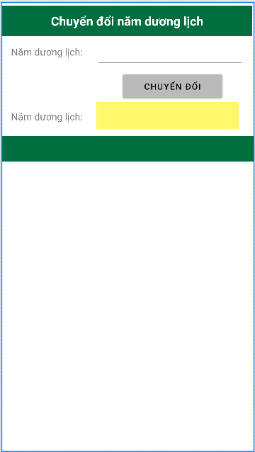

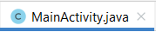
package com.example.fixloi;
import androidx.appcompat.app.AppCompatActivity;
import android.os.Bundle;
import android.view.View;
import android.widget.Button;
import android.widget.EditText;
import android.widget.TextView;
public class MainActivity extends AppCompatActivity {
EditText plain_nam;
TextView txt_ketqua;
Button btn_chuyen;
@Override
protected void onCreate(Bundle savedInstanceState) {
super.onCreate(savedInstanceState);
setContentView(R.layout.activity_main);
plain_nam = (EditText) findViewById(R.id.plaintxt_nam);
txt_ketqua = (TextView) findViewById(R.id.txt_ketqua);
btn_chuyen = (Button) findViewById(R.id.btn_chuyen);
btn_chuyen.setOnClickListener(new View.OnClickListener() {
@Override
public void onClick(View view) {
int namduong = Integer.parseInt(plain_nam.getText().toString());
String can = "", chi = "";
switch (namduong % 10) {
case 0: can = "Canh";break;
case 1: can = "Tân";break;
case 2: can = "Nhâm";break;
case 3: can = "Quý";break;
case 4: can = "Giáp";break;
case 5: can = "Ất";break;
case 6: can = "Bính";break;
case 7: can = "Đinh";break;
case 8: can = "Mậu";break;
case 9: can = "Kỷ";break;
}
switch (namduong % 12) {
case 0: chi = "Thân";break;
case 1: chi = "Dậu";break;
case 2: chi = "Tuất";break;
case 3: chi = "Hợi";break;
case 4: chi = "Tý";break;
case 5: chi = "Sửu";break;
case 6: chi = "Dần";break;
case 7: chi = "Mẹo";break;
case 8: chi = "Thìn";break;
case 9: chi = "Tỵ";break;
case 10: chi = "Ngọ";break;
case 11: chi = "Mùi";break;
};
txt_ketqua.setText(String.valueOf(can+ " "+ chi));
}
});
}
}

BT11: switch to temperature
Hướng dẫn: Chuyển từ 37°C tới F : 37°C x 9/5 + 32 = 98.6°F
Chuyển từ 98.6°F tới C : (98.6°F - 32) x 5/9 = 37°C

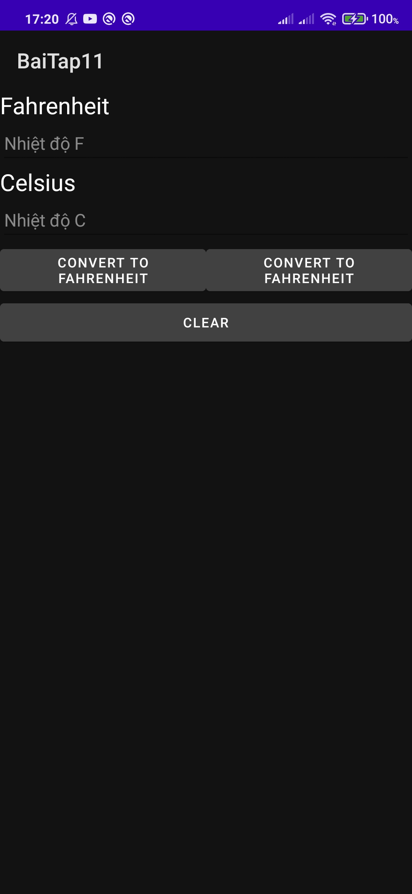
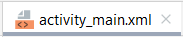
<?xml version="1.0" encoding="utf-8"?>
<LinearLayout
xmlns:android="http://schemas.android.com/apk/res/android"
xmlns:app="http://schemas.android.com/apk/res-auto"
xmlns:tools="http://schemas.android.com/tools"
android:layout_width="match_parent"
android:layout_height="match_parent"
tools:context=".MainActivity"
android:orientation="vertical">
<TextView
android:id="@+id/ed_1"
android:layout_width="match_parent"
android:layout_height="wrap_content"
android:text="Fahrenheit"
android:textSize="24sp"
android:textColor="@color/black">
</TextView>
<EditText
android:id="@+id/ed_f"
android:layout_width="match_parent"
android:layout_height="wrap_content"
android:hint="Nhiệt độ F">
</EditText>
<TextView
android:id="@+id/ed_2"
android:layout_width="match_parent"
android:layout_height="wrap_content"
android:text="Celsius"
android:textColor="@color/black"
android:textSize="24sp">
</TextView>
<EditText
android:id="@+id/ed_c"
android:layout_width="match_parent"
android:layout_height="wrap_content"
android:hint="Nhiệt độ C">
</EditText>
<LinearLayout
android:layout_width="match_parent"
android:layout_height="wrap_content"
android:orientation="horizontal"
android:weightSum="4">
<Button
android:id="@+id/bt_c"
android:layout_width="166dp"
android:layout_height="wrap_content"
android:layout_weight="2"
android:backgroundTint="#CCCCCC"
android:text="Convert to Fahrenheit"
android:textColor="@color/black">
</Button>
<Button
android:id="@+id/bt_f"
android:layout_width="166dp"
android:layout_height="wrap_content"
android:layout_weight="2"
android:backgroundTint="#CCCCCC"
android:text="Convert to Fahrenheit"
android:textColor="@color/black">
</Button>
</LinearLayout>
<Button
android:id="@+id/bt_clear"
android:layout_width="match_parent"
android:layout_height="wrap_content"
android:backgroundTint="#CCCCCC"
android:text="Clear"
android:textColor="@color/black"
>
</Button>
</LinearLayout>


package com.example.baitap11;
import androidx.appcompat.app.AppCompatActivity;
import android.os.Bundle;
import android.view.View;
import android.widget.Button;
import android.widget.TextView;
public class MainActivity extends AppCompatActivity {
TextView ed_f, ed_c;
Button bt_c, bt_f, bt_clear;
@Override
protected void onCreate(Bundle savedInstanceState) {
super.onCreate(savedInstanceState);
setContentView(R.layout.activity_main);
ed_f=(TextView) findViewById(R.id.ed_f);
ed_c=(TextView) findViewById(R.id.ed_c);
bt_c=(Button) findViewById(R.id.bt_c);
bt_f=(Button) findViewById(R.id.bt_f);
bt_clear=(Button) findViewById(R.id.bt_clear);
bt_c.setOnClickListener(new View.OnClickListener() {
@Override
public void onClick(View view) {
float c;
c = Float.parseFloat(ed_c.getText().toString());
ed_f.setText((c*9/5+32)+"");
}
});
bt_f.setOnClickListener(new View.OnClickListener() {
@Override
public void onClick(View view) {
float f;
f = Float.parseFloat(ed_f.getText().toString());
ed_c.setText((f-32)*5/9+"");
}
});
bt_clear.setOnClickListener(new View.OnClickListener() {
@Override
public void onClick(View view) {
ed_c.setText("");
ed_f.setText("");
}
});
}
}

BT12: Thiết kế giao diện đăng nhập.

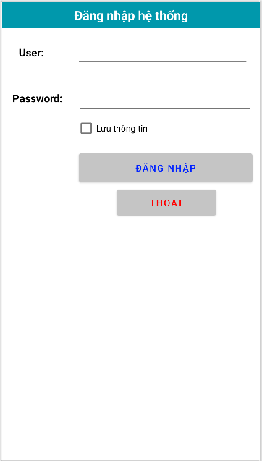

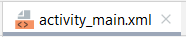
<?xml version="1.0" encoding="utf-8"?>
<androidx.constraintlayout.widget.ConstraintLayout xmlns:android="http://schemas.android.com/apk/res/android"
xmlns:app="http://schemas.android.com/apk/res-auto"
xmlns:tools="http://schemas.android.com/tools"
android:layout_width="match_parent"
android:layout_height="match_parent"
tools:context=".MainActivity">
<TextView
android:id="@+id/textView2"
android:layout_width="match_parent"
android:layout_height="42dp"
android:background="#0098AC"
android:gravity="center"
android:text="Đăng nhập hệ thống"
android:textAlignment="center"
android:textColor="#FFFFFF"
android:textSize="20sp"
android:textStyle="bold"
app:layout_constraintEnd_toEndOf="parent"
app:layout_constraintHorizontal_bias="1.0"
app:layout_constraintStart_toStartOf="parent"
app:layout_constraintTop_toTopOf="parent" />
<TextView
android:id="@+id/textView4"
android:layout_width="62dp"
android:layout_height="47dp"
android:gravity="center"
android:text="User:"
android:textStyle="bold"
android:textColor="#000000"
android:textSize="17dp"
app:layout_constraintBottom_toBottomOf="parent"
app:layout_constraintEnd_toEndOf="parent"
app:layout_constraintHorizontal_bias="0.045"
app:layout_constraintStart_toStartOf="parent"
app:layout_constraintTop_toTopOf="parent"
app:layout_constraintVertical_bias="0.083" />
<TextView
android:id="@+id/textView6"
android:layout_width="81dp"
android:layout_height="49dp"
android:gravity="center"
android:text="Password:"
android:textStyle="bold"
android:textColor="#000000"
android:textSize="17dp"
app:layout_constraintBottom_toBottomOf="parent"
app:layout_constraintEnd_toEndOf="parent"
app:layout_constraintHorizontal_bias="0.048"
app:layout_constraintStart_toStartOf="parent"
app:layout_constraintTop_toTopOf="parent"
app:layout_constraintVertical_bias="0.189" />
<EditText
android:id="@+id/txt_user"
android:layout_width="275dp"
android:layout_height="46dp"
android:ems="10"
android:inputType="textPersonName"
android:textColor="#A931FF"
android:textSize="17dp"
app:layout_constraintBottom_toBottomOf="parent"
app:layout_constraintEnd_toEndOf="@+id/textView2"
app:layout_constraintHorizontal_bias="0.869"
app:layout_constraintStart_toStartOf="parent"
app:layout_constraintTop_toTopOf="parent"
app:layout_constraintVertical_bias="0.083" />
<EditText
android:id="@+id/txt_pass"
android:layout_width="279dp"
android:layout_height="49dp"
android:ems="10"
android:inputType="textPassword"
android:textColor="#A931FF"
android:textSize="17dp"
app:layout_constraintBottom_toBottomOf="parent"
app:layout_constraintEnd_toEndOf="parent"
app:layout_constraintHorizontal_bias="0.901"
app:layout_constraintStart_toStartOf="parent"
app:layout_constraintTop_toTopOf="parent"
app:layout_constraintVertical_bias="0.189" />
<CheckBox
android:id="@+id/cbox_luutt"
android:layout_width="wrap_content"
android:layout_height="wrap_content"
android:text="Lưu thông tin"
app:layout_constraintBottom_toBottomOf="parent"
app:layout_constraintEnd_toEndOf="parent"
app:layout_constraintHorizontal_bias="0.397"
app:layout_constraintStart_toStartOf="parent"
app:layout_constraintTop_toTopOf="parent"
app:layout_constraintVertical_bias="0.26" />
<Button
android:id="@+id/btn_dangnhap"
android:layout_width="277dp"
android:layout_height="58dp"
android:backgroundTint="#C5C5C5"
android:text="Đăng Nhập"
android:textColor="#0022FF"
android:textSize="15dp"
app:layout_constraintBottom_toBottomOf="parent"
app:layout_constraintEnd_toEndOf="parent"
app:layout_constraintHorizontal_bias="0.91"
app:layout_constraintStart_toStartOf="parent"
app:layout_constraintTop_toTopOf="parent"
app:layout_constraintVertical_bias="0.35" />
<Button
android:id="@+id/btn_thoat"
android:layout_width="159dp"
android:layout_height="53dp"
android:backgroundTint="#C5C5C5"
android:text="Thoat"
android:textColor="#FF0000"
android:textSize="15dp"
app:layout_constraintBottom_toBottomOf="parent"
app:layout_constraintEnd_toEndOf="parent"
app:layout_constraintHorizontal_bias="0.722"
app:layout_constraintStart_toStartOf="parent"
app:layout_constraintTop_toTopOf="parent"
app:layout_constraintVertical_bias="0.433" />
</androidx.constraintlayout.widget.ConstraintLayout>

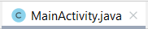
package com.example.baitap12;
import androidx.appcompat.app.AlertDialog;
import androidx.appcompat.app.AppCompatActivity;
import android.content.DialogInterface;
import android.os.Bundle;
import android.view.View;
import android.widget.Button;
import android.widget.CheckBox;
import android.widget.TextView;
import android.widget.Toast;
public class MainActivity extends AppCompatActivity {
TextView txt_user,txt_pass;
CheckBox cbox_luutt;
Button btn_dangnhap,btn_thoat;
@Override
protected void onCreate(Bundle savedInstanceState) {
super.onCreate(savedInstanceState);
setContentView(R.layout.activity_main);
txt_user= (TextView) findViewById(R.id.txt_user);
txt_pass= (TextView) findViewById(R.id.txt_pass);
cbox_luutt= (CheckBox) findViewById(R.id.cbox_luutt);
btn_dangnhap= (Button) findViewById(R.id.btn_dangnhap);
btn_thoat= (Button) findViewById(R.id.btn_thoat);
btn_dangnhap.setOnClickListener(new View.OnClickListener() {
@Override
public void onClick(View view) {
final CheckBox checkBox= findViewById(R.id.cbox_luutt);
if(checkBox.isChecked()){
Toast.makeText(MainActivity.this,"Đăng nhập thành công. THÔNG TIN ĐĂNG NHẬP ĐÃ ĐƯỢC LƯU",Toast.LENGTH_SHORT).show();
}
else {
Toast.makeText(MainActivity.this,"Đăng nhập thành công. THÔNG TIN ĐĂNG NHẬP KHÔNG ĐƯỢC LƯU",Toast.LENGTH_SHORT).show();
}
}
});
btn_thoat.setOnClickListener(new View.OnClickListener() {
@Override
public void onClick(View view) {
AlertDialog.Builder thoat= new AlertDialog.Builder(MainActivity.this);
thoat.setTitle("Thoát chương trình");
thoat.setMessage("Bạn muốn thoát chương trình");
thoat.setPositiveButton("Thoát", new DialogInterface.OnClickListener() {
@Override
public void onClick(DialogInterface dialogInterface, int i) {
finish();
}
});
thoat.setNegativeButton("Không", new DialogInterface.OnClickListener() {
@Override
public void onClick(DialogInterface dialogInterface, int i) {
dialogInterface.cancel();
}
});
thoat.show();
}
});
}
}

BT13: Thiết kế form Thông tin cá nhân.

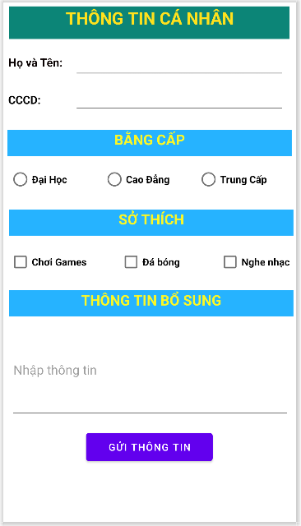

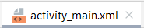
<?xml version="1.0" encoding="utf-8"?>
<androidx.constraintlayout.widget.ConstraintLayout xmlns:android="http://schemas.android.com/apk/res/android"
xmlns:app="http://schemas.android.com/apk/res-auto"
xmlns:tools="http://schemas.android.com/tools"
android:layout_width="match_parent"
android:layout_height="match_parent"
tools:context=".MainActivity">
<TextView
android:id="@+id/textview"
android:layout_width="394dp"
android:layout_height="46dp"
android:background="#0C8577"
android:text="THÔNG TIN CÁ NHÂN"
android:textAlignment="center"
android:textColor="#FFE11D"
android:textSize="24sp"
android:textStyle="bold"
app:layout_constraintBottom_toBottomOf="parent"
app:layout_constraintEnd_toEndOf="parent"
app:layout_constraintHorizontal_bias="0.47"
app:layout_constraintStart_toStartOf="parent"
app:layout_constraintTop_toTopOf="parent"
app:layout_constraintVertical_bias="0.008" />
<TextView
android:id="@+id/textview2"
android:layout_width="399dp"
android:layout_height="37dp"
android:background="#26B3FF"
android:text="BẰNG CẤP"
android:textAlignment="center"
android:textColor="#FAF727"
android:textSize="20sp"
android:textStyle="bold"
app:layout_constraintBottom_toBottomOf="parent"
app:layout_constraintEnd_toEndOf="parent"
app:layout_constraintHorizontal_bias="0.47"
app:layout_constraintStart_toStartOf="parent"
app:layout_constraintTop_toTopOf="parent"
app:layout_constraintVertical_bias="0.258" />
<TextView
android:id="@+id/textview3"
android:layout_width="399dp"
android:layout_height="37dp"
android:background="#26B3FF"
android:text="SỞ THÍCH"
android:textAlignment="center"
android:textColor="#FAF727"
android:textSize="20sp"
android:textStyle="bold"
app:layout_constraintBottom_toBottomOf="parent"
app:layout_constraintEnd_toEndOf="parent"
app:layout_constraintHorizontal_bias="0.666"
app:layout_constraintStart_toStartOf="parent"
app:layout_constraintTop_toTopOf="parent"
app:layout_constraintVertical_bias="0.419" />
<TextView
android:id="@+id/textview4"
android:layout_width="399dp"
android:layout_height="37dp"
android:background="#26B3FF"
android:text="THÔNG TIN BỔ SUNG"
android:textAlignment="center"
android:textColor="#FAF727"
android:textSize="20sp"
android:textStyle="bold"
app:layout_constraintBottom_toBottomOf="parent"
app:layout_constraintEnd_toEndOf="parent"
app:layout_constraintHorizontal_bias="0.666"
app:layout_constraintStart_toStartOf="parent"
app:layout_constraintTop_toTopOf="parent"
app:layout_constraintVertical_bias="0.583" />
<TextView
android:id="@+id/textView2"
android:layout_width="wrap_content"
android:layout_height="wrap_content"
android:text="Họ và Tên:"
android:textColor="#090101"
android:textSize="16sp"
android:textStyle="bold"
app:layout_constraintBottom_toBottomOf="parent"
app:layout_constraintEnd_toEndOf="parent"
app:layout_constraintHorizontal_bias="0.022"
app:layout_constraintStart_toStartOf="parent"
app:layout_constraintTop_toTopOf="parent"
app:layout_constraintVertical_bias="0.103" />
<TextView
android:id="@+id/textView3"
android:layout_width="wrap_content"
android:layout_height="wrap_content"
android:text="CCCD:"
android:textColor="#000000"
android:textSize="16sp"
android:textStyle="bold"
app:layout_constraintBottom_toBottomOf="parent"
app:layout_constraintEnd_toEndOf="parent"
app:layout_constraintHorizontal_bias="0.019"
app:layout_constraintStart_toStartOf="parent"
app:layout_constraintTop_toTopOf="parent"
app:layout_constraintVertical_bias="0.177" />
<EditText
android:id="@+id/txt_hoten"
android:layout_width="296dp"
android:layout_height="49dp"
android:ems="10"
android:inputType="textPersonName"
android:textSize="16sp"
app:layout_constraintBottom_toBottomOf="parent"
app:layout_constraintEnd_toEndOf="parent"
app:layout_constraintHorizontal_bias="0.86"
app:layout_constraintStart_toStartOf="parent"
app:layout_constraintTop_toTopOf="parent"
app:layout_constraintVertical_bias="0.086" />
<EditText
android:id="@+id/txt_cccd"
android:layout_width="296dp"
android:layout_height="49dp"
android:ems="10"
android:inputType="textPersonName"
android:textSize="16sp"
app:layout_constraintBottom_toBottomOf="parent"
app:layout_constraintEnd_toEndOf="parent"
app:layout_constraintHorizontal_bias="0.86"
app:layout_constraintStart_toStartOf="parent"
app:layout_constraintTop_toTopOf="parent"
app:layout_constraintVertical_bias="0.158" />
<RadioGroup
android:id="@+id/rdgroup"
android:layout_width="396dp"
android:layout_height="56dp"
android:orientation="horizontal"
android:weightSum="3"
app:layout_constraintBottom_toBottomOf="parent"
app:layout_constraintEnd_toEndOf="parent"
app:layout_constraintHorizontal_bias="0.533"
app:layout_constraintStart_toStartOf="parent"
app:layout_constraintTop_toTopOf="parent"
app:layout_constraintVertical_bias="0.333">
<RadioButton
android:id="@+id/rbt_daihoc"
android:layout_width="match_parent"
android:layout_height="wrap_content"
android:layout_weight="1"
android:text="Đại Học"
android:textSize="14sp"
android:textStyle="bold" />
<RadioButton
android:id="@+id/rbt_caodang"
android:layout_width="match_parent"
android:layout_height="wrap_content"
android:layout_weight="1"
android:text="Cao Đẳng"
android:textSize="14sp"
android:textStyle="bold" />
<RadioButton
android:id="@+id/rbt_trungcap"
android:layout_width="match_parent"
android:layout_height="wrap_content"
android:layout_weight="1"
android:text="Trung Cấp"
android:textSize="14sp"
android:textStyle="bold" />
</RadioGroup>
<CheckBox
android:id="@+id/cbox_choigame"
android:layout_width="wrap_content"
android:layout_height="wrap_content"
android:text="Chơi Games"
android:textStyle="bold"
app:layout_constraintBottom_toBottomOf="parent"
app:layout_constraintEnd_toEndOf="parent"
app:layout_constraintHorizontal_bias="0.026"
app:layout_constraintStart_toStartOf="parent"
app:layout_constraintTop_toTopOf="parent"
app:layout_constraintVertical_bias="0.499" />
<CheckBox
android:id="@+id/cbox_dabong"
android:layout_width="wrap_content"
android:layout_height="wrap_content"
android:text="Đá bóng"
android:textStyle="bold"
app:layout_constraintBottom_toBottomOf="parent"
app:layout_constraintEnd_toEndOf="parent"
app:layout_constraintStart_toStartOf="parent"
app:layout_constraintTop_toTopOf="parent"
app:layout_constraintVertical_bias="0.499" />
<CheckBox
android:id="@+id/cbox_nghenhac"
android:layout_width="wrap_content"
android:layout_height="wrap_content"
android:text="Nghe nhạc"
android:textStyle="bold"
app:layout_constraintBottom_toBottomOf="parent"
app:layout_constraintEnd_toEndOf="parent"
app:layout_constraintHorizontal_bias="0.971"
app:layout_constraintStart_toStartOf="parent"
app:layout_constraintTop_toTopOf="parent"
app:layout_constraintVertical_bias="0.499" />
<MultiAutoCompleteTextView
android:id="@+id/txt_ttbosung"
android:layout_width="392dp"
android:layout_height="138dp"
android:layout_marginTop="448dp"
android:hint="Nhập thông tin"
app:layout_constraintEnd_toEndOf="parent"
app:layout_constraintHorizontal_bias="0.526"
app:layout_constraintStart_toStartOf="parent"
app:layout_constraintTop_toTopOf="parent" />
<Button
android:id="@+id/btn_guitt"
android:layout_width="178dp"
android:layout_height="51dp"
android:text="Gửi Thông Tin"
app:layout_constraintBottom_toBottomOf="parent"
app:layout_constraintEnd_toEndOf="parent"
app:layout_constraintHorizontal_bias="0.497"
app:layout_constraintStart_toStartOf="parent"
app:layout_constraintTop_toTopOf="parent"
app:layout_constraintVertical_bias="0.882" />
</androidx.constraintlayout.widget.ConstraintLayout>


package com.example.thongtincanhan;
import androidx.appcompat.app.AlertDialog;
import androidx.appcompat.app.AppCompatActivity;
import android.content.DialogInterface;
import android.os.Bundle;
import android.view.View;
import android.widget.Button;
import android.widget.CheckBox;
import android.widget.RadioButton;
import android.widget.RadioGroup;
import android.widget.TextView;
import android.widget.Toast;
public class MainActivity extends AppCompatActivity {
TextView txt_hoten, txt_cccd, txt_ttbosung;
RadioGroup rdgroup;
RadioButton rbt_daihoc, rbt_caodang, rbt_trungcap;
CheckBox cbox_choigame, cbox_dabong, cbox_nghenhac;
Button btn_guitt;
@Override
protected void onCreate(Bundle savedInstanceState) {
super.onCreate(savedInstanceState);
setContentView(R.layout.activity_main);
txt_hoten=(TextView) findViewById(R.id.txt_hoten);
txt_cccd=(TextView) findViewById(R.id.txt_cccd);
txt_ttbosung=(TextView) findViewById(R.id.txt_ttbosung);
rdgroup=(RadioGroup) findViewById(R.id.rdgroup);
rbt_daihoc=(RadioButton) findViewById(R.id.rbt_daihoc);
rbt_caodang=(RadioButton) findViewById(R.id.rbt_caodang);
rbt_trungcap=(RadioButton) findViewById(R.id.rbt_trungcap);
cbox_choigame=(CheckBox) findViewById(R.id.cbox_choigame);
cbox_dabong=(CheckBox) findViewById(R.id.cbox_dabong);
cbox_nghenhac=(CheckBox) findViewById(R.id.cbox_nghenhac);
btn_guitt=(Button) findViewById(R.id.btn_guitt);
btn_guitt.setOnClickListener(new View.OnClickListener() {
@Override
public void onClick(View view) {
String st="";
//Kiểm tra họ tên
String hoten=txt_hoten.getText().toString();
if(hoten.isEmpty()||hoten.length()<=3||hoten.equals("")||hoten==null){
Toast.makeText(MainActivity.this,"Vui lòng nhập lại họ tên !",Toast.LENGTH_SHORT).show();
}
st+="Họ và tên: "+hoten+"\n";
//Kiểm tra CCCD
String cccd=txt_cccd.getText().toString();
if(cccd.isEmpty()||cccd.length()<12||cccd.length()>13||cccd.equals("")||cccd==null){
Toast.makeText(MainActivity.this,"Vui lòng nhập lại số CCCD (12 số) !",Toast.LENGTH_SHORT).show();
}
st+="Số CCCD: "+cccd+"\n";
//Kiểm tra bằng cấp
String bangcap="";
int id=rdgroup.getCheckedRadioButtonId();
if(id==-1){
Toast.makeText(MainActivity.this,"Vui lòng chọn bằng cấp !",Toast.LENGTH_SHORT).show();
}
bangcap=rbt_daihoc.getText()+"";
st+="Bằng cấp: "+bangcap+"\n";
//Kiểm tra sở thích
int dem=0;
String sothich="";
if (cbox_choigame.isChecked())
{
sothich+=cbox_choigame.getText().toString();
dem++;
}
if(cbox_dabong.isChecked())
{
sothich+=", "+cbox_dabong.getText().toString();
dem++;
}
if(cbox_nghenhac.isChecked())
{
sothich+=", "+cbox_nghenhac.getText().toString();
dem++;
}
if(dem==0)
{
Toast.makeText(MainActivity.this,"Sở thích phải chọn ít nhất một !",Toast.LENGTH_SHORT).show();
}
else {
st+="Sở thích: "+sothich+"\n";
}
//Thông tin bổ sung
if(txt_ttbosung.getText().toString().trim().length()!=0){
st+="Thông tin bổ sung: "+txt_ttbosung.getText().toString().trim();
}
String noidung="";
noidung+=st;
AlertDialog.Builder hienthi=new AlertDialog.Builder(MainActivity.this);
hienthi.setTitle("THÔNG TIN CÁ NHÂN");
hienthi.setMessage(noidung);
hienthi.setPositiveButton("Đóng", new DialogInterface.OnClickListener() {
@Override
public void onClick(DialogInterface dialogInterface, int i) {
}
});
AlertDialog alertDialog=hienthi.create();
alertDialog.show();
}
});
}
}

BT14: Position
- Khi click chuột vào từng phần tử trên ListView, sẽ hiển thị vị trí và giá trị phần từ được click vào TextView có màu xanh dương bên trên.

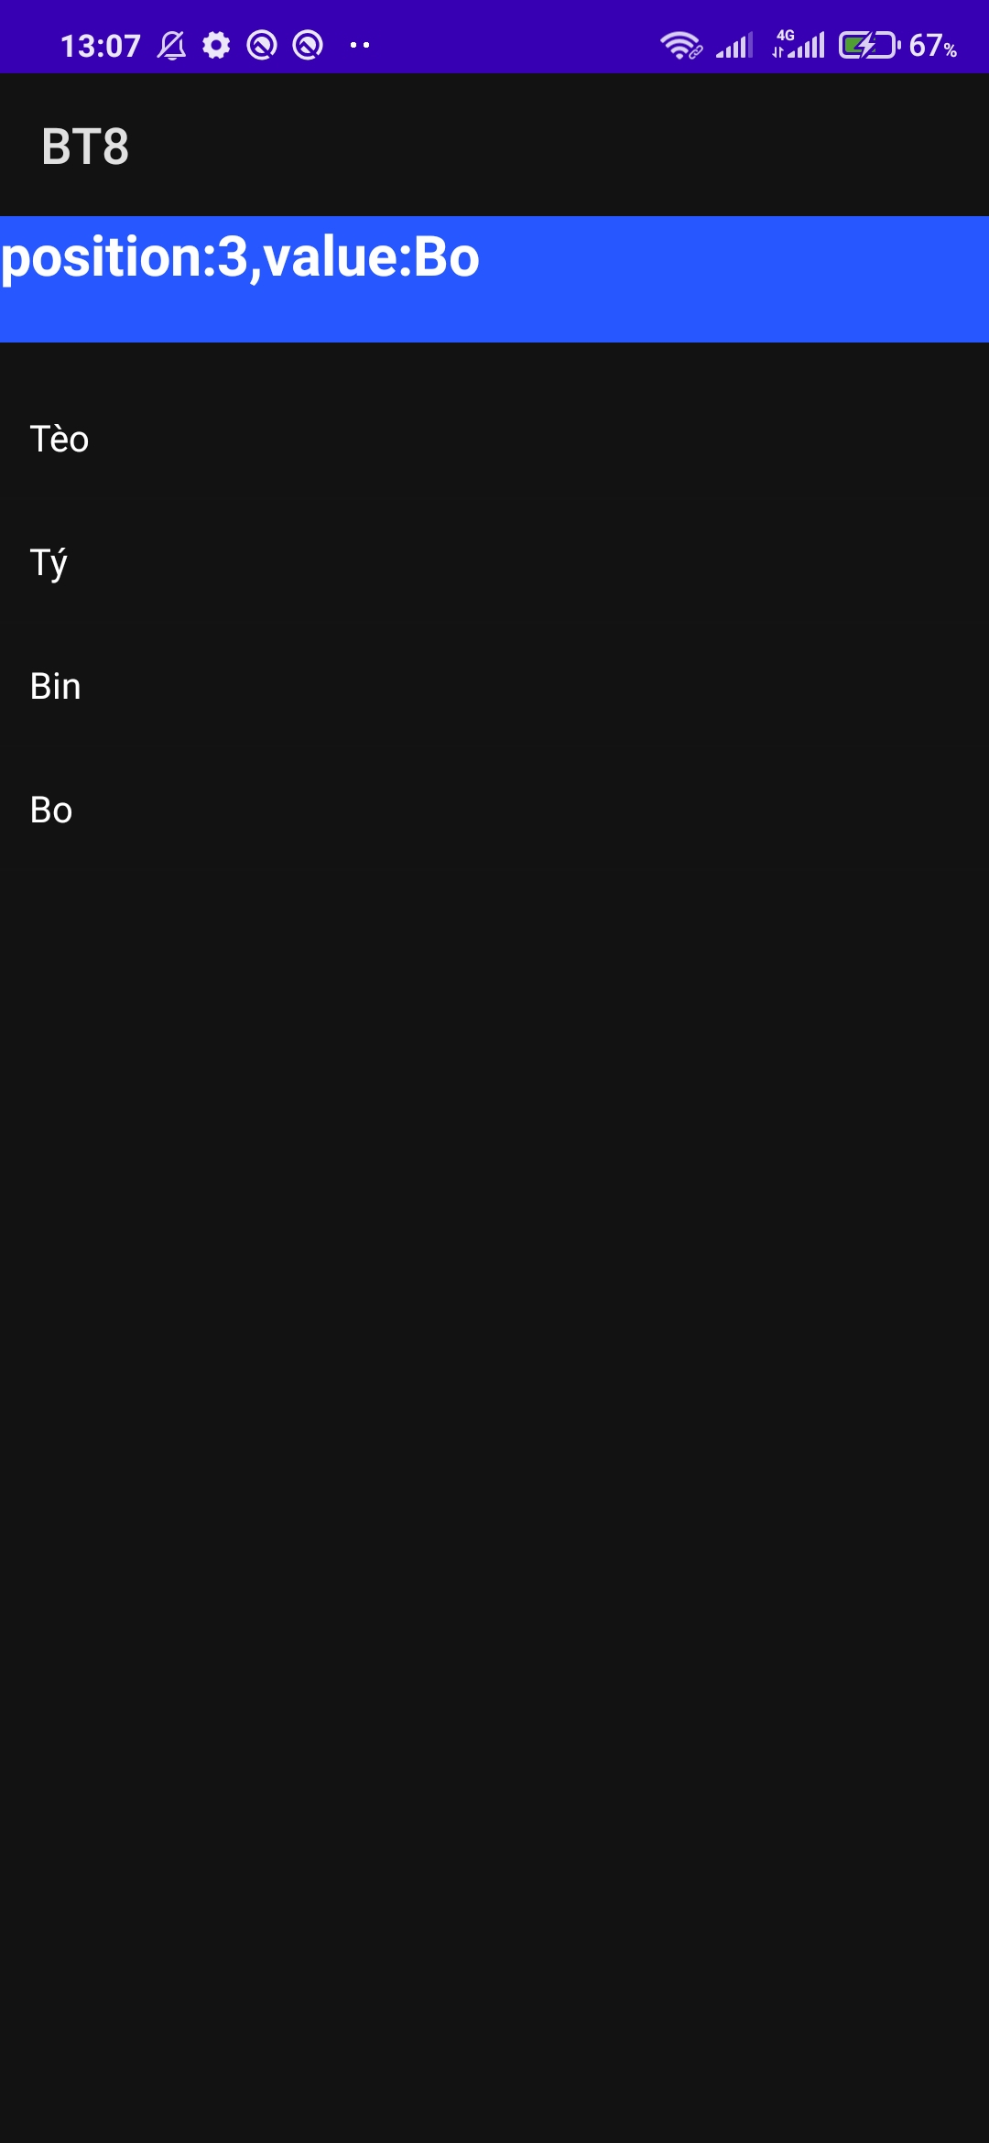

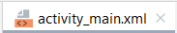
<?xml version="1.0" encoding="utf-8"?>
<androidx.constraintlayout.widget.ConstraintLayout xmlns:android="http://schemas.android.com/apk/res/android"
xmlns:app="http://schemas.android.com/apk/res-auto"
xmlns:tools="http://schemas.android.com/tools"
android:layout_width="match_parent"
android:layout_height="match_parent"
tools:context=".MainActivity">
<TextView
android:id="@+id/text_kq"
android:layout_width="408dp"
android:layout_height="50dp"
android:background="#2758FF"
android:textColor="#000000"
android:textSize="24sp"
android:textStyle="bold"
app:layout_constraintBottom_toBottomOf="parent"
app:layout_constraintEnd_toEndOf="parent"
app:layout_constraintHorizontal_bias="0.0"
app:layout_constraintStart_toStartOf="parent"
app:layout_constraintTop_toTopOf="parent"
app:layout_constraintVertical_bias="0.001" />
<ListView
android:id="@+id/lv"
android:layout_width="408dp"
android:layout_height="359dp"
app:layout_constraintBottom_toBottomOf="parent"
app:layout_constraintEnd_toEndOf="parent"
app:layout_constraintHorizontal_bias="0.333"
app:layout_constraintStart_toStartOf="parent"
app:layout_constraintTop_toTopOf="parent"
app:layout_constraintVertical_bias="0.158" />
</androidx.constraintlayout.widget.ConstraintLayout>

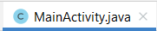
package com.example.bt8;
import androidx.appcompat.app.AppCompatActivity;
import android.os.Bundle;
import android.view.View;
import android.widget.AdapterView;
import android.widget.ArrayAdapter;
import android.widget.ListView;
import android.widget.TextView;
import java.util.ArrayList;
public class MainActivity extends AppCompatActivity {
@Override
protected void onCreate(Bundle savedInstanceState) {
super.onCreate(savedInstanceState);
setContentView(R.layout.activity_main);
ListView lv = findViewById(R.id.lv);
TextView text_kq = findViewById(R.id.text_kq);
ArrayList<String> ten = new ArrayList<>();
ten.add("Tèo");
ten.add("Tý");
ten.add("Bin");
ten.add("Bo");
ArrayAdapter ds = new ArrayAdapter(MainActivity.this, android.R.layout.simple_list_item_1,ten);
lv.setAdapter(ds);
lv.setOnItemClickListener(new AdapterView.OnItemClickListener() {
@Override
public void onItemClick(AdapterView<?> adapterView, View view, int i, long l) {
text_kq.setText("position:"+i+",value:"+ten.get(i));
}
});
}
}

BT15: ListView.
- Mỗi lần người sử dụng chọn nút Nhập, chương trình sẽ lưu dữ liệu trong mục Nhập tên vào ArrayList đồng thời cập nhập danh sách vào ListView

- Khi chọn từng phần tử trong ListView, chương trình sẽ hiển thị vị trí và giá trị của phần tử đang chọn vào TextView màu xanh

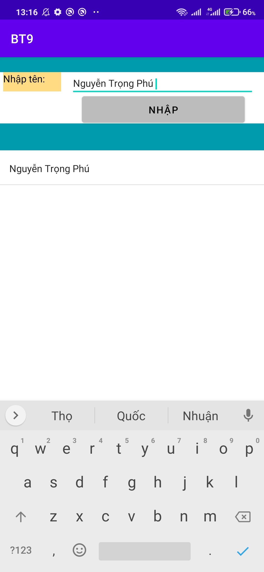

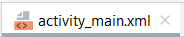

<?xml version="1.0" encoding="utf-8"?>
<androidx.constraintlayout.widget.ConstraintLayout xmlns:android="http://schemas.android.com/apk/res/android"
xmlns:app="http://schemas.android.com/apk/res-auto"
xmlns:tools="http://schemas.android.com/tools"
android:id="@+id/btn_nhap"
android:layout_width="match_parent"
android:layout_height="match_parent"
tools:context=".MainActivity">
<TextView
android:id="@+id/textView"
android:layout_width="86dp"
android:layout_height="29dp"
android:background="#FFDC84"
android:text="Nhập tên:"
android:textColor="#020101"
android:textSize="16sp"
app:layout_constraintBottom_toBottomOf="parent"
app:layout_constraintEnd_toEndOf="parent"
app:layout_constraintHorizontal_bias="0.015"
app:layout_constraintStart_toStartOf="parent"
app:layout_constraintTop_toTopOf="parent"
app:layout_constraintVertical_bias="0.045" />
<EditText
android:id="@+id/txt_nhapten"
android:layout_width="274dp"
android:layout_height="37dp"
android:ems="10"
android:inputType="textPersonName"
android:textSize="16sp"
app:layout_constraintBottom_toBottomOf="parent"
app:layout_constraintEnd_toEndOf="parent"
app:layout_constraintHorizontal_bias="0.883"
app:layout_constraintStart_toStartOf="parent"
app:layout_constraintTop_toTopOf="parent"
app:layout_constraintVertical_bias="0.046" />
<TextView
android:id="@+id/txt_ketqua"
android:layout_width="399dp"
android:layout_height="40dp"
android:background="#009BAC"
android:textSize="16sp"
app:layout_constraintBottom_toBottomOf="parent"
app:layout_constraintEnd_toEndOf="parent"
app:layout_constraintStart_toStartOf="parent"
app:layout_constraintTop_toTopOf="parent"
app:layout_constraintVertical_bias="0.209" />
<ListView
android:id="@+id/lv"
android:layout_width="399dp"
android:layout_height="300dp"
app:layout_constraintBottom_toBottomOf="parent"
app:layout_constraintEnd_toEndOf="parent"
app:layout_constraintHorizontal_bias="0.416"
app:layout_constraintStart_toStartOf="parent"
app:layout_constraintTop_toBottomOf="@+id/txt_ketqua"
app:layout_constraintVertical_bias="0.036" />
<Button
android:id="@+id/btn"
android:layout_width="242dp"
android:layout_height="51dp"
android:backgroundTint="#BCBCBC"
android:text="Nhập"
android:textColor="#000000"
android:textSize="16sp"
app:layout_constraintBottom_toBottomOf="parent"
app:layout_constraintEnd_toEndOf="parent"
app:layout_constraintHorizontal_bias="0.81"
app:layout_constraintStart_toStartOf="parent"
app:layout_constraintTop_toTopOf="parent"
app:layout_constraintVertical_bias="0.114" />
<TextView
android:id="@+id/textView2"
android:layout_width="415dp"
android:layout_height="22dp"
android:background="#009BAC"
app:layout_constraintBottom_toBottomOf="parent"
app:layout_constraintEnd_toEndOf="parent"
app:layout_constraintHorizontal_bias="0.498"
app:layout_constraintStart_toStartOf="parent"
app:layout_constraintTop_toTopOf="parent"
app:layout_constraintVertical_bias="0.0" />
</androidx.constraintlayout.widget.ConstraintLayout>

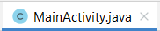
package com.example.bt9;
import androidx.appcompat.app.AppCompatActivity;
import androidx.lifecycle.ViewModelProvider;
import android.os.Bundle;
import android.view.View;
import android.widget.AdapterView;
import android.widget.ArrayAdapter;
import android.widget.Button;
import android.widget.ListView;
import android.widget.TextView;
import java.util.ArrayList;
public class MainActivity extends AppCompatActivity {
TextView txt_nhapten, txt_ketqua;
Button btn;
ListView lv;
ArrayList<String>arrayList=null;
ArrayAdapter<String>arrayAdapter=null;
@Override
protected void onCreate(Bundle savedInstanceState) {
super.onCreate(savedInstanceState);
setContentView(R.layout.activity_main);
txt_nhapten=(TextView) findViewById(R.id.txt_nhapten);
txt_ketqua=(TextView) findViewById(R.id.txt_ketqua);
lv=(ListView) findViewById(R.id.lv);
arrayList=new ArrayList<String>();
btn=(Button) findViewById(R.id.btn);
btn.setOnClickListener(new View.OnClickListener() {
@Override
public void onClick(View view) {
arrayList.add(txt_nhapten.getText()+"");
arrayAdapter=new ArrayAdapter<String>(MainActivity.this, android.R.layout.simple_list_item_1, arrayList);
lv.setAdapter(arrayAdapter);
lv.setOnItemClickListener(new AdapterView.OnItemClickListener() {
@Override
public void onItemClick(AdapterView<?> adapterView, View view, int i, long l) {
txt_ketqua.setText("position:"+i+"value:"+arrayList.get(i));
}
});
}
});
}
}

BT16: Thiết kế danh bạ.

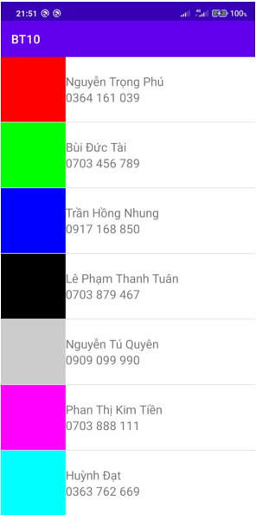

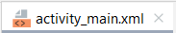
<?xml version="1.0" encoding="utf-8"?>
<LinearLayout
xmlns:android="http://schemas.android.com/apk/res/android"
android:layout_width="match_parent"
android:layout_height="match_parent"
xmlns:app="http://schemas.android.com/apk/res-auto"
android:orientation="horizontal">
<ListView
android:id="@+id/list_item"
android:layout_width="match_parent"
android:layout_height="match_parent">
</ListView>
</LinearLayout>

Tạo thêm 1 Layout XML
: R_Mouse vào
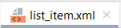
<?xml version="1.0" encoding="utf-8"?>
<LinearLayout xmlns:android="http://schemas.android.com/apk/res/android"
android:layout_width="match_parent"
android:layout_height="match_parent"
android:orientation="horizontal">
<TextView
android:id="@+id/txtIndex"
android:layout_width="100dp"
android:layout_height="100dp"
android:gravity="center">
</TextView>
<LinearLayout
android:layout_width="wrap_content"
android:layout_height="wrap_content"
android:orientation="vertical"
android:layout_gravity="center">
<TextView
android:id="@+id/txtHoten"
android:layout_width="wrap_content"
android:layout_height="wrap_content"
android:text="Họ tên"
android:textSize="20sp"/>
<TextView
android:id="@+id/txtSdt"
android:layout_width="wrap_content"
android:layout_height="wrap_content"
android:text="0000000000"
android:textSize="20sp"/>
</LinearLayout>
</LinearLayout>

Thêm 1 Class
: R_Mouse vào <đặt tên> Class OK

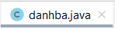
package com.example.bt10;
public class danhba {
String Hoten,Sdt;
Integer mau;
// Quét khối String và Integer, ấn phím Alt+Ins --> Constructor --> chọn hết 3 cái f --> OK
// Quét khối String và Integer, ấn phím Alt+Ins --> Getter --> chọn hết 3 cái f --> OK
// Quét khối String và Integer, ấn phím Alt+Ins --> Setter --> chọn hết 3 cái f --> OK
public void setHoten(String hoten) {
Hoten = hoten;
}
public void setSdt(String sdt) {
Sdt = sdt;
}
public void setMau(Integer mau) {
this.mau = mau;
}
public String getHoten() {
return Hoten;
}
public String getSdt() {
return Sdt;
}
public Integer getMau() {
return mau;
}
public danhba(String hoten, String sdt, Integer mau) {
Hoten = hoten;
Sdt = sdt;
this.mau = mau;
}
}

Thêm 1 Class
: R_Mouse vào <đặt tên> Class OK
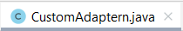
package com.example.bt10;
import android.content.Context;
import android.text.Layout;
import android.view.LayoutInflater;
import android.view.View;
import android.view.ViewGroup;
import android.widget.ArrayAdapter;
import android.widget.TextView;
import androidx.annotation.NonNull;
import java.util.ArrayList;
public class CustomAdaptern extends ArrayAdapter<danhba>{
private Context context;
private int layout;
private ArrayList<danhba> arrdanhba;
//Quét khối 3 cái trên, ấn phím Alt+Ins --> Constructor --> ArrayAdapter(Context:Context,resource:int) --> chọn hết cả 3 --> OK
public CustomAdaptern(@NonNull Context context, int resource, Context context1, int layout, ArrayList<danhba> arrdanhba) {
// Copy thay dòng trên: @NonNull Context context, int layout, @NonNull ArrayList<danhba> arrdanhba
super(context, resource); // Thay bằng dòng này: super(context, layout, arrdanhba);
this.context = context1; // Thay bằng dòng này: this.context = context;
this.layout = layout;
this.arrdanhba = arrdanhba;
}
public class ViewHolder {
TextView txthoten;
TextView txtsdt;
TextView txtmau;
}
@NonNull
@Override
public View getView(int position, @NonNull View convertView, @NonNull ViewGroup parent){
CustomAdaptern.ViewHolder viewHolder;
if (convertView==null) {
convertView = LayoutInflater.from(context).inflate(layout, parent, false);
viewHolder = new ViewHolder();
viewHolder.txtmau= (TextView)
convertView.findViewById(R.id.txtIndex);
viewHolder.txthoten= (TextView)
convertView.findViewById(R.id.txtHoten);
viewHolder.txtsdt= (TextView)
convertView.findViewById(R.id.txtSdt);
convertView.setTag(viewHolder);
}else {
viewHolder= (CustomAdaptern.ViewHolder) convertView.getTag();
}
danhba danhba= arrdanhba.get(position);
viewHolder.txtmau.setBackgroundColor(danhba.getMau());
viewHolder.txthoten.setText(danhba.getHoten());
viewHolder.txtsdt.setText(danhba.getSdt());
return convertView;
}
}

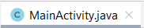
package com.example.bt10;
import androidx.appcompat.app.AppCompatActivity;
import android.graphics.Color;
import android.os.Bundle;
import android.provider.ContactsContract;
import android.widget.ListView;
import java.util.ArrayList;
public class MainActivity extends AppCompatActivity {
@Override
protected void onCreate(Bundle savedInstanceState) {
super.onCreate(savedInstanceState);
setContentView(R.layout.activity_main);
ListView lvContact= (ListView) findViewById(R.id.list_item);
ArrayList<danhba> arrContact =new ArrayList<>();
danhba contact1= new danhba("Nguyễn Trọng Phú","0364 161 039", Color.RED);
danhba contact2= new danhba("Bùi Đức Tài","0703 456 789", Color.GREEN);
danhba contact3= new danhba("Trần Hồng Nhung","0917 168 850", Color.BLUE);
danhba contact4= new danhba("Lê Phạm Thanh Tuân","0703 879 467", Color.BLACK);
danhba contact5= new danhba("Nguyễn Tú Quyên","0909 099 990", Color.LTGRAY);
danhba contact6= new danhba("Phan Thị Kim Tiền","0703 888 111", Color.MAGENTA);
danhba contact7= new danhba("Huỳnh Đạt","0363 762 669", Color.CYAN);
arrContact.add(contact1);
arrContact.add(contact2);
arrContact.add(contact3);
arrContact.add(contact4);
arrContact.add(contact5);
arrContact.add(contact6);
arrContact.add(contact7);
CustomAdaptern customAdaptern= new CustomAdaptern(this,R.layout.list_item,arrContact);
lvContact.setAdapter(customAdaptern);
}
}

BT17: Sắp sếp mảng, tăng dần và giảm dần.

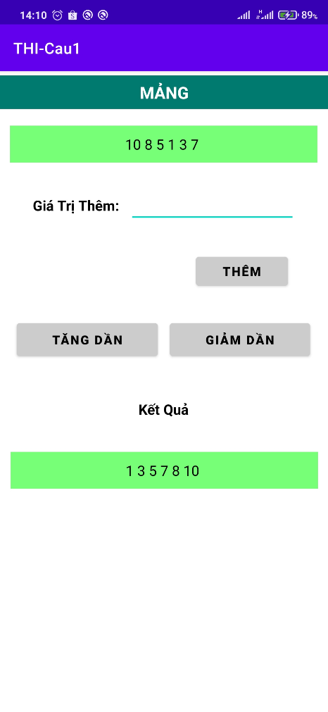
Tăng Dần Giảm Dần
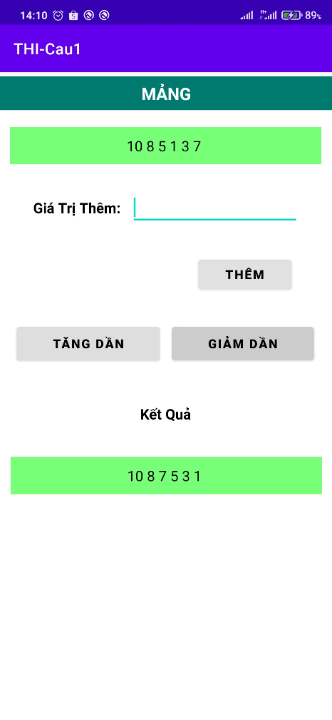

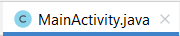
package com.example.thi_cau1;
import androidx.appcompat.app.AppCompatActivity;
import android.os.Bundle;
import android.view.View;
import android.widget.Button;
import android.widget.EditText;
import android.widget.TextView;
import java.util.ArrayList;
import java.util.Collection;
import java.util.Collections;
import java.util.Locale;
public class MainActivity extends AppCompatActivity {
@Override
protected void onCreate(Bundle savedInstanceState) {
super.onCreate(savedInstanceState);
setContentView(R.layout.activity_main);
TextView txt_htgtt= (TextView) findViewById(R.id.txt_htgtt);
TextView txt_ketqua= (TextView) findViewById(R.id.txt_ketqua);
EditText plt_themgt= (EditText) findViewById(R.id.plt_themgt);
Button btn_them= (Button) findViewById(R.id.btn_them);
Button btn_tang= (Button) findViewById(R.id.btn_tang);
Button btn_giam= (Button) findViewById(R.id.btn_giam);
ArrayList<Integer> arrayList= new ArrayList<>(10);
btn_them.setOnClickListener(new View.OnClickListener() {
@Override
public void onClick(View view) {
int giatri=0;
giatri= Integer.parseInt(plt_themgt.getText().toString());
arrayList.add(giatri);
int size= arrayList.size();
String st="";
for (int i= 0; i<size; i++){
st+=arrayList.get(i).toString()+" ";
}
txt_htgtt.setText(st.toString());
}
});
btn_tang.setOnClickListener(new View.OnClickListener() {
@Override
public void onClick(View view) {
Collections.sort(arrayList);
int size= arrayList.size();
String st="";
for (int i= 0; i<size; i++){
st+=arrayList.get(i).toString()+" ";
}
txt_ketqua.setText(st.toString());
}
});
btn_giam.setOnClickListener(new View.OnClickListener() {
@Override
public void onClick(View view) {
Collections.sort(arrayList,Collections.reverseOrder());
int size= arrayList.size();
String st="";
for (int i= 0; i<size; i++){
st+=arrayList.get(i).toString()+" ";
}
txt_ketqua.setText(st.toString());
}
});
}
}

KHIỂM TRA GIỮA KÌ LẦN 1:

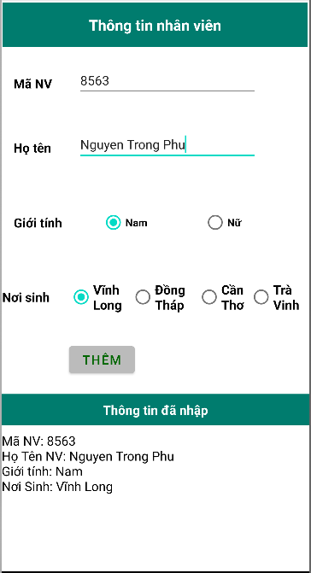
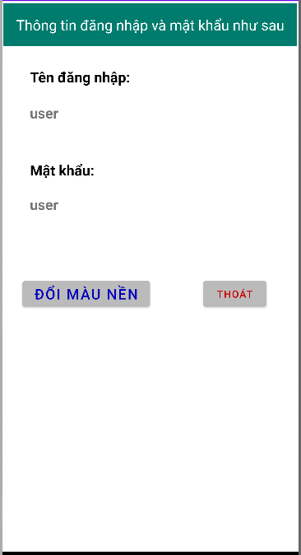
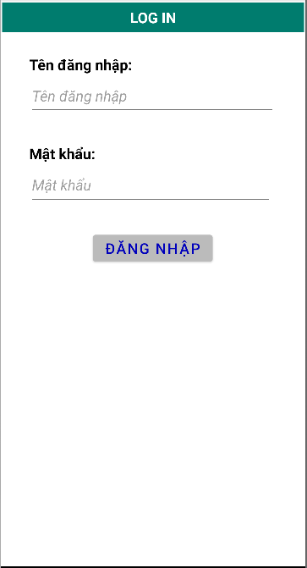
Màn hình 1: Màn hình 2: Màn hình 3:

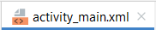
Màn hình 1:
<?xml version="1.0" encoding="utf-8"?>
<androidx.constraintlayout.widget.ConstraintLayout xmlns:android="http://schemas.android.com/apk/res/android"
xmlns:app="http://schemas.android.com/apk/res-auto"
xmlns:tools="http://schemas.android.com/tools"
android:layout_width="match_parent"
android:layout_height="match_parent"
tools:context=".MainActivity">
<TextView
android:id="@+id/textView"
android:layout_width="335dp"
android:layout_height="54dp"
android:text="Tên đăng nhập:"
android:textColor="@color/black"
android:textSize="20dp"
android:gravity="bottom"
android:textStyle="bold"
app:layout_constraintBottom_toBottomOf="parent"
app:layout_constraintEnd_toEndOf="parent"
app:layout_constraintStart_toStartOf="parent"
app:layout_constraintTop_toTopOf="parent"
app:layout_constraintVertical_bias="0.065" />
<TextView
android:id="@+id/textView4"
android:layout_width="335dp"
android:layout_height="54dp"
android:gravity="bottom"
android:text="Mật khẩu:"
android:textColor="@color/black"
android:textSize="20dp"
android:textStyle="bold"
app:layout_constraintBottom_toBottomOf="parent"
app:layout_constraintEnd_toEndOf="parent"
app:layout_constraintStart_toStartOf="parent"
app:layout_constraintTop_toTopOf="parent"
app:layout_constraintVertical_bias="0.234" />
<EditText
android:id="@+id/plain_tenlogin"
android:layout_width="333dp"
android:layout_height="54dp"
android:ems="10"
android:hint="Tên đăng nhập"
android:inputType="textPersonName"
android:textStyle="italic"
android:textSize="20dp"
app:layout_constraintBottom_toBottomOf="parent"
app:layout_constraintEnd_toEndOf="parent"
app:layout_constraintHorizontal_bias="0.487"
app:layout_constraintStart_toStartOf="parent"
app:layout_constraintTop_toTopOf="parent"
app:layout_constraintVertical_bias="0.144" />
<EditText
android:id="@+id/plain_pass"
android:layout_width="328dp"
android:layout_height="55dp"
android:ems="10"
android:hint="Mật khẩu"
android:inputType="textPassword"
android:textSize="20dp"
android:textStyle="italic"
app:layout_constraintBottom_toBottomOf="parent"
app:layout_constraintEnd_toEndOf="parent"
app:layout_constraintHorizontal_bias="0.457"
app:layout_constraintStart_toStartOf="parent"
app:layout_constraintTop_toTopOf="parent"
app:layout_constraintVertical_bias="0.313" />
<Button
android:id="@+id/btn_dangnhap"
android:layout_width="wrap_content"
android:layout_height="wrap_content"
android:text="Đăng nhập"
android:backgroundTint="#BBBBBB"
android:textColor="#0000BB"
android:textSize="20dp"
app:layout_constraintBottom_toBottomOf="parent"
app:layout_constraintEnd_toEndOf="parent"
app:layout_constraintHorizontal_bias="0.498"
app:layout_constraintStart_toStartOf="parent"
app:layout_constraintTop_toTopOf="parent"
app:layout_constraintVertical_bias="0.434" />
<TextView
android:id="@+id/textView5"
android:layout_width="408dp"
android:layout_height="39dp"
android:background="#007C6E"
android:gravity="center"
android:text="LOG IN"
android:textColor="@color/white"
android:textSize="20dp"
android:textStyle="bold"
app:layout_constraintBottom_toBottomOf="parent"
app:layout_constraintEnd_toEndOf="parent"
app:layout_constraintStart_toStartOf="parent"
app:layout_constraintTop_toTopOf="parent"
app:layout_constraintVertical_bias="0.005" />
</androidx.constraintlayout.widget.ConstraintLayout>

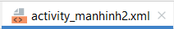
Màn hình 2:
<?xml version="1.0" encoding="utf-8"?>
<androidx.constraintlayout.widget.ConstraintLayout xmlns:android="http://schemas.android.com/apk/res/android"
xmlns:app="http://schemas.android.com/apk/res-auto"
xmlns:tools="http://schemas.android.com/tools"
android:layout_width="match_parent"
android:layout_height="match_parent"
tools:context=".manhinh2">
<LinearLayout
android:id="@+id/linear_doimau"
android:layout_width="match_parent"
android:layout_height="match_parent"
android:orientation="horizontal"
>
</LinearLayout>
<TextView
android:id="@+id/textView2"
android:layout_width="408dp"
android:layout_height="59dp"
android:background="#007C6E"
android:gravity="center"
android:text="Thông tin đăng nhập và mật khẩu như sau"
android:textColor="@color/white"
android:textSize="20dp"
app:layout_constraintBottom_toBottomOf="parent"
app:layout_constraintEnd_toEndOf="parent"
app:layout_constraintHorizontal_bias="0.333"
app:layout_constraintStart_toStartOf="parent"
app:layout_constraintTop_toTopOf="parent"
app:layout_constraintVertical_bias="0.005" />
<TextView
android:id="@+id/textView"
android:layout_width="335dp"
android:layout_height="54dp"
android:gravity="bottom"
android:text="Tên đăng nhập:"
android:textColor="@color/black"
android:textSize="20dp"
android:textStyle="bold"
app:layout_constraintBottom_toBottomOf="parent"
app:layout_constraintEnd_toEndOf="parent"
app:layout_constraintStart_toStartOf="parent"
app:layout_constraintTop_toTopOf="parent"
app:layout_constraintVertical_bias="0.091" />
<TextView
android:id="@+id/textView4"
android:layout_width="335dp"
android:layout_height="54dp"
android:gravity="bottom"
android:text="Mật khẩu:"
android:textColor="@color/black"
android:textSize="20dp"
android:textStyle="bold"
app:layout_constraintBottom_toBottomOf="parent"
app:layout_constraintEnd_toEndOf="parent"
app:layout_constraintStart_toStartOf="parent"
app:layout_constraintTop_toTopOf="parent"
app:layout_constraintVertical_bias="0.273" />
<TextView
android:id="@+id/txt_httenlogin"
android:layout_width="243dp"
android:layout_height="47dp"
android:gravity="bottom"
android:textSize="20dp"
android:textStyle="bold"
app:layout_constraintBottom_toBottomOf="parent"
app:layout_constraintEnd_toEndOf="parent"
app:layout_constraintHorizontal_bias="0.226"
app:layout_constraintStart_toStartOf="parent"
app:layout_constraintTop_toTopOf="parent"
app:layout_constraintVertical_bias="0.169" />
<TextView
android:id="@+id/txt_htpass"
android:layout_width="249dp"
android:layout_height="45dp"
android:gravity="bottom"
android:textSize="20dp"
android:textStyle="bold"
app:layout_constraintBottom_toBottomOf="parent"
app:layout_constraintEnd_toEndOf="parent"
app:layout_constraintHorizontal_bias="0.234"
app:layout_constraintStart_toStartOf="parent"
app:layout_constraintTop_toTopOf="parent"
app:layout_constraintVertical_bias="0.348" />
<Button
android:id="@+id/btn_doimau"
android:layout_width="wrap_content"
android:layout_height="wrap_content"
android:text="Đổi màu nền"
android:textSize="20dp"
android:backgroundTint="#BBBBBB"
android:textColor="#0000BB"
app:layout_constraintBottom_toBottomOf="parent"
app:layout_constraintEnd_toEndOf="parent"
app:layout_constraintHorizontal_bias="0.119"
app:layout_constraintStart_toStartOf="parent"
app:layout_constraintTop_toTopOf="parent"
app:layout_constraintVertical_bias="0.534" />
<Button
android:id="@+id/btn_thoat"
android:layout_width="wrap_content"
android:layout_height="wrap_content"
android:text="Thoát"
android:backgroundTint="#BBBBBB"
android:textColor="#CC0000"
app:layout_constraintBottom_toBottomOf="parent"
app:layout_constraintEnd_toEndOf="parent"
app:layout_constraintHorizontal_bias="0.862"
app:layout_constraintStart_toStartOf="parent"
app:layout_constraintTop_toTopOf="parent"
app:layout_constraintVertical_bias="0.534" />
</androidx.constraintlayout.widget.ConstraintLayout>

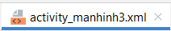
Màn hình 3:

<?xml version="1.0" encoding="utf-8"?>
<androidx.constraintlayout.widget.ConstraintLayout xmlns:android="http://schemas.android.com/apk/res/android"
xmlns:app="http://schemas.android.com/apk/res-auto"
xmlns:tools="http://schemas.android.com/tools"
android:layout_width="match_parent"
android:layout_height="match_parent"
tools:context=".manhinh3">
<TextView
android:id="@+id/textView2"
android:layout_width="408dp"
android:layout_height="59dp"
android:background="#007C6E"
android:gravity="center"
android:text="Thông tin nhân viên"
android:textStyle="bold"
android:textColor="@color/white"
android:textSize="20dp"
app:layout_constraintBottom_toBottomOf="parent"
app:layout_constraintEnd_toEndOf="parent"
app:layout_constraintHorizontal_bias="0.333"
app:layout_constraintStart_toStartOf="parent"
app:layout_constraintTop_toTopOf="parent"
app:layout_constraintVertical_bias="0.005" />
<TextView
android:id="@+id/textView7"
android:layout_width="70dp"
android:layout_height="37dp"
android:gravity="center_vertical"
android:text="Mã NV"
android:textStyle="bold"
android:textSize="17dp"
android:textColor="@color/black"
app:layout_constraintBottom_toBottomOf="parent"
app:layout_constraintEnd_toEndOf="parent"
app:layout_constraintHorizontal_bias="0.046"
app:layout_constraintStart_toStartOf="parent"
app:layout_constraintTop_toTopOf="parent"
app:layout_constraintVertical_bias="0.128" />
<TextView
android:id="@+id/textView9"
android:layout_width="70dp"
android:layout_height="37dp"
android:gravity="center_vertical"
android:text="Họ tên"
android:textColor="@color/black"
android:textSize="17dp"
android:textStyle="bold"
app:layout_constraintBottom_toBottomOf="parent"
app:layout_constraintEnd_toEndOf="parent"
app:layout_constraintHorizontal_bias="0.046"
app:layout_constraintStart_toStartOf="parent"
app:layout_constraintTop_toTopOf="parent"
app:layout_constraintVertical_bias="0.246" />
<TextView
android:id="@+id/textView10"
android:layout_width="74dp"
android:layout_height="48dp"
android:gravity="center_vertical"
android:text="Giới tính"
android:textColor="@color/black"
android:textSize="17dp"
android:textStyle="bold"
app:layout_constraintBottom_toBottomOf="parent"
app:layout_constraintEnd_toEndOf="parent"
app:layout_constraintHorizontal_bias="0.047"
app:layout_constraintStart_toStartOf="parent"
app:layout_constraintTop_toTopOf="parent"
app:layout_constraintVertical_bias="0.382" />
<TextView
android:id="@+id/textView11"
android:layout_width="74dp"
android:layout_height="48dp"
android:gravity="center_vertical"
android:text="Nơi sinh"
android:textColor="@color/black"
android:textSize="17dp"
android:textStyle="bold"
app:layout_constraintBottom_toBottomOf="parent"
app:layout_constraintEnd_toEndOf="parent"
app:layout_constraintHorizontal_bias="0.002"
app:layout_constraintStart_toStartOf="parent"
app:layout_constraintTop_toTopOf="parent"
app:layout_constraintVertical_bias="0.521" />
<TextView
android:id="@+id/textView12"
android:layout_width="match_parent"
android:layout_height="42dp"
android:gravity="center"
android:text="Thông tin đã nhập"
android:textColor="#FFFFFF"
android:textSize="17dp"
android:background="#007C6E"
android:textStyle="bold"
app:layout_constraintBottom_toBottomOf="parent"
app:layout_constraintEnd_toEndOf="parent"
app:layout_constraintHorizontal_bias="0.062"
app:layout_constraintStart_toStartOf="parent"
app:layout_constraintTop_toTopOf="parent"
app:layout_constraintVertical_bias="0.73" />
<EditText
android:id="@+id/plain_manv"
android:layout_width="241dp"
android:layout_height="45dp"
android:ems="10"
android:inputType="number"
android:textSize="17dp"
app:layout_constraintBottom_toBottomOf="parent"
app:layout_constraintEnd_toEndOf="parent"
app:layout_constraintHorizontal_bias="0.594"
app:layout_constraintStart_toStartOf="parent"
app:layout_constraintTop_toTopOf="parent"
app:layout_constraintVertical_bias="0.118" />
<EditText
android:id="@+id/plain_hotennv"
android:layout_width="241dp"
android:layout_height="45dp"
android:ems="10"
android:inputType="textPersonName"
android:textSize="17dp"
app:layout_constraintBottom_toBottomOf="parent"
app:layout_constraintEnd_toEndOf="parent"
app:layout_constraintHorizontal_bias="0.594"
app:layout_constraintStart_toStartOf="parent"
app:layout_constraintTop_toTopOf="parent"
app:layout_constraintVertical_bias="0.237" />
<RadioGroup
android:id="@+id/rdgroup_gt"
android:layout_width="262dp"
android:layout_height="63dp"
android:orientation="horizontal"
android:weightSum="2"
app:layout_constraintBottom_toBottomOf="parent"
app:layout_constraintEnd_toEndOf="parent"
app:layout_constraintHorizontal_bias="0.892"
app:layout_constraintStart_toStartOf="parent"
app:layout_constraintTop_toTopOf="parent"
app:layout_constraintVertical_bias="0.39">
<RadioButton
android:id="@+id/rdb_nam"
android:layout_width="wrap_content"
android:layout_height="wrap_content"
android:layout_weight="1"
android:text="Nam"
android:textStyle="bold" />
<RadioButton
android:id="@+id/rdb_nu"
android:layout_width="wrap_content"
android:layout_height="wrap_content"
android:layout_weight="1"
android:text="Nữ"
android:textStyle="bold" />
</RadioGroup>
<RadioGroup
android:id="@+id/rdgroup_ns"
android:layout_width="310dp"
android:layout_height="64dp"
android:orientation="horizontal"
android:weightSum="4"
app:layout_constraintBottom_toBottomOf="parent"
app:layout_constraintEnd_toEndOf="parent"
app:layout_constraintHorizontal_bias="0.891"
app:layout_constraintStart_toStartOf="parent"
app:layout_constraintTop_toTopOf="parent"
app:layout_constraintVertical_bias="0.533">
<RadioButton
android:id="@+id/rdb_vinhlong"
android:layout_width="wrap_content"
android:layout_height="wrap_content"
android:layout_weight="1"
android:text="Vĩnh Long"
android:textStyle="bold"
android:textSize="17dp" />
<RadioButton
android:id="@+id/rdb_dongthap"
android:layout_width="wrap_content"
android:layout_height="wrap_content"
android:layout_weight="1"
android:text="Đồng Tháp"
android:textStyle="bold"
android:textSize="17dp" />
<RadioButton
android:id="@+id/rdb_cantho"
android:layout_width="wrap_content"
android:layout_height="wrap_content"
android:layout_weight="1"
android:text="Cần Thơ"
android:textStyle="bold"
android:textSize="17dp" />
<RadioButton
android:id="@+id/rdb_travinh"
android:layout_width="wrap_content"
android:layout_height="wrap_content"
android:layout_weight="1"
android:text="Trà Vinh"
android:textStyle="bold"
android:textSize="17dp" />
</RadioGroup>
<Button
android:id="@+id/btn_them"
android:layout_width="wrap_content"
android:layout_height="wrap_content"
android:backgroundTint="#BBBBBB"
android:text="Thêm"
android:textColor="#006600"
android:textSize="17dp"
app:layout_constraintBottom_toBottomOf="parent"
app:layout_constraintEnd_toEndOf="parent"
app:layout_constraintHorizontal_bias="0.278"
app:layout_constraintStart_toStartOf="parent"
app:layout_constraintTop_toTopOf="parent"
app:layout_constraintVertical_bias="0.638" />
<TextView
android:id="@+id/txt_htthongtinnhap"
android:layout_width="match_parent"
android:layout_height="185dp"
android:textSize="17dp"
android:textColor="@color/black"
app:layout_constraintBottom_toBottomOf="parent"
app:layout_constraintEnd_toEndOf="parent"
app:layout_constraintHorizontal_bias="0.0"
app:layout_constraintStart_toStartOf="parent"
app:layout_constraintTop_toTopOf="parent"
app:layout_constraintVertical_bias="0.998" />
</androidx.constraintlayout.widget.ConstraintLayout>

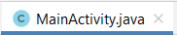
Màn hình 1:
package com.example.ktgkandroid;
import androidx.appcompat.app.AppCompatActivity;
import android.content.Intent;
import android.os.Bundle;
import android.view.View;
import android.widget.Button;
import android.widget.EditText;
public class MainActivity extends AppCompatActivity {
@Override
protected void onCreate(Bundle savedInstanceState) {
super.onCreate(savedInstanceState);
setContentView(R.layout.activity_main);
EditText plain_tenlogin= (EditText) findViewById(R.id.plain_tenlogin);
EditText plain_pass= (EditText) findViewById(R.id.plain_pass);
Button btn_dangnhap= (Button) findViewById(R.id.btn_dangnhap);
btn_dangnhap.setOnClickListener(new View.OnClickListener() {
@Override
public void onClick(View view) {
//XÉT ĐIỀU KIỆN CHO BUTTON ĐĂNG NHẬP
String user, pass;
user= plain_tenlogin.getText().toString();
pass= plain_pass.getText().toString();
if (user.equals("user") && pass.equals("user")){
Intent intent= new Intent(MainActivity.this, manhinh2.class);
intent.putExtra("user",plain_tenlogin.getText().toString());
intent.putExtra("pass",plain_pass.getText().toString());
int CODE= 123;
startActivityForResult(intent, CODE);
}
if (user.equals("admin") && pass.equals("admin")){
Intent intent= new Intent(MainActivity.this, manhinh3.class);
int CODE= 123;
startActivityForResult(intent, CODE);
}
}
});
}
}
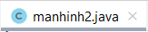
Màn hình 2:

package com.example.ktgkandroid;
import androidx.appcompat.app.AppCompatActivity;
import android.content.Intent;
import android.graphics.Color;
import android.os.Bundle;
import android.view.View;
import android.widget.Button;
import android.widget.LinearLayout;
import android.widget.TextView;
public class manhinh2 extends AppCompatActivity {
@Override
protected void onCreate(Bundle savedInstanceState) {
super.onCreate(savedInstanceState);
setContentView(R.layout.activity_manhinh2);
TextView txt_httenlogin= (TextView) findViewById(R.id.txt_httenlogin);
TextView txt_htpass= (TextView) findViewById(R.id.txt_htpass);
Button btn_doimau= (Button) findViewById(R.id.btn_doimau);
Button btn_thoat= (Button) findViewById(R.id.btn_thoat);
//Hiển thị thông tin đăng nhập từ Main1.
Intent intent= getIntent();
String vl1= intent.getStringExtra("user");
String vl2= intent.getStringExtra("pass");
txt_httenlogin.setText(vl1);
txt_htpass.setText(vl2);
//Bắt sự kiện Button đổi màu nền
LinearLayout layout= (LinearLayout) findViewById(R.id.linear_doimau);
btn_doimau.setOnClickListener(new View.OnClickListener() {
@Override
public void onClick(View view) {
layout.setBackgroundColor(Color.CYAN);
}
});
//Bắt sự kiện cho nút thoát.
btn_thoat.setOnClickListener(new View.OnClickListener() {
@Override
public void onClick(View view) {
finishAffinity();
System.exit(0);
}
});
}
}
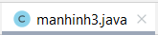
Màn hình 3:

package com.example.ktgkandroid;
import androidx.appcompat.app.AppCompatActivity;
import android.os.Bundle;
import android.view.View;
import android.widget.Button;
import android.widget.EditText;
import android.widget.ListView;
import android.widget.RadioButton;
import android.widget.RadioGroup;
import android.widget.TextView;
public class manhinh3 extends AppCompatActivity {
@Override
protected void onCreate(Bundle savedInstanceState) {
super.onCreate(savedInstanceState);
setContentView(R.layout.activity_manhinh3);
EditText plain_manv= (EditText) findViewById(R.id.plain_manv);
EditText plain_hotennv= (EditText) findViewById(R.id.plain_hotennv);
RadioGroup rdgroup_gt= (RadioGroup) findViewById(R.id.rdgroup_gt);
RadioGroup rdgroup_ns= (RadioGroup) findViewById(R.id.rdgroup_ns);
RadioButton rdb_vinhlong= (RadioButton) findViewById(R.id.rdb_vinhlong);
RadioButton rdb_dongthap= (RadioButton) findViewById(R.id.rdb_dongthap);
RadioButton rdb_cantho= (RadioButton) findViewById(R.id.rdb_cantho);
RadioButton rdb_travinh= (RadioButton) findViewById(R.id.rdb_travinh);
RadioButton rdb_nam= (RadioButton) findViewById(R.id.rdb_nam);
RadioButton rdb_nu= (RadioButton) findViewById(R.id.rdb_nu);
Button btn_them= (Button) findViewById(R.id.btn_them);
TextView txt_htthongtinnhap =(TextView) findViewById(R.id.txt_htthongtinnhap);
btn_them.setOnClickListener(new View.OnClickListener() {
@Override
public void onClick(View view) {
String manv, hotennv;
manv= plain_manv.getText().toString();
hotennv= plain_hotennv.getText().toString();
String gioitinh;
int groupgt= rdgroup_gt.getCheckedRadioButtonId();
switch (groupgt){
case R.id.rdb_nam:
gioitinh= rdb_nam.getText().toString(); break;
case R.id.rdb_nu:
gioitinh= rdb_nu.getText().toString(); break;
default:
throw new IllegalStateException("Unexpected value: " + groupgt);
}
String noisinh;
int groupns= rdgroup_ns.getCheckedRadioButtonId();
switch (groupns){
case R.id.rdb_vinhlong:
noisinh= rdb_vinhlong.getText().toString(); break;
case R.id.rdb_dongthap:
noisinh= rdb_dongthap.getText().toString(); break;
case R.id.rdb_cantho:
noisinh= rdb_cantho.getText().toString(); break;
case R.id.rdb_travinh:
noisinh= rdb_travinh.getText().toString(); break;
default:
throw new IllegalStateException("Unexpected value: " + groupns);
}
txt_htthongtinnhap.setText("Mã NV: "+ manv + "\n" + "Họ Tên NV: "+ hotennv + "\n" + "Giới tính: "+ gioitinh + "\n" + "Nơi Sinh: "+ noisinh );
}
});
}
}

KHIỂM TRA GIỮA KÌ LẦN 2:

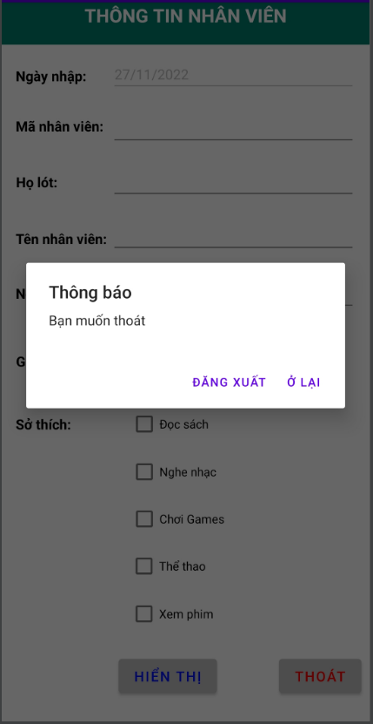
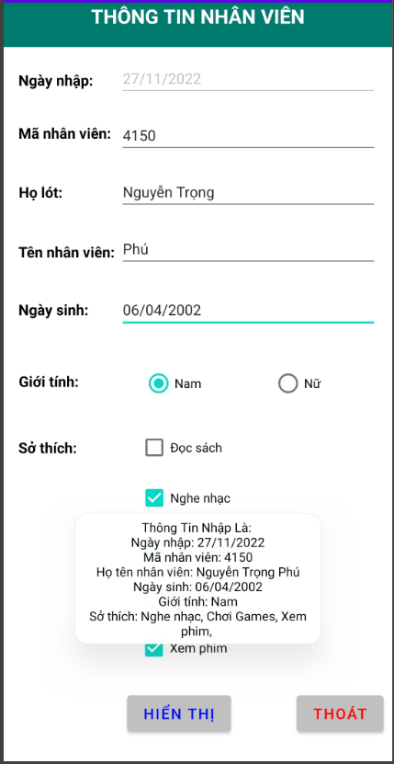
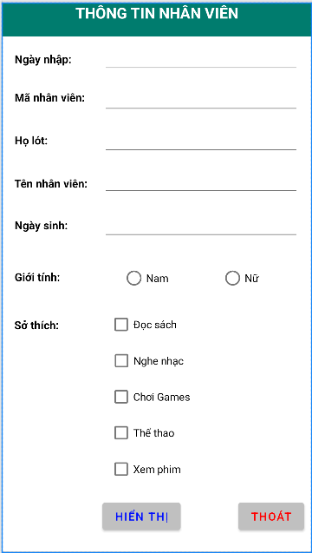
Yều cầu Kết quả và khi ấn nút thoát.

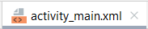
<?xml version="1.0" encoding="utf-8"?>
<androidx.constraintlayout.widget.ConstraintLayout xmlns:android="http://schemas.android.com/apk/res/android"
xmlns:app="http://schemas.android.com/apk/res-auto"
xmlns:tools="http://schemas.android.com/tools"
android:layout_width="match_parent"
android:layout_height="match_parent"
tools:context=".MainActivity">
<CheckBox
android:id="@+id/cb_choigame"
android:layout_width="wrap_content"
android:layout_height="wrap_content"
android:text="Chơi Games"
app:layout_constraintBottom_toBottomOf="parent"
app:layout_constraintEnd_toEndOf="parent"
app:layout_constraintHorizontal_bias="0.468"
app:layout_constraintStart_toStartOf="parent"
app:layout_constraintTop_toTopOf="parent"
app:layout_constraintVertical_bias="0.733" />
<CheckBox
android:id="@+id/cb_nghenhac"
android:layout_width="wrap_content"
android:layout_height="wrap_content"
android:text="Nghe nhạc"
app:layout_constraintBottom_toBottomOf="parent"
app:layout_constraintEnd_toEndOf="parent"
app:layout_constraintHorizontal_bias="0.455"
app:layout_constraintStart_toStartOf="parent"
app:layout_constraintTop_toTopOf="parent"
app:layout_constraintVertical_bias="0.663" />
<CheckBox
android:id="@+id/cb_thethao"
android:layout_width="wrap_content"
android:layout_height="wrap_content"
android:text="Thể thao"
app:layout_constraintBottom_toBottomOf="parent"
app:layout_constraintEnd_toEndOf="parent"
app:layout_constraintHorizontal_bias="0.438"
app:layout_constraintStart_toStartOf="parent"
app:layout_constraintTop_toTopOf="parent"
app:layout_constraintVertical_bias="0.803" />
<CheckBox
android:id="@+id/cb_xemphim"
android:layout_width="wrap_content"
android:layout_height="wrap_content"
android:text="Xem phim"
app:layout_constraintBottom_toBottomOf="parent"
app:layout_constraintEnd_toEndOf="parent"
app:layout_constraintHorizontal_bias="0.449"
app:layout_constraintStart_toStartOf="parent"
app:layout_constraintTop_toTopOf="parent"
app:layout_constraintVertical_bias="0.874" />
<CheckBox
android:id="@+id/cb_docsach"
android:layout_width="wrap_content"
android:layout_height="wrap_content"
android:text="Đọc sách"
app:layout_constraintBottom_toBottomOf="parent"
app:layout_constraintEnd_toEndOf="parent"
app:layout_constraintHorizontal_bias="0.442"
app:layout_constraintStart_toStartOf="parent"
app:layout_constraintTop_toTopOf="parent"
app:layout_constraintVertical_bias="0.592" />
<TextView
android:id="@+id/textView"
android:layout_width="match_parent"
android:layout_height="45dp"
android:gravity="center_horizontal"
android:text="THÔNG TIN NHÂN VIÊN"
android:textColor="@color/white"
android:background="#007C6E"
android:textSize="20dp"
android:textStyle="bold"
app:layout_constraintBottom_toBottomOf="parent"
app:layout_constraintEnd_toEndOf="parent"
app:layout_constraintHorizontal_bias="0.0"
app:layout_constraintStart_toStartOf="parent"
app:layout_constraintTop_toTopOf="parent"
app:layout_constraintVertical_bias="0.0" />
<TextView
android:id="@+id/textView2"
android:layout_width="wrap_content"
android:layout_height="wrap_content"
android:text="Ngày nhập: "
android:textColor="@color/black"
android:textSize="15dp"
android:textStyle="bold"
app:layout_constraintBottom_toBottomOf="parent"
app:layout_constraintEnd_toEndOf="parent"
app:layout_constraintHorizontal_bias="0.048"
app:layout_constraintStart_toStartOf="parent"
app:layout_constraintTop_toTopOf="parent"
app:layout_constraintVertical_bias="0.091" />
<TextView
android:id="@+id/textView4"
android:layout_width="wrap_content"
android:layout_height="wrap_content"
android:text="Mã nhân viên: "
android:textColor="@color/black"
android:textSize="15dp"
android:textStyle="bold"
app:layout_constraintBottom_toBottomOf="parent"
app:layout_constraintEnd_toEndOf="parent"
app:layout_constraintHorizontal_bias="0.051"
app:layout_constraintStart_toStartOf="parent"
app:layout_constraintTop_toTopOf="parent"
app:layout_constraintVertical_bias="0.163" />
<TextView
android:id="@+id/textView5"
android:layout_width="wrap_content"
android:layout_height="wrap_content"
android:text="Họ lót: "
android:textColor="@color/black"
android:textSize="15dp"
android:textStyle="bold"
app:layout_constraintBottom_toBottomOf="parent"
app:layout_constraintEnd_toEndOf="parent"
app:layout_constraintHorizontal_bias="0.044"
app:layout_constraintStart_toStartOf="parent"
app:layout_constraintTop_toTopOf="parent"
app:layout_constraintVertical_bias="0.243" />
<TextView
android:id="@+id/textView6"
android:layout_width="wrap_content"
android:layout_height="wrap_content"
android:text="Tên nhân viên: "
android:textColor="@color/black"
android:textSize="15dp"
android:textStyle="bold"
app:layout_constraintBottom_toBottomOf="parent"
app:layout_constraintEnd_toEndOf="parent"
app:layout_constraintHorizontal_bias="0.051"
app:layout_constraintStart_toStartOf="parent"
app:layout_constraintTop_toTopOf="parent"
app:layout_constraintVertical_bias="0.324" />
<TextView
android:id="@+id/textView7"
android:layout_width="wrap_content"
android:layout_height="wrap_content"
android:text="Ngày sinh: "
android:textColor="@color/black"
android:textSize="15dp"
android:textStyle="bold"
app:layout_constraintBottom_toBottomOf="parent"
app:layout_constraintEnd_toEndOf="parent"
app:layout_constraintHorizontal_bias="0.047"
app:layout_constraintStart_toStartOf="parent"
app:layout_constraintTop_toTopOf="parent"
app:layout_constraintVertical_bias="0.402" />
<TextView
android:id="@+id/textView8"
android:layout_width="wrap_content"
android:layout_height="wrap_content"
android:text="Giới tính: "
android:textColor="@color/black"
android:textSize="15dp"
android:textStyle="bold"
app:layout_constraintBottom_toBottomOf="parent"
app:layout_constraintEnd_toEndOf="parent"
app:layout_constraintHorizontal_bias="0.046"
app:layout_constraintStart_toStartOf="parent"
app:layout_constraintTop_toTopOf="parent"
app:layout_constraintVertical_bias="0.499" />
<TextView
android:id="@+id/textView9"
android:layout_width="wrap_content"
android:layout_height="wrap_content"
android:text="Sở thích: "
android:textColor="@color/black"
android:textSize="15dp"
android:textStyle="bold"
app:layout_constraintBottom_toBottomOf="parent"
app:layout_constraintEnd_toEndOf="parent"
app:layout_constraintHorizontal_bias="0.045"
app:layout_constraintStart_toStartOf="parent"
app:layout_constraintTop_toTopOf="parent"
app:layout_constraintVertical_bias="0.589" />
<EditText
android:id="@+id/plain_ngaynhap"
android:layout_width="262dp"
android:layout_height="41dp"
android:ems="10"
android:enabled="false"
android:inputType="textPersonName"
android:textSize="15dp"
app:layout_constraintBottom_toBottomOf="parent"
app:layout_constraintEnd_toEndOf="parent"
app:layout_constraintHorizontal_bias="0.892"
app:layout_constraintStart_toStartOf="parent"
app:layout_constraintTop_toTopOf="parent"
app:layout_constraintVertical_bias="0.078" />
<EditText
android:id="@+id/plain_manv"
android:layout_width="262dp"
android:layout_height="41dp"
android:ems="10"
android:inputType="number"
android:textSize="15dp"
app:layout_constraintBottom_toBottomOf="parent"
app:layout_constraintEnd_toEndOf="parent"
app:layout_constraintHorizontal_bias="0.892"
app:layout_constraintStart_toStartOf="parent"
app:layout_constraintTop_toTopOf="parent"
app:layout_constraintVertical_bias="0.157" />
<EditText
android:id="@+id/plain_holot"
android:layout_width="262dp"
android:layout_height="41dp"
android:ems="10"
android:inputType="textPersonName"
android:textSize="15dp"
app:layout_constraintBottom_toBottomOf="parent"
app:layout_constraintEnd_toEndOf="parent"
app:layout_constraintHorizontal_bias="0.892"
app:layout_constraintStart_toStartOf="parent"
app:layout_constraintTop_toTopOf="parent"
app:layout_constraintVertical_bias="0.236" />
<EditText
android:id="@+id/plain_tennv"
android:layout_width="262dp"
android:layout_height="41dp"
android:ems="10"
android:inputType="textPersonName"
android:textSize="15dp"
app:layout_constraintBottom_toBottomOf="parent"
app:layout_constraintEnd_toEndOf="parent"
app:layout_constraintHorizontal_bias="0.892"
app:layout_constraintStart_toStartOf="parent"
app:layout_constraintTop_toTopOf="parent"
app:layout_constraintVertical_bias="0.315" />
<EditText
android:id="@+id/plain_ngaysinh"
android:layout_width="262dp"
android:layout_height="41dp"
android:ems="10"
android:inputType="textPersonName"
android:textSize="15dp"
app:layout_constraintBottom_toBottomOf="parent"
app:layout_constraintEnd_toEndOf="parent"
app:layout_constraintHorizontal_bias="0.892"
app:layout_constraintStart_toStartOf="parent"
app:layout_constraintTop_toTopOf="parent"
app:layout_constraintVertical_bias="0.4" />
<RadioGroup
android:id="@+id/rdgroup_gt"
android:layout_width="252dp"
android:layout_height="62dp"
android:orientation="horizontal"
android:weightSum="2"
app:layout_constraintBottom_toBottomOf="parent"
app:layout_constraintEnd_toEndOf="parent"
app:layout_constraintHorizontal_bias="1.0"
app:layout_constraintStart_toStartOf="parent"
app:layout_constraintTop_toTopOf="parent"
app:layout_constraintVertical_bias="0.512">
<RadioButton
android:id="@+id/rdb_nam"
android:layout_width="wrap_content"
android:layout_height="wrap_content"
android:layout_weight="1"
android:text="Nam" />
<RadioButton
android:id="@+id/rdb_nu"
android:layout_width="wrap_content"
android:layout_height="wrap_content"
android:layout_weight="1"
android:text="Nữ" />
</RadioGroup>
<Button
android:id="@+id/btn_hienthi"
android:layout_width="wrap_content"
android:layout_height="wrap_content"
android:backgroundTint="#C0C0C0"
android:text="Hiển thị"
android:textColor="#000FFF"
android:textSize="15dp"
app:layout_constraintBottom_toBottomOf="parent"
app:layout_constraintEnd_toEndOf="parent"
app:layout_constraintHorizontal_bias="0.433"
app:layout_constraintStart_toStartOf="parent"
app:layout_constraintTop_toTopOf="parent"
app:layout_constraintVertical_bias="0.966" />
<Button
android:id="@+id/btn_thoat"
android:layout_width="wrap_content"
android:layout_height="wrap_content"
android:backgroundTint="#C0C0C0"
android:text="Thoát"
android:textColor="#FF0000"
android:textSize="15dp"
app:layout_constraintBottom_toBottomOf="parent"
app:layout_constraintEnd_toEndOf="@+id/rdgroup_gt"
app:layout_constraintHorizontal_bias="0.971"
app:layout_constraintStart_toStartOf="parent"
app:layout_constraintTop_toTopOf="parent"
app:layout_constraintVertical_bias="0.966" />
</androidx.constraintlayout.widget.ConstraintLayout>

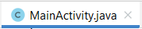
package com.example.ktl2android;
import androidx.appcompat.app.AlertDialog;
import androidx.appcompat.app.AppCompatActivity;
import android.content.DialogInterface;
import android.os.Bundle;
import android.view.View;
import android.widget.Button;
import android.widget.CheckBox;
import android.widget.EditText;
import android.widget.RadioButton;
import android.widget.RadioGroup;
import android.widget.Switch;
import android.widget.Toast;
import java.text.DateFormat;
import java.text.SimpleDateFormat;
import java.util.Calendar;
public class MainActivity extends AppCompatActivity {
@Override
protected void onCreate(Bundle savedInstanceState) {
super.onCreate(savedInstanceState);
setContentView(R.layout.activity_main);
EditText plain_ngaynhap= (EditText) findViewById(R.id.plain_ngaynhap);
EditText plain_manv= (EditText) findViewById(R.id.plain_manv);
EditText plain_holot= (EditText) findViewById(R.id.plain_holot);
EditText plain_tennv= (EditText) findViewById(R.id.plain_tennv);
EditText plain_ngaysinh= (EditText) findViewById(R.id.plain_ngaysinh);
RadioGroup rdgroup_gt= (RadioGroup) findViewById(R.id.rdgroup_gt);
RadioButton rdb_nam= (RadioButton) findViewById(R.id.rdb_nam);
RadioButton rdb_nu= (RadioButton) findViewById(R.id.rdb_nu);
CheckBox cb_docsach= (CheckBox) findViewById(R.id.cb_docsach);
CheckBox cb_nghenhac= (CheckBox) findViewById(R.id.cb_nghenhac);
CheckBox cb_choigame= (CheckBox) findViewById(R.id.cb_choigame);
CheckBox cb_thethao= (CheckBox) findViewById(R.id.cb_thethao);
CheckBox cb_xemphim= (CheckBox) findViewById(R.id.cb_xemphim);
Button btn_hienthi= (Button) findViewById(R.id.btn_hienthi);
Button btn_thoat= (Button) findViewById(R.id.btn_thoat);
//Bắt sự kiện cho Edit Text ngày nhập (tự động lấy theo ngày hệ thống);
DateFormat df= new SimpleDateFormat("dd/MM/yyy");
String date= df.format(Calendar.getInstance().getTime());
//Hiển thị lên Edit Text;
plain_ngaynhap.setText(date);
//Bắt sự kiện cho Button hiển thị;
btn_hienthi.setOnClickListener(new View.OnClickListener() {
@Override
public void onClick(View view) {
//Lấy thông tin của mã nhân viên;
String manv= plain_manv.getText().toString();
//Lấy thông tin họ lót;
String ho= plain_holot.getText().toString();
String holot= "";
//Đếm kt (bắt từ 2 kt trở lên);
String[] ct= ho.split("[ ]");
int dem= ct.length;
for (int i= 0; i<ct.length; i++){
if((ct[i].equals(""))){
dem--;
}
}
if (dem >= 2){
holot= plain_holot.getText().toString();
}else {
Toast.makeText(MainActivity.this,"Họ lót phải nhập ít nhất 2 từ",Toast.LENGTH_SHORT).show();
}
//Lấy thông tin tên nhân viên;
String tennv= plain_tennv.getText().toString();
String tennhanvien= "";
if (tennv.isEmpty() || tennv.equals("") || tennv== null){
Toast.makeText(MainActivity.this,"Tên nhân viên không được bỏ trống",Toast.LENGTH_SHORT).show();
}else {
tennhanvien= tennv;
}
//Lấy thông tin ngày sinh;
String ngaysinh= "";
String ns= plain_ngaysinh.getText().toString();
if (ns.isEmpty() || ns.equals("") || ns== null){
Toast.makeText(MainActivity.this,"Ngày sinh không được bỏ trống!",Toast.LENGTH_SHORT).show();
}else {
ngaysinh= ns;
}
//Lấy thông tin giới tính;
String gioitinh;
int groupgt= rdgroup_gt.getCheckedRadioButtonId();
switch (groupgt){
case R.id.rdb_nam:
gioitinh=rdb_nam.getText().toString();break;
case R.id.rdb_nu:
gioitinh=rdb_nu.getText().toString();break;
default:
throw new IllegalStateException("Unexpected value:"+ groupgt);
}
//Lấy thông tin sở thích;
int demst= 0;
String sothich="";
String sth="";
if (cb_docsach.isChecked()){
sth+= cb_docsach.getText().toString()+ ",";
demst++;
}
if(cb_nghenhac.isChecked())
{
sth+=cb_nghenhac.getText().toString() + ", ";
dem++;
}
if(cb_choigame.isChecked())
{
sth+=cb_choigame.getText().toString() + ", ";
dem++;
}
if(cb_xemphim.isChecked())
{
sth+=cb_xemphim.getText().toString() + ", ";
dem++;
}
if(cb_thethao.isChecked())
{
sth+=cb_thethao.getText().toString() + ", ";
dem++;
}
if (dem ==0){
Toast.makeText(MainActivity.this,"Phải chịn ít nhất một sở thích",Toast.LENGTH_SHORT).show();
}else {
sothich= sth;
}
Toast.makeText(MainActivity.this,"Thông Tin Nhập Là: "+ "\n"+"Ngày nhập: "+date+"\n"+"Mã nhân viên: "+manv+"\n"+"Họ tên nhân viên: "+holot+" "+tennhanvien+"\n"+"Ngày sinh: "+ngaysinh+"\n"+"Giới tính: "+gioitinh+"\n"+"Sở thích: "+sothich,Toast.LENGTH_SHORT).show();
}
});
//Bắt sự kiện cho nút thoát;
btn_thoat.setOnClickListener(new View.OnClickListener() {
@Override
public void onClick(View view) {
AlertDialog.Builder thoat = new AlertDialog.Builder(MainActivity.this);
thoat.setTitle("Thông báo");
thoat.setMessage("Bạn muốn thoát");
//Tạo 2 sự kiện;
thoat.setPositiveButton("Ở lại", new DialogInterface.OnClickListener() {
@Override
public void onClick(DialogInterface dialogInterface, int i) {
dialogInterface.cancel();
}
});
thoat.setNegativeButton("Đăng xuất", new DialogInterface.OnClickListener() {
@Override
public void onClick(DialogInterface dialogInterface, int i) {
finish();
}
});
thoat.show();
}
});
}
}

BÀI TẬP VỀ SPINNER

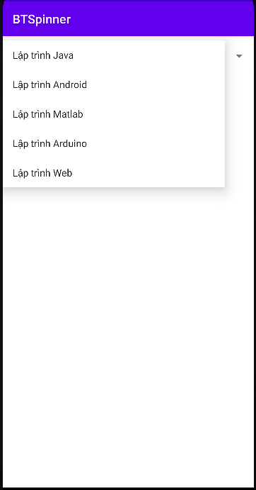
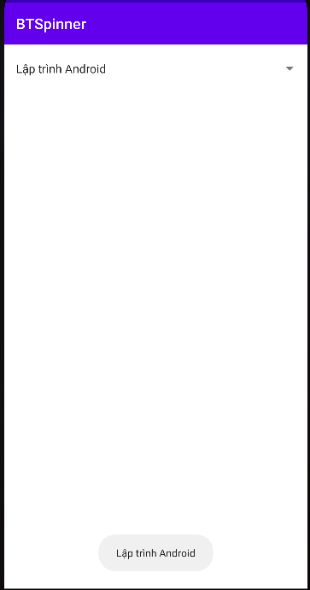
Tạo spinner và hiển thị lên Toast.

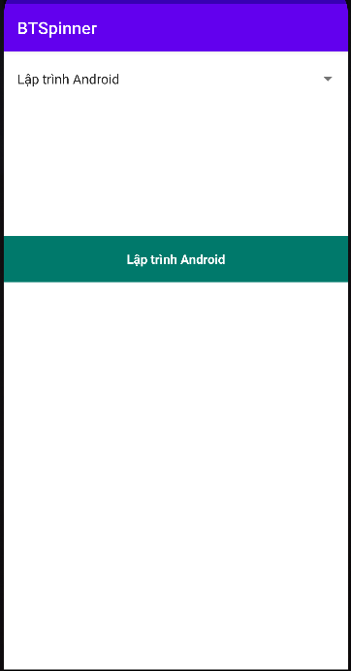
Tạo spinner và hiển thị lên TextView.
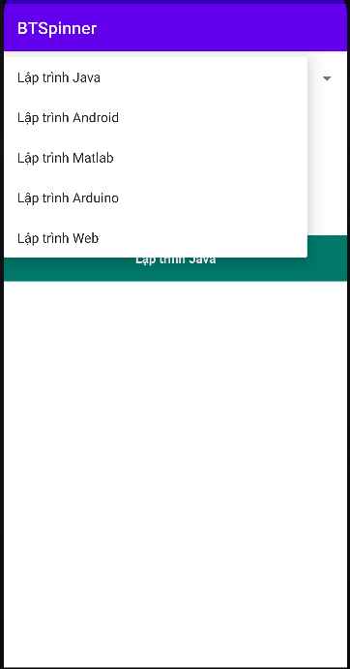
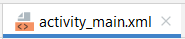
<?xml version="1.0" encoding="utf-8"?>
<androidx.constraintlayout.widget.ConstraintLayout xmlns:android="http://schemas.android.com/apk/res/android"
xmlns:app="http://schemas.android.com/apk/res-auto"
xmlns:tools="http://schemas.android.com/tools"
android:layout_width="match_parent"
android:layout_height="match_parent"
tools:context=".MainActivity">
<Spinner
android:id="@+id/sp_monhoc"
android:layout_width="match_parent"
android:layout_height="52dp"
app:layout_constraintBottom_toBottomOf="parent"
app:layout_constraintEnd_toEndOf="parent"
app:layout_constraintHorizontal_bias="0.444"
app:layout_constraintStart_toStartOf="parent"
app:layout_constraintTop_toTopOf="parent"
app:layout_constraintVertical_bias="0.01" />
</androidx.constraintlayout.widget.ConstraintLayout>

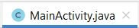
package com.example.btspinner;
import androidx.appcompat.app.AppCompatActivity;
import android.os.Bundle;
import android.renderscript.Sampler;
import android.view.View;
import android.widget.AdapterView;
import android.widget.ArrayAdapter;
import android.widget.Spinner;
import android.widget.TextView;
import android.widget.Toast;
import java.util.ArrayList;
public class MainActivity extends AppCompatActivity {
@Override
protected void onCreate(Bundle savedInstanceState) {
super.onCreate(savedInstanceState);
setContentView(R.layout.activity_main);
//Ánh xạ Spinner;
Spinner sp_monhoc= (Spinner) findViewById(R.id.sp_monhoc);
//TextView txt_ht= (TextView) findViewById(R.id.txt_ht);
//Tạo ArrayList kiểu chuỗi;
ArrayList<String> arrayMonHoc= new ArrayList<String>();
//Add các thuộc tính vào List;
arrayMonHoc.add("Lập trình Java");
arrayMonHoc.add("Lập trình Android");
arrayMonHoc.add("Lập trình Matlab");
arrayMonHoc.add("Lập trình Arduino");
arrayMonHoc.add("Lập trình Web");
//Đỗ dữ liệu từ List vào Adapter;
ArrayAdapter arrayAdapter= new ArrayAdapter(this, android.R.layout.simple_list_item_1,arrayMonHoc);
//Đỗ dữ liệu từ Adapter vào Spinner;
sp_monhoc.setAdapter(arrayAdapter);
//Bắt sự kiện cho Spinner;
sp_monhoc.setOnItemSelectedListener(new AdapterView.OnItemSelectedListener() {
@Override
public void onItemSelected(AdapterView<?> adapterView, View view, int i, long l) {
//Hiển thị lên Toast.
Toast.makeText(MainActivity.this, arrayMonHoc.get(i),Toast.LENGTH_SHORT).show();
//Hiển thị lên TextView.
//txt_ht.setText(arrayMonHoc.get(i));
}
@Override
public void onNothingSelected(AdapterView<?> adapterView) {
}
});
}
}

BT18: Thiết kế album ảnh.

- Khi ấn vào ảnh sẽ hiển thị ảnh đó, ấn back để quay lại.
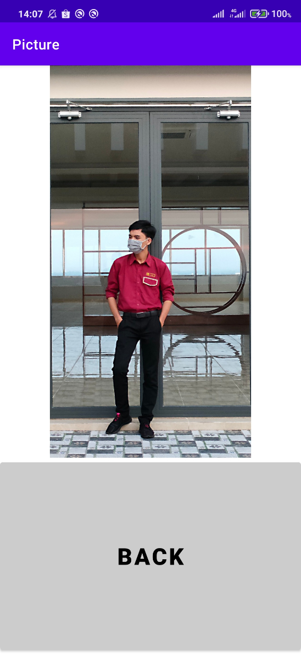
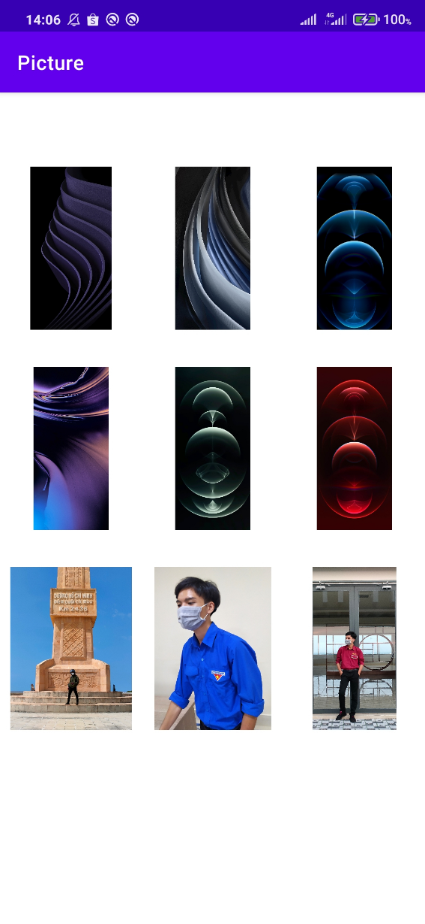

- Khi ấn vào ảnh bất kì, màn hình 2 của ảnh - Màn hình 2 xuất hiện đúng ảnh vừa ấn vào
đó sẽ hiện lên. ấn button Back để quay lại màn hình 1.

- Dán ảnh và tạo ArrayList ảnh
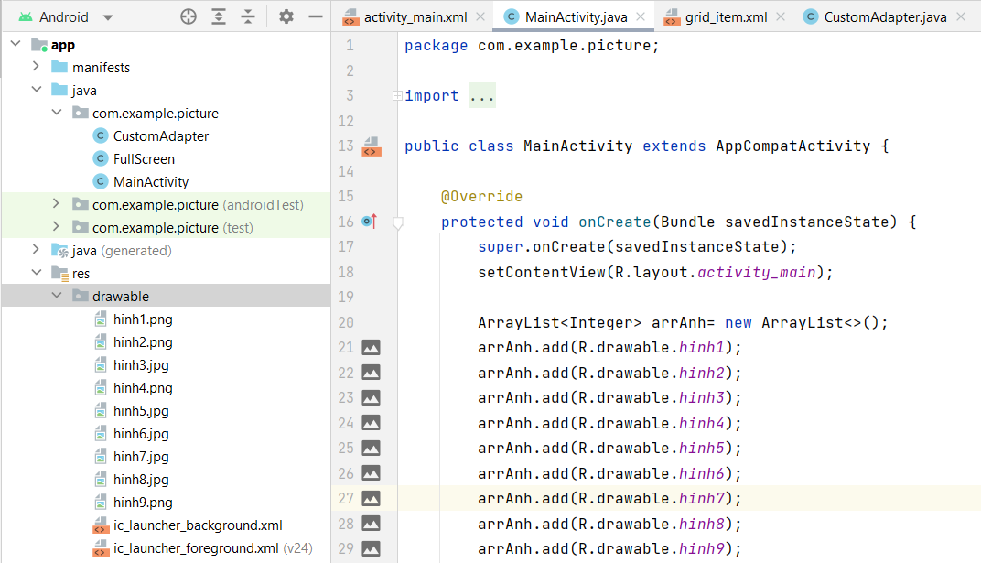
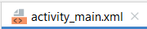
<?xml version="1.0" encoding="utf-8"?>
<LinearLayout xmlns:android="http://schemas.android.com/apk/res/android"
xmlns:app="http://schemas.android.com/apk/res-auto"
xmlns:tools="http://schemas.android.com/tools"
android:layout_width="match_parent"
android:layout_height="match_parent"
android:orientation="vertical"
tools:context=".MainActivity">
<TextView
android:id="@+id/tvSoloMsg"
android:layout_width="match_parent"
android:layout_height="wrap_content" />
<TextView
android:id="@+id/textView1"
android:layout_width="match_parent"
android:layout_height="wrap_content" />
<GridView
android:id="@+id/gridView"
android:layout_width="match_parent"
android:layout_height="wrap_content"
android:gravity="center"
android:numColumns="3" />
</LinearLayout>

Tạo grid_item.xml và thêm gridItem vào trong đó:
: R_Mouse vào
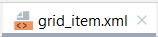
<?xml version="1.0" encoding="utf-8"?>
<LinearLayout xmlns:android="http://schemas.android.com/apk/res/android"
android:layout_width="match_parent"
android:layout_height="match_parent"
android:orientation="vertical">
<TextView
android:id="@+id/tvSoloMsg"
android:layout_width="match_parent"
android:layout_height="wrap_content" />
<TextView
android:layout_width="match_parent"
android:layout_height="wrap_content"
android:id="@+id/textView1"/>
<ImageView
android:layout_gravity="center"
android:id="@+id/imageView"
android:layout_width="150dp"
android:layout_height="150dp"/>
</LinearLayout>

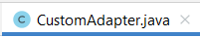
Tạo CustomAdapter:

package com.example.picture;
import android.content.Context;
import android.view.LayoutInflater;
import android.view.View;
import android.view.ViewGroup;
import android.widget.ArrayAdapter;
import android.widget.ImageView;
import androidx.annotation.NonNull;
import androidx.annotation.Nullable;
import androidx.recyclerview.widget.RecyclerView;
import java.util.ArrayList;
public class CustomAdapter extends ArrayAdapter<Integer> {
private Context context;
private int resource;
private ArrayList<Integer> arrAnh;
public CustomAdapter(@NonNull Context context, int resource, @NonNull ArrayList<Integer> objects) {
super(context, resource, objects);
this.context= context;
this.resource= resource;
this.arrAnh= objects;
}
public class ViewHolder{
ImageView imageView;
}
@NonNull
@Override
public View getView(int position, @Nullable View convertView, @Nullable ViewGroup parent){
ViewHolder viewHolder;
if (convertView == null){
convertView= LayoutInflater.from(context).inflate(resource, parent, false);
viewHolder= new ViewHolder();
viewHolder.imageView= (ImageView) convertView.findViewById(R.id.imageView);
convertView.setTag(viewHolder);
}else {
viewHolder= (ViewHolder) convertView.getTag();
}
viewHolder.imageView.setImageResource(arrAnh.get(position));
return convertView;
}
}

Sử dụng CustomAdapter:
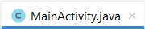

package com.example.picture;
import androidx.appcompat.app.AppCompatActivity;
import android.content.Intent;
import android.os.Bundle;
import android.view.View;
import android.widget.AdapterView;
import android.widget.GridView;
import java.util.ArrayList;
public class MainActivity extends AppCompatActivity {
@Override
protected void onCreate(Bundle savedInstanceState) {
super.onCreate(savedInstanceState);
setContentView(R.layout.activity_main);
ArrayList<Integer> arrAnh= new ArrayList<>();
arrAnh.add(R.drawable.hinh1);
arrAnh.add(R.drawable.hinh2);
arrAnh.add(R.drawable.hinh3);
arrAnh.add(R.drawable.hinh4);
arrAnh.add(R.drawable.hinh5);
arrAnh.add(R.drawable.hinh6);
arrAnh.add(R.drawable.hinh7);
arrAnh.add(R.drawable.hinh8);
arrAnh.add(R.drawable.hinh9);
GridView gridView= (GridView) findViewById(R.id.gridView);
CustomAdapter customAdapter= new CustomAdapter(this, R.layout.grid_item, arrAnh);
gridView.setAdapter(customAdapter);
}
}

Tạo thêm 1 java.class tên là FullScreen.
: R_Mouse vào <đặt tên> Class OK
Tạo sự kiện click: Click item chuyển đến FullScreen. (Viết code trên main).

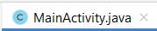
gridView.setOnItemClickListener(new AdapterView.OnItemClickListener() {
@Override
public void onItemClick(AdapterView<?> adapterView, View view, int i, long l) {
Intent intent= new Intent(MainActivity.this, FullScreen.class);
intent.putExtra("idAnh",arrAnh.get(i)+""); //+"" để ép sang kiểu chuổi nhanh vì ảnh là dạng id số.
startActivity(intent);
}
});

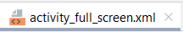

<?xml version="1.0" encoding="utf-8"?>
<LinearLayout xmlns:android="http://schemas.android.com/apk/res/android"
xmlns:app="http://schemas.android.com/apk/res-auto"
xmlns:tools="http://schemas.android.com/tools"
android:layout_width="match_parent"
android:layout_height="match_parent"
android:orientation="vertical"
android:weightSum="3"
tools:context=".FullScreen">
<ImageView
android:id="@+id/imageFull"
android:layout_weight="2"
android:layout_width="match_parent"
android:layout_height="0dp"/>
<Button
android:id="@+id/btn_back"
android:backgroundTint="#CCCCCC"
android:text="Back"
android:textSize="30dp"
android:textColor="@color/black"
android:textStyle="bold"
android:layout_weight="1"
android:layout_width="match_parent"
android:layout_height="0dp"/>
</LinearLayout>

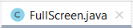

package com.example.picture;
import androidx.appcompat.app.AppCompatActivity;
import android.content.Intent;
import android.os.Bundle;
import android.view.View;
import android.widget.Button;
import android.widget.ImageView;
public class FullScreen extends AppCompatActivity {
@Override
protected void onCreate(Bundle savedInstanceState) {
super.onCreate(savedInstanceState);
setContentView(R.layout.activity_full_screen);
ImageView imageView= (ImageView) findViewById(R.id.imageFull);
Button btn_back= (Button) findViewById(R.id.btn_back);
Intent intent= getIntent();
String chuoiNhan= intent.getStringExtra("idAnh");
//Đổi sang id dạng số
int idAnh= Integer.parseInt(chuoiNhan);
// Set id ảnh vào imagerView
imageView.setImageResource(idAnh);
btn_back.setOnClickListener(new View.OnClickListener() {
@Override
public void onClick(View view) {
finish();
}
});
}
}

SQLite

BT19: Save và Update dữ liệu từ SQLite

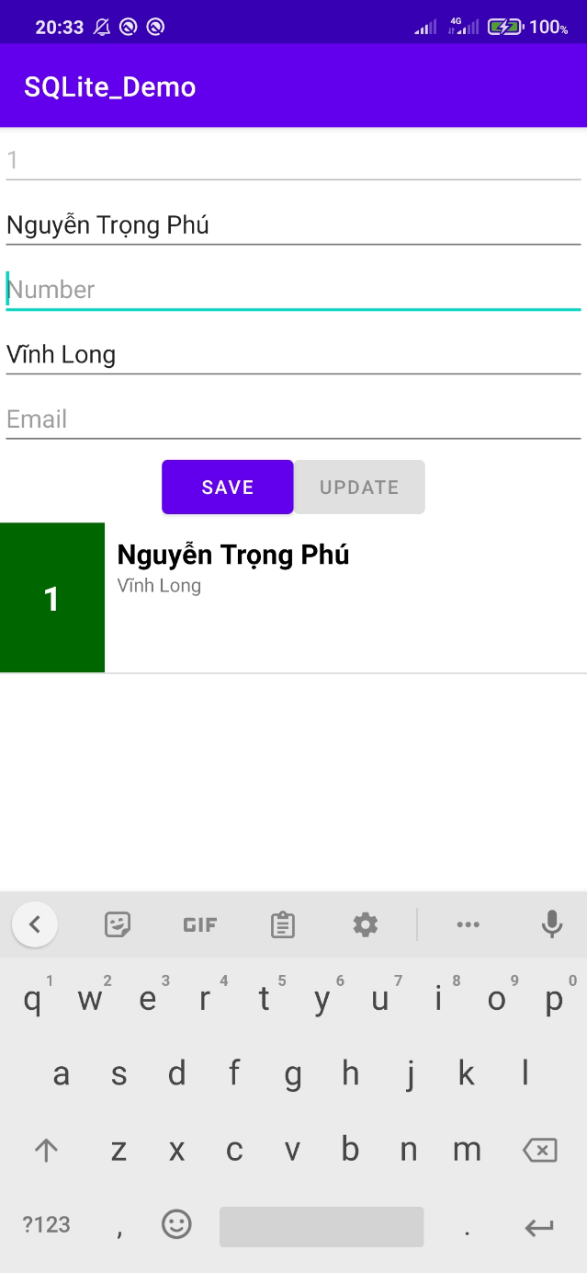
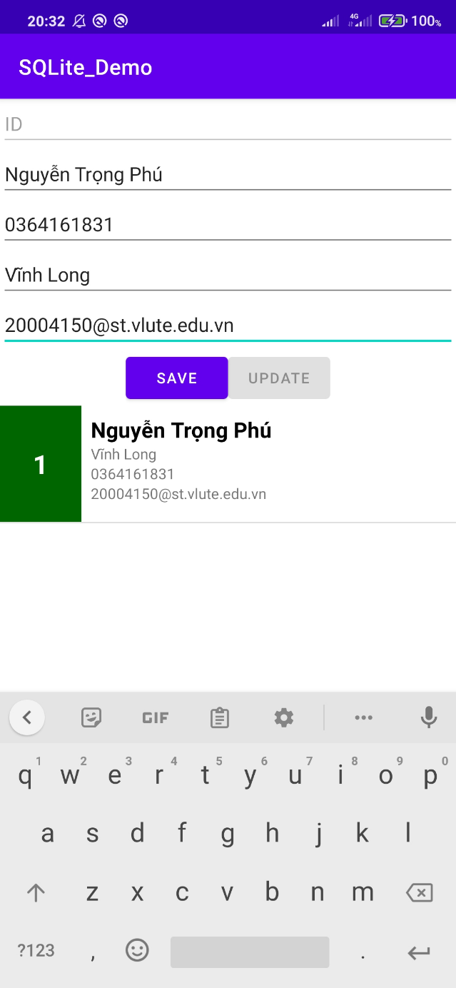
Save dữ liệu Update dữ liệu

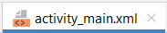
<?xml version="1.0" encoding="utf-8"?>
<LinearLayout
xmlns:android="http://schemas.android.com/apk/res/android"
android:layout_width="match_parent"
android:layout_height="match_parent"
android:orientation="vertical">
<EditText
android:enabled="false"
android:id="@+id/edt_id"
android:layout_width="match_parent"
android:layout_height="wrap_content"
android:hint="ID" />
<EditText
android:id="@+id/edt_name"
android:layout_width="match_parent"
android:layout_height="wrap_content"
android:hint="Name" />
<EditText
android:id="@+id/edt_number"
android:layout_width="match_parent"
android:layout_height="wrap_content"
android:hint="Number" />
<EditText
android:id="@+id/edt_address"
android:layout_width="match_parent"
android:layout_height="wrap_content"
android:hint="Address" />
<EditText
android:id="@+id/edt_email"
android:layout_width="match_parent"
android:layout_height="wrap_content"
android:hint="Email" />
<LinearLayout
android:layout_gravity="center"
android:layout_width="wrap_content"
android:layout_height="wrap_content">
<Button
android:id="@+id/btn_save"
android:layout_width="wrap_content"
android:layout_height="wrap_content"
android:layout_gravity="center"
android:text="Save" />
<Button
android:enabled="false"
android:id="@+id/btn_update"
android:layout_width="wrap_content"
android:layout_height="wrap_content"
android:layout_gravity="center"
android:text="Update" />
</LinearLayout>
<ListView
android:id="@+id/lv_student"
android:layout_width="match_parent"
android:layout_height="match_parent" />
</LinearLayout>

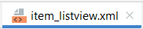
<?xml version="1.0" encoding="utf-8"?>
<LinearLayout
xmlns:android="http://schemas.android.com/apk/res/android"
android:orientation="horizontal"
android:layout_width="match_parent"
android:layout_height="100dp">
<TextView
android:background="#006600"
android:id="@+id/tv_id"
android:text="1"
android:gravity="center"
android:textStyle="bold"
android:textSize="25sp"
android:textColor="#fff"
android:layout_width="70dp"
android:layout_height="match_parent" />
<LinearLayout
android:padding="8dp"
android:orientation="vertical"
android:layout_width="match_parent"
android:layout_height="match_parent">
<TextView
android:textSize="20sp"
android:textColor="@color/black"
android:textStyle="bold"
android:id="@+id/tv_name"
android:layout_width="wrap_content"
android:layout_height="wrap_content" />
<TextView
android:id="@+id/tv_address"
android:layout_width="wrap_content"
android:layout_height="wrap_content" />
<TextView
android:id="@+id/tv_phone_number"
android:layout_width="wrap_content"
android:layout_height="wrap_content" />
<TextView
android:id="@+id/tv_email"
android:layout_width="wrap_content"
android:layout_height="wrap_content" />
</LinearLayout>
</LinearLayout>

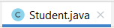
package com.example.sqlite_demo;
public class Student {
private int mID;
private String mName;
private String mAddress;
private String mPhoneNumber;
private String mEmail;
public Student() {
}
public Student(String mName, String mAddress, String mPhoneNumber, String
mEmail) {
this.mName = mName;
this.mAddress = mAddress;
this.mPhoneNumber = mPhoneNumber;
this.mEmail = mEmail;
}
public Student(int mID, String mName, String mAddress, String
mPhoneNumber, String mEmail) {
this.mID = mID;
this.mName = mName;
this.mAddress = mAddress;
this.mPhoneNumber = mPhoneNumber;
this.mEmail = mEmail;
}
public int getmID() {
return mID;
}
public void setmID(int mID) {
this.mID = mID;
}
public String getmName() {
return mName;
}
public void setmName(String mName) {
this.mName = mName;
}
public String getmAddress() {
return mAddress;
}
public void setmAddress(String mAddress) {
this.mAddress = mAddress;
}
public String getmPhoneNumber() {
return mPhoneNumber;
}
public void setmPhoneNumber(String mPhoneNumber) {
this.mPhoneNumber = mPhoneNumber;
}
public String getmEmail() {
return mEmail;
}
public void setmEmail(String mEmail) {
this.mEmail = mEmail;
}
}

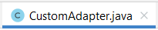
package com.example.sqlite_demo;
import android.content.Context;
import android.view.LayoutInflater;
import android.view.View;
import android.view.ViewGroup;
import android.widget.ArrayAdapter;
import android.widget.TextView;
import androidx.annotation.LayoutRes;
import androidx.annotation.NonNull;
import androidx.annotation.Nullable;
import java.util.List;
public class CustomAdapter extends ArrayAdapter<Student> {
private Context context;
private int resoure;
private List<Student> listStudent;
public CustomAdapter(@NonNull Context context, @LayoutRes int
resource, @NonNull List<Student> objects) {
super(context, resource, objects);
this.context= context;
this.resoure=resource;
this.listStudent=objects;
}
@NonNull
@Override
public View getView(int position, @Nullable View convertView,
@NonNull ViewGroup parent) {
ViewHolder viewHolder;
if(convertView==null){
convertView =
LayoutInflater.from(context).inflate(R.layout.item_listview,parent,
false);
viewHolder = new ViewHolder();
viewHolder.tvId =
(TextView)convertView.findViewById(R.id.tv_id);
viewHolder.tvName =
(TextView)convertView.findViewById(R.id.tv_name);
viewHolder.tvPhoneNumber =
(TextView)convertView.findViewById(R.id.tv_phone_number);
viewHolder.tvEmail =
(TextView)convertView.findViewById(R.id.tv_email);
viewHolder.tvAddress =
(TextView)convertView.findViewById(R.id.tv_address);
convertView.setTag(viewHolder);
}else{
viewHolder = (ViewHolder) convertView.getTag();
}
Student student = listStudent.get(position);
viewHolder.tvId.setText(String.valueOf(student.getmID()));
viewHolder.tvName.setText(student.getmName());
viewHolder.tvAddress.setText(student.getmAddress());
viewHolder.tvEmail.setText(student.getmEmail());
viewHolder.tvPhoneNumber.setText(student.getmPhoneNumber());
return convertView;
}
public class ViewHolder{
private TextView tvId;
private TextView tvName;
private TextView tvAddress;
private TextView tvEmail;
private TextView tvPhoneNumber;
}
}

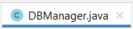
package com.example.sqlite_demo;
import android.content.ContentValues;
import android.content.Context;
import android.database.Cursor;
import android.database.sqlite.SQLiteDatabase;
import android.database.sqlite.SQLiteOpenHelper;
import android.util.Log;
import java.util.ArrayList;
import java.util.List;
public class DBManager extends SQLiteOpenHelper {
private final String TAG = "DBManager";
private static final String DATABASE_NAME = "students_manager";
private static final String TABLE_NAME = "students";
private static final String ID = "id";
private static final String NAME = "name";
private static final String ADDRESS = "address";
private static final String PHONE_NUMBER = "phone";
private static final String EMAIL = "email";
private static int VERSION = 1;
private Context context;
private String SQLQuery = "CREATE TABLE " + TABLE_NAME + " (" +
ID + " integer primary key, " +
NAME + " TEXT, " +
EMAIL + " TEXT, " +
PHONE_NUMBER + " TEXT, " +
ADDRESS + " TEXT)";
public DBManager(Context context) {
super(context, DATABASE_NAME, null, VERSION);
this.context = context;
Log.d(TAG, "DBManager: ");
}
@Override
public void onCreate(SQLiteDatabase sqLiteDatabase) {
sqLiteDatabase.execSQL(SQLQuery);
Log.d(TAG, "onCreate: ");
}
@Override
public void onUpgrade(SQLiteDatabase sqLiteDatabase, int i, int i1) {
Log.d(TAG, "onUpgrade: ");
}
public void addStudent(Student student) {
SQLiteDatabase db = this.getWritableDatabase();
ContentValues values = new ContentValues();
values.put(NAME, student.getmName());
values.put(ADDRESS, student.getmAddress());
values.put(PHONE_NUMBER, student.getmPhoneNumber());
values.put(EMAIL, student.getmEmail());
db.insert(TABLE_NAME, null, values);
db.close();
Log.d(TAG, "addStudent Successfuly");
}
public List<Student> getAllStudent() {
List<Student> listStudent = new ArrayList<>();
String selectQuery = "SELECT * FROM " + TABLE_NAME;
SQLiteDatabase db = this.getWritableDatabase();
Cursor cursor = db.rawQuery(selectQuery,null);
if (cursor.moveToFirst()) {
do {
Student student = new Student();
student.setmID(cursor.getInt(0));
student.setmName(cursor.getString(1)+"");
student.setmEmail(cursor.getString(2));
student.setmPhoneNumber(cursor.getString(3));
student.setmAddress(cursor.getString(4));
listStudent.add(student);
} while (cursor.moveToNext());
}
db.close();
return listStudent;
}
public int updateStudent(Student student){
SQLiteDatabase db = this.getWritableDatabase();
ContentValues contentValues = new ContentValues();
contentValues.put(NAME,student.getmName());
contentValues.put(ADDRESS,student.getmAddress());
contentValues.put(EMAIL,student.getmEmail());
contentValues.put(PHONE_NUMBER,student.getmPhoneNumber());
return db.update(TABLE_NAME,contentValues,ID+"=?",new
String[]{String.valueOf(student.getmID())});
}
public int deleteStudent(int id){
SQLiteDatabase db = this.getWritableDatabase();
return db.delete(TABLE_NAME,ID+"=?",new String[]
{String.valueOf(id)});
}
}

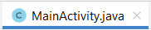
package com.example.sqlite_demo;
import android.app.AlertDialog;
import android.content.DialogInterface;
import android.os.Bundle;
import android.view.View;
import android.widget.AdapterView;
import android.widget.ArrayAdapter;
import android.widget.Button;
import android.widget.EditText;
import android.widget.ListView;
import android.widget.Toast;
import androidx.appcompat.app.AppCompatActivity;
import com.example.sqlite_demo.CustomAdapter;
import com.example.sqlite_demo.DBManager;
import com.example.sqlite_demo.R;
import com.example.sqlite_demo.Student;
import java.util.List;
public class MainActivity extends AppCompatActivity {
private EditText edtName;
private EditText editAddress;
private EditText edtPhoneNumber;
private EditText edtEmail;
private EditText edtId;
private Button btnSave;
private Button btnUpdate;
private ListView lvStudent;
private DBManager dbManager;
private CustomAdapter customAdapter;
private List<Student> studentList;
@Override
protected void onCreate(Bundle savedInstanceState) {
super.onCreate(savedInstanceState);
setContentView(R.layout.activity_main);
dbManager = new DBManager(this);
initWidget();
studentList = dbManager.getAllStudent();
setAdapter();
btnSave.setOnClickListener(new View.OnClickListener() {
@Override
public void onClick(View view) {
Student student = createStudent();
if (student != null) {
dbManager.addStudent(student);
}
updateListStudent();
setAdapter();
}
});
lvStudent.setOnItemClickListener(new AdapterView.OnItemClickListener() {
@Override
public void onItemClick(AdapterView<?> adapterView, View view, int position, long l) {
Student student = studentList.get(position);
edtId.setText(String.valueOf(student.getmID()));
edtName.setText(student.getmName());
editAddress.setText(student.getmAddress());
edtEmail.setText(student.getmEmail());
edtPhoneNumber.setText(student.getmPhoneNumber());
btnSave.setEnabled(false);
btnUpdate.setEnabled(true);
}
});
btnUpdate.setOnClickListener(new View.OnClickListener() {
@Override
public void onClick(View view) {
Student student = new Student();
student.setmID(Integer.parseInt(String.valueOf(edtId.getText())));
student.setmName(edtName.getText()+"");
student.setmAddress(editAddress.getText()+"");
student.setmEmail(edtEmail.getText()+"");
student.setmPhoneNumber(edtPhoneNumber.getText()+"");
int result = dbManager.updateStudent(student);
if(result>0){
updateListStudent();
}
btnSave.setEnabled(true);
btnUpdate.setEnabled(false);
}
});
lvStudent.setOnItemLongClickListener(new AdapterView.OnItemLongClickListener() {
@Override
public boolean onItemLongClick(AdapterView<?> adapterView, View view, final int position, long l) {
AlertDialog.Builder builder = new AlertDialog.Builder(MainActivity.this);
builder.setCancelable(true);
builder.setTitle("Thông báo");
builder.setMessage("Bạn có chắc muốn xóa mục này?");
builder.setPositiveButton("Xác nhận", new DialogInterface.OnClickListener() {
@Override
public void onClick(DialogInterface dialog, int which) {
Student student = studentList.get(position);
int result = dbManager.deleteStudent(student.getmID());
if(result>0){Toast.makeText(MainActivity.this, "Delete successfuly", Toast.LENGTH_SHORT).show();
updateListStudent();
}else
{
Toast.makeText(MainActivity.this,"Delete fail", Toast.LENGTH_SHORT).show();
}
}
});
builder.setNegativeButton("Trở lại", new DialogInterface.OnClickListener() {
@Override
public void onClick(DialogInterface dialog, int which) {
}
});
AlertDialog dialog = builder.create();
dialog.show();
return true;
}
});
}
private Student createStudent() {
String name = edtName.getText().toString();
String address = String.valueOf(editAddress.getText());
String phoneNumber = edtPhoneNumber.getText() + "";
String email = edtEmail.getText().toString();
Student student = new Student(name, address, phoneNumber,
email);
return student;
}
private void initWidget() {
edtName = (EditText) findViewById(R.id.edt_name);
editAddress = (EditText) findViewById(R.id.edt_address);
edtPhoneNumber = (EditText) findViewById(R.id.edt_number);
edtEmail = (EditText) findViewById(R.id.edt_email);
btnSave = (Button) findViewById(R.id.btn_save);
lvStudent = (ListView) findViewById(R.id.lv_student);
edtId = (EditText) findViewById(R.id.edt_id);
btnUpdate = (Button) findViewById(R.id.btn_update);
}
private void setAdapter() {
if (customAdapter == null) {
customAdapter = new CustomAdapter(this,
R.layout.item_listview, studentList);
lvStudent.setAdapter(customAdapter);
}else{
customAdapter.notifyDataSetChanged();
lvStudent.setSelection(customAdapter.getCount()-1);
}
}
public void updateListStudent(){
studentList.clear();
studentList.addAll(dbManager.getAllStudent());
if(customAdapter!= null){
customAdapter.notifyDataSetChanged();
}
}
}

ĐỀ THI ANDROID
Đề 1

Màn hình chính Màn hình 2 Màn hình 3

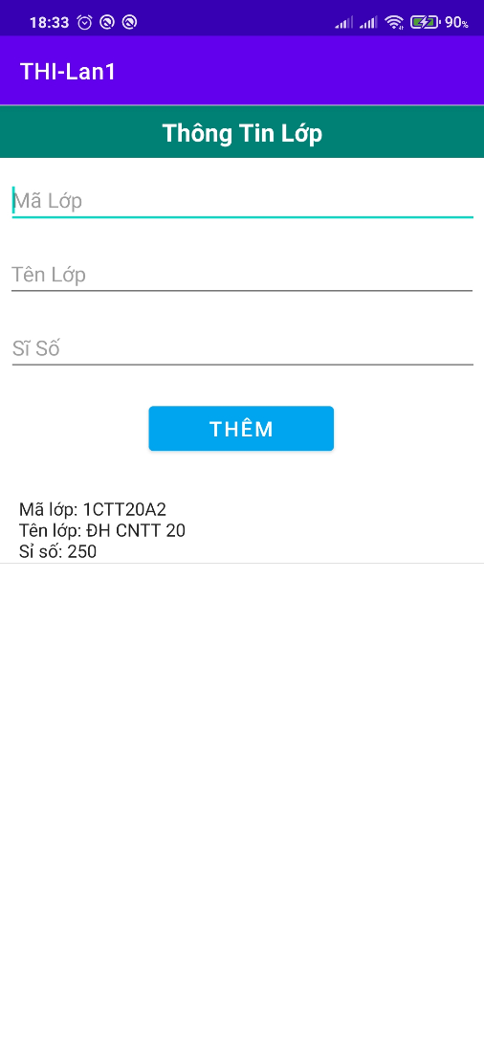
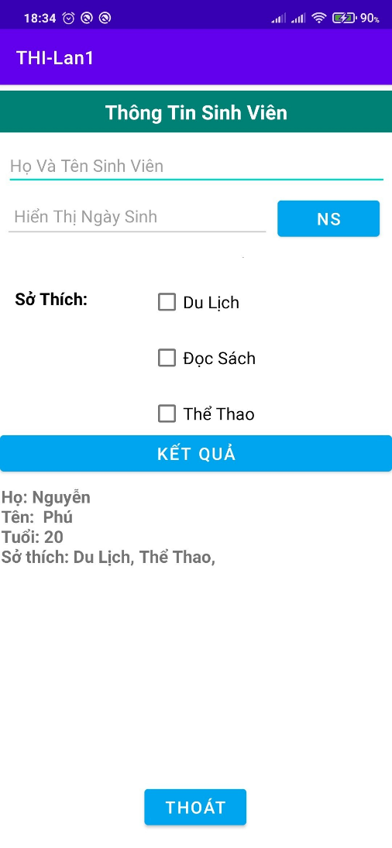
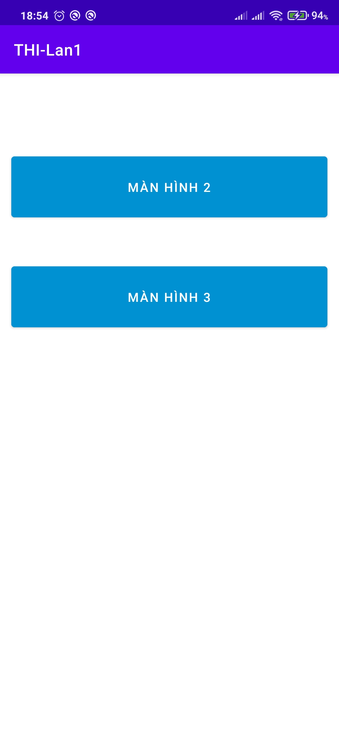

Màn hình 2
+ Button NS : Sử dụng DatePicker để chọn ngày sinh và hiển thị bên Edittext Hiển thị ngày sinh.
+ Button Kết quả : Khi nhấp vào sẽ hiển thị dữ liệu đúng như định dạng bên dưới.(Tách Họ và tên).
+ Button Thoát : Khi nhấp vào sẽ chuyển về màn hình chính.
Màn hình 3
+ Viết lệnh cho phép tạo cơ sở dữ liệu SQLite.
+ Thực hiện thêm thông tin còa cơ sở dữ liệu.
+ Hiển thị cơ sở dữ liệu lên listview.
+ Khi nhấn giữ thông tin trên listview sẽ xóa lớp đang chọn và đồng thời cập nhật lại listview.

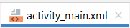
<?xml version="1.0" encoding="utf-8"?>
<androidx.constraintlayout.widget.ConstraintLayout xmlns:android="http://schemas.android.com/apk/res/android"
xmlns:app="http://schemas.android.com/apk/res-auto"
xmlns:tools="http://schemas.android.com/tools"
android:layout_width="match_parent"
android:layout_height="match_parent"
tools:context=".MainActivity">
<Button
android:id="@+id/btn_manhinh2"
android:layout_width="366dp"
android:layout_height="82dp"
android:backgroundTint="#0091D3"
android:text="MÀN HÌNH 2"
android:textSize="16sp"
app:layout_constraintBottom_toBottomOf="parent"
app:layout_constraintEnd_toEndOf="parent"
app:layout_constraintHorizontal_bias="0.488"
app:layout_constraintStart_toStartOf="parent"
app:layout_constraintTop_toTopOf="parent"
app:layout_constraintVertical_bias="0.132" />
<Button
android:id="@+id/btn_manhinh3"
android:layout_width="366dp"
android:layout_height="82dp"
android:backgroundTint="#0091D3"
android:text="MÀN HÌNH 3"
android:textSize="16sp"
app:layout_constraintBottom_toBottomOf="parent"
app:layout_constraintEnd_toEndOf="parent"
app:layout_constraintHorizontal_bias="0.488"
app:layout_constraintStart_toStartOf="parent"
app:layout_constraintTop_toTopOf="parent"
app:layout_constraintVertical_bias="0.318" />
</androidx.constraintlayout.widget.ConstraintLayout>

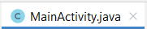
package com.example.thi_lan1;
import androidx.appcompat.app.AppCompatActivity;
import android.content.Intent;
import android.os.Bundle;
import android.view.View;
import android.widget.Button;
public class MainActivity extends AppCompatActivity {
Button btn_manhinh2, btn_manhinh3;
@Override
protected void onCreate(Bundle savedInstanceState) {
super.onCreate(savedInstanceState);
setContentView(R.layout.activity_main);
Button btn_manhinh2=(Button) findViewById(R.id.btn_manhinh2);
Button btn_manhinh3=(Button) findViewById(R.id.btn_manhinh3);
btn_manhinh2.setOnClickListener(new View.OnClickListener() {
@Override
public void onClick(View view) {
Intent intent= new Intent(MainActivity.this,ManHinh2.class);
int CODE= 123;
startActivityForResult(intent,CODE);
}
});
btn_manhinh3.setOnClickListener(new View.OnClickListener() {
@Override
public void onClick(View view) {
Intent intent= new Intent(MainActivity.this,ManHinh3.class);
int CODE= 123;
startActivityForResult(intent,CODE);
}
});
}
}

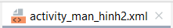
<?xml version="1.0" encoding="utf-8"?>
<androidx.constraintlayout.widget.ConstraintLayout xmlns:android="http://schemas.android.com/apk/res/android"
xmlns:app="http://schemas.android.com/apk/res-auto"
xmlns:tools="http://schemas.android.com/tools"
android:layout_width="match_parent"
android:layout_height="match_parent"
tools:context=".ManHinh2"
android:orientation="horizontal">
<TextView
android:id="@+id/textView"
android:layout_width="match_parent"
android:layout_height="42dp"
android:gravity="center"
android:text="Thông Tin Sinh Viên"
android:textSize="20dp"
android:background="#008175"
android:textStyle="bold"
android:textColor="@color/white"
app:layout_constraintBottom_toBottomOf="parent"
app:layout_constraintEnd_toEndOf="parent"
app:layout_constraintStart_toStartOf="parent"
app:layout_constraintTop_toTopOf="parent"
app:layout_constraintVertical_bias="0.008" />
<EditText
android:id="@+id/edtxt_hotensv"
android:layout_width="382dp"
android:layout_height="43dp"
android:ems="10"
android:hint="Họ Và Tên Sinh Viên"
android:inputType="textPersonName"
android:textSize="17dp"
app:layout_constraintBottom_toBottomOf="parent"
app:layout_constraintEnd_toEndOf="parent"
app:layout_constraintHorizontal_bias="0.551"
app:layout_constraintStart_toStartOf="parent"
app:layout_constraintTop_toBottomOf="@+id/textView"
app:layout_constraintVertical_bias="0.018" />
<EditText
android:id="@+id/edtxt_htns"
android:layout_width="266dp"
android:layout_height="43dp"
android:ems="10"
android:enabled="false"
android:hint="Hiển Thị Ngày Sinh"
android:inputType="textPersonName"
android:textSize="17dp"
app:layout_constraintBottom_toBottomOf="parent"
app:layout_constraintEnd_toEndOf="parent"
app:layout_constraintHorizontal_bias="0.034"
app:layout_constraintStart_toStartOf="parent"
app:layout_constraintTop_toBottomOf="@+id/textView"
app:layout_constraintVertical_bias="0.096" />
<Button
android:id="@+id/btn_noisinh"
android:layout_width="102dp"
android:layout_height="48dp"
android:backgroundTint="#00A5EF"
android:text="NS"
android:textSize="17dp"
app:layout_constraintBottom_toBottomOf="parent"
app:layout_constraintEnd_toEndOf="parent"
app:layout_constraintHorizontal_bias="0.957"
app:layout_constraintStart_toStartOf="parent"
app:layout_constraintTop_toBottomOf="@+id/edtxt_hotensv"
app:layout_constraintVertical_bias="0.012" />
<Button
android:id="@+id/btn_thoat"
android:layout_width="102dp"
android:layout_height="48dp"
android:backgroundTint="#00A5EF"
android:text="Thoát"
android:textSize="17dp"
app:layout_constraintBottom_toBottomOf="parent"
app:layout_constraintEnd_toEndOf="parent"
app:layout_constraintHorizontal_bias="0.498"
app:layout_constraintStart_toStartOf="parent"
app:layout_constraintTop_toBottomOf="@+id/edtxt_hotensv"
app:layout_constraintVertical_bias="0.972" />
<Button
android:id="@+id/btn_ketqua"
android:layout_width="343dp"
android:layout_height="47dp"
android:backgroundTint="#00A5EF"
android:text="Kết Quả"
android:textSize="17dp"
app:layout_constraintBottom_toBottomOf="parent"
app:layout_constraintEnd_toEndOf="parent"
app:layout_constraintStart_toStartOf="parent"
app:layout_constraintTop_toBottomOf="@+id/edtxt_hotensv"
app:layout_constraintVertical_bias="0.384" />
<TextView
android:id="@+id/textView3"
android:layout_width="114dp"
android:layout_height="47dp"
android:layout_marginBottom="516dp"
android:text="Sở Thích:"
android:textColor="@color/black"
android:textSize="17dp"
android:textStyle="bold"
app:layout_constraintBottom_toBottomOf="parent"
app:layout_constraintEnd_toEndOf="parent"
app:layout_constraintHorizontal_bias="0.053"
app:layout_constraintStart_toStartOf="parent" />
<CheckBox
android:id="@+id/cb_docsach"
android:layout_width="128dp"
android:layout_height="48dp"
android:layout_marginBottom="468dp"
android:text="Đọc Sách"
android:textSize="17dp"
app:layout_constraintBottom_toBottomOf="parent"
app:layout_constraintEnd_toEndOf="parent"
app:layout_constraintHorizontal_bias="0.163"
app:layout_constraintStart_toEndOf="@+id/textView3" />
<CheckBox
android:id="@+id/cb_dulich"
android:layout_width="128dp"
android:layout_height="48dp"
android:layout_marginBottom="524dp"
android:text="Du Lịch"
android:textSize="17dp"
app:layout_constraintBottom_toBottomOf="parent"
app:layout_constraintEnd_toEndOf="parent"
app:layout_constraintHorizontal_bias="0.163"
app:layout_constraintStart_toEndOf="@+id/textView3" />
<CheckBox
android:id="@+id/cb_thethao"
android:layout_width="128dp"
android:layout_height="48dp"
android:layout_marginBottom="412dp"
android:text="Thể Thao"
android:textSize="17dp"
app:layout_constraintBottom_toBottomOf="parent"
app:layout_constraintEnd_toEndOf="parent"
app:layout_constraintHorizontal_bias="0.163"
app:layout_constraintStart_toEndOf="@+id/textView3" />
<TextView
android:id="@+id/tview_hienthitt"
android:layout_width="391dp"
android:layout_height="278dp"
android:textSize="17dp"
android:textStyle="bold"
app:layout_constraintBottom_toBottomOf="parent"
app:layout_constraintEnd_toEndOf="parent"
app:layout_constraintStart_toStartOf="parent"
app:layout_constraintTop_toBottomOf="@+id/btn_ketqua"
app:layout_constraintVertical_bias="0.082" />
</androidx.constraintlayout.widget.ConstraintLayout>

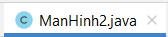

package com.example.thi_lan1;
import androidx.appcompat.app.AppCompatActivity;
import android.annotation.SuppressLint;
import android.app.DatePickerDialog;
import android.content.Intent;
import android.os.Bundle;
import android.view.View;
import android.widget.Button;
import android.widget.CheckBox;
import android.widget.DatePicker;
import android.widget.EditText;
import android.widget.TextView;
import android.widget.Toast;
import java.text.SimpleDateFormat;
import java.util.Calendar;
public class ManHinh2 extends AppCompatActivity {
EditText edtxt_hotensv, edtxt_htns;
TextView tview_hienthitt;
Button btn_thoat, btn_noisinh, btn_ketqua;
CheckBox cb_dulich, cb_docsach, cb_thethao;
@SuppressLint("MissingInflatedId")
@Override
protected void onCreate(Bundle savedInstanceState) {
super.onCreate(savedInstanceState);
setContentView(R.layout.activity_man_hinh2);
edtxt_hotensv= (EditText) findViewById(R.id.edtxt_hotensv);
edtxt_htns= (EditText) findViewById(R.id.edtxt_htns);
tview_hienthitt= (TextView) findViewById(R.id.tview_hienthitt);
btn_thoat= (Button) findViewById(R.id.btn_thoat);
btn_ketqua= (Button) findViewById(R.id.btn_ketqua);
btn_noisinh= (Button) findViewById(R.id.btn_noisinh);
cb_dulich= (CheckBox) findViewById(R.id.cb_dulich);
cb_docsach= (CheckBox) findViewById(R.id.cb_docsach);
cb_thethao= (CheckBox) findViewById(R.id.cb_thethao);
btn_thoat.setOnClickListener(new View.OnClickListener() {
@Override
public void onClick(View view) {
Intent data= new Intent();
setResult(RESULT_OK,data);
ManHinh2.super.finish();
}
});
btn_noisinh.setOnClickListener(new View.OnClickListener() {
@Override
public void onClick(View view) {
ChonNgay();
}
});
}
private void ChonNgay(){
Calendar calendar= Calendar.getInstance();
int ngay= calendar.get(Calendar.DATE);
int thang= calendar.get(Calendar.MONTH);
int nam= calendar.get(Calendar.YEAR);
DatePickerDialog datePickerDialog= new DatePickerDialog(this, new DatePickerDialog.OnDateSetListener() {
@Override
public void onDateSet(DatePicker datePicker, int i, int i1, int i2) {
calendar.set(i, i1, i2);
SimpleDateFormat simpleDateFormat = new SimpleDateFormat("dd/MM/yyyy");
edtxt_htns.setText(simpleDateFormat.format(calendar.getTime()));
}
},nam,thang,ngay);
datePickerDialog.show();
btn_ketqua.setOnClickListener(new View.OnClickListener() {
@Override
public void onClick(View view) {
String kq="";//Biến tổng hiện kết quả
String hoten="";
String htt = edtxt_hotensv.getText().toString();
String[] ht= htt.split("");
hoten = edtxt_hotensv.getText().toString().trim(); //Lấy dữ liệu từ edittext
if (ht.length<2){
Toast.makeText(ManHinh2.this,"Họ tên phải ít nhất 2 từ !",Toast.LENGTH_SHORT).show();
return;
}
hoten=hoten.trim(); // loại bỏ dấu cách đâu và cuối
//tách họ
String ho = hoten.substring(0,hoten.indexOf(" "));
//tách tên đệm
//String tendem = hoten.substring(hoten.indexOf(" "), hoten.lastIndexOf(" ");
//tách tên
String ten = hoten.substring(hoten.lastIndexOf(" "));
kq += "Họ: "+ho + "\n";
kq += "Tên: "+ten + "\n";
//Tuổi
int tuoi=0; // khai báo biến tuổi gán tuổi bằng 0;
String namsinh = edtxt_htns.getText().toString(); //khai báo một biến namsinh lấy dữ liệu từ editText ngày sinh
int nam = Integer.parseInt(namsinh.substring(6)); //khai báo biến năm, cắt chuỗi lấy năm ép từ chuỗi về số nguyên
//lấy năm hiện tại
Calendar c = Calendar.getInstance();
int year = c.get(Calendar.YEAR);
tuoi = year-nam; // tính tuổi lấy năm hiện tại trừ cho biến năm đã lấy ở trên
kq +="Tuổi: " + tuoi +"\n";
//Sở thích
int dem = 0;
String sth="";
if(cb_dulich.isChecked()){
sth+= cb_dulich.getText().toString() + ", ";
dem++;
}
if(cb_docsach.isChecked()){
sth+= cb_docsach.getText().toString() + ", ";
dem++;
}
if(cb_thethao.isChecked()){
sth+= cb_thethao.getText().toString() + ", ";
dem++;
}
if(dem == 0){
Toast.makeText(ManHinh2.this, "Sở thích ít nhất phải chọn một", Toast.LENGTH_SHORT).show();
}
else {
kq += "Sở thích: "+ sth + "\n";
}
tview_hienthitt.setText(kq);
}
});
}
}

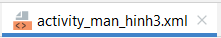

<?xml version="1.0" encoding="utf-8"?>
<androidx.constraintlayout.widget.ConstraintLayout xmlns:android="http://schemas.android.com/apk/res/android"
xmlns:app="http://schemas.android.com/apk/res-auto"
xmlns:tools="http://schemas.android.com/tools"
android:layout_width="match_parent"
android:layout_height="match_parent"
tools:context=".ManHinh3">
<TextView
android:id="@+id/textView"
android:layout_width="match_parent"
android:layout_height="42dp"
android:gravity="center"
android:text="Thông Tin Lớp"
android:textSize="20dp"
android:background="#008175"
android:textStyle="bold"
android:textColor="@color/white"
app:layout_constraintBottom_toBottomOf="parent"
app:layout_constraintEnd_toEndOf="parent"
app:layout_constraintHorizontal_bias="0.498"
app:layout_constraintStart_toStartOf="parent"
app:layout_constraintTop_toTopOf="parent"
app:layout_constraintVertical_bias="0.001" />
<Button
android:id="@+id/btn_them"
android:layout_width="150dp"
android:layout_height="48dp"
android:backgroundTint="#00A5EF"
android:text="Thêm"
android:textSize="17dp"
app:layout_constraintBottom_toBottomOf="parent"
app:layout_constraintEnd_toEndOf="parent"
app:layout_constraintHorizontal_bias="0.498"
app:layout_constraintStart_toStartOf="parent"
app:layout_constraintTop_toTopOf="parent"
app:layout_constraintVertical_bias="0.333" />
<EditText
android:id="@+id/edtxt_malop"
android:layout_width="382dp"
android:layout_height="43dp"
android:ems="10"
android:hint="Mã Lớp"
android:inputType="textPersonName"
android:textSize="17dp"
app:layout_constraintBottom_toBottomOf="parent"
app:layout_constraintEnd_toEndOf="parent"
app:layout_constraintHorizontal_bias="0.551"
app:layout_constraintStart_toStartOf="parent"
app:layout_constraintTop_toTopOf="parent"
app:layout_constraintVertical_bias="0.078" />
<EditText
android:id="@+id/edtxt_tenlop"
android:layout_width="382dp"
android:layout_height="43dp"
android:ems="10"
android:hint="Tên Lớp"
android:inputType="textPersonName"
android:textSize="17dp"
app:layout_constraintBottom_toBottomOf="parent"
app:layout_constraintEnd_toEndOf="parent"
app:layout_constraintHorizontal_bias="0.482"
app:layout_constraintStart_toStartOf="parent"
app:layout_constraintTop_toTopOf="parent"
app:layout_constraintVertical_bias="0.161" />
<EditText
android:id="@+id/edtxt_siso"
android:layout_width="382dp"
android:layout_height="43dp"
android:ems="10"
android:hint="Sĩ Số"
android:inputType="number"
android:textSize="17dp"
app:layout_constraintBottom_toBottomOf="parent"
app:layout_constraintEnd_toEndOf="parent"
app:layout_constraintHorizontal_bias="0.551"
app:layout_constraintStart_toStartOf="parent"
app:layout_constraintTop_toTopOf="parent"
app:layout_constraintVertical_bias="0.244" />
<ListView
android:id="@+id/lv_htthongtin"
android:layout_width="395dp"
android:layout_height="420dp"
app:layout_constraintBottom_toBottomOf="parent"
app:layout_constraintEnd_toEndOf="parent"
app:layout_constraintStart_toStartOf="parent"
app:layout_constraintTop_toTopOf="parent"
app:layout_constraintVertical_bias="0.919" />
</androidx.constraintlayout.widget.ConstraintLayout>

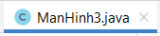

package com.example.thi_lan1;
import androidx.appcompat.app.AppCompatActivity;
import android.content.ContentValues;
import android.database.Cursor;
import android.database.sqlite.SQLiteDatabase;
import android.os.Bundle;
import android.util.Log;
import android.view.View;
import android.widget.AbsListView;
import android.widget.AdapterView;
import android.widget.ArrayAdapter;
import android.widget.Button;
import android.widget.EditText;
import android.widget.ListView;
import android.widget.Toast;
import java.util.ArrayList;
import java.util.concurrent.locks.Condition;
public class ManHinh3 extends AppCompatActivity {
SQLiteDatabase mydatabase;
ArrayList<String> mylist= new ArrayList<>();
@Override
protected void onCreate(Bundle savedInstanceState) {
super.onCreate(savedInstanceState);
setContentView(R.layout.activity_man_hinh3);
EditText edtxt_malop= (EditText) findViewById(R.id.edtxt_malop);
EditText edtxt_tenlop= (EditText) findViewById(R.id.edtxt_tenlop);
EditText edtxt_siso= (EditText) findViewById(R.id.edtxt_siso);
Button btn_them= (Button) findViewById(R.id.btn_them);
ListView lv_htthongtin= (ListView) findViewById(R.id.lv_htthongtin);
ArrayAdapter<String> myadapter= new ArrayAdapter<>(this, android.R.layout.simple_list_item_1, mylist);
lv_htthongtin.setAdapter(myadapter);
mydatabase = openOrCreateDatabase("qlsinhvien.db", MODE_PRIVATE, null);
try {
String sql= "CREATE TABLE thoai (malop TEXT primary key,tenlop TEXT, siso INTEGER)";
mydatabase.execSQL(sql);
}catch (Exception e){
Log.e("Error","Đã tồn tại bảng");
}
btn_them.setOnClickListener(new View.OnClickListener() {
@Override
public void onClick(View view) {
String malop= edtxt_malop.getText().toString();
String tenlop= edtxt_tenlop.getText().toString();
int siso= Integer.parseInt(edtxt_siso.getText().toString());
ContentValues myvalue= new ContentValues();
myvalue.put("malop", malop);
myvalue.put("tenlop", tenlop);
myvalue.put("siso", siso);
String msg="";
if (mydatabase.insert("thoai", null,myvalue) ==-1){
msg= "Lỗi !";
}else{
msg="Thêm thành công !";
}
Toast.makeText(ManHinh3.this,msg,Toast.LENGTH_SHORT).show();
mylist.clear();
Cursor c= mydatabase.query("thoai",null,null,null,null,null,null);
c.moveToFirst();
String data= "";
while (c.isAfterLast() == false){
data= "Mã lớp: " + c.getString(0) + "\nTên lớp: " + c.getString(1) + "\nSỉ số: " + c.getString(2);
c.moveToNext();
mylist.add(data);
}
c.close();
myadapter.notifyDataSetChanged();
}
});
//Xóa dữ liệu trên listview
lv_htthongtin.setOnItemLongClickListener(new AdapterView.OnItemLongClickListener() {
@Override
public boolean onItemLongClick(AdapterView<?> adapterView, View view, int i, long l) {
mylist.remove(i);
myadapter.notifyDataSetChanged();
return false;
}
});
}
}

ĐỀ THI ANDROID
Đề 2

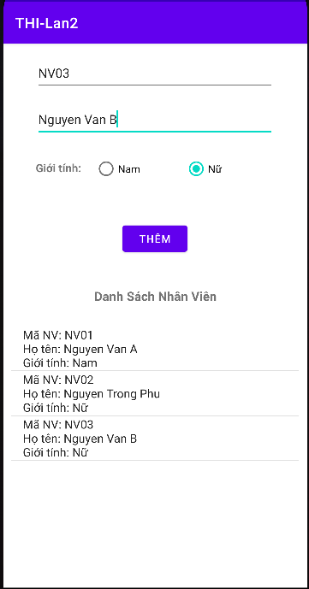
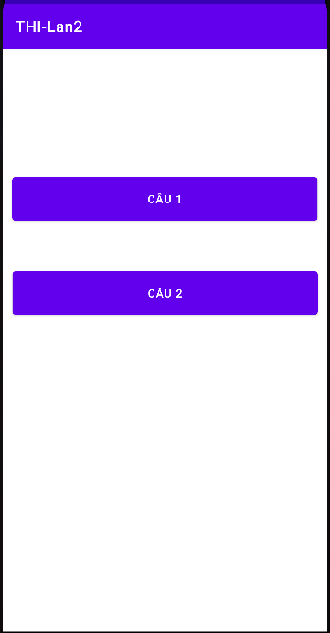
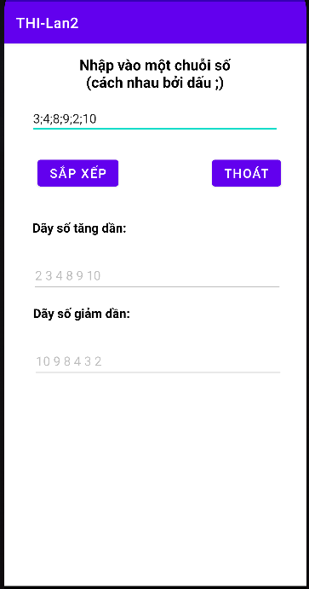
Màn hình 1 Màn hình 2 Màn hình 3

Màn hình 1
package com.example.thi_lan2;
import androidx.appcompat.app.AppCompatActivity;
import android.content.Intent;
import android.os.Bundle;
import android.view.View;
import android.widget.Button;
public class MainActivity extends AppCompatActivity {
@Override
protected void onCreate(Bundle savedInstanceState) {
super.onCreate(savedInstanceState);
setContentView(R.layout.activity_main);
Button btn_cau1=(Button) findViewById(R.id.btn_cau1);
Button btn_cau2=(Button) findViewById(R.id.btn_cau2);
btn_cau1.setOnClickListener(new View.OnClickListener() {
@Override
public void onClick(View view) {
Intent intent=new Intent(MainActivity.this,ManHinh2.class);
int CODE=123;
startActivityForResult(intent,CODE);
}
});
btn_cau2.setOnClickListener(new View.OnClickListener() {
@Override
public void onClick(View view) {
Intent intent= new Intent(MainActivity.this,ManHinh3.class);
int CODE= 123;
startActivityForResult(intent,CODE);
}
});
}
}

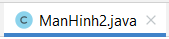
package com.example.thi_lan2;
import androidx.appcompat.app.AppCompatActivity;
import android.graphics.ColorMatrix;
import android.os.Bundle;
import android.view.View;
import android.widget.Button;
import android.widget.EditText;
import java.util.ArrayList;
import java.util.Collections;
public class ManHinh2 extends AppCompatActivity {
String td="", gd="";
ArrayList<Integer> arrayList;
@Override
protected void onCreate(Bundle savedInstanceState) {
super.onCreate(savedInstanceState);
setContentView(R.layout.activity_man_hinh2);
EditText edt_nhapso=(EditText) findViewById(R.id.edt_nhapso);
EditText edt_kqtang=(EditText) findViewById(R.id.edt_kqtang);
EditText edt_kqgiam=(EditText) findViewById(R.id.edt_kqgiam);
Button btn_sapxep=(Button) findViewById(R.id.btn_sapxep);
Button btn_thoat=(Button) findViewById(R.id.btn_thoat);
btn_sapxep.setOnClickListener(new View.OnClickListener() {
@Override
public void onClick(View view) {
arrayList = new ArrayList<>();
String a = edt_nhapso.getText().toString();
String []dl = a.split(";");
for(int i = 0; i < dl.length;i++)
{
arrayList.add(Integer.parseInt(dl[i]));
}
Collections.sort(arrayList);
for(int i = 0; i < arrayList.size();i++)
{
td +=arrayList.get(i)+" ";
}
edt_kqtang.setText(td);
Collections.sort(arrayList,Collections.reverseOrder());
for(int i = 0; i < arrayList.size();i++)
{
gd +=arrayList.get(i)+" ";
}
edt_kqgiam.setText(gd);
}
});
}
}
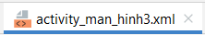
<?xml version="1.0" encoding="utf-8"?>
<androidx.constraintlayout.widget.ConstraintLayout xmlns:android="http://schemas.android.com/apk/res/android"
xmlns:app="http://schemas.android.com/apk/res-auto"
xmlns:tools="http://schemas.android.com/tools"
android:layout_width="match_parent"
android:layout_height="match_parent"
tools:context=".ManHinh3">
<EditText
android:id="@+id/edt_nhapmanv"
android:layout_width="324dp"
android:layout_height="49dp"
android:ems="10"
android:inputType="textPersonName"
android:textSize="17dp"
android:hint="Nhập Mã NV"
app:layout_constraintBottom_toBottomOf="parent"
app:layout_constraintEnd_toEndOf="parent"
app:layout_constraintHorizontal_bias="0.494"
app:layout_constraintStart_toStartOf="parent"
app:layout_constraintTop_toTopOf="parent"
app:layout_constraintVertical_bias="0.023" />
<EditText
android:id="@+id/edt_nhaphotennv"
android:layout_width="324dp"
android:layout_height="49dp"
android:ems="10"
android:inputType="textPersonName"
android:hint="Nhập họ tên nhân viên"
android:textSize="17dp"
app:layout_constraintBottom_toBottomOf="parent"
app:layout_constraintEnd_toEndOf="parent"
app:layout_constraintHorizontal_bias="0.494"
app:layout_constraintStart_toStartOf="parent"
app:layout_constraintTop_toTopOf="parent"
app:layout_constraintVertical_bias="0.114" />
<TextView
android:id="@+id/textView4"
android:layout_width="wrap_content"
android:layout_height="wrap_content"
android:text="Giới tính:"
android:textSize="15dp"
android:textStyle="bold"
app:layout_constraintBottom_toBottomOf="parent"
app:layout_constraintEnd_toEndOf="parent"
app:layout_constraintHorizontal_bias="0.125"
app:layout_constraintStart_toStartOf="parent"
app:layout_constraintTop_toTopOf="parent"
app:layout_constraintVertical_bias="0.221" />
<TextView
android:id="@+id/textView5"
android:layout_width="225dp"
android:layout_height="35dp"
android:text="Danh Sách Nhân Viên"
android:textAlignment="center"
android:textSize="17dp"
android:textStyle="bold"
app:layout_constraintBottom_toBottomOf="parent"
app:layout_constraintEnd_toEndOf="parent"
app:layout_constraintStart_toStartOf="parent"
app:layout_constraintTop_toTopOf="parent"
app:layout_constraintVertical_bias="0.471" />
<RadioGroup
android:id="@+id/rdg_gioitinh"
android:layout_width="244dp"
android:layout_height="59dp"
android:orientation="horizontal"
android:weightSum="2"
app:layout_constraintBottom_toBottomOf="parent"
app:layout_constraintEnd_toEndOf="parent"
app:layout_constraintHorizontal_bias="0.736"
app:layout_constraintStart_toStartOf="parent"
app:layout_constraintTop_toTopOf="parent"
app:layout_constraintVertical_bias="0.215">
<RadioButton
android:id="@+id/rdb_nam"
android:layout_width="match_parent"
android:layout_height="wrap_content"
android:layout_weight="1"
android:text="Nam" />
<RadioButton
android:id="@+id/rdb_nu"
android:layout_width="match_parent"
android:layout_height="wrap_content"
android:layout_weight="1"
android:text="Nữ" />
</RadioGroup>
<Button
android:id="@+id/btn_them"
android:layout_width="wrap_content"
android:layout_height="wrap_content"
android:text="Thêm"
app:layout_constraintBottom_toBottomOf="parent"
app:layout_constraintEnd_toEndOf="parent"
app:layout_constraintHorizontal_bias="0.498"
app:layout_constraintStart_toStartOf="parent"
app:layout_constraintTop_toTopOf="parent"
app:layout_constraintVertical_bias="0.349" />
<ListView
android:id="@+id/lv_hienthikq"
android:layout_width="390dp"
android:layout_height="337dp"
app:layout_constraintBottom_toBottomOf="parent"
app:layout_constraintEnd_toEndOf="parent"
app:layout_constraintHorizontal_bias="0.476"
app:layout_constraintStart_toStartOf="parent"
app:layout_constraintTop_toTopOf="parent"
app:layout_constraintVertical_bias="0.959" />
</androidx.constraintlayout.widget.ConstraintLayout>

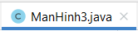
package com.example.thi_lan2;
import androidx.appcompat.app.AppCompatActivity;
import android.content.ContentValues;
import android.database.Cursor;
import android.database.sqlite.SQLiteDatabase;
import android.os.Bundle;
import android.util.Log;
import android.view.View;
import android.widget.ArrayAdapter;
import android.widget.Button;
import android.widget.EditText;
import android.widget.ListView;
import android.widget.RadioButton;
import android.widget.RadioGroup;
import android.widget.Toast;
import java.util.ArrayList;
public class ManHinh3 extends AppCompatActivity {
SQLiteDatabase mydatabase;
ArrayList<String> mylist= new ArrayList<>();
ArrayAdapter<String> myadapter;
@Override
protected void onCreate(Bundle savedInstanceState) {
super.onCreate(savedInstanceState);
setContentView(R.layout.activity_man_hinh3);
EditText edt_nhapmanv= (EditText) findViewById(R.id.edt_nhapmanv);
EditText edt_nhaphotennv=(EditText) findViewById(R.id.edt_nhaphotennv);
RadioGroup rdg_gioitinh=(RadioGroup) findViewById(R.id.rdg_gioitinh);
RadioButton rdb_nam= (RadioButton) findViewById(R.id.rdb_nam);
RadioButton rdb_nu= (RadioButton) findViewById(R.id.rdb_nu);
Button btn_them= (Button) findViewById(R.id.btn_them);
ListView lv_hienthikq= (ListView) findViewById(R.id.lv_hienthikq);
myadapter= new ArrayAdapter<>(this, android.R.layout.simple_list_item_1,mylist);
lv_hienthikq.setAdapter(myadapter);
mydatabase=openOrCreateDatabase("qlnhanvien.db", MODE_PRIVATE, null);
try {
String sql="CREATE TABLE dulieu (manv TEXT primary key,tennv TEXT, gioitinh TEXT)";
mydatabase.execSQL(sql);
}catch (Exception e){
Log.e("Error","Đã tồn tại bảng");
}
btn_them.setOnClickListener(new View.OnClickListener() {
@Override
public void onClick(View view) {
String manv = edt_nhapmanv.getText().toString();
String hotennv = edt_nhaphotennv.getText().toString();
int id = rdg_gioitinh.getCheckedRadioButtonId();
RadioButton ra = findViewById(id);
String gioitinh = ra.getText().toString();
ContentValues myvalue = new ContentValues();
myvalue.put("manv",manv);
myvalue.put("tennv",hotennv);
myvalue.put("gioitinh",gioitinh);
String msg = "";
if(mydatabase.insert("dulieu",null,myvalue)==-1){
msg = "Lỗi !";
}
else{
msg = "Thêm thành công !";
}
Toast.makeText(ManHinh3.this, msg, Toast.LENGTH_SHORT).show();
loaddata();
}
});
}
private void loaddata() {
mylist.clear();
Cursor c= mydatabase.query("dulieu",null,null,null,null,null,null);
c.moveToFirst();
String data= "";
while (c.isAfterLast() == false){
data= "Mã NV: " + c.getString(0) + "\nHọ tên: " + c.getString(1) + "\nGiới tính: " + c.getString(2);
c.moveToNext();
mylist.add(data);
}
c.close();
myadapter.notifyDataSetChanged();
}
}

CODE SQLITE
Code này mình xin của bạn Phan Hồng Phú

*CODE NHẬN:
txtNhan=(TextView) this.findViewById(R.id.txtNhan);
Intent intent = this.getIntent();
String Ten = intent.getStringExtra("Ten");
String Tuoi = intent.getStringExtra("Tuoi");
String Nhan = "Hello "+Ten+" "+Tuoi;
txtNhan.setText(Nhan);
btnQuayLai.setOnClickListener(new View.OnClickListener() {
@Override
public void onClick(View v) {
finish();
}
});
}
@Override
public void finish() {
Intent intent = new Intent(MainActivity2.this,MainActivity.class);
intent.putExtra("feedback",txtTT.getText().toString());
startActivity(intent);
super.finish();
}
}
*CODE GỬI
btnGui.setOnClickListener(new View.OnClickListener() {
@Override
public void onClick(View v) {
Intent intent = new Intent(MainActivity.this,MainActivity2.class);
intent.putExtra("Ten",txtTen.getText().toString());
intent.putExtra("Tuoi",txtTuoi.getText().toString());
startActivity(intent);
}
});
Intent data = getIntent();
txtfb.setText(data.getStringExtra("feedback"));
}
}

*CODE ALERTDIALOG
public class MainActivity extends AppCompatActivity {
AlertDialog.Builder builder;
@Override
protected void onCreate(Bundle savedInstanceState) {
super.onCreate(savedInstanceState);
setContentView(R.layout.activity_main);
builder = new AlertDialog.Builder(this);
btnGui.setOnClickListener(new View.OnClickListener() {
@SuppressLint("ResourceType")
@Override
public void onClick(View v) {
ArrayList <String> list = new ArrayList<String>();
String a = txtHoTen.getText().toString();
String ht[] = a.split(" ");
if(ht.length < 3 || txtHoTen.getText()=="")
{
builder.show();
builder.setMessage("Hảy nhập lại tên ").setPositiveButton("OK", new DialogInterface.OnClickListener() {
@Override
public void onClick(DialogInterface dialog, int which) {
dialog.cancel();
}
});
}
list.add(txtHoTen.getText().toString()+'\n');
list.add(txtCMND.getText().toString()+'\n');
if(btnTrungCap.isChecked()==true)
{
list.add(btnTrungCap.getText().toString()+'\n');
}
else if(btnCaoDang.isChecked()==true)
{
list.add(btnCaoDang.getText().toString()+'\n');
}
else
{
list.add(btnDaiHoc.getText().toString()+'\n');
}
String st ="";
if(btnDocSach.isChecked()==true)
{
st = st + btnDocSach.getText().toString() + " ";
}
if(btnDocBao.isChecked()==true)
{
st =st + btnDocBao.getText().toString()+ " ";
}
if(btnCoding.isChecked()==true)
{
st = st + btnCoding.getText().toString();
}
list.add(st +'\n');
list.add("------------------------"+'\n');
list.add("Thông tin bổ sung"+'\n');
list.add(txtBoSung.getText().toString()+'\n');
list.add("------------------------"+'\n');
String tt ="";
for(int i = 0; i < list.size();i++)
{
tt=tt+ list.get(i);
}
}

* CODE LISTVIEW
public class MainActivity extends AppCompatActivity {
ArrayList<String> list_items = new ArrayList<>();
ArrayAdapter<String> adapter;
ListView l;
TextView txtTT;
@Override
protected void onCreate(Bundle savedInstanceState) {
super.onCreate(savedInstanceState);
setContentView(R.layout.activity_main);
txtTT = (TextView) findViewById(R.id.txtTT);
l = (ListView) findViewById(R.id.l);
list_items.add("A");
list_items.add("B");
list_items.add("C");
list_items.add("D");
adapter = new ArrayAdapter<String>(this, android.R.layout.simple_list_item_1,list_items);
l.setAdapter(adapter);
l.setOnItemClickListener(new AdapterView.OnItemClickListener() {
@SuppressLint("SetTextI18n")
@Override
public void onItemClick(AdapterView<?> parent, View view, int position, long id) {
txtTT.setText("position: "+position + " value "+ list_items.get(position));
}
});
}
CODE SỐ NGUYÊN TỐ
int a = Integer.parseInt(txtSoA.getText().toString());
int d = 0;
if(a <2)
{
txtKQ.setText("Không là số nguyên tố");
}
else
{
for(int i = 1; i <= a;i++)
{
if(a%i == 0)
{
d=d+1;
}
}
if(d == 2)
{
txtKQ.setText("Là số nguyên tố");
}
else
{
txtKQ.setText("Không là số nguyên tố");
}

TOAST
Toast.makeText(TenActivity.this, "Content", Toast.LENGTH_SHORT).show();

* NHẬP TỪNG SỐ VÀ TÁCH CHUỔI SỐ
arrayList = new ArrayList<>();
String a = txtNhap.getText().toString();
for(int i = 0; i < a.length();i++)
{
arrayList.add(Integer.parseInt(String.valueOf(a.charAt(i))));
}
for(int i = 0; i < arrayList.size();i++)
{
kt = kt + arrayList.get(i)+" ";
}
txtHT.setText(kt);

* SẮP XẾP TĂNG DẦN
arrayList = new ArrayList<>();
String a = txtHT.getText().toString();
String []st = a.split(" ");
String td = "";
for(int i = 0; i < st.length;i++)
{
arrayList.add(Integer.parseInt(String.valueOf(st[i])));
}
arrayList.sort(Comparator.naturalOrder());
for(int i = 0; i < arrayList.size();i++)
{
td = td + arrayList.get(i)+" ";
}
txtTD.setText(td);

* SẮP XẾP GIẢM DẦN
arrayList = new ArrayList<>();
String a = txtHT.getText().toString();
String []st = a.split(" ");
String gd = "";
for(int i = 0; i < st.length;i++)
{
arrayList.add(Integer.parseInt(String.valueOf(st[i])));
}
arrayList.sort(Comparator.reverseOrder());
for(int i = 0; i < arrayList.size();i++)
{
gd = gd + arrayList.get(i)+" ";
}
txtGD.setText(gd);

* DATETIMEPICKER
int day, month, year;
Calendar c = Calendar.getInstance();
day = c.get(Calendar.DAY_OF_MONTH);
month = c.get(Calendar.MONTH);
year = c.get(Calendar.YEAR);
DatePickerDialog dpg = new DatePickerDialog(MainActivity.this, new DatePickerDialog.OnDateSetListener() {
@Override
public void onDateSet(DatePicker view, int year, int month, int dayOfMonth) {
String select = new StringBuilder().append(dayOfMonth).append("/").append(month).append("/").append(year).toString();
txtNgaySinh.setText(select);
}
}, year, month, day);
dpg.setTitle("Chọn ngày sinh của bạn ");
dpg.show();

* CODE TẠO CSDL SQLITE

public class DBManager extends SQLiteOpenHelper {
private final String TAG = "DBManager";
private static final String TABLE_NAME = "Students";
private static final String DATABASE_NAME = "DBStudent";
private static final String MSSV = "mssv";
private static final String HOTEN = "hoten";
private String SQLQuery = "CREATE TABLE Students (MSSV TEXT, HOTEN TEXT)";
public DBManager(Context context) {
super(context, DATABASE_NAME, null, 1);
}
@Override
public void onCreate(SQLiteDatabase db) {
db.execSQL(SQLQuery);
}
@Override
public void onUpgrade(SQLiteDatabase db, int oldVersion, int newVersion) {
db.execSQL("DROP TABLE IF EXISTS Students");
}

- CÓ VIEWHODER

THÊM SINH VIÊN

public Boolean themSV(String mssv,String hoten){
SQLiteDatabase db = this.getWritableDatabase();
ContentValues contentValues = new ContentValues();
contentValues.put("mssv",mssv);
contentValues.put("hoten",hoten);
long result = db.insert("Students",null,contentValues);
if(result == -1)
{
return false;
}
else
{
return true;
}
}

* LẤY TOÀN BỘ SINH VIÊN

public ArrayList<SinhVien>layDSSV(){
ArrayList<SinhVien> arr = new ArrayList<>();
SQLiteDatabase db = this.getWritableDatabase();
Cursor cursor = db.rawQuery("SELECT * FROM Students",null);
while (cursor.moveToNext()){
SinhVien sv = new SinhVien(cursor.getString(0),cursor.getString(1));
arr.add(sv);
}
return arr;
}

* CẬP NHẬT DANH SÁCH SV

public int UpdateSV(SinhVien sv){
SQLiteDatabase db = this.getWritableDatabase();
ContentValues contentValues = new ContentValues();
contentValues.put("mssv",sv.getMSSV());
contentValues.put("hoten",sv.getHoTen());
return db.update(TABLE_NAME,contentValues,MSSV+"=?",new String[]{String.valueOf(sv.getMSSV())});
}
* GỌI HÀM LẤY DS TRONG MAIN + CẬP NHẬT KHI LƯU

public class MainActivity extends AppCompatActivity {
TextView txtMSSV,txtHoTen;
Button btnNhap;
ListView listView;
ArrayList<SinhVien> list = new ArrayList<>();
CustomAdapter adapter;
DBManager db = new DBManager(this);
@Override
protected void onCreate(Bundle savedInstanceState) {
super.onCreate(savedInstanceState);
setContentView(R.layout.activity_main);
txtMSSV = findViewById(R.id.txtMSSV);
txtHoTen = findViewById(R.id.txtHoTen);
btnNhap = findViewById(R.id.btnNhap);
listView = findViewById(R.id.listView);
setAdapter();
btnNhap.setOnClickListener(new View.OnClickListener() {
@Override
public void onClick(View v) {
SinhVien sv = new SinhVien();
if(sv != null)
{
db.themSV(txtMSSV.getText().toString(),txtHoTen.getText().toString());
}
db.UpdateSV(sv);
setAdapter();
}
});
}
* HÀM KÈM THEO KHI CẬP NHẬT
public void setAdapter(){
list = db.layDSSV();
adapter = new CustomAdapter(MainActivity.this,R.layout.activity_main,list);
listView.setAdapter(adapter);
}
}

* XÓA SV KHI NHẤN GIỮ LISTVIEW

listView.setOnItemLongClickListener(new AdapterView.OnItemLongClickListener() {
@Override
public boolean onItemLongClick(AdapterView<?> parent, View view, int position, long id) {
AlertDialog.Builder builder = new AlertDialog.Builder(MainActivity.this);
builder.setTitle("Thông Báo");
builder.setMessage("Bạn có muốn xóa sinh viên này");
builder.setPositiveButton("OK", new DialogInterface.OnClickListener() {
@Override
public void onClick(DialogInterface dialog, int which) {
SinhVien sv = list.get(position);
int result = db.XoaSV(sv.getMSSV());
if(result > 0)
{
Toast.makeText(MainActivity.this,"Xóa thành công",Toast.LENGTH_SHORT).show();
UpdateListSV();
}
else
{
Toast.makeText(MainActivity.this,"Xóa thất bại ",Toast.LENGTH_SHORT).show();
}
}
}).setNegativeButton("Cancel", new DialogInterface.OnClickListener() {
@Override
public void onClick(DialogInterface dialog, int which) {
dialog.cancel();
}
});
builder.show();
return true;
}
});

* HÀM KÈM THEO KHI XÓA

public void UpdateListSV(){
list.clear();
list.addAll(db.layDSSV());
if(adapter != null)
{
adapter.notifyDataSetChanged();
}
}

* CUSTOMADAPTER
public class CustomAdapter extends ArrayAdapter<SinhVien> {
private Context context;
private int resoure;
private List<SinhVien> listSinhVien;
public CustomAdapter(@NonNull Context context, int resource, @NonNull List<SinhVien> objects) {
super(context, resource, objects);
this.context = context;
this.resoure = resource;
this.listSinhVien= objects;
}
@NonNull
@Override
public View getView(int position, @Nullable View convertView, @NonNull ViewGroup parent) {
ViewHolder viewHolder;
if(convertView == null)
{
convertView = LayoutInflater.from(context).inflate(R.layout.custom_listview,parent,false);
viewHolder = new ViewHolder();
viewHolder.txtmssv = convertView.findViewById(R.id.txtmssv);
viewHolder.txthoten = convertView.findViewById(R.id.txthoten);
convertView.setTag(viewHolder);
}
else
{
viewHolder = (ViewHolder) convertView.getTag();
}
SinhVien sv = listSinhVien.get(position);
viewHolder.txtmssv.setText(sv.getMSSV());
viewHolder.txthoten.setText(sv.getHoTen());
return convertView;
}
public class ViewHolder{
private TextView txtmssv;
private TextView txthoten;
}
}

