Thema: RNA -Seq

# Name: Dang Quynh Tram Nguyen

1. **Verfahren Methode:**

Genome

Mappen mit hisat2, dabei die Spleiße auf den Reads erkannt werden und die Isoformen nicht verpasst werden.

1. **Readcounts**

Nutzen featureCounts.

|  |  |
| --- | --- |
| **Bezeichnungen** | **Read Counts** |
| Control 1 | 11153277 |
| Control 2 | 13913852 |
| E2 1 | 12238113 |
| E2 2 | 13055193 |

1. **Scatterplot**

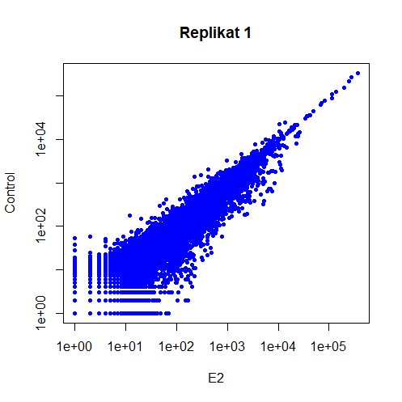

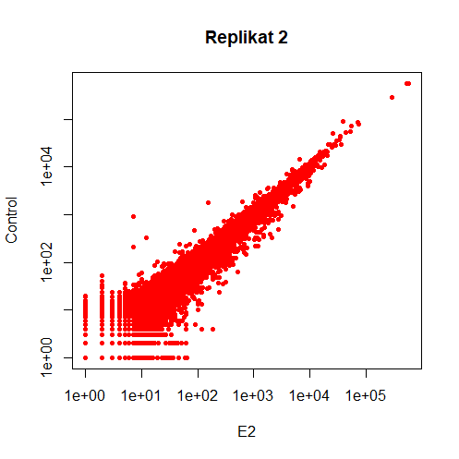

1. **Differentiell exprimierten Gene**

Log2 Fold Change: E2/Control

Adjusted p-value < 0.1

(adjusted p-value passt besser bei Signifikant-Test, um FDR (False Discovery Rate) zu vermeiden)

**RNA-Seq**

10 hochregulierte Gene (in insgesamt 18 Gene)

|  |  |  |
| --- | --- | --- |
|  | Gene | FoldChange |
| 1 | ENSG00000188176.12 | 6.822972 |
| 2 | ENSG00000166828.3 | 5.510313 |
| 3 | ENSG00000109101.8 | 5.401593 |
| 4 | ENSG00000249346.7 | 5.374084 |
| 5 | ENSG00000256347.1 | 5.171756 |
| 6 | ENSG00000264010.1 | 4.514731 |
| 7 | ENSG00000272472.1 | 3.748731 |
| 8 | ENSG00000163485.17 | 3.690794 |
| 9 | ENSG00000171126.8 | 3.470043 |
| 10 | ENSG00000110799.14 | 3.334392 |

Runterreguliertes Gen (nur 1 Gen)

|  |  |  |
| --- | --- | --- |
|  | Gene | FoldChange |
| 1 | ENSG00000273686.4 | -6.286141 |

P-value < 0.1

10 hochregulierte Gene

|  |  |  |
| --- | --- | --- |
|  | Gene | FoldChange |
| 1 | ENSG00000117154.12 | 7.309385 |
| 2 | ENSG00000188176.12 | 6.822972 |
| 3 | ENSG00000159337.7 | 6.595091 |
| 4 | ENSG00000258972.1 | 6.563768 |
| 5 | ENSG00000287963.1 | 6.550750 |
| 6 | ENSG00000105695.15 | 6.538347 |
| 7 | ENSG00000260741.1 | 6.524079 |
| 8 | ENSG00000161031.13 | 6.183282 |
| 9 | ENSG00000228760.10 | 6.003975 |
| 10 | ENSG00000264750.1 | 5.792670 |

10 runterregulierte Gene

|  |  |  |
| --- | --- | --- |
|  | Gene | FoldChange |
| 1 | ENSG00000233013.10 | -7.415451 |
| 2 | ENSG00000274487.3 | -6.775796 |
| 3 | ENSG00000013275.8 | -6.660092 |
| 4 | ENSG00000231945.8 | -6.492600 |
| 5 | ENSG00000273686.4 | -6.286141 |
| 6 | ENSG00000241204.1 | -5.817708 |
| 7 | ENSG00000278574.4 | -5.467507 |
| 8 | ENSG00000232913.8 | -5.443682 |
| 9 | ENSG00000223367.6 | -5.427978 |
| 10 | ENSG00000285390.2 | -5.368107 |

**ChIP-Seq**

10 hochregulierte Gene (insgesamt 1897 Gene)

|  |  |  |
| --- | --- | --- |
|  | Gene | FoldChange |
| 1 | ENSG00000201415.1 | 7.34351350864729 |
| 2 | ENSG00000255811.1 | 7.1931792243235 |
| 3 | ENSG00000259031.1 | 6.83228123327435 |
| 4 | ENSG00000266160.2 | 6.73511870086582 |
| 5 | ENSG00000274678.1 | 6.58996988590545 |
| 6 | ENSG00000280311.1 | 6.54217193404255 |
| 7 | ENSG00000260284.1 | 6.3274679047158 |
| 8 | ENSG00000267375.1 | 6.21533902661312 |
| 9 | ENSG00000226416.2 | 6.17635811950151 |
| 10 | ENSG00000237604.1 | 6.13094790324045 |

Runterreguliertes Gen (nur 1)

|  |  |  |
| --- | --- | --- |
|  | Gene | FoldChange |
| 1 | ENSG00000136933.17 | -2. 38192888271525 |