Supplementary Information
We provide additional experimental results, sensitivity analyses and details of the NH3/H2 measurement apparatus and acquisition protocol. Numerical summaries use ten predefined seeds and are conditional on the observed test exposures. The accompanying data exports retain unrounded results.

Table S1. Fold-level MAE (ppm), mean ± seed SD
Gas | Fold | Pairs | Policy | MAE
CO | 1 | 21 | Fine-tuned | 70.88 ± 17.27
Ethylene | 1 | 21 | Fine-tuned | 2.456 ± 0.570
CO | 1 | 21 | Frozen | 81.39 ± 14.49
Ethylene | 1 | 21 | Frozen | 2.914 ± 0.780
CO | 1 | 21 | Scratch | 83.56 ± 24.03
Ethylene | 1 | 21 | Scratch | 3.159 ± 1.091
CO | 2 | 18 | Fine-tuned | 76.25 ± 15.60
Ethylene | 2 | 18 | Fine-tuned | 1.675 ± 0.184
CO | 2 | 18 | Frozen | 74.09 ± 16.26
Ethylene | 2 | 18 | Frozen | 1.517 ± 0.224
CO | 2 | 18 | Scratch | 105.82 ± 18.97
Ethylene | 2 | 18 | Scratch | 1.989 ± 0.283
CO | 3 | 22 | Fine-tuned | 48.52 ± 9.40
Ethylene | 3 | 22 | Fine-tuned | 1.686 ± 0.328
CO | 3 | 22 | Frozen | 47.18 ± 12.14
Ethylene | 3 | 22 | Frozen | 1.711 ± 0.357
CO | 3 | 22 | Scratch | 80.47 ± 31.42
Ethylene | 3 | 22 | Scratch | 2.684 ± 0.590
H2 | 1 | 57 | Fine-tuned | 45.39 ± 4.30
NH3 | 1 | 57 | Fine-tuned | 41.99 ± 5.37
H2 | 1 | 57 | Frozen | 39.17 ± 3.27
NH3 | 1 | 57 | Frozen | 37.38 ± 3.48
H2 | 1 | 57 | Scratch | 70.00 ± 15.43
NH3 | 1 | 57 | Scratch | 52.04 ± 9.25
H2 | 2 | 57 | Fine-tuned | 37.28 ± 7.90
NH3 | 2 | 57 | Fine-tuned | 26.53 ± 5.04
H2 | 2 | 57 | Frozen | 32.11 ± 4.01
NH3 | 2 | 57 | Frozen | 25.24 ± 4.21
H2 | 2 | 57 | Scratch | 44.98 ± 11.13
NH3 | 2 | 57 | Scratch | 30.59 ± 8.63
H2 | 3 | 57 | Fine-tuned | 35.13 ± 2.95
NH3 | 3 | 57 | Fine-tuned | 17.05 ± 4.34
H2 | 3 | 57 | Frozen | 37.40 ± 4.31
NH3 | 3 | 57 | Frozen | 17.72 ± 2.31
H2 | 3 | 57 | Scratch | 46.91 ± 7.11
NH3 | 3 | 57 | Scratch | 20.94 ± 4.31
H2 | 4 | 57 | Fine-tuned | 26.36 ± 4.22
NH3 | 4 | 57 | Fine-tuned | 18.83 ± 3.31
H2 | 4 | 57 | Frozen | 30.66 ± 4.48
NH3 | 4 | 57 | Frozen | 22.77 ± 4.16
H2 | 4 | 57 | Scratch | 25.70 ± 3.99
NH3 | 4 | 57 | Scratch | 16.22 ± 3.48
H2 | 5 | 57 | Fine-tuned | 55.99 ± 4.86
NH3 | 5 | 57 | Fine-tuned | 38.39 ± 2.50
H2 | 5 | 57 | Frozen | 59.73 ± 4.79
NH3 | 5 | 57 | Frozen | 44.10 ± 3.37
H2 | 5 | 57 | Scratch | 66.43 ± 8.92
NH3 | 5 | 57 | Scratch | 44.66 ± 5.92
H2 | 6 | 57 | Fine-tuned | 31.60 ± 2.29
NH3 | 6 | 57 | Fine-tuned | 17.36 ± 1.54
H2 | 6 | 57 | Frozen | 34.77 ± 2.70
NH3 | 6 | 57 | Frozen | 19.26 ± 1.76
H2 | 6 | 57 | Scratch | 41.20 ± 4.27
NH3 | 6 | 57 | Scratch | 21.59 ± 3.25

Table S2. Seed-count sensitivity within the revised primary protocol
Gas | First 3 gain % | All 10 gain % | Later 7 gain % | Positive / 10
CO | 28.48 | 27.50 | 27.06 | 10
Ethylene | 26.09 | 25.73 | 25.57 | 9
H2 | 18.40 | 21.49 | 22.72 | 10
NH3 | 13.30 | 13.91 | 14.15 | 9

Table S2b. Secondary full-budget fixed split and drift seed sensitivity
Analysis | Gas | First 3 gain % | All 10 gain % | Later 7 gain %
fixed_split | CO | 27.23 | 25.43 | 24.71
fixed_split | Ethylene | 31.14 | 24.31 | 21.01
fixed_split | H2 | 27.22 | 23.29 | 21.52
fixed_split | NH3 | 32.44 | 19.59 | 12.96
drift_partition_8 | MacroMAE | 25.61 | 18.80 | 15.63
drift_partition_9 | MacroMAE | 17.97 | 18.35 | 18.52
drift_partition_10 | MacroMAE | -11.95 | -0.50 | 4.17
Prefixes use the predefined order 42, 142, …, 942; all ten remain the reporting set. A random-order 95% envelope is a subset diagnostic, not a confidence interval. More seeds change an estimated mean; they do not weaken a trained model or increase the number of independent physical exposures.
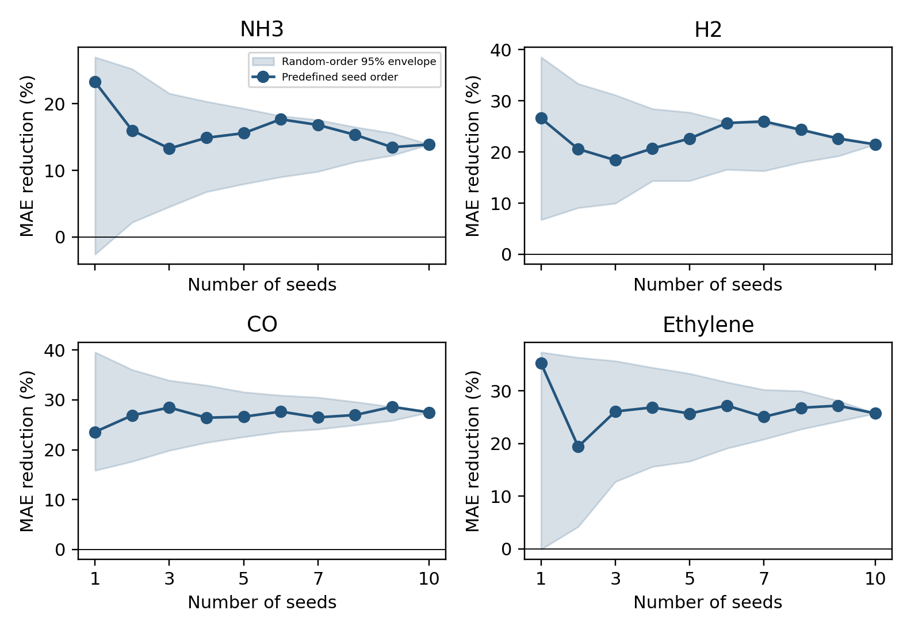
Fig. S1. Primary relative MAE reduction against scratch as seeds accumulate; shading shows 2.5th–97.5th percentiles of 2,000 random subsets at each count.

Table S2a. Every primary seed prefix (errors and intervals in ppm)
Gas | Seeds | Scratch | Fine-tuned | Gain % | Difference 95% interval
CO | 1 | 94.72 | 72.38 | 23.58 | [-10.73, 40.80]
Ethylene | 1 | 2.754 | 1.783 | 35.24 | [0.536, 1.689]
H2 | 1 | 54.39 | 39.92 | 26.61 | [2.49, 27.40]
NH3 | 1 | 31.34 | 24.04 | 23.28 | [1.27, 11.46]
CO | 2 | 97.23 | 71.07 | 26.90 | [2.83, 39.51]
Ethylene | 2 | 2.495 | 2.011 | 19.41 | [-0.222, 1.355]
H2 | 2 | 48.85 | 38.79 | 20.58 | [1.01, 22.83]
NH3 | 2 | 30.62 | 25.71 | 16.02 | [-2.62, 10.99]
CO | 3 | 93.44 | 66.83 | 28.48 | [3.80, 41.93]
Ethylene | 3 | 2.693 | 1.990 | 26.09 | [-0.002, 1.502]
H2 | 3 | 46.74 | 38.14 | 18.40 | [2.19, 19.06]
NH3 | 3 | 29.61 | 25.67 | 13.30 | [-1.07, 9.43]
CO | 4 | 90.43 | 66.53 | 26.43 | [4.89, 40.50]
Ethylene | 4 | 2.760 | 2.018 | 26.86 | [0.156, 1.397]
H2 | 4 | 49.09 | 38.93 | 20.69 | [3.10, 20.90]
NH3 | 4 | 30.86 | 26.26 | 14.91 | [-0.50, 9.69]
CO | 5 | 87.55 | 64.24 | 26.62 | [6.63, 37.84]
Ethylene | 5 | 2.670 | 1.984 | 25.70 | [0.156, 1.265]
H2 | 5 | 49.39 | 38.20 | 22.64 | [4.36, 20.71]
NH3 | 5 | 30.92 | 26.10 | 15.59 | [0.32, 9.26]
CO | 6 | 89.41 | 64.68 | 27.66 | [8.76, 38.90]
Ethylene | 6 | 2.703 | 1.967 | 27.23 | [0.259, 1.230]
H2 | 6 | 50.83 | 37.78 | 25.67 | [5.55, 23.25]
NH3 | 6 | 31.54 | 25.97 | 17.68 | [1.43, 10.28]
CO | 7 | 86.97 | 63.92 | 26.50 | [7.37, 36.65]
Ethylene | 7 | 2.622 | 1.965 | 25.07 | [0.129, 1.168]
H2 | 7 | 51.31 | 37.98 | 25.99 | [6.14, 22.22]
NH3 | 7 | 31.77 | 26.42 | 16.84 | [1.56, 9.55]
CO | 8 | 89.21 | 65.15 | 26.97 | [10.41, 36.09]
Ethylene | 8 | 2.670 | 1.954 | 26.79 | [0.226, 1.243]
H2 | 8 | 50.54 | 38.23 | 24.36 | [4.64, 21.09]
NH3 | 8 | 31.15 | 26.36 | 15.36 | [0.80, 8.97]
CO | 9 | 91.21 | 65.11 | 28.62 | [12.06, 39.43]
Ethylene | 9 | 2.670 | 1.944 | 27.20 | [0.260, 1.201]
H2 | 9 | 49.80 | 38.53 | 22.63 | [3.73, 19.95]
NH3 | 9 | 30.91 | 26.74 | 13.49 | [0.01, 8.48]
CO | 10 | 89.95 | 65.22 | 27.50 | [12.85, 37.53]
Ethylene | 10 | 2.611 | 1.939 | 25.73 | [0.247, 1.143]
H2 | 10 | 49.20 | 38.63 | 21.49 | [3.57, 18.78]
NH3 | 10 | 31.01 | 26.69 | 13.91 | [0.38, 8.30]

Table S3. Random minus farthest-point design MAE (ppm)
Gas | Pairs | Policy | Random | Farthest | Difference [95% interval]
CO | 5 | Scratch | 179.22 | 163.06 | 16.16 [-31.10, 53.12]
Ethylene | 5 | Scratch | 4.890 | 5.226 | -0.335 [-1.621, 0.930]
CO | 10 | Scratch | 144.05 | 156.04 | -11.99 [-46.20, 25.05]
Ethylene | 10 | Scratch | 3.881 | 3.610 | 0.271 [-0.951, 1.591]
CO | 20 | Scratch | 83.83 | 89.30 | -5.47 [-26.51, 14.46]
Ethylene | 20 | Scratch | 2.489 | 2.465 | 0.024 [-0.422, 0.504]
CO | 24 | Scratch | 63.63 | 63.63 | 0.00 [0.00, 0.00]
Ethylene | 24 | Scratch | 2.149 | 2.149 | 0.000 [0.000, 0.000]
H2 | 5 | Scratch | 159.51 | 161.51 | -2.00 [-19.61, 11.72]
NH3 | 5 | Scratch | 98.51 | 86.39 | 12.12 [-13.67, 38.24]
H2 | 10 | Scratch | 137.23 | 124.16 | 13.07 [-14.68, 36.59]
NH3 | 10 | Scratch | 69.60 | 67.52 | 2.08 [-23.07, 23.84]
H2 | 20 | Scratch | 70.48 | 70.73 | -0.25 [-24.56, 22.33]
NH3 | 20 | Scratch | 42.35 | 36.84 | 5.51 [-2.55, 13.76]
H2 | 40 | Scratch | 43.21 | 51.53 | -8.32 [-11.53, -4.60]
NH3 | 40 | Scratch | 25.40 | 29.86 | -4.46 [-6.35, -1.66]
H2 | 57 | Scratch | 41.20 | 41.20 | 0.00 [0.00, 0.00]
NH3 | 57 | Scratch | 21.59 | 21.59 | 0.00 [0.00, 0.00]
CO | 5 | Fine-tuned | 143.07 | 111.46 | 31.61 [13.34, 51.92]
Ethylene | 5 | Fine-tuned | 4.323 | 3.468 | 0.855 [-0.595, 2.151]
CO | 10 | Fine-tuned | 108.99 | 80.99 | 28.00 [-4.59, 62.23]
Ethylene | 10 | Fine-tuned | 3.081 | 2.418 | 0.663 [0.069, 1.392]
CO | 20 | Fine-tuned | 54.22 | 47.42 | 6.80 [0.99, 12.18]
Ethylene | 20 | Fine-tuned | 1.987 | 1.843 | 0.144 [-0.137, 0.457]
CO | 24 | Fine-tuned | 47.45 | 47.45 | 0.00 [0.00, 0.00]
Ethylene | 24 | Fine-tuned | 1.627 | 1.627 | 0.000 [0.000, 0.000]
H2 | 5 | Fine-tuned | 143.53 | 128.91 | 14.62 [-5.72, 35.31]
NH3 | 5 | Fine-tuned | 89.75 | 86.02 | 3.74 [-17.95, 28.62]
H2 | 10 | Fine-tuned | 103.24 | 81.88 | 21.36 [-0.61, 42.36]
NH3 | 10 | Fine-tuned | 52.62 | 38.92 | 13.69 [5.83, 20.77]
H2 | 20 | Fine-tuned | 47.14 | 48.38 | -1.24 [-9.01, 5.32]
NH3 | 20 | Fine-tuned | 34.40 | 29.53 | 4.87 [1.89, 8.05]
H2 | 40 | Fine-tuned | 36.78 | 41.67 | -4.89 [-7.31, -2.45]
NH3 | 40 | Fine-tuned | 21.85 | 25.22 | -3.37 [-5.50, -1.12]
H2 | 57 | Fine-tuned | 31.60 | 31.60 | 0.00 [0.00, 0.00]
NH3 | 57 | Fine-tuned | 17.36 | 17.36 | 0.00 [0.00, 0.00]
The export column scratch_mae in this reused paired-comparison routine is the comparator mean (random design here); transfer_mae is the farthest-point mean. Positive differences favor farthest-point design. These exploratory comparisons are not multiplicity-adjusted.

Table S4. Generic SSL minus sensor-aware MAE (ppm)
Gas | Pairs | Generic | Sensor-aware | Difference [95% interval]
CO | 5 | 119.26 | 111.46 | 7.80 [-6.70, 21.72]
Ethylene | 5 | 3.996 | 3.468 | 0.529 [-0.592, 1.703]
CO | 10 | 93.05 | 80.99 | 12.05 [-9.66, 30.80]
Ethylene | 10 | 2.735 | 2.418 | 0.317 [-0.119, 0.694]
CO | 20 | 51.08 | 47.42 | 3.66 [-0.87, 7.73]
Ethylene | 20 | 1.622 | 1.843 | -0.221 [-0.446, 0.015]
CO | 24 | 52.52 | 47.45 | 5.08 [-2.31, 12.72]
Ethylene | 24 | 1.437 | 1.627 | -0.189 [-0.336, -0.034]
H2 | 5 | 121.62 | 128.91 | -7.30 [-30.60, 12.11]
NH3 | 5 | 74.57 | 86.02 | -11.45 [-31.77, 9.40]
H2 | 10 | 91.13 | 81.88 | 9.25 [-0.74, 19.71]
NH3 | 10 | 39.49 | 38.92 | 0.56 [-3.19, 4.20]
H2 | 20 | 49.92 | 48.38 | 1.54 [-2.56, 5.51]
NH3 | 20 | 31.61 | 29.53 | 2.08 [0.38, 3.91]
H2 | 40 | 41.33 | 41.67 | -0.34 [-2.49, 2.11]
NH3 | 40 | 24.17 | 25.22 | -1.05 [-2.19, 0.11]
H2 | 57 | 35.18 | 31.60 | 3.58 [1.53, 5.40]
NH3 | 57 | 16.13 | 17.36 | -1.23 [-2.46, -0.16]
The control is a compact reimplementation inspired by PatchTST, not the official forecasting configuration. See Section IV for architectural differences. PLSR candidates use 1, 2, 3, 5, 8 or 12 components when below the fitting-sample/feature bound. RBF SVR searches C ∈ {0.1, 1, 10}, gamma ∈ {scale, 0.001}, epsilon ∈ {0.01, 0.1}, on fixed-normalized targets. Selection minimizes adaptation-validation normalized MAE. Extra Trees uses 300 trees and minimum leaf size 2. XGBoost uses 300 trees, depth 3, learning rate 0.03, and row/feature fractions 0.9. Test predictions are clipped to the same target ranges as neural models.

Table S4a. All-budget baseline MAE (ppm), mean ± SD
Gas | Pairs | Model | MAE
CO | 5 | Extra Trees | 132.28 ± 25.01
Ethylene | 5 | Extra Trees | 3.318 ± 0.578
CO | 5 | Fine-tuned | 111.46 ± 23.96
Ethylene | 5 | Fine-tuned | 3.468 ± 1.248
CO | 5 | Generic SSL | 119.26 ± 23.91
Ethylene | 5 | Generic SSL | 3.996 ± 1.136
CO | 5 | PLSR | 143.45 ± 41.09
Ethylene | 5 | PLSR | 3.427 ± 0.858
CO | 5 | Scratch | 163.06 ± 47.96
Ethylene | 5 | Scratch | 5.226 ± 1.469
CO | 5 | SVR | 131.59 ± 5.17
Ethylene | 5 | SVR | 3.812 ± 0.378
CO | 5 | XGBoost | 164.46 ± 41.00
Ethylene | 5 | XGBoost | 4.956 ± 1.288
CO | 10 | Extra Trees | 121.83 ± 26.67
Ethylene | 10 | Extra Trees | 2.438 ± 0.303
CO | 10 | Fine-tuned | 80.99 ± 27.98
Ethylene | 10 | Fine-tuned | 2.418 ± 0.484
CO | 10 | Generic SSL | 93.05 ± 28.68
Ethylene | 10 | Generic SSL | 2.735 ± 0.560
CO | 10 | PLSR | 76.36 ± 49.19
Ethylene | 10 | PLSR | 2.703 ± 0.579
CO | 10 | Scratch | 156.04 ± 27.60
Ethylene | 10 | Scratch | 3.610 ± 1.421
CO | 10 | SVR | 102.30 ± 8.29
Ethylene | 10 | SVR | 3.032 ± 0.380
CO | 10 | XGBoost | 99.25 ± 35.41
Ethylene | 10 | XGBoost | 4.701 ± 1.142
CO | 20 | Extra Trees | 104.17 ± 10.63
Ethylene | 20 | Extra Trees | 1.616 ± 0.266
CO | 20 | Fine-tuned | 47.42 ± 7.79
Ethylene | 20 | Fine-tuned | 1.843 ± 0.506
CO | 20 | Generic SSL | 51.08 ± 6.44
Ethylene | 20 | Generic SSL | 1.622 ± 0.304
CO | 20 | PLSR | 31.57 ± 8.90
Ethylene | 20 | PLSR | 2.056 ± 0.424
CO | 20 | Scratch | 89.30 ± 39.24
Ethylene | 20 | Scratch | 2.465 ± 0.745
CO | 20 | SVR | 51.12 ± 10.66
Ethylene | 20 | SVR | 2.212 ± 0.213
CO | 20 | XGBoost | 64.95 ± 9.22
Ethylene | 20 | XGBoost | 2.903 ± 0.914
CO | 24 | Extra Trees | 90.46 ± 7.17
Ethylene | 24 | Extra Trees | 1.398 ± 0.197
CO | 24 | Fine-tuned | 47.45 ± 7.38
Ethylene | 24 | Fine-tuned | 1.627 ± 0.275
CO | 24 | Generic SSL | 52.52 ± 12.59
Ethylene | 24 | Generic SSL | 1.437 ± 0.275
CO | 24 | PLSR | 25.57 ± 8.48
Ethylene | 24 | PLSR | 1.994 ± 0.377
CO | 24 | Scratch | 63.63 ± 10.68
Ethylene | 24 | Scratch | 2.149 ± 0.359
CO | 24 | SVR | 53.01 ± 7.26
Ethylene | 24 | SVR | 2.013 ± 0.226
CO | 24 | XGBoost | 55.90 ± 11.13
Ethylene | 24 | XGBoost | 2.491 ± 0.352
H2 | 5 | Extra Trees | 147.77 ± 35.20
NH3 | 5 | Extra Trees | 56.11 ± 9.00
H2 | 5 | Fine-tuned | 128.91 ± 16.84
NH3 | 5 | Fine-tuned | 86.02 ± 34.16
H2 | 5 | Generic SSL | 121.62 ± 35.14
NH3 | 5 | Generic SSL | 74.57 ± 31.27
H2 | 5 | PLSR | 156.59 ± 14.73
NH3 | 5 | PLSR | 51.90 ± 10.24
H2 | 5 | Scratch | 161.51 ± 22.40
NH3 | 5 | Scratch | 86.39 ± 36.11
H2 | 5 | SVR | 147.89 ± 36.56
NH3 | 5 | SVR | 67.15 ± 11.23
H2 | 5 | XGBoost | 163.11 ± 27.20
NH3 | 5 | XGBoost | 98.92 ± 24.61
H2 | 10 | Extra Trees | 108.23 ± 26.56
NH3 | 10 | Extra Trees | 48.09 ± 4.98
H2 | 10 | Fine-tuned | 81.88 ± 19.54
NH3 | 10 | Fine-tuned | 38.92 ± 4.56
H2 | 10 | Generic SSL | 91.13 ± 30.27
NH3 | 10 | Generic SSL | 39.49 ± 5.12
H2 | 10 | PLSR | 133.49 ± 29.68
NH3 | 10 | PLSR | 44.47 ± 6.31
H2 | 10 | Scratch | 124.16 ± 28.13
NH3 | 10 | Scratch | 67.52 ± 40.50
H2 | 10 | SVR | 116.17 ± 23.18
NH3 | 10 | SVR | 48.21 ± 6.82
H2 | 10 | XGBoost | 110.10 ± 13.23
NH3 | 10 | XGBoost | 69.34 ± 10.88
H2 | 20 | Extra Trees | 69.90 ± 11.10
NH3 | 20 | Extra Trees | 39.65 ± 2.44
H2 | 20 | Fine-tuned | 48.38 ± 9.70
NH3 | 20 | Fine-tuned | 29.53 ± 2.38
H2 | 20 | Generic SSL | 49.92 ± 7.00
NH3 | 20 | Generic SSL | 31.61 ± 3.35
H2 | 20 | PLSR | 116.94 ± 25.77
NH3 | 20 | PLSR | 39.09 ± 4.60
H2 | 20 | Scratch | 70.73 ± 30.45
NH3 | 20 | Scratch | 36.84 ± 7.89
H2 | 20 | SVR | 76.97 ± 20.72
NH3 | 20 | SVR | 35.54 ± 6.09
H2 | 20 | XGBoost | 83.40 ± 9.19
NH3 | 20 | XGBoost | 46.36 ± 8.16
H2 | 40 | Extra Trees | 51.73 ± 4.98
NH3 | 40 | Extra Trees | 34.14 ± 3.52
H2 | 40 | Fine-tuned | 41.67 ± 2.75
NH3 | 40 | Fine-tuned | 25.22 ± 2.10
H2 | 40 | Generic SSL | 41.33 ± 3.36
NH3 | 40 | Generic SSL | 24.17 ± 1.74
H2 | 40 | PLSR | 90.80 ± 10.20
NH3 | 40 | PLSR | 32.04 ± 5.77
H2 | 40 | Scratch | 51.53 ± 6.60
NH3 | 40 | Scratch | 29.86 ± 2.74
H2 | 40 | SVR | 38.34 ± 4.15
NH3 | 40 | SVR | 25.34 ± 3.44
H2 | 40 | XGBoost | 62.60 ± 4.85
NH3 | 40 | XGBoost | 39.78 ± 7.64
H2 | 57 | Extra Trees | 37.33 ± 2.04
NH3 | 57 | Extra Trees | 21.63 ± 1.73
H2 | 57 | Fine-tuned | 31.60 ± 2.29
NH3 | 57 | Fine-tuned | 17.36 ± 1.54
H2 | 57 | Generic SSL | 35.18 ± 2.74
NH3 | 57 | Generic SSL | 16.13 ± 1.23
H2 | 57 | PLSR | 75.50 ± 18.25
NH3 | 57 | PLSR | 28.44 ± 4.76
H2 | 57 | Scratch | 41.20 ± 4.27
NH3 | 57 | Scratch | 21.59 ± 3.25
H2 | 57 | SVR | 31.37 ± 4.53
NH3 | 57 | SVR | 20.74 ± 1.62
H2 | 57 | XGBoost | 48.65 ± 2.38
NH3 | 57 | XGBoost | 26.96 ± 4.61

Table S5. All-policy per-gas drift errors at 20 labels/gas
Partition | Gas | Policy | MAE ppm | NMAE %
8 | Acetaldehyde | Constant | 11.79 ± 7.58 | 4.06 ± 2.61
8 | Acetone | Constant | 57.28 ± 12.80 | 11.74 ± 2.62
8 | Ammonia | Constant | 17.06 ± 4.97 | 1.80 ± 0.52
8 | Ethanol | Constant | 77.11 ± 7.16 | 13.07 ± 1.21
8 | Ethylene | Constant | 94.67 ± 11.81 | 32.65 ± 4.07
8 | Toluene | Constant | 59.57 ± 6.19 | 62.71 ± 6.52
8 | Acetaldehyde | Fine-tuned | 16.40 ± 7.04 | 5.65 ± 2.43
8 | Acetone | Fine-tuned | 33.23 ± 1.62 | 6.81 ± 0.33
8 | Ammonia | Fine-tuned | 31.75 ± 8.84 | 3.34 ± 0.93
8 | Ethanol | Fine-tuned | 2.87 ± 3.09 | 0.49 ± 0.52
8 | Ethylene | Fine-tuned | 14.63 ± 4.06 | 5.04 ± 1.40
8 | Toluene | Fine-tuned | 17.82 ± 7.90 | 18.76 ± 8.32
8 | Acetaldehyde | Frozen | 13.44 ± 3.77 | 4.63 ± 1.30
8 | Acetone | Frozen | 31.53 ± 1.41 | 6.46 ± 0.29
8 | Ammonia | Frozen | 30.10 ± 8.50 | 3.17 ± 0.89
8 | Ethanol | Frozen | 3.48 ± 3.28 | 0.59 ± 0.56
8 | Ethylene | Frozen | 16.43 ± 3.21 | 5.67 ± 1.11
8 | Toluene | Frozen | 19.55 ± 6.72 | 20.58 ± 7.08
8 | Acetaldehyde | Scratch | 20.21 ± 11.03 | 6.97 ± 3.81
8 | Acetone | Scratch | 32.11 ± 1.93 | 6.58 ± 0.39
8 | Ammonia | Scratch | 38.91 ± 12.96 | 4.10 ± 1.36
8 | Ethanol | Scratch | 6.22 ± 3.63 | 1.05 ± 0.62
8 | Ethylene | Scratch | 17.30 ± 5.68 | 5.97 ± 1.96
8 | Toluene | Scratch | 28.96 ± 6.90 | 30.49 ± 7.27
9 | Acetaldehyde | Constant | 10.05 ± 7.51 | 3.46 ± 2.59
9 | Acetone | Constant | 24.91 ± 13.28 | 5.10 ± 2.72
9 | Ammonia | Constant | 10.50 ± 6.96 | 1.11 ± 0.73
9 | Ethanol | Constant | 77.11 ± 7.16 | 13.07 ± 1.21
9 | Ethylene | Constant | 94.67 ± 11.81 | 32.65 ± 4.07
9 | Toluene | Constant | 59.57 ± 6.19 | 62.71 ± 6.52
9 | Acetaldehyde | Fine-tuned | 29.07 ± 8.48 | 10.02 ± 2.92
9 | Acetone | Fine-tuned | 22.19 ± 6.21 | 4.55 ± 1.27
9 | Ammonia | Fine-tuned | 16.53 ± 9.71 | 1.74 ± 1.02
9 | Ethanol | Fine-tuned | 2.39 ± 2.65 | 0.40 ± 0.45
9 | Ethylene | Fine-tuned | 12.28 ± 4.36 | 4.23 ± 1.50
9 | Toluene | Fine-tuned | 28.65 ± 11.03 | 30.16 ± 11.61
9 | Acetaldehyde | Frozen | 29.77 ± 4.49 | 10.27 ± 1.55
9 | Acetone | Frozen | 23.19 ± 5.32 | 4.75 ± 1.09
9 | Ammonia | Frozen | 17.62 ± 8.69 | 1.85 ± 0.92
9 | Ethanol | Frozen | 2.44 ± 2.87 | 0.41 ± 0.49
9 | Ethylene | Frozen | 12.71 ± 3.98 | 4.38 ± 1.37
9 | Toluene | Frozen | 27.73 ± 7.11 | 29.19 ± 7.48
9 | Acetaldehyde | Scratch | 30.22 ± 8.42 | 10.42 ± 2.90
9 | Acetone | Scratch | 22.35 ± 4.69 | 4.58 ± 0.96
9 | Ammonia | Scratch | 21.34 ± 13.22 | 2.25 ± 1.39
9 | Ethanol | Scratch | 2.00 ± 2.16 | 0.34 ± 0.37
9 | Ethylene | Scratch | 13.59 ± 5.25 | 4.69 ± 1.81
9 | Toluene | Scratch | 46.58 ± 13.62 | 49.03 ± 14.33
10 | Acetaldehyde | Constant | 76.54 ± 2.66 | 26.39 ± 0.92
10 | Acetone | Constant | 408.40 ± 8.85 | 83.69 ± 1.81
10 | Ammonia | Constant | 415.97 ± 7.50 | 43.79 ± 0.79
10 | Ethanol | Constant | 78.13 ± 2.39 | 13.24 ± 0.40
10 | Ethylene | Constant | 74.27 ± 1.49 | 25.61 ± 0.51
10 | Toluene | Constant | 33.02 ± 2.06 | 34.76 ± 2.17
10 | Acetaldehyde | Fine-tuned | 70.15 ± 6.78 | 24.19 ± 2.34
10 | Acetone | Fine-tuned | 298.21 ± 62.08 | 61.11 ± 12.72
10 | Ammonia | Fine-tuned | 341.99 ± 29.11 | 36.00 ± 3.06
10 | Ethanol | Fine-tuned | 63.48 ± 5.29 | 10.76 ± 0.90
10 | Ethylene | Fine-tuned | 63.00 ± 10.18 | 21.72 ± 3.51
10 | Toluene | Fine-tuned | 21.48 ± 4.35 | 22.61 ± 4.58
10 | Acetaldehyde | Frozen | 72.39 ± 4.36 | 24.96 ± 1.50
10 | Acetone | Frozen | 285.49 ± 63.18 | 58.50 ± 12.95
10 | Ammonia | Frozen | 316.10 ± 48.02 | 33.27 ± 5.05
10 | Ethanol | Frozen | 65.16 ± 5.24 | 11.04 ± 0.89
10 | Ethylene | Frozen | 59.67 ± 5.23 | 20.57 ± 1.81
10 | Toluene | Frozen | 25.75 ± 6.08 | 27.11 ± 6.40
10 | Acetaldehyde | Scratch | 64.32 ± 10.02 | 22.18 ± 3.45
10 | Acetone | Scratch | 318.77 ± 21.20 | 65.32 ± 4.34
10 | Ammonia | Scratch | 341.17 ± 47.66 | 35.91 ± 5.02
10 | Ethanol | Scratch | 62.47 ± 9.20 | 10.59 ± 1.56
10 | Ethylene | Scratch | 51.07 ± 7.13 | 17.61 ± 2.46
10 | Toluene | Scratch | 16.23 ± 4.84 | 17.08 ± 5.09

Table S5a. Historical reporting ranges from partitions 1–6 (ppm)
Gas | Minimum | Maximum | Range
Ethanol | 10.00 | 600.00 | 590.00
Ethylene | 10.00 | 300.00 | 290.00
Ammonia | 50.00 | 1000.00 | 950.00
Acetaldehyde | 10.00 | 300.00 | 290.00
Acetone | 12.00 | 500.00 | 488.00
Toluene | 5.00 | 100.00 | 95.00

Table S6. Small-budget drift macro errors, mean ± SD
Partition | Labels/gas | Policy | Macro-MAE ppm | Macro-NMAE %
8 | 1 | Constant | 88.18 ± 26.42 | 25.28 ± 8.31
8 | 1 | Fine-tuned | 40.73 ± 24.75 | 16.36 ± 19.63
8 | 1 | Frozen | 45.57 ± 27.97 | 18.92 ± 27.04
8 | 1 | Scratch | 46.22 ± 20.34 | 18.12 ± 10.66
8 | 2 | Constant | 86.33 ± 28.40 | 29.98 ± 17.85
8 | 2 | Fine-tuned | 44.37 ± 5.14 | 11.02 ± 1.80
8 | 2 | Frozen | 45.97 ± 4.42 | 11.84 ± 2.79
8 | 2 | Scratch | 50.39 ± 5.95 | 15.83 ± 5.85
8 | 5 | Constant | 52.04 ± 9.09 | 21.60 ± 4.26
8 | 5 | Fine-tuned | 35.55 ± 7.65 | 9.21 ± 3.43
8 | 5 | Frozen | 34.96 ± 7.97 | 9.05 ± 2.69
8 | 5 | Scratch | 38.02 ± 7.28 | 9.84 ± 3.46
8 | 10 | Constant | 47.50 ± 5.31 | 17.36 ± 2.44
8 | 10 | Fine-tuned | 30.05 ± 6.09 | 8.37 ± 3.24
8 | 10 | Frozen | 27.18 ± 4.19 | 6.55 ± 0.97
8 | 10 | Scratch | 34.93 ± 6.77 | 9.66 ± 3.25
8 | 20 | Constant | 52.91 ± 3.07 | 21.00 ± 1.54
8 | 20 | Fine-tuned | 19.45 ± 3.37 | 6.68 ± 1.74
8 | 20 | Frozen | 19.09 ± 2.25 | 6.85 ± 1.34
8 | 20 | Scratch | 23.95 ± 3.46 | 9.19 ± 1.49
9 | 1 | Constant | 81.78 ± 26.67 | 24.12 ± 8.32
9 | 1 | Fine-tuned | 39.47 ± 20.58 | 13.56 ± 11.81
9 | 1 | Frozen | 43.25 ± 19.01 | 14.88 ± 14.87
9 | 1 | Scratch | 44.65 ± 20.38 | 17.46 ± 10.04
9 | 2 | Constant | 85.73 ± 28.18 | 29.90 ± 17.50
9 | 2 | Fine-tuned | 48.76 ± 5.38 | 11.94 ± 2.15
9 | 2 | Frozen | 50.50 ± 4.55 | 13.06 ± 3.40
9 | 2 | Scratch | 53.15 ± 6.03 | 16.61 ± 6.24
9 | 5 | Constant | 48.70 ± 9.11 | 20.88 ± 4.30
9 | 5 | Fine-tuned | 43.45 ± 8.11 | 12.78 ± 5.76
9 | 5 | Frozen | 41.33 ± 6.89 | 11.75 ± 3.81
9 | 5 | Scratch | 44.84 ± 4.97 | 11.98 ± 3.46
9 | 10 | Constant | 41.84 ± 5.14 | 16.17 ± 2.37
9 | 10 | Fine-tuned | 33.39 ± 7.33 | 9.01 ± 2.33
9 | 10 | Frozen | 30.83 ± 5.20 | 7.68 ± 1.13
9 | 10 | Scratch | 40.63 ± 3.54 | 11.28 ± 2.89
9 | 20 | Constant | 46.13 ± 3.07 | 19.68 ± 1.52
9 | 20 | Fine-tuned | 18.52 ± 4.60 | 8.52 ± 2.48
9 | 20 | Frozen | 18.91 ± 3.25 | 8.48 ± 1.63
9 | 20 | Scratch | 22.68 ± 2.86 | 11.88 ± 2.12
10 | 1 | Constant | 177.17 ± 10.32 | 39.52 ± 3.02
10 | 1 | Fine-tuned | 206.22 ± 24.05 | 47.14 ± 13.39
10 | 1 | Frozen | 209.72 ± 29.55 | 50.43 ± 23.17
10 | 1 | Scratch | 199.79 ± 14.71 | 44.84 ± 6.20
10 | 2 | Constant | 212.96 ± 15.13 | 51.87 ± 9.35
10 | 2 | Fine-tuned | 225.23 ± 15.18 | 49.28 ± 3.65
10 | 2 | Frozen | 224.86 ± 16.02 | 48.72 ± 4.14
10 | 2 | Scratch | 222.05 ± 15.74 | 48.44 ± 3.76
10 | 5 | Constant | 192.76 ± 4.52 | 41.03 ± 1.29
10 | 5 | Fine-tuned | 196.99 ± 23.05 | 42.51 ± 4.63
10 | 5 | Frozen | 207.84 ± 33.72 | 46.61 ± 7.37
10 | 5 | Scratch | 192.46 ± 22.93 | 40.09 ± 4.96
10 | 10 | Constant | 186.96 ± 2.84 | 38.63 ± 0.66
10 | 10 | Fine-tuned | 196.18 ± 17.97 | 41.83 ± 4.40
10 | 10 | Frozen | 191.79 ± 15.94 | 41.18 ± 3.51
10 | 10 | Scratch | 191.07 ± 18.61 | 40.41 ± 3.95
10 | 20 | Constant | 181.05 ± 2.13 | 37.91 ± 0.54
10 | 20 | Fine-tuned | 143.05 ± 12.49 | 29.40 ± 3.07
10 | 20 | Frozen | 137.43 ± 13.49 | 29.24 ± 2.67
10 | 20 | Scratch | 142.34 ± 11.06 | 28.12 ± 2.31
Below 20 labels/gas the predefined target is fixed-log Huber; at 20 it is historical fitted-log Huber. Therefore this primary budget series also changes scaling at 20. The fixed-log 20-label rows in Table S7 provide a like-for-like scaling control. One-label runs have no validation holdout.

Table S7. All-policy 20-label loss/scaling controls
Partition | Transform | Policy | Macro-MAE ppm | Macro-NMAE %
8 | linear_huber | Fine-tuned | 26.94 ± 4.16 | 12.49 ± 4.10
8 | linear_huber | Frozen | 27.67 ± 7.34 | 11.06 ± 3.86
8 | linear_huber | Scratch | 32.50 ± 6.46 | 16.02 ± 6.66
8 | linear_mae | Fine-tuned | 22.48 ± 4.17 | 8.20 ± 3.21
8 | linear_mae | Frozen | 22.73 ± 3.55 | 7.55 ± 1.96
8 | linear_mae | Scratch | 27.01 ± 6.50 | 11.61 ± 4.91
8 | log_fixed_huber | Fine-tuned | 22.68 ± 5.59 | 7.65 ± 2.86
8 | log_fixed_huber | Frozen | 20.32 ± 4.02 | 6.42 ± 1.79
8 | log_fixed_huber | Scratch | 26.49 ± 2.40 | 9.07 ± 1.43
8 | log_huber | Constant | 52.91 ± 3.07 | 21.00 ± 1.54
8 | log_huber | Fine-tuned | 19.45 ± 3.37 | 6.68 ± 1.74
8 | log_huber | Frozen | 19.09 ± 2.25 | 6.85 ± 1.34
8 | log_huber | Scratch | 23.95 ± 3.46 | 9.19 ± 1.49
9 | linear_huber | Fine-tuned | 25.50 ± 6.16 | 13.09 ± 4.63
9 | linear_huber | Frozen | 26.49 ± 9.66 | 11.44 ± 4.99
9 | linear_huber | Scratch | 32.04 ± 7.62 | 17.25 ± 7.21
9 | linear_mae | Fine-tuned | 20.70 ± 4.75 | 8.91 ± 3.98
9 | linear_mae | Frozen | 20.28 ± 3.36 | 7.72 ± 2.42
9 | linear_mae | Scratch | 25.69 ± 6.77 | 12.70 ± 5.14
9 | log_fixed_huber | Fine-tuned | 26.11 ± 6.19 | 8.90 ± 3.19
9 | log_fixed_huber | Frozen | 23.28 ± 4.85 | 7.51 ± 2.02
9 | log_fixed_huber | Scratch | 33.68 ± 4.07 | 12.02 ± 2.17
9 | log_huber | Constant | 46.13 ± 3.07 | 19.68 ± 1.52
9 | log_huber | Fine-tuned | 18.52 ± 4.60 | 8.52 ± 2.48
9 | log_huber | Frozen | 18.91 ± 3.25 | 8.48 ± 1.63
9 | log_huber | Scratch | 22.68 ± 2.86 | 11.88 ± 2.12
10 | linear_huber | Fine-tuned | 145.56 ± 11.05 | 33.00 ± 2.61
10 | linear_huber | Frozen | 146.40 ± 15.93 | 34.00 ± 3.12
10 | linear_huber | Scratch | 144.08 ± 16.57 | 32.73 ± 6.79
10 | linear_mae | Fine-tuned | 137.55 ± 12.87 | 29.63 ± 2.73
10 | linear_mae | Frozen | 135.74 ± 14.12 | 30.82 ± 3.44
10 | linear_mae | Scratch | 135.23 ± 14.38 | 28.78 ± 3.05
10 | log_fixed_huber | Fine-tuned | 184.96 ± 9.99 | 38.53 ± 2.25
10 | log_fixed_huber | Frozen | 185.66 ± 14.61 | 39.28 ± 2.75
10 | log_fixed_huber | Scratch | 171.19 ± 14.04 | 35.00 ± 2.42
10 | log_huber | Constant | 181.05 ± 2.13 | 37.91 ± 0.54
10 | log_huber | Fine-tuned | 143.05 ± 12.49 | 29.40 ± 3.07
10 | log_huber | Frozen | 137.43 ± 13.49 | 29.24 ± 2.67
10 | log_huber | Scratch | 142.34 ± 11.06 | 28.12 ± 2.31

Table S8. Capacity and distinct fitting records; seed 42
Dataset | Budget | Policy | Total | Trainable | Encoder | Head | Records
co_ethylene | 24 | Fine-tuned | 101002 | 101002 | 31144 | 69858 | 19
co_ethylene | 24 | Frozen | 101002 | 69858 | 31144 | 69858 | 19
co_ethylene | 24 | Generic SSL | 91714 | 91714 | 21856 | 69858 | 19
co_ethylene | 24 | Scratch | 101002 | 101002 | 31144 | 69858 | 19
co_ethylene | 5 | Fine-tuned | 101002 | 101002 | 31144 | 69858 | 4
co_ethylene | 5 | Frozen | 101002 | 69858 | 31144 | 69858 | 4
co_ethylene | 5 | Generic SSL | 91714 | 91714 | 21856 | 69858 | 4
co_ethylene | 5 | Scratch | 101002 | 101002 | 31144 | 69858 | 4
nh3_h2 | 57 | Fine-tuned | 117514 | 117514 | 31272 | 86242 | 46
nh3_h2 | 57 | Frozen | 117514 | 86242 | 31272 | 86242 | 46
nh3_h2 | 57 | Generic SSL | 108098 | 108098 | 21856 | 86242 | 46
nh3_h2 | 57 | Scratch | 117514 | 117514 | 31272 | 86242 | 46
nh3_h2 | 5 | Fine-tuned | 117514 | 117514 | 31272 | 86242 | 4
nh3_h2 | 5 | Frozen | 117514 | 86242 | 31272 | 86242 | 4
nh3_h2 | 5 | Generic SSL | 108098 | 108098 | 21856 | 86242 | 4
nh3_h2 | 5 | Scratch | 117514 | 117514 | 31272 | 86242 | 4
sensor_drift | 1 | Fine-tuned | 29542 | 29542 | 24992 | 4550 | 6
sensor_drift | 1 | Frozen | 29542 | 4550 | 24992 | 4550 | 6
sensor_drift | 1 | Scratch | 29542 | 29542 | 24992 | 4550 | 6
sensor_drift | 20 | Fine-tuned | 29542 | 29542 | 24992 | 4550 | 96
sensor_drift | 20 | Frozen | 29542 | 4550 | 24992 | 4550 | 96
sensor_drift | 20 | Scratch | 29542 | 29542 | 24992 | 4550 | 96
sensor_drift | 20 | Fine-tuned | 29542 | 29542 | 24992 | 4550 | 96
sensor_drift | 20 | Frozen | 29542 | 4550 | 24992 | 4550 | 96
sensor_drift | 20 | Scratch | 29542 | 29542 | 24992 | 4550 | 96
Architecture counts are constant for each dataset/policy. Fitting exposure counts can vary with selected repeated coordinates; complete per-seed counts are saved in statistics/model_size.csv. Parameter/exposure ratios are descriptive and do not alone quantify generalization.

NH3/H2 dataset and acquisition details

Sensor array
We use an array of 20 MEMS metal-oxide gas-sensor channels based on SnO2 nanowires with Pt/Ag surface modification. The sensors operate using a thermal-gradient sensing principle and provide complementary responses to NH3 and H2. The chamber accommodates the array in a 5 x 4 arrangement. We monitor the channels in four groups: CH1-CH5, CH6-CH10, CH11-CH15 and CH16-CH20, with electrical supply settings in the range 3.0-3.4 V.

Gas chamber and delivery system
We deliver NH3 and H2 to the sensor chamber through an automated mass-flow-controlled mixing system. The apparatus comprises gas supplies, background-gas delivery, mass-flow controllers, a switching valve, the sensor chamber, a power supply and a computer for control and recording. The switching valve directs the prepared mixture to the chamber during exposure. The outlet is connected to an exhaust line, and a cleaning-gas flow supports recovery between exposures. Figure S2 shows the system layout; Fig. S3 shows the sensor hardware, chamber assembly and mass-flow-controller installation.

Acquisition protocol
We programmed single-gas and binary NH3/H2 conditions spanning 0–500 ppm for each gas, with nonzero settings of 25, 50, 100, 200, 300, 400 and 500 ppm. Each sequence starts at gas delivery and records the complete 180-s exposure plus 700-s recovery cycle (880 s total). The acquisition interface was configured for a 2.0-s sampling interval. Acquisition took place over six days, but the six Combination-ID partitions were not intended as day splits. Day-by-day mixture details were not logged, preventing a reliable exposure-to-day mapping and leave-one-day-out evaluation. Temperature and relative humidity were neither controlled nor measured. These facts are clarified by the acquisition team; no timestamp-based cadence validation or retrospective environmental measurements are claimed.
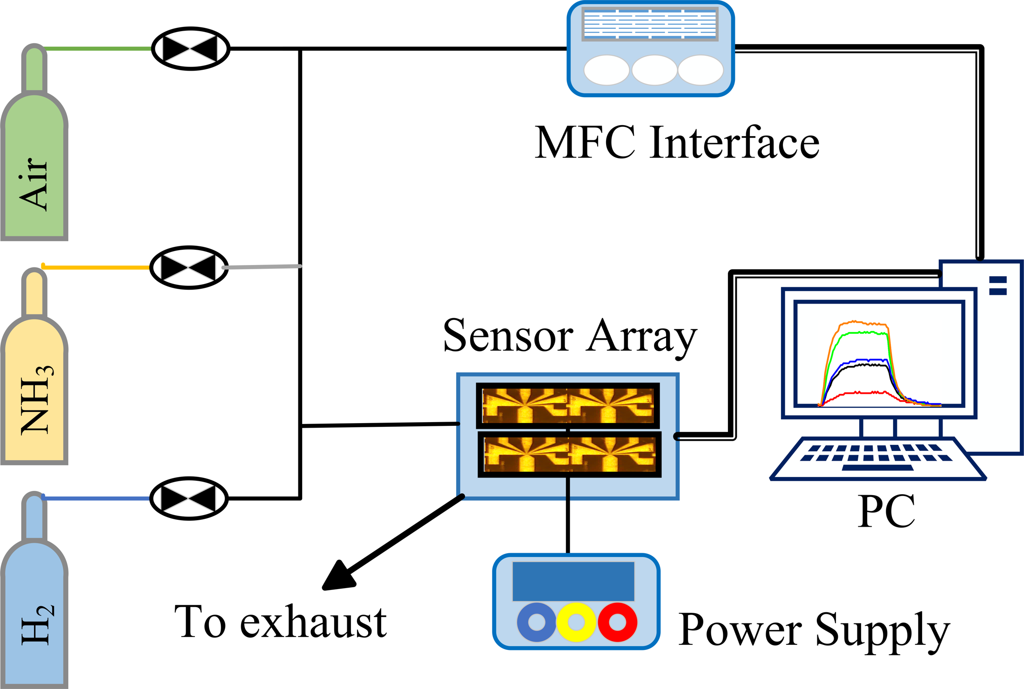
Fig. S2. Layout of our NH3/H2 mixing and measurement system, including gas supplies, mass-flow control, sensor array, power supply, exhaust and computer interface.
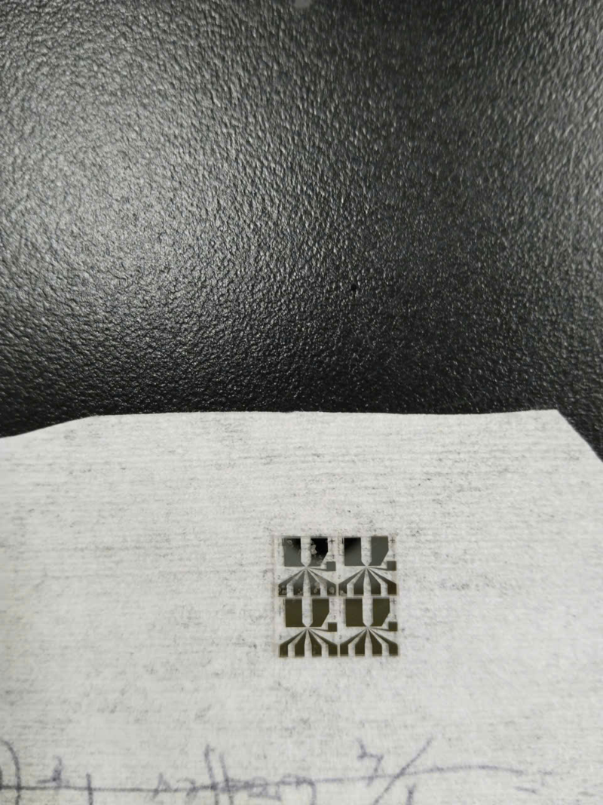  (a) MEMS sensor hardware | 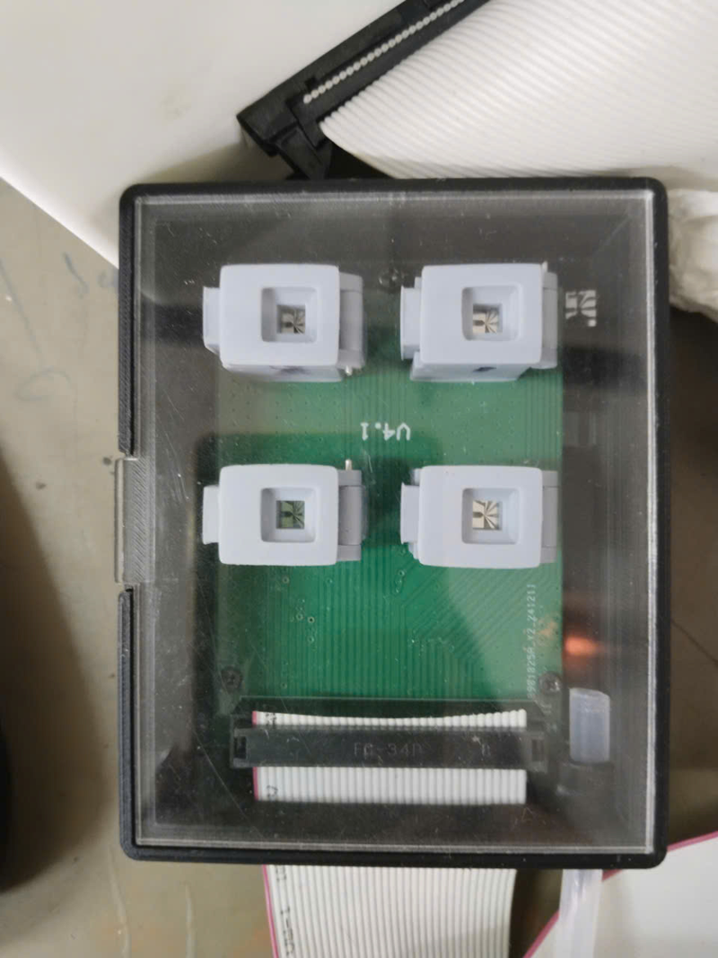  (b) Sensor chamber | 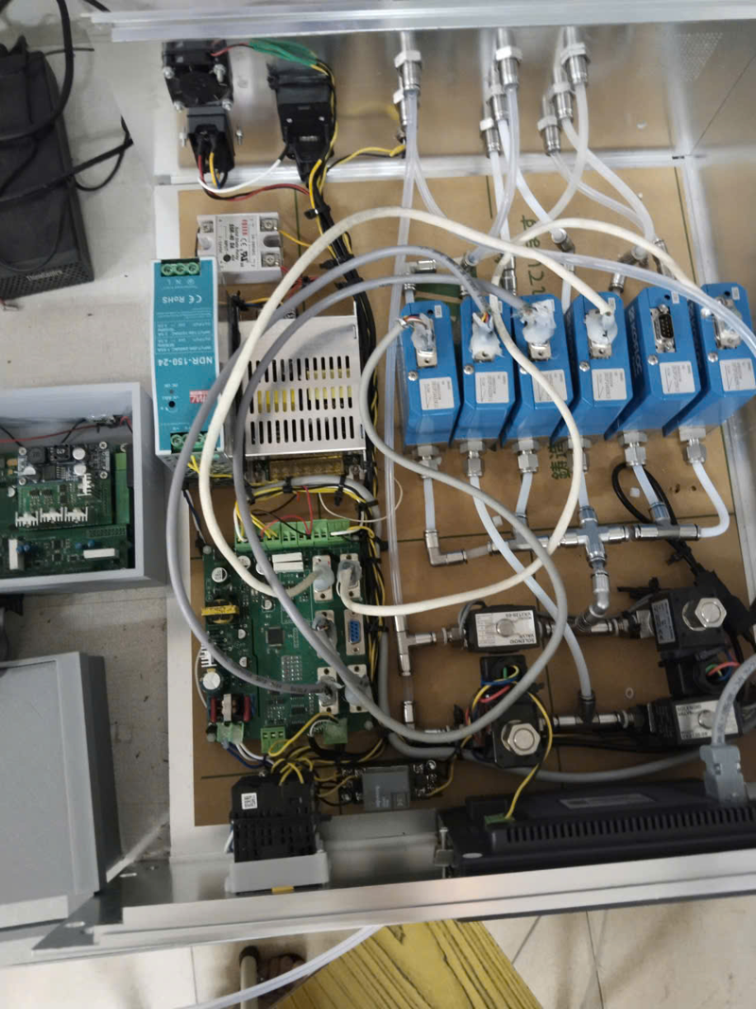  (c) Mass-flow controllers
Fig. S3. Photographs of their experimental hardware: (a) sensor devices, (b) the chamber assembly containing the sensor array, and (c) the mass-flow-controller installation.

Revision 3.0: additional analysis and protocol clarification

Acquisition independence and environmental limitations
Identifier separation and stored-signal fingerprint checks establish digital separation only. Acquisition days may be shared across evaluation roles; without exposure-to-day records, overlap cannot be quantified. The existing folds support held-out identifier evaluation, not verified day independence. Environmental variation cannot be quantified retrospectively. Future experiments will measure and record temperature and humidity; exposure-linked day/session logs are needed to enable day-held-out validation.

Physical timing and exact window definitions
The configured interval is 2.0 s. Aggregate counts give 162,404/378 = 429.64 observations per 880-s sequence, corresponding approximately to 2.048 s per observation. This is consistent with the configured interval, but is not a timestamp measurement. A 64-sample window represents about 128 s nominally or 131 s by this aggregate calculation (71–73% of the 180-s exposure); the first-to-last timestamp span at nominal cadence is 63 intervals, or 126 s. The first sample marks gas-delivery onset.
For an L-sample sequence, with zero-based indices: early windows start at offsets 0–4; middle windows start at floor((L−68)/2) plus offsets 0–4; late windows start at L−68 plus offsets 0–4. Each has 64 consecutive samples. Tests use only offset zero. Full-cycle windows linearly interpolate the complete interval [offset, L−1] to 64 points, using offsets 0–4 for pretraining/fitting and zero for testing. Full-cycle inputs include gas exposure and recovery. For approximately 430-sample cycles, middle and late windows predominantly probe recovery. Scalers are refitted using the corresponding pretraining windows; the primary early window remains predefined.

Multiplicity sensitivity
Table S9 retains equal fold weighting and independently resamples paired seed and fold axes. The 98.75% marginal percentile intervals implement a Bonferroni sensitivity for four comparisons using 200,000 draws (RNG seed 42). A second 200,000-draw run with RNG seed 2026 gives the same zero-inclusion decisions; endpoint shifts are at most 0.15 ppm. These are conditional descriptive bootstrap intervals. Bonferroni adjustment does not repair the limited number of chronological folds, overlapping training data, or unavailable acquisition-day labels. The original unadjusted Table I remains unchanged.
Table S9. Four-comparison multiplicity sensitivity; scratch minus fine-tuned MAE (ppm).
Gas | Difference | 98.75% interval | Test folds
NH3 | 4.31 | [-0.60, 9.46] | 6
H2 | 10.58 | [2.08, 21.54] | 6
CO | 24.74 | [8.63, 41.71] | 3
Ethylene | 0.672 | [0.167, 1.249] | 3
NH3 includes zero after adjustment; H2, CO and ethylene remain positive. CO/ethylene intervals are indicative with only three test folds. NH3 is also the weakest case at five pairs and for sensor-ID/attention ablations.

CO ablation uncertainty
Table S10. Full-budget CO ablation-minus-full-model MAE: exploratory paired-seed percentile bootstrap, 200,000 draws, RNG seed 42, unadjusted 95% intervals. Seeds remain paired; test exposures are not resampled as independent acquisitions.
Removed | Mean ± SD (ppm) | 95% interval (ppm)
Attention | 10.27 ± 12.18 | [2.68, 16.94]
Temporal mask | 7.93 ± 14.86 | [-0.33, 17.00]
The temporal-mask contrast includes zero. The attention contrast is positive in this conditional analysis, so it should not be called a statistical null solely because its mean is smaller than one SD. Both have substantial variability and neither supports a universal component benefit.

Representative pretraining compute
Representative seed-42 pretraining reruns on one NVIDIA GeForce RTX 3060 took 38.8 s for NH3/H2 (1,260 windows) and 19.9 s for CO/ethylene (735 windows), each for 60 epochs with batch size 64. Timings include model initialization and optimization but exclude data loading, scaling and checkpoint writes. They are per-model measurements, not reconstructed total campaign costs; checkpoints are reused across adaptation budgets. Software and timing details are supplied in the supplement.
Timing environment: Python 3.13.2, PyTorch 2.12.1+cu126, CUDA 12.6. One GPU was used. The reported reruns use the original pretraining implementation and fixed-split preprocessing, without adaptation training or reuse of a cached pretrained state. The combined measured time for these two representative runs is 58.6 s; it is not the total ten-seed/multi-fold experiment cost. Descriptor-benchmark pretraining uses 40 epochs (batch size 256); its wall time was not measured in this raw-response timing check. Hardware/software and source hashes are saved in evidence/compute_measurement.json.

Loss denominator guard
Equation (14) guards both denominators. The V3.0 raw-response implementation adds clamp_min(1) to the visible denominator. With at most three spans of length 16 in a 64-sample window and at most three entirely hidden channels, at least 16 temporal positions remain visible in each nonhidden channel. The visible denominator is therefore always positive for the reported 16-/20-channel protocols. This defensive code change leaves their loss unchanged; historical predictions and results are retained.

