Sensor-Aware Self-Supervised Transfer Learning for Label-Efficient Multigas Electronic Nose Calibration
Dinh-Van Nguyen, DangThiThu Ha, Thu-Huong Nguyen , and NguyenDuc Hoa
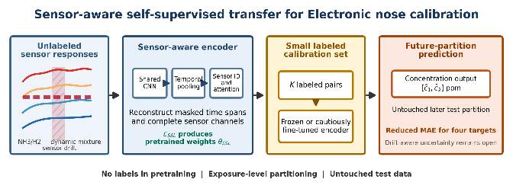
Abstract— Precisely labeled gas mixtures require concentration control or reference quantification, whereas mixtures without carefully controlled ppm can provide inexpensive unlabeled sensor responses. This motivates self-supervised pretraining on a large unquantified mixture pool followed by calibration with a small precisely labeled set. The authors evaluate the label-efficiency premise using existing datasets with concentration labels withheld during pretraining. A shared temporal encoder, sensor-identity embeddings, cross-sensor attention, and structured masked reconstruction are evaluated with a predefined fine-tuned transfer policy and 10 seeds. Primary evaluation uses six held-partition NH3/H2 folds and three rolling chronological CO/ethylene folds. Relative MAE reductions against scratch are NH3 13.9%, H2 21.5%, CO 27.5%, Ethylene 25.7%. Paired seed-and-fold bootstrap intervals exclude zero for these four comparisons, conditional on the observed exposures. Fixed-split experiments compare all adaptation policies, calibration designs, classical regression, a compact PatchTST-style SSL control, architectural ablations, and window placement. The proposed architecture is not uniformly superior to generic SSL or classical models. Long-term drift evaluation includes constant controls, normalized errors, small budgets, and target-loss sensitivity; regression is conditional on known gas identity. These results support label-efficient same-system recalibration. Prospective pretraining on cheaply acquired, unquantified mixtures and its cost savings remain to be evaluated.
Index Terms— Electronic nose, self-supervised learning, transfer learning, gas concentration regression, sensor drift, label-efficient calibration, sensor attention.

Introduction
E
lectronic noses estimate gas properties from partially selective sensor arrays. Precise concentration labels require controlled delivery or reference measurement, making calibration costly across gases, mixtures and sessions. Sensor aging can require repeated calibration.
The authors seek to learn from inexpensive mixture-response recordings and reserve precise concentration measurements for a small calibration set. Preparation settings do not substitute for measured gas-phase ppm. Controlled-exposure datasets with labels withheld during pretraining test this premise retrospectively; they do not establish the cost or performance of a prospectively acquired unquantified mixture pool.
Limited-label electronic-nose research includes pseudo-labeling for recognition [1], [2] and domain adaptation, few-shot learning and meta-learning for drift [3]–[7]. Quantitative calibration remains less studied.
Temporal modeling [8]–[10], small-data transfer [11] and domain-adaptive regression [12] motivate reusable representations for concentration estimation.
The authors' shared temporal encoder learns response dynamics, while sensor identities and cross-sensor attention retain array structure. Masked intervals and channels are reconstructed before frozen or fine-tuned concentration regression. Two raw-response datasets support label-budget and multi-fold evaluation; a descriptor benchmark tests oracle-class regression under future drift. Generic SSL, chemometric, calibration-design and ablation controls retain adverse and null results. Figure 1 summarizes the pipeline.

Related Work
Fonollosa et al. [8] used reservoir computing to recover rapidly changing concentrations from slow sensor responses, demonstrating transient information beyond steady-state features.
Quantitative models include GAF-MTF/CNN-LSTM feature fusion [9], a lightweight transferred network with a single MEMS sensor [10], small-data parameter-feature transfer [11], and teacher-student domain-adaptive regression [12].
M-Training [1] and M-S4VMs [2] use predicted labels for gas recognition, with potential reinforcement of incorrect pseudo-labels.
Self-supervision instead derives targets from measurements. Time-series objectives include reconstruction, masking, contrastive and adversarial learning [13]. Masking intervals and channels encourages temporal and cross-sensor inference without concentration pseudo-labels.
Drift changes the response distribution. TDACNN [3] and SAD-CNN [5] address domain differences; MDCN [4], CEGNN [6] and meta-learning [7] use limited reference data or transferable representations. Most 36-month-benchmark studies emphasize gas identity. The authors examine concentration regression in future partitions with true identity supplied.
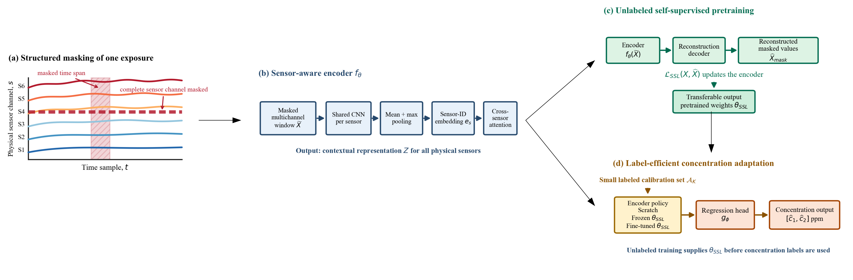
Fig.1. Full sensor-aware pretraining, adaptation pipeline.
The authors' contribution is a controlled evaluation of masked sensor-aware learning for quantitative same-system recalibration, with limited labels, held-out partitions, chronological tests and direct competing controls.
PatchTST [18] and multivariate Transformers [19] use masked time-series learning; TS2Vec [20] uses hierarchical contrastive representations. The authors' compact PatchTST-style regression control compares the complete sensor-aware design with generic masking. Different encoders and capacities prevent isolating sensor identity alone.
PLSR [21] and SVR [22] provide chemometric controls alongside Extra Trees [26] and XGBoost [27]. Farthest-point design is related to concentration-space coverage methods [23]. Nonexchangeable conformal inference [24] and covariate-shift conformal prediction [25] motivate a cautious interpretation of uncertainty under chronological sensor drift.

Proposed Method

Problem Formulation
For the two raw-response datasets, one gas exposure is represented as the multichannel time series in (1), with the two-gas concentration target in (2)
$$X_{i}∈R^{T×S}, (1)$$
where $T$ is the number of temporal samples and $S$ is the number of physical sensors. The target is a two-dimensional concentration vector,
$$y_{i}=\left[\begin{matrix}y_{i1} \\ y_{i2}\end{matrix}\right]∈R^{2}. (2)$$
For the NH3/H2 dataset, $T=64$ and $S=20$. For the dynamic gas mixture dataset, $T=64$ and $S=16$.
Pretraining reconstructs responses without concentration labels, emulating an unlabeled mixture pool. The small precisely labeled adaptation set in (3) trains the encoder and regression head under (4).
$$A_{K}=\{(X_{i},y_{i})\}_{i=1}^{K}, (3)$$
where $K$ controls the labeled calibration budget. After pretraining, the encoder $f_{θ}$ and regression head $g_{ϕ}$ are optimized by
(θ*,ϕ*)=argminθ,ϕ(Xi,yi)∈AK​lHubergϕ(fθ(Xi)),yi|AK| (4)
Depending on the adaptation policy, $θ$ is either randomly initialized, frozen after self-supervised pretraining, or updated with a lower learning rate.

Shared Temporal Sensor Encoder
The first stage extracts a temporal representation for each sensor. The authors use the same dilated 1-D convolutional encoder $ψ_{θ}$ for all physical channels. For sensor $s$ in exposure $i$,
$$H_{is}=ψ_{θ}(X_{i}[:,s]). (5)$$
The per-sensor temporal encoding in (5) is summarized by combining mean and maximum pooling into the sensor token in (6),
$$h_{is}=\left[MeanPool(H_{is});MaxPool(H_{is})\right]. (6)$$
Shared weights learn common channel dynamics with fewer sensor-specific parameters; mean and maximum pooling retain overall and strong local responses.
The implemented temporal encoder receives two channels per sensor: the scaled signal and its binary observation mask. It applies three convolutions with channel widths $2→24→32→32$, kernel sizes $(5,5,3)$, and dilations $(1,2,4)$, respectively. Padding preserves the 64-sample length, and GELU follows each convolution. Mean and maximum pooling produce 64 features, which are projected through a GELU-activated linear layer to a 32-dimensional sensor token.

Physical Sensor Identity Encoding
Sharing the temporal network introduces a possible ambiguity. Two different physical sensors may produce temporal features with a similar numerical pattern, even though their selectivity is different. The authors therefore attach a learned identity embedding $e_{s}$ to each sensor token,
$$z_{is}=h_{is}+e_{s}. (7)$$
The jointly learned embedding in (7) preserves physical channel identity without hand-coded gas selectivity.
Sensor identities encode channel correspondence, not one-sensor/one-gas selectivity. Experiments reuse the same array within each dataset and do not establish cross-device transfer.

Cross-sensor Self-Attention
The sensor tokens are stacked as in (8)
$$Z_{i}=[z_{i1},z_{i2},…,z_{iS}]^{⊤}∈R^{S×d}. (8)$$
The authors then apply Transformer-style self-attention across the sensor dimension. Query, key, and value matrices are given by (9),
$$Q=Z_{i}W_{Q}, K=Z_{i}W_{K}, V=Z_{i}W_{V}, (9)$$
and the attention output is given by (10)
$$A_{i}=softmax\left(\frac{QK^{⊤}}{\sqrt{d_{k}}}\right)V. (10)$$
Cross-sensor attention models the joint pattern of cross-sensitive responses used to infer gas mixtures.
The implementation uses two pre-normalized Transformer encoder layers. Each layer has a 32-dimensional token size, four attention heads, a 96-unit feed-forward sublayer, GELU activation, and dropout 0.1. A final layer normalization is applied to the contextual sensor tokens. For raw-response regression, the (S) token matrix is flattened; it is not pooled across sensors. The regression head has dimensions (32S), GELU activations, and dropout 0.15 after the 128-unit layer.

Structured Masked Self-Supervision
Pretraining reconstructs inputs corrupted by temporal-span and complete-channel masks.
First, contiguous temporal spans are removed. For mask $M$,
$$M_{bts}=0 \text{if} a_{k}≤t<a_{k}+w_{k}$$
$$\text{and} Z_{bks}=1, (11)$$
The temporal-span mask in (11) uses a span length sampled as in (12),
$$w_{k}∼U\{6,…,16\}, (12)$$
and per-sensor participation follows (13)
$$Z_{bks}∼Bernoulli(0.45). (13)$$
Three temporal spans are sampled per example to encourage inference of missing dynamics.
The authors also hide one to three complete sensor channels, requiring reconstruction from the remaining array responses.
The masked reconstruction loss is given by (14):
$$L_{SSL}=\frac{∑(1-M)(\hat{X}-X)^{2}}{max(1,∑(1-M))}+0.05\frac{∑M(\hat{X}-X)^{2}}{∑M}. (14)$$
The first term emphasizes the hidden entries. The second provides a smaller consistency penalty on visible values. The authors also concatenate the mask with the corrupted signal, as in (15),
$$X^{in}=[X⊙M, M], (15)$$
so that a masked value is not confused with a real zero. This avoids need for target pseudo-labels during pretraining.

Adaptation Policies and Calibration-Pair Design
Scratch trains from random initialization; frozen transfer fits only the head; fine-tuning updates the pretrained encoder at a lower learning rate. Fine-tuning is predefined for every gas, without test-based policy selection. Farthest-point design requires known candidate concentrations, unlike label-free pretraining. Its budget includes fitting and validation labels but excludes candidate-pool quantification costs.
Calibration pairs are designed using known concentration coordinates by farthest-point sampling, following the limited-experiment calibration motivation in [14]. Let $P$ be the candidate set and $S_{k}$ the selected set after $k$ steps. The next pair is
$$p_{k+1}=arg\max_{p∈P\backslash S_{k}}\min_{q∈S_{k}}∥\tilde{p}-\tilde{q}∥_{2}, (16)$$
where $\tilde{p}$ denotes the normalized concentration pair.

Datasets and Experiment Protocol

NH3/H2 dataset
The NH3/H2 dataset [29] contains 162,404 observations from 20 Nano MEMS sensor channels, grouped into 378 recorded sequences, with concentrations of 0–500 ppm for each gas. The authors form six partitions of 63 sequences using consecutive Combination identifiers; these partitions do not establish separate acquisition days or physically independent measurements.
The primary NH3/H2 evaluation holds out each of the six partitions in turn, uses the preceding cyclic partition for adaptation, and uses the remaining four for pretraining. Because some pretraining partitions follow the test partition, this is held-partition validation, not prospective forecasting. The secondary fixed split uses partitions 1–4 for pretraining (252 exposures; 1,260 windows), partition 5 for adaptation, and partition 6 for testing. Five 64-sample training windows use offsets 0–4; tests use offset zero only. Related image-based mixed-gas estimation is described by Ha et al. [30].
Within every fold, complete exposures are assigned before window extraction. Response scaling is fitted exclusively to that fold’s pretraining responses. Adaptation fitting and validation exposures are disjoint, and all policies use identical group assignments within each seed and budget. Test exposures are excluded from preprocessing fits, pretraining, calibration design, fitting, and checkpoint selection. A budget counts both fitting and validation concentration pairs.

Dynamic Gas Mixture Dataset
The dynamic gas mixture dataset is publicly available from the UCI Machine Learning Repository [15]. Its acquisition and continuous-monitoring protocol are described in [8]. This work uses the CO and ethylene portion, prepared as 245 chronological exposure runs with 16 response channels and 1,225 stored windows. Each run contributes five 64-sample windows at offsets 0, 20, 40, 60, and 80. The processed target scale is 0–533.33 ppm for CO and 0–20 ppm for ethylene.
Primary CO/ethylene validation divides the 245 acquisition-ordered groups into seven blocks and evaluates three rolling folds, each with three pretraining blocks followed by one adaptation block and one future test block. Secondary fixed-split experiments retain five blocks of 49 groups: blocks 1–3 pretrain, block 4 adapts, and block 5 tests. Budgets are 5, 10, 20, and 24 unique concentration pairs. Training uses five stored offsets; the test uses one window per group.

Sensor Drift Dataset
To evaluate long-term drift, the authors use the public sensor drift dataset [16]. The drift-compensation setting is described by Vergara et al. [17], and calibration with a limited number of experiments is examined in [14]. The dataset contains 13,910 complete records organized into ten time-based partitions spanning months 1–36. Each record holds 128 values: eight engineered descriptors for each of 16 sensor channels, so that each sample is a 16×8 matrix. The eight descriptors per sensor are two resistance-change features, three rising-response exponential-moving-average features, and three decaying-response exponential-moving-average features; they are engineered descriptors rather than consecutive temporal samples. The six gases are ethanol, ethylene, ammonia, acetaldehyde, acetone, and toluene.
Partitions 1–6 (months 1–20) pretrain the descriptor encoder; partition 7 (month 21) provides adaptation labels; partitions 8–10 are separate future tests. The authors evaluate 1, 2, 5, 10, and 20 labels per gas with 10 seeds. At 20 labels/gas, 16 fit and four validate each gas, identically across policies. One label/gas has no disjoint holdout and therefore uses the predefined final epoch; larger budgets select checkpoints using adaptation-only validation.
Raw temporal curves are unavailable in this benchmark, so the self-supervised masking is adapted to the representation. A complete sensor is masked independently with probability 0.18. One descriptor group—the resistance pair, the rising descriptors, or the decaying descriptors—is selected per record and hidden independently on each sensor with probability 0.35, and individual descriptors are additionally masked with probability 0.08. The shared principle remains structured reconstruction of physically grouped sensor information. The descriptor encoder maps the eight scaled descriptors and eight mask indicators through a shared 16→64→32 GELU multilayer perceptron, adds a learned 32-dimensional sensor-identity embedding, applies the same two-layer four-head Transformer, and pools mean and maximum across the 16 contextual tokens followed by a 64-unit GELU layer with dropout 0.15.
The supervised objective for this extension contains only the gas-conditional concentration term. Six gas-conditional regression heads output normalized log-concentration values, and the known gas identity selects the corresponding output; no gas-classification head is trained or evaluated. The reported concentration MAE is therefore an oracle-class conditional metric: it assumes gas identity is available and does not represent end-to-end concentration prediction for an unknown gas. The predefined 20-label analysis uses the normalized log targets in (17); fixed-scale log and linear losses are additional sensitivity controls.
Figure 2 preserves the original secondary fixed-split schematic and the primary chronological drift roles. Primary NH3/H2 cyclic folds and CO/ethylene rolling folds are specified above. Pretraining withholds concentration labels; adaptation and test roles remain disjoint.
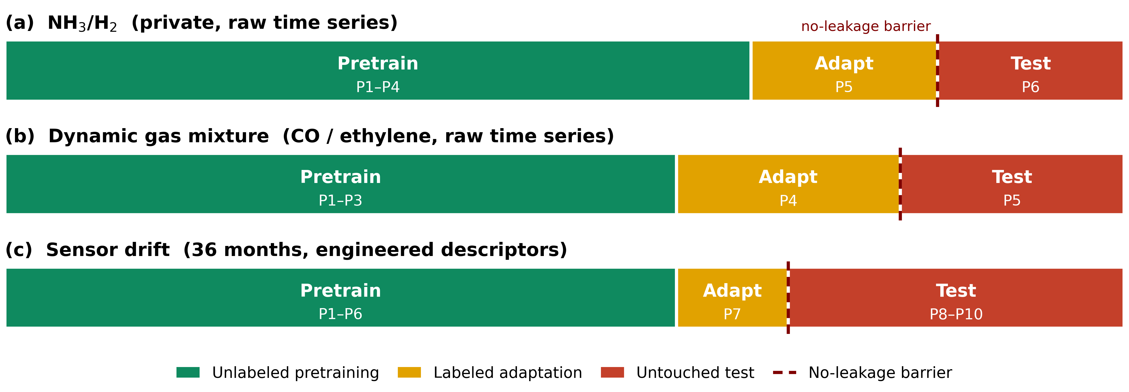
Fig. 2. Leakage-controlled secondary fixed splits and chronological drift roles; the primary multi-fold protocols are specified in Section IV.

Preprocessing and Optimization
For the two raw-response datasets, a per-sensor robust scaler is fitted on unlabeled pretraining windows only. The center is the median and the scale is the interquartile range; scaled values are clipped to $[-12,12]$. Targets are divided by fixed implementation scales before Huber training: $[500,500]$ ppm for the NH3/H2 dataset and $[533.33,20]$ ppm for the dynamic gas mixture dataset. Predictions are transformed back to ppm and clipped to these ranges.
Raw-response pretraining uses AdamW for 60 epochs with learning rate $8×{10}^{-4}$, weight decay ${10}^{-4}$, batch size 64, and gradient-norm clipping at 2. Supervised fitting uses 120 epochs and Huber loss with $δ=0.1$ in normalized target space. Scratch training uses learning rate $5×{10}^{-4}$. Frozen transfer trains only the head at ${10}^{-3}$. Fine-tuning uses $8×{10}^{-5}$ for the encoder and $8×{10}^{-4}$ for the head. All supervised policies use weight decay $2×{10}^{-4}$ and batches of at most 64 samples.
Sensor drift dataset features are robust-scaled using partitions 1–6 with the 10th–90th percentile range and clipped to $[-10,10]$. Descriptor pretraining uses 40 AdamW epochs, learning rate $8×{10}^{-4}$, weight decay ${10}^{-4}$, batch size 256, and gradient clipping at 2. Supervised sensor drift dataset fitting uses 120 epochs, weight decay $2×{10}^{-4}$, and adaptation-only minimum-loss checkpoint selection, except for the one-label final-epoch protocol. The head learning rate is $8×{10}^{-4}$; the encoder rate is $5×{10}^{-4}$ from scratch and $8×{10}^{-5}$ during fine-tuning. Concentration is transformed per gas as
$$u_{i}=\frac{log(1+c_{i})-μ_{r_{i}}}{σ_{r_{i}}}, (17)$$
where $r_{i}$ is the true gas class and $μ_{r},σ_{r}$ are estimated from the supervised fitting subset only. The sensor drift dataset Huber term uses $δ=0.5$.
All revised experiments use seeds 42, 142, 242, 342, 442, 542, 642, 742, 842, and 942, with seed-specific pretraining. Approximately 20% of selected exposure groups are reserved for validation. Random and farthest-point calibration designs are crossed with scratch and fine-tuning at every fixed-split budget. Full multi-fold coverage uses all available adaptation pairs, whose number can differ between rolling folds.
Dataset-specific hardware and environmental settings remain unverified; the related VOC-array study [28] does not establish the NH3/H2 acquisition configuration. Digital audits found no identical stored signal fingerprints or identifier overlap across 11 split definitions, but do not prove physical acquisition independence. The concentration range does not validate low-concentration ambient monitoring. Supplementary ?NH3/H2 dataset and acquisition details? provides the metadata limitations and audit scope.
NH3/H2 sensitivity tests compare early, middle, late, and full-exposure 64-sample inputs, refitting scalers on the corresponding pretraining windows. Early windows remain predefined. Exact sample-position definitions are supplied in the supplement; without a verified sampling frequency, positions cannot be interpreted as durations.
The generic SSL control uses eight nonoverlapping length-8 patches per channel, 32-dimensional tokens, two four-head Transformer layers, 96-unit feed-forward blocks, shared channel weights, temporal positions, and three masked patches per channel. It has no physical sensor embeddings or cross-channel attention. Temporal mean pooling feeds the same concatenated-channel regression head, so channel ordering remains available. Instance normalization is omitted to preserve absolute responses and match preprocessing; capacity differs and is reported. Pretraining/adaptation data, budgets, seeds, scaling and checkpoint rules match the proposed model.
Classical regressors receive flattened pretraining-scaled windows: 1,280 NH3/H2 or 1,024 CO/ethylene features. PLSR and separate-target RBF SVR additionally standardize features using fitting data only. Hyperparameters are selected by adaptation-validation normalized MAE. Tree settings are fixed. At 20 drift labels/gas, historical log-Huber is compared with log1p(c)/log1p(1000), linear c/1000 Huber, and linear c/1000 MAE. Below 20 labels/gas the fixed log scale avoids estimating a standard deviation from tiny fitting sets. The 1000-ppm divisor is a numerical unit, not an asserted physical maximum. Constant controls use only the per-gas fitting mean.

Evaluation Metrics
Besides using standard metrics like MAE, RMSE and R², the authors also measure the 90th percentile of absolute error , given by (18) to examine large errors.
$$Q_{0.9,j}={quantile}_{0.9}\left(|y_{ij}-{\hat{y}}_{ij}|\right), (18)$$
Relative transfer gain is defined as in (19):
$$Gain(\%)=100\frac{E_{scratch}-E_{transfer}}{E_{scratch}}, (19)$$
For sensor drift dataset concentration regression, the authors report the unweighted mean across six gases in (20),
$$MacroMAE=\frac{1}{6}\sum_{r=1}^{6}{{MAE}_{r}}. (20)$$
The authors report seed means and sample SD (ddof=1). Paired 95% bootstrap intervals use 5,000 crossed seed-and-fold resamples, weighting folds equally and conditioning on observed test exposures. Repeated predictions are not independent exposures, and overlapping training folds limit population inference. Fixed-split controls resample paired seeds; the control comparisons are exploratory and not multiplicity-adjusted. Drift NMAE divides each gas MAE by its concentration range in historical partitions 1–6, whose labels are used for reporting only. This permits an equal-gas macro-NMAE when a test-partition range is zero; the test-range diagnostic is also retained.

Results

Self-Supervised Pretraining
Figure 3 shows ten-seed reconstruction diagnostics. Losses across differently scaled datasets are not concentration-accuracy comparisons; subsequent results use held-out predictions.
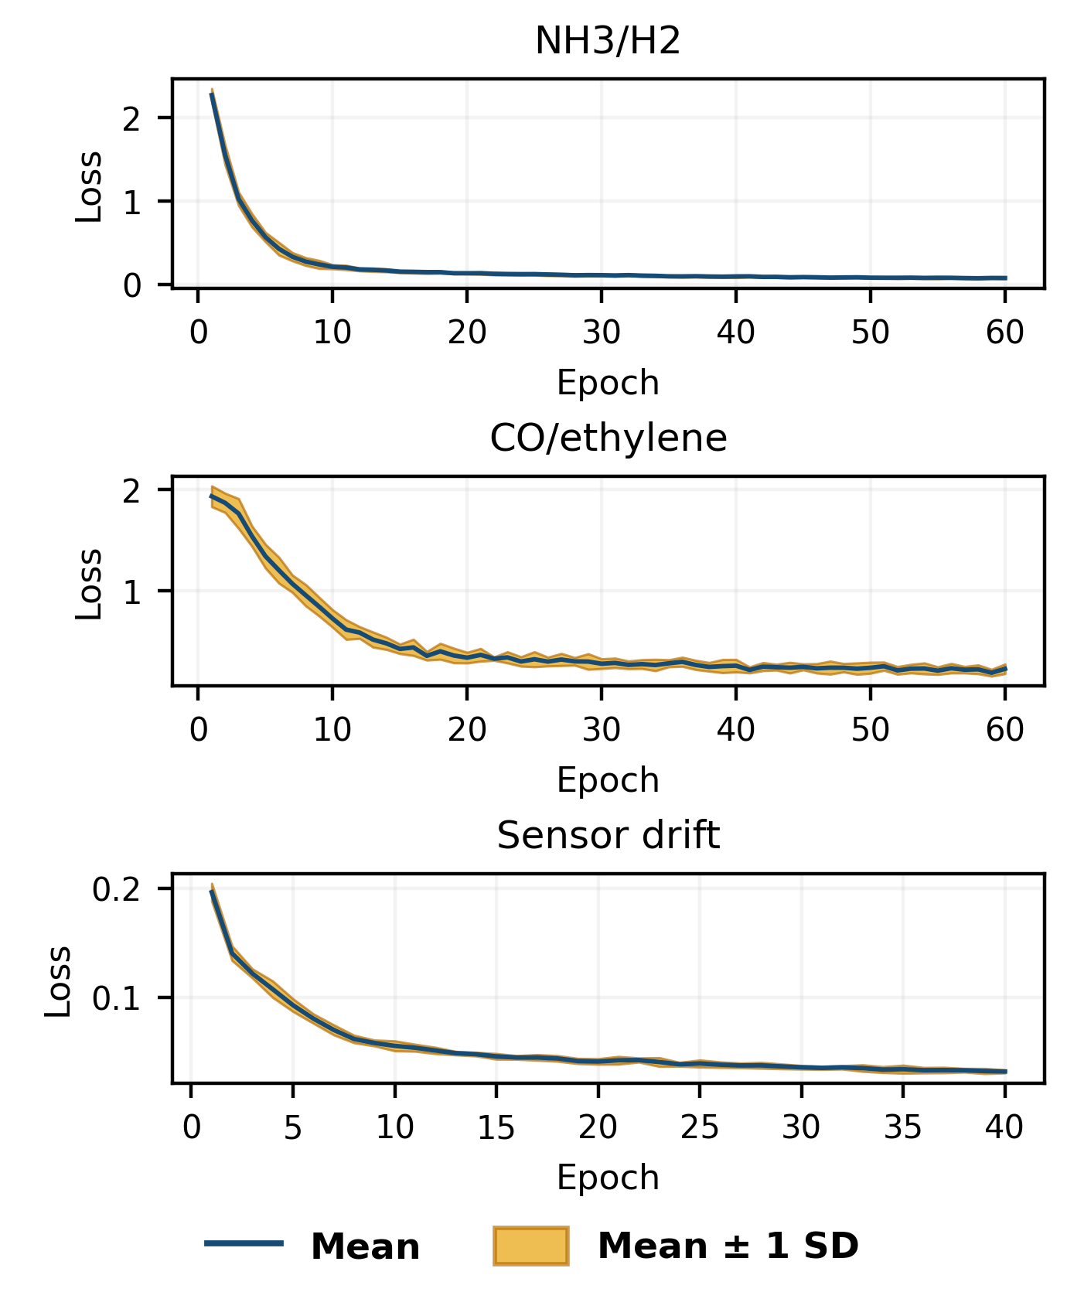
Fig. 3. Reconstruction loss over 10 seeds: blue line, mean; orange band, mean ± one seed SD. Raw-response pretraining uses 60 epochs; descriptor pretraining uses 40.

Primary Multi-Fold Validation
Table I compares fine-tuning with scratch under matched adaptation groups and holdouts. All four paired intervals exclude zero, with NH3 closest to zero. Inference is conditional on observed exposures, not new arrays or acquisition campaigns.
Table I. Primary Multi-Fold MAE and Paired Difference (ppm)
Gas | Scratch | Fine-tuned | Difference | 95% interval
NH3 | 31.01 | 26.69 | 4.31 | [0.38, 8.30]
H2 | 49.20 | 38.63 | 10.58 | [3.57, 18.78]
CO | 89.95 | 65.22 | 24.74 | [12.85, 37.53]
Ethylene | 2.611 | 1.939 | 0.672 | [0.247, 1.143]
Relative reductions are NH3: 13.9%, H2: 21.5%, CO: 27.5%, Ethylene: 25.7%. Across-fold SD of fine-tuned mean MAE is NH3: 11.07 ppm, H2: 10.59 ppm, CO: 14.71 ppm, Ethylene: 0.448 ppm. NH3/H2 includes 378 distinct test identifiers over six folds (3,780 predictions per gas across seeds); CO/ethylene includes 105 identifiers over three rolling tests (1,050 predictions per gas). Supplementary Table S1 retains every fold and all policies.
Primary improvements do not erode systematically across ten seeds. Supplementary Table S2 and Fig. S1 report seed prefixes and random-order sensitivity; all ten seeds are retained.

Fixed-Split Label-Budget Analysis
Table II reports all adaptation policies as mean ± seed SD. Budgets include validation labels. These fixed-split experiments are secondary to the multi-fold evaluation; neither the policy nor the budget is chosen from test performance. At full budget the paired means favor fine-tuning over scratch, but errors do not decrease monotonically at every budget.
Table II. Fixed-Split MAE (ppm), Mean ± SD Over Ten Seeds
Gas | Pairs | Scratch | Frozen | Fine-tuned
NH3 | 5 | 86.39 ± 36.11 | 82.85 ± 31.89 | 86.02 ± 34.16
NH3 | 10 | 67.52 ± 40.50 | 41.08 ± 7.01 | 38.92 ± 4.56
NH3 | 20 | 36.84 ± 7.89 | 31.10 ± 2.80 | 29.53 ± 2.38
NH3 | 40 | 29.86 ± 2.74 | 25.09 ± 2.01 | 25.22 ± 2.10
NH3 | 57 | 21.59 ± 3.25 | 19.26 ± 1.76 | 17.36 ± 1.54
H2 | 5 | 161.51 ± 22.40 | 129.17 ± 12.17 | 128.91 ± 16.84
H2 | 10 | 124.16 ± 28.13 | 78.73 ± 18.12 | 81.88 ± 19.54
H2 | 20 | 70.73 ± 30.45 | 48.04 ± 8.65 | 48.38 ± 9.70
H2 | 40 | 51.53 ± 6.60 | 41.26 ± 2.34 | 41.67 ± 2.75
H2 | 57 | 41.20 ± 4.27 | 34.77 ± 2.70 | 31.60 ± 2.29
CO | 5 | 163.06 ± 47.96 | 125.10 ± 34.73 | 111.46 ± 23.96
CO | 10 | 156.04 ± 27.60 | 77.08 ± 25.00 | 80.99 ± 27.98
CO | 20 | 89.30 ± 39.24 | 49.96 ± 8.66 | 47.42 ± 7.79
CO | 24 | 63.63 ± 10.68 | 46.81 ± 9.60 | 47.45 ± 7.38
Ethylene | 5 | 5.226 ± 1.469 | 3.916 ± 1.680 | 3.468 ± 1.248
Ethylene | 10 | 3.610 ± 1.421 | 2.449 ± 0.464 | 2.418 ± 0.484
Ethylene | 20 | 2.465 ± 0.745 | 1.879 ± 0.534 | 1.843 ± 0.506
Ethylene | 24 | 2.149 ± 0.359 | 1.668 ± 0.241 | 1.627 ± 0.275
For example, fine-tuned CO MAE is 47.42 ± 7.79 ppm at 20 pairs and 47.45 ± 7.38 ppm at 24 pairs. Figure 4 retains all three policies rather than a test-selected policy summary.
Fixed-split gains attenuate with additional seeds, especially NH3 (32.4% for the first three versus 19.6% for all ten). Detailed seed sensitivity is supplementary; primary conclusions use multi-fold evidence.

Calibration-Design Control
Random and farthest-point designs are crossed with both training policies at every budget. At five pairs, random minus farthest-point fine-tuned MAE is NH3: 3.74 ppm (95% interval -17.95 to 28.62); H2: 14.62 ppm (95% interval -5.72 to 35.31); CO: 31.61 ppm (95% interval 13.34 to 51.92); Ethylene: 0.855 ppm (95% interval -0.595 to 2.151). The design effect is therefore target-dependent. It uses known concentration coordinates and must not be interpreted as active acquisition of unknown labels. All-budget paired design and transfer contrasts are in Supplementary Table S3.
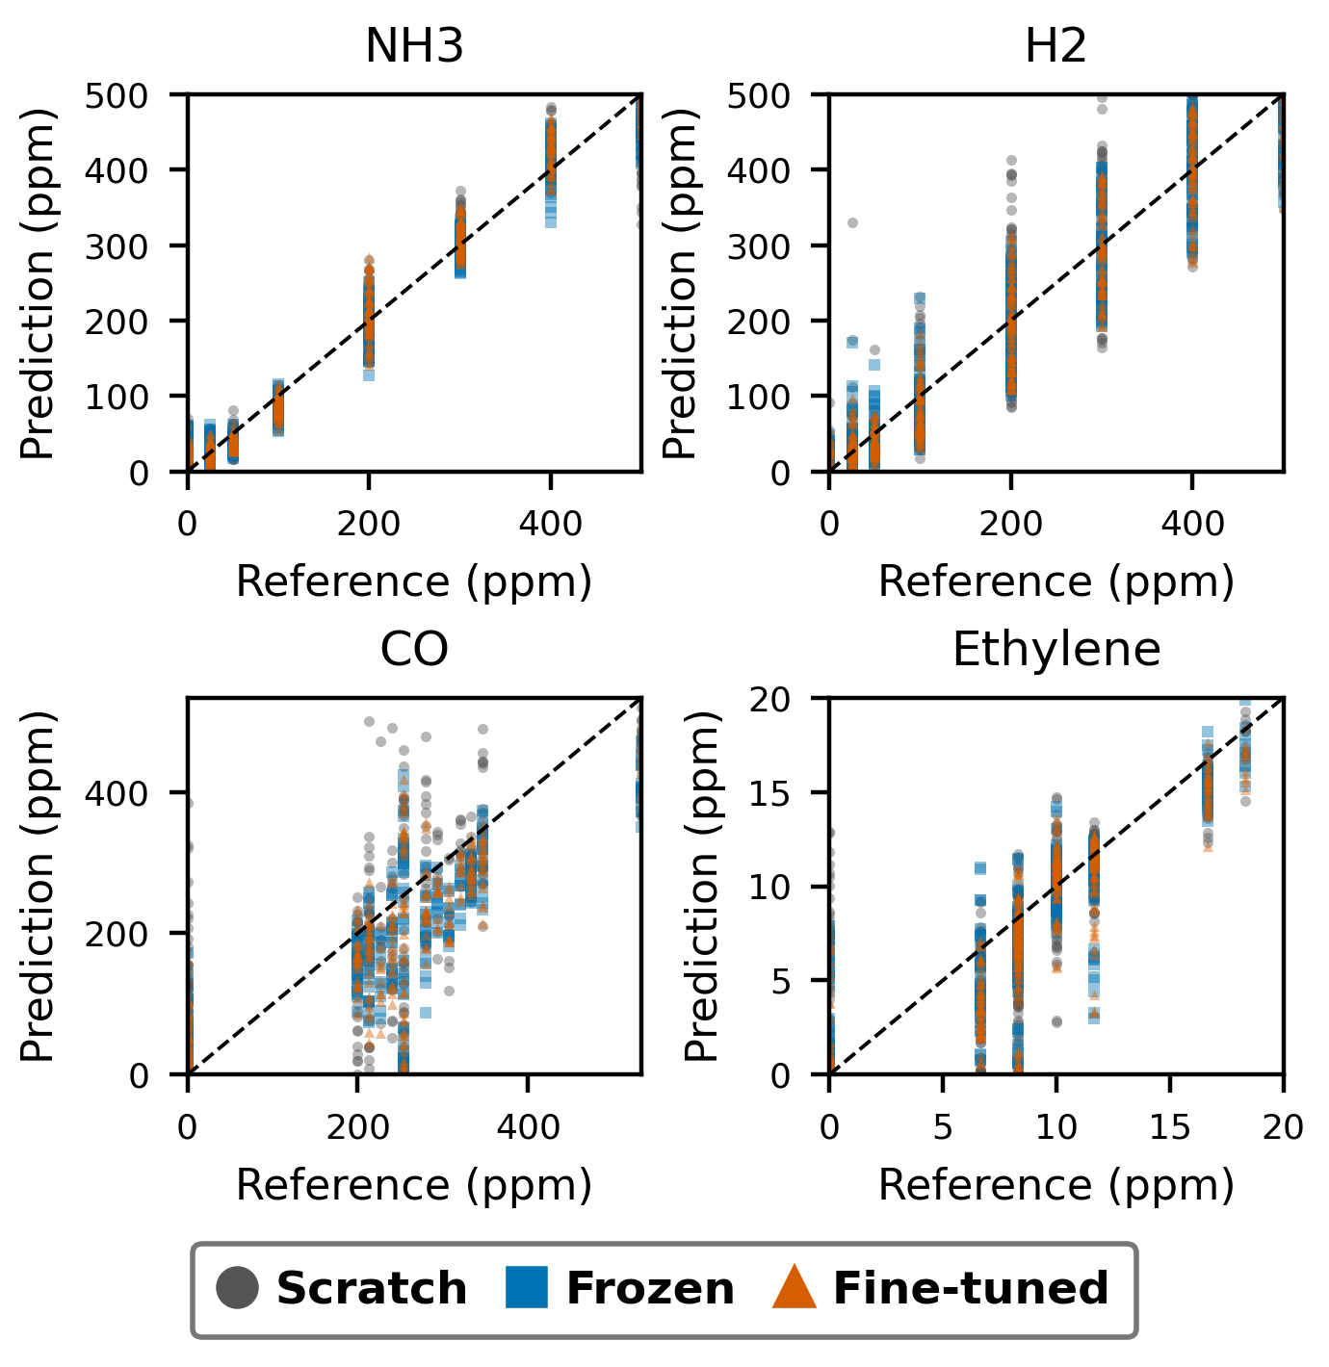
Fig. 4. Secondary full-budget predictions from all 10 seeds: gray circles, Scratch; blue squares, Frozen; orange triangles, Fine-tuned. Points repeat test exposures across seeds; the dashed line is identity, not a fitted trend.
Table III. Five-Pair Design Control, MAE (ppm), Mean ± SD
Gas | Design | Scratch | Fine-tuned
NH3 | Random | 98.51 ± 29.07 | 89.75 ± 29.49
NH3 | Farthest | 86.39 ± 36.11 | 86.02 ± 34.16
H2 | Random | 159.51 ± 12.93 | 143.53 ± 30.16
H2 | Farthest | 161.51 ± 22.40 | 128.91 ± 16.84
CO | Random | 179.22 ± 31.43 | 143.07 ± 22.16
CO | Farthest | 163.06 ± 47.96 | 111.46 ± 23.96
Ethylene | Random | 4.890 ± 1.836 | 4.323 ± 1.682
Ethylene | Farthest | 5.226 ± 1.469 | 3.468 ± 1.248

Baseline Comparison
The sensor-aware model is not uniformly strongest. PLSR CO MAE is 25.57 ± 8.48 ppm versus 47.45 ± 7.38 ppm for fine-tuning; Extra Trees ethylene MAE is 1.398 ± 0.197 ppm versus 1.627 ± 0.275 ppm. These are observed means under the declared fixed split, not a claim of universal statistical superiority. PLSR/SVR validation grids and all budget results are documented in the supplement.
Paired full-budget generic-SSL comparisons favor the sensor-aware model on H2, favor generic SSL on NH3 and ethylene, and are inconclusive for CO. Lower-budget effects are also mixed (Supplementary Table S4). Encoder and capacity differences preclude attributing these contrasts solely to sensor identity.
Table IV. Full-Budget Baseline MAE (ppm), Mean ± SD
Model | NH3 | H2 | CO | Ethylene
Scratch | 21.59 ± 3.25 | 41.20 ± 4.27 | 63.63 ± 10.68 | 2.149 ± 0.359
Extra Trees | 21.63 ± 1.73 | 37.33 ± 2.04 | 90.46 ± 7.17 | 1.398 ± 0.197
XGBoost | 26.96 ± 4.61 | 48.65 ± 2.38 | 55.90 ± 11.13 | 2.491 ± 0.352
PLSR | 28.44 ± 4.76 | 75.50 ± 18.25 | 25.57 ± 8.48 | 1.994 ± 0.377
SVR | 20.74 ± 1.62 | 31.37 ± 4.53 | 53.01 ± 7.26 | 2.013 ± 0.226
Generic SSL | 16.13 ± 1.23 | 35.18 ± 2.74 | 52.52 ± 12.59 | 1.437 ± 0.275
Fine-tuned | 17.36 ± 1.54 | 31.60 ± 2.29 | 47.45 ± 7.38 | 1.627 ± 0.275

Ablation and Window Sensitivity
Table V. Full-Budget Ablation Minus Full-Model MAE (ppm), Mean ± SD
Removed | NH3 | H2 | CO | Ethylene
No sensor ID | -0.06 ± 1.66 | 4.73 ± 3.73 | 5.17 ± 10.05 | 0.097 ± 0.462
No attention | -3.01 ± 1.49 | 1.99 ± 3.50 | 10.27 ± 12.18 | -0.140 ± 0.264
No time mask | 2.10 ± 2.17 | 1.73 ± 3.30 | 7.93 ± 14.86 | -0.016 ± 0.360
No sensor mask | -0.78 ± 2.00 | 4.34 ± 3.75 | 1.83 ± 8.34 | 0.027 ± 0.215
Table V reports within-seed ablation-minus-full-model differences: positive values favor the complete model. Effects vary by gas; sampling and optimization cannot be separated from physical selectivity, and no component is uniformly beneficial.
Removing sensor identity changes NH3 MAE by -0.06 ± 1.66 ppm, compared with 4.73 ± 3.73 ppm for H2. Removing attention lowers NH3 error by 3.01 ppm on average. Thus the original large cross-gas identity-effect ratio is not treated as a stable physical constant, and the attention module is not uniformly beneficial.
Table VI. Window Sensitivity, MAE (ppm), Mean ± SD
Window | NH3 scratch | NH3 transfer | H2 scratch | H2 transfer
Early | 21.59 ± 3.25 | 17.36 ± 1.54 | 41.20 ± 4.27 | 31.60 ± 2.29
Middle | 34.55 ± 5.01 | 29.60 ± 3.23 | 33.99 ± 4.10 | 35.60 ± 3.08
Late | 56.71 ± 5.88 | 54.75 ± 4.40 | 52.12 ± 7.87 | 51.28 ± 4.89
Full | 20.24 ± 1.76 | 18.05 ± 2.48 | 38.36 ± 2.56 | 35.75 ± 2.46
Window placement changes absolute error and transfer effects (Table VI): late windows are worse for both gases, and middle-window H2 does not improve. Full-exposure resampling is a control, not a test-selected optimum; early windows remain predefined.

Long-Term Drift
The primary 20-label/gas transform is historical per-gas log-Huber; the constant predictor uses the same fitting records. Scratch minus fine-tuned macro-MAE is partition 8: 4.50 ppm (95% interval 2.55 to 6.19); partition 9: 4.16 ppm (95% interval 2.41 to 6.22); partition 10: -0.71 ppm (95% interval -8.40 to 6.91). These intervals resample seeds, conditional on each test partition. The comparison describes concentration regression with true gas identity supplied; it excludes classification errors.
Table VII. Oracle-Class Drift Macro-MAE (ppm), Mean ± SD
Policy | Partition 8 | Partition 9 | Partition 10
Constant | 52.91 ± 3.07 | 46.13 ± 3.07 | 181.05 ± 2.13
Scratch | 23.95 ± 3.46 | 22.68 ± 2.86 | 142.34 ± 11.06
Frozen | 19.09 ± 2.25 | 18.91 ± 3.25 | 137.43 ± 13.49
Fine-tuned | 19.45 ± 3.37 | 18.52 ± 4.60 | 143.05 ± 12.49
Partition 10 shows no clear improvement: its paired interval includes zero. Constant and normalized-error controls remain necessary; favorable conditional comparisons do not establish severe-drift deployment robustness.
Table VIII. Fine-Tuned Per-Gas NMAE (% of Historical Range), Mean ± SD
Gas | Partition 8 | Partition 9 | Partition 10
Ethanol | 0.49 ± 0.52 | 0.40 ± 0.45 | 10.76 ± 0.90
Ethylene | 5.04 ± 1.40 | 4.23 ± 1.50 | 21.72 ± 3.51
Ammonia | 3.34 ± 0.93 | 1.74 ± 1.02 | 36.00 ± 3.06
Acetaldehyde | 5.65 ± 2.43 | 10.02 ± 2.92 | 24.19 ± 2.34
Acetone | 6.81 ± 0.33 | 4.55 ± 1.27 | 61.11 ± 12.72
Toluene | 18.76 ± 8.32 | 30.16 ± 11.61 | 22.61 ± 4.58
Macro | 6.68 ± 1.74 | 8.52 ± 2.48 | 29.40 ± 3.07
Table VIII uses each gas’s fixed historical concentration range and weights gases equally; it avoids allowing high-ppm analytes to dominate the normalized macro score. All-policy per-gas MAE and NMAE, reference ranges, and all five budgets are in Supplementary Tables S5–S6. A one-label/gas run is a fixed-epoch tiny-sample test, not a validated checkpoint comparison.
Under fixed-log scaling, fine-tuned one-label/gas macro-MAE is 8: 40.73 ± 24.75 ppm, 9: 39.47 ± 20.58 ppm, 10: 206.22 ± 24.05 ppm. Its large seed variation and the substantial partition-10 error limit claims of extreme label efficiency. Budget effects are not uniformly monotonic. The fixed-log 20-label control is retained to separate budget effects from the primary protocol’s change to fitted-log scaling at 20 labels.
Table IX. Fine-Tuned Loss/Scaling Sensitivity, Macro-MAE (ppm), Mean ± SD
Target / loss | Partition 8 | Partition 9 | Partition 10
Log fitted SD | 19.45 ± 3.37 | 18.52 ± 4.60 | 143.05 ± 12.49
Log fixed | 22.68 ± 5.59 | 26.11 ± 6.19 | 184.96 ± 9.99
Linear Huber | 26.94 ± 4.16 | 25.50 ± 6.16 | 145.56 ± 11.05
Linear MAE | 22.48 ± 4.17 | 20.70 ± 4.75 | 137.55 ± 12.87
Log-Huber and linear MAE optimize different error geometries. Table IX tests alternatives without choosing the primary transform from test scores. Fixed scaling avoids fitting log variance from 16 records per gas. Supplementary Table S7 retains every policy and fitted scale.
Historical fitted-log Huber has the lowest observed fine-tuned macro-MAE among these transforms in partitions 8 and 9. In partition 10, linear MAE gives 137.55 ± 12.87 ppm versus 143.05 ± 12.49 ppm for fitted-log Huber, while fixed-log Huber rises to 184.96 ± 9.99 ppm. The apparent severe-drift benefit of changing the loss is therefore not a uniform scaling improvement, and the linear-MAE transfer-versus-scratch interval also includes zero.

Tail Error, Capacity, and Uncertainty
Table X. Full-Budget Mean R², RMSE and Q0.9 Across Ten Seeds
Gas | Policy | R² | RMSE | Q0.9
NH3 | Scratch | 0.962 | 31.16 | 48.79
NH3 | Frozen | 0.975 | 25.57 | 44.64
NH3 | Fine-tuned | 0.979 | 23.29 | 38.11
H2 | Scratch | 0.881 | 57.78 | 96.54
H2 | Frozen | 0.925 | 46.01 | 78.41
H2 | Fine-tuned | 0.935 | 42.90 | 74.15
CO | Scratch | 0.617 | 94.89 | 162.79
CO | Frozen | 0.771 | 73.58 | 110.76
CO | Fine-tuned | 0.777 | 72.93 | 109.51
Ethylene | Scratch | 0.558 | 3.257 | 5.769
Ethylene | Frozen | 0.749 | 2.457 | 3.703
Ethylene | Fine-tuned | 0.742 | 2.483 | 4.130
CO remains quantitatively limited even after transfer: mean R² is 0.777, and Q0.9 is 109.51 ppm on the 0–533.33 ppm scale. Relative improvement must not be equated with adequate quantitative calibration. Table X includes scratch tail errors and frozen transfer as well as fine-tuning.
NH3/H2: 117,514 proposed parameters (31,272 encoder; 86,242 head), all trainable in fine-tuning versus 86,242 in frozen transfer; generic SSL has 108,098. The seed-42 full-budget fitting subset has 46 distinct exposures, giving 2,555 proposed parameters per fitting exposure. CO/ethylene: 101,002 proposed parameters (31,144 encoder; 69,858 head), all trainable in fine-tuning versus 69,858 in frozen transfer; generic SSL has 91,714. The seed-42 full-budget fitting subset has 19 distinct exposures, giving 5,316 proposed parameters per fitting exposure. Five overlapping windows do not multiply the independent sample count. Supplementary Table S8 gives low/full-budget model sizes and drift counts; high parameter-to-exposure ratios remain an overfitting concern despite regularization and validation.
Chronological/session shift violates the exchangeability assumption of standard split-conformal coverage [24], [25]. Such intervals are diagnostic under shift, not deployment guarantees. Shift-aware uncertainty remains unevaluated.

Discussion and Conclusion
Sensor-aware masked pretraining supports label-efficient same-system recalibration. Under predefined fine-tuning, primary multi-fold MAE reductions versus scratch are 13.9% for NH3, 21.5% for H2, 27.5% for CO and 25.7% for ethylene.
These gains do not establish architectural superiority: generic SSL and classical regressors outperform the proposed model on some targets. Ablation, window, calibration-design and budget effects are target-dependent. Remaining absolute and tail errors, especially for CO, limit practical calibration adequacy.
Oracle-class drift regression improves in partitions 8-9 but not clearly in partition 10. The evaluation assumes known gas identity. Constant, normalized-error and loss controls show that representation reuse alone does not establish severe-drift robustness.
Ten seeds quantify training/design variability, not independent acquisitions. Intervals condition on observed exposures; NH3 is close to zero, chronological folds are few and training folds overlap. Fixed-split estimates are seed-sensitive. Physical exposure independence and cross-device generalization require further evidence; sensor identities depend on channel correspondence.
Label withholding tests the learning premise retrospectively, not acquisition-cost savings. Known-coordinate calibration design excludes candidate-pool quantification costs. Prospective work should combine inexpensive unquantified mixtures, limited precise adaptation labels and independent quantified tests with cost accounting and acquisition metadata. Temporal adaptation and shift-aware uncertainty are further priorities.

References
[1] P. Jia, T. Huang, S. Duan, L. Ge, J. Yan, and L. Wang, “A novel semi-supervised electronic nose learning technique: M-Training,” Sensors, vol. 16, no. 3, Art. no. 370, 2016, doi: 10.3390/s16030370.
[2] T. Huang, P. Jia, P. He, S. Duan, J. Yan, and L. Wang, “A novel semi-supervised method of electronic nose for indoor pollution detection trained by M-S4VMs,” Sensors, vol. 16, no. 9, Art. no. 1462, 2016, doi: 10.3390/s16091462.
[3] Y. Zhang et al., “TDACNN: Target-domain-free domain adaptation convolutional neural network for drift compensation in gas sensors,” Sensors and Actuators B: Chemical, vol. 361, Art. no. 131739, 2022, doi: 10.1016/j.snb.2022.131739.
[4] Y. Tian et al., “Metric Network for E-Nose Drift Compensation: Few-Shot Learning for Robust Gas Sensing,” IEEE Sensors Journal, vol. 25, no. 9, 2025, doi: 10.1109/JSEN.2025.3553376.
[5] Y. Heng et al., “An electronic nose drift compensation algorithm based on semi-supervised adversarial domain adaptive convolutional neural network,” Sensors and Actuators B: Chemical, vol. 422, Art. no. 136642, 2025, doi: 10.1016/j.snb.2024.136642.
[6] Y. Tian, Y. Sun, and S. Zhang, “CEGNN: Contrastive edge labeling graph neural network for sensor drift adaptation in electronic noses,” Sensors and Actuators B: Chemical, vol. 445, Art. no. 138470, 2025, doi: 10.1016/j.snb.2025.138470.
[7] V. K. Gupta et al., “Target-Domain Data Free Model-Agnostic-Meta-Learning Framework for Time-Varying Drift Correction for E-Nose,” IEEE Sensors Letters, vol. 9, no. 8, 2025, doi: 10.1109/LSENS.2025.3591494.
[8] J. Fonollosa, S. Sheik, R. Huerta, and S. Marco, “Reservoir computing compensates slow response of chemosensor arrays exposed to fast varying gas concentrations in continuous monitoring,” Sensors and Actuators B: Chemical, vol. 215, pp. 618–629, 2015, doi: 10.1016/j.snb.2015.03.028.
[9] W. Ni et al., “Multi-task deep learning model for quantitative volatile organic compounds analysis by feature fusion of electronic nose sensing,” Sensors and Actuators B: Chemical, vol. 417, Art. no. 136206, 2024, doi: 10.1016/j.snb.2024.136206.
[10] Z. Tang et al., “Discrimination of VOCs with e-nose consisting of a single MEMS sensor using lightweight deep learning model based on SqueezeNet,” Sensors and Actuators B: Chemical, vol. 422, Art. no. 136640, 2025, doi: 10.1016/j.snb.2024.136640.
[11] X. Xia et al., “The parameter-feature-based transfer learning for mixed gas monitoring under small datasets,” Sensors and Actuators B: Chemical, vol. 441, Art. no. 137975, 2025, doi: 10.1016/j.snb.2025.137975.
[12] H. Mei et al., “A semi-supervised domain adaptation for cross-gas concentration prediction with multi-target and bidirectional transfer for E-nose system,” Sensors and Actuators B: Chemical, vol. 450, Art. no. 139242, 2026, doi: 10.1016/j.snb.2025.139242.
[13] K. Zhang et al., “Self-Supervised Learning for Time Series Analysis: Taxonomy, Progress, and Prospects,” IEEE Transactions on Pattern Analysis and Machine Intelligence, vol. 46, no. 10, pp. 6775–6794, 2024, doi: 10.1109/TPAMI.2024.3387317.
[14] I. Rodriguez-Lujan, J. Fonollosa, A. Vergara, M. L. Homer, and R. Huerta, “On the calibration of sensor arrays for pattern recognition using the minimal number of experiments,” Chemometrics and Intelligent Laboratory Systems, vol. 130, pp. 123–134, 2014, doi: 10.1016/j.chemolab.2013.10.012.
[15] J. Fonollosa, “Gas sensor array under dynamic gas mixtures,” UCI Machine Learning Repository, 2015, doi: 10.24432/C5WP4C.
[16] A. Vergara, “Gas Sensor Array Drift at Different Concentrations,” UCI Machine Learning Repository, 2012, doi: 10.24432/C5MK6M.
[17] A. Vergara, S. Vembu, T. Ayhan, M. A. Ryan, M. L. Homer, and R. Huerta, “Chemical gas sensor drift compensation using classifier ensembles,” Sensors and Actuators B: Chemical, vols. 166–167, pp. 320–329, 2012, doi: 10.1016/j.snb.2012.01.074.
[18] Y. Nie, N. H. Nguyen, P. Sinthong, and J. Kalagnanam, "A Time Series is Worth 64 Words: Long-term Forecasting with Transformers," ICLR, 2023. https://arxiv.org/abs/2211.14730
[19] G. Zerveas, S. Jayaraman, D. Patel, A. Bhamidipaty, and C. Eickhoff, "A Transformer-based Framework for Multivariate Time Series Representation Learning," KDD, 2021. https://arxiv.org/abs/2010.02803
[20] Z. Yue et al., "TS2Vec: Towards Universal Representation of Time Series," AAAI, 2022. https://arxiv.org/abs/2106.10466
[21] S. Wold, M. Sjostrom, and L. Eriksson, "PLS-regression: a basic tool of chemometrics," Chemometrics and Intelligent Laboratory Systems, vol. 58, pp. 109–130, 2001. https://doi.org/10.1016/S0169-7439(01)00155-1
[22] A. J. Smola and B. Scholkopf, "A tutorial on support vector regression," Statistics and Computing, vol. 14, pp. 199–222, 2004. https://doi.org/10.1023/B:STCO.0000035301.49549.88
[23] R. W. Kennard and L. A. Stone, "Computer Aided Design of Experiments," Technometrics, vol. 11, pp. 137–148, 1969. https://doi.org/10.1080/00401706.1969.10490666
[24] R. F. Barber, E. J. Candes, A. Ramdas, and R. J. Tibshirani, "Conformal prediction beyond exchangeability," Annals of Statistics, vol. 51, 2023. https://arxiv.org/abs/2202.13415
[25] R. J. Tibshirani, R. F. Barber, E. J. Candes, and A. Ramdas, "Conformal Prediction Under Covariate Shift," NeurIPS, 2019. https://arxiv.org/abs/1904.06019
[26] P. Geurts, D. Ernst, and L. Wehenkel, "Extremely randomized trees," Machine Learning, vol. 63, pp. 3–42, 2006. https://doi.org/10.1007/s10994-006-6226-1
[27] T. Chen and C. Guestrin, "XGBoost: A Scalable Tree Boosting System," KDD, pp. 785–794, 2016. https://arxiv.org/abs/1603.02754
[28] Dang Thi Thu Ha, Nguyen Dinh Van, Nguyen Duc Hoa, and Nguyen Van Duy, “Design and Analysis of a Volatile Organic Compounds Mixture Dataset for Indoor Air Quality Monitoring,” in Proceedings of the 4th Annual International Conference on Material, Machines, and Methods for Sustainable Development (MMMS2024), Lecture Notes in Mechanical Engineering. Cham: Springer, 2025, pp. 85–92, doi: 10.1007/978-3-031-93816-0_11.
[29] D.-V. Nguyen, "Nano MEMS Electronic Nose Responses to Ammonia and Hydrogen," Harvard Dataverse, V1, 2026, doi: 10.7910/DVN/LWUSKO.
[30] DangThiThu Ha, NguyenDinh Van, and NguyenDuc Hoa, "Image-Based Hybrid Autoencoder–LSTM for Mixed-Gas Estimation in Electronic Nose," IEEE Sensors Journal, vol. 26, no. 3, pp. 4739–4748, Feb. 2026, doi: 10.1109/JSEN.2025.3642226.

Dinh-Van Nguyen earned his Ph.D. in Information Technology from Mines ParisTech (Paris School of Mines) in 2019, focusing on localization methods for autonomous vehicles. He is currently a lecturer at the Faculty of Communication Engineering, School of Electrical and Electronic Engineering, Hanoi University of Science and Technology.
His research interests include artificial intelligence-based data analysis, smart environments, and application of digital games in intelligent education.

DangThiThu Ha is a lecturer at Hoa Lu University, Ninh Binh, Vietnam. In 2011, she obtained her master’s degree in computer science from the Hanoi National University of Education, where her research emphasized data science and security for diverse applications.
She is currently pursuing doctoral studies in computer science at the School of Information and Communication Technology at Hanoi University of Science and Technology. Her primary research interests lie in artificial intelligence and innovative applications in electronic nose systems.

Thu-Huong Nguyen earned her bachelor degree in Hanoi University of Science and Technology in 2025. she is currently a master student and teaching assistant at the Faculty of Communication Engineering, School of Electrical and Electronic Engineering, Hanoi University of Science and Technology.
Her research interests include artificial intelligence-based data analysis, smart environments, and application of digital games in intelligent education.

NguyenDuc Hoa obtained his PhD degree in Materials Science and Engineering in 2009 at Chungnam National University in Korea. He is currently a full Professor at Hanoi University of Science and Technology, Vietnam.
He has published more than 100+ ISI papers. He has approximately 8000 citations with an H-index of 58. His research has covered a wide range of nanostructured materials from their synthesis, fundamentals, and applications. He collaborated on several projects focusing on the outreach and education of students in the thematic of pollutant gases and related smart sensing platforms useful for their detection. He also developed inorganic materials and the use of machine learning towards smart sensing devices.
He was awarded a JSPS fellowship and conducted research at the National Institute for Materials Science (NIMS, Japan) from 2009 to 2011.
Original study repository: https://github.com/ngdvan/Transfer-learning-Enose.

Dinh-Van Nguyen is with School of Electrical and Electronic Engineering, Hanoi University of Science and Technology, Ha Noi, Viet Nam (e-mail: van.nguyendinh@hust.edu.vn). DangThiThu Ha is with Hoa Lu University, Ninh Binh, Viet Nam (e-mail: dttha.nnth@hluv.edu.vn), and Hanoi University of Science and Technology, Hanoi, Viet Nam (ha.dtt230053d@sis.hust.edu.vn). Thu-Huong Nguyen is with School of Electrical and Electronic Engineering, Hanoi University of Science and Technology, Ha Noi, Viet Nam (e-mail: huong.nguyenthu4@hust.edu.vn). NguyenDuc Hoa is with School of Materials Science and Engineering, Hanoi University of Science and Technology, Hanoi, Viet Nam (e-mail: hoa.nguyenduc@hust.edu.vn).

