Supplementary Information
The authors provide additional experimental results, sensitivity analyses and details of the NH3/H2 measurement apparatus and acquisition protocol. Numerical summaries use ten predefined seeds and are conditional on the observed test exposures. The accompanying data exports retain unrounded results.

Table S1. Fold-level MAE (ppm), mean ± seed SD
Gas | Fold | Pairs | Policy | MAE
CO | 1 | 21 | Fine-tuned | 70.88 ± 17.27
Ethylene | 1 | 21 | Fine-tuned | 2.456 ± 0.570
CO | 1 | 21 | Frozen | 81.39 ± 14.49
Ethylene | 1 | 21 | Frozen | 2.914 ± 0.780
CO | 1 | 21 | Scratch | 83.56 ± 24.03
Ethylene | 1 | 21 | Scratch | 3.159 ± 1.091
CO | 2 | 18 | Fine-tuned | 76.25 ± 15.60
Ethylene | 2 | 18 | Fine-tuned | 1.675 ± 0.184
CO | 2 | 18 | Frozen | 74.09 ± 16.26
Ethylene | 2 | 18 | Frozen | 1.517 ± 0.224
CO | 2 | 18 | Scratch | 105.82 ± 18.97
Ethylene | 2 | 18 | Scratch | 1.989 ± 0.283
CO | 3 | 22 | Fine-tuned | 48.52 ± 9.40
Ethylene | 3 | 22 | Fine-tuned | 1.686 ± 0.328
CO | 3 | 22 | Frozen | 47.18 ± 12.14
Ethylene | 3 | 22 | Frozen | 1.711 ± 0.357
CO | 3 | 22 | Scratch | 80.47 ± 31.42
Ethylene | 3 | 22 | Scratch | 2.684 ± 0.590
H2 | 1 | 57 | Fine-tuned | 45.39 ± 4.30
NH3 | 1 | 57 | Fine-tuned | 41.99 ± 5.37
H2 | 1 | 57 | Frozen | 39.17 ± 3.27
NH3 | 1 | 57 | Frozen | 37.38 ± 3.48
H2 | 1 | 57 | Scratch | 70.00 ± 15.43
NH3 | 1 | 57 | Scratch | 52.04 ± 9.25
H2 | 2 | 57 | Fine-tuned | 37.28 ± 7.90
NH3 | 2 | 57 | Fine-tuned | 26.53 ± 5.04
H2 | 2 | 57 | Frozen | 32.11 ± 4.01
NH3 | 2 | 57 | Frozen | 25.24 ± 4.21
H2 | 2 | 57 | Scratch | 44.98 ± 11.13
NH3 | 2 | 57 | Scratch | 30.59 ± 8.63
H2 | 3 | 57 | Fine-tuned | 35.13 ± 2.95
NH3 | 3 | 57 | Fine-tuned | 17.05 ± 4.34
H2 | 3 | 57 | Frozen | 37.40 ± 4.31
NH3 | 3 | 57 | Frozen | 17.72 ± 2.31
H2 | 3 | 57 | Scratch | 46.91 ± 7.11
NH3 | 3 | 57 | Scratch | 20.94 ± 4.31
H2 | 4 | 57 | Fine-tuned | 26.36 ± 4.22
NH3 | 4 | 57 | Fine-tuned | 18.83 ± 3.31
H2 | 4 | 57 | Frozen | 30.66 ± 4.48
NH3 | 4 | 57 | Frozen | 22.77 ± 4.16
H2 | 4 | 57 | Scratch | 25.70 ± 3.99
NH3 | 4 | 57 | Scratch | 16.22 ± 3.48
H2 | 5 | 57 | Fine-tuned | 55.99 ± 4.86
NH3 | 5 | 57 | Fine-tuned | 38.39 ± 2.50
H2 | 5 | 57 | Frozen | 59.73 ± 4.79
NH3 | 5 | 57 | Frozen | 44.10 ± 3.37
H2 | 5 | 57 | Scratch | 66.43 ± 8.92
NH3 | 5 | 57 | Scratch | 44.66 ± 5.92
H2 | 6 | 57 | Fine-tuned | 31.60 ± 2.29
NH3 | 6 | 57 | Fine-tuned | 17.36 ± 1.54
H2 | 6 | 57 | Frozen | 34.77 ± 2.70
NH3 | 6 | 57 | Frozen | 19.26 ± 1.76
H2 | 6 | 57 | Scratch | 41.20 ± 4.27
NH3 | 6 | 57 | Scratch | 21.59 ± 3.25

Table S2. Seed-count sensitivity within the revised primary protocol
Gas | First 3 gain % | All 10 gain % | Later 7 gain % | Positive / 10
CO | 28.48 | 27.50 | 27.06 | 10
Ethylene | 26.09 | 25.73 | 25.57 | 9
H2 | 18.40 | 21.49 | 22.72 | 10
NH3 | 13.30 | 13.91 | 14.15 | 9

Table S2b. Secondary full-budget fixed split and drift seed sensitivity
Analysis | Gas | First 3 gain % | All 10 gain % | Later 7 gain %
fixed_split | CO | 27.23 | 25.43 | 24.71
fixed_split | Ethylene | 31.14 | 24.31 | 21.01
fixed_split | H2 | 27.22 | 23.29 | 21.52
fixed_split | NH3 | 32.44 | 19.59 | 12.96
drift_partition_8 | MacroMAE | 25.61 | 18.80 | 15.63
drift_partition_9 | MacroMAE | 17.97 | 18.35 | 18.52
drift_partition_10 | MacroMAE | -11.95 | -0.50 | 4.17
Prefixes use the predefined order 42, 142, …, 942; all ten remain the reporting set. A random-order 95% envelope is a subset diagnostic, not a confidence interval. More seeds change an estimated mean; they do not weaken a trained model or increase the number of independent physical exposures.
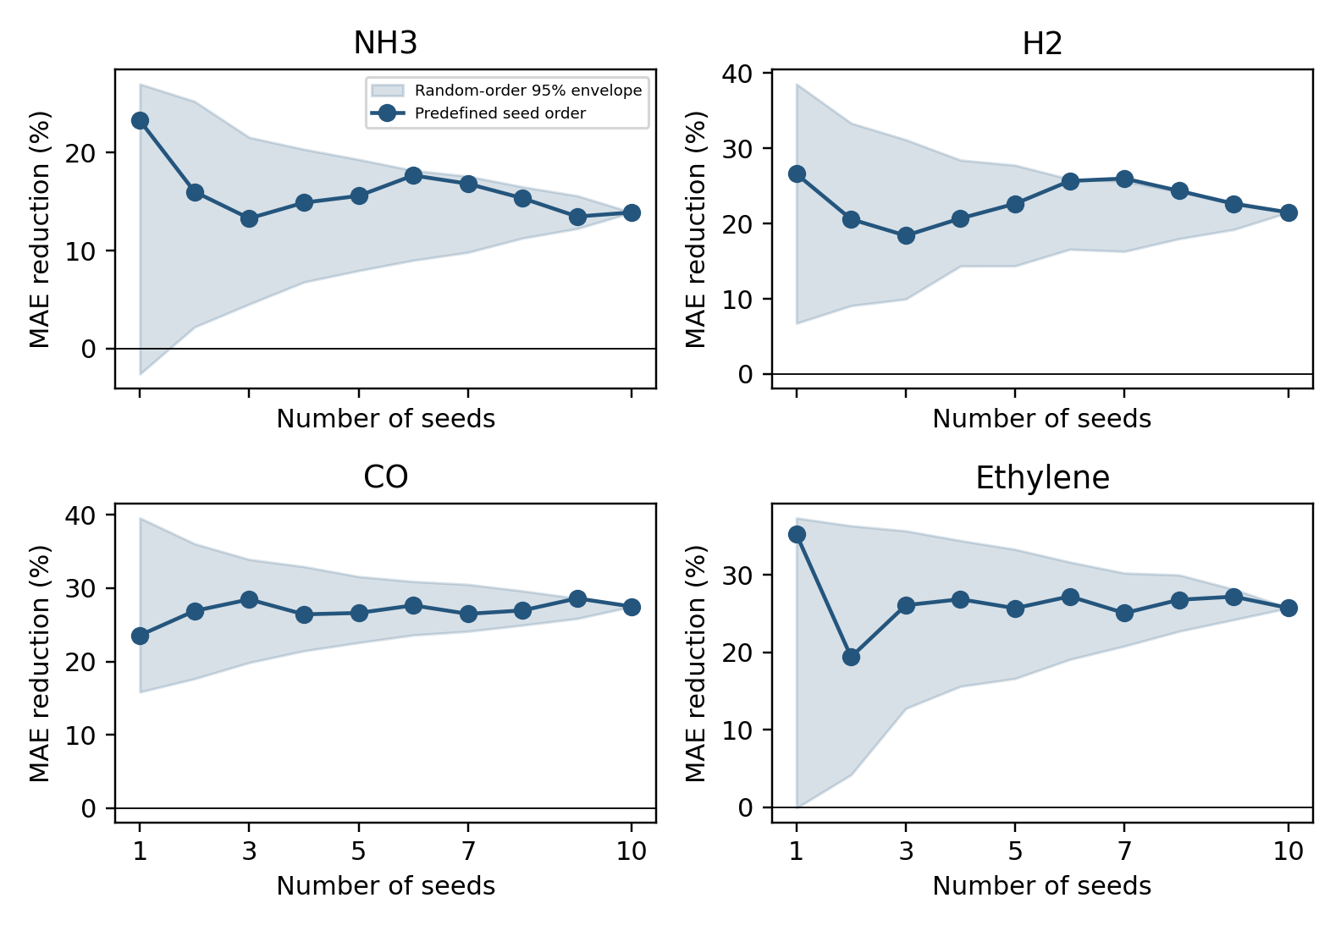
Fig. S1. Primary relative MAE reduction against scratch as seeds accumulate; shading shows 2.5th–97.5th percentiles of 2,000 random subsets at each count.

Table S2a. Every primary seed prefix (errors and intervals in ppm)
Gas | Seeds | Scratch | Fine-tuned | Gain % | Difference 95% interval
CO | 1 | 94.72 | 72.38 | 23.58 | [-10.73, 40.80]
Ethylene | 1 | 2.754 | 1.783 | 35.24 | [0.536, 1.689]
H2 | 1 | 54.39 | 39.92 | 26.61 | [2.49, 27.40]
NH3 | 1 | 31.34 | 24.04 | 23.28 | [1.27, 11.46]
CO | 2 | 97.23 | 71.07 | 26.90 | [2.83, 39.51]
Ethylene | 2 | 2.495 | 2.011 | 19.41 | [-0.222, 1.355]
H2 | 2 | 48.85 | 38.79 | 20.58 | [1.01, 22.83]
NH3 | 2 | 30.62 | 25.71 | 16.02 | [-2.62, 10.99]
CO | 3 | 93.44 | 66.83 | 28.48 | [3.80, 41.93]
Ethylene | 3 | 2.693 | 1.990 | 26.09 | [-0.002, 1.502]
H2 | 3 | 46.74 | 38.14 | 18.40 | [2.19, 19.06]
NH3 | 3 | 29.61 | 25.67 | 13.30 | [-1.07, 9.43]
CO | 4 | 90.43 | 66.53 | 26.43 | [4.89, 40.50]
Ethylene | 4 | 2.760 | 2.018 | 26.86 | [0.156, 1.397]
H2 | 4 | 49.09 | 38.93 | 20.69 | [3.10, 20.90]
NH3 | 4 | 30.86 | 26.26 | 14.91 | [-0.50, 9.69]
CO | 5 | 87.55 | 64.24 | 26.62 | [6.63, 37.84]
Ethylene | 5 | 2.670 | 1.984 | 25.70 | [0.156, 1.265]
H2 | 5 | 49.39 | 38.20 | 22.64 | [4.36, 20.71]
NH3 | 5 | 30.92 | 26.10 | 15.59 | [0.32, 9.26]
CO | 6 | 89.41 | 64.68 | 27.66 | [8.76, 38.90]
Ethylene | 6 | 2.703 | 1.967 | 27.23 | [0.259, 1.230]
H2 | 6 | 50.83 | 37.78 | 25.67 | [5.55, 23.25]
NH3 | 6 | 31.54 | 25.97 | 17.68 | [1.43, 10.28]
CO | 7 | 86.97 | 63.92 | 26.50 | [7.37, 36.65]
Ethylene | 7 | 2.622 | 1.965 | 25.07 | [0.129, 1.168]
H2 | 7 | 51.31 | 37.98 | 25.99 | [6.14, 22.22]
NH3 | 7 | 31.77 | 26.42 | 16.84 | [1.56, 9.55]
CO | 8 | 89.21 | 65.15 | 26.97 | [10.41, 36.09]
Ethylene | 8 | 2.670 | 1.954 | 26.79 | [0.226, 1.243]
H2 | 8 | 50.54 | 38.23 | 24.36 | [4.64, 21.09]
NH3 | 8 | 31.15 | 26.36 | 15.36 | [0.80, 8.97]
CO | 9 | 91.21 | 65.11 | 28.62 | [12.06, 39.43]
Ethylene | 9 | 2.670 | 1.944 | 27.20 | [0.260, 1.201]
H2 | 9 | 49.80 | 38.53 | 22.63 | [3.73, 19.95]
NH3 | 9 | 30.91 | 26.74 | 13.49 | [0.01, 8.48]
CO | 10 | 89.95 | 65.22 | 27.50 | [12.85, 37.53]
Ethylene | 10 | 2.611 | 1.939 | 25.73 | [0.247, 1.143]
H2 | 10 | 49.20 | 38.63 | 21.49 | [3.57, 18.78]
NH3 | 10 | 31.01 | 26.69 | 13.91 | [0.38, 8.30]

Table S3. Random minus farthest-point design MAE (ppm)
Gas | Pairs | Policy | Random | Farthest | Difference [95% interval]
CO | 5 | Scratch | 179.22 | 163.06 | 16.16 [-31.10, 53.12]
Ethylene | 5 | Scratch | 4.890 | 5.226 | -0.335 [-1.621, 0.930]
CO | 10 | Scratch | 144.05 | 156.04 | -11.99 [-46.20, 25.05]
Ethylene | 10 | Scratch | 3.881 | 3.610 | 0.271 [-0.951, 1.591]
CO | 20 | Scratch | 83.83 | 89.30 | -5.47 [-26.51, 14.46]
Ethylene | 20 | Scratch | 2.489 | 2.465 | 0.024 [-0.422, 0.504]
CO | 24 | Scratch | 63.63 | 63.63 | 0.00 [0.00, 0.00]
Ethylene | 24 | Scratch | 2.149 | 2.149 | 0.000 [0.000, 0.000]
H2 | 5 | Scratch | 159.51 | 161.51 | -2.00 [-19.61, 11.72]
NH3 | 5 | Scratch | 98.51 | 86.39 | 12.12 [-13.67, 38.24]
H2 | 10 | Scratch | 137.23 | 124.16 | 13.07 [-14.68, 36.59]
NH3 | 10 | Scratch | 69.60 | 67.52 | 2.08 [-23.07, 23.84]
H2 | 20 | Scratch | 70.48 | 70.73 | -0.25 [-24.56, 22.33]
NH3 | 20 | Scratch | 42.35 | 36.84 | 5.51 [-2.55, 13.76]
H2 | 40 | Scratch | 43.21 | 51.53 | -8.32 [-11.53, -4.60]
NH3 | 40 | Scratch | 25.40 | 29.86 | -4.46 [-6.35, -1.66]
H2 | 57 | Scratch | 41.20 | 41.20 | 0.00 [0.00, 0.00]
NH3 | 57 | Scratch | 21.59 | 21.59 | 0.00 [0.00, 0.00]
CO | 5 | Fine-tuned | 143.07 | 111.46 | 31.61 [13.34, 51.92]
Ethylene | 5 | Fine-tuned | 4.323 | 3.468 | 0.855 [-0.595, 2.151]
CO | 10 | Fine-tuned | 108.99 | 80.99 | 28.00 [-4.59, 62.23]
Ethylene | 10 | Fine-tuned | 3.081 | 2.418 | 0.663 [0.069, 1.392]
CO | 20 | Fine-tuned | 54.22 | 47.42 | 6.80 [0.99, 12.18]
Ethylene | 20 | Fine-tuned | 1.987 | 1.843 | 0.144 [-0.137, 0.457]
CO | 24 | Fine-tuned | 47.45 | 47.45 | 0.00 [0.00, 0.00]
Ethylene | 24 | Fine-tuned | 1.627 | 1.627 | 0.000 [0.000, 0.000]
H2 | 5 | Fine-tuned | 143.53 | 128.91 | 14.62 [-5.72, 35.31]
NH3 | 5 | Fine-tuned | 89.75 | 86.02 | 3.74 [-17.95, 28.62]
H2 | 10 | Fine-tuned | 103.24 | 81.88 | 21.36 [-0.61, 42.36]
NH3 | 10 | Fine-tuned | 52.62 | 38.92 | 13.69 [5.83, 20.77]
H2 | 20 | Fine-tuned | 47.14 | 48.38 | -1.24 [-9.01, 5.32]
NH3 | 20 | Fine-tuned | 34.40 | 29.53 | 4.87 [1.89, 8.05]
H2 | 40 | Fine-tuned | 36.78 | 41.67 | -4.89 [-7.31, -2.45]
NH3 | 40 | Fine-tuned | 21.85 | 25.22 | -3.37 [-5.50, -1.12]
H2 | 57 | Fine-tuned | 31.60 | 31.60 | 0.00 [0.00, 0.00]
NH3 | 57 | Fine-tuned | 17.36 | 17.36 | 0.00 [0.00, 0.00]
The export column scratch_mae in this reused paired-comparison routine is the comparator mean (random design here); transfer_mae is the farthest-point mean. Positive differences favor farthest-point design. These exploratory comparisons are not multiplicity-adjusted.

Table S4. Generic SSL minus sensor-aware MAE (ppm)
Gas | Pairs | Generic | Sensor-aware | Difference [95% interval]
CO | 5 | 119.26 | 111.46 | 7.80 [-6.70, 21.72]
Ethylene | 5 | 3.996 | 3.468 | 0.529 [-0.592, 1.703]
CO | 10 | 93.05 | 80.99 | 12.05 [-9.66, 30.80]
Ethylene | 10 | 2.735 | 2.418 | 0.317 [-0.119, 0.694]
CO | 20 | 51.08 | 47.42 | 3.66 [-0.87, 7.73]
Ethylene | 20 | 1.622 | 1.843 | -0.221 [-0.446, 0.015]
CO | 24 | 52.52 | 47.45 | 5.08 [-2.31, 12.72]
Ethylene | 24 | 1.437 | 1.627 | -0.189 [-0.336, -0.034]
H2 | 5 | 121.62 | 128.91 | -7.30 [-30.60, 12.11]
NH3 | 5 | 74.57 | 86.02 | -11.45 [-31.77, 9.40]
H2 | 10 | 91.13 | 81.88 | 9.25 [-0.74, 19.71]
NH3 | 10 | 39.49 | 38.92 | 0.56 [-3.19, 4.20]
H2 | 20 | 49.92 | 48.38 | 1.54 [-2.56, 5.51]
NH3 | 20 | 31.61 | 29.53 | 2.08 [0.38, 3.91]
H2 | 40 | 41.33 | 41.67 | -0.34 [-2.49, 2.11]
NH3 | 40 | 24.17 | 25.22 | -1.05 [-2.19, 0.11]
H2 | 57 | 35.18 | 31.60 | 3.58 [1.53, 5.40]
NH3 | 57 | 16.13 | 17.36 | -1.23 [-2.46, -0.16]
The control is a compact reimplementation inspired by PatchTST, not the official forecasting configuration. See Section IV for architectural differences. PLSR candidates use 1, 2, 3, 5, 8 or 12 components when below the fitting-sample/feature bound. RBF SVR searches C ∈ {0.1, 1, 10}, gamma ∈ {scale, 0.001}, epsilon ∈ {0.01, 0.1}, on fixed-normalized targets. Selection minimizes adaptation-validation normalized MAE. Extra Trees uses 300 trees and minimum leaf size 2. XGBoost uses 300 trees, depth 3, learning rate 0.03, and row/feature fractions 0.9. Test predictions are clipped to the same target ranges as neural models.

Table S4a. All-budget baseline MAE (ppm), mean ± SD
Gas | Pairs | Model | MAE
CO | 5 | Extra Trees | 132.28 ± 25.01
Ethylene | 5 | Extra Trees | 3.318 ± 0.578
CO | 5 | Fine-tuned | 111.46 ± 23.96
Ethylene | 5 | Fine-tuned | 3.468 ± 1.248
CO | 5 | Generic SSL | 119.26 ± 23.91
Ethylene | 5 | Generic SSL | 3.996 ± 1.136
CO | 5 | PLSR | 143.45 ± 41.09
Ethylene | 5 | PLSR | 3.427 ± 0.858
CO | 5 | Scratch | 163.06 ± 47.96
Ethylene | 5 | Scratch | 5.226 ± 1.469
CO | 5 | SVR | 131.59 ± 5.17
Ethylene | 5 | SVR | 3.812 ± 0.378
CO | 5 | XGBoost | 164.46 ± 41.00
Ethylene | 5 | XGBoost | 4.956 ± 1.288
CO | 10 | Extra Trees | 121.83 ± 26.67
Ethylene | 10 | Extra Trees | 2.438 ± 0.303
CO | 10 | Fine-tuned | 80.99 ± 27.98
Ethylene | 10 | Fine-tuned | 2.418 ± 0.484
CO | 10 | Generic SSL | 93.05 ± 28.68
Ethylene | 10 | Generic SSL | 2.735 ± 0.560
CO | 10 | PLSR | 76.36 ± 49.19
Ethylene | 10 | PLSR | 2.703 ± 0.579
CO | 10 | Scratch | 156.04 ± 27.60
Ethylene | 10 | Scratch | 3.610 ± 1.421
CO | 10 | SVR | 102.30 ± 8.29
Ethylene | 10 | SVR | 3.032 ± 0.380
CO | 10 | XGBoost | 99.25 ± 35.41
Ethylene | 10 | XGBoost | 4.701 ± 1.142
CO | 20 | Extra Trees | 104.17 ± 10.63
Ethylene | 20 | Extra Trees | 1.616 ± 0.266
CO | 20 | Fine-tuned | 47.42 ± 7.79
Ethylene | 20 | Fine-tuned | 1.843 ± 0.506
CO | 20 | Generic SSL | 51.08 ± 6.44
Ethylene | 20 | Generic SSL | 1.622 ± 0.304
CO | 20 | PLSR | 31.57 ± 8.90
Ethylene | 20 | PLSR | 2.056 ± 0.424
CO | 20 | Scratch | 89.30 ± 39.24
Ethylene | 20 | Scratch | 2.465 ± 0.745
CO | 20 | SVR | 51.12 ± 10.66
Ethylene | 20 | SVR | 2.212 ± 0.213
CO | 20 | XGBoost | 64.95 ± 9.22
Ethylene | 20 | XGBoost | 2.903 ± 0.914
CO | 24 | Extra Trees | 90.46 ± 7.17
Ethylene | 24 | Extra Trees | 1.398 ± 0.197
CO | 24 | Fine-tuned | 47.45 ± 7.38
Ethylene | 24 | Fine-tuned | 1.627 ± 0.275
CO | 24 | Generic SSL | 52.52 ± 12.59
Ethylene | 24 | Generic SSL | 1.437 ± 0.275
CO | 24 | PLSR | 25.57 ± 8.48
Ethylene | 24 | PLSR | 1.994 ± 0.377
CO | 24 | Scratch | 63.63 ± 10.68
Ethylene | 24 | Scratch | 2.149 ± 0.359
CO | 24 | SVR | 53.01 ± 7.26
Ethylene | 24 | SVR | 2.013 ± 0.226
CO | 24 | XGBoost | 55.90 ± 11.13
Ethylene | 24 | XGBoost | 2.491 ± 0.352
H2 | 5 | Extra Trees | 147.77 ± 35.20
NH3 | 5 | Extra Trees | 56.11 ± 9.00
H2 | 5 | Fine-tuned | 128.91 ± 16.84
NH3 | 5 | Fine-tuned | 86.02 ± 34.16
H2 | 5 | Generic SSL | 121.62 ± 35.14
NH3 | 5 | Generic SSL | 74.57 ± 31.27
H2 | 5 | PLSR | 156.59 ± 14.73
NH3 | 5 | PLSR | 51.90 ± 10.24
H2 | 5 | Scratch | 161.51 ± 22.40
NH3 | 5 | Scratch | 86.39 ± 36.11
H2 | 5 | SVR | 147.89 ± 36.56
NH3 | 5 | SVR | 67.15 ± 11.23
H2 | 5 | XGBoost | 163.11 ± 27.20
NH3 | 5 | XGBoost | 98.92 ± 24.61
H2 | 10 | Extra Trees | 108.23 ± 26.56
NH3 | 10 | Extra Trees | 48.09 ± 4.98
H2 | 10 | Fine-tuned | 81.88 ± 19.54
NH3 | 10 | Fine-tuned | 38.92 ± 4.56
H2 | 10 | Generic SSL | 91.13 ± 30.27
NH3 | 10 | Generic SSL | 39.49 ± 5.12
H2 | 10 | PLSR | 133.49 ± 29.68
NH3 | 10 | PLSR | 44.47 ± 6.31
H2 | 10 | Scratch | 124.16 ± 28.13
NH3 | 10 | Scratch | 67.52 ± 40.50
H2 | 10 | SVR | 116.17 ± 23.18
NH3 | 10 | SVR | 48.21 ± 6.82
H2 | 10 | XGBoost | 110.10 ± 13.23
NH3 | 10 | XGBoost | 69.34 ± 10.88
H2 | 20 | Extra Trees | 69.90 ± 11.10
NH3 | 20 | Extra Trees | 39.65 ± 2.44
H2 | 20 | Fine-tuned | 48.38 ± 9.70
NH3 | 20 | Fine-tuned | 29.53 ± 2.38
H2 | 20 | Generic SSL | 49.92 ± 7.00
NH3 | 20 | Generic SSL | 31.61 ± 3.35
H2 | 20 | PLSR | 116.94 ± 25.77
NH3 | 20 | PLSR | 39.09 ± 4.60
H2 | 20 | Scratch | 70.73 ± 30.45
NH3 | 20 | Scratch | 36.84 ± 7.89
H2 | 20 | SVR | 76.97 ± 20.72
NH3 | 20 | SVR | 35.54 ± 6.09
H2 | 20 | XGBoost | 83.40 ± 9.19
NH3 | 20 | XGBoost | 46.36 ± 8.16
H2 | 40 | Extra Trees | 51.73 ± 4.98
NH3 | 40 | Extra Trees | 34.14 ± 3.52
H2 | 40 | Fine-tuned | 41.67 ± 2.75
NH3 | 40 | Fine-tuned | 25.22 ± 2.10
H2 | 40 | Generic SSL | 41.33 ± 3.36
NH3 | 40 | Generic SSL | 24.17 ± 1.74
H2 | 40 | PLSR | 90.80 ± 10.20
NH3 | 40 | PLSR | 32.04 ± 5.77
H2 | 40 | Scratch | 51.53 ± 6.60
NH3 | 40 | Scratch | 29.86 ± 2.74
H2 | 40 | SVR | 38.34 ± 4.15
NH3 | 40 | SVR | 25.34 ± 3.44
H2 | 40 | XGBoost | 62.60 ± 4.85
NH3 | 40 | XGBoost | 39.78 ± 7.64
H2 | 57 | Extra Trees | 37.33 ± 2.04
NH3 | 57 | Extra Trees | 21.63 ± 1.73
H2 | 57 | Fine-tuned | 31.60 ± 2.29
NH3 | 57 | Fine-tuned | 17.36 ± 1.54
H2 | 57 | Generic SSL | 35.18 ± 2.74
NH3 | 57 | Generic SSL | 16.13 ± 1.23
H2 | 57 | PLSR | 75.50 ± 18.25
NH3 | 57 | PLSR | 28.44 ± 4.76
H2 | 57 | Scratch | 41.20 ± 4.27
NH3 | 57 | Scratch | 21.59 ± 3.25
H2 | 57 | SVR | 31.37 ± 4.53
NH3 | 57 | SVR | 20.74 ± 1.62
H2 | 57 | XGBoost | 48.65 ± 2.38
NH3 | 57 | XGBoost | 26.96 ± 4.61

Table S5. All-policy per-gas drift errors at 20 labels/gas
Partition | Gas | Policy | MAE ppm | NMAE %
8 | Acetaldehyde | Constant | 11.79 ± 7.58 | 4.06 ± 2.61
8 | Acetone | Constant | 57.28 ± 12.80 | 11.74 ± 2.62
8 | Ammonia | Constant | 17.06 ± 4.97 | 1.80 ± 0.52
8 | Ethanol | Constant | 77.11 ± 7.16 | 13.07 ± 1.21
8 | Ethylene | Constant | 94.67 ± 11.81 | 32.65 ± 4.07
8 | Toluene | Constant | 59.57 ± 6.19 | 62.71 ± 6.52
8 | Acetaldehyde | Fine-tuned | 16.40 ± 7.04 | 5.65 ± 2.43
8 | Acetone | Fine-tuned | 33.23 ± 1.62 | 6.81 ± 0.33
8 | Ammonia | Fine-tuned | 31.75 ± 8.84 | 3.34 ± 0.93
8 | Ethanol | Fine-tuned | 2.87 ± 3.09 | 0.49 ± 0.52
8 | Ethylene | Fine-tuned | 14.63 ± 4.06 | 5.04 ± 1.40
8 | Toluene | Fine-tuned | 17.82 ± 7.90 | 18.76 ± 8.32
8 | Acetaldehyde | Frozen | 13.44 ± 3.77 | 4.63 ± 1.30
8 | Acetone | Frozen | 31.53 ± 1.41 | 6.46 ± 0.29
8 | Ammonia | Frozen | 30.10 ± 8.50 | 3.17 ± 0.89
8 | Ethanol | Frozen | 3.48 ± 3.28 | 0.59 ± 0.56
8 | Ethylene | Frozen | 16.43 ± 3.21 | 5.67 ± 1.11
8 | Toluene | Frozen | 19.55 ± 6.72 | 20.58 ± 7.08
8 | Acetaldehyde | Scratch | 20.21 ± 11.03 | 6.97 ± 3.81
8 | Acetone | Scratch | 32.11 ± 1.93 | 6.58 ± 0.39
8 | Ammonia | Scratch | 38.91 ± 12.96 | 4.10 ± 1.36
8 | Ethanol | Scratch | 6.22 ± 3.63 | 1.05 ± 0.62
8 | Ethylene | Scratch | 17.30 ± 5.68 | 5.97 ± 1.96
8 | Toluene | Scratch | 28.96 ± 6.90 | 30.49 ± 7.27
9 | Acetaldehyde | Constant | 10.05 ± 7.51 | 3.46 ± 2.59
9 | Acetone | Constant | 24.91 ± 13.28 | 5.10 ± 2.72
9 | Ammonia | Constant | 10.50 ± 6.96 | 1.11 ± 0.73
9 | Ethanol | Constant | 77.11 ± 7.16 | 13.07 ± 1.21
9 | Ethylene | Constant | 94.67 ± 11.81 | 32.65 ± 4.07
9 | Toluene | Constant | 59.57 ± 6.19 | 62.71 ± 6.52
9 | Acetaldehyde | Fine-tuned | 29.07 ± 8.48 | 10.02 ± 2.92
9 | Acetone | Fine-tuned | 22.19 ± 6.21 | 4.55 ± 1.27
9 | Ammonia | Fine-tuned | 16.53 ± 9.71 | 1.74 ± 1.02
9 | Ethanol | Fine-tuned | 2.39 ± 2.65 | 0.40 ± 0.45
9 | Ethylene | Fine-tuned | 12.28 ± 4.36 | 4.23 ± 1.50
9 | Toluene | Fine-tuned | 28.65 ± 11.03 | 30.16 ± 11.61
9 | Acetaldehyde | Frozen | 29.77 ± 4.49 | 10.27 ± 1.55
9 | Acetone | Frozen | 23.19 ± 5.32 | 4.75 ± 1.09
9 | Ammonia | Frozen | 17.62 ± 8.69 | 1.85 ± 0.92
9 | Ethanol | Frozen | 2.44 ± 2.87 | 0.41 ± 0.49
9 | Ethylene | Frozen | 12.71 ± 3.98 | 4.38 ± 1.37
9 | Toluene | Frozen | 27.73 ± 7.11 | 29.19 ± 7.48
9 | Acetaldehyde | Scratch | 30.22 ± 8.42 | 10.42 ± 2.90
9 | Acetone | Scratch | 22.35 ± 4.69 | 4.58 ± 0.96
9 | Ammonia | Scratch | 21.34 ± 13.22 | 2.25 ± 1.39
9 | Ethanol | Scratch | 2.00 ± 2.16 | 0.34 ± 0.37
9 | Ethylene | Scratch | 13.59 ± 5.25 | 4.69 ± 1.81
9 | Toluene | Scratch | 46.58 ± 13.62 | 49.03 ± 14.33
10 | Acetaldehyde | Constant | 76.54 ± 2.66 | 26.39 ± 0.92
10 | Acetone | Constant | 408.40 ± 8.85 | 83.69 ± 1.81
10 | Ammonia | Constant | 415.97 ± 7.50 | 43.79 ± 0.79
10 | Ethanol | Constant | 78.13 ± 2.39 | 13.24 ± 0.40
10 | Ethylene | Constant | 74.27 ± 1.49 | 25.61 ± 0.51
10 | Toluene | Constant | 33.02 ± 2.06 | 34.76 ± 2.17
10 | Acetaldehyde | Fine-tuned | 70.15 ± 6.78 | 24.19 ± 2.34
10 | Acetone | Fine-tuned | 298.21 ± 62.08 | 61.11 ± 12.72
10 | Ammonia | Fine-tuned | 341.99 ± 29.11 | 36.00 ± 3.06
10 | Ethanol | Fine-tuned | 63.48 ± 5.29 | 10.76 ± 0.90
10 | Ethylene | Fine-tuned | 63.00 ± 10.18 | 21.72 ± 3.51
10 | Toluene | Fine-tuned | 21.48 ± 4.35 | 22.61 ± 4.58
10 | Acetaldehyde | Frozen | 72.39 ± 4.36 | 24.96 ± 1.50
10 | Acetone | Frozen | 285.49 ± 63.18 | 58.50 ± 12.95
10 | Ammonia | Frozen | 316.10 ± 48.02 | 33.27 ± 5.05
10 | Ethanol | Frozen | 65.16 ± 5.24 | 11.04 ± 0.89
10 | Ethylene | Frozen | 59.67 ± 5.23 | 20.57 ± 1.81
10 | Toluene | Frozen | 25.75 ± 6.08 | 27.11 ± 6.40
10 | Acetaldehyde | Scratch | 64.32 ± 10.02 | 22.18 ± 3.45
10 | Acetone | Scratch | 318.77 ± 21.20 | 65.32 ± 4.34
10 | Ammonia | Scratch | 341.17 ± 47.66 | 35.91 ± 5.02
10 | Ethanol | Scratch | 62.47 ± 9.20 | 10.59 ± 1.56
10 | Ethylene | Scratch | 51.07 ± 7.13 | 17.61 ± 2.46
10 | Toluene | Scratch | 16.23 ± 4.84 | 17.08 ± 5.09

Table S5a. Historical reporting ranges from partitions 1–6 (ppm)
Gas | Minimum | Maximum | Range
Ethanol | 10.00 | 600.00 | 590.00
Ethylene | 10.00 | 300.00 | 290.00
Ammonia | 50.00 | 1000.00 | 950.00
Acetaldehyde | 10.00 | 300.00 | 290.00
Acetone | 12.00 | 500.00 | 488.00
Toluene | 5.00 | 100.00 | 95.00

Table S6. Small-budget drift macro errors, mean ± SD
Partition | Labels/gas | Policy | Macro-MAE ppm | Macro-NMAE %
8 | 1 | Constant | 88.18 ± 26.42 | 25.28 ± 8.31
8 | 1 | Fine-tuned | 40.73 ± 24.75 | 16.36 ± 19.63
8 | 1 | Frozen | 45.57 ± 27.97 | 18.92 ± 27.04
8 | 1 | Scratch | 46.22 ± 20.34 | 18.12 ± 10.66
8 | 2 | Constant | 86.33 ± 28.40 | 29.98 ± 17.85
8 | 2 | Fine-tuned | 44.37 ± 5.14 | 11.02 ± 1.80
8 | 2 | Frozen | 45.97 ± 4.42 | 11.84 ± 2.79
8 | 2 | Scratch | 50.39 ± 5.95 | 15.83 ± 5.85
8 | 5 | Constant | 52.04 ± 9.09 | 21.60 ± 4.26
8 | 5 | Fine-tuned | 35.55 ± 7.65 | 9.21 ± 3.43
8 | 5 | Frozen | 34.96 ± 7.97 | 9.05 ± 2.69
8 | 5 | Scratch | 38.02 ± 7.28 | 9.84 ± 3.46
8 | 10 | Constant | 47.50 ± 5.31 | 17.36 ± 2.44
8 | 10 | Fine-tuned | 30.05 ± 6.09 | 8.37 ± 3.24
8 | 10 | Frozen | 27.18 ± 4.19 | 6.55 ± 0.97
8 | 10 | Scratch | 34.93 ± 6.77 | 9.66 ± 3.25
8 | 20 | Constant | 52.91 ± 3.07 | 21.00 ± 1.54
8 | 20 | Fine-tuned | 19.45 ± 3.37 | 6.68 ± 1.74
8 | 20 | Frozen | 19.09 ± 2.25 | 6.85 ± 1.34
8 | 20 | Scratch | 23.95 ± 3.46 | 9.19 ± 1.49
9 | 1 | Constant | 81.78 ± 26.67 | 24.12 ± 8.32
9 | 1 | Fine-tuned | 39.47 ± 20.58 | 13.56 ± 11.81
9 | 1 | Frozen | 43.25 ± 19.01 | 14.88 ± 14.87
9 | 1 | Scratch | 44.65 ± 20.38 | 17.46 ± 10.04
9 | 2 | Constant | 85.73 ± 28.18 | 29.90 ± 17.50
9 | 2 | Fine-tuned | 48.76 ± 5.38 | 11.94 ± 2.15
9 | 2 | Frozen | 50.50 ± 4.55 | 13.06 ± 3.40
9 | 2 | Scratch | 53.15 ± 6.03 | 16.61 ± 6.24
9 | 5 | Constant | 48.70 ± 9.11 | 20.88 ± 4.30
9 | 5 | Fine-tuned | 43.45 ± 8.11 | 12.78 ± 5.76
9 | 5 | Frozen | 41.33 ± 6.89 | 11.75 ± 3.81
9 | 5 | Scratch | 44.84 ± 4.97 | 11.98 ± 3.46
9 | 10 | Constant | 41.84 ± 5.14 | 16.17 ± 2.37
9 | 10 | Fine-tuned | 33.39 ± 7.33 | 9.01 ± 2.33
9 | 10 | Frozen | 30.83 ± 5.20 | 7.68 ± 1.13
9 | 10 | Scratch | 40.63 ± 3.54 | 11.28 ± 2.89
9 | 20 | Constant | 46.13 ± 3.07 | 19.68 ± 1.52
9 | 20 | Fine-tuned | 18.52 ± 4.60 | 8.52 ± 2.48
9 | 20 | Frozen | 18.91 ± 3.25 | 8.48 ± 1.63
9 | 20 | Scratch | 22.68 ± 2.86 | 11.88 ± 2.12
10 | 1 | Constant | 177.17 ± 10.32 | 39.52 ± 3.02
10 | 1 | Fine-tuned | 206.22 ± 24.05 | 47.14 ± 13.39
10 | 1 | Frozen | 209.72 ± 29.55 | 50.43 ± 23.17
10 | 1 | Scratch | 199.79 ± 14.71 | 44.84 ± 6.20
10 | 2 | Constant | 212.96 ± 15.13 | 51.87 ± 9.35
10 | 2 | Fine-tuned | 225.23 ± 15.18 | 49.28 ± 3.65
10 | 2 | Frozen | 224.86 ± 16.02 | 48.72 ± 4.14
10 | 2 | Scratch | 222.05 ± 15.74 | 48.44 ± 3.76
10 | 5 | Constant | 192.76 ± 4.52 | 41.03 ± 1.29
10 | 5 | Fine-tuned | 196.99 ± 23.05 | 42.51 ± 4.63
10 | 5 | Frozen | 207.84 ± 33.72 | 46.61 ± 7.37
10 | 5 | Scratch | 192.46 ± 22.93 | 40.09 ± 4.96
10 | 10 | Constant | 186.96 ± 2.84 | 38.63 ± 0.66
10 | 10 | Fine-tuned | 196.18 ± 17.97 | 41.83 ± 4.40
10 | 10 | Frozen | 191.79 ± 15.94 | 41.18 ± 3.51
10 | 10 | Scratch | 191.07 ± 18.61 | 40.41 ± 3.95
10 | 20 | Constant | 181.05 ± 2.13 | 37.91 ± 0.54
10 | 20 | Fine-tuned | 143.05 ± 12.49 | 29.40 ± 3.07
10 | 20 | Frozen | 137.43 ± 13.49 | 29.24 ± 2.67
10 | 20 | Scratch | 142.34 ± 11.06 | 28.12 ± 2.31
Below 20 labels/gas the predefined target is fixed-log Huber; at 20 it is historical fitted-log Huber. Therefore this primary budget series also changes scaling at 20. The fixed-log 20-label rows in Table S7 provide a like-for-like scaling control. One-label runs have no validation holdout.

Table S7. All-policy 20-label loss/scaling controls
Partition | Transform | Policy | Macro-MAE ppm | Macro-NMAE %
8 | linear_huber | Fine-tuned | 26.94 ± 4.16 | 12.49 ± 4.10
8 | linear_huber | Frozen | 27.67 ± 7.34 | 11.06 ± 3.86
8 | linear_huber | Scratch | 32.50 ± 6.46 | 16.02 ± 6.66
8 | linear_mae | Fine-tuned | 22.48 ± 4.17 | 8.20 ± 3.21
8 | linear_mae | Frozen | 22.73 ± 3.55 | 7.55 ± 1.96
8 | linear_mae | Scratch | 27.01 ± 6.50 | 11.61 ± 4.91
8 | log_fixed_huber | Fine-tuned | 22.68 ± 5.59 | 7.65 ± 2.86
8 | log_fixed_huber | Frozen | 20.32 ± 4.02 | 6.42 ± 1.79
8 | log_fixed_huber | Scratch | 26.49 ± 2.40 | 9.07 ± 1.43
8 | log_huber | Constant | 52.91 ± 3.07 | 21.00 ± 1.54
8 | log_huber | Fine-tuned | 19.45 ± 3.37 | 6.68 ± 1.74
8 | log_huber | Frozen | 19.09 ± 2.25 | 6.85 ± 1.34
8 | log_huber | Scratch | 23.95 ± 3.46 | 9.19 ± 1.49
9 | linear_huber | Fine-tuned | 25.50 ± 6.16 | 13.09 ± 4.63
9 | linear_huber | Frozen | 26.49 ± 9.66 | 11.44 ± 4.99
9 | linear_huber | Scratch | 32.04 ± 7.62 | 17.25 ± 7.21
9 | linear_mae | Fine-tuned | 20.70 ± 4.75 | 8.91 ± 3.98
9 | linear_mae | Frozen | 20.28 ± 3.36 | 7.72 ± 2.42
9 | linear_mae | Scratch | 25.69 ± 6.77 | 12.70 ± 5.14
9 | log_fixed_huber | Fine-tuned | 26.11 ± 6.19 | 8.90 ± 3.19
9 | log_fixed_huber | Frozen | 23.28 ± 4.85 | 7.51 ± 2.02
9 | log_fixed_huber | Scratch | 33.68 ± 4.07 | 12.02 ± 2.17
9 | log_huber | Constant | 46.13 ± 3.07 | 19.68 ± 1.52
9 | log_huber | Fine-tuned | 18.52 ± 4.60 | 8.52 ± 2.48
9 | log_huber | Frozen | 18.91 ± 3.25 | 8.48 ± 1.63
9 | log_huber | Scratch | 22.68 ± 2.86 | 11.88 ± 2.12
10 | linear_huber | Fine-tuned | 145.56 ± 11.05 | 33.00 ± 2.61
10 | linear_huber | Frozen | 146.40 ± 15.93 | 34.00 ± 3.12
10 | linear_huber | Scratch | 144.08 ± 16.57 | 32.73 ± 6.79
10 | linear_mae | Fine-tuned | 137.55 ± 12.87 | 29.63 ± 2.73
10 | linear_mae | Frozen | 135.74 ± 14.12 | 30.82 ± 3.44
10 | linear_mae | Scratch | 135.23 ± 14.38 | 28.78 ± 3.05
10 | log_fixed_huber | Fine-tuned | 184.96 ± 9.99 | 38.53 ± 2.25
10 | log_fixed_huber | Frozen | 185.66 ± 14.61 | 39.28 ± 2.75
10 | log_fixed_huber | Scratch | 171.19 ± 14.04 | 35.00 ± 2.42
10 | log_huber | Constant | 181.05 ± 2.13 | 37.91 ± 0.54
10 | log_huber | Fine-tuned | 143.05 ± 12.49 | 29.40 ± 3.07
10 | log_huber | Frozen | 137.43 ± 13.49 | 29.24 ± 2.67
10 | log_huber | Scratch | 142.34 ± 11.06 | 28.12 ± 2.31

Table S8. Capacity and distinct fitting records; seed 42
Dataset | Budget | Policy | Total | Trainable | Encoder | Head | Records
co_ethylene | 24 | Fine-tuned | 101002 | 101002 | 31144 | 69858 | 19
co_ethylene | 24 | Frozen | 101002 | 69858 | 31144 | 69858 | 19
co_ethylene | 24 | Generic SSL | 91714 | 91714 | 21856 | 69858 | 19
co_ethylene | 24 | Scratch | 101002 | 101002 | 31144 | 69858 | 19
co_ethylene | 5 | Fine-tuned | 101002 | 101002 | 31144 | 69858 | 4
co_ethylene | 5 | Frozen | 101002 | 69858 | 31144 | 69858 | 4
co_ethylene | 5 | Generic SSL | 91714 | 91714 | 21856 | 69858 | 4
co_ethylene | 5 | Scratch | 101002 | 101002 | 31144 | 69858 | 4
nh3_h2 | 57 | Fine-tuned | 117514 | 117514 | 31272 | 86242 | 46
nh3_h2 | 57 | Frozen | 117514 | 86242 | 31272 | 86242 | 46
nh3_h2 | 57 | Generic SSL | 108098 | 108098 | 21856 | 86242 | 46
nh3_h2 | 57 | Scratch | 117514 | 117514 | 31272 | 86242 | 46
nh3_h2 | 5 | Fine-tuned | 117514 | 117514 | 31272 | 86242 | 4
nh3_h2 | 5 | Frozen | 117514 | 86242 | 31272 | 86242 | 4
nh3_h2 | 5 | Generic SSL | 108098 | 108098 | 21856 | 86242 | 4
nh3_h2 | 5 | Scratch | 117514 | 117514 | 31272 | 86242 | 4
sensor_drift | 1 | Fine-tuned | 29542 | 29542 | 24992 | 4550 | 6
sensor_drift | 1 | Frozen | 29542 | 4550 | 24992 | 4550 | 6
sensor_drift | 1 | Scratch | 29542 | 29542 | 24992 | 4550 | 6
sensor_drift | 20 | Fine-tuned | 29542 | 29542 | 24992 | 4550 | 96
sensor_drift | 20 | Frozen | 29542 | 4550 | 24992 | 4550 | 96
sensor_drift | 20 | Scratch | 29542 | 29542 | 24992 | 4550 | 96
sensor_drift | 20 | Fine-tuned | 29542 | 29542 | 24992 | 4550 | 96
sensor_drift | 20 | Frozen | 29542 | 4550 | 24992 | 4550 | 96
sensor_drift | 20 | Scratch | 29542 | 29542 | 24992 | 4550 | 96
Architecture counts are constant for each dataset/policy. Fitting exposure counts can vary with selected repeated coordinates; complete per-seed counts are saved in statistics/model_size.csv. Parameter/exposure ratios are descriptive and do not alone quantify generalization.

NH3/H2 dataset and acquisition details

Sensor array
The authors use an array of 20 MEMS metal-oxide gas-sensor channels based on SnO2 nanowires with Pt/Ag surface modification. The sensors operate using a thermal-gradient sensing principle and provide complementary responses to NH3 and H2. The chamber accommodates the array in a 5 x 4 arrangement. The authors monitor the channels in four groups: CH1-CH5, CH6-CH10, CH11-CH15 and CH16-CH20, with electrical supply settings in the range 3.0-3.4 V.

Gas chamber and delivery system
The authors deliver NH3 and H2 to the sensor chamber through an automated mass-flow-controlled mixing system. The apparatus comprises gas supplies, background-gas delivery, mass-flow controllers, a switching valve, the sensor chamber, a power supply and a computer for control and recording. The switching valve directs the prepared mixture to the chamber during exposure. The outlet is connected to an exhaust line, and a cleaning-gas flow supports recovery between exposures. Figure S2 shows the system layout; Fig. S3 shows the sensor hardware, chamber assembly and mass-flow-controller installation.

Acquisition protocol
The authors program a sequence of single-gas and binary NH3/H2 conditions spanning 0-500 ppm for each gas. Nonzero concentration settings are 25, 50, 100, 200, 300, 400 and 500 ppm. For each condition, the authors expose the array to the prepared gas mixture for 180 s, then apply a 700-s recovery period, giving an 880-s measurement cycle. The authors record the multichannel responses throughout exposure and recovery, using a nominal 2.0-s sampling setting in the acquisition interface. The response increases during gas delivery and returns toward its baseline during recovery. The authors repeat the acquisition protocol on six separate measurement days. The computer interface controls the programmed sequence and records the response channels for subsequent concentration-regression analysis.
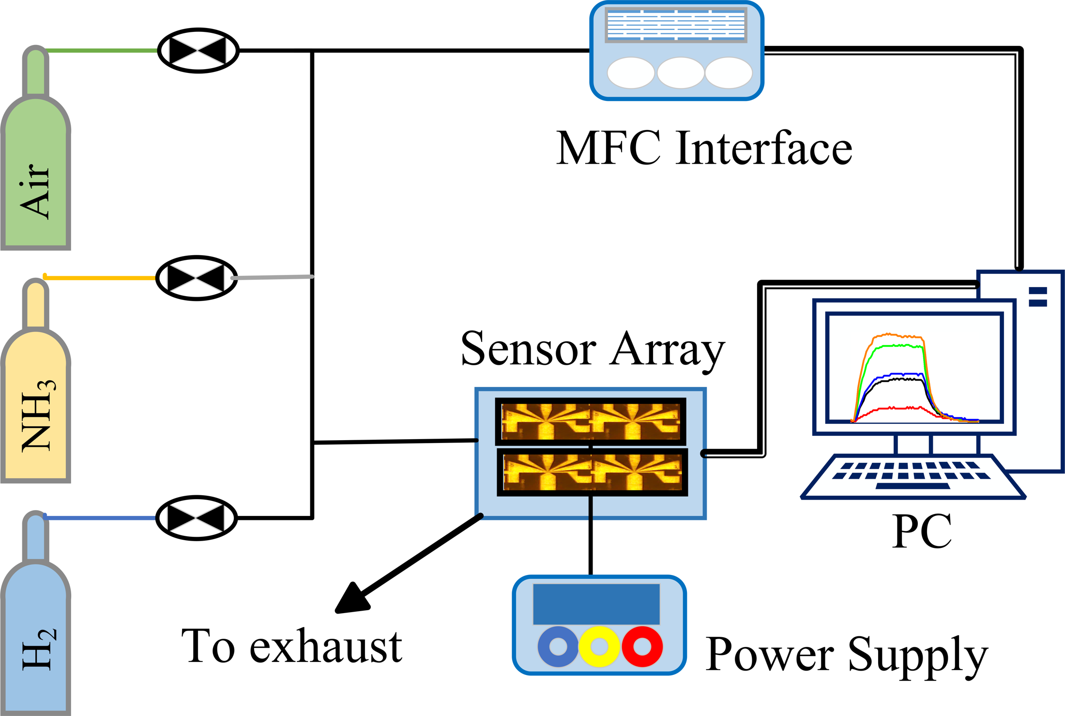
Fig. S2. Layout of their NH3/H2 mixing and measurement system, including gas supplies, mass-flow control, sensor array, power supply, exhaust and computer interface.
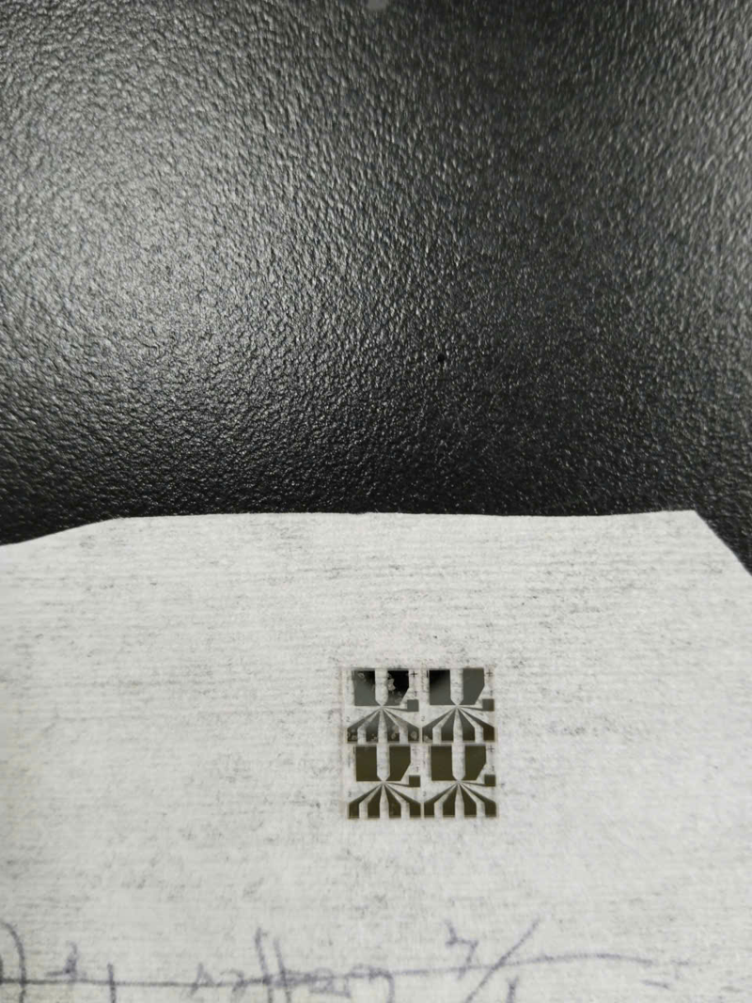  (a) MEMS sensor hardware | 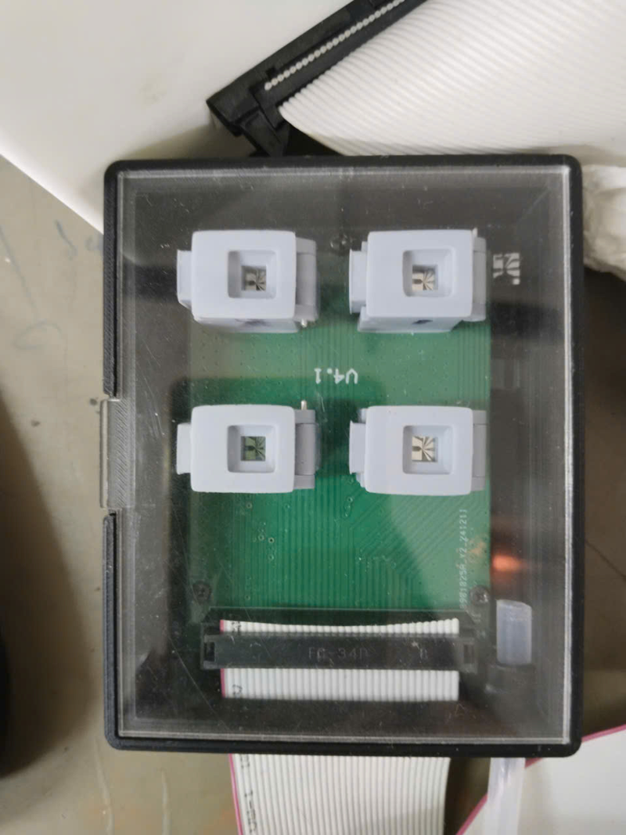  (b) Sensor chamber | 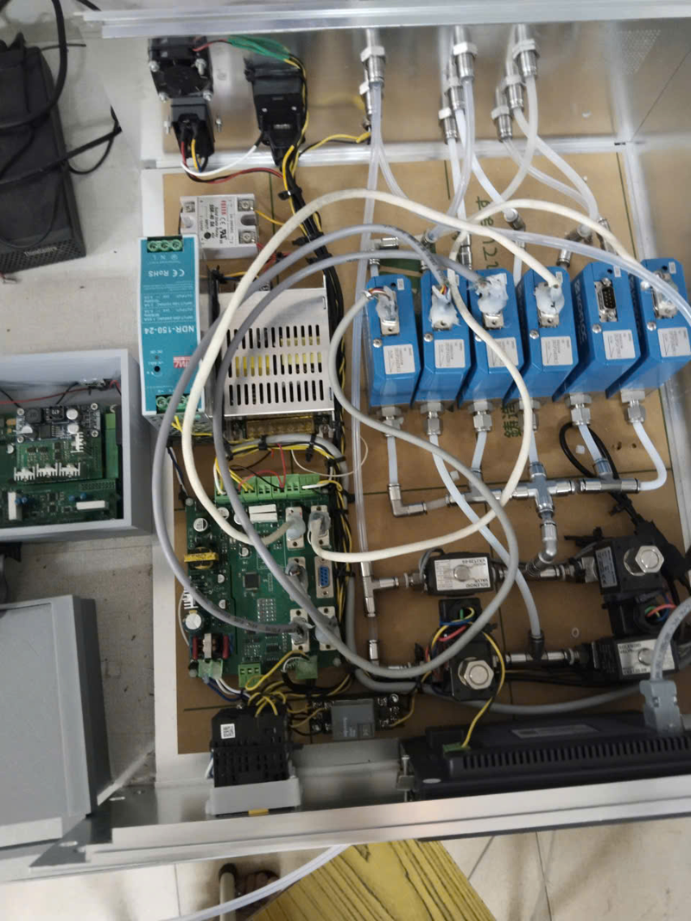  (c) Mass-flow controllers
Fig. S3. Photographs of their experimental hardware: (a) sensor devices, (b) the chamber assembly containing the sensor array, and (c) the mass-flow-controller installation.

