Overview
An invoice is a list of services rendered to your customer, containing prices and charges. Any invoice will feature the name of your company and your contact information, the name of your customer, their contact information, as well as the invoices number and ID, the date at which it was issued, its due date, whether there is a carried-over balance, and so on.
Sometimes an invoice will simply reflect the items of a corresponding purchase order, while in other cases, it will include additional charges not directly related to a purchase order, such as taxes, additional fees, special discounts, late payment fees, etc.
An invoice can have several representations.
- Web (HTML): The HTML representation is the one you can see in your web browser, when using the web-based graphic user interface of jbilling.
- PDF: The PDF version is normally called 'paper invoice', because this is version is the one use for printing invoices. Paper invoices can be customized to match your company’s corporate image.
- Email: You can write the text of an email, using variables to represent values such as total, due date, etc. Invoice emails can optionally have as an attachment the PDF version of the invoice as well. The email representation of an invoice is handled by jbilling as a notification. See the notifications documentation for more information.

The relationship between purchase orders and invoices
In jbilling, it is very important that you can trace the series of events that are key for a billing process. Billing information accumulates over time, creating a history of events with your customers. We want you to know when something happened, and most important, why. When a customer is sent an invoice, this is done because she has bought something from you. These items are listed in the invoice.
In jbilling, the even of the purchase is backed by the purchase order document. Therefore, there can not be an invoice without at least one purchase order. Payments and invoices have a similar relationship: a payment should be paying an invoice, so there should not be a payment without first having an invoice:
Purchase
orders
Invoice
Payment

Creating invoices
Since invoices can only be created based purchase orders, you first need to create these. Then, the actual invoice can be generated in two ways:
- The billing process generates an invoice automatically (please refer to the Billing Process Documentation).
- An invoice is created manually (please refer to the Purchase Order Documentation).

Modifying an invoice
An invoice cannot be edited directly. You can not quickly change a total of a quantity. If you could do this, we would loose the traceability of the purchase order – invoice relationship.
The only way to modify an invoice is by creating and applying a new purchase order that will either cancel out or correct the erroneous invoice. For more details, please refer to the Purchase Order Documentation.

Deleting and invoice
To delete an invoice, click on Invoices and on List. Click on the radio button of the invoice you wish to delete, and then on the ‘Delete’ link on the left side of the screen. You are then asked to confirm this choice. Please keep in mind that once an invoice has been deleted, it is deleted permanently.
Once an invoice has been deleted, the purchase order that had generated the invoice in the first place, gets automatically modified to the status it held before the invoice was generated.
Example
An invoice is generated out of a one-time purchase order. This one-time purchase order’s status will then change from ‘Active’ to ‘Finished’. When the invoice is deleted, the status of the purchase order will go back to ‘Active’. The purchase order will probably generate a new invoice again if not modified.

The invoice details screen
To view an existing invoice, click on Invoices and on List in the top menu. Then, click on the radio button of the invoice of your choice. The invoice details page is displayed:
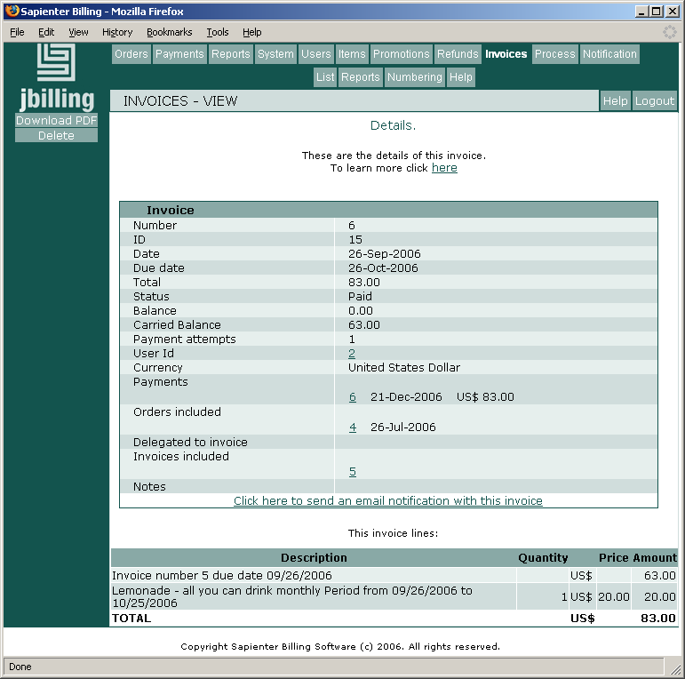
Let's take this invoices as an example and analyze the data. Invoice number 6 has a total of 83$. 63 dollars come actually from a previous invoice that was not paid and is overdue (Carried Balance is 63.00 and there is an invoice line with the other invoice balance). We can see in 'Invoices included' the ID of the invoice that has been carried over to this one. By clicking on it, we'll get to the details of that invoice.
Our invoice is currently paid, there is no outstanding balance (Status is 'Paid', and Balance is 0.00). One payment is related to this invoice, and it has paid it in full. The payment in question is #6, and by clicking on this number we'll go to the payment details screen.
The invoice date is 9/26 and payment was expected before 8/26. The invoice was paid late, on 12/21.
We can download a PDF version of this invoice by clicking on 'Download PDF'. This is usually done by customers to get a hard copy of the invoice. You can send the invoice as an email by clicking on 'Click ere to send an email notification with this invoice'.

Numbering
The system will, by default, apply to your first invoice generated, the number 1. If, however, your company has generated previous invoices from a legacy system, it is necessary to tell the system what number the first invoice it generates for you should bear.
Invoices will be generated useing the number that you provide. The system will increment this number by one for every new invoice.
With Sapienter, you have the option of adding a prefix to your invoice numbering. This prefix can have up to 20 characters and can be any digit, letter or symbol. To configure the number of your first invoice, and perhaps the prefix to your invoices, click on Invoice, then Numbering. You can update the invoice numbering at any time.

