How the billing process works
jbilling is a powerful billing system built to help you save time. Basically, you will need to configure it only once, and then let it automatically generate your invoices, and perhaps process payments for these invoices, without having to think about it or do anything else but create purchase orders for new sales and monitor that all is going as you expect. It is also very flexible and its configuration can easily be modified and adjusted as you get to know the system and as your company grows.
The basic purpose of the billing process is the automatic generation of invoices
The billing process is at the very core of jbilling. To configure this critical process, it is important to understand how it operates and to know its different parameters and options.
The billing administrator of your company will configure jbilling and schedule the billing process to run periodically. The period for this schedule can be of any length of time (weekly, monthly, etc). Alternatively, the administrator can, at anytime, manually set a date for the next billing process, overruling the date automatically calculated by the system.
In addition to generating invoices, the billing process will attempt, should you select that option, to process payments cleared by credit cards and direct debit by communicating with a payment processor, which will proceed with the payment the moment an invoice is generated. This additional step of processing payments immediately after the generating of invoices is called automatic payment processing.

The Billing Period
The billing period is the single most important parameter to configure. It will determine how often the billing process runs, therefore how often invoices are generated. A monthly billing period will run once per month, a weekly one, once per week and so on. This seems quite simple, but as a very important consequence: the amount of time the process will ‘see’ into the future.
The billing process looks into a specific period of time, for purchase orders that should produce an invoice. If the process runs on January 1st and the period is set for one month, then the process will generate invoices for any purchase order that has ‘billable time’ falling on any day of January. To understand what ‘billable time’ is, let’s take a closer look into the way the billing process selects a purchase order to create a new invoice.

Selecting Purchase Orders
Although the billing period defines how often invoices are generated, it has nothing to do with how many invoices are generated. Whether an invoice is created or not depends exclusively on what purchase orders a customer has. For example, let’s say that we have a weekly billing period, and a monthly, pre-paid purchase order. In this example, we will set the start date as January 1st:
- The purchase order is created with ‘Active since’ equal to January 1st .
- On January 1st, the billing process runs. Since the billing period is set as weekly, the period of the run is from January 1 to January 7. It generates one invoice for the purchase order, but since this is a monthly purchase order, the invoice will cover the period January 1 – January 31.
- On January 8, the billing process runs again. This time for the period of January 8 to January 14. The purchase order does not hold billable time during this period. When you notice the purchase order’s details, you find the ‘Next day to invoice’ field, set as February 1. Therefore no new invoices are generated for this purchase order.
- On January 15 and 22 the billing process runs, with the same result as the previous run: no new invoices.
- Only on January 29 does the billing run generates a new invoice. This is because the run period covers from January 29 to February 5. Since the purchase order has billable time starting on February 1, it will produce a new invoice.
The billing process will generate one invoice per customer, combining all the applicable purchase orders.
The billing process will generate one invoice per customer (there is an exception to this rule, see the ‘Due Dates’ section). But what if the customer has many purchase orders with billable time? The process will still generate only one invoice, containing all the items belonging to all the applicable purchase orders. Let’s take the previous example and add to it a one-time purchase order, on January 20. Being a one-time purchase order, it will not recur. On January 29, the billing process runs, but this time it finds two purchase orders falling in its time range. It will still generate one single invoice for this customer, but the new invoice will display the charges from both purchase orders.

Purchase Order’s Periods Included in Invoices
The billing process will normally include one period of the purchase order when it generates a new invoice. In the previous example, it included one month. However, the rule is that it will include as many periods from the purchase order as it can fit in the billing period. Let’s take the previous example again, but this time extending the billing period from one week, to two months. This will create more ‘room’ to include more periods from the purchase order. This time, when the process runs on January 1st, it generates one invoice from the purchase order, but with two months worth of charges instead of one. This happens because the period of the run now includes from January 1 to February 29. The run can fit two of the purchase order periods (two times one month) within its scope.
Let’s see an example of this: Trend Inc. has a customer that has been advertising since January 1st. However, there was some misunderstanding and the purchase order wasn’t created. On March 1st this is discovered and the purchase order is finally created, but with an ‘Active since’ backdated to January 1st. This is a pre-paid monthly purchase order for a total of $100. When the billing process runs on March 15, the invoice for this customer is for a total of $300.
Here is how this happens:
- The billing run takes place on March 15; its period is weekly so the time span goes from March 15 to March 21.
- The billing process has now to take this purchase order and start including periods from it, in an invoice, until it has no more billable time before March 21.
- After adding three periods (months) to the invoice, the ‘Next day to invoice’ becomes April 1st. The process does not add any further periods to this invoice, since the ‘Next day to invoice’ date is now past the end of the billing run scope (March 21).

Selecting the Right Billing Period
There are a few factors to consider when selecting the billing period. There is no such thing as a one correct way to determine the billing period. It will depend on your business rules and your customers’ expectations. The following are just a set of guidelines to help you with your decision.
An important factor to consider is the periods of your purchase orders. The billing period should be no greater that the shortest period of your recurring purchase orders. For example, if you have some purchase orders that generate invoices on a weekly basis, you do not want to have a billing period longer than a week. This is true even if your weekly purchase orders are a minority, and the rest are all monthly. You still want to match the shortest of your purchase order’s period.
Another important factor to consider is how you want to manage your billing schedule. Do you prefer to have a single monthly billing day? This translates to one day in the month where all the invoices are generated. All your customers will be receiving their invoices the same day. The other option is to bill your customers depending on when, in the month, they initially subscribed to your services.
Note that these to options define when the invoices are created in the billing run, and how many invoices are created in the billing run. Not how often any single customer receives her invoice. How often any customer receives invoices is determined only by the period of her purchase orders. Here we are exploring the billing process configuration.
There are two basic choices, let’s explore them through an example: Trend Inc. sells ad banners and invoices to its customers monthly, which means that all the recurring purchase orders are monthly.
Single monthly billing day:
The 1st of each month, all of Trend Inc.’s customers receive an invoice with the current charges. The billing period is, therefore, 1 Month. However, what if a customer signs up in the middle of the month? If the purchase order is simply created and it is left to the process to generate invoices, it could take a few weeks for it to generate the first invoice.
Trend does not want this. It prefers to invoice and get paid immediately, the company terms being that all purchases are to be pre-paid. Also, if left as is, when the process runs, it will include two periods from the purchase order in the first invoice (see the previous section to know why). This is not what the customer expects.
The solution for this is for Trend Inc. to create a one-time purchase order with the prorated charges until the end of the month. Then a recurring purchase order with an ‘Active since’ dated for the first day of the following month. A customer signing up on January 15 for a $100 ad, will require of Trend Inc. the following actions:
- A one time purchase order for 50$ (half the monthly charge, since registering half way through the month).
- A monthly purchase order for 100$, with an ‘Active since’ equal to February 1.
- If Trend Inc. wants to get paid immediately for the 50$, then a manual invoice has to be generated by clicking on the link ‘Generate invoice and payment’ found on the purchase order screen. Otherwise both purchase orders will be picked up by the process on February 1 and generate one invoice for 150$.

Several billing days in a month:
Trend Inc. sets the billing period to one week. Remember, the customers will still receive one invoice per month because the purchase orders are monthly. When a new customer signs up, a single monthly purchase order is created. Since the process runs every week, only a few days will pass until the customer receives her first invoice. From then on, the customer will receive one invoice per month, around the same day every month.
Let's compare this set-up with the previous scenario. With this one, there is no need for a one-time purchase orders to reflect the fraction of an initial period. Invoices are generated weekly, so there are about four billing runs per month. In the previous scenario there was just one monthly run. Thus, in this scenario each run will generate about a quarter of the invoices compared with the previous choice. This is because the total number of generated invoices remains the same when the whole month is considered.
Even though the purchase orders are all monthly, a weekly billing period is a very good alternative for Trend Inc. The first impression is to think that billing your customers the first day of every month should be the simplest configuration, but as you can see in the example, in Trend Inc. ‘s case. it is much more complicated that way because of the handling of customers signing up on different days of the month.
As the example demonstrates, a weekly billing process reduces the complexity. Although each customer can have a different billing day, jbilling will take care of invoicing each of them at the right time.

Invoices Carried Over to Other Invoices
By default, when the billing process generates a new invoice, it will include in it any previous overdue invoice. In other words, an invoice that remains unpaid when the next invoice is being generated, is going to be carried over to the new invoice. This way, your customers can simply pay their latest invoice and bring their accounts up-to-date, even if they had failed to pay a previous invoice.
When the billing process runs and it is generating a new invoice for a customer, it checks if this customer has any overdue invoice remaining unpaid. If that is the case, it will add a line to the new invoice (for each of the overdue invoices) with the legend ‘Overdue invoice … due date …’ with the information of the invoice being carried over.
When this happen, the following fields will be affected:
- The new invoice will have a ‘Carried balance’ with the amount that was taken from the overdue invoice
- The overdue invoice will be marked as ‘paid’. Its balance has been transferred to the new invoice, so it no longer has to be paid.
- The overdue invoice will show ‘Delegated to invoice’ followed by the ID of the new invoice.
- The balance of the overdue invoice is now 0.

Due Dates
When an invoice is generated, the system assigns it a due date. This date is calculated by adding to the billing process date, the period of time you configured under ‘Configuration’. For example, if the billing process is running on October 1 and the configured due date is 1 month, the resulting invoices will have November 1 as their due date. If the configured due date is 30 days, the result will be October 31.
You can override the due date for a specific customer. These are optional values. If you enter 1 month for the billing process due date configuration (company wide), but then create a customer with a due date of 90 days, the later value will take precedence for that customer only.
The same applies at the purchase order level, where you can enter a due date value that will apply to that specific purchase order, regardless of that particular customer's due date, or the company wide due date’s value. This, however, has an important consequence: what happens if two purchase orders should be included in one invoice, but the two purchase orders have different due dates? In such a case, the system will generate one invoice per purchase order, each invoice with its own due date.

Automatic Payment Processing
As part of the billing process, jbilling can attempt to get your invoices paid with credit card numbers, as soon as they are generated, by using an ACH (automatic clearing house). This is done through a payment processor. jbilling will submit the transactions to this payment processor, which will reply with the result of the transaction.
Depending on your notification preferences, the billing process will send an email to your customers with the result of the payment, which could have either failed, or been successful. If a customer does not have the information necessary to submit the payment (a credit card for example), the billing process will not attempt the payment.
Automatic payment processing works by connecting to a payment processor that handles the payment authorization. This means that you need an account with a payment processor before this feature can work. jbilling needs to know about the type of account that you have and the parameters of it. See the Getting Started guide for details on how to configure a payment processor.
There are many reasons why a payment can fail: the credit card is suspended, or expired. It might be maxed out or with an invalid name. Other problems might be on the payment processor side: it might be temporarily unavailable, or simply not working properly. In any case, it is a good practice to retry a payment before taking action and suspend the customer's account.
jbilling can retry those payments that were failed by the payment processor when the automatic payment processing took place. You can choose how many retries you want, and how many days have to go by in between those retries. These are configuration parameters covered in the next section.
Normally, you will have jbilling configured to send notifications with the result of an automatic payment. Thus, typically a failed payment will result on an email to your customer stating that the invoice remains unpaid. There is a good chance that the problem can be solved in only a few days, just before the retry takes place. By setting up automatic retries jbilling the payment can be received without your intervention.

Configuration of Parameters
There are a few parameters that will determine how your billing process will run.
To access your billing process configuration click on Process and then Configuration:

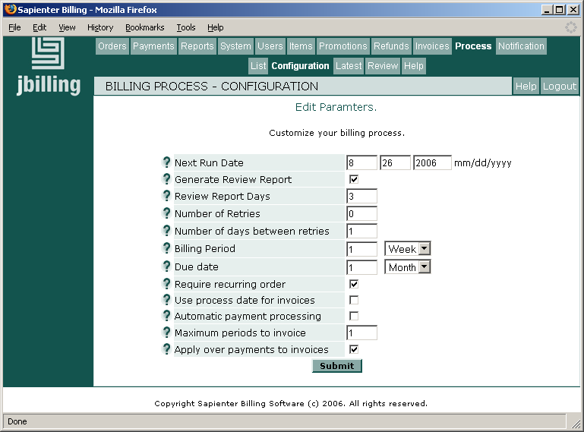

Next Run Date
This is the date where the billing process is schedule to run. Right after installing jbilling, you'll need to enter a date in this field. This is the date at which the very first run of your billing process will take place.
You need to enter this date only once, to override the installation's default value. Once the first run will have taken place, the date for the next run will be automatically updated by the system.
Advanced tip:
At any time, it is possible to manually specify a date for the next billing run. This should not be necessary under normal circumstances, but it is a feature that can come in handy if needed. Should you chose to manually change the date of the next billing run, the new date you enter will overrun the one that had been automatically selected by the system, in accordance with your last configuration. The system will thereon process the billing run according to this new date.
For example, given the date September 2004, Trend, for whom jbilling has been automatically generating invoices on the first of every month, decides to change the ‘Next Run Date’ to September 15th 2004. Thereon, jbilling will automatically generate invoice on the 15th of every month (assuming a 'Billing Period' of 1 month).

Generate Review Report
This is a flag indicating to the system to run a preview of the billing process before the real process takes place and invoices are sent to your customers. The Review Report is like a ‘pretend’ run. It is a great tool to help identify any problem with the invoicing before the run actually happens. It allows the Billing Administrator, should mistakes or inaccuracies be noticed, to apply changes to purchase orders, edit customers’ contact information, enter payments, modify the description of an item or its price, etc.
It is recommended to set this flag ‘on’, for the first few billing cycles at the very least. Since the Review Report does not generate real invoices, the only way to view them is by clicking on Process and then on Review. For more details, please see section “Review Report, Overview”, below.

Review Report Days
How many days before the real billing process do you want the Review Report to be generated? In other words, how many days before the value in 'Next Run Date' do you want to review the process? The greater the number of days, the less accurate the report will be. For example, if the Review Report runs 15 days before the billing process, there are likely to be payments or purchase orders created during that period of time, and you will not have had an opportunity to review how these transactions affect the invoices generated. A good number of days to start with is 5.
Example: Trend Inc. turns the flag “On” for the system to generate a Review Report and indicates it wants it done 5 days before the billing run. Considering that the next billing process will run on the 1st of July, the Review Report for the month of July will therefore be generated on June 25th.

Number of retries
Some of your customers, or all of them, might have opted for the automatic payment processing option (either by using a credit card number or by direct debit). In these cases, jbilling will proceed with clearing the payment the moment an invoice is generated. Should this attempt to process a payment fail, jbilling can try again.
In this field, you specify how many retries you wish for. You can find more information about payment retries in the 'Automatic Payment Processing' section of this document.
Example: Trend Inc has many customers who’s invoices get automatically paid for every time new ones are generated. It happens that one customer has a problem with its bank account, or that another one has not renewed its credit card, therefore, jbilling’s attempt to clear the payment fails. Trend Inc. indicated to the system that it should retry 2 times to clear a payment.

Number of days between retries
Enter here how many days you wish to have in between retries. It is recommended to allow for enough time in between the retries for your customers to sort out whatever difficulty might have prevented the first payment from being cleared.
Example:
Trend Inc. enters 5 days in between the retries (therefore, a first retry on the 5th of the month and a second one on the 10th). This means a total of three attempts to receive payment: the initial one with the original billing process, plus two retries.

Billing Period
When the billing process takes place, the system looks ahead for the period of time specified during the configuration of the system. The system will generate an invoice for any purchase order containing billable time, falling within this period of time. The system allows for this period to be any length of time (weekly, monthly, etc even daily).
You don't want this period to be too long. It is too long when some invoices can get more than one period of time from a purchase order. On the other hand, a period is too short when you have unnecessary runs that produce no invoices.
Example:
Trend Inc. sells banners of advertisement displayed on the Internet. Some are sold in one week packages, others in one month packages and yet others in 3 month packages. These services are all pre-paid and are generally hired over many cycles. Thus, for Trend a one week billing process is a good choice: it is the shortest period of any of their purchase orders.

Due Date
The Due Date is the period of time your customers are given to pay their invoice before it becomes overdue. This field here represents the default Due Date, company wide. It is possible to override this Due Date for a customer in particular to whom you wish to give a unique one (either when creating a new customer, or when editing the information for an existing one). This can also be done at the Purchase Order level, where you assign a particular Due Date for one Purchase Order in particular (either when creating a new P.O., or when editing the information for an existing one), which will override the other ones.
See the 'Due Dates' section for more information.

Require Recurring Order
If this box is checked, the system will generate an invoice for a customer only if there is at least one recurring Purchase Order included in the invoice. This will prevent the system from generating invoices for one-time Purchase Orders (probably with small totals), and force it to include them in the invoices including recurring Purchase Orders.
If your customers expect an even flow of invoices, say one per month, you might need to have this box checked. This would prevent the billing process to generate an invoice in the middle of the month for a one-time purchase order. This one will be later picked up along with the recurring monthly purchase order.
Let's see an example. Trend's customers receive their invoices in a monthly basis, in the 1st of each month. This does not prevent them from making one-time purchases any time in the month. Trend finds it easier to collect payments when the invoicing remains simple: one invoice per month per customer. Therefore, it does not want these one-time sells to generate invoices of their own, it wants them to be included in the monthly invoices along with the regular recurring fees. In this case, Trend will turn on the 'Require Recurring Order' option.

Use process date for invoices
If this check-box is set, all the invoices generated by the billing process will be created with the same date of the billing process.
If this check-box is not set, the date of the resulting invoices will be taken from the purchase orders included in each invoice. The period from the purchase order being included in an invoice will be the main factor for the invoice date.
Let’s explore some examples where 'Use process date for invoices' is set:
Period being invoice from the purchase order | Billing process date | Invoice date
July 10 – August 9 | July 8 | July 10
August 10 – September 9 | August 11 | August 10
September 10 – October 9 | September 9 | September 10

In all cases, the invoice date is equal to the first day being invoices. As you can see, what determines the invoice date is not the billing process, but the period that is being included from a purchase order.
If many purchase orders are being included in a single invoice, the earliest period from a recurring purchase order will take precedence. This means that if you have a recurring purchase order generating invoices, with some one-time purchase orders included as well, the date to set the invoice date will be taken from the recurring purchase order only.
The invoice date is very important, because the due date of the invoice will be calculated based on the invoice date.

Automatic Payment Processing
As part of the billing process, Sapienter can attempt to get your invoices paid as soon as they are generated by the billing process. This is done for payment methods such credit cards or ACH (automatic clearing house). Sapienter will submit the transactions to a payment processor, which will reply with the result of the transaction.
The billing process will send an email to your customers with the result of the payment, which could have either failed, or been successful. If a customer does not have the information necessary to submit the payment (a credit card for example), the billing process will not attempt the payment.
There is more information about automatic payment processing in the previous section.

Maximum periods to invoice
This parameter sets a limit on how many periods from a purchase order will be included in an invoice, and applies only to recurring purchase orders. Under normal circumstances, you will always have just one period going into a new invoice. For example, from a new monthly purchase order active since June 1st, the month of June is billed in the first invoice.
However, when you are entering a purchase order that is backdated, you might want several periods to be included in an invoice. In the previous example, if the current date was August 15, you might want the first invoice to include June, July and even August if the order is prepaid.
By setting this parameter to 1, the system will never try to 'catch-up' with the billing of a backdated order. Higher values will allow for this up to the number specified.

Apply over payments to invoices
By using this option, the system will automatically link new invoices to payments that have some balance left. If you receive a payment that exceeds the latest invoice, or receive the payment in advance, you can use this option to automatically apply the balance of that payment to future invoices.
When an invoice is generated (either manually or by the billing process) the system will verify if the related customer has payments with balance grater that zero. If that is the case, it will use those payments towards the payment of the new invoice. A payment can have a balance greater than zero when it has been created without linking it to an invoice, or when its amount is greater that the balance of the invoice that was linked to.
Let's put this in an example. One of Trend's customers gets a 100$ invoice every month. This month the customer, by mistake, sent a 150$ cheque. Since it is more trouble to send the cheque back and get a new one for the right amount, it's been agreed that the extra 50$ will go as a partial payment for the next invoice.
By turning on the option 'Apply over payments to invoices', Trend does not have to do anything special about this situation. It will simply enter the 150$ payment and get it linked to the current invoice. Next month, a new invoice for 100$ will be generated. But this time it will be already linked to a payment and will have a balance of just 50$.

Viewing the Process Results
Once the billing process has run, you will want to know what is that happened: how many invoices were generated, how many got paid automatically, etc? Also, you might want in the future to take a look to the results of previous billing process:

The list of billing processes
To get a list of all the billing processes generated for your company, click on Process and then on List. Each record in this list represents a billing process. By clicking on any of them you will get its details.
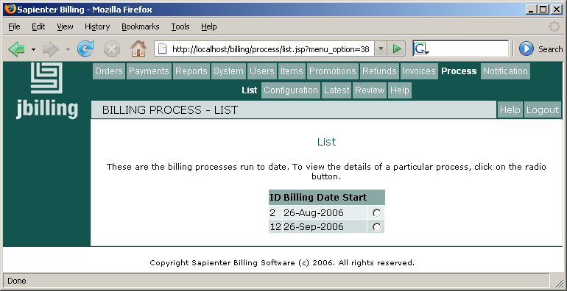

Examining the latest billing process
To view the latest Billing Process, click on Process, then on Latest. As you can see, the screen here contains much detail related to your latest Billing Process.
There are two sections, the billing process and the total. Let's go over the fields of these sections:
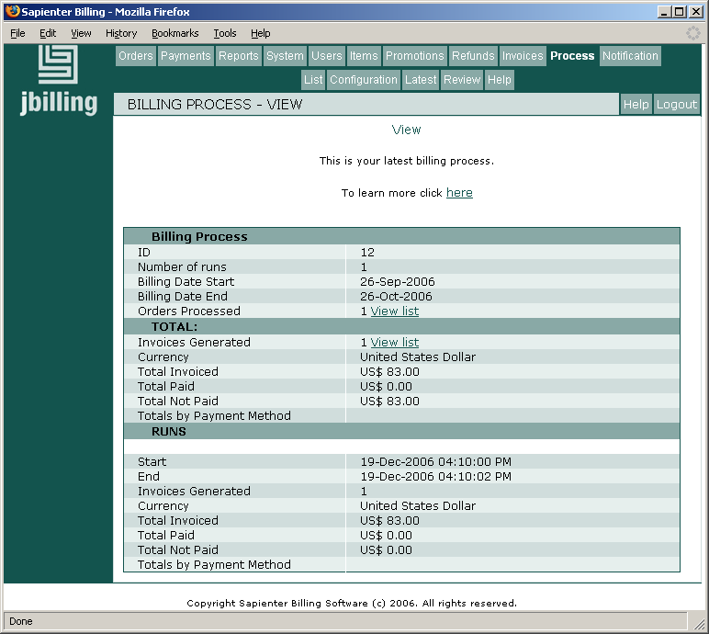

Billing Process
- ID: This number was automatically assigned by the system to uniquely identify this billing process.
- Number of runs: The first run simply refers to the billing run that took place. Should this number be higher than “1”, then it indicates how many times jbilling re-tried to process payments that failed at the first attempt.
- Billing Dates: These dates refer to the period of time that has been billed, as opposed to when the billing took place.
- Orders Processed: This number refers to how many Purchase Orders were included in invoices. Click on View List to display the list of Purchase Orders.

Total
The ‘Total’, shows the aggregate values of all the runs. It is an addition of all the fields from the runs. Thus, it includes the initial billing run, plus all the retries. Here you can see how much you invoiced (and should get paid) and how much you actually got paid through the automatic payment processing.
- Invoices Generated: The Number of invoices this billing run generated. Click on View List to display the list of invoices.
- Currency: The currency used in your billing process.
- Total paid: Refers to the amount jbilling successfully processed automatically, adding up all the runs, using a payment processor. These are payments that the processor has confirmed as good. Do not confuse this number with the total payments you've received on the invoices that this process has generated. That would include payments such as cheques and credit cards done after the billing process.
- Total not paid: This total includes the payments that for some reason did not get paid. It could be that the payment was attempted using a payment processor, but it was rejected (for example, an expired or maxed out credit card). It could also be that the customer did not provide a payment method that allows for automatic processing, such a credit card or ACH, and will pay by cheque instead.
- Total by payment method: Same as Total paid, but discriminated by payment method. You will be getting a total for each credit card type.

Runs
These sections detail what happened during the initial billing process, and then, if applicable, the subsequent runs that were, in fact, ’re-tries’. In the example illustrated in the screen shot, there is only one run: the initial billing process. If there were other runs, they could only be retries. Retries do not generate invoices, they only try to get those invoices still unpaid paid through a payment processor.

- The Total Invoiced represents the sum of all the invoices generated during the billing process. In our example, one invoice was generated.
- Total Paid is the total in payments that jbilling’s automatic payment processing successfully cleared.
- Total Not Paid is the money jbilling’s was not able to collect through a payment processor.

The Process Review Report
The Review Report is a ‘pretend’ billing run. It normally runs a few days before the genuine billing process. You decide if the review report will be generated, and if so how many days before the real process, using the parameters in the process configuration.
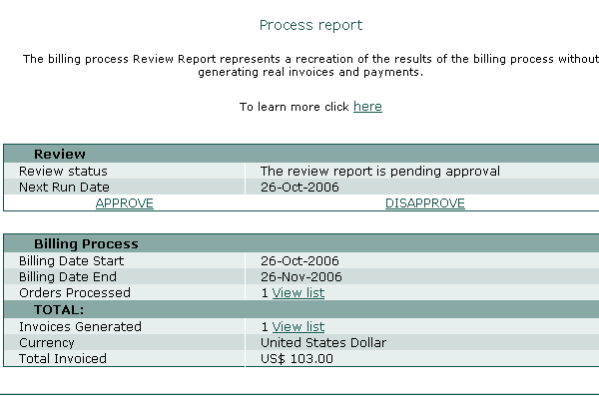
The review report is not a real billing process, so it does not send invoices to your customers, nor does it process payments. It is a great tool to help identify any problem with the invoicing before the billing run actually happens. It allows the Billing Administrator, should mistakes or inaccuracies be noticed, to apply changes to purchase orders, edit customers’ contact information, enter payments, modify the description of an item or its price, etc. Since the Review Report does not generate true invoices, the only way to view these simulated invoices is by clicking on Process and then on Review.
The Review Report, once generated, can be in one of three states:
- Neutral: The system has generated the Review Report and is waiting for the Billing Administrator of your company to either approve of disapprove it. If left ignored, your ‘real’ billing process will not run. Your Billing Administrator would then receive an email on the day your Billing should be processed, warning her that the approval of the Review Report is required in order to allow the billing to run as planned.
- Disapproved: The Review Report was generated and disapproved by your Billing Administrator. Whether changes to the purchase orders are applied or not, the system will automatically generate another Review Report within 24 hours, which will once more need to be either approved or disapproved. This allows you to verify that the system interpreted the way you were hoping for, the changes you might have applied.
- Approved: The Review Report was generated by the system and approved by your Billing Administrator. If the Review Report was approved before the date planned for your next billing run, your billing process will happen as planned.
In short, once a Review Report is generated, it needs to be approved before your billing is allowed to run. If left to Neutral, it will prevent the system from generating the ‘real’ billing run (the one that will actually send invoices to your customers) from happening.
Once the Review Report is generated and waiting for a response, it is possible to apply changes to Purchase Orders or customers’ files before approving it, and then simply approve it. This is not a recommended process. If you have made changes to affect the results of the billing process, then you should disapprove the review so it runs again. Then, once the system has generated another Review Report, verify that the changes show up the way you expected and finally approve the Review.
It is important to note that the real billing process it is not based on the review report itself, but on the other documents: purchase orders, invoices, payment etc. and their status at the moment that the billing process runs. If you enter any data that would affect the billing process, for example, entering a new purchase order, then this will be consider by the billing process regardless of the status of the review report.
Let's see an example of this: the review report runs, and shows that 10 invoices are going to be created for a total of 1000$. You then approve this report, to allow the billing process to take place. Still, after this approval but before the real billing process takes place, you enter a new order for 100$. Your review report, the one that you approved, still shows 10 invoices for 1000$; yet, when the real billing process runs, you get 11 invoices for 1100$.
The billing process can be the same as the review process only if no data has changed in between each run. This might not be realistic to achieve, depending on the size of your customer base. On one hand, you want the review process to run right before the real process, minimizing the time in between them. This will prevent the situation described above. On the other hand, you need some time in between the review process and the real one to fix any issues actually found thanks to the review process. The actual days in between these two processes depends very much on your business rules.

