Introduction
jbilling’s Reports Engine is a powerful and flexible tool that will allow you to query all your billing information. It doesn’t limit you to a single set of reports; it allows you to create your own reports. This chapter will guide you through all the parameters, creating one example report in the process. The final section contains many common reports given as examples. To start, click on the tab Reports at the top of the screen:

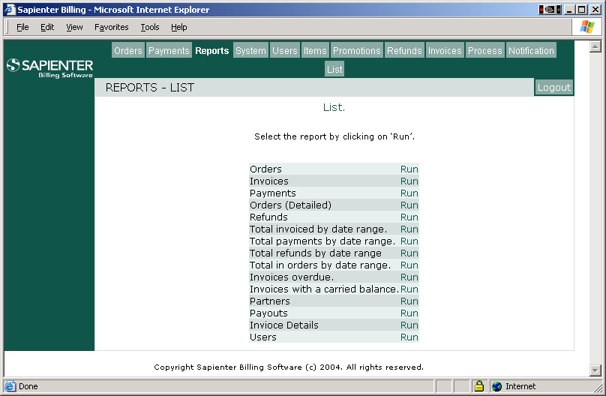
Here you can see a list of the available reports. Beside the name of each report, there is a ‘Run’ link. Clicking on it will take you to the parameters screen. Let’s take a brief look at each of the standard reports:

Name | Each row represents | Common usage
Orders | One purchase order | How much has been sold? Which customers have placed a new purchase order?  Which orders are about to expire?
Invoices | One invoice | How much has been invoiced? Which invoices have been paid, or should be paid? Which invoices are about to be overdue?
Payments | One payment | How much has been received in payment? How much using credit cards (or other methods)?
Orders (Details) | A purchase order line. Includes the item ID, prices and quantity. | How much of one particular item has been sold? How many items have been sold?
Refunds | One refund | How much has been given in refunds? Which customers have been given refunds?
Total invoiced by date range | A single number representing the total invoiced | The total invoiced given a starting and ending date.
Total payments by date range | A single number representing the total received in payments | The total received in payments given a starting and ending date.
Total refunds by date range | A single number representing the total refunded | The total in refunds given a starting and ending date.
Total in orders by date range | A single number representing the total in purchase orders | The total amount in purchase orders given a starting and ending date.
Invoices overdue | One invoice that is overdue | Which invoices are now overdue?
Invoices with a carried balance | One invoice that is carrying a balance from an overdue invoice. | Which of the current invoices (yet to be paid), have as part of their total previously overdue invoices?
Partners | One partner | How much is it owed to the affiliates?
Payouts | A payout to a partner | How much has been paid to the affiliates?
Invoice Details | An invoice line | How much has been invoiced for a particular item? How much in taxes has been invoiced?
Users | One user | Which customers are now in the ageing process? Which customers are from a particular state/country?

The reports engine
Click on the link beside ‘Invoices’ to go to the invoices parameters screen:
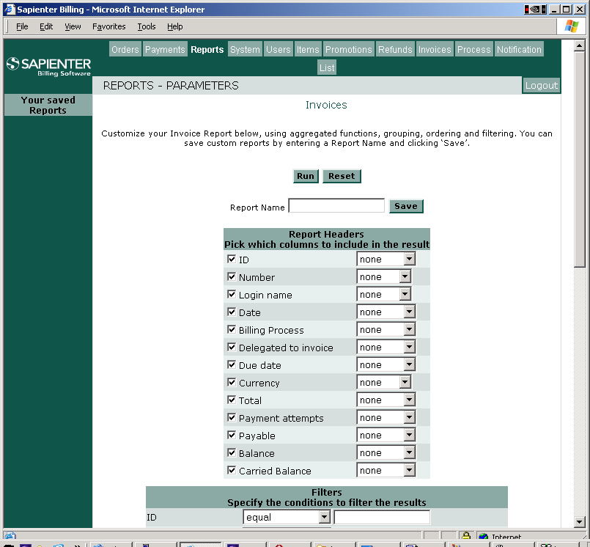

In the parameters screen, you will set all the parameters that will determine the information listed by the report. There are three blocks of fields that are important to identify:
- The columns to select are in the first block, and are under the title ‘Report Headers’.
- The filters, second block
- The columns which will indicate how the results will be ordered are in the third block.
We will go over the details for each of these blocks later in this tutorial.
Hit the ‘Run’ button to get your first report executed. By default, all the columns in the report have a check mark beside them (with no particular order applied to them), and none of the filters are selected. If left as such, it would result into generating a list of all the invoices of your company.

Interpreting the results
At any time, you can click on the ‘Run’ button to execute the chosen report. This will take you to the Results screen. In this screen each row represents one item. For example, if you are running the Invoices report, each line represents one invoice. You will see a link at the far right of each row that says ‘Details’. If you click on it, it will bring you to the invoice’s details screen, where you can see all the information about the selected invoice.
To save the results, click on the link ‘Download’. This will generate a comma separated filed (csv) with all the rows returned by the report. This file is readable by many applications including Microsoft Excel.
If you want to go back to the reports parameters screen, click on the ‘Back’ link that is on top of the results page.

Selecting the columns
The first list of fields is the list of columns that will be included in results. This list is under the title ‘Report Headers’ and has three columns:
- A check-box that indicates if the column will be shown in the results.
- The name of the column
- A drop-down menu to select a function to apply to this column
Example
Let’s start with a simple example. We will get a list of all the invoices.
Click on Reports then on the Run link beside the ‘Invoices’ report to get to the Invoices report screen.
By default, all the columns are selected. In most cases, this is going to result in too many columns being retrieved. We will limit the result to just the following columns: Number, Login name, Date, Payable and Total. Make sure that only these columns have their check-box set:

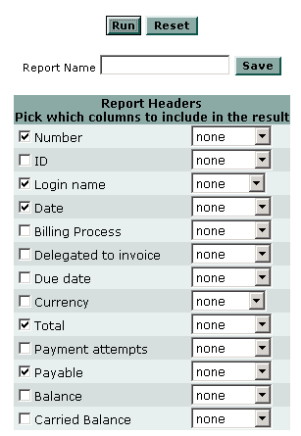

Now click on the button ‘Run’ to execute this report and get the results.

Functions
You can apply a function to get the data processed by the report engine. This usually results in less rows being retrieved. For example, instead of each individual invoice, you might want all their totals added up to get a grand total on how much was invoiced. Then you will need to apply a ‘Sum’ function to the field ‘Total’. When you run the report you will be getting only one row as a result with the total of all the invoices totals.
These are the functions available:
- Sum: It will add up all the values into a single total.
- Average: Same as ‘Sum’ but it will divide the total by the number of rows processed.
- Minimum: It will return the minimum value found.
- Maximum: The opposite of minimum, returning the maximum value found.
- Grouped: This is not a real function; it is useful when running reports that have functions that apply to a group of rows only. This will be explained in the next section.

Let’s put these functions to work: From the previous example, clear all the check-boxes, leaving only ‘Total’ selected. Then click on the drop-down menu to select ‘Sum’. This means that we only want the total of the invoices, and we want it added up.

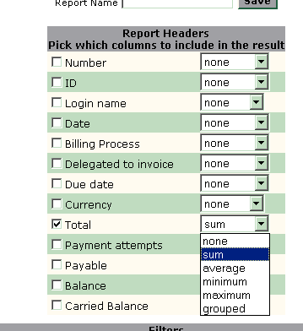

Click on Run and you will see a single number representing the total invoiced.
It is possible to select only a few columns. But all these selected columns must have the either a function selected or none of them can. In other words, you cannot have some with “none” for function and some with “sum”.
For instance, if in the previous example you had selected ‘Login name’ from the list, and left it with ‘none’ as a function, and had selected ‘Total’ and had applied to it the function ‘sum’, you would have gotten the following error: ‘The field ‘Login name’ has to be aggregated’.
This happens because the engine doesn’t know if you want all the rows with the login name, or a single one with the totals added up.

Grouping
Grouping allows us to tell the report’s engine to group a set of rows and then apply a function to them. To mark a column as ‘grouped’, simply select this option from the drop-down menu.
In our invoices example, let’s say that now we want the total invoiced for each user. Instead of one grand total, we want one total per customer.
We will need the Total selected, with the function ‘Sum’. Now we will also select ‘Login name’ with ‘Grouped’ applied:

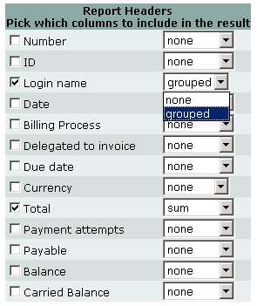

With this, we are saying: Take all the invoices of each user, add them up, and give me the total. Click on ‘Run’ to get the results.

Filtering the results
In almost all situations, we do not want a report to be based on all the records at once. In our example, we have been working with all the invoices ever generated. But we most probably want to limit the report to a period of time, or a particular customer, or some other condition.
The second block of fields in the report’s screen is for the filters. Here is where you will specify the conditions that a row has to meet in order to be included in the report’s result. There are three columns on this list:
- Column name
- Operator: the mathematical condition to meet
- Input field: Here you enter the value to compare against. If left blank, the column is not included for filtering. The value ‘null’, represents an empty value. For numeric fields, you can enter multiple values separated by commas.
Let’s continue the previous example by adding a filter. This will limit the invoices being included in the sum to those generated in the first quarter of 2004. This case involves two conditions because we want to specify a range of dates:

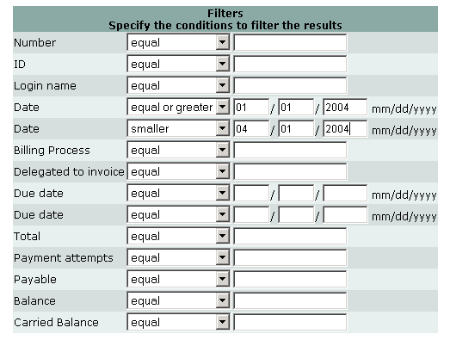

We can translate this filter to the following sentence:
Include only the invoices generated after or on the first day of 2004, and before (not including) April 2004.
Click on ‘Run’ to get the results.

Getting the results in order
To make the results more readable and useful, especially when they involve thousands of records, it is important to be able to get them in the right order. The third block of fields allows you to specify how you want the results to be ordered. For each column, you can select the order position.
Let’s order the previous example by the Login Name. This way, it is going to be easy to locate a particular user in the results:

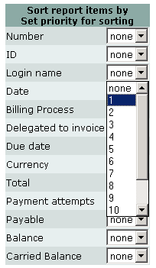

By assigning the order position 1 to the column Login name, the results will be ordered by Login name. We could have added subsequent columns to the order, giving them each a ‘2’, ‘3’, ‘4’, etc. as order position. Every column included has to have its own unique order position; otherwise we will get the error: ‘The order values have to be consecutive’.

Saving your work
You can spend many hours fine-tuning the parameters of a report. And most probably, you will want to run this report again later, or even use it as a template where you make small modifications to get different results. To save all the parameters that you have entered so far, simply enter a name for your report in the input field ‘Report Name’ and then click on the button Save.
For our invoices example, let’s enter ‘total invoiced per customer’:

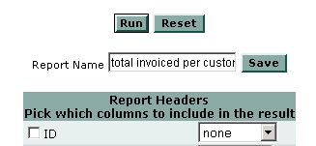

The saved report will show up on the left menu with the name that you gave it. When you click on the ‘Load’ link, all the parameters of the saved report will be applied.

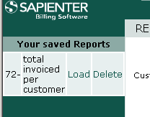

You can also delete a saved report. To do it, just click on the ‘Delete’ link. A confirmation message will follow.

Advance Filtering

Dealing with Codes
You have probably noticed that many reports have ‘Code’ fields. For instance, the Payments report has two of them: ‘Result Code’ and ‘Method Code’. These code fields pair with another field that contains the meaning of the code. ‘Result Code’ will pair with ‘Result’ and ‘Method Code’ with ‘Method’. When you run the Payments report you can see that for a payment with Result Code ‘1’ the Result field is always ‘Successful’.
This is important when using filters. If you want your Payments report to only list successful payments, you need to enter a ‘1’ for the ‘Result Code’ field.

Multiple values for a filter field
In some occasions, you might need to filter many values for a single field. You can do that by separating them with a ‘,’. When you specify multiple values, you can only use the operators ‘equal’ or ‘not equal’. Also, multiple values are only allowed for numeric fields.
Let’s see an example: a list of payments done with Visa and MasterCard. If you run the Payments report, you will notice that the Method Code for Visa is 2, and the one for MasterCard is 3. All we need is a report with a filter on the Method Code with both values: 2 and 3:

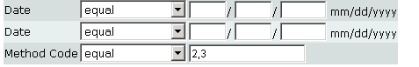
Note that a comma is needed to separate the different values. Without using the multiple values, we would have needed to run the report twice, once for Visa (2), and a second one for MasterCard (3). And how do you modify this report to list payments not done with Visa or MasterCard (done with any other payment method)? It is very easy, simply change the operator from ‘equal’ to ‘not equal’.

Empty values (null)
Another common situation is the need to specify an empty value for a filter. In any filter field, you can enter ‘null’, and the report will interpret that as the empty value. When you specify ‘null’, you can only use the operators ‘equal’ or ‘not equal’.
For example, you might want a list of invoices that have not been delegated to another invoice. When an invoice has been included in another invoice, the field ‘Delegated to invoice’ has the ID of the target invoice. When an invoice has not been included in another invoice, ‘Delegated to invoice’ has simply no value. Since in this example we want to list only those invoices, we need to enter ‘null’ in the filter field ‘Delegated to invoice’.

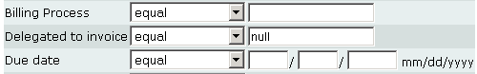

To get a list of the invoices that have been delegated to another invoice, simply change the operator from ‘equal’ to ‘not equal’.

Examples

Total invoiced in the first week of August.
It is very important to know how much has been invoiced in a given period of time. The total invoiced is in many cases the revenue of your company. This example will demonstrate this for the first week of August. The result will include the invoices generated by the billing process, as well as those generated manually.

- Click on Reports and then on the Run link by the Invoices report.
- In the Report Headers section, select only the ‘Total’ column, leaving all the rest unselected.
- In the drop-down menu of the ‘Total’ column, select ‘Sum’
- In the filters section, select the option ‘equal or greater’ for the first ‘Date’ field.
- For that same field, enter ‘08/02/2004
- For the second ‘Date’ field, select ‘smaller’ and enter ‘08/09/2004’

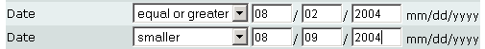

- Click on the button Run to get the results.

Total invoiced per customer in the first week of August.
This report will tell you who has been invoiced in a given period of time, and for how much. If a customer has more than one invoice, they will be consolidated in a single total. Customers that have not been invoiced in the selected period will not be included in the results

- Click on Reports and then on the Run link by the Invoices report.
- In the Report Headers section, select the ‘Total’ and ‘Login Name’ column, leaving all the rest unselected.
- In the drop-down menu of the ‘Login Name’ column, select ‘grouped’.
- In the drop-down menu of the ‘Total’ column, select ‘Sum’
- In the filters section, select the option ‘equal or greater’ for the first ‘Date’ field.
- For that same field, enter ‘08/02/2004
- For the second ‘Date’ field, select ‘smaller’ and enter ‘08/09/2004’
- In the Sorting section, select ‘1’ for the ‘Login Name’.

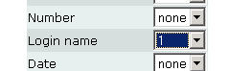
- Click on the button Run to get the results.

Total paid in the first week of August
This report will add up all the successful payments received in the first week of August. Payments that have failed for any reason are excluded. All the payment methods are included. Here you can see the usage of result codes; since ‘1’ means a successful on-line payment, and ‘4’ a payment that has been manually entered (usually a cheque), we will include only the payments with these results.

- Click on Reports and then on the Run link by the Payments report.
- In the Report Headers section, select only the ‘Amount’ column, leaving all the rest unselected.
- In the drop-down menu of the ‘Amount’ column, select ‘Sum’.
- In the filters section, select the option ‘equal or greater’ for the first ‘Date’ field.
- For that same field, enter ‘08/02/2004.
- For the second ‘Date’ field, select ‘smaller’ and enter ‘08/09/2004’.
- For the first ‘Result Code’ filter field, enter ‘1, 4’.

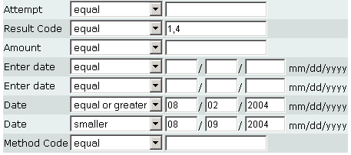
- Click on the button Run to get the results.

List of invoices that have been paid
This report will help you track which customers have paid and which haven’t. For this, we need to specify that the invoice needs to have been already paid (Payable = 0, meaning that is not payable). We also need to exclude the invoices that have been delegated to other invoices (Delegated to invoice = null). Invoices that have been delegated will show up as not payable, but this is because their balance has been transferred to another invoice, not because a payment has been received. You might want to add a filter on the ‘Due date’ to narrow the list down to those whose due date falls in a specific period of time.

- Click on Reports and then on the Run link by the Invoices report.
- In the Report Headers section, select the following columns: ‘ID’, ‘Number’, ‘Login Name’, ‘Date’, ‘Due date’, ‘Total’.
- In the filters section, select the ‘equal’ option for the ‘Payable’ field and enter ‘0’
- For the ‘Delegated to invoice’ filter field, select the ‘equal’ option and enter ‘null’

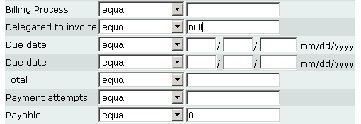

List of overdue invoices
The easiest way to get a list of overdue invoices is by running the ‘Invoices overdue’ report: Click on Reports and then on the Run link by the Invoices overdue report. The report will list the invoices that are overdue at the time you are running the report. If you need a list of overdue invoices for a different date, you will need to configure your own report based on the Invoices report.

Amount of items sold
Let’s count how many items are present in active orders. We will restrict the count to one item in particular. For example, for the fictitious company Trend in the business of selling advertisement on the net, the item ID 232 represents a banner. You can find out the ID of any of your items by clicking on Items.
- Click on Reports and then on the Run link by the ‘Orders (Detailed)’ report.
- Leave only the Quantity field selected and pick the ‘Sum’ function.
- In the filters section, enter the item id that you want to count on the field ‘Item Number’. For Trend this would be 232.
- For the filter field ‘Status Code’ enter ‘1’. This will limit the count to only the currently Active purchase orders.
- Click on the button Run to get the results.

How much are we owed in overdue payments?
Because an overdue invoice can be carried over into the next billing run, and show up on the latest invoice, two reports have to be run in order to get a correct answer to this question. One to add up the total of overdue invoices, and another to sum up the carried over balance on invoices that have not yet been paid and are not yet overdue.

First report: Adding up the total of overdue invoices.
- Click on Reports, than on Run beside ‘Invoices’.
- In the ‘Reports Headers’ block, de-select everything except ‘Total’ and select ‘Sum’ in the drop menu.
- In the ‘Filters’ block below, go to the ‘Due Date’ line and chose ‘Smaller’ in the drop menu. Write today’s date in the fields beside.
- Still in the ‘Filters’ block, ‘Payable’ should equal ‘1’.
- Click on ‘Run’ at the top of the screen and write down the number provided.
Second report: Summing up the carried over balance on invoices that have not yet been paid but are not yet overdue.
- Click on Reports, than on Run beside ‘Invoices’.
- In the ‘Reports Headers’ block, de-select everything except ‘Carried Balance’ and select ‘Sum’ in the drop menu.
- In the ‘Filters’ block below, go to the ‘Due Date’ line and chose ‘equal or greater’ in the drop menu. Write today’s date in the fields beside.
- Still in the ‘Filters’ block, ‘Payable’ should equal ‘1’.
- Click on ‘Run’ at the top of the screen and add this second number to the one the first report provided you with.

