Introduction
In many occasions, each of your customers actually represents many individual customers, gathered under one organization. These individual customers are the end users of your services, but they should not be invoiced directly. The invoice should go to the organization and should include all the charges of each of the end customers.
A typical example is a company providing cellphones to their employees. If you are the cellphone provider, your customer is the company, not the employees. But they are the end users of your services. The company wants one invoice, but it has to clearly separate the usage of each of its employees. You do not want to send an individual invoice to each employee, they are not the ones paying.
jbilling allows this multiple-level customer organization through its sub-account support. The organization will then ‘own’ many sub-accounts. We can visualize this as the organization being the ‘parent’ account, and each of the end customers or sub-accounts being the ‘children’ accounts.
The main concept behind this is that a customer account can be a parent account that is linked to many children account. Both the parent and the children accounts can have their own purchase orders representing the services that they are subscribed to or have bought from you.
When the billing process generates invoices, it will create just one invoice for the parent account, including all the charges from the purchase orders belonging to the children accounts. The resulting invoice will be divided in sections, on per sub-account, with a description of the account, the items and a sub-total.

When to use sub-accounts
As a general rule, you should organize your customers as parent-children when the child account can be identified as the end user of your services, and the parent account the one that receives (and pays) the invoice. Putted in a different way, if the one using your services is different that then one paying for them, there's a good change you will need to use sub-accounts.
This general rule applies to many practical situations that initially can look quite different from one another, yet they share the same account structure. Let’s see some common ones:
A large account, with multiple locations: Your customer is an organization that has multiple locations or branches. Each of these locations is subscribed to your services in a fairly independent way. Still, you are to send one invoice to the head office, where it is going to be received and paid. This invoice will clearly state all the charges for each of the locations.
An organization with many users: This would be the case for a mobile phone company selling to businesses. A typical client will be a company with many employees. Some of these employees will receive a cell phone paid by the company. This client will need to receive one single invoice per period with the details of the charges related to each of its employees. Therefore, the company will be represented as a parent account, and each employee as a child account.
A reseller of your services: A reseller will buy your services and resell them to its customers. The reseller will take care of billing these customers in its own terms. You will have to invoice the reseller for all the services that have been resold. You can set up this situation with the reseller being a parent account, and each of the end users as a child account. The end user will not receive an invoice, the reseller will. The invoice will detail which end users are included and with which services.

Creating a parent-children account
We need to create the parent account first. To do this, click on Users, then Customers and then on the link ‘New’.

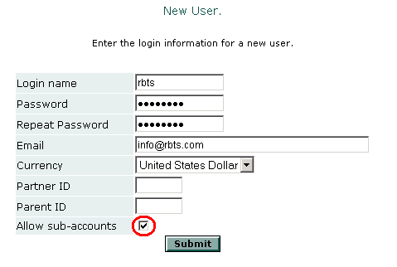
Enter the new customer’s information just as a normal new account, except for the field ‘Allow sub-account’. Make sure that this check-box is checked. This will indicate that the new customer will be a parent account.
Click on ‘Submit’ and take notice of the number that the system has assigned to this new user. We will need this number to create children account of this parent.

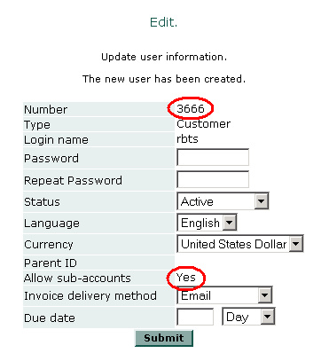
Notice also, that the field ‘Allow sub-accounts’ is shown as ‘Yes’. This confirms that our new customer is a parent account.
We will skip in this example the steps to enter this customer’s contact and payment information. To learn more about this, consult the users documentation.
The next step is to create a new child account. Click again on Users, then Customers and then on the link ‘New’. Enter the child account login information along with the number of the parent account:
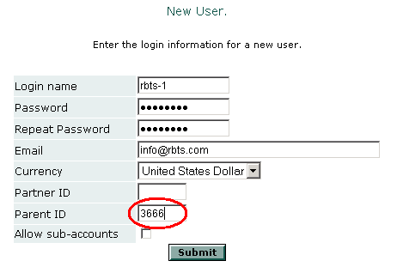
Since children accounts can not login to jbilling, the login name, password and email are not going to be used. Still, the system requires these fields so you will need to enter some information.
For children accounts, it is very important to enter the First Name and Last Name of the contact information. These are the fields that will be used as a header in the invoice when the items belonging to this child are listed.

The differences between sub-accounts a common accounts
Parent and children accounts work pretty much the same as common accounts. Still, there are a few differences that are important to mention:

Listing parent and children accounts
When you click on Users and then Customers the list of customers does not include children accounts. Only normal accounts or parent accounts are listed. To view the children accounts associated to a parent account, start by selecting the parent account.
The usual customer screen shows up, with a few differences. First, the number of children account is added to the user’s information. Also, a link to this customer’s list of children accounts is available:

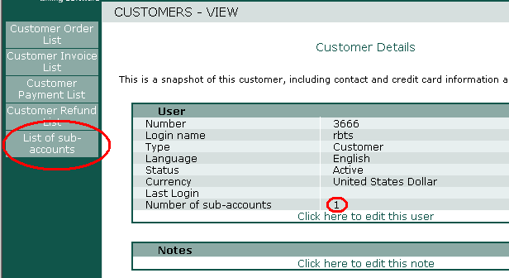

Purchase orders
Parent and children accounts can have their own purchase orders. These will be included in the invoices generated for the parent account.

For children
To create a purchase order for a children account, you follow the exact same steps for the creation of a purchase order for a normal account. The only difference is that you have to first select the parent account from the list of customers to create the new purchase order. Since this is a parent account, the list of children accounts will be displayed. Now you have to select the children account that will own the new purchase order.

For parents
Follow the same steps as when creating a purchase order for a normal customer. When you select the customer that is a parent account, you will see a list of the children account that this parent has. Along with this list, there is a link ‘Use parent’. Click on this link to indicate that you want to create a purchase order for the parent account.

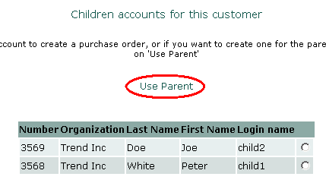

Sub-accounts login
Children accounts can not login to jbilling. These accounts do not receive invoices or submit payments, so there would be little value for them to login to jbilling.
On the other hand, parent accounts will find all their billing information and history by login in to jbilling, just like a normal account. Additionally, parent accounts can list the sub-account that they own and verify their information

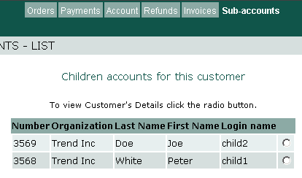

Invoices
Children accounts do not receive invoices. Instead, all their related purchase orders are included in the invoice sent to their parent.
Parents receive an invoice that compiles the charges for all its children. Let’s take a look to the lines of an example invoice:

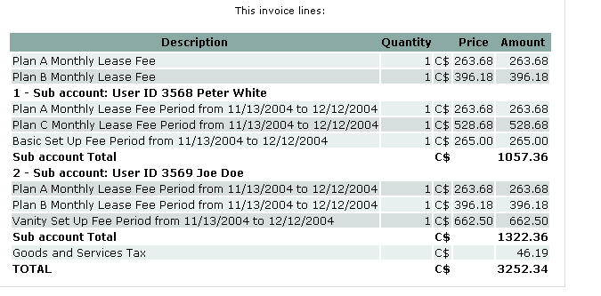

The header for each children section uses the first name and last name of the primary contact of the children account. The items in the invoices are order by the item number (just like in a normal invoice), but also grouped by sub-account. You can also see that this invoice had some items from a purchase order that belongs directly to the parent account. These items are listed first.

