Overview
The blacklist is a list of customer and/or payment information that is used to filter payment requests, which are expected to fail, before they reach a payment processor gateway. There are currently six filters implemented: user id, name, phone number, address, credit card and IP address. Different filter types can be enabled or disabled without affecting the data in the blacklist.
Administrators and clerks have the ability to add or remove individual customers to/from the blacklist through the GUI. The GUI also shows any matches the customer has in the blacklist.
When the aging process takes a customer status to 'Suspended' or higher, all their available details, such as used id, credit card, address, etc., are added to the blacklist. The idea is that this customer tries to resubscribe later with any of the same details, they automatically blacklisted.
Batch upload of a comma-separated values (CSV) blacklist file through the GUI is also possible. It can either add to or replace existing uploaded blacklist entries.

Activating the Blacklist
To active the blacklist, two plug-in need to be added to your system configuration, as well as a preference enabled with the id of the payment filter plug-in configuration.

Payment Filter Plug-in Setup
Click on System, then Plug-ins to access the plug-in configuration page. By default, you will not be replacing an existing plug-in, but adding a new one: Click on the 'Add a new Plug-In' link.
The new plug-in is the following:
com.sapienter.jbilling.server.payment.tasks.PaymentFilterTask
It's important that plug-in is configured to be the first payment processor in the plug-in processing order. This is so a payment only reaches a real payment processor if it isn't first stopped by the blacklist payment filter. See 'Plug-in Configuration' under the 'System Configuration' chapter.

Plug-in Parameters
By default, all filter types are disabled. Each filter type you wish to use must be explicitly enabled as a plug-in parameter. The following table lists all possible parameters. Setting a value of false or removing a parameter causes it to be disabled.
Name | Value
enable_filter_user_id | true
enable_filter_name | true
enable_filter_cc_number * | true
enable_filter_address | true
enable_filter_phone_number | true
enable_filter_ip_address ** | true
ip_address_ccf_id ** | 3
Notes:
* | In jBilling 1.1.2, this was unfortunately left as 'enable_filter_test'.
** | The IP address is a custom contact field (CCF). If this filter is enabled, the id of the IP address CCF must be provided as the value of the 'ip_address_ccf_id' parameter. See the section 'Custom contact fields' under the chapter 'Users'.

Blacklist Preference Setup
Preference type 43 needs to be set to indicate the id of the payment filter plug-in. See 'Appendix A' for information on adding preferences. The plug-in id is the number next to the class name of the configured plug-in. The configuration might look like the following screenshot:
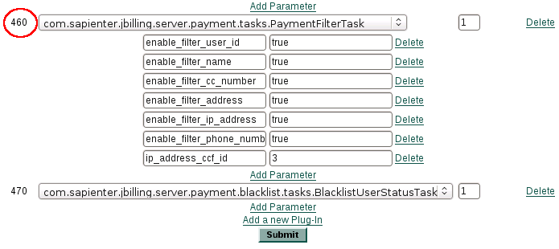
If the id of the PaymentFilterTask plug-in is 460 and the next preference id will be 100, the SQL would be something like this:
INSERT INTO PREFERENCE (ID, TYPE_ID, TABLE_ID, FOREIGN_ID, INT_VALUE, STR_VALUE, FLOAT_VALUE)
VALUES (100, 43, 5, 1, 460, NULL, NULL)

Blacklist Suspended Customer Plug-in Setup
If you would like customers that are moved into the 'suspended' status or higher from a lower status to have their details automatically blacklisted, the following plug-in needs to simply be added through the plug-in configuration screen (System, then Plug-ins):
com.sapienter.jbilling.server.payment.blacklist.tasks.BlacklistUserStatusTask

Blacklist Matches
When viewing the customer details screen (click Users, then Customers and select a customer), an information box lists any blacklist matches for that particular customer. It only includes matches for the enabled filters. Below is an example:

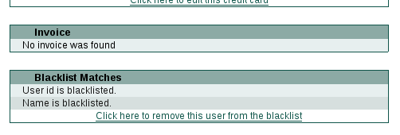
Add/Remove Link
The add/remove link on the bottom of the 'Blacklist Matches' box, shown above, allows administrators or clerks to add or remove a customer's user id from the blacklist. This can be done whether the user id blacklist filter is enabled or disabled.

Batch Upload
The batch upload feature allows externally generated comma-separated values (CSV) blacklist files to be uploaded through the GUI. It can either add to or replace existing uploaded blacklist entries.
It will not modify blacklist entries that were created by the add/remove link or because customers have had their status become 'suspended' or higher.
To get to the Batch Upload screen, click on System, then Blacklist.
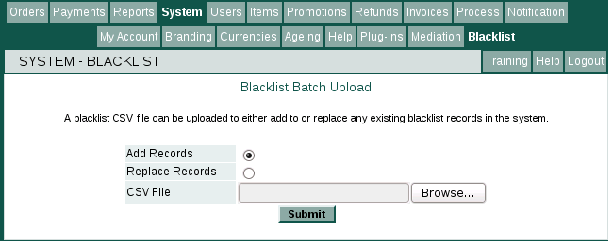
Select whether to 'Add Records' or 'Replace Records', choose a CSV file, then press 'Submit'.

CSV Format
Each line of the CSV file corresponds with one blacklist entry. It is assumed there is no column name header line present. The columns are as follows:
TYPE, FIRST_NAME, LAST_NAME, ADDRESS_1, ADDRESS_2, CITY, STATE_PROVINCE, POSTAL_CODE, COUNTRY_CODE, PHONE_COUNTRY_CODE, PHONE_AREA_CODE, PHONE_NUMBER, IP_ADDRESS, CC_NUMBER, USER_ID
The type field is an integer that indicates what blacklist entry type the line belongs to. Valid values are:
Type Number | Type Name | Fields
1 | USER_ID | USER_ID
2 | NAME | FIRST_NAME, LAST_NAME
3 | CC_NUMBER | CC_NUMBER
4 | ADDRESS | ADDRESS_1, ADDRESS_2, CITY, STATE_PROVINCE, POSTAL_CODE, COUNTRY_CODE
5 | IP_ADDRESS | IP_ADDRESS
6 | PHONE_NUMBER | PHONE_COUNTRY_CODE, PHONE_AREA_CODE, PHONE_NUMBER
At least one field is required for each line type.

Example
The following is an example of a valid CSV file:
1,,,,,,,,,,,,,,1006
2,Joe,Bloggs,,,,,,,,,,,,
4,,,321 Main Rd.,,Vancouver,BC,V6B2E2,CA,,,,,,
6,,,,,,,,,61,02,55554321,,,
3,,,,,,,,,,,,,5105105105105100,
5,,,,,,,,,,,,123.123.123.123,,

Failed Payments
When a payment is failed by the blacklist filter, the payment authorization record looks something like this (a blacklisted credit card number, for example):
