Item management
Items represent the catalog of services or goods sold by your company. Here is where you detail the description and price of an item. An item can be also be a promotion, interest, late fees, a tax or anything else that you might want an invoice to contain.
Creating items and item categories is the very first task that you have to do to get jbilling set-up. Here you have to answer the question: what is that my company sells and how can categorize these items?

Create an Item
As illustrated below, to create an item, click on ‘Items ‘and then on ‘Create’.
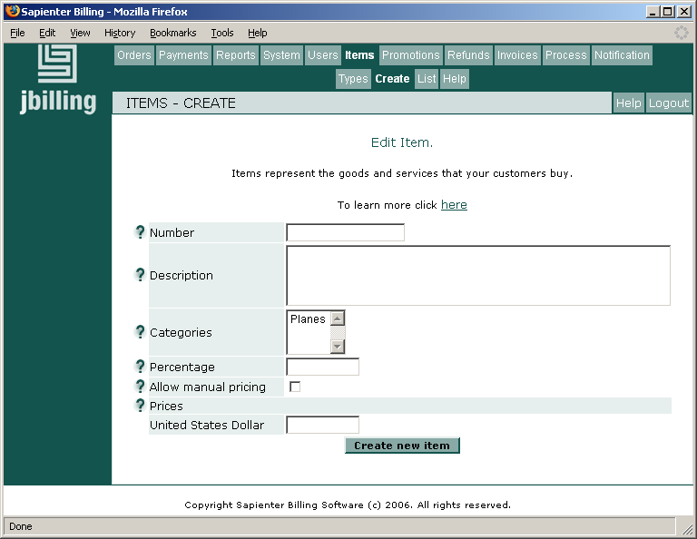

Number
This field is optional. It is the identification you will use internally to distinguish your item. It is deceiving to call it “number”, as you could assign to your item any letter, number, symbol or a combination of all three. It is possible to assign the same ‘number’ to more than one item. The numbers and letters you assign to your item will affect the order in which it will appear among other items, once listed on an invoice. This is actually the most important effect that the item number has: it determines how items will be ordered in an invoice.
If item's order in an invoice is important to you, you should think of a 'number strategy' to follow. Let's say that you want all your normal items to show up first, followed by any discounts and last the taxes. That how you want the invoices to display the lines. In that case, you might want to start the item numbers with a letter that follows these three groups. 'A' for normal items, 'B' for discounts, and 'C' for taxes. This is just a prefix, then you can follow with a number. For example:
A-1 Monthly front page banner
A-2 Featured article
B-1 One year subscription discount
C-1 State taxes.
It is important not to confuse the Number with the ID the system will automatically assign to an item which cannot be edited. The ID is just a sequential number that helps jbilling to internally identify items.

Description
Here is where an item is named and perhaps described briefly. These name and description will eventually be displayed on the invoice. It can be edited when creating a purchase order (see documentation relating to purchase orders). Here, the default language of your company should be used, which was configured during sign-up.
If you need to enter the description in more than one language, you can do so later by editing the item. Initially, you just need to enter the description in your company's default language.

Category
Select what category the item is to belong to. Each item needs to be assigned to at least one category and may belong to more than one.

Percentage
Filling out this field indicates that you wish for the value of this item to be calculated as a percentage of the total of the purchase order. A common example is a tax, such as the VAT (Value Added Tax) or GST (Goods and Services Tax), which is a fixed percentage of the total value of the purchase. If this field is filled out, the ‘price’ field(s) has (have) to be left blank.

Allow Manual Pricing
Flagging an item as ‘manual price’, allows for its price to be modified when creating a purchase order. Its price becomes in fact a ‘suggested price’. For example, Trend‘s price for a top banner is 300$, but this item is flagged as ‘manual price’. A sales representative can then give a one time special price to a customer. When the purchase order is being created the price will be an editable field, allowing the sales representative to enter any number. If the item is not flagged as ‘manual price’, the price will not be editable.

Price
If you have filled out the ‘percentage’ field, this section should be left blank. You will see listed here as many currencies as you have previously chosen to work with in ‘System Currencies’. You have to fill out at least one field. It is possible to fill out more than one field while leaving some blank. Any field you fill out will prevail and the ones left blank will be automatically converted by the system.

Edit
Click on ‘Items’, then on ‘List’ at the top of the screen. Click on a radio button to edit and update the information of an item.

Language
By default, the description of an item will appear on an invoice in the language your company chose during sign-up. If you have clients who understand a different language, you might want to have the possibility of listing items in that other language. You can provide this translated description as follow: Click on ‘Items’ and on ‘List’ at the top of the screen, then click on a radio button which will lead to the page where you can edit the information of an item. Select the language of your choice, enter the translated description in the correct field and click on ‘Submit’ at the bottom of the screen. Click on ‘Reload’ to either see or edit the description in this other language.

Delete
To delete an item, click on ‘Items’, and on ‘List’ at the top of the screen, then click on a radio button which will lead to the page where you can edit the information of an item. Click on ‘Delete’ at the top of the page.

Special pricing

Description
This feature is useful to allocate an ongoing special price to a customer in particular. It can only be edited by the billing administrator and it will be the price showing up on a purchase order every time one is created for this customer. Once created, the system will then automatically use this special price, for this item, for this customer only. The pricing for any other customer is not affected by this. For example, Trend sells advertisement banners on the Internet They normally sell their Package “A” for $100, but would like to offer it to one customer in particular for $90 per month instead.

Creating a special price
Click on Users, then on the radio button beside the name of the chosen customer. Click on ‘Edit this user’s pricing’ button, located in the menu to the left of the screen. Then, click on the radio button of the item you wish to price. Once at the ‘’Item Pricing‘ screen, type in the price at which you will be selling this item to this specific customer. Click on ‘Submit’

Editing a special price
Click on Users, then on the radio button beside the name of the chosen customer. Click on ‘Edit this user’s pricing’ button, located in the menu to the left of the screen. Then, click on the radio button of the item you wish to edit. Once at the ‘’Item Pricing‘ screen, type in the new price. Click on ‘Submit’
Any new purchase orders, created from then on, will feature this item with the new special price. Please note, though, that any purchase orders created during the period of time for which the item had the old special price, the price before it was edited, will remain with the old special price.

Deleting a special price
Click on Users, then on the radio button beside the name of the chosen customer. Click on ‘Edit this user’s pricing’ button, located in the menu to the left of the screen. Then, click on the radio button of the item for which you wish to eliminate the special price feature. Once at the ‘’Item Pricing‘ screen, click on ‘Delete’.
The price for this item will automatically go back to normal, in other words, to the price it is for all customers. Any new purchase orders created from then on will feature this item at its normal price. Please note, though, that any purchase orders created after the introduction of a special price, and before it was deleted, will remain with the special price for the item in question.

Categories

Overview
An item needs to belong to at least one category. Categories will help when running reports as they make easier the identification of certain items distorting the result of a report. For example, in a report rendering the revenue for a given year, it is important to exclude taxes. Therefore, placing all the items relating to taxes into a single category facilitates this.
Categories have a types associated. This type can be 'Items', 'Tax' or 'Penalties'. The type affects how the invoices are calculated and how the items are presented in the invoice. For example, an item that belongs to a category type 'Tax' will not be included as the base when calculating another tax. For PDF versions of invoices, where the total 'tax' amount is segregated, jbilling knows which item is a tax by checking to which category it belongs.

Creating a category
To create a category, click on ‘Items’, then on ‘Types’ and finally on ‘Create Type’ on the top left side of the screen. A field will appear where you enter the name you wish to give to a new category. Then click on ‘Create new category’.

List
To display a list of the existing categories, click on ‘List/Edit Types’ at the left of the screen.

Edit
To Edit the name of a category, click on ‘List/Edit Categories’ at the left of the screen. Click on a radio button to edit and update the information of a particular category.

Delete
To Delete a category, click on ‘List/Edit Categories’ at the left of the screen. Click on the radio button beside the category you would like to delete. Click on ‘Delete’ located just above the field.

