Overview
In a nutshell, any charge made to your customers must be backed by a purchase order. A subscription, a single purchase, a tax or interests on a late payment: they are all represented by a purchase order.
Purchase orders provide the main source of information for the next generation of invoices. A purchase order will generate at least one invoice, and in many cases several invoices across many billing cycles. On the other hand, many purchase orders can be involved in the generation of a singe invoice. Let’s see examples of both cases.
One Purchase Order Generating Many Invoices
In this case, a purchase order could be valid for several months and generate one invoice per billing cycle.
Example
This would be the case when one of Trend Inc.’s customers orders the top banner for four months, paying monthly. This subscription is represented by just one purchase order. The customer will receive four invoices, one each month.
Many Purchase Orders Generating One Invoice
This happens when many purchase orders are active for the same customer, for a given billing cycle.
Example
Continuing with the previous example, let’s say this customer, after one month of running the top banner, decides to buy from Trend Inc. a lateral banner in other pages as well. This would involve creating a new purchase order. As long as both orders are active, they will generate one invoice with both charges, the top and lateral banners. Customers always get a single invoice per billing cycle. This invoice compiles all active purchase orders.

Creating orders
For space purposes, in the application, purchase orders are simply referred to as Orders. To start creating one, click on Orders, then on Create. The first step is to select which customer this purchase order will belong to. A list of users is featured; select a customer from it by clicking on the radio button.

Main parameters
The main parameters of this purchase order will then be displayed:
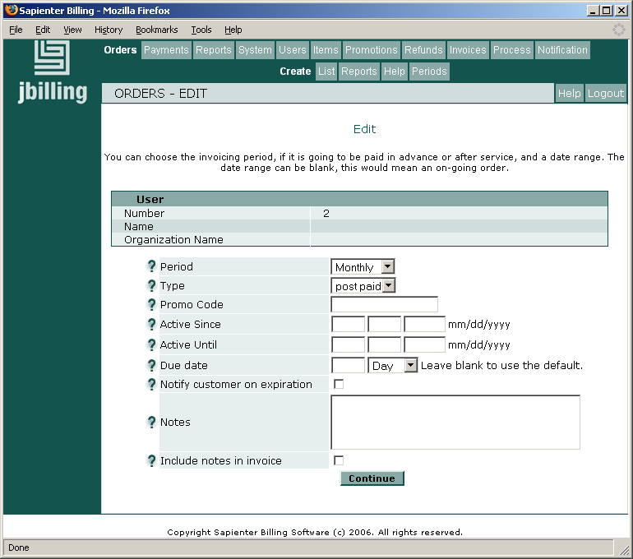
Let's review each of the purchase orders fields:

Period
The order's period determines how often the order will generate an invoice. A purchase order can reflect a one-time purchase or a periodic service invoiced for each period. The list of periods displayed in this drop-down menu corresponds to the order periods that have been configured for your company. If you want to add or modify these periods, you can do so by clicking on Orders and the Periods. To learn more about this see the section Order Periods of this document.
A one-time purchase order is going to be included in only one invoice. This kind of purchase orders are similar to a retail sale, where there is no commitment from the customer to repeat the transaction.

Type
The type of a purchase order indicate when the purchased services will be paid. This can be in advance (pre-paid), or after service (post-paid).

Example
Our example company, Trend Inc., always bills its customers in advance, so all its purchase orders are pre-paid. Customers have to pay before they can see their ads on-line. On the other hand, a landscape maintenance company would send an invoice to a customer once the job is done, exemplifying a post-paid purchase order.

Promo Code
Enter here the code of a promotion if one applies to this order. If so, the item related to the promotion will be automatically included in this order. See the 'Promotions' documentation for more information.

Active Since / Until
Here you can specify if this order applies to a limited period of time. If the field ‘Since’ is left blank the purchase order will considered for invoice generation since the date is created. If the field ‘Until’ is left blank, it implies this purchase order will be on-going, with no specific end date.
Periodic or Recurring
A periodic or recurring purchase order assigns a period of time which will determine how often the purchase order will recur. The periods available to a purchase order can be seen and modified by clicking on Orders and then Periods.
Example
For example Trend Inc. only wants to allow recurring purchase orders every: 15 days, 1 month or 3 months. How to configure jBilling to use these there periods is explained in the 'Order Periods' section. Let’s examine some combinations of values for periodic purchase orders:
Period | Active Since | Active Until | Result
Monthly | Blank | Blank | An invoice will be generated every month, starting at the date the order is created. This order is on-going and will keep generating invoices until the customer decides to cancel her subscription.
15 days | Blank | July 1st, 2003 | An invoice will be generated every 15 days, starting the day the order is created. This will end on July 1st.
3 Months | May 1st, 2003 | Blank | The customer will be billed for 3 months starting on May 1st, even if the order was created before this date. This order is on-going and will keep generating invoices until the customer decides to cancel her subscription.
Monthly | May 1st, 2003 | June 30th, 2003 | This order will generate two invoices, one for May and another one for June.

Due date
The due date that will be applied to all your customers, company wide, is in the Billing Process Configuration section. In the Customer section, you could choose to specify a due date that will apply to a client in particular. Here, at the purchase order level, you can override the previous configurations and apply a due date to one particular purchase order, and therefore to one specific invoice.

Notify customer upon expiration
This only applies when an ‘Active Until’ date has been specified. Should you check this box, jBilling will automatically send a notification to your customer, reminding her that the purchase order has expired. Up to 3 messages can be sent; this, when they are sent and the text sent, are all determined in Notifications Preferences.

Adding items
The main parameters of the new purchase order are set. As you can see, these parameters are about the order's behavior over time. Now it is time to add items to the order with the services that have been purchased.
From the order main parameters screen click on the ‘Continue’ button. This will lead you to the page where items can be added to the purchase order. A list of items is displayed with an ‘Add’ button beside each of them. Enter the quantity you wish to add and then click on ‘Add’. You will see the item being included in the top-right box that represents the summary of the new purchase order. You may use this review box to remove an item: click on ‘Delete’ on the left of the item that you want to remove.

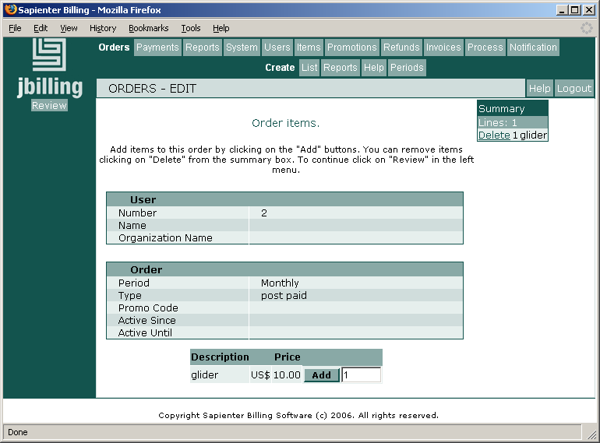
Once you are satisfied with the items of this new order, click on ‘Review’ in the left screen menu. This new screen will show all the information entered so far. You can modify some of this information here too. To go back to the previous screen, click on Add Items, on the left menu. You can choose to cancel this purchase order as well, by clicking on Cancel, also in the left menu. Once you are satisfied with the new purchase order, click on the ‘Submit Order’ button.

In this review screen, you can easily change the quantity of any item. You might be able to modify the prices as well, but only if the item has the attribute ‘Allow manual pricing’ checked. Otherwise the price is read-only.
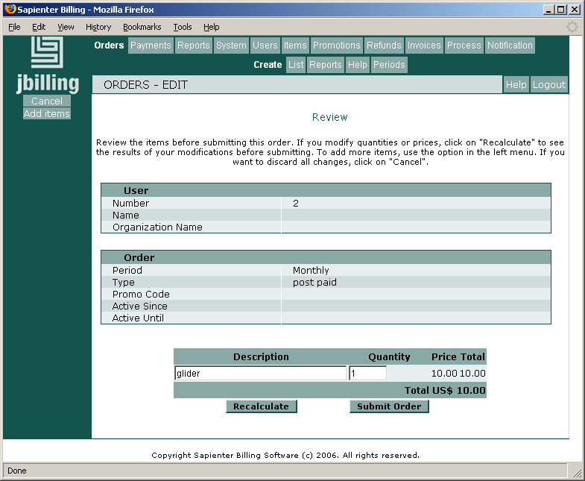

Pro-rating
Pro-rating is a new feature introduce with jBilling 1.1.1, to allow for the invoicing of partial periods. When you have a recurring order, it will generate an invoice per period, for example, an invoice every month. Under normal circumstances, your customer will receive an invoice for the whole period, therefore for the full amount of the services she has subscribed.
However, it is very possible that for the first or last period of the subscription, your customer has to be invoiced for only a fraction of the full period. In these cases, the system has to calculate the amount to be invoiced considering the total time invoiced compared to the time of a full period. This 'fractional invoicing' is what we call pro-rating.
Let's see a typical scenario where pro-rating is necessary. A customer is subscribed to a number of services, receiving an invoice every 10th of the month. Every month, on the 10th, this customer receives one invoice with all the charges for the services she is receiving from your company.
One month, on the 20th, the customer calls your customer service to subscribe to a another service that is 60$ a month. She will not want from now on, to get an invoice on the 10th, plus another one on the 20th with only the new service. It be best to keep one simple monthly invoice. However, since she is subscribing on the 20th, you can't charge a full month.
With pro-rating, you can add a new order with the new service and specify that the order should fit the '10th of the month' cycle. The next invoice will add about two thirds of the full period (40$ in the example) for this initial period of the new service. Subsequent invoices will show the full period of 60$.
A similar situation happens when the customer cancels a service and you need to invoice for that last part of a period proportionally to the price of a full period. In our previous example, if the customer wants to cancel, being the last day the 25th, then the next invoice should show the charge for the period between the 10th (being the beginning of the billing cycle), and the 25th.

Enabling pro-rating.
By default, pro-rating is not enabled in jBilling. This means that jBilling expects all orders to invoice full periods only. If you try to enter an order that does not fit full periods, you will get an error. For example, an order with an 'active since' of February 1st and 'active until' of March 10th will produce an error.
You need to tell jBilling that you want to work with fractions of a period by using pro-rating. There are two steps to do this: setup a preference and configure plug-ins.
Preference 42 indicates if a company is going to be using pro-rating or not. Since the default is not, you need to override it. Take a look to Appendix A for details on how to add a preference. The following is a quick example:

INSERT INTO PREFERENCE (ID, TYPE_ID, TABLE_ID, FOREIGN_ID, INT_VALUE, STR_VALUE, FLOAT_VALUE )
VALUES ( 100, 42, 5, 1, 1, null, null )

Now we need to change the default plug-ins that deal with invoice generation so the system can make the additional calculations that pro-rating requires.
Click on 'System', then on 'Plug-ins'. The screen with all the plug-in configuration shows up. You need to replace
com.sapienter.jbilling.server.pluggableTask.BasicCompositionTask
with:
com.sapienter.jbilling.server.process.task.DailyProRateCompositionTask
and also:
com.sapienter.jbilling.server.pluggableTask.BasicOrderPeriodTask
with:
com.sapienter.jbilling.server.process.task.ProRateOrderPeriodTask
These two new plug-ins don't take any parameters (just like the original ones), so this is just a simple replacement. Click on 'Submit' to get the new plug-in configuration saved.
Calculating fractions of a period
The plug-in that you just configured will take the length of the cycle and count the number of days in it. It will divide the total of the order by the number of days in the cycle. This is the daily cost. It will multiply the daily cost by the total number of days in the period. This means that 15 days on June will be half the monthly price, but not so for July, since it has 31 days.
This is the 'daily' pro-rating plug-in, you can implement other type of pro-rate calculations by creating your own plug-in.

The order 'cycle' attribute
Once pro-rating is enabled, you will see a new attribute in your orders:
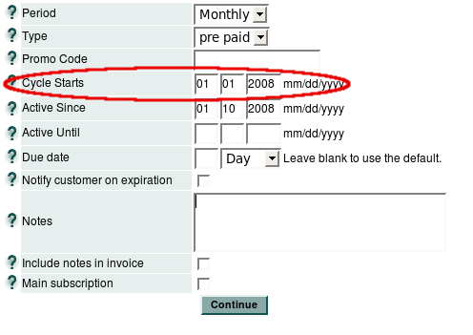
We call this new attribute the order's 'cycle' date. It tells the system when is it that this order should generate an invoice. Any invoice coming from this order has to be aligned to this date:
- If the 'active since' is not the same as (or aligned to) the cycle date, then you will have a first invoice with a pro-rated value. This is, an amount that is smaller than the total of the order.
- The 'active since' is not a required field. If left blank, it defaults to the order's creation date.
- If the 'active until' is not aligned to the cycle date, then the last invoice from this order will be pro-rated.
- The 'active until' is not a required field. If left blank the order is on-going.
As you can see, this new attribute to define the cycle of the order adds to the 'active since' and 'active until' to give orders pro-rating behavior. Still, the 'active since' and 'active until' do exactly the same as they used to, their meaning has not changed.
Also, the cycle date is not a required field. If left blank, the order will simply be a 'normal' order without any pro-rating. If specified, you will only be able to change the cycle date as long as the order has not generated any invoices.
What does it mean 'aligned'? The order will generate an invoice considering the cycle date and the order's period. In the above screen-shot, the cycle starts on the first of January and the order is Monthly. What this really means is that the customer expects an invoice on the first day of every month.
Now, because the order starts on the 10th of January (the customer is getting her service activated this date), then the first invoice will still be on January the first, but rather than for the full amount, it will be only for the 10 to 31 period, or about two thirds of the monthly total.
As you can see, the cycle date is an attribute at the order level. Any order can have its own value for this date. This allows for very complex scenarios that you probably want to avoid, in practice is probably be better to have all the recurring orders for a give customer with the same cycle date.

Examples

Sign-up in the middle of the month
Trend is a company that prefers to invoice all its customer on the 1st of the month. Those that sign-up any other day but the 1st will have the first period pro-rated. That is, from the day the sign-up to the end of the month.
Susan sign-up for her front page add on January 10th . A new purchase order with a cycle date of January 1st and and active since January 10th is created. The next invoice will only include the 10 to 31 period. Subsequent invoices will have full months included. All this using one single purchase order.

Cancellation in the middle of the month
Susan has a pre-paid monthly plan, so she has already paid 100$ for the month of June. She calls on June 16th to cancel the service immediately. She should receive a credit for the remaining of the month (this means that the credit plug-in is in place, see the 'Credits' section for more information).
To do this, the order needs to be edited, adding June 16th as the 'active until'. The system will automatically create a new order with a negative price with June 16th as 'active since', and July 1st as 'active until'. Having pro-rating activated, we will see the billing process creating an invoice with a total of -50 dollars for the period of time that had been originally invoiced, but later had to be refunded to Susan because of the early cancellation.
By only changing the 'active until' of the original order, we will have a new order to represent the cancellation credit. The original order will be now in 'finished' state.

Change of service.
Even more common than signing up for a new service or canceling an existing service, is a customer changing a current service. Susan calls Trend on the 25th to upgrade her existing front page banner ad from a side bar to the top bar. This new ad, of course, has a different price. Susan gets an invoice every 15th of the month with all the advertisement charges.
First, the existing order for the side bar has to end. We do this by simply editing the order and adding an 'active until' with today's date (the 25th in the example). Then, we create a new monthly order with one item, the top bar ad. It will have a cycle date of the 15th. We can leave the active since blank, so it takes today's date as a default.
The next invoice will show two charges: one for the side bar ad for the period of 15 to 24, and another one for the item top bar ad for the period of 25 to 14 (next month). We are using a pro-rated end of period plus a pro-rated start period to replace a subscription.

Credit for early cancellations
When an subscriber calls to cancel one or more services, it could be that the cancellation is in effect for a period that has been already invoiced. If that is the case, we need to produce some way to credit the account. Another way to see it is that we invoiced too soon too much and a correction is needed.
This does not apply for orders that are post-paid. In that case, a cancellation will not affect a period that as been already invoiced simply because we invoice after the service has been provided. For example, if a monthly order is post-paid and a customer cancels that order on the 15th or the month, changing the 'active until' will be enough: the next invoice will simply cover the fraction of a period left in the order, and the order will change to 'finished' status.
If the order is pre-paid, then we might need a credit depending when the customer calls and when the service should end. If the service should finish some time within the next period, then you don't need a credit. If the service finishes earlier, within an already invoiced period, then a credit is necessary.

Activating automatic credits
Credits are usually done on fractions of a period. This means that, if you are canceling a monthly order and a credit is necessary, it is going to be for less that a full month. Because of this (end period being only partial), you will need to activate fist the pro-rating features, this is described in its own section.
Activating automatic credits is done with the addition of one plug-in to your system configuration. Click on 'System', then 'Plug-ins' to access the plug-in configuration page. By default, you will not be replacing an existing plug-in, but adding a new one: Click on the 'Add a new Plug-In' link.
The plug-in in question is the following:
com.sapienter.jbilling.server.order.task.RefundOnCancelTask
The plug-in can work without any parameters. If you want the system to add an arbitrary item to the orders it will create as credits, then you can add a parameter per item. The parameter name has to start with 'item' (lower case). The parameter value will be the item id to add to the orders.
For example, to add item 10 and item 13 to all credit orders, you will need two parameters for this plug-in:
Name | Value
item-A | 10
item-B | 13

Using automatic credits
Once the plug-in is configured, the system will automatically create credit orders when appropriate. This is triggered by adding an 'active until'. The new value for 'active until' has to be within an already invoiced date:
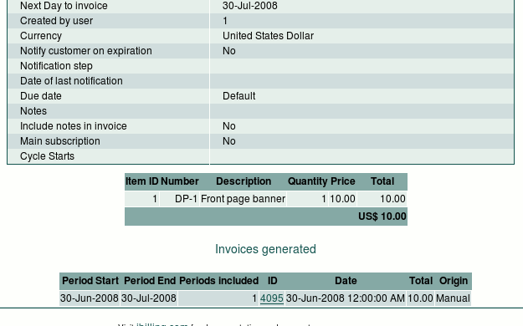
In the above screen-shot, which value for 'active until' would trigger a credit order? It will have to be before July 30, 2008. See that this is the 'next day to invoice' and also a date that is within the period that has been invoice already. So a date like July 20, 2008 will do.
When this order is edited with a new active until, two things happen:
- This order's status is changed to 'finished', and a note is added.
- A new order is created to represent the credit.
Let's take a look to how one of these 'credit' orders look like. Following the previous example, the credit order after entering an 'active since' of July 20, 2008 will look like this:
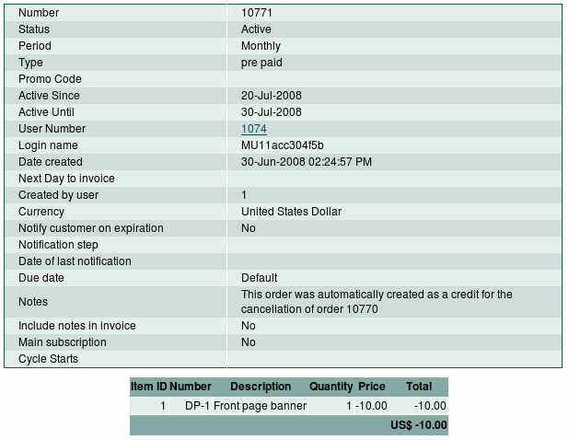
The main parameters to the new order are:
- The order has all the items from the original (canceled) order, but with the prices made negative.
- The credit order covers only the period of time that needs to be refunded. In this case, it is just the last 10 days of the original subscription.
- The credit order comes with a note, to clarify why it was created.
Partial order cancellations are also possible. If the quantity of an item is reduced in an order (or an item is deleted from it), and todays date is within an already invoiced billing period, a refund is generated.

Applying the credit
Once we have the purchase order created for us to represent the credit note, we need to decide what to do with it. There are a few possibilities, which one is the best depends on the status of the latest invoice and if the customer remains subscribed to some other services or not.
The last invoices remains unpaid: In this case, we can take the credit order and apply it to the latest invoice. You can do this by selecting the credit order and clicking on the link 'Apply to invoice'. The invoice will then show the credit items with a new total. The customer will need to receive this new 'amended' invoice.
The customer still has some active orders: In this case it might be best not to do anything. Just leave the credit order to be picked up by the billing process and be added to the next invoice. All the active orders will contribute items to the next invoice, this includes the current active subscriptions plus our new credit order. This alternative makes sense as long as the total of the next invoice remains positive.
The customer is not longer a customer: If the customer has canceled all her services, there isn't any remaining recurring active orders. What to do with the credit order will depend on the way your company deals with refunds: you can immediately generate an invoice (manually or with the help of the billing process), and then send a cheque along with the negative invoice to the customer. You could also have automatic payment processing setup with a payment gateway that will process negative amounts as refunds. See preferences 44-46 in 'Appendix A' for information on activating automatic negative payments (credits).

Fees for early cancellation
Like credits for early cancellations (above), fees may also be generated when a order is canceled. Fees are generated not only for cancellations within a period that has already been invoiced, but also for future periods that were canceled.
The 'active until' field of an order is used for cancellation. When an 'active until' field is moved forward to an earlier date, a fee is generated for every period that will no longer be invoiced. If 'active until' was instead empty, then a fee is only generated if the cancellation includes a period that has been already invoiced.
Partial order cancellations also possible. When the quantity of an order line in an existing order is reduced, fees can be generated.
The business logic for applying fees is handled by BRMS (business rules management system) rules. See the chapter 'Rules and BRMS' in the 'jBilling Extension Guide' document.

Activating automatic fees
Activating automatic fees is done with the addition of one plug-in to your system configuration. Click on System, then Plug-ins to access the plug-in configuration page. By default, you will not be replacing an existing plug-in, but adding a new one: Click on the 'Add a new Plug-In' link.
The plug-in in question is the following:
com.sapienter.jbilling.server.order.task.CancellationFeeRulesTask
As with any rule-based plug-in, the parameters it takes point to the location where the rules package is deployed. See the section 'Deployment' in the chapter 'Rules and BRMS' from the 'jBilling Extension Guide'.

Rules for fees
See the section 'Item relationship management' in the chapter 'Rules and BRMS' from the 'jBilling Extension Guide' for more information about the RulesItemManager plug-in from which CancellationFeeRulesTask is extended.

Data Model
As CancellationFeeRulesTask is a subclass of RulesItemManager, the rules you create have available to them all the information related to the canceled order, including order lines, user and contact details, etc. For partial cancellations, the only order line added to the Drools 'working memory' is the modified line, which has its quantity set to the amount of the item that was canceled.

Helper Service
The rules will have access to the helper service CancellationFeeRulesTask.FeeOrderManager, which is a subclass of RulesItemManager.OrderManager. The name of the global that is an instance of this class is also 'order'.
FeeOrderManager adds the following useful methods:
- void applyFee(Integer itemId, Double quantity, Integer daysInPeriod)
This applies the item as a fee with the quantity specified. daysInPeriod is used for calculating how many periods have been canceled. The number of periods calculated to be canceled is multiplied with the item quantity.
- void applyFee(Integer itemId, Double quantity)
Applies the item as a fee with the quantity specified. A default period of 30 days is used for the number of periods canceled calculation.
- void applyFee(Integer itemId)
Applies the item as a fee with the default quantity of 1.0 and period of 30 days.
- Date getNewActiveUntil()
The order's original 'active until'.
- Date getOldActiveUntil()
The order's new 'active until'.

Example
The following rule applies fee 24 with the same quantity as the number of item 1 that were canceled. Note that the item quantity is also multiplied by the periods canceled.
rule 'Cancel Item 1 Fee'
when
OrderLineDTO( itemId == 1, $quantity : quantity )
then
order.applyFee(24, $quantity);
end

Using automatic fees
When a order is canceled, a 'one time' order is generated with any fees applied by the rules.
Order cancellation can be total or partial.
- A total order cancellation is achieved by changing the order's 'active until' forward to an earlier date (which will generate fees multiplied by the number of periods canceled), or if 'active until' was empty, by setting an 'active until' within an already invoiced period.
- A partial order cancellation is achieved by reducing the quantity of an item in an order (includes deleting the item). If 'active until' has a date set, the fee will be multiplied by the number of periods canceled, otherwise if it the order is currently within a billing period, fees for one period are generated. One order fee is generated for each reduced order line.

Example
- First we'll create an order containing item 1 with a quantity of 3 . The order will be a post-paid order set with an 'active until' set three months into the future. If todays date is 2008-12-6, 'active until' is set to 2008-3-6. The order is immediately manually invoiced:
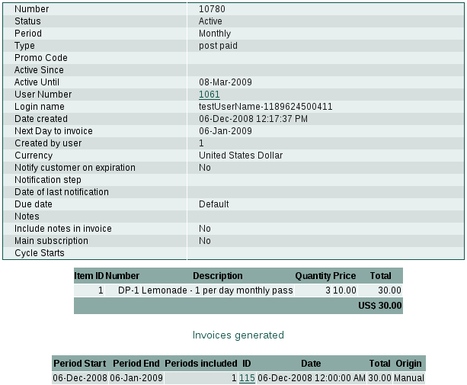
- Now we will go back and edit the order. A quantity of '-1' is added for item 1, reducing the quantity to 2. The order is then updated:
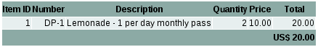
A new fee order has automatically been generated. If we having a look at this order, we can see that it has fee 24 with a quantity of 3. This is because the example rule above adds a fee for each item 1 that was canceled. In this case we canceled 1 quantity of item 1, but over three billing periods (determined by the 'active until'):
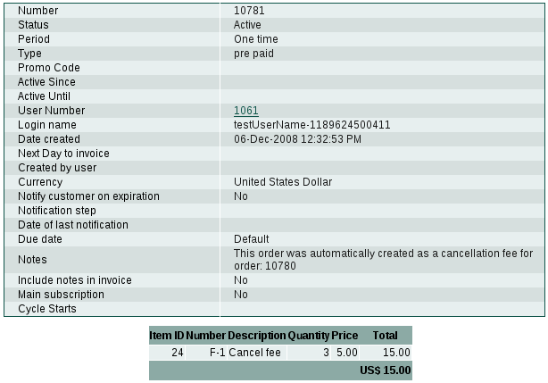
- Now we'll go back and edit the 'active until' of the original order. This set to the next invoice date (2008-1-6), thus canceling two periods. Another fee order is generated. We see that it has a quantity of 4 (2 billing periods x the 2 remaining items canceled):
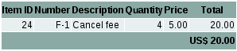

Browsing purchase orders
To list your purchase orders, click on Orders, then on List at the top of the screen. A list of all your purchase orders will appear in chronological order, starting with the latest one. Click on a radio button to see the details relating to a particular order.

Details of a Purchase Order
From here you can see all the details of the selected purchase order. You can also manipulate and run commands on it. Three tables show up on this screen:
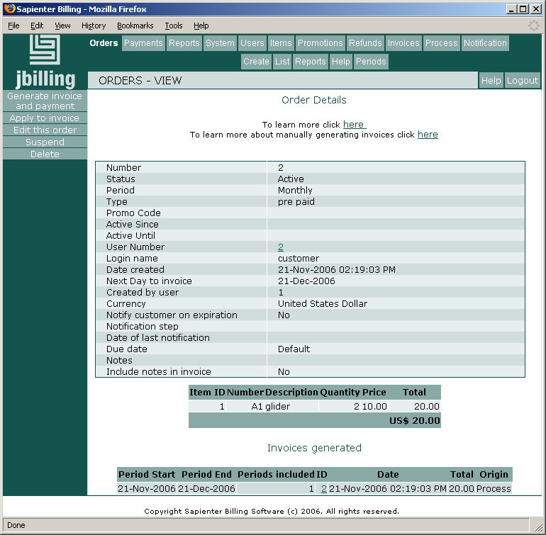

Order Details
The first table reveals the order's core information, such as the date this order was created, what is it status (active, finished, etc.), the length of time each period covers, etc. Clicking on the ‘User Number’ will link you to the customer’s screen.
An important field to highlight is ‘Next Day to invoice’. This is a date that represents the first day yet to be invoiced. In other words, the next time this order is included in an invoice, will be for the date shown in this field. This date is only relevant for recurring orders. When it is blank, it means that this order has not been included in any invoice yet, and therefore the third table (Invoices generated) will be empty.
Let's examine the above example. This is an monthly invoice, created on 11/21/2006. That same date an invoice was generated, which included one month : from 11/21/2006 to 12/21/2006. Thus, the value of 'Next day to invoice' is 12/21/2006 because that day is the fist one not yet included in any invoice.

Items
The second table lists the items contained in this purchase order, how many of each, and their price.

Invoices
The third table relates to the invoices this purchase order might have generated. It helps you see what was sent to a customer and when. If there has been no invoice generated, then this table will be empty.
‘Period Start’ and ‘Period End’
They expose what period the invoice covered which, in the screen shot of our example, above, started on November 21 2006 and ended on December 21 2006. Please note that the ‘Date End’,is not included in the period. That is why the ‘Next Day to Invoice’ , in the Order Details table, is December 21 2006
This only applies for purchase orders that are recurring; one-time purchase orders will show this as blank
Periods
‘Periods’ lets you know how many periods were included. In our example, two periods were covered (we know they were each one month long from consulting the ‘Period’ line in the ‘Order Details’ table.
ID
This is the ID of the invoice where this purchase order has been applied. Clicking on the ID will lead you to the details screen of the invoice itself.
Date
Date the invoice was generated.
Origin
It can be either ‘Manual’ or ‘Process’. 'Manual' is when the invoice was created manually by clicking on the ‘Generate Invoice and Payment’ button on the left menu. 'Process' is when the invoice was generated automatically by the billing process.

Managing purchase orders

Generate Invoice and Payment
‘Generate Invoice and Payment’ features on the left menu of the ‘Order Details’ screen. This is the ‘manual’ way to generate an invoice from a purchaser order, as opposed to invoices automatically generated by the billing process.
When you click on this link, the system will attempt to generate an invoice and will redirect you to the payment page so you can immediately get the invoice paid. You can ignore the payment part and simply stop after the invoice has been generated.
To understand the results of this manual generation it is very important to consider that the system will user the billing period configured under Process Configuration to determine how far in the future will ‘see’. When attempting to generate an invoice, the system will define the period to bill. This period will start from the current date. The end will be the current date plus whatever period you have defined as the billing period in the process configuration.
Let’s see some examples. We will assume that today is July 1st and this is done with a monthly pre-paid purchase order. The billing period will be one month. Therefore, the system will be trying to bill for the period of July 1 – July 31.

Active Since | Next Day to invoice | Result | Comments
July 1st | Blank | 1 period invoiced | An invoice for July is created
July 20th | Blank | 1 period invoiced | The system is looking until the end of July. Since there is some billable time after July 20, it will generate an invoice for the period July 20 – August 19
August 1st | Blank | No invoice generated | This is beyond the period. It reaches only until July 31
June 15th | Blank | 2 periods invoiced | There is some past time here to invoice. The system adds one period and reaches July 15, but after that there is still one period within the window July 1 – July 31, so another period is included. Thus, the resulting invoice will include two periods from the order.
July 1st | August 1st | No invoice generated | This purchase order’s next day to invoice is beyond the period being considered. Keep in mind that it is only seeing until July 31.

Errors when trying to generate a manual invoice
However, it could be that the purchase order can not generate an invoice. If that is the case, you will receive an error message. These are the causes and possible solutions of this error:
- This order is not in ‘Active’ status. If the order is suspended, you just need to click on ‘Activate’ to get it to ‘Active’ status.
- This order has no ‘billable time’ left and is in ‘Finish’ status. This will happen with a ‘One Time’ purchase order that has already generated its invoice. It could also be that is a recurring order with a set ‘Active Until’ date that has been reached. If that is the case, modify the ‘Active Until’ to its new value, change the status of the order to ‘Active’ and try again. You might want to consider creating a new purchase order instead.
- The ‘next day to invoice ‘or ‘active until’ are too far in the future. The solution could be to modify the billing period from the process configuration. See the examples above for a better explanation on how this happens.

Too many periods added to the invoice
This could happen when the ‘Active Since’ of the purchase order is backdated, as you can see in the previous examples. There are many ways to solve this. We'll go through a few of them mostly to illustrate how the many order/configuration billing parameters work together.
Let's start with the easiest way, to change the process configuration 'Maximum periods to invoice'. This parameter puts a limit on how many periods from a purchase order can be included in a single invoice.
Another way, is to change the billing period from the process configuration to a shorter period. For example, from 1 month to 1 week. This way, you are shortening how far in the future the system will try to invoice. Make sure you rollback your changes to the billing configuration once you have generated the invoice.
Additionally, you could temporarily set the ‘Active Until’ of the purchase order, then generate the invoice and edit the purchase order to remove the ‘Active Until’. For example, being today July 1st, for a pre-paid monthly purchase order with an Active Since on May 1st you can set the ‘Active Until’ to May 31st, then generate an invoice (only one period will be included), and edit the purchase order to remove the ‘Active Until’.

Apply to Invoice
This allows you to directly apply a single Purchase order to an existing invoice. Click on Order and on List, then on the radio button of your selected purchase order. On the left menu screen, click on ‘Apply to Invoice’. You will be presented with a list of the invoices belonging to this customer. Select the invoice that will receive this purchase order’s items.
The purchase order has to comply with the same requirements as if you where generating a manual invoice. See the previous section for description of these requirements.
This is the only way to modify an existing invoice, since you can not directly modify invoices manually. It should be used exceptionally to fix an error. A common situation for this feature is the following: a customer has received an invoice that is wrong. You agree to fix this invoice and do so by creating a one-time purchase order that reflects the changes. Then apply the purchase order to the existing invoice. Since this is a one-time purchase order, it will not be included in any further invoices.

Suspend/Activate
Changing the status of an order will cause it to either start or stop generating invoices. Click on Order and on List, then on the radio button of your selected purchase order. On the left menu screen, click on ‘ Suspend’ or ‘Activate’. Click on Yes to confirm.

Edit
To edit a purchase order, click on Orders, then on List at the top of the screen. Select the purchase order you wish to edit by clicking on the radio button beside it. On the left menu, click on ‘Edit this order’. Click on ‘Continue’ when you are done.

Delete
To delete a purchase order, click on Orders, then on List at the top of the screen. Select the purchase order you wish to delete by clicking on the radio button beside it. On the left menu, click on ‘Delete this order’.

Order Periods
Your purchase orders always have assigned an order period. This determines how often the purchase order will generate an invoice. Non-recurring purchase order will have ‘one-time’ as order period. When you create a new purchase order, you will be selecting the billing period from a drop-down menu. You can use any number of days, weeks, months or years as billing periods. How to add and modify the options in this menu is explained in this section.
Start by clicking on Orders and then on Periods. The screen with the current order periods is displayed:

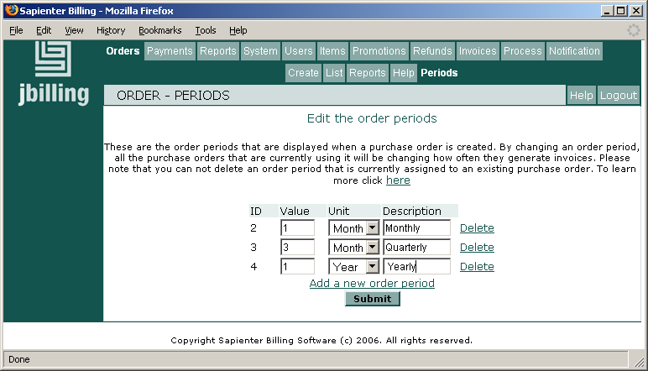

Edit
You can change an existing order period by simply entering a new value on the ‘name’, ‘value’ or ‘description’ fields, and then clicking on ‘Submit’.

It is important to consider the implications of changing an order period that is currently being used by active purchase orders. All the purchase orders that are using the order period will be affected by these changes.
For example, if you had purchase orders that were using the order period id #2, which was 1 month, and then change that order period to 3 months, all there purchaser order will be generating invoices in a 3 month period instead of the monthly period. Even if this is the desired effect, keep in mind that it would be very confusing for a someone in the future to understand you billing history.
This could be a very easy way to change the periodicity of existing purchase orders, but has to be use with caution and with full understanding of the consequences.

Adding a new order period
You if want to have an additional order period, simply click on the link ‘Add a new order period’. A new period will be displayed with a default set of values that you can change immediately. Change these default values to those of your new order period.
Once you have clicked on ‘Submit’ the order period is immediately available. When you create a new purchase order the new order period will be displayed in the drop-down menu. Adding a new order period does not have any impact on existing purchase orders.

Delete an order period
If you have billing periods that are not in use, it is a good practice to delete them to avoid making mistakes when creating a new purchase order. Just click on the ‘Delete’ link by the right side of the order period that you want to delete. You will not be able to delete a billing period that is currently assigned to a purchase order.

