Overview
jbilling can help you manage those accounts that sell your services for a commission. We will call this accounts ‘Partner Accounts’ to avoid confusion with other terms. It is common to refer to this as ‘affiliates’ or even ‘sales representatives’. As a broad definition, they are any individual or organization that brings new customers to you, and gets paid a commission based on the revenue related this new customers.
Our definition of ‘Partner accounts’ does not include an organization that resells your services to its own customers. This reseller will buy from you and sell to its customers. You will send an invoice to the reseller, and the reseller will send invoices to its customers. This situation is covered by the ‘Sub-Accounts’ feature. Please refer to its documentation to learn more about it.
jbilling will help you track the commissions that you have to pay to each of your partners and alert you when a payout is due. You can also list your partners, the customers that each of them ‘own’, among many reports. A partner can have special pricing for your items; this pricing will be extended to the partner’s customers. Last but not least, your partners can login to jbilling to check their accounts, which includes payouts, list of customers, etc.

Parameters
A view to the parameters associated with a partner will reveal most of the functionality that jbilling offers to manage these accounts. Click on Users then Partners and the left menu option Defaults

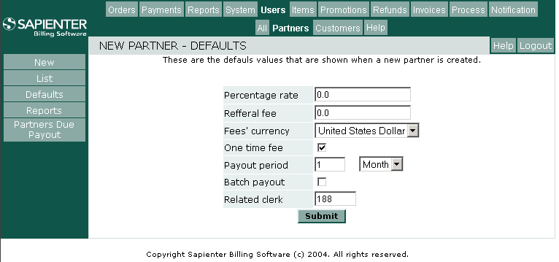

Defaults
Every partner will have a set of parameters. You will define these parameters when you create the partner’s user account. By default, a set of values will be assigned to these parameters. These values are the default values. They are meant to make the creation of a new partner easier.

Percentage rate
A partner can either have a percentage commission or a flat fee commission. Specifying a percentage rate means that a partner will get paid a commission based on the total revenue brought by its customers. In this case, revenue means the amount that a customer has successfully paid. Note that this is different than the amount invoiced to a customer.

Referral fee
This represents a flat fee that is paid as a commission. Unlike a percentage rate, a referral fee is not proportional to the revenue that the customers brought by a partner generated.

Currency
Here you can specify in which currency a partner will be paid

One time fee
If this check-box is set, your partners will get paid only once per customer. Otherwise they will be paid periodically as long as a customer remains active.

Payout period
This is a period of time that indicates how often your partners will receive payouts. Note that his parameter takes affect only if ‘one time fee’ is not checked. Otherwise, partners get paid only once per referred customer.

Batch payout
Just as jbilling can process payments from your customers automatically with the billing process, it is possible to send funds through a payment processor. This allows you to fully automate the payouts to your partners. However, you will have to have an account with a payment processor that supports this kind of transactions.

Related clerk
You have to assign a staff user to your partners. This user will be receiving emails that the system sends regarding payouts to the partners.
In this field, you have to enter the ID of a staff user. If you do not have any staff user besides the billing administrator, then use the billing administrator’s ID number.

Creating a new partner account
Click on Users then Partners and New in the left menu. You will be entering the basic login information for the partner account. After clicking on ‘Continue’ you will be displayed with the partner’s parameters. These parameters are initialized to the defaults that you have specified (see ‘Defaults’ above for more information about the default parameters).
Once the account is created, the system assigns a partner ID to the new account. This ID will be necessary when creating a new customer that has been referred by this partner. This link between a customer and a partner is what allows the system to calculate the commissions for a partner.

Managing a partner account

List
To list all you partners, click on Users and the Partners. The list will show you the next payout date scheduled for each partner, as well as the current amount due. You can then see the details of a particular partner by clicking on the radio button on the right side of each listed partner.

Details
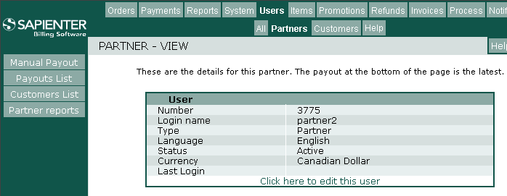

In this screen, you can find various information about the selected partner. The most important of it is the partner’s parameters: when is the next payout, amount due, etc. You will also find the record of the latest payout given to this partner.
From here, you can also click on the links at the bottom of each box to update the partner’s record. For example, to change the password click on the link ‘Click here to edit this user’.

Let’s go over the options that you can find in the left menu:

Manual Payout:
This option allows you to immediately enter a payout to a partner. You will be prompted with the date range that you want to include in this payout, as well as the payment method.
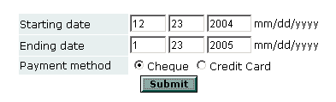
The system will calculate the amount for this payout, base on the payments that this partner’s customers have for the given date range, and the partner’s parameters. The more important parameters for this calculation are ‘Percentage rate’ and ‘Referral fee’.
Once you click on ‘Submit’, you will be forwarded to a page similar to the payment page. In this page you have to enter the payment details of the payout.

Payouts List
This is a list of all the partner’s payouts, starting from the newest. You can click on the radio button by the right side of a payout record to see the payout’s details.

Customers List
This is a list of all the customers referred by this partner. You can see the details of any of these customers by clicking on the radio buttons.

Reports
These are a set of reports that query data related to the customers of the currently selected partner. To learn more about how to run a report, refer to the Reports Documentation.
- Customer’s orders: Returns one record per purchase order belonging to a customer referred by this partner.
- Customer’s payments: Returns one record per payment belonging to a customer referred by this partner.
- Customer’s refunds: Returns one record per refund belonging to a customer referred by this partner.

Partners due a payout
jbilling will send an email to the staff user in charge of each partner when a partner is scheduled to be paid. To get a list of all the partners whose ‘next payout date’ is earlier than today, click on Users then Partners and then on the left menu option Partners due a payout.

