Paying invoices
The last step in a billing cycle takes place when your customers pay their invoices. A payment reduces the balance of an invoice, and when that balance reaches zero, the invoice is considered paid.
The most common situation is to receive one payment per invoice, and for the total amount of the invoice. In this case, we will have one payment per invoice, without any further complexity. This is the ideal case and could perfectly be the case for your company.
However, there are many other situations that can happen that will make the relationship between payment and invoices more complex. A customer might send a payment for the wrong amount, smaller or grater than her invoice. Or she might send one payment to pay two invoices. Eventually, you might have many payment associated with one invoice, or many invoices associated with one payment.
In jbilling, the association of a payment to an invoices is called 'link'. A payment is linked to an invoice when it is paying it. jbilling will track these links: it will tell you how much a payment is paying for each invoices that it has a link with. Also, if an invoice is being paid by many payment, it will tell you which are these payment and how much each of them are paying to an invoice.
The balance of an invoice is how much of it remains to be paid. The balance of a payment is how much of it is still not linked to an invoice. If a payment has a balance greater than zero, it means that it can still be linked to an invoice. You can create and remove links to invoices very easily from the web-based interface.
Let's go through an example to better illustrate the relationship between payments an invoices.
- On June 1st a new customer sends a cheque to Trend for 50$. She does so because she thinks that that is the sign-up fee.
- On June 15th, this same customer receives an invoice for 100$. She then sends a cheque for 100$.
- On July 15th, she gets an invoice for a total of 100$, but with a balance of 50$. She then sends a cheque for 50$.
We have now the following payment/invoice situation:
Payment number 1 is paying 50$ of invoice number 1. This invoice is also partially paid by payment number 2. Between these two payment, the invoice is fully paid.
Payment number 2 also pays invoice number 2 for half of its value. The rest of that invoice is paid by payment number 3.
So we have three payments, and two invoices, but the middle payment is linked to both invoices.

Types of payments
We can classify payments in two ways: by how they are entered in the system, and if the payment has been processed by a payment processor. Let’s see these two categories in more detail:

By method: manual or automatic
A payment can be entered manually by a staff user or a customer directly in the system, or it can be automatically created by the billing process.
Entering a payment manually is described in detail below, in its own section. It basically means to select the invoice that is getting paid and to enter the payment details, like the cheque number and amount in the case of a cheque.
A payment is automatically created by the billing process when using a payment processor to, for example, submit credit card payments. To learn more about automatic payment processing, refer to the Billing Process Documentation.

By processor: entered or processed
Payments can be ‘entered’ or ‘processed’. We call entered payments to those that you simply enter in the system. There is no real-time processing to get the payment approved by a third party payment processor.
A good example for this is a paper cheque that you receive from one of your customers. If you process a credit card payment outside the system, for example, by calling directly the credit card issuer by phone, you will also simply enter the payment on the system, without any further processing.
A ‘processed’ payment is submitted to a payment processor, which is going to reply if the payment has been successful or not. If the payment is accepted, the funds will be deposited directly into your merchant account. This process is all done in real-time, with the whole transaction taking only a few seconds. A typical example of this kind of payment is a credit card payment.
For those payment methods that could be both ‘entered’ and ‘processed’, the field ‘Process real-time’ will show a check-box. If you submit the payment with the check-box set, the payment will be processed through your payment processor; otherwise it will be simply entered.

Combinations
Let’s review some combinations of these two types of payments. Note that some are not applicable, such an automatic payment that is entered (automatic payments are always processed in real-time).

 | Entered | Processed
Manual | A staff user, like the billing administrator, enters a paper cheque or a credit card payment that has been approved on the phone. | A staff user or a customer submits a payment that is cleared in real time by your payment processor. This is usually done for credit card payments.
Automatic | Not applicable. | The billing process submits a payment for each invoice immediately after it has been generated. The payment processor returns the result of each payment in real-time.

Payment methods
jbilling supports several payment methods. By default, jbilling is configured for credit cards and cheques. However, it support ACH (automatic clearing house) as well. You can configure the system to specify which payment methods you want to accept. Doing this involves changing some data directly in the database, so it is out of the scope of this document. Only those payment methods that you have decided to work with will be displayed in the payment’s menu.
Some payment methods can be processed in real-time and allow you to work with automatic payment processing (to learn more about these terms, see the section ‘Types of payments’ above). For this, you will need an account with a payment processor.
A payment processor (also known as ‘payment gateway’) is an independent company, in to way related to jbilling, which provides you with a real-time processing of payments. The payment processor will take your payment submission and forward it to the appropriate financial institution for instant approval. The result of the transaction will be captured by jbilling to take the corresponding action on the customer’s account.
If you want to add credit card support, or add another credit card brand to your list of accepted credit cards, you will first have to contact your payment processor or open a merchant account. These and similar actions are outside your jbilling account, they are all related with your payment processor.
These are the payment methods currently supported:
- Credit cards.
- Automatic clearing house (ACH). Allows direct transfers from bank accounts. It is also called ‘direct debit’, because your customer’s bank account is directly debited the payment’s amount.
- Cheque (paper).

New payments
To submit a new payment in the system, start by click on Payments and then on the payment method that you will be using for the new payment. For example, to enter a new credit card payment, click on Payments and the Credit Card.

Selecting a customer
The first step is to select the customer that the new payment is for. You will be displayed with a list of customers, select one by clicking on a radio button.
Now that you have selected the customer, the page with the payment details is displayed. The following is the one for credit card payments:

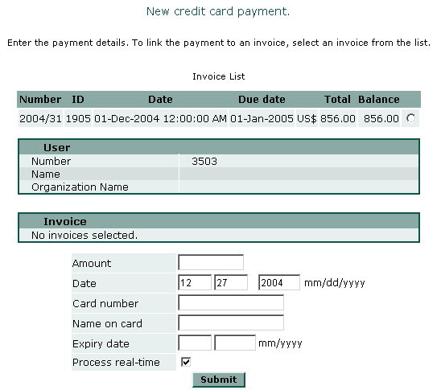

Linking to an invoice
The next step is to select from the invoice’s list the invoice that this payment will be applied to. Only those invoices that have some balance are displayed in this list. A payment should always be linked to an invoice. In theory, every time you are entering a payment is because a customer has first received an invoice requesting this payment.
Although is technically possible to go ahead and enter a payment that is not linked to any invoice, this should be done only for very exceptional circumstances, usually related to migrating from a legacy billing system to jbilling. Note that this option is not available to customers login in to jbilling to submit an on-line payment. Customers always have to select an invoice before being able to submit a payment.
Once you have selected an invoice, its balance will be copied to the amount field of the payment. You can modify this by simply editing the field.
Partial payments are supported by the system. The amount paid will be deducted from the invoice’s balance. If the balance reaches zero, the invoice is marked as ‘paid’ (Status equal to 'Paid').

Submitting the payment
The payment information varies depending on the payment method. Credit card payment will require the card number, name, etc. while cheque payment will have different required fields.
For those payment methods that support real-time processing (see ‘Types’ above), here you can select if you want the payment to simply be entered, or if you want it to be submitted to the payment processor for immediate processing.
Once you have entered all the payment information, click on ‘Submit’ to review all the payment information. The review screen will simply display all the payment’s details for you to review before the payment is finally submitted.

The payment details screen
When you click on Payments, the list of payments will be displayed. You can then see the details of a particular payment by clicking on any of the radio buttons:
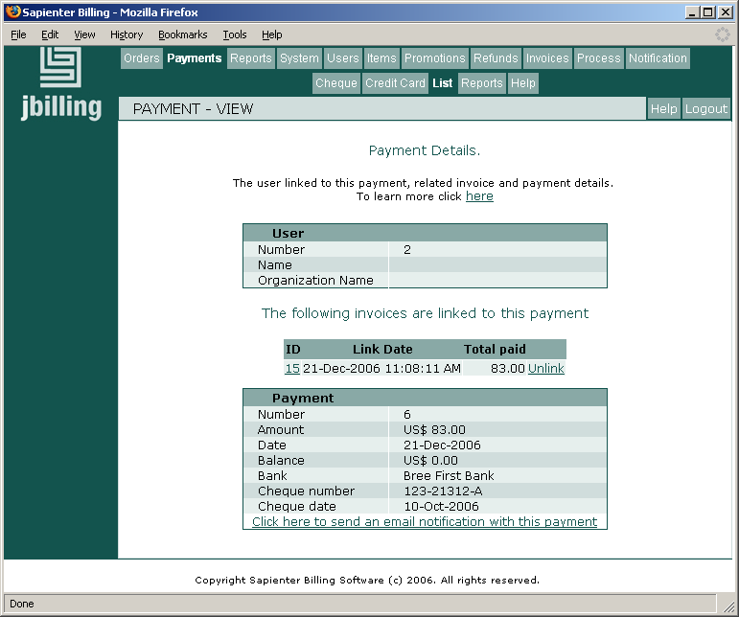
There is a section with the list of links that this payment has with invoices. Here you can see which invoices this payment is paying, when the link was created and how much of the invoice is being paid. The left column is the ID of the invoice, if you click on it you will be taken to the invoice details screen.
It is from this list that you can also remove a link to an invoice, by clicking on 'Unlink'. The effects of this operation are described in the following section.
The fields displayed will depend on the payment method. In any case, you can send an email with the information of this payment (as specified by the payments notifications), by just clicking on the link ‘Click here to send an email notification with this payment’.
For payment methods that can be processed with a payment processor, the result of a payment can be:
- Successful: The payment was submitted to a payment processor and approved.
- Failed: The payment was submitted to a payment processor and declined.
- Entered: The payment was not sent to a payment processor, it was simply entered in the system. See the section ‘Types’ above for more information.
If no result is shown, the payment was entered, not submitted to a payment processor.

Deleting, modifying and linking a payment
Before you can delete or edit a payment, you need to remove all the links between the payment and any invoices. A payment can not be modified as long as it is linked to invoices. To remove the link between a payment and an invoice, click on 'Unlink'. This will undo the effect of the payment by increasing the invoice balance and also increasing the payment balance.
Once a payment is on its own, without actually paying any invoices, you will see the option 'Delete', on the left side of the screen. By clicking on it, you will be removing the payment from the system.
Another option that can be present when the payment is not linked to invoices, is 'Edit'. This option also requires that the payment has been entered manually (see 'Types of payments' above). A payment that was processed by a payment processor can not be modified. Otherwise, payments entered such as cheques and manual credit cards can be edited to correct errors.
The last operation that you can do with an existing payment is to link it to invoices. For this, the payment has to have a balance grater than zero. Linking a payment to an invoice amounts to use the payment to pay (at least partially) the invoice. This is usually done when the payment is created (either manually or by the billing process), so manually linking a payment to an invoice should be an exception.
To create the link, click on 'Pay an invoice with this payment' option on the right side of the screen, which will take you to a list of the customer's current invoices with some amount yet to be paid. From here, you just follow a similar procedure than the one to create a payment.
Note that all the payment's balance will be used to pay the invoice, up to the total balance of the invoice. If a payment has 50$ balance, and the invoice 50$ or more, then the payment will be paying 50$ and finish with zero balance. If the invoice's balance is smaller than 50$, then it will be fully paid and the payment will have some balance left.

Refunds
Refunds represent the return of certain amount of funds to a customer. Refunds can be summarized as payments that have the opposite effect. Instead of reducing an invoice’s balance, they increase it. You will issue a refund only when you have received a payment first. When you create a refund, you will link it to the payment that is being refunded, just like a payment is linked to the invoice that is being paid.
Except for the differences described above, managing refunds is just like managing payments. You select the method, like cheque, credit card, etc. You select the customer and the amount. They can be total, returning the total amount of the payment, or partial. Refunds also follow the same rules as payments for the processing. They can be simply ‘entered’, or they can be processed in real-time through your payment processor. Note that not all payments processors allow you to submit on-line refunds.
For example, an ‘entered’ refund would be a cheque that you send to a customer because the customer over paid you or was overcharged for some services. For a processed refund, you would normally be refunding a payment that was also processed on-line through a payment processor. In the case of a credit card refund, your customer’s credit card will be refunded in real-time, just like a payment is cleared in real-time.
For refunds involving a payment processor, jbilling only submits the refund request and shows to you the result that is returned by the payment processor. For the details and ramifications of how this affects your customer’s payment instrument (credit card, bank account), or how this affects your merchant account, you would have to contact your payment processor.

