Customers and other types of users
Your customers are the base of all the information stored and generated by jBilling. They buy your goods and services, thus, they are the recipients of the invoices that jBilling generates. They will login to jBilling to view their invoices, update their contact information (address, phone number, etc.), edit their credit card information, submit payments, etc.
The data about your customers must be entered in the system before you can start placing purchase orders. Entering your customers information is typically the second step on getting jBilling set-up, right after the items are entered.
There are other types of users that also interact with the billing system. Your staff, for example, will also need to login to fulfill roles such as customer service (telling a customer about a late invoice, or that a cheque arrived, etc), billing administrator (configure the billing process, approve the process review, etc), among others.

The customers list
The list of customers is the most important list in the system. From here, you can then navigate to a particular invoice, payment or order. Since you usually know the customer that you want to work on, it is common to start from the customers list.
Click on Users, then on Customers. A list of all your customers will appear. As in any list in jBilling, you can search for a particular record using filters. By clicking on the right side button of any of the records, you will get a detail screen loaded with information:
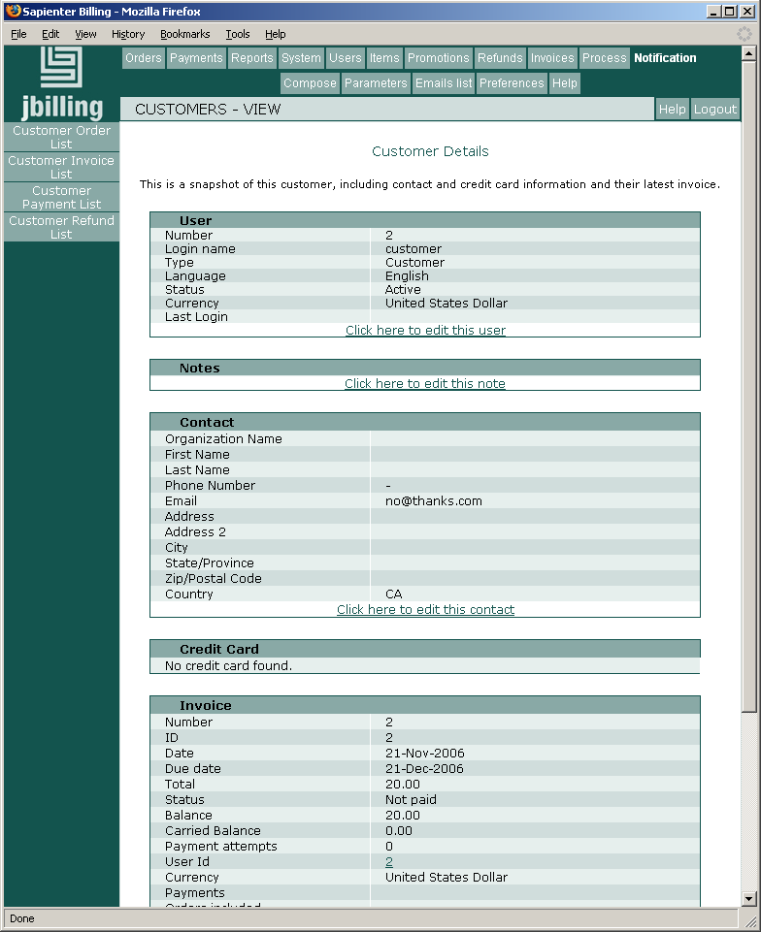

New users

Creating a customer
To create a customer, go to Users, then Customers and click on New, in the left menu option. This first screen will query for your customer’s basic login information.
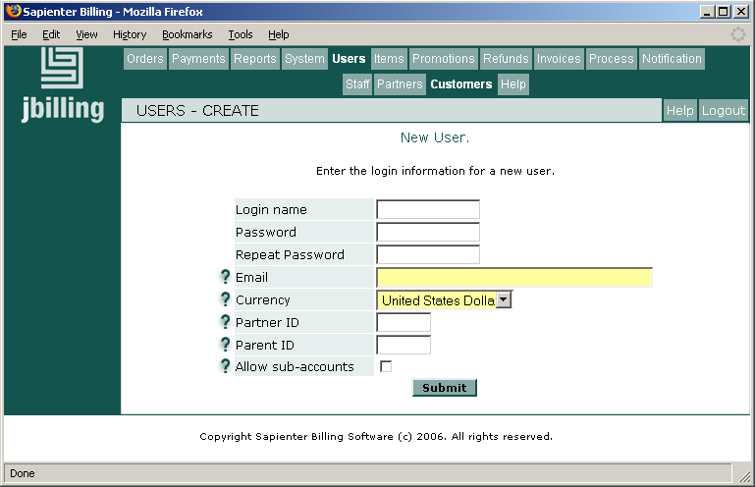
Once this basic information has been submitted, you can start creating purchase orders for this customer. To continue entering information for this customer, such as contact information, credit card information, etc, click on the various options appearing on the left menu once you have submitted the initial data.

Contact Types
This feature allows you to organize the multiple types of contacts you might have for each customer. For example, you might have the main contact information for a customer as well as its accounting contact information. This way, you could be submitting all the email notifications (invoices, payments, reminders, etc), to both your customer and his/her accountant.
Like 'custom contact fields', this is not yet doable through the user interface so you would need to enter some configuration data directly in the database. Make sure to select a name for each type. Each of these types can be included in the email notifications. Please note that one type has to be the primary contact, which will be used for the address on the printed invoice. The primary contact will always be included in the email notifications, whether the box has been checked or not.
Let's configure the system with a new contact type called “Technical”. First, insert a row in the contact_type table:

jbilling_test=> select * from contact_type;
id | entity_id | is_primary
----+-----------+------------
1 | |
2 | 1 | 1
3 | 2 | 1
(3 rows)
jbilling_test=> insert into contact_type (id, entity_id, is_primary) values (4, 1, 0);

Note that the id has to be unique and consecutive. That number will identify our new contact type from now on.
Now we need to name the contact type, that is done in the international_description table:

insert into international_description (table_id, foreign_id, psudo_column, language_id, content) values (28, 4, 'description', 1, 'Technical');

Note the '4' that is referring to our contact type, and the name Technical, which could be any string you want.
That's it, now all you customers can have two contacts, the primary contact and the technical contact we just added.
Login Name / Password
The login name and password will allow your customer to access her billing information. This information could be included on the invoices sent to them. This is done by using ‘notification variables’. Consult the notifications documentation to learn more about this.

Email
The electronic address where all email notifications for this customer will be sent. This email address will be assigned to the customer’s primary contact.
This field is required, so you would need to enter a fake email address if you do not have it or are not interested in email notifications. The reason why this field is so important in jBilling is because the system is much more effective when customers can be easily (and cheaply) contacted to notify them of billing events: a new invoice, an invoice reminder, the result of a payment, etc. See the notifications documentation for more information.

Currency
Select the preferred currency this customer will operate with.

preference Partner ID
If this customer has been referred to you by a partner, enter the partner’s number here.

Parent ID
If this customers belongs to a ‘Parent Customer', enter the ‘Parent Customer’s ID here. This is related to the ‘Sub-accounts’ feature. You can find more about sub-accounts in its own documentation.

Allow Sub accounts
Check this box if this customer will have ‘children’ accounts. This is related to the ‘Sub-accounts’ feature. You can find more about sub-accounts in its own documentation.

Submit Basic Login Information
Once you have entered this customer’s information, click on ‘Submit’. This will create the new customer, and display the User Edit screen. At this stage, it is possible for you to start creating purchase orders for this customer. Click on the various options in the left menu to keep entering information for this customer.

Contact Information
Once you have submitted the basic login information, click on ‘Edit this user’s contact information’ in the left menu. The Organization Name, Last Name and First Name are especially important because the list of your customers will display these fields. This list is used in many features: purchase order, payment, etc. The address will be displayed on the PDF format of the invoices

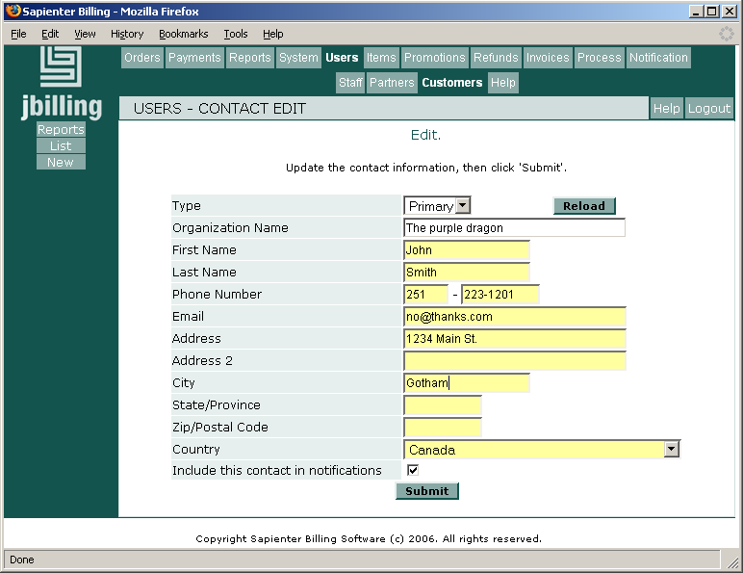

Credit Card Information
To enter you customer’s credit card information, click on ‘Edit this user’s credit card information’ in the left menu, once you have submitted the basic login information.

ACH Information
To enter you customer’s ACH information, click on ‘Edit this user’s ACH information’ in the left menu, once you have submitted the basic login information.

Pricing
You have already allocated prices to items, company wide, when you were creating your items. Should you wish to offer a special price on an item for this customer in particular click on ‘Edit this users pricing’ in the left menu once you have submitted the basic login information.

Include this contact in Notifications
You have the option of sending email notifications to your customers (reminders, announcements, warnings, etc.) Check this box if you want to include this contact’s email on the list of recipients. Note that this is only relevant if you are working with more than one contact type (see ‘Contact Types’ above), and will only take affect on those types that are not the primary one. The contact type considered ‘primary’ is always preference included in the email notifications. If you want a customer to never get any notifications, simply remove the email address for his/her contacts.

Create Staff Users
To create a new staff user, simply click on Users, then All and on ‘Create New User’ in the left menu. In this screen you can enter the basic information about a new user, just like when creating a new customer (see above).

Type
Chose the ‘type’ this staff user will belong to, according to the privileges they will have. For most people within your organization, you might prefer to select the type ‘Clerk’. This will allow the new user to see the billing information, without being able to modify important configuration parameters.

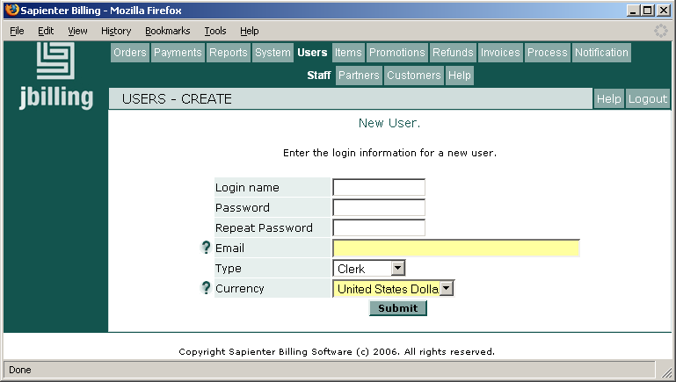

Updating a customer record
At any time, you can modify a customer’s information by going to Users, then Customers and selecting the customer to modify by clicking on the radio button. Once in the customer’s information screen, you will find many links that allow you to edit the customer’s various data: login, contact, credit card, etc. For example, click on the link ‘Click here to edit this user’ to edit the login information.

Due Date
Click on Users and a list will show up. Click on the radio button beside the chosen customer and the Edit screen will appear. The last field on this screen is ‘Due Date’. You have already selected a due date in the Billing Process Configuration section, which will be applied as default, to all your customers, company wide. Here, you can chose to specify a due date for this client in particular, which will overrun the company’s default.

Invoice delivery method
Here you can choose how this customer will receive his/her invoices:
- Email: The system sends the invoices as an email only.
- Paper: The system will not send an email to the customer. Instead, the invoice will be included in a file with all the other paper invoices. This file is in PDF format and will be emailed as an attachment to the billing administrator or to system administrator depending on your choice in Notification Preferences. Printing the invoices is simplified by the fact that all of them are in one single file.
- Email + Paper: Both methods are used: an email and a paper invoice as described above.

Deleting users
To remove a user of any type, click on Users, and then click on All. Select the user you wish to delete by clicking on the radio button. Then, click on ‘Delete this User’ in the menu on the left.

Dynamic Balance
The Dynamic Balance feature allows customers to pay in advance for their usages through either a Pre-Paid Balance, or a Credit Limit.
- Customers with a Pre-Paid Balance pay up front before they receive any product or service. As usage occurs, the cost is deducted from the user's pre-paid balance until none remains.
- Users with a Credit Limit are allowed to accrue 'debt' until a set credit limit is reached. All usage by the customer is paid on credit, and the user is responsible for paying off the credit that they have used.
Note a customer will only be prevented from exceeding their configured limit (going over the credit limit, or spending more than their pre-paid balance allows) when using the 'validatePurchase' API call. Additional orders may still be created manually through the UI, or through the standard 'createOrder' API.
Management of dynamic balances is provided by a plug-in, and it must be configured for either 'Pre-Paid Balance' or 'Credit Limit' balance types to be used.
To configure the plug-in, click on System, then on Plug-ins. Add a new plug-in with no parameters (processing order is not important):
com.sapienter.jbilling.server.user.balance.DynamicBalanceManagerTask

Customer Configuration
A customers dynamic balance configuration can be set or changed by editing an existing customer. To do this, go to Users, then Customers, and select the user you wish to edit using the radio buttons. From the 'Customer Details' screen, click the 'Click here to edit this user' link.

Balance Type
Balance type allows you to change how a users dynamic balance is to be handled, or if the dynamic balance feature is to be used at all.
- None: The user's account will not hold a balance, instead all charges accrued will be included in the next invoice.
- Credit Limit: The user's account may accrue charges up to the set credit limit value. Charges will automatically be paid from the users credit pool until the set limit is reached. User's are responsible for paying their credit debt as well as any overages.
- Pre-Paid Balance: The user must pay into their account to offset future charges. Charges will be automatically paid from the users pre-paid balance until the balance reaches zero. Users are responsible for maintaining their pre-paid balance.

Credit Limit
Only available when Balance Type is set to 'Credit Limit'. This field contains the users current credit limit as a dollar amount.

Automatic Recharge
Only available when Balance Type is set to 'Pre-Paid Balance', and an Automatic Recharge plug-in has been configured. This field contains a dollar amount that will be automatically charged to the users credit card when their balance drops below the company wide threshold. If this field is set to zero or left blank, no automatic charges will be made for the user.

Configuring Automatic Recharge
Automatic Recharge is a feature only available to 'Pre-Paid Balance' customers. This feature will create a payment using the customers configured credit card whenever their balance drops below a configured threshold. The payment amount is configured on a per-user basis (see the above Customer Configuration), allowing each user to define how much they wish to be charged. The recharge threshold however, is company wide - a setting of $5.00 will cause any users with a configured automatic recharge amount to be charged when their balance drops below $5.00. The idea is to allow users to maintain a Pre-Paid Balance with as little effort as possible.
By default, this feature is not enabled; payments must be created manually to top up the Pre-Paid Balance. This feature can be enabled by performing two steps, configuring the plug-in and setting the Automatic Recharge Threshold.
To configure the plug-in, click on System, then on Plug-ins. Add a new plug-in with no parameters (processing order is not important):
com.sapienter.jbilling.server.user.tasks.AutoRechargeTask

Preference 49 configures a companies Automatic Recharge Threshold. Since by default this preference is not configured, you'll need to set it. As a quick example, you can set an automatic recharge threshold of $5.00 by inserting a new row into the preference table:
insert into preference (id, type_id, table_id, foreign_id, float_value) values (22, 49, 5, 1, 5.00);

Note that the id has to be unique and consecutive. This can easily be established by incrementing the last known id (select max(id)+1 from preference). For more information on how to setup a preference, take a look at Appendix A.

Custom contact fields
It is possible to have the fields of the contact information customized to your needs. These fields can show up on the printed invoice. For example, you might need a tax number to appear on the printed invoices, for legal or accounting purposes. You might wish to have home phone and work phone numbers for your customers.
Custom contact fields (CCF) are also important when using some of jBilling extensions. Many plug-ins require a CCF as part of their configuration. For example, there is a payment processor plug-in that allows you to assign a payment gateway to a customer. The payment gateway that all the customer's payments will be processed through is entered in a CCF. The plug-in then reads that the CCF content before routing the payment request to the appropriate gateway.

Database configuration
To enable custom contact fields you need to enter some specific configuration data directly to the database that jBilling runs on. Unfortunately, this is not doable directly from the web-based user interface.
You need to inert one row into the table CONTACT_FIELD_TYPE per CCF. These are the table's columns:
id: This is a unique numeric value that identifies this CCF. Simply enter the next available number. If this is your first CCF, this would be 1.
entity_id: Your company's number in jBilling, typically 1 in a system running only one company.
prompt_key: This is the name of the field, which will be used in the contact screen. Because of jBilling's need to be able to run in multiple languages, you will need to add the name of your CCF to a text file. See below for details.
data_type: This will be the type of content that this field will be used for. Use 'string' if it is text, or 'integer' for number.
customer_readonly: Here you will have a 1, if you don't want customers to be able to change the value of the CCF. Otherwise, make this column a 0. Customers can see or change the value of a CCF when (and if) they login to jBilling and go to their contact information screen.
The following is an example of a SQL command that inserts a row into the database to add one new CCF:
insert into contact_field_type (id, entity_id, prompt_key,
data_type, customer_readonly)
values (432, 1, 'ccf.web_site', 'string', 1);

Text configuration
Once you've added the CCF to the database, you need to add the CCF's name to a file with the text that is displayed in jBilling's GUI. This file is called ApplicationResources.properties. This file has a key, then an '=' and the value for that key. What you entered in contact_field_type.prompet_key is the key for your CCF. So now you have to add a line to ApplicationResources.properties with the key you chose before followed by '=' and the text that will be displayed to the user.
This file is not standing alone in some directory. It is inside the jbilling' jar' file (billing.war). There are two way to edit ApplicationResources.properties. One is to do so and the repackage billing.war. For this you need to have the jBilling source code and make a build. If you are a developer, you will find this very easy, step-by-step instructions are available in jBilling's web site.
The second way to do the edition, is to open billing.war with an application that can handle zip files (7zip, for example). Open billing.war and go to the directory /WEB-INF/classes. There you'll find ApplicationResources.properties. You will have to edit the file, and the replace the one that is in billing.war.
Following the previous example, we will add the following line to ApplicationResources.properties:
ccf.web_site=Web Site
When we go to the contact screen, we can see now the additional field:
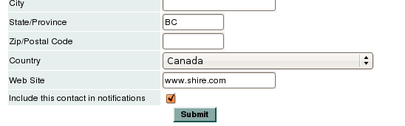Illustration 1: The 'Web Site' field is not part of the contact

FAQ
- How do I generate a list of all the invoices belonging to one customer in particular?
Click on User, then Customers at the top of the screen. Click on the radio button beside the chosen Customer. Click on ‘Customer Invoice List’ on the left menu.

- How do I generate a list of all the purchase orders belonging to one customer in particular?
Click on User, then Customers at the top of the screen. Click on the radio button beside the chosen Customer. Click on ‘Customer Order List’ in the left menu.

- How can I view the latest invoice generated for one customer in particular?
Click on User, then Customers at the top of the screen. Click on the radio button beside the chosen Customer. Scroll down and see the ‘Invoice’ window.

- How can I change the contact information (address, phone number, etc.) of a customer?
Click on User, then Customers at the top of the screen. Click on the radio button beside the chosen Customer. Scroll down and see the ‘Contact’ window; click on ‘Click here to edit this contact’.

- How can I modify the email address we have for a customer?
Click on User, then Customers at the top of the screen. Click on the radio button beside the chosen Customer. Scroll down and see the ‘Contact’ window; click on ‘Click here to edit this contact’.

- How can I change a customer’s the Credit Card information?
Click on User, then Customers at the top of the screen. Click on the radio button beside the chosen Customer. Scroll down and see the ‘Credit Card’ window; click on ‘Click here to edit this Credit Card information’.

- How can my staff write comments regarding a customer’s file and communicate together without the customer having access to this information?
This is possible only if, in Notifications Parameters, the box ‘Customer's notes on invoice’ was not checked.) Click on User, then Customers at the top of the screen. Click on the radio button beside the chosen Customer. Scroll down and see the ‘Notes’ window; click on ‘Click here to edit this note’.

