Branding
By default, jbilling web-based application has the jbilling logo in the top left corner, as well as jbilling’s image: fonts, colors, etc. You might want to change these for your own colors and logo. This way, when your customers login to the system, they will find the familiar ‘look and feel’ from your company.
Please note that the branding of jbilling can only be done within the parameters of the Jbilling Public License (JPL). You can change the parameters described in this document, while other references to jbilling and Sapienter Billing Software have to be left in place. For more information, the JPL is available at http://www.jbilling.com/JPL
Branding the application to fit your needs is very simple. There are two parameters for you to modify. By default they are blank (empty), which means that jbilling’s defaults will be used.

Logo URL
This is the location your logo for the top left corner. The file has to be in any of the Internet supported formats (jpg and gif for example). You have to enter the complete URL of the location of the file, for example https://www.yourcompany.com/images/logo.gif.
If you have installed jbilling to run with encryption (where all the addresses start with ‘https’ instead of ‘http’), you will need to provide the logo URL from a secured host as well. If you provide a location for you logo that is not encrypted (starts with ‘http’), most web browsers will display a warning message when accessing every page.

Cascade style sheet URL
Cascade style sheets provide a way to specify all the display attributes of a web page. This includes colors, fonts, text formatting, spaces between characters, etc. jbilling’s web-based application relies on a .css file for all its formatting attributes. You can find this .css file at http://your_host/billing/css/jbilling.css (where 'your_host' is the location of the host where you've installed jbilling, such as 'localhost').
Once you have modified this file with your preferences, you will have to put it in a web server and enter its location in the system by clicking on System and then Branding. The same issues regarding the ‘http’ and ‘https’ protocols described for the logo apply for this parameter as well.

Currencies
You can sell your products and services in several markets that have different currencies. jbilling will invoice your customers in the currency that they are expecting, and will make any currency exchange calculations in the process.
The fist step is to configure which currencies you want to use. Click on System and then Currencies. A list of the currently supported currencies will appear. jbilling ships with some pre-installed currencies. Adding new ones is not difficult, but involves inserting rows directly in the database and it is beyond the scope of this guide.
Make sure to set the check-box under the column ‘In Use’ for every currency that you want to use. The system will provide a default exchange rate as shown under ‘System exchange rate’. This is how each currency compares against the US dollar. You can override this rate with your own. Make sure to click on ‘Submit’ once you have finished making your changes.
Once you have selected which currencies you will be using and their exchange rates, you can assign one of these currencies to each of your customers. This is done when the customer account is created, or by editing an existing customer. You can learn more about this in the User chapter.
Another important step is related to your items. You can provide each of them with prices in the different currencies that you are using. You only have to provide the price in one currency, and if the item is going to be sold in a different one, the system will perform the currency conversion. Still, you can provide a price in all the currencies. Doing so will prevent the system from doing any conversions, it will simple pick the prices in the right currency.
When you create a purchase order to a customer, the item’s list will be displayed in the customer’s currency. This price will follow the rules described above: if the item has a price defined for the needed currency, it will use it. Otherwise a currency conversion will take place.

The ageing process

Introduction
What happens when a customer hasn’t paid her invoice and the due date has come and past? This is the issue that the ageing process addresses. The term ‘Ageing’ is given to reflect the several steps that a customer account goes through, starting with ‘Active’ and ending with ‘Deleted’. This process notifies your customers about their overdue invoices, and changes the status of that customer’s account. Go to the Ageing configuration screen by clicking on System and then Ageing.
The ageing process can automate the suspension of non-paying customers.
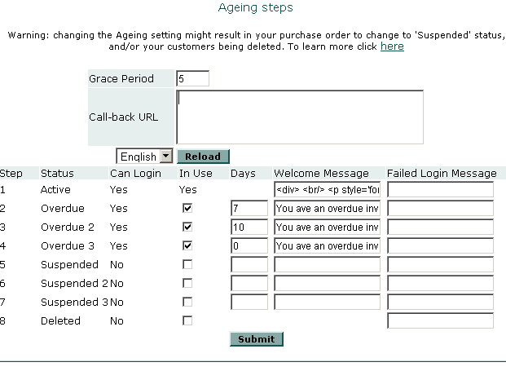
Let's go over the events that relate to the ageing process:
- An invoice is overdue, because its due date is past the current date.
- The grace period gives the customer a few more days before any action is taken.
- After the grace period is over, the ageing steps are applied, depending on which ones you've configured.
You configure when and which of these events happen mostly through the following parameters. Note that if you do not want the ageing process to take place at all, you just need to turn off all the check-boxes of the ageing steps and click 'Submit'.
There are eight steps. The only one that is mandatory is the first one, 'Active', that is actually consider outside the ageing process. All your customers start in 'Active' status. If the have an invoice that is overdue, they will remain in 'Active' status for the number of days specified in the Grace Period.
When the grace period is over, the ageing process takes the customer to the first ageing step. This is the first step that has checked the 'In Use' check-box. A customer will remain in that status for the number of days specified in the 'Days' column.
When that period is over, the process takes the customer to the next step. The system will only move your customers through states that you have selected as 'In Use' by checking the 'In Use' check-box.
By submitting a payment, a customer gets out of the ageing process and back to 'Active' status
This automatic process of taking your customer through various ageing steps happens only as long as the customer does not pay her invoices. If she gets the invoice that is overdue paid, she gets out of the ageing process and back to 'Active' status. The system can send an email notification for this event as well.
As you can see, you can select how many steps are involved (up to eight), and for how long a customer is in each step. Let's go over each of these parameters in more detail

Grace period
For a customer to get into the Ageing process, one of her invoices has to go overdue. When this happens, the system will wait the amount of days that you specify under ‘Grace Period’ before moving the customer to the first step. The grace period allows for cheques to arrive by mail, for instance, should you have customers sending their payments using slower means.

Steps
The key attribute of an ageing step is its status. The status of a step is pre-configured: step 1 is active, step 2 is overdue, step 5 is suspended, etc. Each of these statuses have very important consequences to a customer account. Let's review them:
- Active: This is the normal status of a customer, before entering the ageing steps.
- Overdue/2/3: A customers has failed to submit a payment before the due date. The customers will receive emails containing a text you will have selected and at a frequency of your choice (see example bellow). Other than this notifications, there are no other changes in the customer account: all the purchase orders remain exactly the same.
- Suspended/2/3: Once a customer’s account is suspended, the system will update all the customer’s active purchase orders to ‘suspended’ status, and therefore stop generating invoices for this account. The system also sends a notification to the customer.
- Deleted: At this stage, a customer’s account is deleted from the system. For obvious reasons, you have to be careful when using this step. Normally, you will only use this ageing step when you are sure a customer will not pay her invoices and you just want to remove her account from the system.
There is also a column called ‘Can login’. This is not related with login in to jbilling. Your customers can always login into the system (except in the ‘deleted’ status). This way, they can take action to get up-to-date with their payments, like updating their credit card information or submitting a payment. The column ‘Can login’ is only relevant when integrating your system with jbilling through one of the integration APIs.
You can select which steps your customers will go through in the ageing process by using the 'In Use' check-box of each step. If the check-box is checked, the ageing process will use the step, otherwise it will be ignored.
The column 'Days' of each step represents the amount of days your customers will stay in this step before moving on to the next step. For the last step, this value has to be zero. A customer reaching the last ageing step will stay in that state until she actually pays and is back to 'Active'.
The 'Welcome Message' is the message that will be displayed right after login. Here you can also specify the welcome message for the Active status. This is an important message that will be displayed to all your active customers immediately after they login to jbilling. Please note that this text accepts HTML tags, you can use these tags to customize the look of your welcome screen.
You might not want your customers to ever login to jbilling. If that is the case, the welcome message is irrelevant for you.
The 'Failed login message' is only relevant when using an integration method. When a customer wants to access your services, your system can query jbilling for this message to be displayed.
For each step that you select (marking the ‘In use’ flag), you will have to specify the notification email message. You can do this by clicking on menu option Notification and then on each of the notifications that apply to the statuses you selected for your Ageing process.
Each ageing step is related to a notification.
For example, if you've selected the steps 2 (Overdue), 5 (Suspended) and 8 (Deleted), you will have to enter the text for the notifications User Overdue, User Suspended and User Deleted. Additionally, you will need to enter the text for the notification ‘User Reactivated’, which is sent when a customer in the Ageing process goes back to ‘Active’ status after a payment.

Example
As you can see in the screen-shot earlier in this chapter, our example for Trend has a 5 day grace period, which indicates it wants to have 5 days go by before a customer gets notified by e-mail that their payment is late. In other words, a customer will be bothered with emails only 5 days after an invoice is actually overdue.
This is done mostly because many of Trend's customers pay by cheque, and this kind of payment requires someone from the accounting department to actually login to jbilling and manually enter the payment. Since there is some human intervention required, Trend chooses to use a grace period of five days.
For the ageing steps, Trend switches on 3 steps: Overdue, Overdue 2 and Overdue 3. There are no steps from the 'Suspended' group. Trend prefers not to automate these steps because they involve more than simply sending emails asking customers to pay their late invoices. Suspended steps go farther and suspend purchase orders that other wise would be active.
For Trend this is not a good choice. It does not have such a large number of customers that would require to automate this part of the collection process. It prefers to take those customers that had reached the 'Overdue 3' step and give them a call directly before any further action is taken.
The idea of this example is to show you that the best choice for the ageing process configuration depends on many factors on how you run your company: how large it is? is the relationship with your customers personalized, or you favor a fully automated system? Trend finds a balance by automating part of the process with jbilling, and leaving the rest to its human resources.
Let's take a closer look to the parameters of these three steps for Trend: We will assume an invoice with a due date of June 1st .
Overdue: (7 Days). The message related to this step is sent right after the grace period is over, on June 6th . A customer would be in 'Overdue' state for 7 days, starting on June 6th and ending on June 13th.
Overdue 2: (10 Days). The message related to this step is sent on June 13th, when the customer is moved from 'Overdue' state to 'Overdue 2' state. A customer would be in 'Overdue 2' state for 10 days, starting on June 13th and ending on June 23rd.
Overdue 3: (0 Days) Since this period is the last one selected; the value next to it needs to be zero. The message related to this step will be sent on June 23rd. From here the only change of status that can happen automatically is when the customer pays and she is back to 'Active' status. The only other way that her status can change is by a manual change: an employee of Trend editing her account and changing her to 'Suspended', 'Deleted' or other arbitrary values.

Plug-in Configuration
At the very core of jbilling there are modules with most of the business logic code. These modules have been organized following a 'plug-in' architecture: a module can be easily replaced by another one, thus altering the behavior of jbilling. We call them 'plug-ins' because they can be swapped without having to deal with the source code: you don't need a programmer to do this.
Plug-ins are Java classes, that is why the names follow the Java naming conventions. There are a number of plug-ins available by default with the standard jbilling. The details of each of these plug-ins such as their parameters are out of the scope of this document. You will only need this when you want to extend or modify a plug-in, or may be create your own.
You can add, remove and change a plug-in by clicking on System and the Plug-ins. A list with all your plug-ins is displayed:
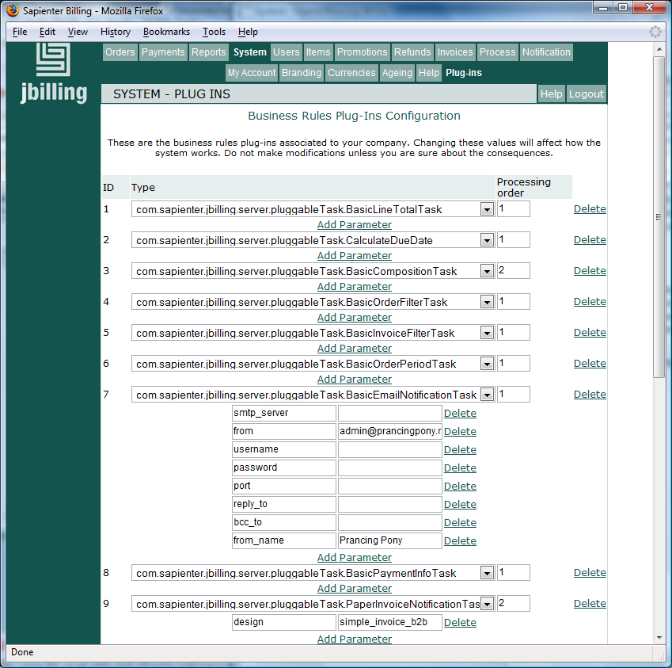
Each plug-in has three fields:
ID: This is an internal unique number that helps to identify this plug-in. This is largely for internal use of jbilling, but might be useful to you at times. For example, the 'router' plug-in that allows you to assign a payment processor to a user, needs to know about other plug-ins. It does so by taking the IDs of those plug-ins as its parameters.
Type: This is the Java class name that will be used by jbilling when a plug-in of this category is needed. For example, when jbilling needs to send a notification, it will go look into your configuration to see which plug-in is there that belongs to the notification category.
Processing order: Some times you will have more than one plug-in for the same category. Let's see an example with payment processors. You could have two accounts with two difference payment gateways. You can add them both as plug-ins, but you need to give one the processing order '1' and the other one a '2'. They can not have the same processing order, otherwise an error will happen. The system will always start by using the plug-in with processing order 1. If that gateway is unavailable, it will try the next one (this is normally called 'fail over strategy'). You can have any number of payment processors configured this way.
Additionally, a plug-in can have parameters. Not all do, but it is not unusual. A parameter gives the plug-in some additional information on how to behave, and makes the plug-in more easily reusable.
For example, the 'PaperInvoiceNotificationTask' is responsible for generating a PDF invoice. It takes one parameter: 'design' with the name of the file that has you paper invoice design. You can create a new design and simply change this parameter to start using it. This way, it is easy to have many designs available and change the active one at any time.

Changing the plug-ins configuration
To add a new plug-in, go to the bottom of the page and click on the 'Add a new plug-in' link. This will create a new plug-in with a default value. You will have to select the class name of the plug-in you want to add from the drop-down list. Click on Submit when you are done.
You might then want to add some parameters to this plug-in. For that, click on the 'Add parameter' link just below you recently added plug-in. A new parameter with a default value will appear. Change the default value for the parameter name and value that you want and click 'Submit'.
Deleting a plug-in or parameter is equally easy. Just click on the 'Delete' link on the right side of the plug-in or parameter that you want to delete.

