Volunteer Engagement Platform — Architecture Overview
Executive briefing — what the system is, how it is structured, the architectural patterns it implements, and the choices we want leadership to understand.
Version 1.0 · June 2026

Executive Summary
We operate a multi-tenant SaaS platform that automates volunteer operations for nonprofits, faith communities, and event organizers. The product is SMS-first: volunteers interact entirely by text message, and admins use a web panel plus an SMS command channel. AI is woven throughout — but used selectively, behind a layered system that prioritizes reliability and cost control over showy AI everywhere. The architecture is designed around three guiding principles: every tenant's data is strictly isolated; the cheapest, fastest, most reliable path handles the dominant case; and every decision the system makes is auditable after the fact.

What the System Does
The platform handles the full operational lifecycle of a volunteer event: scheduling, recruiting volunteers via targeted SMS waves, booking them into specific service slots, sending reminders, processing day-of check-in and check-out (also by SMS), handling mid-event role changes, capturing post-event quality reviews, and awarding milestones, badges, and other recognition. A separate donations track is in development. The same backend serves an admin web panel, a Twilio SMS endpoint for inbound volunteer messages, and a scheduler that runs background jobs.

Architecture Diagram
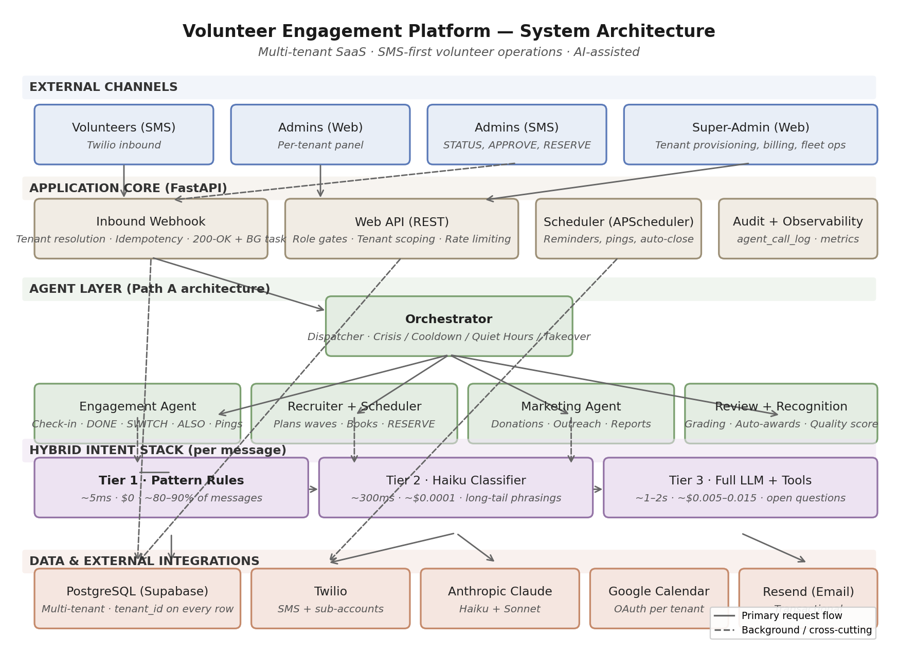
Figure 1. System architecture across five horizontal layers: external channels at the top, application core, the agent layer, the hybrid intent stack, and data + external integrations at the bottom. Solid arrows show primary request flow; dashed arrows show background work and cross-cutting writes.

Key Architectural Patterns We Implemented
The architecture implements ten patterns we want leadership to understand at a conceptual level. Each section explains what the pattern is, why it was chosen, and what the business benefit is.

1. Multi-Tenant Row-Level Isolation
What it is. Every record in our database — contacts, bookings, conversations, settings, AI prompts, credentials — is tagged with the tenant it belongs to. Every database query the application makes automatically scopes by that tenant. There is no shared data across tenants except platform-level infrastructure.
Why we chose it. We chose row-level isolation over per-tenant databases or per-tenant servers because it gives us the strongest tenant boundary at the lowest operating cost. We can onboard a new tenant in minutes instead of hours, deploy schema changes once instead of per-tenant, and keep our cloud bill flat as the tenant count grows. The trade-off — that we depend on application-level scoping — is mitigated by making tenant scoping part of every shared base query, so no developer can accidentally write a tenant-leaking query.
Business benefit. Faster onboarding, lower marginal cost per tenant, simpler operations. Each tenant carries its own Twilio number, Anthropic key, Google Calendar credentials, and SMS prompts — stored on its tenant row — so credential changes do not require redeploys.

2. Path-A Agent Architecture
What it is. The AI-driven parts of the system are organized into four specialized 'agents': an Orchestrator that decides which agent should handle a message, an Engagement Agent that owns the live event lifecycle, a Recruiter + Scheduler Agent that fills events, and a Marketing Agent (in design) that runs donation campaigns. Each agent follows the same internal shape — planner, executor, reporter, intents — so the code is uniform across agents.
Why we chose it. Without this structure, AI features tend to sprawl into a single overgrown handler that is hard to test, debug, or modify safely. The agent shape forces a separation between deciding what to do, doing it, and explaining what was done. This makes it possible to swap one agent's implementation without touching the others, and gives us a clean seam where new agents can be added later.
Business benefit. Faster feature delivery, lower regression risk, easier onboarding for new engineers. The agent boundary is also a natural place to attribute cost and observability — we can see at a glance which agent is consuming AI budget.

3. Hybrid Intent Stack (regex → small AI → full AI)
What it is. Every inbound volunteer or admin message passes through up to three tiers: deterministic pattern rules, a fast lightweight AI classifier, and a full conversational AI as a fallback. Each tier hands off to the next only when it cannot answer confidently.
Why we chose it. We weighed pure-rules (too rigid, breaks on phrasing variations) and pure-AI (too expensive and too slow at scale, and probabilistic on mission-critical actions). The tiered design gives us the cost and reliability profile of rules for the dominant 80–90% of messages while still handling the long tail gracefully. See the companion document 'Hybrid Intent Routing for Volunteer SMS' for the full comparison.
Business benefit. AI cost is dominated by the cheapest tier. Check-in and check-out — the mission-critical operational moments — are 100% deterministic. Long-tail phrasings still work. Gross margin is decoupled from message volume.

4. Webhook Buffer (return-fast, process-later)
What it is. When a volunteer's SMS arrives at our Twilio webhook, we acknowledge it within ~30 milliseconds and process the message in the background. The volunteer's reply is sent separately, after processing completes.
Why we chose it. Twilio enforces strict response timeouts on its webhooks. If our application stalls — say, the AI vendor is temporarily slow — we still owe Twilio a fast response, or the message gets retried, duplicated, or lost. Returning immediately and processing in the background isolates carrier reliability from application reliability.
Business benefit. We can take seconds to process a message without ever missing a webhook. Carrier-side retries do not turn into duplicate check-ins. The system stays responsive under load.

5. Graceful Degradation of External Dependencies
What it is. Every external service we depend on — Twilio, Anthropic, Google Calendar, Resend, Supabase Auth — is wrapped in a soft-fail pattern. If the service is slow or down, the application falls back to a safe default rather than blocking or erroring.
Why we chose it. External services have their own outages, rate limits, and latency spikes. If a single external dependency could block our entire platform, our uptime ceiling would be the product of all of them — which is much lower than any individual vendor's SLA. Soft-failing means a temporary vendor issue degrades a feature, not the whole product.
Business benefit. Higher effective uptime than any single vendor offers. Cost predictability — a vendor outage does not snowball into emergency engineering work.

6. Optimistic Concurrency Control
What it is. Records that can be modified by both volunteers and admins simultaneously — pending service-change approvals, bookings, conversation state — carry a version number. Updates check that the version still matches; if a different writer got there first, the operation fails cleanly with a 'please retry' signal.
Why we chose it. On a busy event, an admin might be approving a service change at the same moment the volunteer is texting a new request. Locking the record would queue admin actions behind volunteer SMS, which is the wrong priority order. Optimistic concurrency lets both operations proceed in parallel and only intervenes when there is a real collision.
Business benefit. No lock contention on hot rows during peak event traffic. Admins see clean retry prompts on the rare collision, rather than mysterious stalls.

7. Graph-Shaped Audit Trail
What it is. Every routing decision the system makes — which agent handled a message, which tier of the intent stack fired, which AI tool was invoked, how much each operation cost — is recorded in a structured audit log. The log captures the relationships between events (this turn fired these tools, which produced this reply), not just a flat list.
Why we chose it. An AI-assisted system that cannot explain its own behavior is a compliance and support liability. We made the deliberate choice to capture the structured chain of decisions as a graph so that the answer to 'why did the system send this reply?' is always available — for compliance, customer support, and product iteration.
Business benefit. Fast incident triage. Compliance-friendly audit posture. Direct visibility into where AI cost is being spent.

8. Domain-Driven Folder Structure
What it is. Both the backend and frontend are organized into feature folders that mirror business domains: bookings, recruitment, conversations, recognition, observability, and so on. Each domain owns its own data access, business logic, and UI components.
Why we chose it. When code is organized by technical layer (controllers, services, models), changes to a single feature touch every layer and the diff is hard to review. Organizing by domain keeps related code together, so a feature change is a self-contained, reviewable unit.
Business benefit. Faster feature delivery, smaller pull requests, lower review overhead. New engineers can ship to a single domain before needing to understand the whole system.

9. Per-Tenant Configuration Surface
What it is. Tenant-specific behavior — SMS prompts, feature flags, external credentials, AI model preferences, recognition definitions, opt-in messaging — lives in a key-value configuration table scoped to the tenant. Admins can edit this from the web panel; changes apply on the next message.
Why we chose it. Tenants serve different communities and have different voices. Hard-coding behavior would force us to fork the codebase per tenant or ship surveys of 'preferences' in code. The configuration table lets a tenant customize voice, messaging, and operational rules without engineering involvement.
Business benefit. Tenants self-serve their own customization. Engineering stays focused on platform work rather than per-tenant tweaks. Compliance with each tenant's brand and tone.

10. Two-Sided LLM Personas
What it is. When the AI does need to converse, it does so with one of two personas: a customer-facing persona for volunteers and an admin-facing persona for staff. Each has its own system prompt, its own set of tools, and its own context blocks. Volunteers never see admin tools; admins never see customer tools.
Why we chose it. A single shared persona forces every tool call to defend against the wrong audience using it — a customer accidentally invoking an admin operation, or vice versa. Splitting the persona at the entry point pushes that concern into the routing layer where it belongs, instead of into every individual tool.
Business benefit. Smaller attack surface. Clearer tool semantics. Each persona can be tuned independently for its audience without regression risk on the other.

Key Points to Highlight
Beyond the named patterns, there are five design choices we want leadership to be able to defend in conversations with prospects, investors, and auditors.
Cost-tiered AI. AI cost grows with message complexity, not with message volume. Our dominant operations — check-in, check-out, status pings, reminders — are deterministic and cost nothing per message. This is the difference between a tenant doubling their volunteer base and our cost staying flat, versus our cost doubling with them.
Mission-critical reliability. The operational moments where errors are most visible — a volunteer marked as no-show who actually arrived — are handled by deterministic code, not probabilistic AI. We accept slightly less flexibility in those moments in exchange for perfect reliability.
Vendor diversification by design. We depend on Twilio (SMS), Anthropic (AI), Supabase (PostgreSQL + Auth), Google (Calendar), and Resend (Email). Each integration is wrapped so that a vendor outage degrades one capability rather than breaking the platform. Replacing any vendor is a contained engineering project, not a rewrite.
Auditable by default. Every routing decision, every AI invocation, every state change is recorded in a structured log. We can answer 'what did the system do and why?' for any message after the fact. This matters for compliance, customer support, and incident review.
Single-product, multi-tenant. We chose row-level multi-tenancy from the beginning rather than starting single-tenant and retrofitting later. Onboarding a new tenant takes minutes. Schema migrations apply once. Our marginal cost per tenant is dominated by usage, not infrastructure overhead.

Strategic Concerns That Shaped the Architecture
Three strategic concerns shaped the architecture as a whole, and are worth making explicit:
- Margin protection at scale. Every architectural choice that moves work onto deterministic, in-process code instead of external AI calls protects our gross margin as tenants grow. This is the difference between a profitable scale story and an AI-cost-eats-revenue story.
- Operational trust. Volunteer operations is a domain where missed check-ins, lost confirmations, and silent failures directly damage customer relationships. The architecture is tilted toward reliability — soft-failing dependencies, audit logs, deterministic routing — because the reputational cost of a quiet bug is higher than the engineering cost of preventing it.
- Optionality. The agent layer, the per-tenant configuration surface, and the soft-failing external-dependency pattern together mean that future changes — adding a new agent, swapping an AI vendor, supporting a new SMS provider — are contained refactors, not platform rewrites. This is what makes future product bets cheap.

What This Architecture Sets Us Up to Do Next
Several enhancements are in flight or designed but not yet built. Each is a deliberate extension of the architecture rather than a redesign:
- Donation campaigns and a Marketing Agent with a public donation page and pluggable payment processors.
- Semantic search powered by pgvector + Voyage AI embeddings, for conversation recall and similar-past-event suggestions.
- Pluggable external contact data sources so a tenant's CRM, HRIS, or identity provider can be the source of truth for volunteer profiles.
- An MCP server surface so external AI agents (Claude Desktop, Cursor, tenant-built tools) can integrate with our platform.
- Twilio sub-account provisioning for per-tenant SMS isolation, billing attribution, and 10DLC registration.
- Issue-reporting pipeline (hallucinations, system errors, customer feedback) with LLM classification routing to the right inbox.

Bottom Line
The headline is that we have built — and continue to build — a platform that uses AI as a tool, not as a magic wand. The architecture is opinionated about where AI adds value, where it doesn't, and how to make sure the cost and reliability tradeoffs are visible and reversible. This is the foundation that lets us scale tenants without scaling cost, defend our gross margin in an AI-priced market, and ship new product surfaces without rewriting what already works.

