Huyin Song (25331396) ENGE707 Kaggle AI Competition Assessment
Kaggle username: huyinsong (Huyin Song)

TASK 1:
This problem is a case of image recognition and classification. The idea is to construct, evaluate, and optimize a machine learning pipeline that when given a bunch of images the machine will be able to classify each image into their likely respective classes/types of the 8 named; CatEye, DogEye, CatFace, DogFace, CatMouth, DogMouth, CatNose, or DogNose. For example, give the machine ten images of a cat’s eye. The optimal result would be the machine correctly classifying all ten of those images as ‘CatEye’.
I start off by inspecting the structure of the training and test data through Python and Microsoft Excel. There are 63,660 jpg files present inside the training folder and 29,443 jpg files inside the test folder. Simple observation shows nearly all images are of cats and dogs and their various parts like their eyes, nose, and mouth. The given excel file has just two features, ‘image_id’ and ‘class’, containing the image index ID associated with the training folder’s images and class as the correct class that each image should be of. ‘image_id’ is a 64-bit integer variable while ‘class’ is a string. This means I will need to encode the class feature into a numerical variable in order for the machine to feasibly use it.
With a simple python cell, I find the number of images in each class, they are;
Class | Image count | Percentage (%)
CatEye | 13,884 | 21.81
CatFace | 6,942 | 10.90
CatMouth | 6,942 | 10.90
CatNose | 6,942 | 10.90
DogEye | 11,580 | 18.19
DogFace | 5,790 | 9.10
DogMouth | 5,790 | 9.10
DogNose | 5,790 | 9.10
So, it seems we have a class representation imbalance. CatEye and DogEye are easily the most represented class out of all classes, skewing representation in their favour when compared to smaller classes like DogNose and such. This will need to be address.

Next, representative sample images were generated with Python of each class and their corresponding image. For simplicity I decided to use the very first image of each class be their representative. Please see the image below:
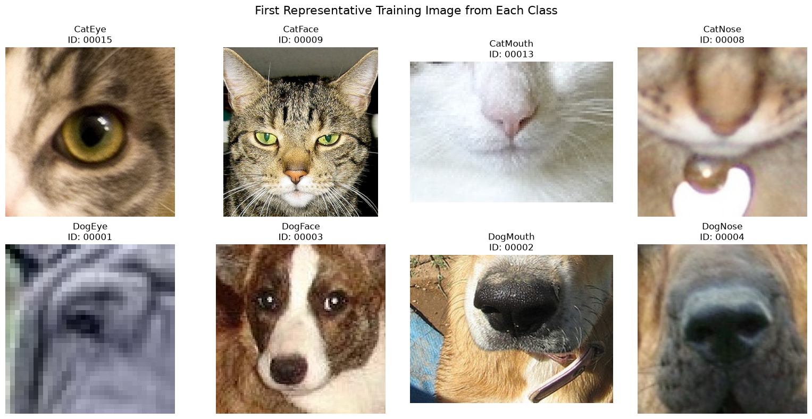

I performed both manual and code checks to inspect the images and their properties. Manual review reveals significant differences throughout image resolutions; this will be address later. With code it was also revealed that there were no corrupted images as far as I am aware (Python checked and could read every image fine), there were unfortunately duplicate images present (for example, training images 00356.jpg and 06903.jpg are exactly identical). To preserve the complete database and training files I decided it would be best to only remove the duplicates and their associated labels in the database in only local memory in each Kernel, thus I will do so by code, there are only 15 duplicates so the training integrity should remain okay. Checking blurriness in an image is a bit of a pain so I opted for a surface level manual check, I generally found most images to be not blurry but did find one image 07413.jpg to be a bit blurry, we can conclude blurriness is present but roughly not a majority nor a significant portion of the population (Please see the image below for image 07413.jpg). As for unclear class boundaries a surface level manual check was done, images looked good did not find an unclear one, cannot conclude all images are okay but automatic tests in Python is tricky.
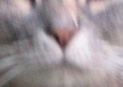
My plan is to split the training images into 80/20, 80% of the images and labels to train and 20% to test to evaluate the performance on how well it did. I may then optimize the model for accuracy as that the is Kaggle competition’s measured metric, then I will use the model on the test image set to generate a corresponding submission database to submit.

TASK 2:
To address the variance in image sizes and resolutions, I have decided to shrink or scale larger or smaller images to 128 x 128 pixels. I handled this with the transforms Resize and ToTensor functions which should be hopefully sufficient. Furthermore, Transforms also gave me the ability to implement a RandomHorizontalFlip and RandomRotation to which I set to 10 degrees and p=0.5, which should sometimes introduce more variance into the training data to better generalize the model. I specifically did this in the local memory; the original image set is untouched and is only temporary in each Kernel run.
Next, I mapped the either different string labels to integer values from 0 to 7 which logically is sufficient and would not cause errors. They are clear and distinct.
To ensure efficient data loading as we have quite a number of records and images, I used a dataloader objects with a batch size of 64 giving me 796 training batches as well as 199 validation batches after the 80/20 training split (seed of 42 to maintain reproducibility). This should keep the data loading controllable and efficient.
As for avoiding data leakage, I have tried to keep it contained and are unaware of any leakages, I will update this report if I find any.

TASK 3:
I chose to use a custom CNN architecture model for this application. I reasoned it was suitable because CNNs were designed to handle digital images in image classification which is exactly what I need. Furthermore, it handles computational resource efficiently and can be shaped to match whatever custom needs I need (cat and dog classification for example).
To briefly describe the architecture and components; I pass it the 128 x 128 pixel RGB image of what I need classified in the Input layer, the convolutional layer is next up and detects basic patterns in the image such as the colours, edges, and textures. Next it goes to the Activation ReLU function where CNN learns complex patterns of the image that couldn’t be captured with just the Convolutional layer. Next is the Pooling layer where we apply Max Pooling, basically reducing the special dimensions while keeping the important responses. Next the data is passed onto the flatten layer where it is compressed into a single value where it then goes into the Fully Connected layer where it uses the value and extracted features to make a prediction. Lastly, out comes the prediction value which we can use as the machine’s most likely guess at what exactly classification the image provided is of. The architecture is quite linear and has few components.
The output image; 8 output units on the 8 target classes as I’ve described in task 1, with ReLU as the activation and prioritizes the index with the highest output score.
As for the various settings, I chose to use a loss function that penalises the model for incorrect class predictions and to apply heavier weights to underrepresented classes as we have a class imbalance present (the weights of which I calculated and now am applying). This should encourage the model to try to improve its accuracy while addressing the class imbalance. I used an ‘Adam’ optimiser with a 0.001 learning rate, I reasoned Adam being the popular widely used starting option should be a decent pick for my application, then choose 0.001 learning rate to be a starter baseline. These choices may not be optimal and are simply my arbitrary choice.
To run the first training, I again used the 64 batch size which shouldn’t be too large nor small paired with a 10 epoch count. Again, not too little not too much I reason. Training took roughly 10 minutes on my RTX 3070 with CUDA, epoch 7 had the highest accuracy metric at 74.29% validation accuracy, to which I restored the checkpoint and will use. In theory, this pipeline should be capable of generating the Kaggle predictions I need for submission.

Task 4:
Add in previous tasks later, like fittings and numbers.
Several strategies have already been applied to help improve the generalisation of the model during training. For example, I applied data augmentation when I applied the Transforms function giving some images a slight rotation or a random horizontal flip, this helps the model train on images that aren’t ‘well-oriented’. I used a dropout of p=0.3, as well as something like best-checkpoint selection where I reloaded epoch 7 which had the best measured accuracy of all 10 epoches. These techniques should boost the generalisation of the model and help it perform more accurately when benchmarked on the test cases.
Given that the metric being measured in the Kaggle competition is accuracy, I believe I should refine my training strategy a little towards aiming for the highest accuracy I could possibly get even at the cost of the other performance metrics and measures.

Task 5:

Task 6:

Task 7:

S

