Hotel management application

By Ly Pham Gia Nghia

1. Software requirement

-Hotel need an application that can help them manage rooms and customer

2.Scope

-User can login/logout

-User can add a room ,remove a room,update room status

-User can make a reservation base on given information of customer

-User can add, delete, update a customer

-User can calculate invoice base on the number of days the customer stayed

3.Database

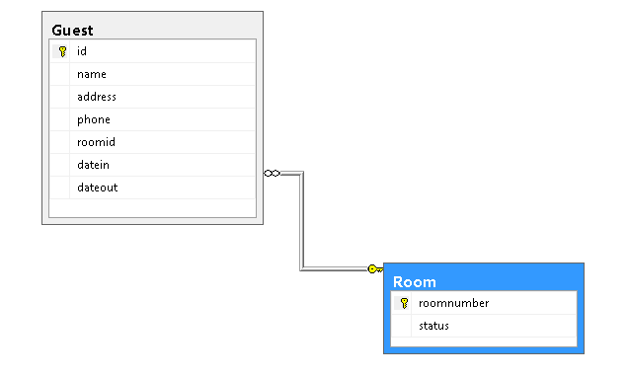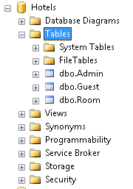

4.Usecase diagram

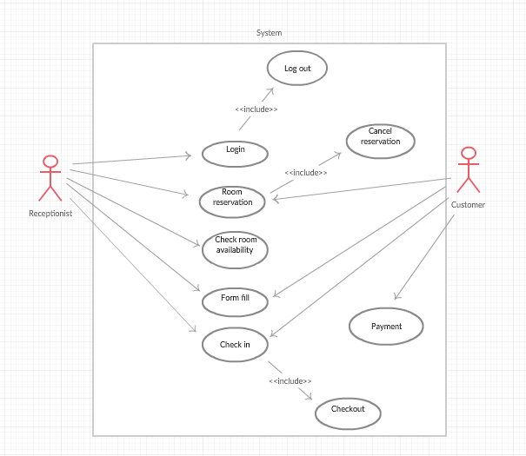

5.Software design decription

-Create this software base on 3-layers architecture

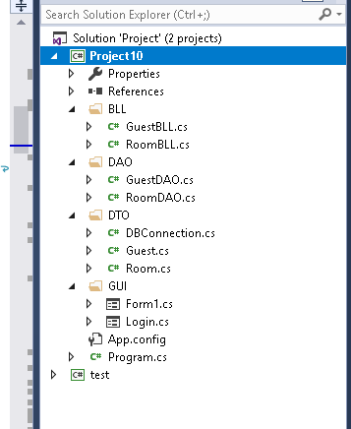

-Use ADO.NET to connect to database

-Create the login form,username and password in database

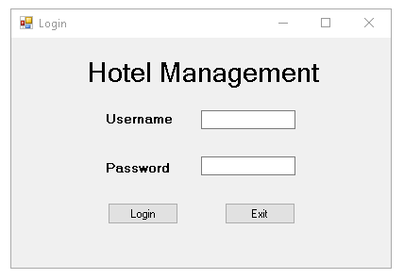

-Create the main form which contain all the method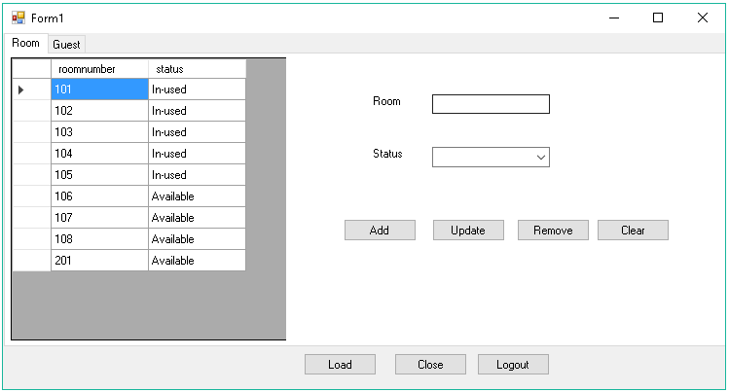

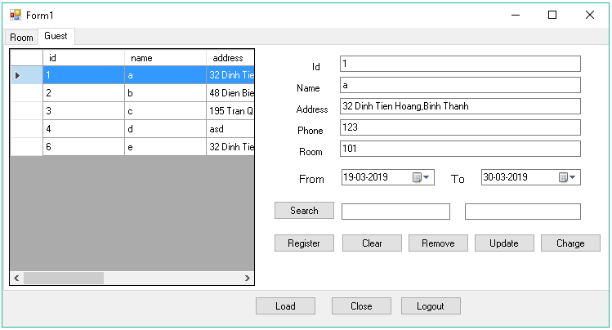

-Code the insert,delete,update,search for both Room and Guest table

-Charging the money: total days \* room money

6.Validation

-Room number is an Int

-There are two room status: “Available” and “In-used” that can be updated

-Room number cannot be updated (primary key)

-User cannot delete an room that is used

-User cannot enter a room number that is already exist

-Room id is mapping to Room number (foreign key)

-Which cannot be added if it dont exist in the Room table

-Room id cannot be updated

-Id cannot be updated (primary key) and its must be an Int.Also phone number is an Int

-User cannot added a duplicated id or roomid

-Search a room base on id

-