COCSHOP MANAGEMENT SYSTEM
Software Requirement Specification

Project Code: CSMS
Document Code: CSMS_SRS – v1.0

Ho Chi Minh City – 2/2015

Record of change
*A - Added M - Modified D - Deleted
Effective Date | Changed Items | A*  M, D | Change Description | New Version

SIGNATURE PAGE

ORIGINATOR: <Name> <Date>
<Position>Student

REVIEWERS: <Name> <Date>
<Position>

<Name, if it’s needed> <Date>
<Position>

APPROVAL: <Name> <Date>
<Position>
TABLE OF CONTENTS
1 Introduction 7
1.1 Purpose 7
1.2 Scope 7
1.3 Definitions, Acronyms, and Abbreviations 7
1.4 References 8
1.5 Overview 8
2 Overall Description 9
2.1 System Overview 9
2.2 System Diagram 11
2.3 Context Diagram 11
2.4 User Characteristics 11
2.5 Principal Actors 11
2.6 Constraints 11
2.7 Assumptions and Dependencies 12
2.8 Requirement and Subset 12
3 FUNCTIONAL Requirements 13
3.1 User Requirement Specification 13
3.2 System Requirement Specification 14
3.3 <Use Cases Diagram for each actor> 17
4 NON-FUNCTIONAL Requirements 19
4.1 Usability 19
4.2 Reliability 19
4.3 Performance 19
4.4 Supportability 19
4.5 Design Constraints 20
4.6 On-line User Documentation and Help System Requirements 20
4.7 Purchased Components 20
4.8 Interfaces 20
4.9 Licensing Requirements 20
4.10 Legal, Copyright, and Other Notices 20
4.11 Applicable Standards 21
5 Supporting Information 22

Introduction

Purpose
- This document describes functional and non-functional requirement, constraints, and other factors necessary to provide a complete and comprehensive description of the requirements for the software.
- This system is intended to create new way of order product from CocShop by using webpage or mobile to order product online. This system is also help CocShop manage their staff, inventory, finance.
- It is intended for use by:
- The Admin can Manage user’s Account.
- The Manager can Manage Product and View Report.
- The Salesperson can Manage Online Orders and Record Offline Orders which sold directly at store.
- The Guest can Search Product, View details Product’s information, Order and Cancel Orders.
- Factors which should be taken into account in specifying and designing this system are:
N/A

Scope
- This document describes the requirements of CocShop Management System which will support CocShop can get orders from customers directly at store or via using mobile device and web application. This system also can support CocShop manage staff and export report.
- The system is used by types of user as Guest and Authenticated User:
- Guest
- Authenticated User: Admin, Manager, Salesperson
- The system should be used the network as internet’s bandwidth 2Mbs.

Definitions, Acronyms, and Abbreviations
Terms | Definitions
- CSMS | - CocShop Management System
- Admin | - Administrator

References
- Fsoft SRS templates.

Overview
- Section 2: gives an overall description of the software. It gives what level of proficiency is expected of the user, some general constraints while making the software and some assumptions and dependencies that are assumed.
- Section 3: gives specific requirements which the software is expected to deliver. Functional requirements are given by various use cases.
- Section 4: gives non-functional requirements some performance requirements and design constraints are also given.
- Finally in Section 5, describe to supporting information about system.

Overall Description

System Overview
- This document describes the requirements of CocShop Management System which will support CocShop can get orders from customers directly at store or via using mobile device and web application. This system also can support CocShop manage staff and export report.
- The system is used by types of user as Guest and Authenticated User:
- Guest
- Authenticated User: Admin, Manager, Salesperson
- After the software is executed. The software allow the users login to use their role or use this system as Guest
- With Guest, the Guest can Search Product, View details Product’s information, Order Product, Cancel Orders and Login to be a Authenticated User.
- With Admin, the Admin can Manage Account via Create Account, Activate/Deactivate Account, Update Account. The Admin also can View Report and Configure System
- With Manager, the Manager can Manage Product via Create Product, View Product’s Details, Activate/Deactivate Product, Update Product, Import Product. The Manage also can View Report about inventory, finance and Manage Staff.
- With Salesperson, the Salesperson can Manage Online Orders via Accept Orders, Deny Orders, Confirm Delivery. The Salesperson also can Record Offline Orders.
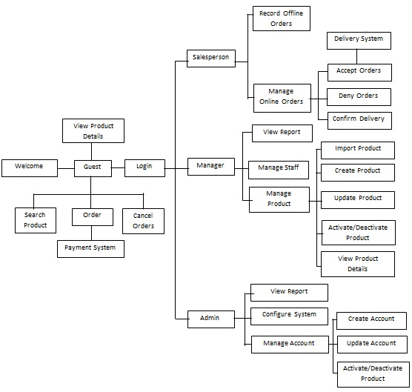

System Diagram
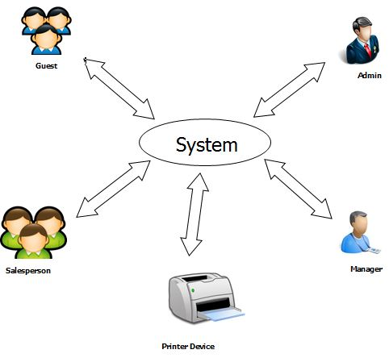

Context Diagram
N/A

User Characteristics
N/A

Principal Actors
N/A

Constraints
N/A

Assumptions and Dependencies
N/A

Requirement and Subset
N/A

FUNCTIONAL Requirements

User Requirement Specification

Guest Requirement
Guest is a person who doesn’t login to the system. Guest can do functions:
- Login
- Search Product
- View Product Details
- Order
- Cancel Order

3.1.2 Admin Requirement
Admin is a boss of CocShop. Admin has an account and after login successful, Admin can do functions:
- Manage Account
- Create Account
- Activate/Deactivate Account
- Update Account
- View Report
- Configure System

3.1.3 Manager Requirement
Manager is an employee of CocShop. Manager has an account which is allocated by Admin. After login successful, Manager can do functions:
- Manage Product
- Create Product
- Search Product
- View Product Details
- Activate/Deactivate Product
- Update Product
- Import Product
- View Report
- Manage Staff

3.1.4 Salesperson
Salesperson is an employee of CocShop. Salesperson is an account which is allocated by Admin. After login successful, Salesperson can do functions:
- Manage Online Orders
- Accept Orders
- Deny Orders
- Confirm Delivery
- Record Offline Orders

System Requirement Specification

3.2.1 External Interface Requirements

User Interface
- The interface of website and android application is clear, easy for user to use.
- The error, warning messages must be clear, easy to understand.

Hardware Interfaces
- Android:
- Run OS 4.0 or higher.
- Ram 512Mb or higher.
- Connect to internet.
- Webserver:
- Processor: Core i3 2.2Ghz or higher
- Ram 2048Mb or higher.
- Connect to internet, minium speed 4Mbs
- Client:
- Processor: Pentium Core2Duo 1.73Ghz or higher
- Ram 1048Mb or higher.
- Connect to internet, minium speed 2Mbs

Software Interface
- Webserver:
- Run OS Windows Server 2008 or higher
- Browser: Internet Explorer 7 or higher
- Database: SQL Server 2008
- Software
- Client:
- Run OS Windows XP or higher
- Browser: IE, Firefox, Chrome
- Database: SQL Server 2008

Communication Protocol
- Android: Communication between server system and tablet should be maintained using SOAP protocol
- Website: Communication between server system and client should be maintained using HTTP protocol

3.2.2 System Feature
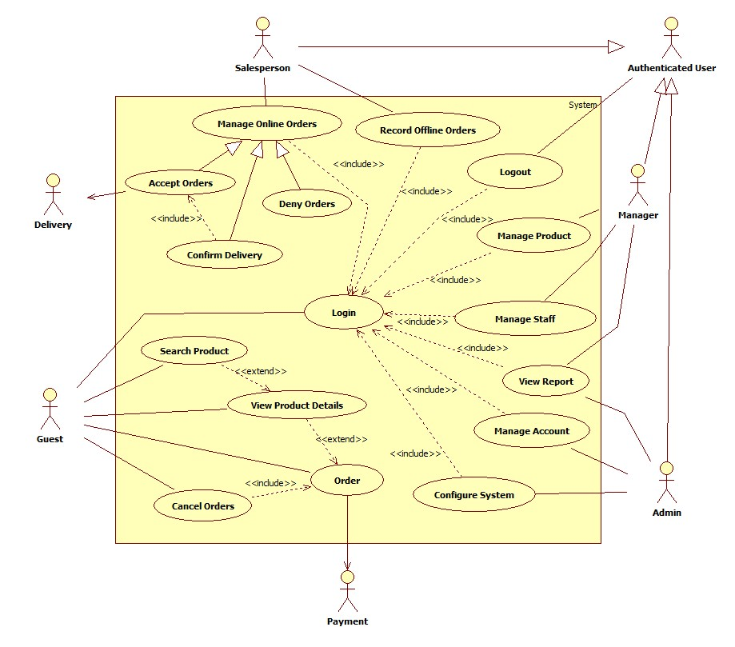

<Use Cases Diagram for each actor>

3.3.1 <Guest> Overview Use Case
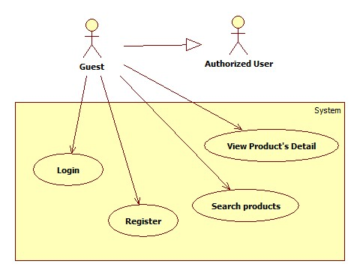

View Product’s Detail
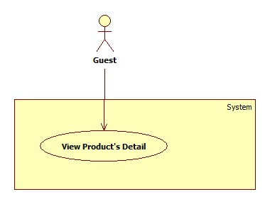

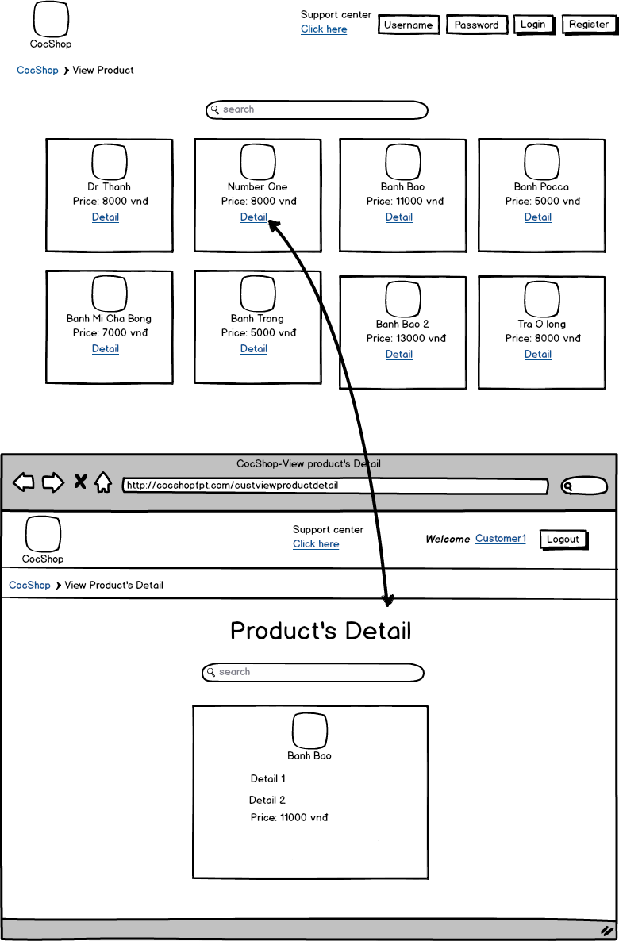

USE CASE – View Product’s Detail
Use Case No. | UC001 | Use Case Version | 1.0
Use Case Name | View Product’s Detail
Author | Võ Quang Chánh
Date | 3/3/2015 | Priority | Normal
Actor: Guest
Summary: View Product’s Detail
Goal:
View detail of product
Triggers:
- The actor click button link “Detail” on particular product
Pre-conditions: The actor access web page “http:/cocshopfpt.com”

Post-conditions:
Main Success Scenario:
Step | Actor Action | System Response
1 | - The actor click button link “Detail” on particular product | - Display product’s detail page

Relationships: View product’s detail
Business Rules:

Search Product
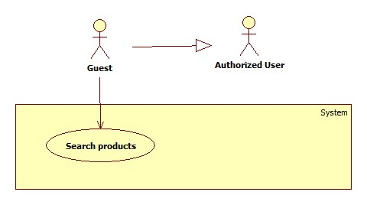
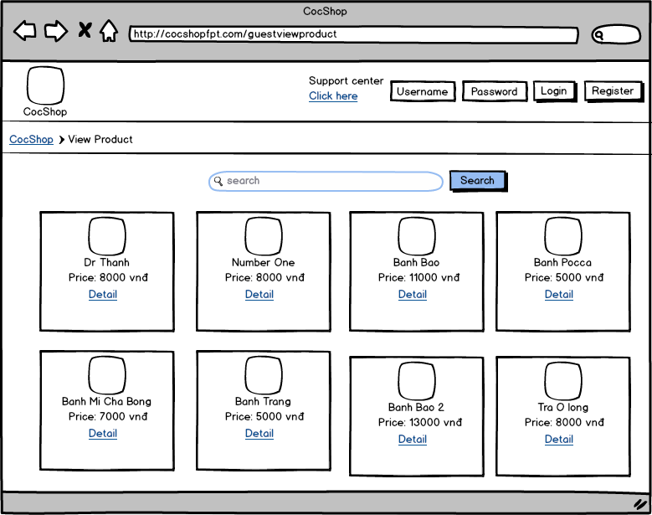

USE CASE – Search Product
Use Case No. | UC001 | Use Case Version | 1.0
Use Case Name | Search Product
Author | Võ Quang Chánh
Date | 3/3/2015 | Priority | Normal
Actor: Guest
Summary: Search Product
Goal:
Search products
Triggers:
- The actor fill keyword in search text field
- The actor click button “Search”

Pre-conditions: The actor access web page “http:/cocshopfpt.com”

Post-conditions:

Main Success Scenario:
Step | Actor Action | System Response
1 | - The actor fill keyword in search text field | - Get information
2 | - The actor click button “Search” | - Display result that actor required  [Exception 1]

Exception:
[Exception 1]
No | Condition | System Response
1 | -Keyword is blank or results are not thing | - Display all product that CosShop sales as default

Relationships: Search product
Business Rules:

Register
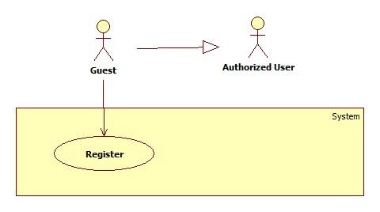
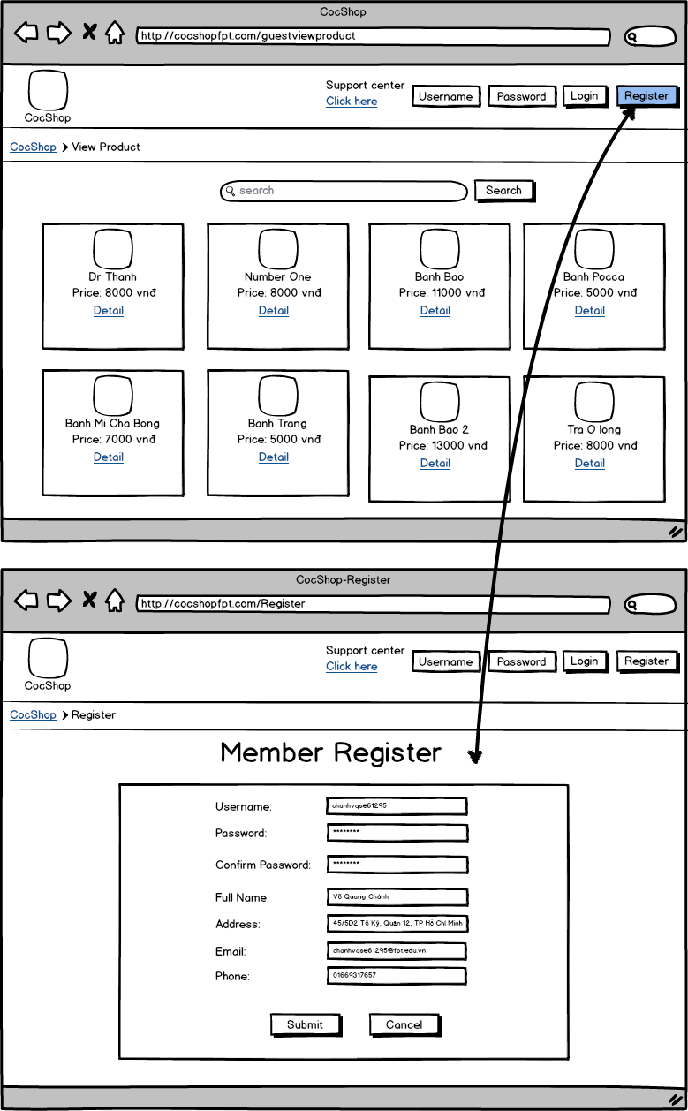

USE CASE – Register
Use Case No. | UC001 | Use Case Version | 1.0
Use Case Name | Register
Author | Võ Quang Chánh
Date | 3/3/2015 | Priority | Normal
Actor: Guest
Summary: Register
Goal:
Guest register account for become an customer
Triggers:
- The actor fill new member information
- The actor click button “submit”

- Pre-conditions: The actor access web page “http:/cocshopfpt.com” and the actor click on button “Register”

Post-conditions:

Main Success Scenario:
Step | Actor Action | System Response
1 | -The actor fill information for register to become new customer | - Get information
2 | -The actor click on button “submit”  [Alternative 1] | - Create new account for customer  [Exception 1]

Alternative Scenario:
No | Condition | System Response
1 | [Alternative 1]  -If actor click on button “Cancel” | - Clear all value information field  - Go back home page

Exception:

No | Condition | System Response
1 | -If information input is not correct | - Show messages “Your information is not correct. Please try again”.  - Required actor input information again

Relationships: Register
Business Rules:

Login
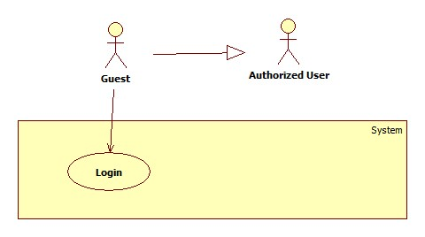
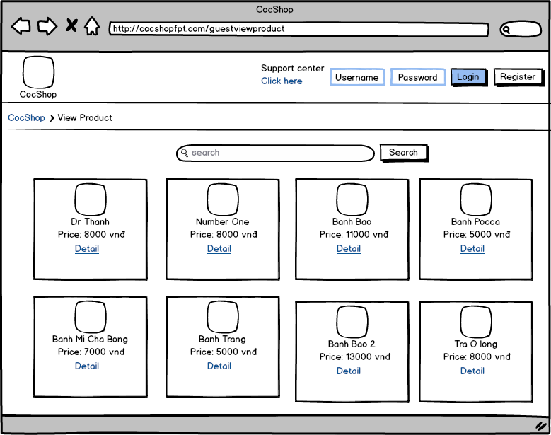

USE CASE – Login
Use Case No. | UC001 | Use Case Version | 1.0
Use Case Name | Login
Author | Võ Quang Chánh
Date | 3/3/2015 | Priority | Normal
Actor: Guest
Summary: Login
Goal:
Guest login into system as their role
Triggers:
- The actor fill username and password in username text field and password text field
- The actor click button “Login”
Pre-conditions: The actor access web page “http:/cocshopfpt.com”

Post-conditions:

Main Success Scenario:
Step | Actor Action | System Response
1 | - The actor fill username and password in username | - Get information
2 | -The actor click button “Login” | - Allow guest login into system as their role  [Exception 1]

Exception:
[Exception 1]
No | Condition | System Response
1 | -If username and password is not correct | - Show messages “Username or password is not correct. Please try again!”  - Required actor input Username and Password again

Relationships: Login
Business Rules:

3.3.2 <Customer> Overview Use Case

Search Product
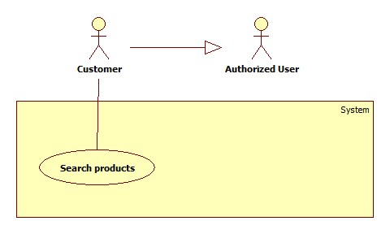
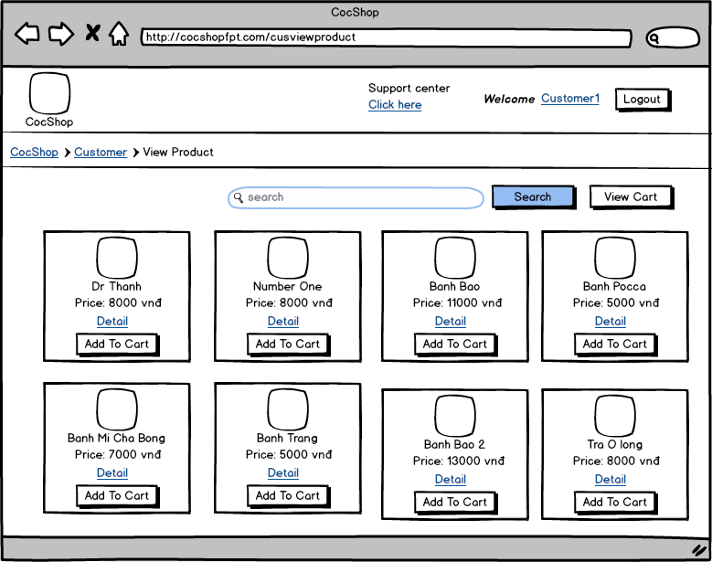

USE CASE – Search Product
Use Case No. | UC001 | Use Case Version | 1.0
Use Case Name | Search Product
Author | Võ Quang Chánh
Date | 3/3/2015 | Priority | Normal
Actor: Customer
Summary: Search Product
Goal:
Search products
Triggers:
- The actor fill keyword in search text field
- The actor click button “Search”

Pre-conditions: User must be login system with role is a Customer

Post-conditions:

Main Success Scenario:
Step | Actor Action | System Response
1 | - The actor fill keyword in search text field | - Get information
2 | - The actor click button “Search” | - Display result that actor required  [Exception 1]

Exception:
No | Condition | System Response
1 | -Keyword is blank or results are not thing | - Display all product that CosShop sales as default

Relationships: Search Products
Business Rules:

View Product’s Detail
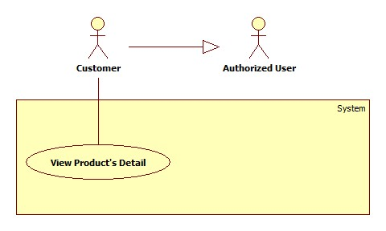

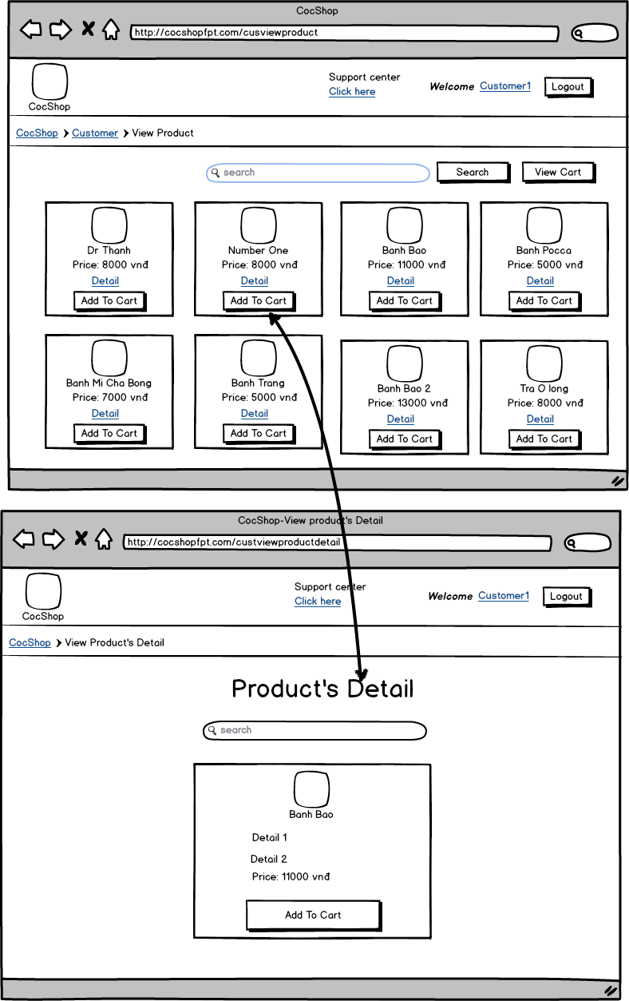

USE CASE – View Product’s Detail
Use Case No. | UC001 | Use Case Version | 1.0
Use Case Name | View Product’s Detail
Author | Võ Quang Chánh
Date | 3/3/2015 | Priority | Normal
Actor: Customer
Summary: View Product’s Detail
Goal:
View product’s detail information
Triggers:
- The actor click button link “Detail” on particular product

Pre-conditions: User must be login system with role is a Customer

Post-conditions:

Main Success Scenario:
Step | Actor Action | System Response
1 | - The actor click button link “Detail” on particular product | - Display product’s detail page

Relationships: View product’s detail
Business Rules:

Order
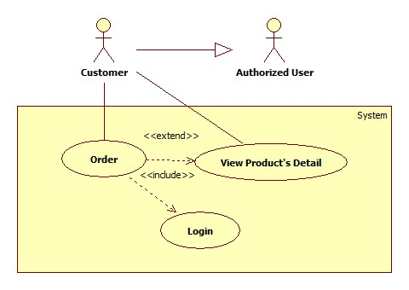

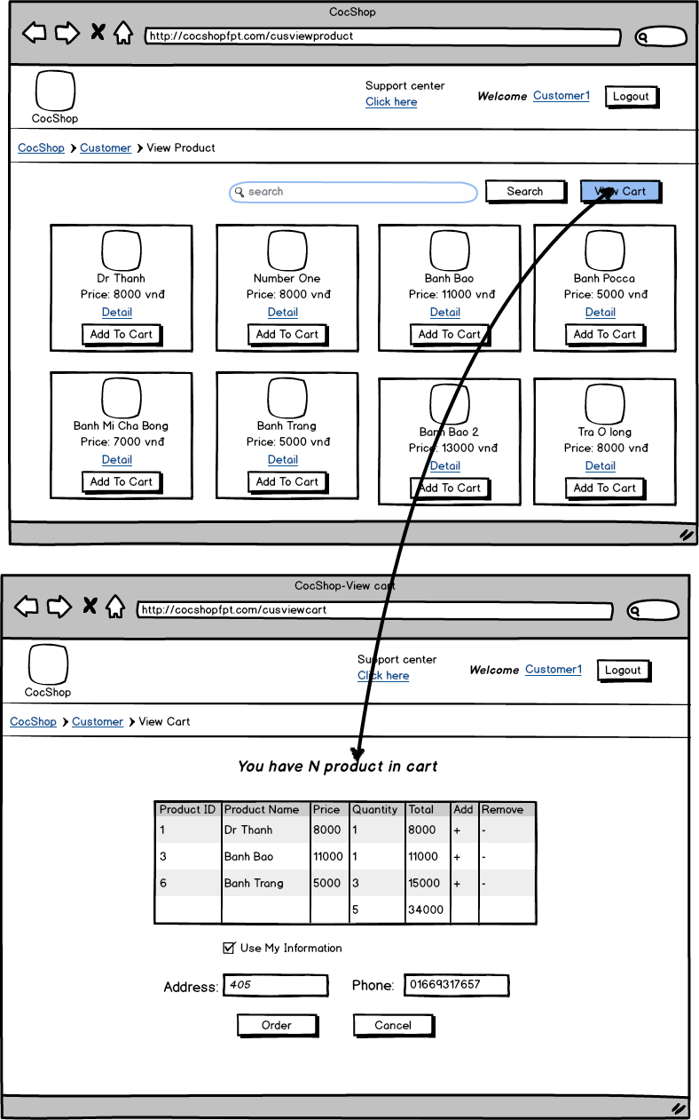
USE CASE – Order
Use Case No. | UC007 | Use Case Version | 1.0
Use Case Name | Order
Author | Võ Quang Chánh
Date | 3/3/2015 | Priority | Normal
Actor: Customer
Summary: Customer order for buy products
Goal:
Customer order products
Triggers:
- The actor add to cart more than one product
- The actor click button “View Cart”
- The actor click button “Order”
Pre-conditions: User must be login system with role is a Customer

Post-conditions:

Main Success Scenario:
Step | Actor Action | System Response
1 | -The actor add to cart more than one product | - Create cart for actor
2 | -The actor click on button “View Cart” | - Display View Cart page
3 | -The actor fill information  [Alternative 1]
4 | -The actor click on button “Order”  [Alternative 2] | - Add new order into list order waiting for salesperson accept  [Exception 1]

Alternative Scenario:

No | Condition | System Response
1 | [Alternative 2]  -If actor click check box “Use My Information” | - Auto fill address and phone as actor’s profile
2 | [Alternative 2]  -If actor click button “Cancel” | - Clear actor cart

Exception:

No | Condition | System Response
1 | -If information input is not correct | - Show message “Incorrect information. Please try again!”  - Required actor fill information again

Relationships: Update Import’s Detail
Business Rules:

Cancel Orders
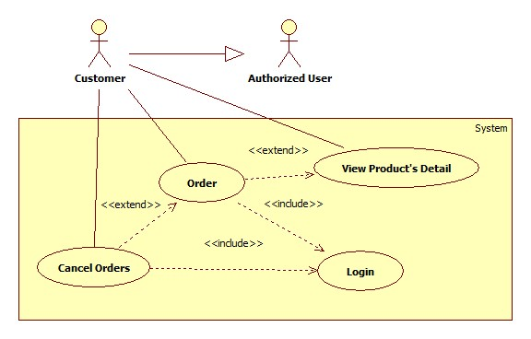
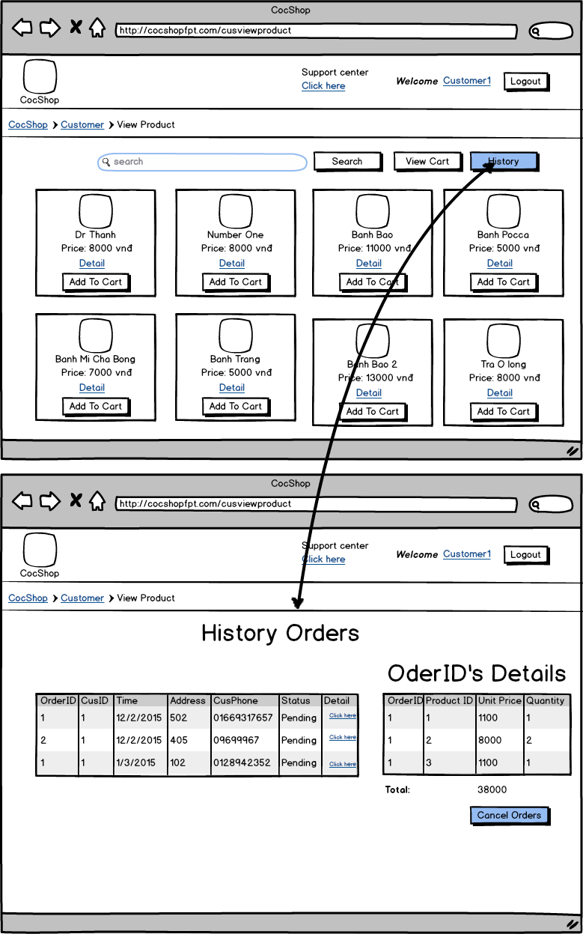
USE CASE – Cancel Orders
Use Case No. | UC007 | Use Case Version | 1.0
Use Case Name | Cancel Order
Author | Võ Quang Chánh
Date | 3/3/2015 | Priority | Normal
Actor: Customer
Summary: Cancel orders
Goal:
Cancel orders
Triggers:
- The actor click button “History”
- The actor click button link “Click here” on Detail column of list of order table
- The actor click button “Cancel Orders”
Pre-conditions: User must be login system with role is a Customer

Post-conditions:

Main Success Scenario:
Step | Actor Action | System Response
1 | -The actor click button “History” | - Display History Orders page
2 | -The actor click button link “Click here” on Detail column of list of order table | - Display this order’s detail and button “Cancel Orders”
3 | -The actor click button “Cancel Orders” | Show confirm dialog “Are you sure?”
4 | -The actor click button “Yes”  [Alternative 1] | - Cancel this orders  [Exception 1]

Alternative Scenario:

No | Condition | System Response
1 | [Alternative 1]  -If actor click button “Cancel” | - Confirm dialog disappear

Exception:
[Exception 1]
No | Condition | System Response
1 | -If this order’s status became “Delivering” | - Show messages “You can’t cancel this orders because it’s on delivering process.”

Relationships: Update Import’s Detail
Business Rules:

Edit Profile
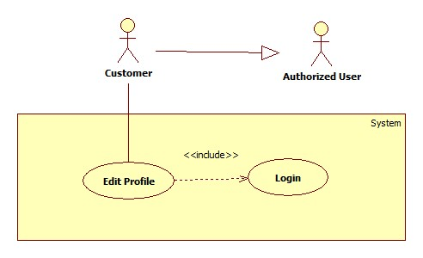
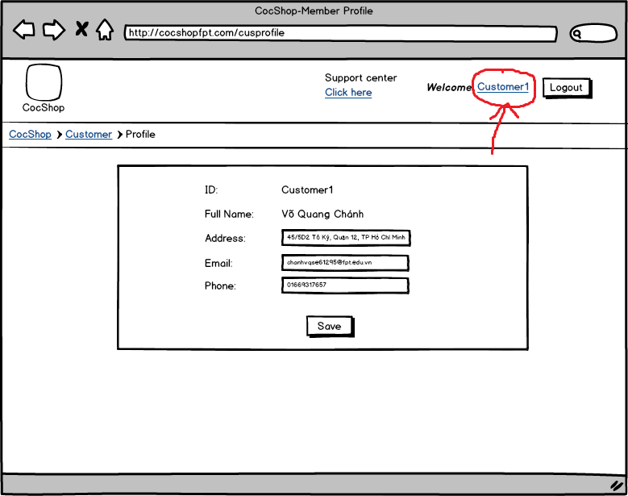

USE CASE – Edit Profile
Use Case No. | UC007 | Use Case Version | 1.0
Use Case Name | Edit Profile
Author | Võ Quang Chánh
Date | 3/3/2015 | Priority | Normal
Actor: Customer
Summary: Edit Profile
Goal:
Customer edit profile
Triggers:
- The actor click customer’s username button link on left of button “Logout”
- The actor change their information
- The actor click button “Save”
Pre-conditions: User must be login system with role is a Customer

Post-conditions:

Main Success Scenario:
Step | Actor Action | System Response
1 | - The actor click customer’s username button link on left of button “Logout” | - Display Customer’s Profile page
2 | - The actor change their information | - Add new order into list order waiting for salesperson accept  [Exception 1]
3 | -The actor click button “Save” | - Show confirm dialog “Are you sure?”
4 | -The actor click on button “YES”  [Alternative 1] | - Update customer’s profile  [Exception 1]

Alternative Scenario:

No | Condition | System Response
1 | [Alternative 1]  -Actor lick button “NO” | - Confirm dialog disappear

Exception:

No | Condition | System Response
1 | -If information input is not correct | - Show message “Incorrect information. Please try again!”  - Required actor fill information again

Relationships: Update Import’s Detail
Business Rules:

Logout

3.3.3 <Admin> Overview Use Case

Add Role
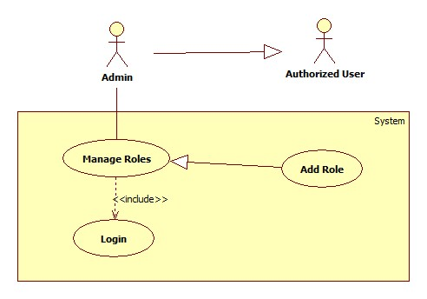
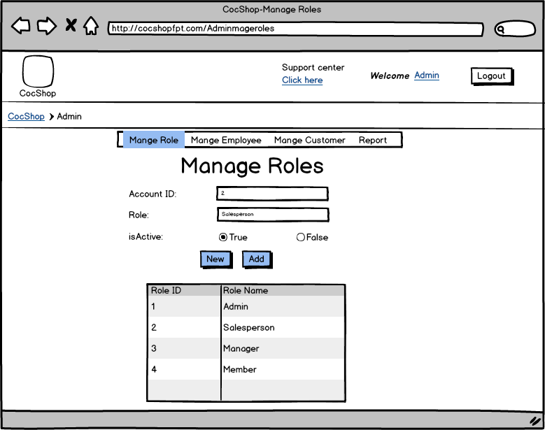

USE CASE – Add Role
Use Case No. | UC0012 | Use Case Version | 1.0
Use Case Name | Add Role
Author | Võ Quang Chánh
Date | 3/3/2015 | Priority | Normal
Actor: Admin
Summary: Add Role
Goal:
Add new role
Triggers:
- The actor fill value information about new role
- The actor click button “Add”
Pre-conditions: User must be access Mange Role page with role is a Admin

Post-conditions:
Main Success Scenario:
Step | Actor Action | System Response
1 | -The actor fill value information about new role
2 | -Click button “Add”  [Alternative 1] | - Add new Role  [Exception 1]

Alternative Scenario:

No | Condition | System Response
1 | [Alternative 1]  -Actor click button “New” | - Clear all role’s information value field

Exception:
[Exception 1]
No | Condition | System Response
1 | -If information is not correct | - Show message “Incorrect information. Please try again!”  - Required actor fill information again

Relationships: Add new role
Business Rules:

Update Role
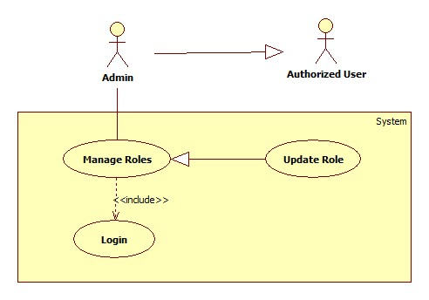
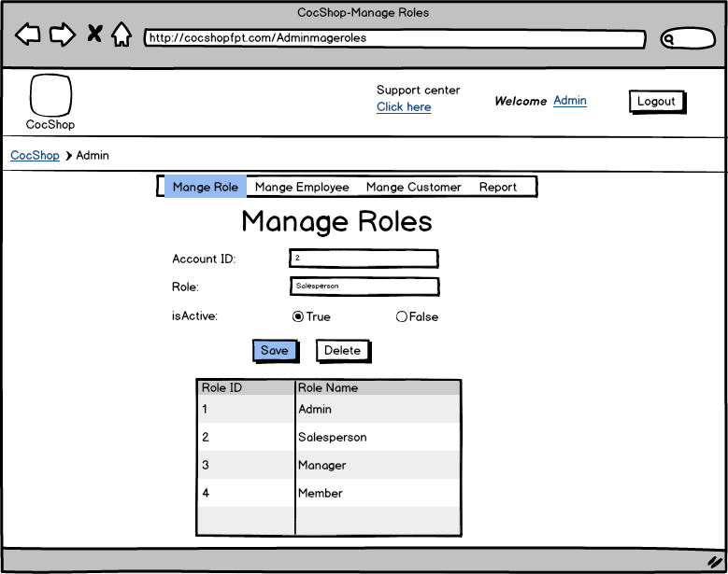

USE CASE – Update Role
Use Case No. | UC014 | Use Case Version | 1.0
Use Case Name | Update Role
Author | Võ Quang Chánh
Date | 3/3/2015 | Priority | Normal
Actor: Admin
Summary: Update Role
Goal:
Update Role’s information
Triggers:
- The actor select Role which actor want to update in Role table
- The actor change Category’s information
- The actor click button “Save”
Pre-conditions: User must be access Manage Role page with role is a Admin

Post-conditions:
Main Success Scenario:
Step | Actor Action | System Response
1 | -Select role form role’s table | - Display Role’s information that actor selected  - Display two button “Save” and “Delete”, hide button “Add”
2 | -Change role’s information
3 | -Click button “Save” | - Show confirm dialog “Are you sure?”
4 | -Click button “YES”  [Alternative 1] | - Update new information of Role which actor selected to changed  - Hide two button “Save” and “Delete”, display button “Add”  [Exception 1]

Alternative Scenario:

No | Condition | System Response
1 | [Alternative 1]  -If actor click button “NO” | - Confirm dialog disappear

Exception:

No | Condition | System Response
1 | -If information input is not correct | - Show message “Input information is not correct. Please try again!”  - Required actor input information again

Relationships: Update Role’s information
Business Rules:

Delete Role
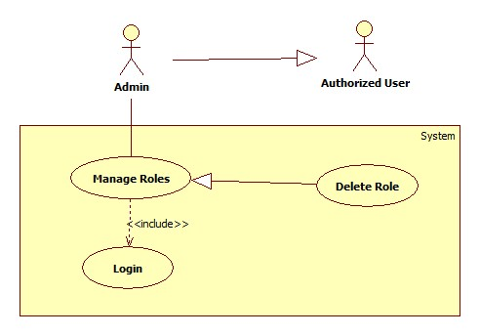
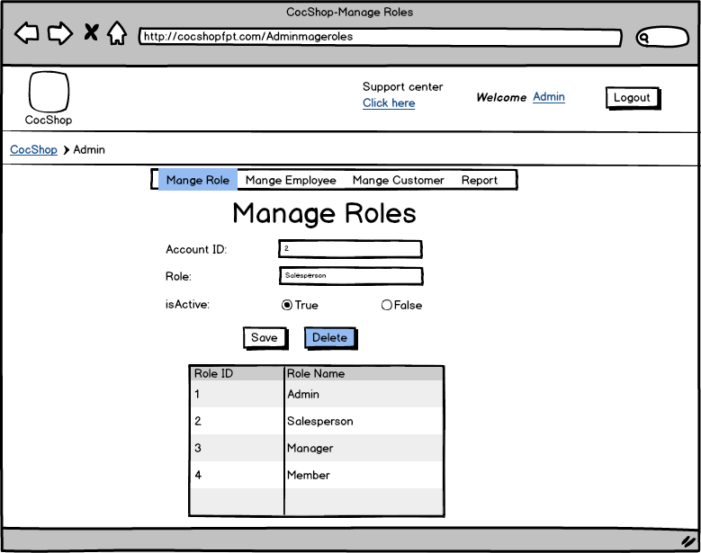

USE CASE – Delete Role
Use Case No. | UC015 | Use Case Version | 1.0
Use Case Name | Delete Role
Author | Võ Quang Chánh
Date | 3/3/2015 | Priority | Normal
Actor: Manager
Summary: Delete Role
Goal:
Delete Role
Triggers:
- The actor select role which actor want to delete in role table
- The actor click button “Delete”
Pre-conditions: User must be access Manage Role page with role is a Admin

Post-conditions:

Main Success Scenario:
Step | Actor Action | System Response
1 | -Select role form role’s table | - Display role’s information that actor selected  - Display two button “Save” and “Delete”, hide button “Add”
2 | -Click on button “Delete” | - Show confirm dialog “Are you sure?”
3 | -Click button “YES”  [Alternative 1] | - Delete role that actor selected  - Hide two button “Save” and “Delete”, display button “Add”  - Clear all value information field  [Exception 1]

Alternative Scenario:
[Alternative 1]
No | Condition | System Response
1 | [Alternative 1]  -If actor click button “NO” | - Confirm dialog disappear

Exception:
[Exception 1]
No | Condition | System Response
1 | -If this role still handle by another user | - Show message “Can’t now delete this role because it’s still handle by User

Relationships: Delete Role
Business Rules: Don’t allow delete role when it’s still handle by another user

Add Employee
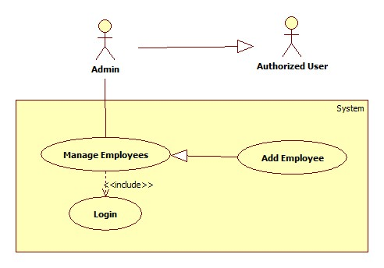

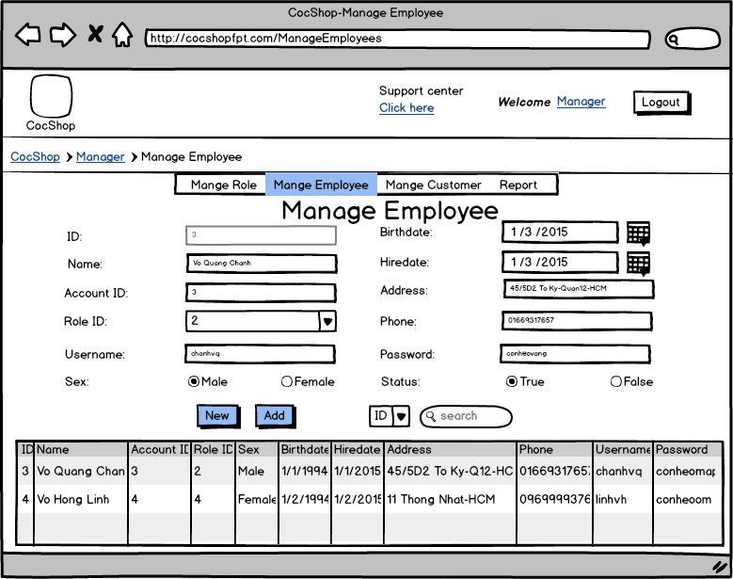

USE CASE – Add Employee
Use Case No. | UC009 | Use Case Version | 1.0
Use Case Name | Add Employee
Author | Võ Quang Chánh
Date | 3/3/2015 | Priority | Normal
Actor: Admin
Summary: Add Employee
Goal:
Add Employee
Triggers:
- The actor fill value information about new employee
- The actor click button “Add”
Pre-conditions: User must be access Manage Employee page with role Admin

Post-conditions:
Main Success Scenario:
Step | Actor Action | System Response
1 | -The actor fill value information about new Employee
2 | -Click button “Add”  [Alternative 1] | - Add new employee  [Exception 1]

Alternative Scenario:
[Alternative 1]
No | Condition | System Response
1 | -Actor lick button “New” | - Clear all value information field

Exception:
[Exception 1]
No | Condition | System Response
1 | -If information is not correct | - Show message “Incorrect information. Please try again!”  - Required actor fill information again

Relationships: Add new employee
Business Rules:

Search Employee

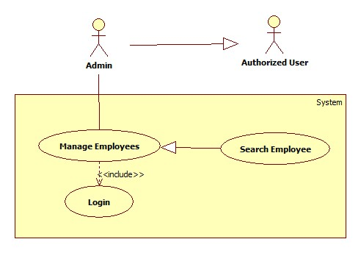
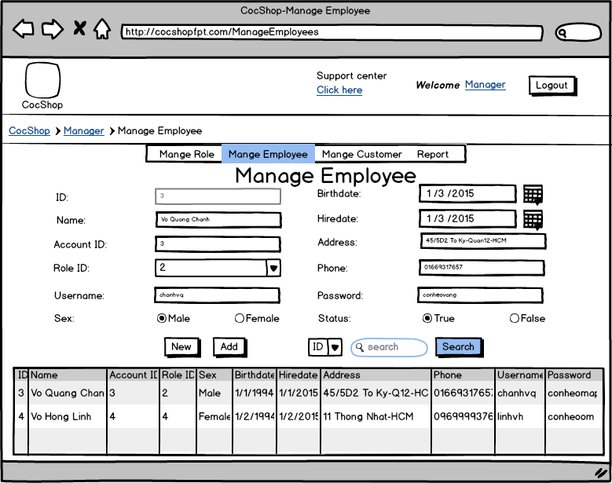

USE CASE – Search Employee
Use Case No. | UC010 | Use Case Version | 1.0
Use Case Name | Search Employee
Author | Võ Quang Chánh
Date | 3/3/2015 | Priority | Normal
Actor: Admin
Summary: Search Employee
Goal:
Search Employee
Triggers:
- The actor selected type of keyword for search
- The actor fill keyword in search text field
- The actor click button “Search”
Pre-conditions: User must be access Manage Employee page with role is a Admin

Post-conditions:
Main Success Scenario:
Step | Actor Action | System Response
2 | - The actor selected type of keyword for search and fill keyword in search text field
3 | -Click button “Search” | - Display result that actor required  [Exception 1]

Exception:
No | Condition | System Response
1 | -Keyword is blank or results are not thing | - Display all employees as default

Relationships: Search Employee
Business Rules:

Update Employee
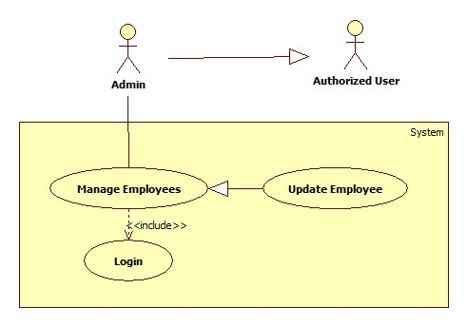
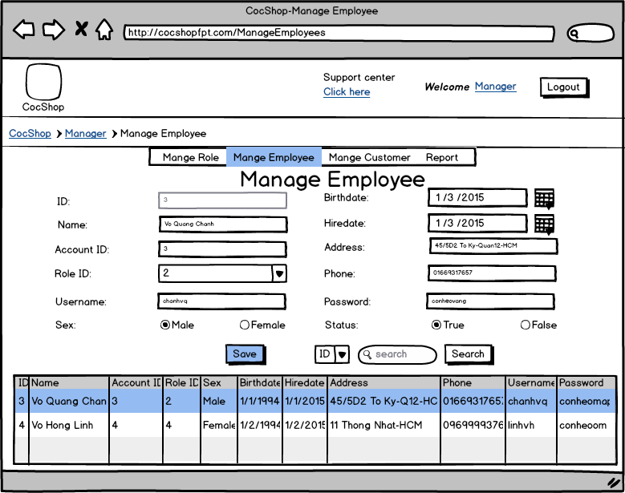
USE CASE – Update Employee
Use Case No. | UC0011 | Use Case Version | 1.0
Use Case Name | Update Employee
Author | Võ Quang Chánh
Date | 3/3/2015 | Priority | Normal
Actor: Admin
Summary: Update Employee
Goal:
Update Employee
Triggers:
- The actor selected employee form employee table
- The actor change information of product
- The actor click button “Save”
Pre-conditions: User must be access Mange Employee page with role is a Admin

Post-conditions:

Main Success Scenario:
Step | Actor Action | System Response
1 | -The actor selected employee form product table | - Display employee’s information that actor selected  - Display button “Save” , hide button “Add”
2 | -The actor change employee’s information
3 | -Click button “Save” | - Show confirm dialog “Are you sure?”
4 | -Actor click button “YES”  [Alternative 1] | - Update employee  - Hide button “Save” , Display button “Add”  - Clear all value information field  [Exception 1]

Alternative Scenario:

No | Condition | System Response
1 | [Alternative 1]  -actor click button “NO” | - Confirm dialog disappear

Exception:

No | Condition | System Response
1 | -If information is not correct | - Show message “Incorrect information. Please try again!”  - Required actor fill information again

Relationships: Update Product
Business Rules:

3.3.4 <Manager> Overview Use Case

Add Import
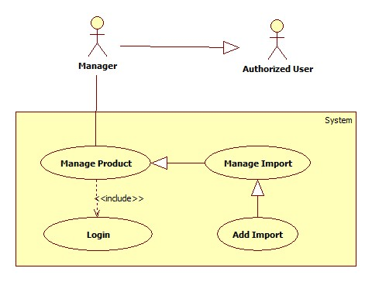

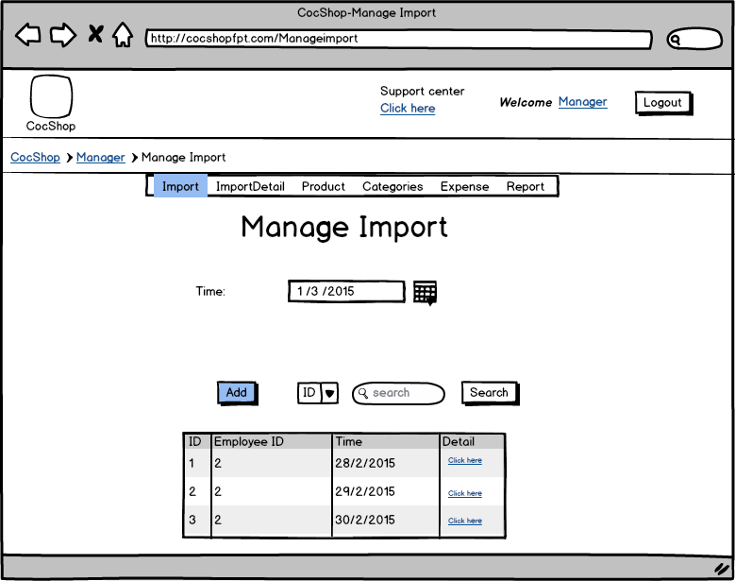

USE CASE – Add Import
Use Case No. | UC001 | Use Case Version | 1.0
Use Case Name | Add Import
Author | Võ Quang Chánh
Date | 3/3/2015 | Priority | Normal
Actor: Manager
Summary: Create Import
Goal:
Add new Import for import product into inventory
Triggers:
- The actor set time of import
- The actor click button “Add”
Pre-conditions: User must be access Import page with role is a Manager

Post-conditions:
Main Success Scenario:
Step | Actor Action | System Response
1 | -Complete set time of new import
2 | -Click button “Add” | - Redirect to Import’s Detail

Relationships: Add new Import
Business Rules:

Search Import
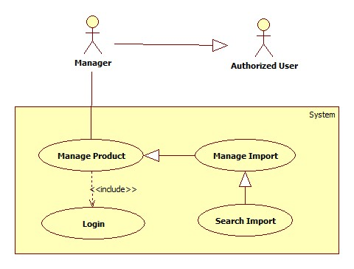

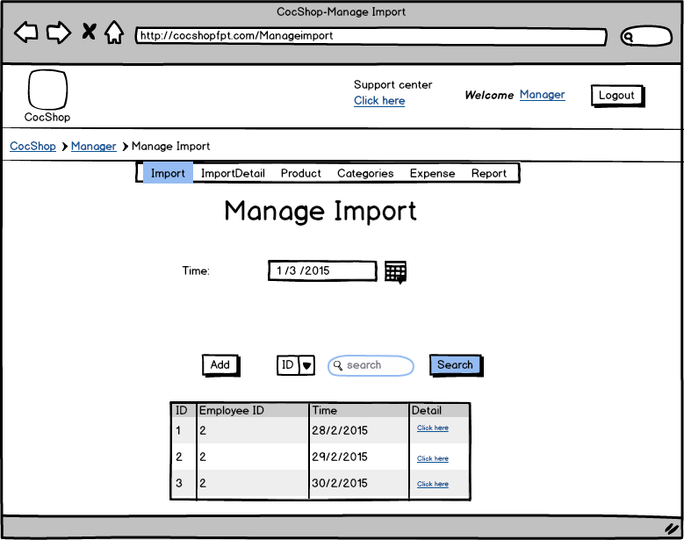

USE CASE – Search Import
Use Case No. | UC002 | Use Case Version | 1.0
Use Case Name | Search Import
Author | Võ Quang Chánh
Date | 3/3/2015 | Priority | Normal
Actor: Manager
Summary: Search Import
Goal:
Search particular Import
Triggers:
- The actor set type of search in Type Dropdown List
- The actor fill keyword in Search text field
- The actor click button “Search”
Pre-conditions: User must be access Manage Import page with role is a Manager

Post-conditions:
Main Success Scenario:
Step | Actor Action | System Response
1 | -Complete set type of search keyword and fill keyword in Search text field
2 | -Click button “Search” | - Display result that actor request  - [Exception 1]

Exception:
No | Condition | System Response
1 | -Keyword is blank or results are not thing | - Display all as Import as default

Relationships: Search Import
Business Rules: List of import must be in order

Update Import
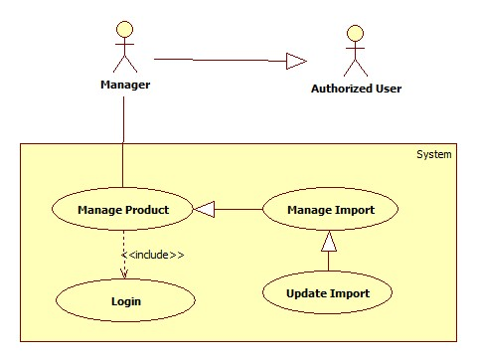

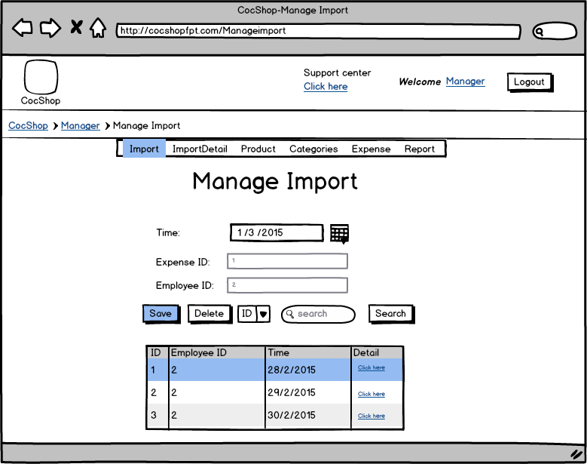

USE CASE – Update Import
Use Case No. | UC003 | Use Case Version | 1.0
Use Case Name | Update Import
Author | Võ Quang Chánh
Date | 3/3/2015 | Priority | Normal
Actor: Manager
Summary: Update Import
Goal:
Update Import’s information
Triggers: The actor select import which actor want to update in imports table
- The actor change import’s information
- The actor click button “Save”
Pre-conditions: User must be Manage Import page with role is a Manager

Post-conditions:
Main Success Scenario:
Step | Actor Action | System Response
1 | -Select import form import’s table | - Display import’s information that actor selected  - Display two button “Save” and “Delete”  - Hide button “Add”
2 | -Change import’s information | - Get information
3 | -Click button “Save”  [Alternative 1,2] | - Show confirm dialog “Are you sure?”

Alternative Scenario:
[Alternative 1]
No | Condition | System Response
1 | -If actor click button “OK” | - Update new information of import which actor selected to changed  - Hide two button “Save” and “Delete”  - Display button “Add”  - Clear all value information field  [Exception 1]
2 | -If actor click button “NO” | - Confirm dialog disappear

Exception:
[Exception 1]
No | Condition | System Response
1 | -If information input is not correct | - Show messages “Your information is not correct. Please try again”.  - Required actor input information again

Relationships: Update Import’s information
Business Rules:

Delete Import
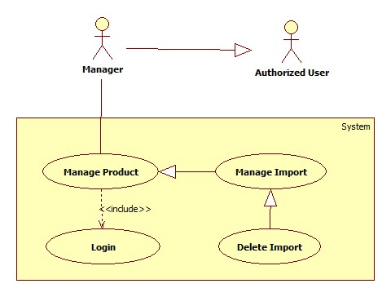

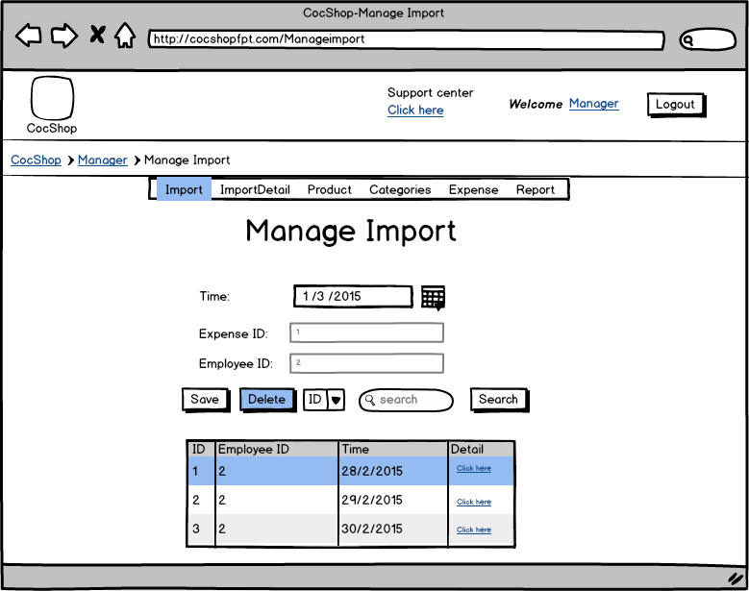

USE CASE – Delete Import
Use Case No. | UC004 | Use Case Version | 1.0
Use Case Name | Delete Import
Author | Võ Quang Chánh
Date | 3/3/2015 | Priority | Normal
Actor: Manager
Summary: Delete Import
Goal:
Delete Import
Triggers:
- The actor select import which actor want to delete in imports table
- The actor click button “Delete”
Pre-conditions: User must be access Manage Import page with role is a Manager

Post-conditions:
Main Success Scenario:
Step | Actor Action | System Response
1 | -Select import form import’s table | - Display import’s information that actor selected  - Display two button “Save” and “Delete”  - Hide button “Add”
2 | -Click on button “Delete”  [Alternative 1,2] | - Show confirm dialog “Are you sure?”

Alternative Scenario:

No | Condition | System Response
1 | [Alternative 1]  -If actor click button “OK” | - Delete import that actor selected  - Hide two button “Save” and “Delete”  - Display button “Add”  - Clear all value information field  [Exception 1]
2 | [Alternative 2]  -If actor click button “NO” | - Confirm dialog disappear

Exception:
[Exception 1]
No | Condition | System Response
1 | -If import that actor select have more than zero row in Import’s Detail | - Show message “Can’t now delete this import because it’s still handle by Import’s Detail”

Relationships: Delete Import
Business Rules: Don’t allow delete import when it’s still have information in Import’s Detail

Add Import’s Detail
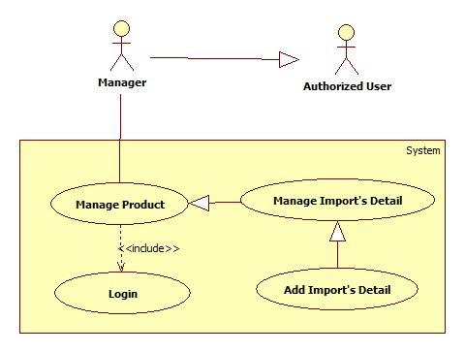

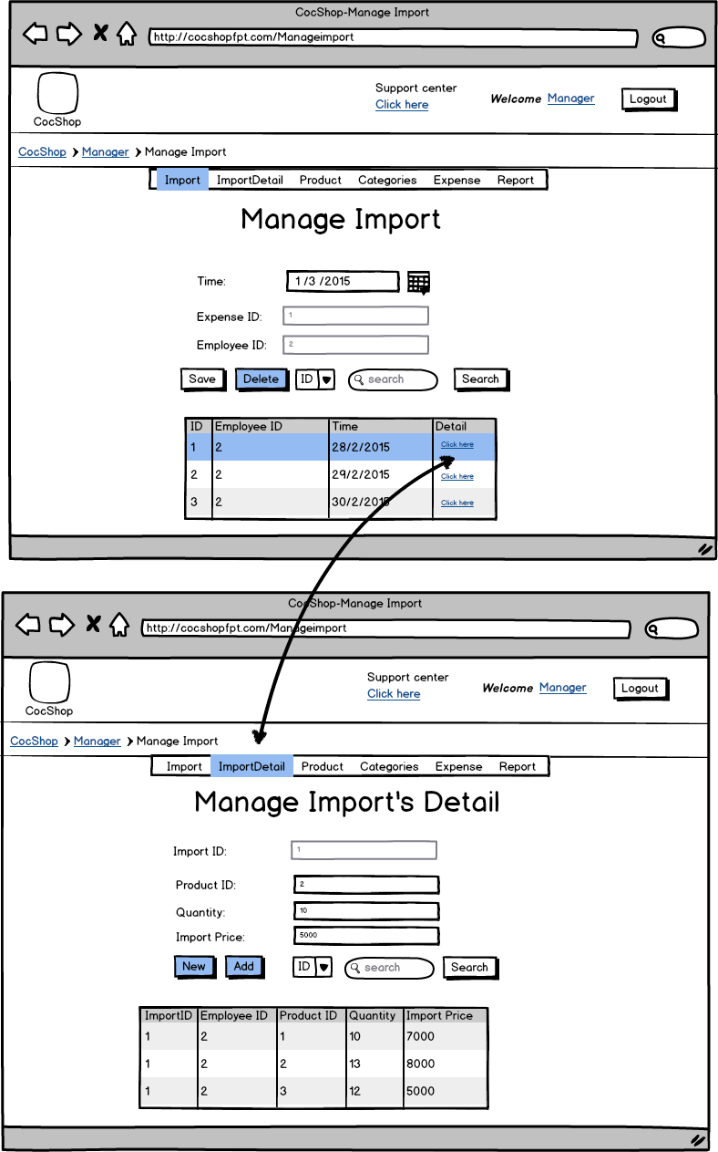
USE CASE – Add Import’s Detail
Use Case No. | UC005 | Use Case Version | 1.0
Use Case Name | Add Import’s Detail
Author | Võ Quang Chánh
Date | 3/3/2015 | Priority | Normal
Actor: Manager
Summary: Add Import’s Detail
Goal:
Add import’s detail
Triggers:
- The actor fill value information about new import’s detail
- The actor click button “Add”

Pre-conditions: User must be login system with role is a Manager, The actor click button link in Mange Import page “Click here” then come to Import’s Detail page

Post-conditions:
Main Success Scenario:
Step | Actor Action | System Response
3 | -The actor fill value information about new import’s detail
4 | -Click button “Add”  [Alternative 1] | - Add new Import’s Detail  - Clear all value information field  [Exception 1]

Alternative Scenario:

No | Condition | System Response
1 | [Alternative 1]  -Actor click button “New” | - Clear all value information field

Exception:
[Exception 1]
No | Condition | System Response
1 | -If information is not correct | - Show message “Incorrect information. Please try again!”  - Required actor fill information again

Relationships: Add Import’s Detail
Business Rules:

Search Import’s Detail
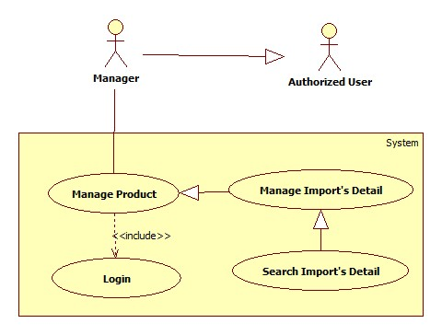

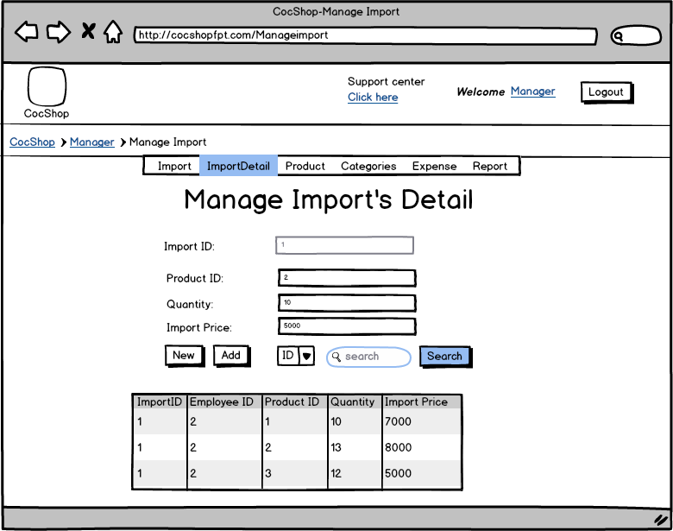

USE CASE – Search Import’s Detail
Use Case No. | UC006 | Use Case Version | 1.0
Use Case Name | Search Import’s Detail
Author | Võ Quang Chánh
Date | 3/3/2015 | Priority | Normal
Actor: Manager
Summary: Search Import’s Detail
Goal:
Search import’s detail
Triggers:
- The actor selected type of keyword for search
- The actor fill keyword in search text field
- The actor click button “Search”
Pre-conditions: User must be login system with role is a Manager. The actor click button link in Mange Import page “Click here” then come to Import’s Detail page

Post-conditions:
Main Success Scenario:
Step | Actor Action | System Response
1 | -The actor click button link in Mange Import page “Click here” then come to Import’s Detail page | - Display Manage Import’s Detail page
2 | - The actor selected type of keyword for search and fill keyword in search text field | - System get information
3 | -Click button “Search” | - Display result that actor required  [Exception 1]

Exception:
No | Condition | System Response
1 | -Keyword is blank or results are not thing | - Display all Import’s Detail as default

Relationships: Search Import’s Detail
Business Rules:

Update Import’s Detail
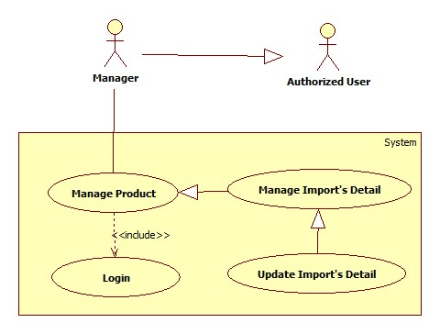
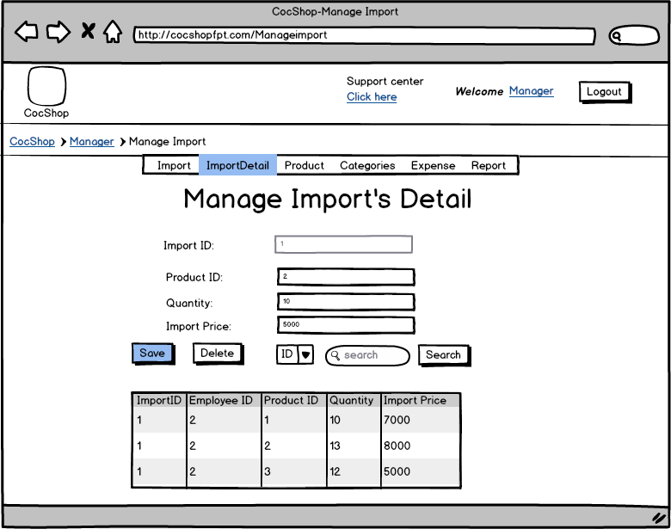

USE CASE – Update Import’s Detail
Use Case No. | UC007 | Use Case Version | 1.0
Use Case Name | Update Import’s Detail
Author | Võ Quang Chánh
Date | 3/3/2015 | Priority | Normal
Actor: Manager
Summary: Update Import’s Detail
Goal:
Update import’s detail
Triggers:
- The actor selected import’s detail form import’s detail table
- The actor change information of import’s detail
- The actor click button “Save”
Pre-conditions: User must be access Mange Import's Detail page with role is a Manager

Post-conditions:

Main Success Scenario:
Step | Actor Action | System Response
1 | -The actor selected import’s detail form import’s detail table | - Display import’s detail that actor selected  - Display two button “Save” and “Delete”, hide button “Add”
2 | -The actor change import’s detail information | - Get information
3 | -Click button “Save”  [Alternative 1,2] | - Show confirm dialog “Are you sure?”

Alternative Scenario:

No | Condition | System Response
1 | [Alternative 1]  -If actor click button “OK” | - Update Import’s detail  - Hide two button “Save” and “Delete”, add button “Add”  - Clear all value information field  [Exception 1]
2 | [Alternative 2]  -If actor click button “NO” | - Confirm dialog disappear

Exception:
[Exception 1]
No | Condition | System Response
1 | -If information input is not correct | - Show message “Incorrect information. Please try again!”  - Required actor fill information again

Relationships: Update Import’s Detail
Business Rules:

Delete Import’s Detail
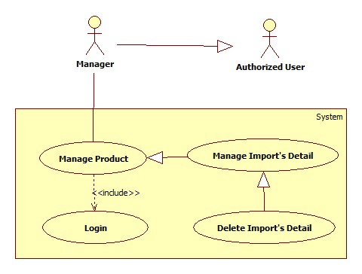

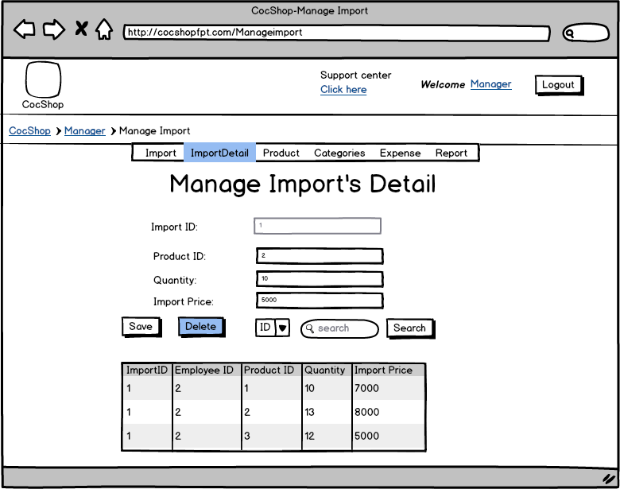

USE CASE – Delete Import’s Detail
Use Case No. | UC008 | Use Case Version | 1.0
Use Case Name | Delete Import’s Detail
Author | Võ Quang Chánh
Date | 3/3/2015 | Priority | Normal
Actor: Manager
Summary: Delete Import’s Detail
Goal:
Delete Import’s Detail
Triggers:
- The actor selected import’s detail from import’s detail table
- The actor click button “Delete”
Pre-conditions: User must be access Manage Import’s Detail page with role is a Manager
Post-conditions:

Main Success Scenario:
Step | Actor Action | System Response
1 | -Click on item “ImportDetail” | - Display Manage Import’s Detail page  - Display button “Add”
2 | -Select import’s detail form import’s detail table | - Display import’s detail information that actor selected  - Display two button “Save” and “Delete”, hide button “Add”
3 | -Click on button “Delete” | - Show confirm dialog “Are you sure?”  [Alternative 1]

Alternative Scenario:
[Alternative 1]
No | Condition | System Response
1 | -If actor click button “OK” | - Delete import’s detail that actor selected  - Hide two button “Save” and “Delete”, display button “Add”  - Clear all value information field
2 | -If actor click button “NO” | - Confirm dialog disappear

Relationships: Delete Import’s Detail
Business Rules: If Import’s detail has been delete then quantity of product in inventory also has been minus

Add Product
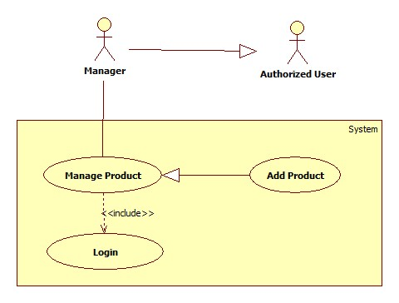

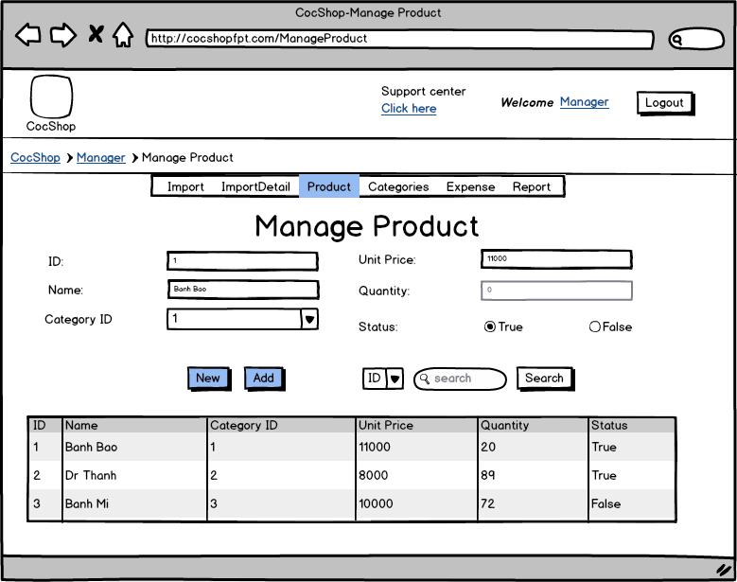

USE CASE – Add Product
Use Case No. | UC009 | Use Case Version | 1.0
Use Case Name | Add Product
Author | Võ Quang Chánh
Date | 3/3/2015 | Priority | Normal
Actor: Manager
Summary: Add Product
Goal:
Add product
Triggers:
- The actor fill value information about new product
- The actor click button “Add”
Pre-conditions: User must be access product page with role Manger

Post-conditions:
Main Success Scenario:
Step | Actor Action | System Response
1 | -The actor fill value information about new product
2 | -Click button “Add”  [Alternative 1] | - Add new product  [Exception 1]

Alternative Scenario:
[Alternative 1]
No | Condition | System Response
1 | -If actor click button “New” | - Clear all value information field

Exception:
[Exception 1]
No | Condition | System Response
1 | -If information is not correct | - Show message “Incorrect information. Please try again!”  - Required actor fill information again

Relationships: Add new product
Business Rules:

Search Product
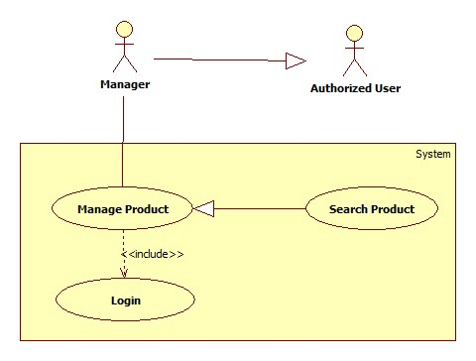
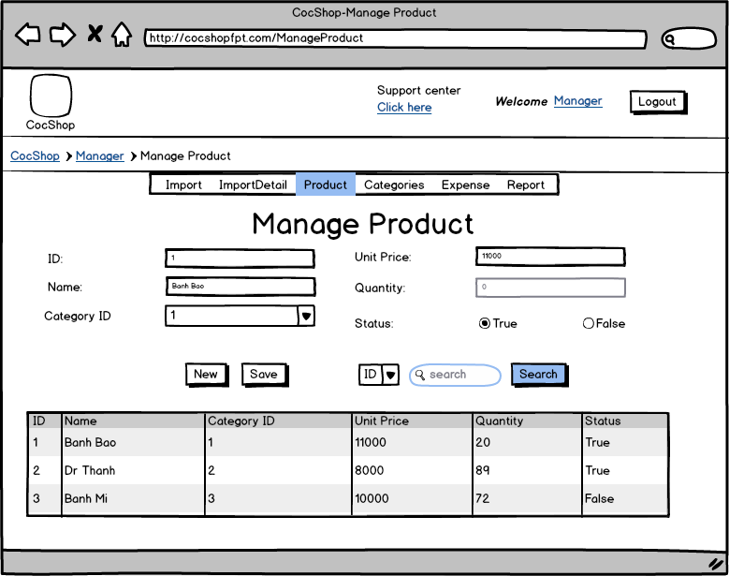

USE CASE – Search Product
Use Case No. | UC010 | Use Case Version | 1.0
Use Case Name | Search Product
Author | Võ Quang Chánh
Date | 3/3/2015 | Priority | Normal
Actor: Manager
Summary: Search Product
Goal:
Search product
Triggers:
- The actor selected type of keyword for search
- The actor fill keyword in search text field
- The actor click button “Search”
Pre-conditions: User must be access Manage Product page with role is a Manager

Post-conditions:
Main Success Scenario:
Step | Actor Action | System Response
2 | - The actor selected type of keyword for search and fill keyword in search text field
3 | -Click button “Search” | - Display result that actor required  [Exception 1]

Exception:
No | Condition | System Response
1 | -Keyword is blank or results are not thing | - Display all Products as default

Relationships: Search Product
Business Rules:

Update Product
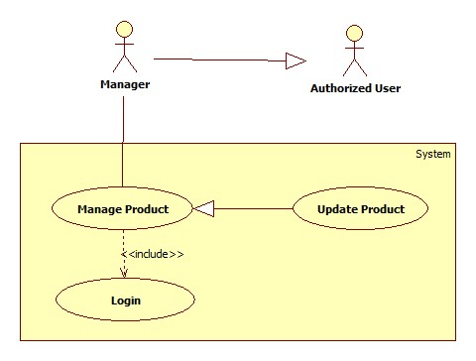
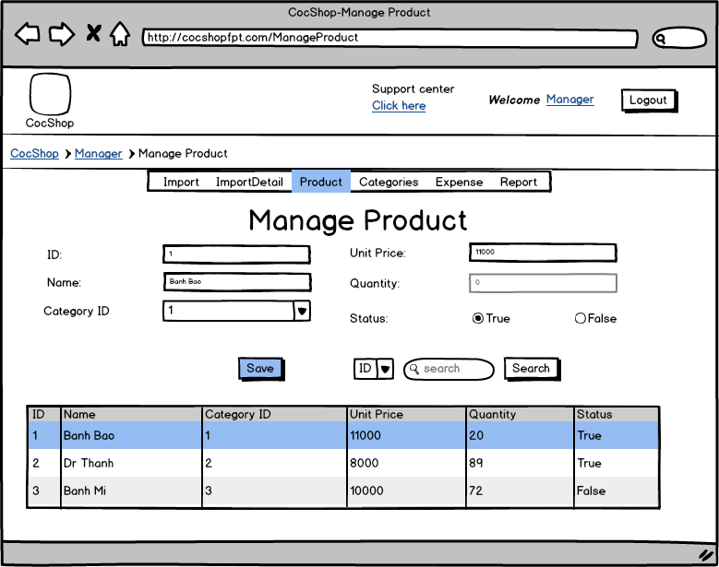

USE CASE – Update Product
Use Case No. | UC0011 | Use Case Version | 1.0
Use Case Name | Update Product
Author | Võ Quang Chánh
Date | 3/3/2015 | Priority | Normal
Actor: Manager
Summary: Update Product
Goal:
Update Product
Triggers:
- The actor selected product form product table
- The actor change information of product
- The actor click button “Save”
Pre-conditions: User must be access Mange Product page with role is a Manager

Post-conditions:

Main Success Scenario:
Step | Actor Action | System Response
1 | -The actor selected product form product table | - Display product’s information that actor selected  - Display button “Save” , hide button “Add”
2 | -The actor change product’s information
3 | -Click button “Save” | - Show confirm dialog “Are you sure?”
4 | -Actor click button “YES”  [Alternative 1] | - Update Product  - Hide button “Save” , Display button “Add”  - Clear all value information field  [Exception 1]

Alternative Scenario:

No | Condition | System Response
1 | [Alternative 1]  -actor click button “NO” | - Confirm dialog disappear

Exception:

No | Condition | System Response
1 | -If information is not correct | - Show message “Incorrect information. Please try again!”  - Required actor fill information again

Relationships: Update Product
Business Rules:

Add Category
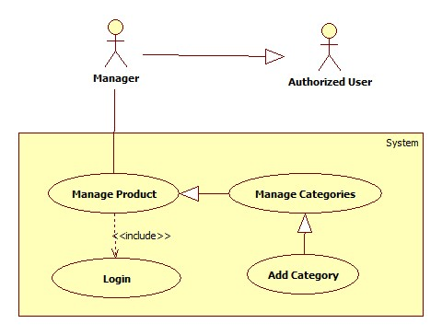
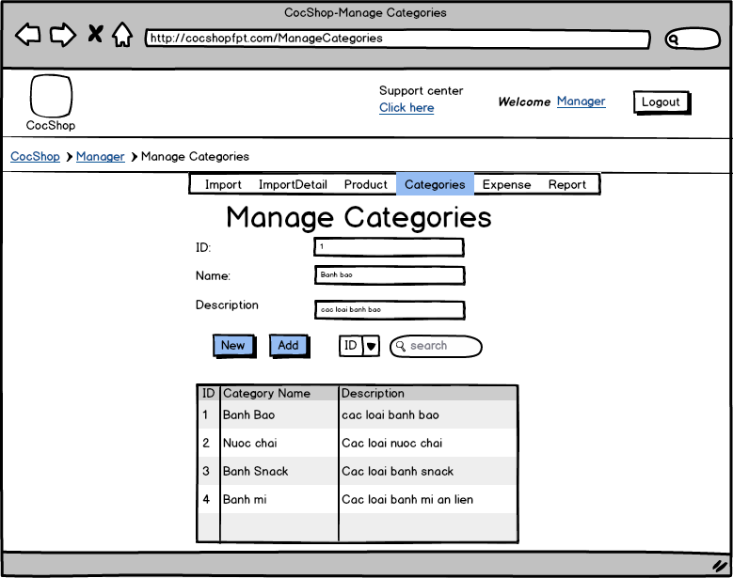

USE CASE – Add Category
Use Case No. | UC0012 | Use Case Version | 1.0
Use Case Name | Add Category
Author | Võ Quang Chánh
Date | 3/3/2015 | Priority | Normal
Actor: Manager
Summary: Add Category
Goal:
Add new category
Triggers:
- The actor fill value information about new category
- The actor click button “Add”
Pre-conditions: User must be access mange Categories page with role is a Manager

Post-conditions:
Main Success Scenario:
Step | Actor Action | System Response
1 | -The actor fill value information about new category
2 | -Click button “Add”  [Alternative 1] | - Add new Category  [Exception 1]

Alternative Scenario:

No | Condition | System Response
1 | [Alternative 1]  -Actor click button “New” | - Clear all category’s information value field

Exception:
[Exception 1]
No | Condition | System Response
1 | -If information is not correct | - Show message “Incorrect information. Please try again!”  - Required actor fill information again

Relationships: Add new Category
Business Rules:

Search Category
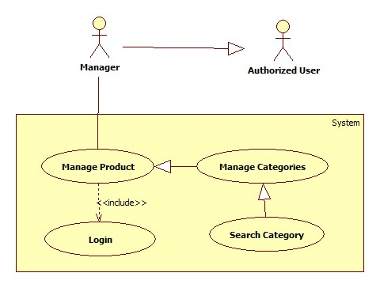
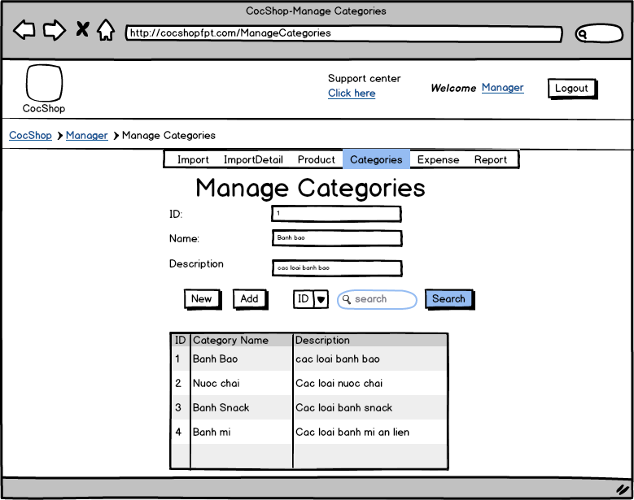
USE CASE – Search Category
Use Case No. | UC013 | Use Case Version | 1.0
Use Case Name | Search Category
Author | Võ Quang Chánh
Date | 3/3/2015 | Priority | Normal
Actor: Manager
Summary: Search Category
Goal:
Search particular Category
Triggers:
- The actor set type of search
- The actor fill keyword in Search text field
- The actor click button “Search”
Pre-conditions: User must be access Manage Categories page with role is a Manager

Post-conditions:
Main Success Scenario:
Step | Actor Action | System Response
1 | -Complete set type of search keyword and fill keyword in Search text field
2 | -Click button “Search” | - Display result that actor request  [Exception 1]

Exception:
No | Condition | System Response
1 | -Keyword is blank or results are not thing | - Display all Categories as default

Relationships: Search Category
Business Rules:

Update Category
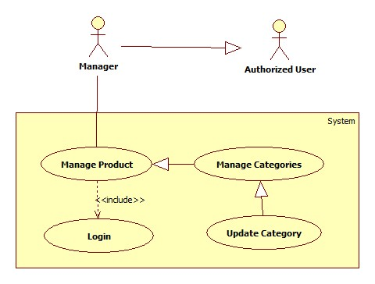
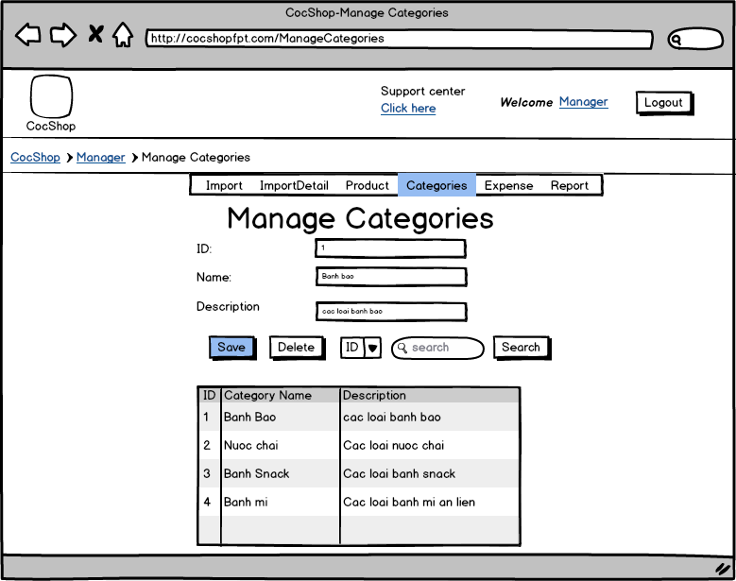

USE CASE – Update Category
Use Case No. | UC014 | Use Case Version | 1.0
Use Case Name | Update Category
Author | Võ Quang Chánh
Date | 3/3/2015 | Priority | Normal
Actor: Manager
Summary: Update Category
Goal:
Update Category’s information
Triggers:
- The actor select import which actor want to update in Categories table
- The actor change Category’s information
- The actor click button “Save”
Pre-conditions: User must be access Manage Categories page with role is a Manager

Post-conditions:
Main Success Scenario:
Step | Actor Action | System Response
1 | -Select category form category’s table | - Display Category’s information that actor selected  - Display two button “Save” and “Delete”, hide button “Add”
2 | -Change import’s information
3 | -Click button “Save” | - Show confirm dialog “Are you sure?”
4 | -Click button “YES”  [Alternative 1] | - Update new information of Category which actor selected to changed  - Hide two button “Save” and “Delete”, display button “Add”  [Exception 1]

Alternative Scenario:

No | Condition | System Response
1 | [Alternative 1]  -If actor click button “NO” | - Confirm dialog disappear

Exception:

No | Condition | System Response
1 | -If information input is not correct | - Show message “Input information is not correct. Please try again!”  - Required actor input information again

Relationships: Update Category’s information
Business Rules:

Delete Category
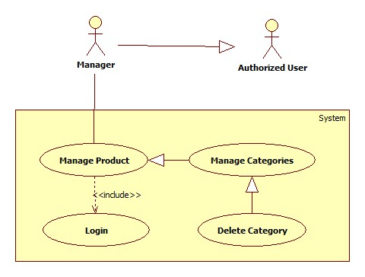

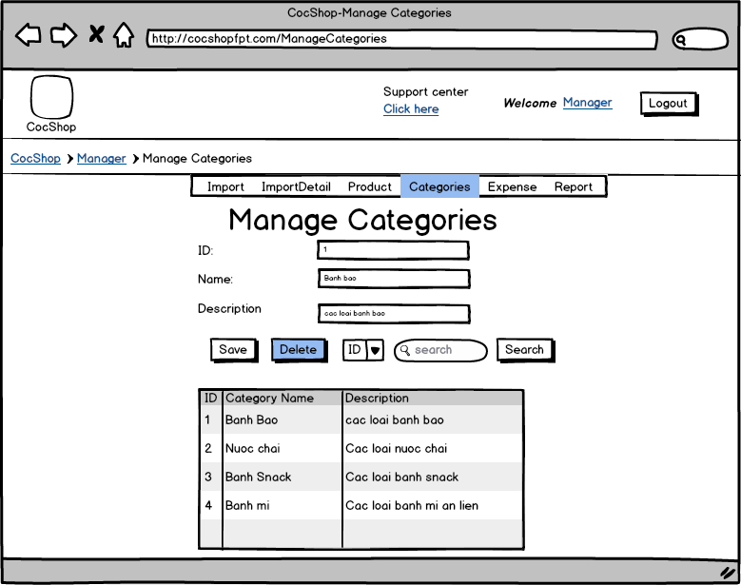

USE CASE – Delete Category
Use Case No. | UC015 | Use Case Version | 1.0
Use Case Name | Delete Category
Author | Võ Quang Chánh
Date | 3/3/2015 | Priority | Normal
Actor: Manager
Summary: Delete Category
Goal:
Delete Category
Triggers:
- The actor select category which actor want to delete in category table
- The actor click button “Delete”
Pre-conditions: User must be access Manage Categories page with role is a Manager

Post-conditions:

Main Success Scenario:
Step | Actor Action | System Response
1 | -Select category form category’s table | - Display Category’s information that actor selected  - Display two button “Save” and “Delete”, hide button “Add”
2 | -Click on button “Delete” | - Show confirm dialog “Are you sure?”
3 | -Click button “YES”  [Alternative 1] | - Delete Category that actor selected  - Hide two button “Save” and “Delete”, display button “Add”  - Clear all value information field  [Exception 1]

Alternative Scenario:
[Alternative 1]
No | Condition | System Response
1 | [Alternative 1]  -If actor click button “NO” | - Confirm dialog disappear

Exception:
[Exception 1]
No | Condition | System Response
1 | -If this category still handle by another product | - Show message “Can’t now delete this Category because it’s still handle by Product

Relationships: Delete Category
Business Rules: Don’t allow delete Category when it’s still handle by another product

Manage Expense
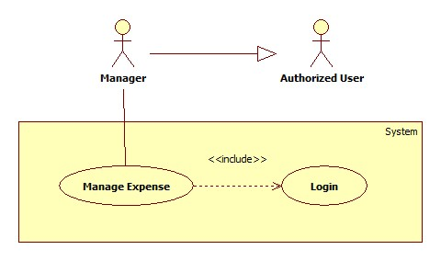

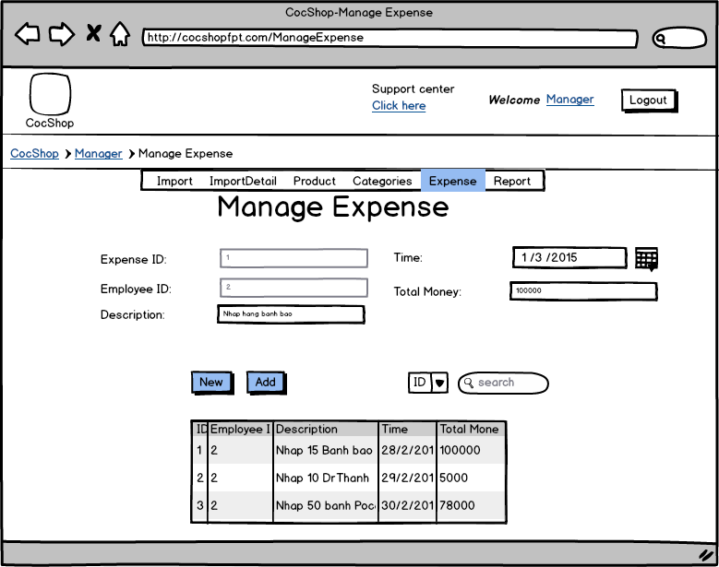

USE CASE – Mange Expense
Use Case No. | UC001 | Use Case Version | 1.0
Use Case Name | Mange Expense
Author | Võ Quang Chánh
Date | 3/3/2015 | Priority | Normal
Actor: Manager
Summary: Mange Expense
Goal:
Mange Expense
Triggers:
- The actor fill all information for new expense
- The actor click button “Add”

Pre-conditions: User must be access Mange Expense page with role is a Manager

Post-conditions:
Main Success Scenario:
Step | Actor Action | System Response
1 | - The actor fill all information for new expense
2 | -Click button “Add”  [Alternative 1] | - Add new Expense  - Clear all value information field  [Exception 1]

Alternative Scenario:
[Alternative 1]
No | Condition | System Response
1 | -If actor click button “New” | - Clear all value information field

Exception Scenario:
[Exception 1]
No | Condition | System Response
1 | -If information input is not correct | - Display message “Incorrect input information. Please try again! ”  - Required actor input information correct

Relationships: Add new Expense
Business Rules:

3.3.5 <Salesperson> Overview Use Case
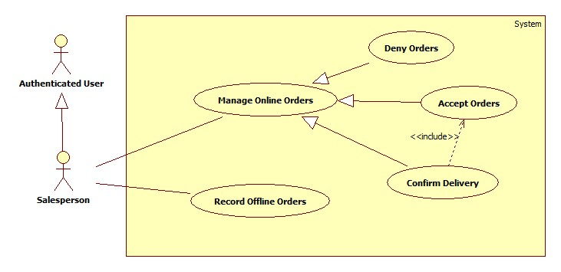

Manage Online Orders

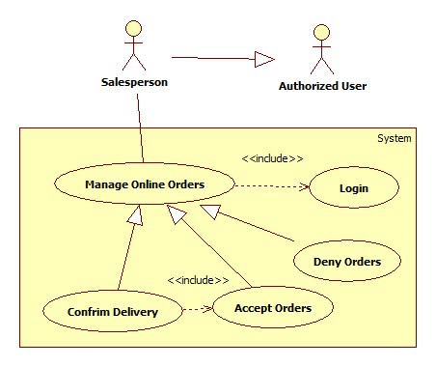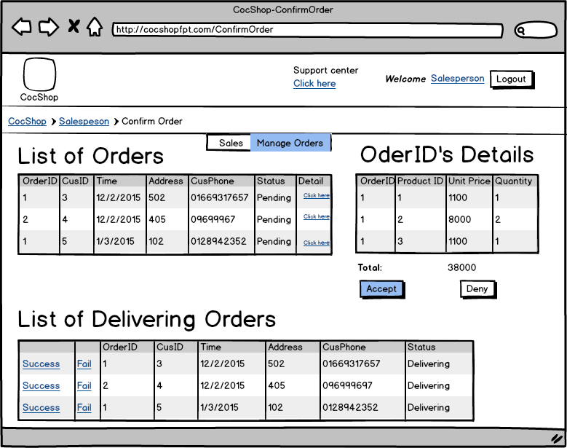
USE CASE – Manage Online Orders
Use Case No. | UC001 | Use Case Version | 1.0
Use Case Name | Manage Online Orders
Author | Võ Quang Chánh
Date | 3/3/2015 | Priority | Normal
Actor: Salesperson
Summary: Manage Online Orders
Goal:
Manage Online Orders
Triggers:
- The actor select orders in list of orders table then view this order’s detail table

Pre-conditions: User must be access Manage Online Orders page with role is a Salesperson

Post-conditions: Clear this order’s table, hide two button “Accept” and “Deny”

Main Success Scenario:
Step | Actor Action | System Response
1 | - The actor select orders in list of orders table then view this order’s detail table | - Display this order’s detail, display two button “Accept” and “Deny”
2 | -Click button “Accept”  [Alternative 1,2,3] | - Record this order with status “Delivering”  - Hide this order’s detail, hide two button “Accept” and “Deny”

Alternative Scenario:

No | Condition | System Response
1 | [Alternative 1]  -Actor click button link “Deny” | - Set this order’s status “Fail”
2 | [Alternative 2]  -Actor click button link “Success” on List Of Delivering Orders Table | - Set this order’s status “Success”
3 | [Alternative 3]  -Actor click button link “Fail” on List Of Delivering Orders Table | - Set this order’s status “Fail”

Relationships: Manage Orders
Business Rules:

Record Offline Orders
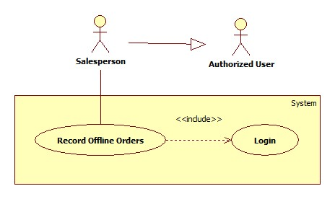
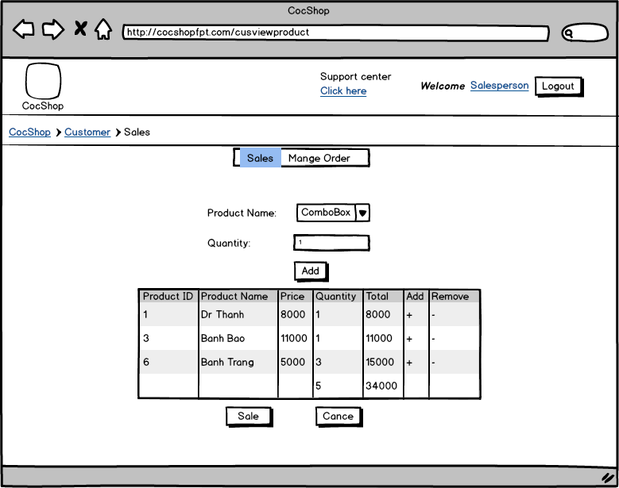

USE CASE – Manage Offline Orders
Use Case No. | UC001 | Use Case Version | 1.0
Use Case Name | Manage Offline Orders
Author | Võ Quang Chánh
Date | 3/3/2015 | Priority | Normal
Actor: Salesperson
Summary: Manage Offline Orders
Goal:
Manage Offline Orders
Triggers:
- The actor select product and set quantity of product
- The actor click button “Add” to add product into order
- The actor click button “Sale”

Pre-conditions: User must be access Sales page with role is a Salesperson

Post-conditions: Clear this order’s table, hide two button “Accept” and “Deny”

Main Success Scenario:
Step | Actor Action | System Response
1 | - The actor select product and add quantity of product
2 | -Click button “Add” | - Add new line in orders with product and quantity information
3 | -Click button “Sale”  [Alternative 1] | - Accept orders and confirm it’s status is “success”

Alternative Scenario:

No | Condition | System Response
1 | [Alternative 1]  -Actor click button “Cancel” | - Clear all information value of this orders

Relationships: Manage Offline Orders
Business Rules:

NON-FUNCTIONAL Requirements

Usability
- Android device:
- With the friendly interface, user can use it easily that they don’t waste many times for training and research the system.
- Staff will be able to use this system after one hours training, they can use the system well.
- An application must be easy to install.
- Management Website:
- Guest can order via online or directly. Authorized User have to login to the system to use main functionalities.
- The interface should be elegant, simple and easy to look.

Reliability
- The system should be online 24/7 and be able to response to user within maximum 10s for each request.
- Guest can order between 6:30 and 18:30.
- Database should be daily backed up .
- Not conflict with other software.
- Mean Time Between Failures(MTBF): 1 month
- Mean time to Repair (MTTR): immediately when admin find out problem. Average 1 day
- Maximum Bugs or Defect Rate: 20 bugs/500 operational time units
- Implementation code must be easy to maintain.

Performance
- Every page should be completely displayed within: average 4 second and maximum 10 seconds.
- Network: work efficient with a 128kb/s or higher with internet
- The loading image and information speed depends of the speed of network

Supportability
- This system should run well on a PC, Laptop with big display screen.
- It operated well in Windows platform.
- Android can run from the version 4.0 or higher.
- All the errors should be logged, supporting for bug fixing and maintenance.
- The interface will be implemented as website an can be opened by most popular web browsers
- Google Chrome
- Firefox
- Chrome+

Design Constraints
The design constraints of system:
- Language is Vietnamese
- Just use this system after connecting with internet

On-line User Documentation and Help System Requirements
- The help document and introduction can be accessed on its website for member.
- The document include: How to use all function in the system, some errors can meet and way to solve it.

Purchased Components
This system don’t need to bought the component

Interfaces
- The system’s interface must be attractive and using colour to separate errors message same the standard errors.
- The system has friendly interfaces

Licensing Requirements
- Now, this system is the first version release and it is under customer’s possession.
- After giving this for customer, the software company just has responsibilities to guarantee
- This system can use with other company if it licensed

Legal, Copyright, and Other Notices
- If any requirement mentioned above is not satisfied, the can decline to receive the whole system
- This software will keep track of everything required by copyright licensing agencies in Vietnam

Applicable Standards
- It can operate well in Viet Nam country and respond all applicable standards

Supporting Information

