**Cách dùng lớp java.util.TreeSet: Cây BST cân bằng**

* Lưu trữ dữ liệu dạng cây có thứ tự một tập phần tử phân biệt nhau (Set)
* Không có cơ chế đồng bộ (synchronized/ thread safe) 🡪 Hai luồng cùng đồng thời truy xuất một TreeSet có thể làm dữ liệu mất nhất quán.
* Thứ tự được dùng: thứ tự tự nhiên (nếu phần tử là số hoặc chuỗi) hoặc do người dùng tự định nghĩa thông qua một biến interface Comparator (hành vi *int compare(T obj1, T obj2)*) hoặc phần tử trong TreeSet có hiện thực interface Comparable (hành vi *int CompareTo (T obj)*).
* Độ phức tạp của các tác vụ add, remove, contains là **O(logn).**

**Các hành vi thông dụng:**

|  |  |
| --- | --- |
| **Constructors** | |
| **Constructor** | **Description** |
| **TreeSet**() | Constructs a new, empty tree set, sorted according to the natural ordering of its elements. |
| **TreeSet**​(**Collection**<? extends **E**> c) | Constructs a new tree set containing the elements in the specified collection, sorted according to the *natural ordering* of its elements. |
| **TreeSet**​(**Comparator**<? super **E**> comparator) | Constructs a new, empty tree set, sorted according to the specified comparator. |
| **TreeSet**​(**SortedSet**<**E**> s) | Constructs a new tree set containing the same elements and using the same ordering as the specified sorted set. |

**Add operations**

|  |  |  |
| --- | --- | --- |
| boolean | **add**​(**E** e) | Adds the specified element to this set if it is not already present. |
| boolean | **addAll**​(**Collection**<? extends **E**> c) | Adds all of the elements in the specified collection to this set. |

**Search operations:**

|  |  |  |
| --- | --- | --- |
| **E** | **ceiling**​(**E** e) | Returns the least element in this set greater than or equal to the given element, or null if there is no such element. |
| E | **floor****​(****E****e)** | Returns the greatest element in this set less than or equal to the given element, or null if there is no such element. |
| boolean | **contains****​(****Object****o)** | Returns true if this set contains the specified element. |
| E | **first****()** | Returns the first (lowest) element currently in this set. |
| E | **last****()** | Returns the last (highest) element currently in this set. |

**Remove operations**

|  |  |  |
| --- | --- | --- |
| boolean | **remove**​(**Object** o) | Removes the specified element from this set if it is present. |

Methods for Traversing:

|  |  |  |
| --- | --- | --- |
| Iterator<E> | **iterator****()** | Returns an iterator over the elements in this set in ascending order. |
| **Iterator**<**E**> | **descendingIterator**() | Returns an iterator over the elements in this set in descending order. |

**Demonstration 1: Using Comparable interface**

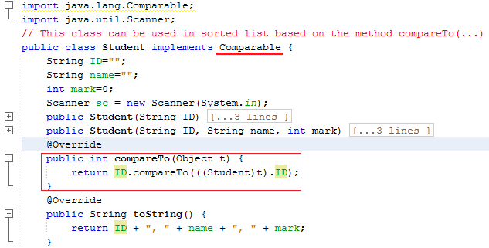

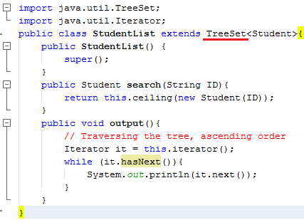

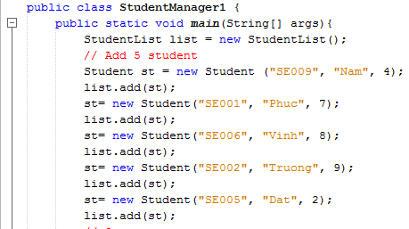

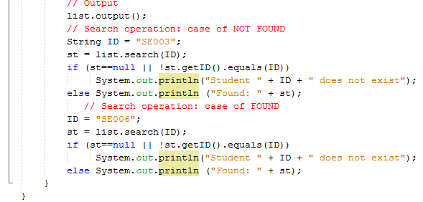

**Result:**

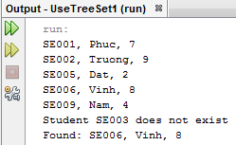

**Demonstration 2: Using Comparator interface**

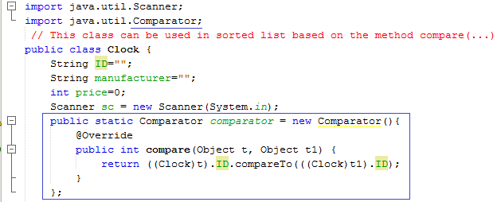



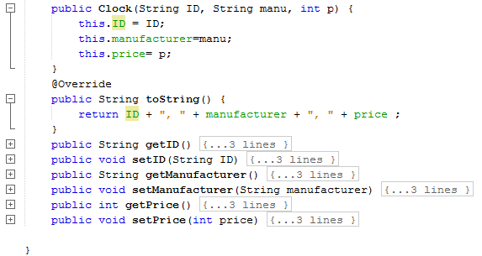

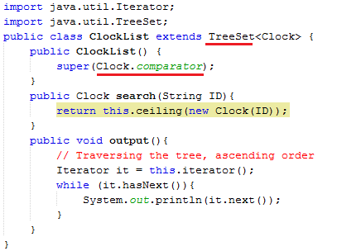

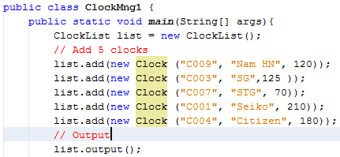

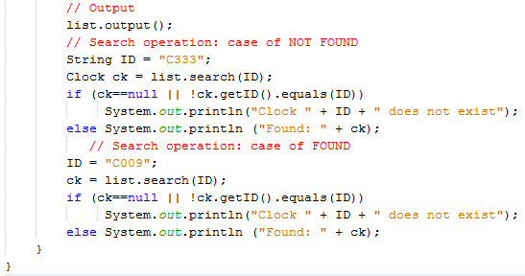

**Result:**

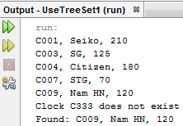

**Làm thêm Menu: Thêm/ Tìm/ Xóa/ Cập nhật/ Xuất**