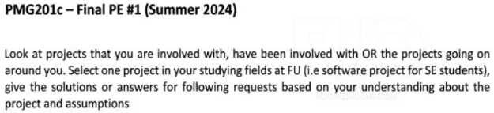

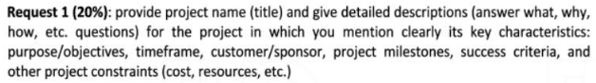

**Project Title: Smart Management System**

**Project Purpose:**

* **Goal**: Develop an efficient and user-friendly project management platform to help businesses track, manage, and optimize project workflows.
* **Objectives**:
  + Improve team collaboration
  + Reduce errors
  + Enhance overall productivity

**Project Timeframe:**

* **Duration**: 12 months (January 2024 to December 2024)

**Customer/Sponsor:**

* **Sponsor**: FPT Education

**Project Milestones:**

1. **Requirements Gathering (January - February 2024)**: Collect and document all project requirements.
2. **System Design (March - April 2024)**: Design the system architecture.
3. **Development (May - September 2024)**: Implement the system's features and functionality.
4. **Testing (October 2024)**: Conduct testing to ensure the system meets all requirements.
5. **Deployment (November 2024)**: Deploy the system to production.
6. **Training and Support (December 2024)**: Provide training and initial user support.

**Success Criteria:**

* Completion of all milestones on time and within budget.
* Positive user feedback during testing and post-deployment.
* Full integration with existing systems.

**Project Constraints:**

* **Budget**: $100,000
* **Team**: 5 developers, 2 testers, 1 business analyst, 1 project manager



**Roles and Responsibilities:**

1. **Project Manager (PM)**
   * **Responsibilities**:
     + Oversee project schedule and budget.
     + Coordinate communication between stakeholders and the team.
2. **Business Analyst (BA)**
   * **Responsibilities**:
     + Gather and document project requirements.
     + Ensure requirements are understood by the development team.
3. **Lead Developer**
   * **Responsibilities**:
     + Design and develop core system functionalities.
     + Guide the development team and review code quality.
4. **Tester**
   * **Responsibilities**:
     + Create and execute test cases to validate system functionality.
     + Identify and report defects to the development team.
5. **System Architect**
   * **Responsibilities**:
     + Design the overall system architecture for scalability and reliability.
     + Make key technical decisions regarding the tech stack and integration.



**In-Scope and Out-of-Scope Items:**

**In-Scope Items:**

1. **Task Management Module**: Allows users to create, assign, and track project tasks.
2. **Reporting Dashboard**: Visual reports on project progress and performance.
3. **User Permissions**: Manage different levels of user access.
4. **Data Backup**: Automatic project data backup to prevent loss.
5. **Mobile Access**: Access the system via a mobile app.

**Out-of-Scope Items:**

1. **Legacy System Data Migration**: Migrating old data from legacy systems.
2. **Custom Integrations**: Integration with third-party tools not specified in requirements.
3. **Advanced Analytics**: Implementing machine learning-based analytics.
4. **Customer Support Feature**: A direct customer support module within the system.
5. **Multilingual Support**: Supporting languages other than English.
6. **Customization for Clients**: Personalized customizations for different clients.
7. **On-site Deployment**: Deploying the system on client’s local servers.
8. **Extended Warranty**: Providing support beyond the initial deployment.
9. **Custom Branding**: Implementing unique branding for each client.
10. **VR/AR Capabilities**: Integration of virtual or augmented reality features.



**Activities and Relationships:**

**Key Activities:**

1. **Requirements Gathering (A)**
2. **System Design (B)**
3. **Development of Core Modules (C)**
4. **Development of User Interface (D)**
5. **Integration Testing (E)**
6. **User Acceptance Testing (F)**
7. **System Deployment (G)**
8. **User Training (H)**
9. **Data Backup Implementation (I)**
10. **Project Closure (J)**

**Activity Relationships:**

* **A → B (FS)**: System design starts after requirements gathering.
* **B → C (FS)**: Core module development begins after system design.
* **C → D (SS)**: UI development runs parallel to core module development.
* **C → E (FS)**: Integration testing starts after core module development.
* **E → F (FF)**: User acceptance testing finishes as integration testing completes.
* **F → G (FS)**: Deployment starts after user acceptance testing.
* **G → H (SS)**: Training starts during deployment.
* **H → J (FS)**: Project closure occurs after training.
* **D → I (FF)**: Data backup implementation finishes after UI completion.

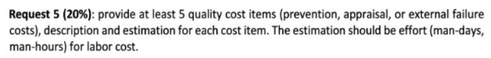

**Quality Cost Items:**

1. **Training Costs**:
   * **Description**: Training the development team on new technologies.
   * **Estimation**: 40 man-hours
2. **Testing Costs**:
   * **Description**: Cost of testing tools and environments.
   * **Estimation**: 60 man-hours
3. **Rework Costs**:
   * **Description**: Time spent fixing defects found during testing.
   * **Estimation**: 80 man-hours
4. **Audit Costs**:
   * **Description**: External audit services for compliance.
   * **Estimation**: 20 man-hours
5. **Documentation Costs**:
   * **Description**: Creating user and technical documentation.
   * **Estimation**: 50 man-hours