Nguyen Van Tu Cuong – K16 FPT HCM

WATERFALL (Traditional)

For this situation, I suggest Waterfall Development Methodology, since

+ The project does not have many requirements (The project has only 4 core features).

+ The requirements may not change occassionally, and they can be defined at an early stage (since the features are described quite clearly).

+ Our team does not have many developers and testers (4 developers & 2 testers), and their technological understanding are not very good.

+ The project is just a small one, and the time allocated is 2 weeks, a short period of time.

I have created a detail plan for this project. I’ll describe it

The whole project is devided into 5 phases.

+ Phase 1 – Requirements (about 2 days): My team will analyst and specific requirements to create a detail tasks list in Trello.

+ Phase 2 – Design (about 4 days): My team will design the system, the database the whole project’s UI in Figma.

+ Phase 3 – Implementation: Since our team do not have mobile developer, so that I decide to develop for web users only.

- Front-End: Using ReactJS. After finishing several components, our developers will process unit tests.

- Back-End: Using .NET. After finishing some functions and endpoints, our developers will process unit tests.

+ Phase 4 – Testing: Our testers will process manual tests to ensure that there are no bugs leftover.

Phase 3 and Phase 4 process respectively, and take about 1 week.

+ Phase 5 – Maintenance: Our team will maintain the project after delivering, then improve it.

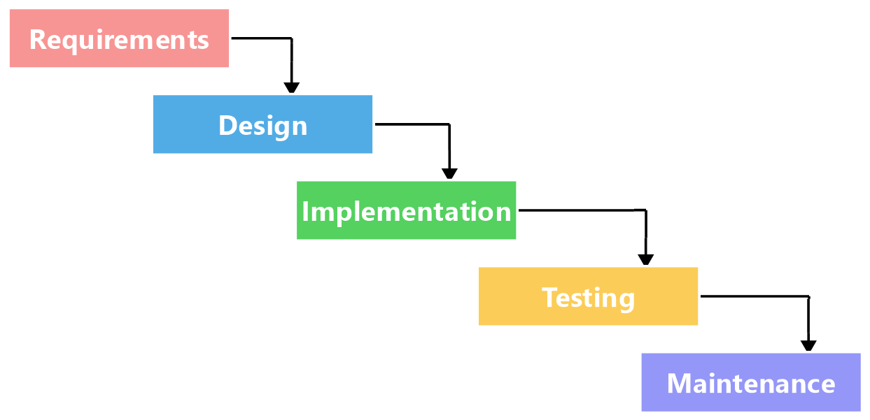

SCRUM (Agile)

For this situation, I suggest Scrum Development Methodology, since

+ Scrum is suitable for this project, since the project has quite many requirements (3 large core features).

+ The requirements may easily to change.

+ The requirements are not clearly, so they may not determine easily in early stage.

+ Customer can appoarch the demo of the project, to provide feedbacks to make the project complete.

I have created a detail plan for this project. I’ll describe it

The project has 3 core features, they are

+ Createing an account and a family profile

+ Search

+ Job posting

So that I will run 3 sprints for the whole project, each sprint takes 2 weeks, and the scope is to finish 1 feature listed above.

Firstly, I and my bussiness analyst team will create a general plan for the whole project, and design the database using MySQL.

Each sprint is devided into 5 small phases

+ Phase 1 – Meet and plan (First day of the first week): I and my whole team (BA, Developers, Testers, …) will conduct a meeting to create a detail tasks list in Jira, and gather each member’s report about what they have done and will have done.

+ Phase 2 – Design (about 3-4 days): I and my business analyst team will design and config the system, config the database if needed, my design team will design the sprint’s UI in Figma.

+ Phase 3 – Code & Test (about 1 week): I, my developer team and my tester team will process programming and testing respectively.

In coding section

- Front-End: Using ReactJS. After finishing several components, our developers will process unit tests and intergration tests.

- Back-End: Using .NET. After finishing some functions and endpoints, our developers will process unit tests and intergration tests.

- Mobile: Using Flutter, our developers will process unit tests and intergration tests.

In testing section

- Our tester team will process manual test and automation tests.

- Our QA, QC (Quality Assurance, Quality Control) team will ensure the quality of the project.

+ Phase 4 - Release: The demo version of project is delivered to customer.

+ Phase 5 – Feedback: Customer will experience and provide feedbacks. I and my whole team will receive the feedbacks to complete.

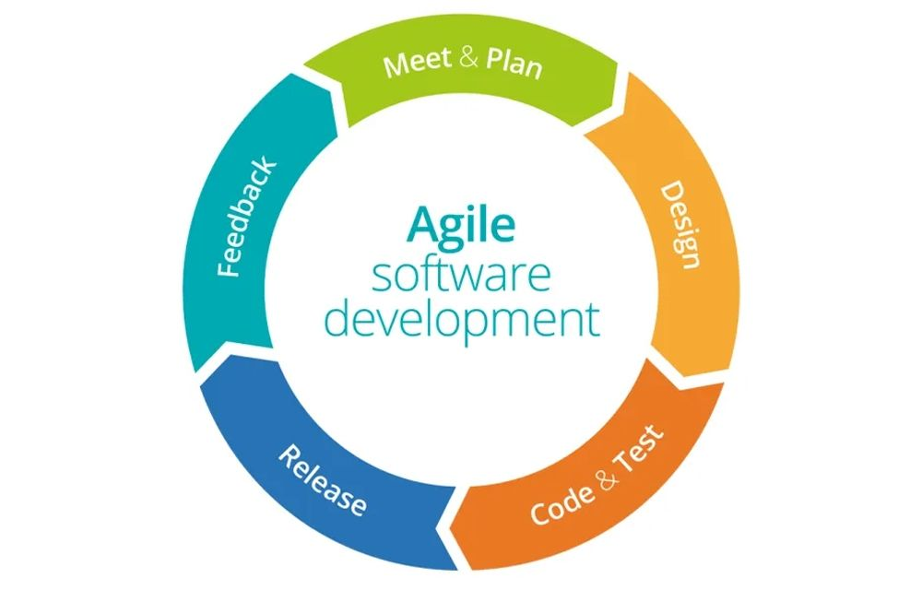

Final Fall 2021

2. The reason for choosing Agile are

+ Scrum is suitable for any project.

+ Each member can handle many tasks, for example, developers can tests.

+ Can detect bugs in early stage.

+ Can be applied for projects which requirements are not clearly at early stage.

+ Customer can appoarch the demo of the project, to provide feedbacks to make the project complete.

b, There are some project constraints (ràng buộc trong dự án) needed to changed/managed. Specifically, they are

+ Time allocated for the project sould be longer (6-8 weeks, since we may run 3-4 sprints, each sprint last 2 weeks).

+ The team may need several developers and testers with good technical understanding.

+ The team may need BAs, product manager, QAs (Quality Assurance – Đảm bảo chất lượng), QCs (Quality Control – Quản lý chất lượng), … to ensure the management of the team, the quality of the products,…

+ …

3.

Function Requirements:

+ Submit the application form (Servlet): This feature is to allow students to fill then submit an application form, to enroll Ronald University.

+ Register a course (Servlet): This feature is to allow students to register any course they want, after paying fee.

+ Import progess mark, using CSV or Excel file (Servlet): This feature is to allow teachers to import progress mark by using either CSV or Excel file.

+ Give mark to the web form: This feature is to allow teachers to import mark to the web form.

+ View and print grade reports: This feature is to allow students to view or print grade report that are published.

+ Sign in: This feature is to allow unauthenticated users to get access to the application with a single role (student, teacher, admin, …)

+ Sign up: This feature is to allow guests to create a single account.

+ Sign out: This feature is to allow authenticated users to log out.

+….

Non-functional requirements

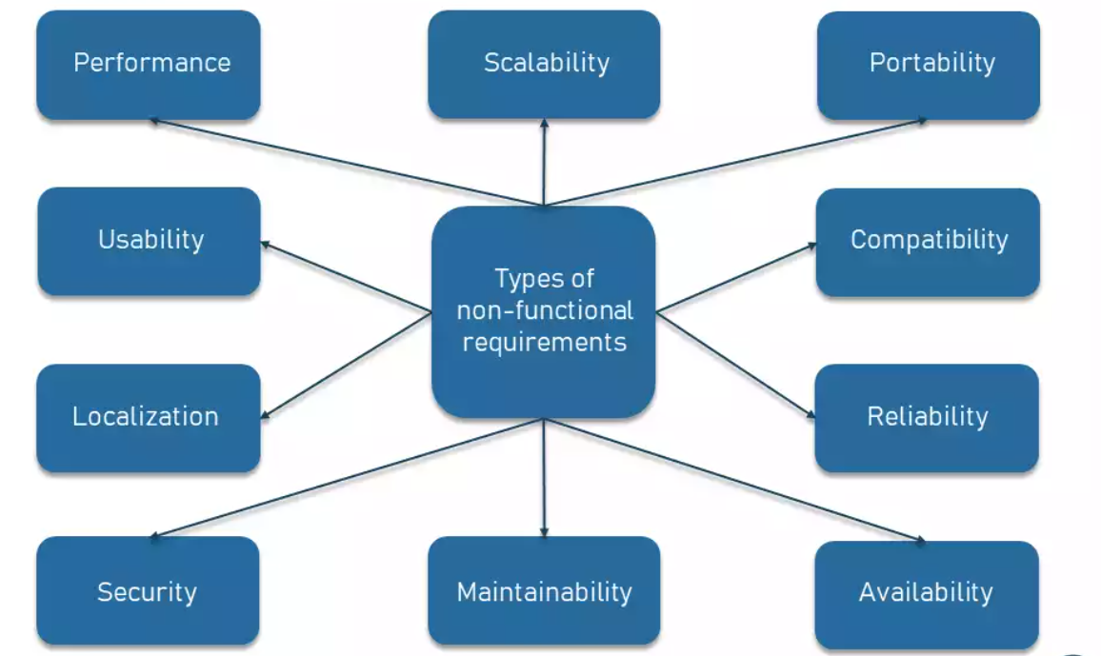

**Performance and scalability.**How fast does the system return results? How much will this performance change with higher workloads?

+ How fast does the system return results?

Ex: The system takes no more than 3s to make the UI re-render. (Load lại trang thì không được tốn quá 3s).

+ How much will this performance change with higher workloads?

Ex: The system can handle 1000 users at the same time.

**Portability and compatibility.**Which hardware, operating systems, and browsers, along with their versions does the software run on? Does it conflict with other applications and processes within these environments?

Which hardware, operating systems, and browsers, along with their versions does the software run on?

Ex: The system can run smoothly in any kind of browser (CocCoc, FireFox, Chrome, Opera, …), and can run functionality in any kind of oprating system (Windows, Linus, MacOS, …).

Does it conflict with other applications and processes within these environments?

Ex: The system do not conflict with other application (VPN, Anti-Virus Software, …).

**Reliability, maintainability, availability.**How often does the system experience critical failures? How much time does it take to fix the issue when it arises? And how is user availability time compared to downtime?

How often does the system experience critical failures?   
Ex: The system must oprate well and rarely crash.

How much time does it take to fix the issue when it arises?

Ex: The system takes no longer than 3 hours to resolve problem in case it arises.

**Security.**How well are the system and its data protected against attacks?

Ex: The system uses digital signature to ensure security between client and server.

**Localization.**Is the system compatible with local specifics?

**Usability.**How easy is it for a customer to use the system?

Ex: The UX/UI is friendly and easy to use.

5. I think security attribute and scalability attribute are likely to important when deciding a website ‘fap.fpt.edu.vn’. Since

+ FAP holds an extreme large private data of students and lectures. If the data leaked, attackers can steal the information, which is very dangerous. So that, the security attribute is very important.

+ When FAP pulish subject FE marks, the number of students using FAP at the same time rise incrediblity, this may let to the crash of the server. So that, the scalability attribute is important, too.

3, User stories

As a student, I want to feed back my own lectures so that they can improve their teaching skills.

As a student, I want to get mark notifications on my smart phone so that I can get the information in time.

As a teacher, I want to check my students' attendances so that they must take responsibility for their absences.

As a teacher, I want to remove my students from their class if they behave disrepectfully to me so that they can behave better.

**...**

4,

STORY MAP for actor GUEST (User that are not logged in)

|  |  |  |  |
| --- | --- | --- | --- |
| ACTOR: GUEST | Authentication | | Enroll |
|  | Sign In | Sign Up | Apply via application |
| Release 1 | Sign in via given account | Create new account | View application |
|  |  | Save application |
|  |  | Fill & Edit application |
|  |  | Submit appication |
| Release 2 | Sign in via Google account |  |  |

STORY MAP for actor STUDENT

|  |  |  |  |  |  |  |  |
| --- | --- | --- | --- | --- | --- | --- | --- |
| ACTOR: Student | Course registration | | | Viewing and printing reports | | Information | |
|  | Create a course registration | Send the course registrion | Select payment method | View reports | Print reports | View student’s information | Edit student’s infomation |
| Release 1 | Create automatically | Send via application | Select internal banking such as VCB, … | View report vie Excel | Print report via printer | // không ghi vì cái màu xanh nó đã quá clear rồi, không cần lgi thêm |  |
| View report vie CSV | Print report via fax |  |  |
| Release 2 | Create manually | Send via email | Select external banking such as VISA,… |  |  |  |  |

STORY MAP for actor TEACHER

|  |  |  |  |  |  |  |  |  |  |  |
| --- | --- | --- | --- | --- | --- | --- | --- | --- | --- | --- |
| ACTOR: Teacher | Evaluation | | |  | Grading | | | Training and placement | | |
|  | Create evaluation | Edit evaluation | Submit evaluation | Delete evaluation | Create grading | Edit grading | Submit grading | Display interviews | Puting on shortlist | Decarele results |
| Relese 1 | Create automatically |  |  |  | Create automatically |  |  | Search for an interview |  | Show result vie  Email |
|  |  |  |  |  |  |  | Display up-to-date interviews |  | Show result via  app |
| Release 2 | Create manually |  |  |  | Create manually |  |  |  |  |  |

Final Fall 22

5,

Option 1: No

The answer is NO. Since

Đối với rủi ro, ở giai đoạn phân tích cần một chuyên gia có chuyên môn cao để thực hiện việc phân tích.

Không hữu ích với dự án có quy mô nhỏ.

Thời gian và chi phí cho dự án có thể là vô hạn vì đặc tính xoắn ốc của mô hình.

Tài liệu cho dự án có thể rất dài vì có các giai đoạn trung gian.

Rủi ro có thể không đáp ứng được tiến độ hoặc ngân sách.

Sự thành công của dự án phụ thuộc rất nhiều vào giai đoạn phân tích rủi ro.

Option 2: Yes

The answer is YES. Since

Lượng phân tích rủi ro cao. Do đó việc tránh rủi ro được tăng cường.

Ước lượng chi phí dễ dàng như việc hoàn thành một prototype trong một fragment nhỏ.

Ứng dụng tốt đối với các dự án lớn và quan trọng.

Kiểm soát tài liệu và phê duyệt chặt chẽ.

Chức năng bổ sung hoặc thay đổi có thể được thêm vào những giai đoạn sau.

Phần mềm sẽ được sản xuất sớm trong vòng đời của phần mềm.

Ứng dụng được phát triển nhanh và các tinh năng được thêm vào một cách có hệ thống.

Luôn có thời gian cho khách hàng để phản hồi về sản phẩm.

End users must feedback in early.

Team must come up with a good and detail plans.

….

b,

Test White Box (test đọc code, test xem chức năng của hàm có đúng k)

Testing: Unit test -> Test từng hàm xem hàm đó có chạy như mình mong đợi hay không: Việc này của dev

Intergration Test -> Test các thành phần liệu nó có làm việc tốt hay không: việc này của dev hay là của QA.

Test blackbox (test output, ra output là được)

Manual Test: Tạo ra những test case, sau đó chạy = tay.

Automation Test: Tạo ra 1 cái test tự động, afk -> test được.

The testing that I suggest the team do is

+ Unit Testing: A unit test is a way of testing a unit - the smallest piece of code that can be logically isolated in a system. Our development team will process unit test in order to confirm that each unit in our system functions properly.  
I suggest Jest(Javscript) to do unit test in Front-End, I suggest Swizzar(.NET) to perform unit test in back-end, I suggest …

+ Intergation Testing: **Integration Testing** is defined as a type of testing where software modules are integrated logically and tested as a group. Our developemt team will process intergration test in order to confirm that each component works well with each order.

I suggest Jest(Javscript) to do unit test in Front-End, I suggest Swizzar(.NET) to perform unit test in back-end, I suggest …

+ Automation Testing: **Test Automation** is the best way to increase the effectiveness, test coverage, and execution speed in software testing. Our tester team will use automation test due to

* Manual Testing of all workflows, all fields, all negative scenarios is time and money consuming
* It is difficult to test for multilingual sites manually
* Test Automation in software testing does not require Human intervention. You can run automated test unattended (overnight)
* Test Automation increases the speed of test execution
* Automation helps increase Test Coverage
* Manual Testing can become boring and hence error-prone.

I suggest Jest(Javscript) to do unit test in Front-End, I suggest Swizzar(.NET) to perform unit test in back-end, I suggest …