**Request 1:**

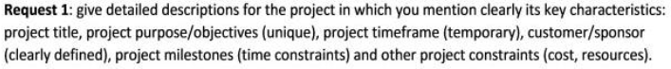  
**Project Title:** FPT Student Learning Management (SLM) System

**Project Purpose/Objectives:** The SLM system aims to make it easier for both professors and students at FPT University to manage and track educational progress. Key goals are:

1. Give administrators tools to set up the system, handle subject details, and manage users.
2. Help professors check their classes, view student lists, and grade performance.
3. Allow students to sign up for classes, take online tests, turn in homework, and see their grades.
4. Create reports about student grades for academic review and decisions.

**Project Timeframe:** The project will take 4 months, covering all stages from planning to launch.

**Customer/Sponsor:** FPT University is the main supporter and user of this project. Other schools and educational bodies might use the system in the future.

**Project Milestones:**

1. Gathering and Analyzing Requirements (Week 1-2)
2. Designing the System (Week 3-4)
3. Developing and Testing the Software (Week 5-10)
4. More Testing and User Approval (Week 11-12)
5. Launching the System (Week 13-16)

**Other Project Constraints:**

* **Budget:** The project has a budget of $10,000.
* **Team:** The project involves 3 developers, 1 tester, 2 designers, and 2 business analysts, all working under project management.
* **Technology:** The system uses Spring Boot for backend, Angular for frontend, and AWS for hosting.

**Request 2:**



**Why Pick a Project-Focused Team:**

1. **Everyone Works Just on This Project:** Team members only work on this project, giving it their full attention to hit the 4-month target.
2. **Talking Gets Easier:** With everyone focused on the project, it’s quicker to talk things out and make decisions.
3. **Quick on Your Feet:** This setup lets the team quickly adjust if things change, keeping the project on track.
4. **People Know Their Jobs:** Everyone knows exactly what they need to do, which means they're likely to take their jobs seriously.

**Bottom Line:** A team set up just for the project helps get things done without delays, aiming for a successful finish in 4 months.

**Request 3:**

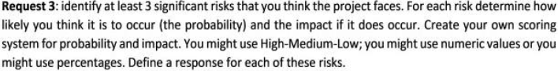

**Risk 1: Wrong Budget Estimate**

* **Possibility:** Medium
* **Impact:** High
* **Mitigation Plan:** Improve teamwork.
* **Contingency Plan:** Reduce project parts.

**Risk 2: Tight Schedule**

* **Possibility:** High
* **Impact:** High
* **Mitigation Plan:** Sort tasks by importance.
* **Contingency Plan:** Ask for more time.

**Risk 3: Manager Lacks Skills**

* **Possibility:** Medium
* **Impact:** Medium
* **Mitigation Plan:** Provide training and online learning.
* **Contingency Plan:** Support with an assistant manager.

**Risk 4: Poor Teamwork**

* **Possibility:** Medium
* **Impact:** Medium
* **Mitigation Plan:** Motivate and inspire team members.
* **Contingency Plan:** Continue motivation efforts.

**Request 4:**

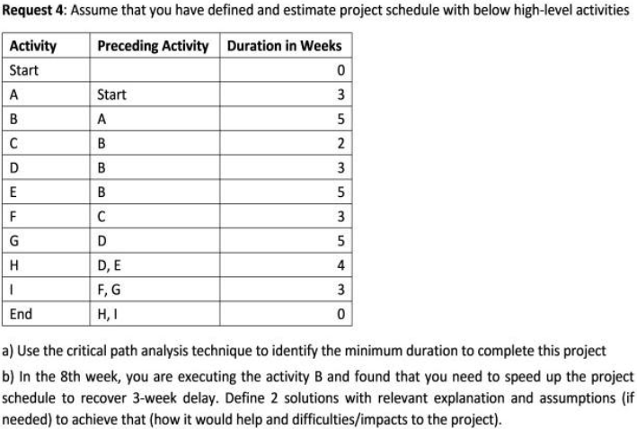

**Project Path Overview:**

* **Path 1:** Start -> A -> B -> C -> F -> I -> End (16 weeks)
* **Path 2 (Critical Path):** Start -> A -> B -> D -> G -> I -> End (19 weeks)
* **Path 3:** Start -> A -> B -> D -> H -> End (15 weeks)
* **Path 4:** Start -> A -> B -> E -> H -> End (17 weeks)

**Key Information:** The longest path, Path 2, defines the project's minimum timeframe of 19 weeks. Currently, the project is 3 weeks behind schedule, meaning the goal is to finish in 16 weeks.

**Current Status:** 8 weeks into the project, we're working on task B. To meet the new 16-week goal, tasks on the critical path (D, G, I) and the task on Path 4 (E) need to be shortened since Path 4 will exceed the new timeframe.

**Action Plan:**

1. **Reduce task G's duration** from 5 weeks to 2 weeks.
2. **Reduce task E's duration** by 1 week.

**Methods to Shorten Tasks:**

* **Add more people:** Bring additional team members to work on tasks G and E.
* **Increase working hours:** Have the team work extra hours on these tasks.
* **Offer incentives:** Provide rewards for early completion of tasks G and E.

**Request 5:**

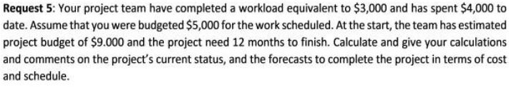

**# First, we need to define the given values from the image provided.**

**EV = 3000 # Earned Value**

**AC = 4000 # Actual Cost**

**PV = 5000 # Planned Value**

**BAC = 9000 # Budget at Completion**

**# We calculate the various project management metrics based on the given values.**

**CV = EV - AC # Cost Variance**

**SV = EV - PV # Schedule Variance**

**CPI = EV / AC # Cost Performance Index**

**SPI = EV / PV # Schedule Performance Index**

**# Now we calculate the forecast for completion in terms of cost and schedule.**

**EAC = BAC / CPI # Estimate at Completion for cost**

**ETC = EAC - AC # Estimate to Completion for cost**

**# For schedule, we need to calculate the time to complete based on the SPI.**

**# Assuming the project duration is in months and follows a linear progression.**

**DAC = 12 # Duration at Completion in months**

**EDAC = DAC / SPI # Estimated Duration at Completion in months**

**CV, SV, CPI, SPI, EAC, ETC, EDAC**

**Current Numbers:**

* **Value Earned (EV):** $3,000
* **Actual Cost (AC):** $4,000
* **Planned Value (PV):** $5,000
* **Total Budget (BAC):** $9,000
* **Planned Time (DAC):** 12 months

**Where We Stand:**

* **Cost Variance (CV):** We're $1,000 past the budget (EV - AC = -$1,000).
* **Schedule Variance (SV):** We're lagging by $2,000 worth of work (EV - PV = -$2,000).
* **Cost Performance Index (CPI):** Only getting $0.75 value for each $1 spent (EV/AC = 0.75).
* **Schedule Performance Index (SPI):** Progressing at 60% speed (EV/PV = 0.6).

**Current Status:** We're spending too much and moving too slowly. We should talk to our customer about more money and more time.

**Looking Forward:**

* **Estimated at Completion (EAC):** Might end up costing $12,000 in total (BAC/CPI = 9000/0.75).
* **Estimated Time to Complete (ETC):** Expect to need $8,000 more to finish (EAC - AC = 12000 - 4000).
* **Estimated Duration at Completion (EDAC):** Might take 20 months to finish (DAC/SPI = 12/0.6).