  L1 sp23

Q1:

Software Requirements Specification

for

EduNext

Version 1.0 approved

Prepared by

Nguyen Trong Nghia SE161777

FPT University HCM Campus

<March 28, 2023>

Q2:

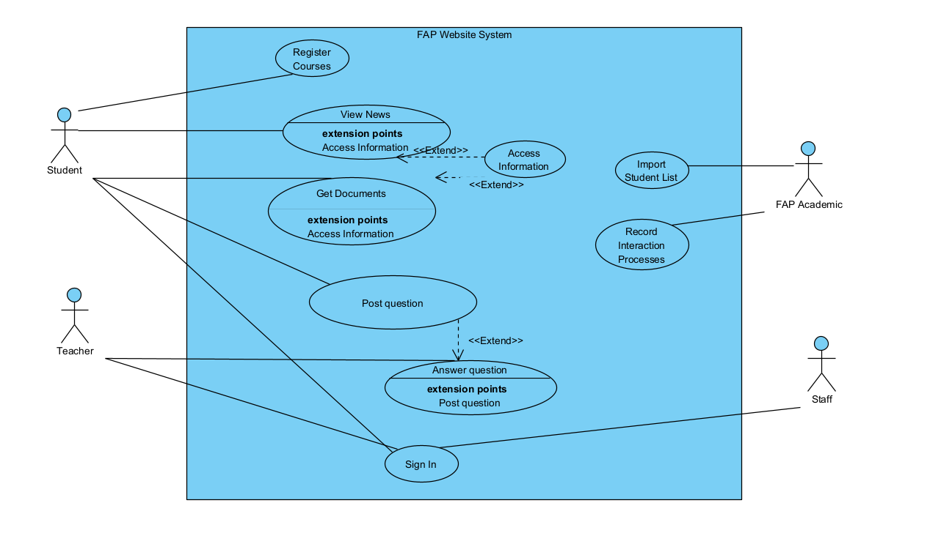

1. In this exam paper, the name of the rectangle is: FAP Website System
2. The actor may be human, other software systems or devices. In this exam paper, list the name of >= 3 actors is: Student, Teacher, Staff, FAP Academic
3. In this exam paper, list the name of >= 5 use cases are:

* Import Student List
* Sign In (using @fpt.edu.vn email accounts)
* View News
* Get Documents
* Access Information
* Register Courses
* Record Interaction Processes
* Post question
* Answer question

1. The actors are inside or outside of the rectangle ?

* The actors are outside of the rectangle.

1. The ovals represent the use cases are inside or outside of the rectangle ?

* The ovals represent the use cases inside of the rectangle.

1. The **primary actor** of the use case **register the courses** is: Student.
2. The **secondary actor** of the use case **register the courses** is: Teacher.
3. Based on the fact you already used FAP website. The use cases in this exam paper may have relationship.
4. List the name of two use cases that have extend relationship: Get Documents and Access Information
5. The name of base use case (in 8.a) is: Get Documents
6. The name of extended use case (in 8.a) is: Access Information
7. The dashed line with an arrow that points to which use case? : Get Documents
8. Based on the fact you already used FAP website. The use cases in this exam paper may have relationship.
9. List the name of two use cases that have include relationship: Post question and Answer question.
10. The name of based use case (in 9.a) is: Post question.
11. The name of extend use case (in 9s.a) is Answer question.
12. The dashed line with an arrow that points to which use case? : Answer question.

Q3: <Answer of Q3 by fill the content to below table that reflect this exam paper>

|  |  |  |  |
| --- | --- | --- | --- |
| UC ID and Name: | (0.1 point) the UC – 1 and the use case name here: Post question | | |
| Created By: | (0.1 point) minhlqse160929@fpt.edu.vn | Date Created: | (0.1 point) March 27, 2023 |
| Primary Actor: | (0.2 point) Student | Secondary Actors: | (0.2 point) Teacher |
| Trigger: | (0.3 point) Student want to post question | | |
| Description: | (0.1 point) This use case allows the student to post question | | |
| Preconditions: | 1. … (0.3 point) Must login with Student role 2. ….The system must be running | | |
| Postconditions: | …. (0.3 point) New question will be added to the system.  2. Redirect to the question detail page.  3. After posted, teacher can see and answer. | | |
| Normal Flow: | 1. (0.7 point) Login with student role 2. Student navigates to the post questions page. 3. Student enters question. 4. Student click the Submit button. 5. The system saves the question and displays a confirmation message | | |
| Alternative Flows: | 1. (0.7 point) N/A | | |
| Exceptions: | 1 (0.3 point) Question cannot add   1. Invalid field 2. Unexpected error 3. Internet connection lost. The system forwards to Lost Internet page. | | |
| Priority: | (0.1 point) High | | |
| Frequency of Use: | (0.1 point) Usually. | | |
| Business Rules: | (0.2 point) The question must be less than 4 sentences.  The question must be less than 17.500 characters.  Student must be trained to use application. | | |
| Other Information: | (0.1 point) N/A | | |
| Assumptions: | (0.1 point) The system must be ready and already set up to post new question. | | |

**Q4:** <The answer of Q4 must have detail and specific in number of 2 non-functional requirements>

The two non-functional requirements are:

**Performance Requirement:**   
**Statement 1:** The system must be able to handle a minimum of 1000 simultaneous users without slowing down or crashing. Explanation: This statement specifies the minimum number of users that the system should be able to handle without any performance issues. The tester can test the system's performance by simulating a load of 1000 users and measuring the response time of the system. If the response time is within the acceptable range, the test can be considered passed. If the response time is too slow or the system crashes, the test will fail.

**Statement 2**: The system must be able to generate a report within 10 seconds for a dataset of 10000 records. Explanation: This statement specifies the time it should take for the system to generate a report for a particular dataset. The tester can test the system's performance by generating a report for a dataset of 10000 records and measuring the time it takes for the system to complete the task. If the system generates the report within 10 seconds, the test can be considered passed. If it takes longer than 10 seconds, the test will fail.

**Security Requirement:**

**Statement 1**: The system must encrypt all sensitive data using AES 256-bit encryption. Explanation: This statement specifies the level of encryption that should be used to secure sensitive data in the system. The tester can test the system's security by attempting to access the sensitive data without the proper authentication and authorization. If the system does not allow access to the data, the test can be considered passed. If the data can be accessed without proper authentication and authorization or if the data is not encrypted, the test will fail.

**Statement 2:** The system must be able to generate a report within 10 seconds for a dataset of 10000 records. Explanation: This statement specifies the time it should take for the system to generate a report for a particular dataset. The tester can test the system's performance by generating a report for a dataset of 10000 records and measuring the time it takes for the system to complete the task. If the system generates the report within 10 seconds, the test can be considered passed. If it takes longer than 10 seconds, the test will fail.