PE_PRN231_SP24TrialTest
SUMMER 2024
Subject: PRN231
Duration: 90 minutes

INSTRUCTIONS
Please read the instructions carefully before doing the questions.
- You are NOT allowed to use any device to share data with others.
- You must use Visual Studio 2019 or above, MSSQL Server 2012 or above for your development tools.
IMPORTANT – before you start doing your solution, MUST do the following steps:
- Create Solution/Project in Visual Studio named PEPRN231_SP24TrialTest_StudentFullname_BE for API, and PEPRN231_SP24TrialTest_StudentCode_FE for Client Application. Set the default Client application for your project as Login page.
- Create your MS SQL database named WatercolorsPainting2024DB by running code in script WatercolorsPainting2024DB.sql.
- You are not allowed to connect directly to a database from ASP.NET Core Web API, every database connection must be used with Repository and Data Access Objects.
- The database connection string must get from the appsettings.json file. In the case your code connects direct to the database from ASP.NET Core Web API or hard coded the connection string, you will get 0 point.
- Please check before you submit your work, no syntax error(s) in the submitted PE. If there are syntax errors or compilation errors in your PE program, you will not pass the PE requirements, the point will be 0.
- Your work will be considered invalid (0 point) if your code inserts stuff that is unrelated to the test.

Implement a part of Watercolors Painting Application. The below Figure is a part of WatercolorsPainting2024DB database.
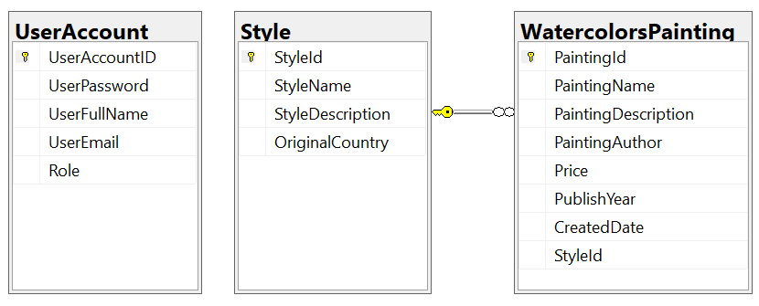
Note that: Member role: Administrator = 1; Staff = 2; Manager=3; Customer = 4. A Style will have many watercolors paintings, one watercolors painting will belong to only one Style.

Part 01 (7.0 points). Create an API using ASP.NET Core Web API with Entity Framework Core. A MS SQL Server database will be created to persist the data and it will be used for reading and managing data.

- Check authentication/authorization with the ASP.NET Core Web API with JSON Web Token (JWT)
- Manager role will have a permission to all actions (CRUD and search).
- Staff role will have only permission to search information.
Note that the permission for Authentication feature is using UserEmail and UserPassword.

- You must use OData to implement the ASP.NET Core Web API. CORS is using in this case.
- Implement CRUD actions with WatercolorsPainting table. Add new item with the requirements:
  - All fields are required.
  - Value for PaintingName includes a-z, A-Z, space and digit 0-9. Each word of the PaintingName must begin with the capital letter.
  - Value for PublishYear>=1000 and CreatedDate = current date.
  - The value for Price must be >= 0.
- Get all items includes all WatercolorsPainting information and StyleName.
- Search all items WatercolorsPainting table with 2 conditions: PaintingAuthor or PublishYear (using relative search)

Part 02 (3.0 points).
Student can choose one of these options for client application
- ASP.NET Core Web App with MVC
- ASP.NET Core Razor Pages
- Windows Forms
- Windows Presentation Foundation
- Authentication function
If user with a manager role or staff role logs in successfully, save this information to a temporary parameter.
- All CRUD actions are required with manager role
- Search information is required with manager role or staff role.
In the case login unsuccessfully, display “You are not allowed to access this function!”
- Check if login successfully, search all items with 2 conditions: PaintingAuthor or PublishYear (using relative search)
- Check if login successfully, delete the selected item with the confirmation then update the list of items.
- Check if login successfully, add new item with the requirements:
  - All fields are required.
  - Value for PaintingName includes a-z, A-Z, space and digit 0-9. Each word of the PaintingName must begin with the capital letter.
  - Value for PublishYear>=1000 and CreatedDate = current date.
  - The value for Price must be >= 0.

