PharmApp PDF Search Index
End-User Guide
For customers using the Windows EXE build
Version: 2026 release

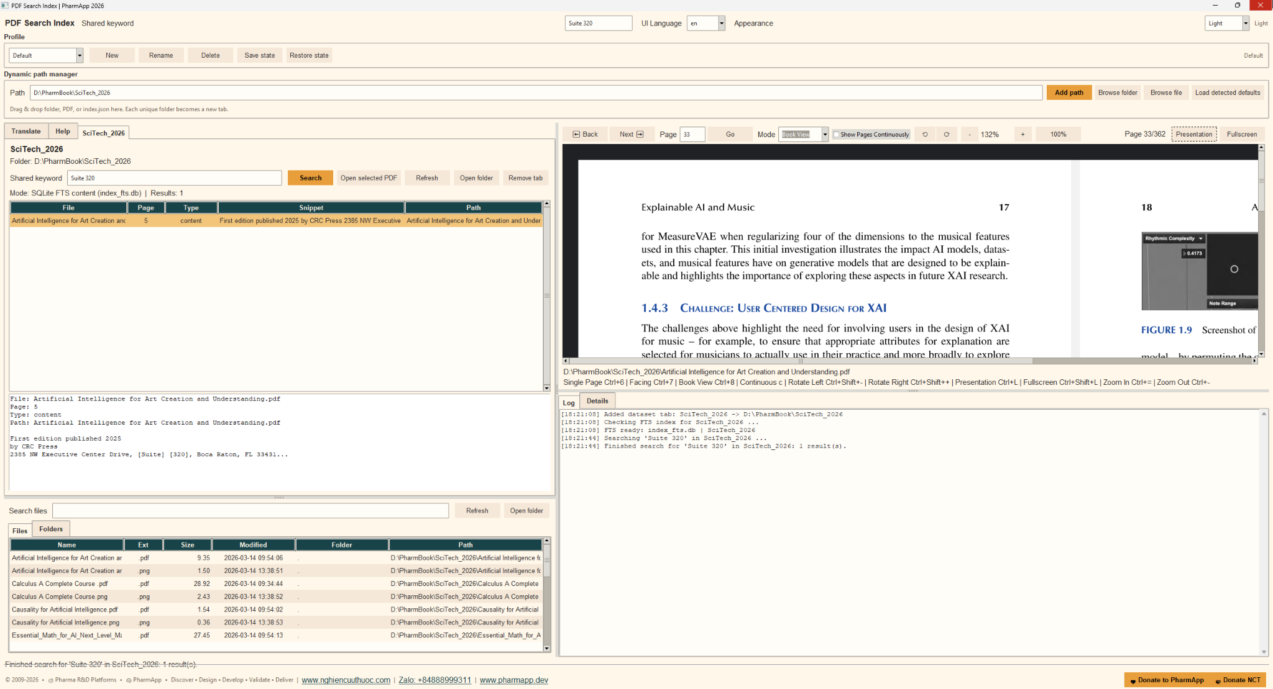
Application interface example

What this application does
- PharmApp PDF Search Index helps you search large PDF collections by indexed content or by PDF filename.
- If the selected folder already contains index_fts.db, searches use SQLite FTS for high speed.
- If the folder contains index.json but no index_fts.db, the application can create the FTS index automatically on first use or when the dataset is prepared.
- The application also includes a PDF viewer, file explorer, logging panel, and optional translation workflow.
Quick start
1. Launch PharmApp PDF Search Index.
2. In Dynamic path manager, paste a folder path or use Browse folder / Browse file / Add path.
3. Open the new dataset tab created from that folder.
4. Enter a keyword in Shared keyword or in the dataset keyword box.
5. Click Search.
6. Select a result to open the matching PDF page in the viewer.
7. Use Refresh if the source folder has changed.
Main screen areas
Area | Purpose
Dynamic path manager | Adds a folder, PDF, or index.json. Each unique folder becomes a dataset tab.
Dataset tabs | Each tab is an independent searchable library.
Search results panel | Shows file name, page, match type, snippet, and path.
PDF viewer | Opens the selected PDF and supports page navigation, zoom, rotation, facing/book view, continuous mode, presentation, and fullscreen.
Explorer | Lists files and folders inside the selected dataset.
Log / Details | Shows status messages, indexing activity, and selected result details.

Typical workflow
1. Add the document folder that contains your PDFs and optional index.json.
2. Wait for the application to check or build the FTS index if needed.
3. Search for a topic, phrase, code, compound, section title, or filename fragment.
4. Review the snippet in the result list.
5. Open the result and read the target page in the built-in viewer.
6. Use the explorer panel if you want to browse files manually.
About automatic indexing
- First-time setup may take longer when the application needs to create index_fts.db.
- After index_fts.db is available, repeated searches are much faster.
- Keep index.json and the PDF folder together when possible.
- If documents are updated, use Refresh so the application can re-check the dataset.
Tips and troubleshooting
- No results: confirm that you opened the correct dataset tab and that the keyword is spelled correctly.
- Slow first search: this is normal when the FTS index is being created.
- PDF did not open: confirm that the PDF file still exists in the dataset folder.
- Updated source files: click Refresh after adding, removing, or replacing PDFs.
- Use concise keywords first, then refine with longer phrases if needed.
Useful viewer controls
Single Page: Ctrl+6 | Facing: Ctrl+7
Book View: Ctrl+8 | Continuous mode: c
Zoom in / out: Ctrl+= / Ctrl+- | Rotate left / right: Ctrl+Shift+- / Ctrl+Shift++
Presentation: Ctrl+L | Fullscreen: Ctrl+Shift+L
For regulated, technical, or large-scale libraries, PharmApp is most effective when the dataset folder is kept organized and the search index is allowed to complete before heavy use.

