Contents
I. INTRODUCTON 3
1.1 Background 3
1.2 Research Questions 6
1.3 Research Objectives 6
1.4 Research Contributions 7
1.5 Scope of the Study 7
II. LITERATURE REVIEW 8
2.1 Educational Data Mining (EDM) Paradigm 8
2.2 Social Network Analysis (SNA) 8
2.3 Centrality Measures in Social Network Analysis (SNA) 9
2.4 Temporal Dimension in Educational Data Mining (EDM) 10
2.5 Comparative Tree-Based Classification Algorithms 10
2.6 Early Warning Systems (EWS) in Education 12
2.7 Synthesis of Previous Studies and State-of-the-Art Mapping 12
III. RESEARCH METHODOLOGY 15
3.1 Research Framework 15
3.2 Data Preparation 17
3.3 Data Preprocessing and Stratified Data Splitting 17
3.4 Social Network Analysis (SNA) Feature Engineering 18
3.5 Temporal Feature Construction 18
3.6 Comparative Classification Modeling 19
3.7 Hyperparameter Optimization 20
3.8 Model Evaluation and Early Warning System (EWS) Prototype 21
IV. RESULTS AND DISCUSSION 23
4.1 Comparative Classification Performance 23
4.2 Feature Contribution and Model Interpretability (SHAP Analysis) 28
4.3 Early Warning System (EWS) Prototype and Intervention Zoning 29
V. CONCLUSION AND RECOMMENDATIONS 35
5.1 Conclusions 35
5.2 Theoretical and Practical Contributions 36
5.3 Limitations and Future Work 37
VI. References 38

INTRODUCTON

Background
High-quality education serves as the fundamental foundation for developing intelligent and globally competitive graduates. As stated by Afandi et al. (2024), student graduation rates constitute one of the primary indicators used to evaluate the performance of academic institutions while simultaneously reflecting the effectiveness of educational delivery. Achieving high-quality graduates requires an academic performance assessment mechanism capable of identifying potential learning-related problems at an early stage throughout the educational process. This challenge has become increasingly significant as student dropout remains a persistent issue faced by higher education institutions worldwide, with the highest risk occurring during the first year of study before gradually declining in subsequent years (Paura et al., 2025). A similar phenomenon is also observed in digital education ecosystems, where the transition toward online learning platforms is accompanied by high rates of academic failure and increasing numbers of students discontinuing their studies within virtual learning environments (Althibyani, 2024).
Indonesia's low higher education participation rate, recorded at only six percent in 2022, requires higher education institutions to place greater emphasis on students' psychological well-being as a strategy to reduce dropout rates (Afandi et al., 2024). This limited access implies that every student who successfully gains admission to a university bears the responsibility of completing their studies successfully, while institutions are equally expected to ensure their students' academic achievement through graduation. This expectation has become even more pronounced following the shift in higher education funding policies toward a performance-based model, in which financial support is allocated according to student graduation rates rather than merely the number of enrolled students (Paura et al., 2025). This change in the funding mechanism further underscores the importance of identifying and predicting the factors contributing to student dropout as a foundation for developing more effective intervention strategies (Paura et al., 2025). Consequently, artificial intelligence (AI)-based student academic performance prediction systems have become increasingly essential for supporting the early identification of students at risk of academic failure while improving overall academic success (Afandi et al., 2024).
Research in the field of Educational Data Mining (EDM) generally utilizes large-scale administrative datasets to predict students' academic performance. However, most existing models still rely primarily on individual activity logs, such as access duration and click frequency, and therefore fail to adequately capture the dynamics of social interactions among students (Althibyani, 2024). Social Network Analysis (SNA) offers a more comprehensive perspective by modeling the social relationships among students. Nevertheless, its implementation has thus far been dominated by studies based on relatively small-scale datasets, limiting the generalizability of the resulting models (Afandi et al., 2024). Centrality measures, such as Degree Centrality and Closeness Centrality, are theoretically regarded as effective indicators for identifying patterns of collaboration, peer influence, and information flow that cannot be captured by conventional EDM approaches (Singh et al., 2025). This gap indicates that the potential integration of large-scale administrative data with SNA-based relational information has not yet been fully exploited in the development of academic performance prediction models. Accordingly, this study is designed to bridge this gap by integrating large-scale administrative datasets with SNA-derived relational feature extraction, with the aim of developing a more holistic and representative model for predicting students' academic performance.
Contemporary Educational Data Mining (EDM) models are still predominantly based on single-time-point measurements, relying primarily on historical academic achievement as the main source for predicting student performance. In reality, the predictive power of individual variables is dynamic, as academic indicators such as Grade Point Average (GPA) have been shown to contribute strongly during the early stages of study but are gradually surpassed by behavioral and social integration indicators as students progress through their academic journey (Glandorf et al., 2024). Academic success is also determined not only by individual capabilities but also by the quality of long-term social relationships, which provide access to information, resources, and emotional support throughout higher education (Saqr et al., 2020). A student's position within a social network, represented through centrality measures, has been identified as a significant predictor of academic achievement because it reflects the intensity of information exchange and the strength of peer relationships (Saqr et al., 2020). Consequently, prediction models that rely solely on historical academic data without accounting for temporal dynamics and the relational characteristics among students may produce less accurate estimates of academic risk, particularly during critical stages of students' educational trajectories.

This study proposes a more comprehensive approach to academic performance prediction by integrating Social Network Analysis (SNA) into the Educational Data Mining (EDM) framework while incorporating the temporal dimension. The proposed approach is designed to extract students' social characteristics through centrality measures that represent collaboration patterns, information flow, and peer influence, while simultaneously accounting for changes in the predictive strength of individual variables throughout students' academic trajectories (Glandorf et al., 2024; Saqr et al., 2020). Model development will utilize the Open University Learning Analytics Dataset (OULAD) as the primary data source, as it provides large-scale information on students' academic records and learning activities that is well suited for extracting both administrative and relational features. The resulting data representations will subsequently be evaluated using three classification algorithms, XGBoost, Random Forest, and Decision Tree, to identify the model that achieves the highest predictive performance in forecasting students' academic outcomes. Ultimately, the proposed approach is expected to produce a more representative prediction model that supports the development of timely, evidence-based academic intervention strategies.
Predictions of academic performance and the risk of academic failure serve not only as analytical outputs but also as a foundation for designing timely and targeted interventions for students who require additional support (Althibyani, 2024). The predictive capabilities of artificial intelligence algorithms provide higher education institutions with opportunities to identify at-risk students and develop intervention strategies that enhance student retention and academic success (Paura et al., 2025). This study aims to develop an academic performance prediction model by integrating administrative data with social network characteristics derived from the Open University Learning Analytics Dataset (OULAD). Furthermore, it compares the performance of three classification algorithms, XGBoost, Random Forest, and Decision Tree, using a consistent evaluation framework to identify the best-performing model. The resulting insights are expected to assist instructors and academic program administrators in designing more personalized learning experiences, including tailored instructional strategies and adaptive scaffolding that address the characteristics and learning needs of individual students (Hashemifar et al., 2025). Ultimately, this study is expected to make a practical contribution to the development of decision support systems in higher education by providing a more adaptive and accurate prediction model capable of supporting improvements in the quality of academic services.

Research Questions
Based on the background presented above, the research questions addressed in this study are as follows:
- How can a hybrid feature representation integrating Social Network Analysis (SNA) characteristics, Virtual Learning Environment (VLE) administrative logs, and temporal features from the Open University Learning Analytics Dataset (OULAD) be designed and implemented to develop a student academic performance prediction model?
- How do the XGBoost, Random Forest, and Decision Tree algorithms compare in predicting students' academic performance using the proposed hybrid feature representation, as evaluated by the Accuracy, Precision, Recall, and F1-score metrics?
- How do the contributions (feature importance) of administrative features, Social Network Analysis (SNA) features, and temporal features change across different observation periods, and how do these changes affect the predictive performance of the resulting models?
- How can an Early Warning System (EWS) prototype be developed and evaluated based on the best-performing prediction model to enable the early identification of students at risk of declining academic performance?

Research Objectives
Based on the research questions formulated above, the objectives of this study are as follows:
- To develop a student academic performance prediction model by integrating a hybrid feature representation that combines Social Network Analysis (SNA) characteristics, Virtual Learning Environment (VLE) administrative logs, and temporal features derived from the Open University Learning Analytics Dataset (OULAD).
- To compare the performance of the XGBoost, Random Forest, and Decision Tree algorithms in predicting students' academic performance using the proposed hybrid feature representation, as evaluated by the Accuracy, Precision, Recall, and F1-score metrics.
- To analyze the changes in the contributions (feature importance) of administrative features, Social Network Analysis (SNA) features, and temporal features across different observation periods, as well as their impact on the predictive performance of the resulting models.
- To develop and evaluate an Early Warning System (EWS) prototype based on the best-performing prediction model for the early identification of students at risk of declining academic performance.

Research Contributions
This study is expected to provide the following contributions:
- To contribute to the advancement of Educational Data Mining (EDM) methodologies by integrating Social Network Analysis (SNA) features, Virtual Learning Environment (VLE) administrative data, and temporal features from the Open University Learning Analytics Dataset (OULAD), thereby enriching academic performance prediction approaches with a more comprehensive and interpretable framework.
- To provide an Early Warning System (EWS) prototype based on the best-performing prediction model that can support higher education institutions in decision-making processes for identifying at-risk students and implementing timely, data-driven academic intervention strategies.
- To provide insights into students' academic risk levels, feature importance characteristics, and the dynamic factors influencing academic performance, thereby enabling instructors to design more effective academic support, adaptive learning strategies, and targeted interventions tailored to the individual learning needs of students.

Scope of the Study
The scope and limitations of this study are defined as follows:
- This study uses the Open University Learning Analytics Dataset (OULAD) as the sole data source, comprising administrative data, Virtual Learning Environment (VLE) activity logs, and other supporting information. Accordingly, the study does not incorporate data from social media platforms, other Learning Management Systems (LMSs), or any external data sources beyond OULAD.
- The Social Network Analysis (SNA) is limited to the extraction of network topology metrics, specifically Degree Centrality and Closeness Centrality, derived from student-to-student relationships. Consequently, the study does not include discussion forum text analysis using Natural Language Processing (NLP), sentiment analysis, or other forms of unstructured data processing.
- The predictive modeling is restricted to a comparative evaluation of the XGBoost, Random Forest, and Decision Tree classification algorithms using the proposed hybrid feature representation.
- The research output is limited to the development and evaluation of an Early Warning System (EWS) prototype as a decision support framework based on the prediction results.

LITERATURE REVIEW

Educational Data Mining (EDM) Paradigm
Educational Data Mining (EDM) is a research field that focuses on the application of computational methods to analyze educational data and discover patterns that facilitate a deeper understanding of learning processes (Romero & Ventura, 2020). The EDM paradigm leverages various sources of educational data, including learning activity records and student characteristics, which are subsequently analyzed using machine learning techniques to predict students' academic outcomes (Rajendran et al., 2022).
One of the most widely used datasets in Educational Data Mining (EDM) research is the Open University Learning Analytics Dataset (OULAD), which provides records of students' activities within the Virtual Learning Environment (VLE), together with academic outcome data for the development of predictive models (Althibyani, 2024). EDM studies based on OULAD typically utilize individual activity logs, such as students' interaction patterns with online learning materials, as predictive features for academic success (Althibyani, 2024). However, these approaches primarily focus on individual learning behaviors and therefore do not explicitly incorporate information regarding the social relationships among students within the learning environment.

Social Network Analysis (SNA)
Modern learning ecosystems are influenced by the concept of social capital, which refers to the benefits derived from long-term social relationships, including access to informational resources and emotional support (Saqr et al., 2020). Social interactions within educational environments can be classified into several network types, such as student–teacher networks, which represent relationships between instructors and students, and peer-to-peer networks, which capture collaborative relationships among students (Singh et al., 2025). In computer science, these interaction structures can be mathematically represented as a formal graph, (G=(V,E)), consisting of a set of vertices and edges (Arif, 2015; Kahari, 2021). The set (V) denotes the vertices (or nodes) representing entities within the network, whereas the set (E) represents the edges that define the relationships connecting these entities (Arif, 2015; Kahari, 2021).
Graph-based analysis through Social Network Analysis (SNA) has been widely employed to investigate social relationships in educational settings. Learning activity data can be utilized to construct peer relationship networks, enabling the analysis of the associations between social network structures and students' academic performance (Zhou et al., 2023). Afandi et al. (2024) demonstrated that mapping student relationships using SNA can effectively support the analysis of academic performance based on social network characteristics. Nevertheless, the application of SNA in educational research has largely been confined to relatively small-scale datasets, leaving its implementation on large-scale educational datasets as an important avenue for further investigation (Afandi et al., 2024). Accordingly, this study employs SNA-based graph feature extraction on a large-scale administrative dataset to incorporate relational information into an academic performance prediction model.

Centrality Measures in Social Network Analysis (SNA)
Degree centrality is a network centrality measure used to quantify the level of direct connectivity of an actor within an academic social network (Laghridat & Essalih, 2023). This metric represents the number of direct connections an entity has with other members of the network and can be used to characterize the level of local interaction of a node (Saxena & Iyengar, 2020). The normalized degree centrality is calculated using the following equation:
$$C_{D}\left(v\right)=\frac{\deg\left(v\right)}{N-1}$$
where ($C_{D}\left(v\right)$) denotes the degree centrality of node (v), ($\deg\left(v\right)$) represents the number of direct connections associated with node (v), and (N) is the total number of nodes in the network (Kahari, 2021; Laghridat & Essalih, 2023). In the context of technology-enhanced learning, this metric can be employed to identify students who exhibit higher levels of direct interaction within a learning network.
Closeness centrality is a network centrality measure used to quantify the proximity of an actor to all other members of a network based on the shortest path distances between nodes (Arif, 2015). This metric reflects the ability of a node to access or disseminate information efficiently throughout the network by considering the lengths of the shortest paths to all other nodes (Kahari, 2021). Closeness centrality is calculated using the following equation:
$$C_{C}\left(v\right)=\frac{N-1}{\sum_{u≠v}{d}\left(u,v\right)}$$
where ($C_{C}\left(v\right)$) denotes the closeness centrality of node (v), (N) is the total number of nodes in the network, and ($d\left(u,v\right)$) represents the length of the shortest path between nodes (u) and (v) (Arif, 2015; Saxena & Iyengar, 2020). The combined use of degree centrality and closeness centrality provides a more comprehensive representation of network structure, as these measures capture complementary aspects of social connectivity by describing both the direct connectedness of an actor and its relative position within the network's information flow.

Temporal Dimension in Educational Data Mining (EDM)
The temporal dimension in Educational Data Mining (EDM) emphasizes the importance of analyzing changes in students' learning behaviors over time rather than relying solely on static data representations (Hidayat et al., 2026). A temporal approach enables learning activity data to be partitioned into multiple observation periods (snapshots), facilitating the identification of evolving patterns of student engagement throughout the learning process (Hidayat et al., 2026). Segmenting data into successive observation periods provides insights into behavioral changes that may not be observable when all learning activities are aggregated into a single static representation.
The importance of the temporal dimension is further supported by research on student dropout prediction, which demonstrates that the contribution of individual features to prediction outcomes may vary throughout students' academic trajectories (Glandorf et al., 2024). Certain variables may exhibit stronger predictive power during the early stages of study, whereas others become more influential in later stages, making the selection of observation periods a critical factor in predictive modeling (Glandorf et al., 2024). This concept of temporal variability forms the foundation of the present study, which adopts a snapshot-based temporal approach to examine changes in feature contributions and their impact on the predictive performance of academic performance prediction models.

Comparative Tree-Based Classification Algorithms
2.5.1 Decision Tree
Decision Tree is a supervised classification algorithm that constructs a decision tree by recursively partitioning the dataset based on the values of selected features (Costa et al., 2025). The node-splitting process is performed by evaluating the class purity of each data partition. One of the most widely used criteria for assessing split quality is the Gini Impurity, which is defined as follows:
$$Gini\left(S\right)=1-\sum_{i=1}^{n}{P_{i}^{2}}$$
where (S) denotes the dataset associated with a given node, (n) represents the number of target classes, and ($P_{i}$) is the proportion of samples belonging to the (i)-th class within that node (Costa et al., 2025). A lower Gini Impurity value indicates a higher level of class purity after the split. Although Decision Tree models are highly interpretable due to their intuitive tree structure, they are prone to overfitting when the tree becomes excessively complex and appropriate regularization or pruning mechanisms are not applied (Costa et al., 2025).
2.5.2 Random Forest
Random Forest is an ensemble learning algorithm that combines multiple Decision Trees to produce a more robust and stable classification model than a single decision tree (Rajendran et al., 2022). The algorithm employs the bootstrap aggregating (bagging) technique by constructing multiple decision trees from different bootstrap samples drawn from the training dataset (Costa et al., 2025). In addition to bootstrap sampling, Random Forest randomly selects a subset of features during the tree construction process to increase diversity among the individual models. The final classification is determined through a majority voting mechanism across all constructed trees (Rajendran et al., 2022). This ensemble approach reduces model variance and mitigates several limitations of a single Decision Tree, particularly with respect to its ability to generalize to unseen data (Costa et al., 2025).
2.5.3 XGBoost (eXtreme Gradient Boosting)
XGBoost is a gradient boosting algorithm that incrementally constructs a predictive model by combining multiple decision trees (Taqatqeh & Agoyi, 2026). Unlike Random Forest, which builds decision trees independently, XGBoost generates trees sequentially, with each new tree designed to correct the prediction errors made by the preceding model (Wiens et al., 2025). The learning process is driven by the optimization of an objective function that simultaneously minimizes prediction error and incorporates regularization terms to control model complexity (Wiens et al., 2025; Taqatqeh & Agoyi, 2026). One formulation of the split evaluation score used in XGBoost can be expressed as follows:
$$SS=\frac{{\left(\sum{r}esidual_{i}\right)}^{2}}{\sum{\left[prior_{p}i\left(1-prior_{p}i\right)\right]}+λ}$$
where (SS) denotes the similarity score of a leaf node, (residual_i) represents the residual error of the (i)-th observation, ($prior_{pi}$) denotes the predicted probability obtained from the previous boosting iteration, and ($λ$) is the regularization parameter used to control model complexity (Wiens et al., 2025). The sequential boosting mechanism and the incorporation of regularization make XGBoost one of the most widely adopted algorithms for modeling tabular datasets with complex feature characteristics (Taqatqeh & Agoyi, 2026).

Early Warning Systems (EWS) in Education
Early Warning Systems (EWS) in educational settings are predictive frameworks designed to identify students who are at risk of experiencing academic difficulties, thereby enabling timely intervention and support (Taqatqeh & Agoyi, 2026). EWS leverages data-driven prediction models to assist educational institutions in understanding students' academic conditions and determining appropriate intervention strategies. This predictive approach addresses the limitations of conventional academic evaluation, which often occurs only after academic problems have emerged, by providing risk assessments before academic failure takes place (Taqatqeh & Agoyi, 2026).
The development of modern EWS has increasingly shifted toward more interpretable analytical approaches through techniques such as Explainable Artificial Intelligence (XAI), which facilitate the identification of factors contributing to prediction outcomes (Taqatqeh & Agoyi, 2026). Consequently, prediction results extend beyond simple risk scores by providing insights into the factors associated with students' academic conditions. Furthermore, the concept of prescriptive learning analytics expands the utility of predictive models by analyzing potential behavioral changes and intervention strategies based on patterns identified from student data (Hidayat et al., 2026).
In addition to predictive capability, the temporal dimension has become an important consideration in the development of early warning systems. Paura et al. (2025) demonstrated that dropout risk analysis can incorporate temporal information to identify periods during which students face varying levels of academic risk. This concept provides the foundation for the present study, which aims to develop an EWS prototype based on an academic performance prediction model that integrates administrative features, Social Network Analysis (SNA) features, and temporal features.

Synthesis of Previous Studies and State-of-the-Art Mapping
A review of previous studies indicates that research on student academic performance prediction has evolved from approaches based on learning activity logs to those incorporating the analysis of social structures within educational environments. Romero and Ventura (2020) introduced the Educational Data Mining (EDM) paradigm through the knowledge discovery process and the application of machine learning techniques to educational data. However, their work remained primarily conceptual and did not focus on the empirical evaluation of predictive algorithms using large-scale datasets. Rajendran et al. (2022) applied Random Forest and Gradient Boosting algorithms to institutional academic data by exploring demographic and academic performance features. Nevertheless, their approach remained static and did not account for social interactions among students.
The use of large-scale educational datasets was subsequently advanced by Althibyani (2024), who employed the Open University Learning Analytics Dataset (OULAD) to develop machine learning-based classification models using Virtual Learning Environment (VLE) activity logs and students' assessment scores. Despite the comprehensive scope of the dataset, the proposed approach focused primarily on individual learning behaviors and did not incorporate graph-based representations of students' social relationships. A different perspective was presented by Afandi et al. (2024), who applied Social Network Analysis (SNA) to investigate the structure of student relationships. However, their study was conducted on a relatively small dataset, thereby limiting the generalizability of the resulting models.
The incorporation of the temporal dimension has also gained increasing attention. Glandorf et al. (2024) analyzed changes in the predictive strength of dropout indicators using longitudinal student data, highlighting the importance of accounting for temporal dynamics in predictive modeling. However, their study did not integrate graph-based relational features into the temporal analysis. Similarly, Paura et al. (2025) employed a Cox proportional hazards model for survival analysis to estimate both the risk and timing of student dropout based on institutional administrative data. Nevertheless, their work focused primarily on time-to-event risk estimation and did not evaluate the comparative performance of modern classification algorithms.
Recent studies have also focused on advancing tree-based predictive algorithms. Wiens et al. (2025) investigated the optimization of the XGBoost algorithm for heterogeneous tabular data through regularization techniques; however, their study was not specifically conducted within the educational domain. Taqatqeh and Agoyi (2026) developed an Early Warning System architecture employing Decision Tree, Random Forest, XGBoost, and SHAP to support academic risk prediction. Nevertheless, the feature engineering process was limited to administrative attributes and did not incorporate temporally evolving social network information. Hidayat et al. (2026) introduced a snapshot-based temporal approach by extracting temporal velocity features from students' digital learning activity logs. However, their analysis of behavioral dynamics did not consider changes in students' structural positions within social networks.
Based on this review, previous studies remain constrained by the separation of three key perspectives: large-scale administrative data analysis, temporal modeling, and the exploration of students' social network structures. To date, limited research has integrated graph-based centrality measures, particularly Degree Centrality and Closeness Centrality, with temporal representations in large-scale educational datasets such as the Open University Learning Analytics Dataset (OULAD), while simultaneously evaluating their predictive effectiveness using Decision Tree, Random Forest, and XGBoost. This research gap forms the primary motivation for the present study, which proposes a hybrid-feature academic performance prediction model that integrates Educational Data Mining (EDM), Social Network Analysis (SNA), and temporal modeling as the foundation for the development of an Early Warning System (EWS) prototype.
The state-of-the-art mapping further reveals a clear methodological divide between studies utilizing large-scale administrative datasets and those focusing on students' social interactions. Research based on datasets such as OULAD has predominantly relied on individual learning activity logs, whereas Social Network Analysis (SNA) has largely been applied to relatively small-scale network datasets. The integration of graph centrality measures, particularly Degree Centrality and Closeness Centrality, with snapshot-based temporal representations in large-scale administrative educational datasets remains an underexplored research area. This gap provides the foundation for the present study, which aims to develop a hybrid-feature academic performance prediction model by integrating Educational Data Mining (EDM), Social Network Analysis (SNA), and tree-based classification modeling, thereby establishing a robust foundation for the development of an Early Warning System (EWS) prototype.

RESEARCH METHODOLOGY

Research Framework
This study is conducted through a series of interconnected stages to develop a student academic performance prediction model by integrating Social Network Analysis (SNA), Educational Data Mining (EDM), and the temporal dimension. In general, the research workflow, beginning with data preparation and concluding with the development of an Early Warning System (EWS) prototype, is illustrated in Figure 1.
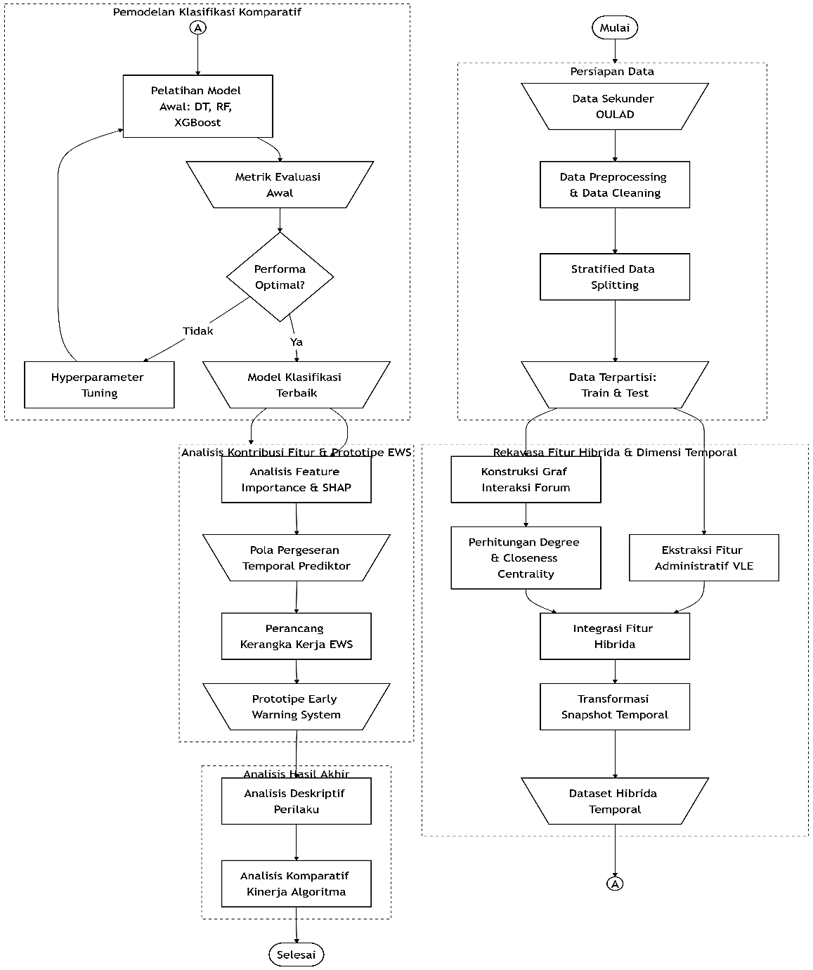
Figure 1. Research workflow
The detailed description of each stage in the research workflow is presented as follows:
- Data Preparation
The initial stage of this study utilizes the Open University Learning Analytics Dataset (OULAD) as the primary data source. This stage includes data preprocessing and data cleaning to ensure that the dataset is suitable for subsequent modeling tasks. The processed dataset is then partitioned into a training set and a testing set, which serve as the basis for evaluating the predictive performance of the developed models.
- Hybrid Feature Engineering and Temporal Representation
The feature engineering stage involves integrating administrative information, Virtual Learning Environment (VLE) activity data, and Social Network Analysis (SNA)-based relational features. Student interaction data are transformed into a graph structure to derive centrality measures, including Degree Centrality and Closeness Centrality. These features are subsequently combined into a hybrid feature representation and organized according to temporal observation periods (temporal snapshots) to capture changes in students' characteristics over time.
- Comparative Classification Modeling
The modeling stage is conducted by implementing three tree-based classification algorithms: Decision Tree, Random Forest, and XGBoost. These algorithms are trained using the proposed temporal hybrid feature representation and subsequently evaluated using the classification metrics of Accuracy, Precision, Recall, and F1-score. The best-performing model is selected as the foundation for the subsequent stage of the study.
- Feature Contribution Analysis and EWS Prototype Development
The best-performing model is subsequently analyzed using a feature importance approach to determine the contribution of each feature to the prediction outcomes. This analysis provides insights into the respective roles of administrative features, Social Network Analysis (SNA) features, and temporal features in the classification process. The resulting predictive model is then used as the foundation for designing an Early Warning System (EWS) prototype to identify students who are at risk of experiencing a decline in academic performance.
- Analysis of Research Findings
The final stage of the study involves analyzing the comparative performance of the classification algorithms and the patterns of feature contributions identified by the best-performing model. This analysis aims to address the research questions by evaluating the effectiveness of the proposed prediction model, the impact of the temporal dimension, and the contribution of social network features in improving the prediction of students' academic performance.

Data Preparation
This study employs the Open University Learning Analytics Dataset (OULAD) as the primary secondary data source for predicting students' academic performance. OULAD is a heterogeneous relational dataset consisting of seven interconnected CSV tables that collectively represent demographic information, learning interaction logs, and academic assessment records (Althibyani, 2024). The complete experimental dataset is publicly available through the Kaggle repository at: https://www.kaggle.com/datasets/anlgrbz/student-demographics-online-education-dataoulad.
Data extraction is performed by selecting the relational tables that are relevant to the proposed hybrid feature engineering process. Students' demographic characteristics and baseline profile information are obtained from the studentInfo table, while course enrollment and withdrawal records are retrieved from the studentRegistration table. Daily learning activity logs within the Virtual Learning Environment (VLE) are extracted from the studentVle and vle tables. Academic assessment components and students' assessment outcomes are obtained by integrating the assessments and studentAssessments tables (Althibyani, 2024). The integration of these relational tables constitutes the primary computational foundation for constructing both administrative and social relational features within a temporal framework.

Data Preprocessing and Stratified Data Splitting
The data preprocessing stage is conducted to prepare the OULAD dataset for the subsequent classification modeling process. The initial preprocessing procedures include assessing data quality and handling missing values in the attributes utilized in this study. Missing values are addressed using appropriate imputation techniques to preserve the number of observations while ensuring that the dataset is suitable for subsequent analysis.
Following data cleaning, the processed dataset is partitioned into a training set and a testing set using the stratified data splitting approach. This technique preserves the distribution of the target classes across both subsets, ensuring that the training and evaluation processes remain representative of the original dataset. The target variable in this study consists of three categories: Pass, Fail, and Withdrawn. Stratified partitioning therefore provides a more reliable and representative evaluation of model performance based on the selected classification metrics.

Social Network Analysis (SNA) Feature Engineering
The Social Network Analysis (SNA) feature engineering stage transforms student interaction data into a graph-based network representation. The network is modeled as a formal graph ($G=\left(V,E\right)$), where (V) represents the set of nodes corresponding to individual students, and (E) denotes the interaction relationships among students within the network (Arif, 2015; Kahari, 2021). This graph representation is employed to characterize the social interaction patterns that emerge from students' activities in the digital learning environment.
The constructed interaction graph is subsequently represented as an adjacency matrix, which serves as a data structure describing the relationships among nodes in the network (Saxena & Iyengar, 2020). This matrix forms the basis for computing network metrics that capture the structural characteristics of each student within the academic social network. In this study, two centrality measures, Degree Centrality and Closeness Centrality, are employed to represent students' levels of direct connectivity and their relative positions within the network's information flow, respectively. The resulting centrality measures are then integrated with administrative features and learning activity features to construct the proposed hybrid feature representation for the subsequent prediction modeling stage.

Temporal Feature Construction
The temporal feature construction stage is performed by partitioning students' activity data according to the chronological sequence of observations throughout the academic period. Interaction log data are organized into multiple temporal snapshots, each representing students' learning activities during a specific observation period, such as the first and second halves of the academic semester (Hidayat et al., 2026). This temporal segmentation is intended to capture changes in students' learning behaviors over time, enabling the resulting features to represent behavioral dynamics rather than merely the aggregated learning activities across the entire semester.

This temporal approach is motivated by the observation that the predictive relevance of academic indicators may evolve throughout students' academic trajectories (Glandorf et al., 2024). Each temporal snapshot is subsequently used as a separate data representation during the modeling stage to analyze the contributions of administrative features, Social Network Analysis (SNA) features, and learning activity features to the prediction outcomes. This transformation produces a temporal hybrid feature representation that integrates administrative information, learning behavior, and students' social network characteristics as input to the classification algorithms.

Comparative Classification Modeling
The modeling stage is conducted through a comparative experimental framework involving three tree-based classification algorithms: Decision Tree, Random Forest, and XGBoost. These algorithms are selected to evaluate how different modeling approaches influence the prediction of students' academic performance using the proposed temporal hybrid feature representation. Model training is performed using the engineered feature set, which integrates administrative information, learning activity data, Social Network Analysis (SNA) features, and temporal features, as illustrated in Figure 2.
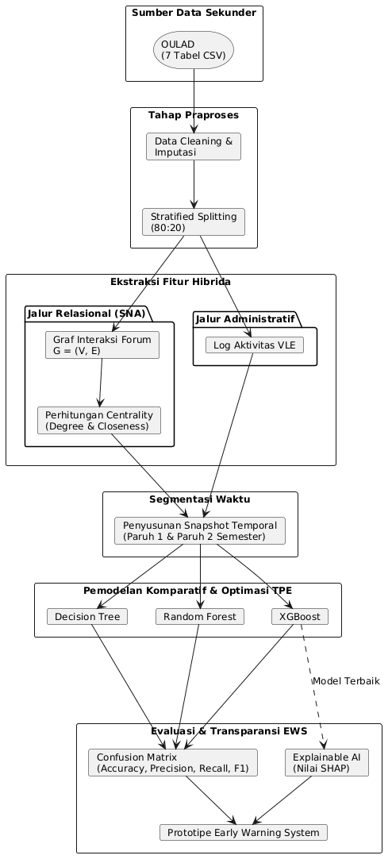
Figure 2. Architecture of the temporal hybrid prediction pipeline

The selection of tree-based algorithms is motivated by the tabular nature of the dataset, which consists of heterogeneous feature types. Decision Tree serves as the baseline single-tree model, whereas Random Forest and XGBoost are employed as ensemble learning approaches for comparison with the baseline. To ensure an objective comparison, all three models are trained and evaluated under an identical experimental protocol.

Model training is performed independently for each temporal snapshot generated during the previous stage. The prediction results produced by each algorithm are subsequently evaluated using the classification metrics of Accuracy, Precision, Recall, and F1-score. The comparative evaluation of these metrics is used to identify the algorithm that delivers the best predictive performance in classifying students' academic performance categories.

Hyperparameter Optimization
The hyperparameter optimization stage is conducted to determine the optimal parameter configuration for each classification algorithm employed in this study. The optimization process utilizes the Tree-structured Parzen Estimator (TPE), a Bayesian optimization approach that systematically searches for the optimal combination of hyperparameters within a predefined search space (Hidayat et al., 2026). Compared with manual parameter selection, this approach enables a more efficient and systematic exploration of candidate hyperparameter configurations.

The optimization process focuses on the principal hyperparameters that substantially influence model learning, including learning rate, maximum tree depth (max_depth), and number of estimators (n_estimators) for the algorithms that support these parameters. Each hyperparameter configuration is evaluated using the training dataset for each temporal snapshot generated in the previous stage. Model performance metrics are used as the optimization objective to identify the configuration that yields the best predictive performance.

The selected hyperparameter configuration is subsequently adopted as the final model configuration for the evaluation stage. This process ensures that each classification algorithm is evaluated under its optimal parameter settings before comparative performance assessment using the classification metrics of Accuracy, Precision, Recall, and F1-score.

Model Evaluation and Early Warning System (EWS) Prototype
Model evaluation is conducted to objectively assess the predictive performance of the classification algorithms based on their predictions on the testing dataset. The evaluation process is based on the confusion matrix, which consists of four fundamental components: True Positive (TP), representing the number of correctly predicted positive instances; True Negative (TN), representing the number of correctly predicted negative instances; False Positive (FP), representing the number of negative instances incorrectly classified as positive; and False Negative (FN), representing the number of positive instances incorrectly classified as negative (Christen et al., 2023). These components serve as the basis for calculating the evaluation metrics of Accuracy, Precision, Recall, and F1-score.
The Accuracy metric is computed as:
$$Accuracy=\frac{TP+TN}{TP+FP+FN+TN}$$
This metric measures the proportion of all predictions that are correctly classified. The Precision metric is calculated as:
$$Precision=\frac{TP}{TP+FP}$$

which quantifies the proportion of predicted positive instances that are actually positive. The Recall metric is computed as:

$$Recall=\frac{TP}{TP+FN}$$

which measures the model's ability to correctly identify all actual positive instances. The harmonic balance between Precision and Recall is measured using the F1-score, defined as:

$$F1\text{-}Score=2×\frac{Precision×Recall}{Precision+Recall}$$

The use of multiple evaluation metrics provides a comprehensive assessment of model performance, particularly when the dataset exhibits class imbalance. Among these metrics, the F1-score is considered especially important because it balances the trade-off between the model's ability to correctly identify positive instances and the precision of its positive predictions (Christen et al., 2023).

The best-performing model identified through the evaluation process is subsequently used as the foundation for the development of an Early Warning System (EWS) prototype. The prototype utilizes the model's prediction results to identify students who are at risk of declining academic performance, as illustrated by the intervention zoning matrix presented in Figure 3.

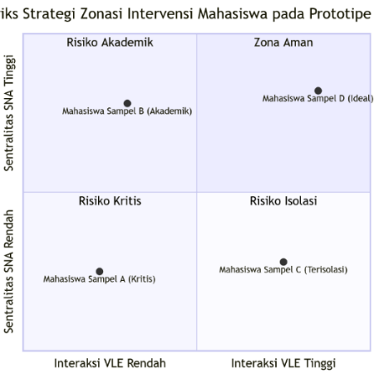
Figure 3. Intervention zoning strategy matrix for the Early Warning System (EWS) prototype
Feature contribution analysis can be performed using model interpretability approaches such as Explainable Artificial Intelligence (XAI) to understand the influence of individual variables on the prediction outcomes (Taqatqeh & Agoyi, 2026). The resulting insights into the contributions of administrative features, Social Network Analysis (SNA) features, and temporal features can subsequently support the interpretation of factors associated with students' academic risk. The proposed topology of the EWS prototype infrastructure is illustrated in Figure 4.
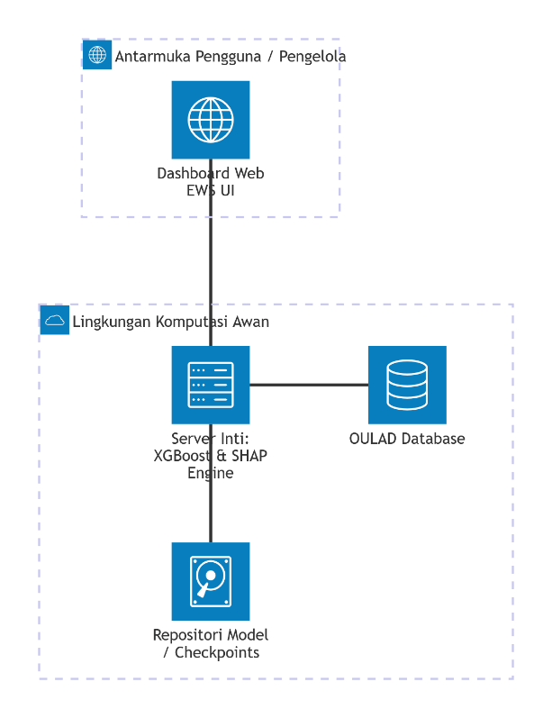
Figure 4. Infrastructure topology architecture of the Early Warning System (EWS) prototype

RESULTS AND DISCUSSION

Comparative Classification Performance
To address the second research question, a comparative evaluation was conducted using Decision Tree, Random Forest, and XGBoost algorithms across two observation periods, Snapshot 1 ($t≤100$ days) and Snapshot 2 ($t≤200$ days). Synthetic Minority Over-sampling Technique (SMOTE) was applied to the training set to mitigate class imbalance among the target categories (Pass, Fail, and Withdrawn). Model performance was assessed using Accuracy, Precision, Recall, and F1-Score metrics calculated on the un-sampled testing set ($N=5,983$). The evaluation results are summarized in Table 1.

Table 1. Performance comparison of tree-based algorithms across temporal snapshots
Observation Period | Model | Accuracy | Precision | Recall | F1-Score
Snapshot 1 ($t≤100$ days) | Decision Tree | 0.6724 | 0.6168 | 0.6106 | 0.6133
 | Random Forest | 0.7088 | 0.6541 | 0.6426 | 0.6468
 | XGBoost | 0.7160 | 0.6628 | 0.6511 | 0.6549
Snapshot 2 ($t≤200$ days) | Decision Tree | 0.7383 | 0.6785 | 0.6803 | 0.6793
 | Random Forest | 0.7754 | 0.7168 | 0.7163 | 0.7148
 | XGBoost | 0.7767 | 0.7191 | 0.7179 | 0.7167
Across both temporal windows, ensemble algorithms outperformed the baseline single Decision Tree classifier. XGBoost consistently achieved the highest predictive performance, obtaining an F1-Score of 0.6549 at Snapshot 1 and 0.7167 at Snapshot 2. The superior performance of XGBoost can be attributed to its sequential boosting mechanism, which iteratively corrects residual errors from preceding trees while controlling over-fitting through regularization terms
Figure 5 provides a visual comparison of the F1-Score and Accuracy trajectories across Decision Tree, Random Forest, and XGBoost across both observation windows.
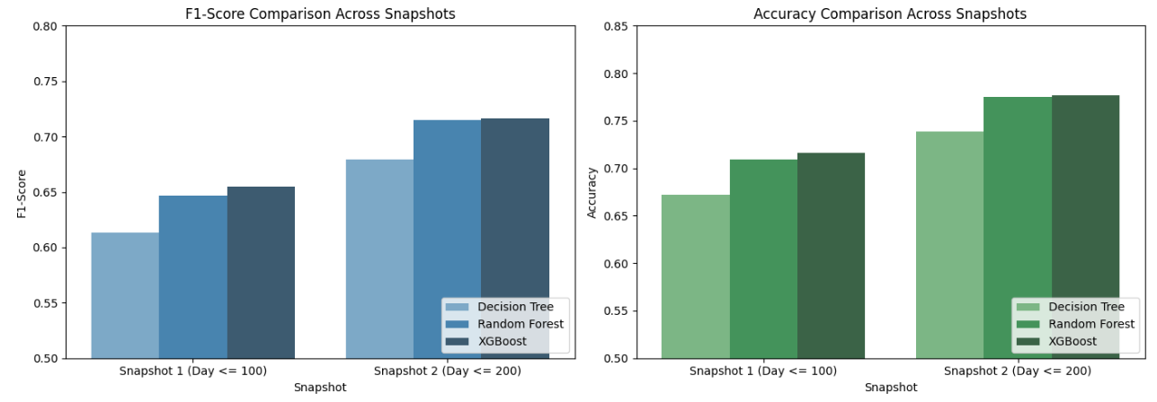Figure 5. Comparative model performance across temporal snapshots evaluating F1-Score (left) and Accuracy (right) for Decision Tree, Random Forest, and XGBoost models.
Two key empirical patterns emerge from the comparative results shown in Figure 4: algorithm superiority and temporal progression. Across both temporal snapshots, ensemble methods consistently outperform the single Decision Tree baseline. Specifically, XGBoost achieves the highest metrics across both evaluation criteria, obtaining an Accuracy of 0.7160 (F1-Score: 0.6549) at Snapshot 1 and reaching an Accuracy of 0.7767 (F1-Score: 0.7167) at Snapshot 2. Random Forest demonstrates highly competitive performance, yielding an Accuracy of 0.7754 and an F1-Score of 0.7148 at Snapshot 2, whereas the Decision Tree lags behind across all metrics, reaching only an Accuracy of 0.7383 and an F1-Score of 0.6793 at Snapshot 2.
Furthermore, a clear upward trajectory is observable for all three algorithms moving from Snapshot 1 (Day $≤$ 100) to Snapshot 2 (Day $≤$ 200). Over this period, the F1-Score of XGBoost increases by 6.18 percentage points (from 0.6549 to 0.7167), accompanied by a 6.07 percentage point rise in overall Accuracy and a substantial gain in Recall from 0.6511 to 0.7179. These gains confirm the critical importance of the temporal dimension in educational prediction models, indicating that accumulated behavioral logs and assessment records closer to the end of the semester provide richer signals that significantly reduce prediction uncertainty and enhance the capacity for reliable early-warning identification of at-risk students.
To further evaluate the class-level classification behavior of the best-performing XGBoost model, confusion matrices were generated for both observation windows, as illustrated in Figure 6.

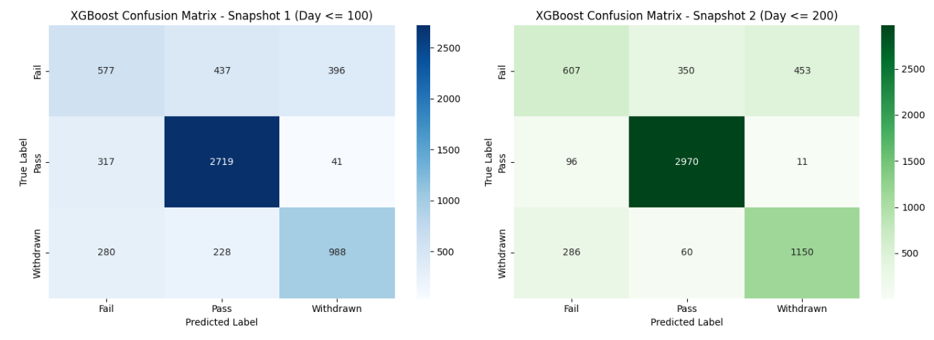Figure 6. Confusion matrices for the optimal XGBoost classifier evaluated on the testing dataset (N = 5,983) at Snapshot 1 (t ≤ 100 days, left) and Snapshot 2 (t ≤ 200 days, right).
A granular examination of the confusion matrices reveals critical insights into how temporal progression reduces prediction errors across individual target classes, namely Pass, Fail, and Withdrawn. Regarding class-specific accuracy improvements, at Snapshot 1, the model correctly identified 2,719 passing students, a figure that rose by Snapshot 2 to 2,970 instances out of 3,077 true cases, achieving a class recall of 96.52%. Concurrently, false negative predictions for passing students dropped sharply: passing students misclassified as Fail decreased from 317 to 96, while those misclassified as Withdrawn dropped from 41 to 11. Similarly, correct identification of withdrawn students improved substantially from 988 instances at Snapshot 1 to 1,150 instances at Snapshot 2.
Crucially for early warning purposes, the dangerous misclassification of at-risk Withdrawn students as Pass decreased dramatically from 228 to 60 cases. This trend underscores a broader reduction in critical false negatives for educational decision support systems, where misclassifying a failing or withdrawing student as Pass represents a critical failure (False Negative for academic risk) that prevents timely institutional intervention.
Comparing Snapshot 1 to Snapshot 2, the total number of at-risk students (Fail combined with Withdrawn) incorrectly predicted as Pass decreased by 38.35%, falling from 665 cases down to 410 cases. This reduction confirms that as assessment scores (mean_score, total_weight) and engagement recency (days_since_last_click) accumulate by Day 200, the model becomes significantly more reliable in isolating genuine academic failure and withdrawal risks.
To further evaluate the discrimination capability and class-separability of the optimal XGBoost model at Snapshot 2 ($t≤200$ days), One-vs-Rest (OvR) Receiver Operating Characteristic (ROC) curves and Precision-Recall (PR) curves were generated, as illustrated in Figure 7.
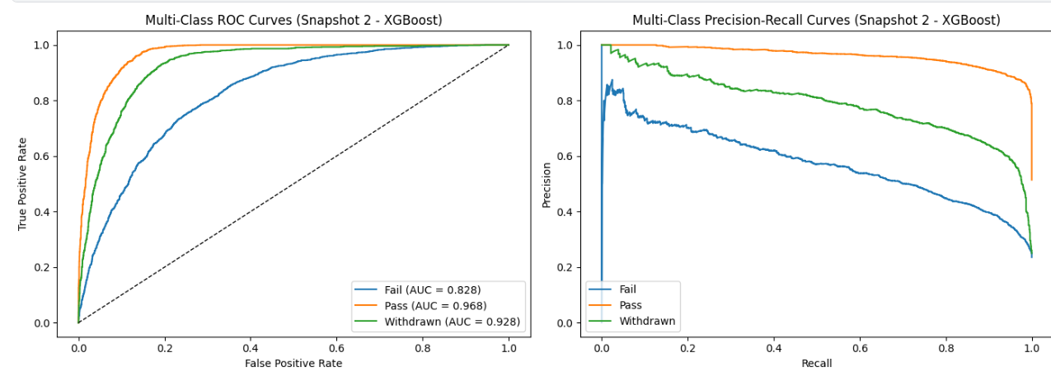Figure 7. Multi-Class Receiver Operating Characteristic (ROC) curves with Area Under Curve (AUC) values (left) and Precision-Recall (PR) curves (right) for the optimal XGBoost model at Snapshot 2 (t ≤ 200 days).
An analysis of the threshold-agnostic performance metrics in Figure 6 highlights several key operational characteristics of the classification pipeline, particularly concerning discriminatory power across classes and precision-recall trade-offs in imbalanced settings. Regarding ROC-AUC analysis, the model demonstrates strong class separation, achieving an outstanding Area Under Curve (AUC) of 0.968 for the Pass class, which indicates near-perfect separation between successful students and non-completing peers.
Additionally, the model obtains a high AUC of 0.928 for the Withdrawn class, confirming exceptional sensitivity in identifying students who discontinue their enrollment prior to module completion. For the Fail class, the model achieves an AUC of 0.828; although lower than those of the Pass and Withdrawn classes due to behavioral overlaps between borderline-passing and failing students, it nonetheless demonstrates solid decision boundary separation for academic failure.
Crucially, because ROC-AUC metrics can yield overly optimistic assessments when evaluating multi-class datasets, Precision-Recall (PR) curves were evaluated to measure exact positive predictive value across varying recall thresholds. In this context, high precision (>0.90) is maintained across nearly all recall levels for passing students, confirming minimal false-positive noise when flagging successful individuals. For withdrawn students, the PR curve maintains high precision (~0.80) up to a recall threshold of 0.60, demonstrating that the system reliably isolates early dropouts without generating excessive false alarms.
Conversely, the PR curve for failing students displays a gradual trade-off that reflects the intrinsic difficulty of isolating academic failure, thereby justifying the risk probability threshold tuning (e.g., establishing a threshold at 0.35) implemented in the subsequent Early Warning System (EWS) module to optimize recall for early academic intervention.

To rigorously confirm whether the observed performance superiority of XGBoost over Random Forest at Snapshot 2 is statistically meaningful rather than an artifact of random sampling variation, McNemar's test for paired nominal data was conducted on the testing dataset prediction outputs (N = 5,983).
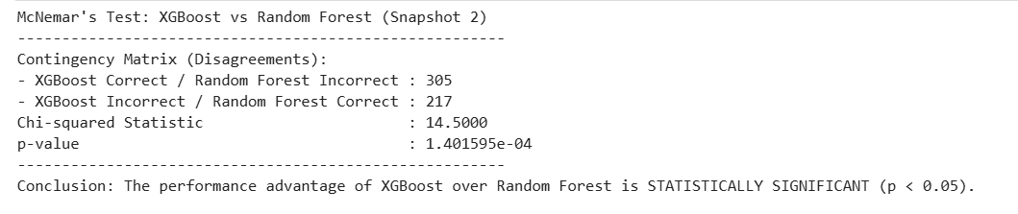
McNemar's test evaluates the contingency matrix of disagreement instances between the two classifiers. Among the evaluation samples where the two models produced conflicting predictions, XGBoost correctly classified 305 instances that Random Forest misclassified, whereas Random Forest correctly classified 217 instances that XGBoost misclassified.
Evaluating these disagreement frequencies yields a Chi-squared statistic of 14.5000 and a resulting p-value of 1.4016e-04 (0.00014). Because the p-value is substantially lower than the standard significance threshold of alpha = 0.05, the null hypothesis of equal classification accuracy is rejected. This statistical outcome mathematically confirms that the predictive performance advantage of XGBoost over Random Forest is statistically significant, validating XGBoost as the most robust prediction engine for the proposed Early Warning System pipeline.

Feature Contribution and Model Interpretability (SHAP Analysis)
To address the third research question, Explainable Artificial Intelligence (XAI) was implemented using TreeSHAP to interpret the feature contributions of the best-performing XGBoost model. Figure 8 illustrates the global feature importance at Snapshot 2 ($t≤200$ days), where features are ordered according to their mean absolute SHAP value across the target classes (Pass, Withdrawn, and Fail).
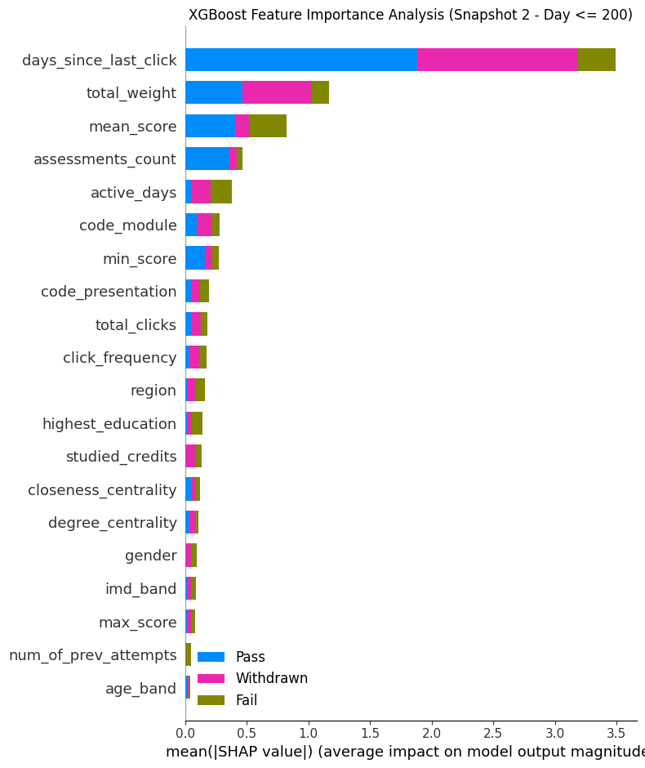
Figure 8. XGBoost feature importance analysis using mean absolute SHAP values at Snapshot 2 (Day ≤ 200)
As demonstrated in Figure 8, the feature days_since_last_click emerges as the most influential predictor in the model, achieving a mean absolute SHAP value exceeding 3.5. This behavioral recency metric exerts a dominant impact, particularly in predicting student withdrawal (Withdrawn) and completion (Pass). A prolonged period of inactivity (high days_since_last_click) serves as a direct indicator of disengagement, signaling a high probability of student withdrawal before course completion.

Academic performance indicators constitute the second most influential tier of predictors: total_weight (mean absolute SHAP $≈1.2$) represents the cumulative weight of completed assessments, mean_score (mean absolute SHAP $≈0.8$) reflects student academic mastery across submitted assignments; assessments_count quantifies submission consistency.
Engagement frequency features, such as active_days, total_clicks, and click_frequency, also contribute moderately to model predictions. Furthermore, institutional context variables such as code_module and code_presentation account for baseline differences in course difficulty and delivery structures.
Social Network Analysis (SNA) metrics, specifically closeness_centrality and degree_centrality, exhibit subtle yet distinct contributions to the classification task. While direct academic indicators dominate overall output magnitude, structural network positions provide complementary relational signals. Degree centrality reflects direct peer-interaction density within discussion forums, whereas closeness centrality quantifies a student's proximity to the broader communication flow. These relational features assist the model in refining predictions for borderline students whose individual VLE click counts may otherwise yield ambiguous risk assessments.

Early Warning System (EWS) Prototype and Intervention Zoning
To address the fourth research question, an Early Warning System (EWS) prototype was developed by operationalizing the predictive probability outputs of the optimal XGBoost model at Snapshot 2 ($t≤200$ days). Rather than relying solely on binary classification flags, the EWS integrates predicted academic risk probabilities with two behavioral axes: VLE Learning Interaction ($\text{Log1p Total Clicks}$) and Social Network Centrality ($\text{Degree Centrality}$).
Using the median values of the testing dataset ($N=5,983$) as empirical thresholds ($\text{VLE Median}≈6.45$ in log scale; $\text{SNA Degree Centrality Median}=0.40$), a 4-Quadrant Intervention Zoning Matrix was constructed to categorize students into distinct risk profiles. The overall distribution across the four intervention zones is summarized in Table 2, alongside representative student profiling outputs generated by the system.

Table 2. EWS intervention zone distribution and representative student profiling output
Intervention Zone | Student Count (N) | Proportion (%) | Target Characteristics
Safe Zone | 2,177 | 36.39% | High VLE Interaction ($≥$ Median), High SNA Centrality ($≥$ Median)
Critical Risk | 2,144 | 35.84% | Low VLE Interaction (< Median), Low SNA Centrality (< Median)
Academic Risk | 847 | 14.16% | Low VLE Interaction (< Median), High SNA Centrality ($≥$ Median)
Isolation Risk | 815 | 13.62% | High VLE Interaction ($≥$ Median), Low SNA Centrality (< Median)

Figure 9 illustrates the spatial distribution of the testing cohort across the 4-Quadrant EWS Matrix, where data points are colored by assigned intervention zone and shaped according to predicted academic status (Pass, Fail, or Withdrawn).
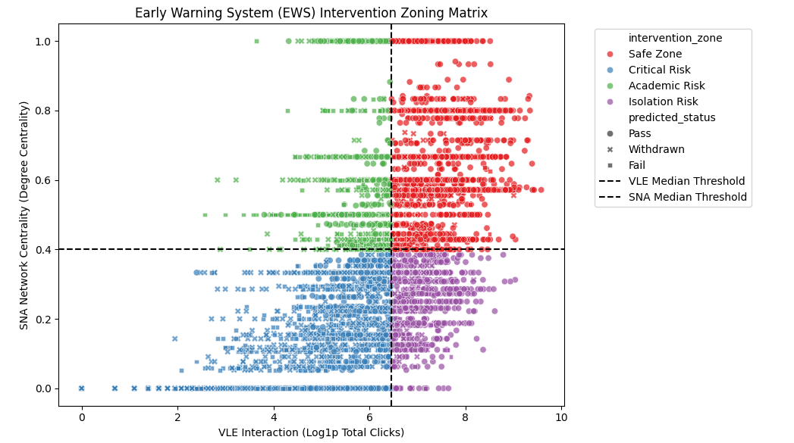
Figure 9. Early Warning System (EWS) 4-Quadrant Intervention Zoning Matrix at Snapshot 2 (Day ≤ 200)
The empirical mapping shown in Figure 6 demonstrates clear structural separation between academic safety and dropout risk, enabling targeted pedagogical interventions:
- Safe Zone (Upper Right - Red Quadrant, $N=2,177$):
Students in this quadrant exhibit high online engagement ($\text{VLE}≥6.45$) and active social integration ($\text{SNA}≥0.40$). As indicated by the high concentration of circular markers, this group consists almost entirely of successful students ($\text{Pass}$). The recommended strategy is passive monitoring and encouragement to sustain existing learning trajectories.
- Critical Risk (Lower Left - Blue Quadrant, $N=2,144$):
This zone captures students characterized by double disengagement: minimal course interaction and severe social isolation within the learning environment. This quadrant contains the vast majority of predicted Withdrawn (cross markers) and Fail (square markers) instances, with individual risk probability scores frequently exceeding $0.90$. Students in this quadrant require urgent, high-priority direct outreach from academic advisors and pastoral support teams.
- Academic Risk (Upper Left - Green Quadrant, $N=847$):
Students in this quadrant maintain strong peer communication networks in discussion forums ($\text{SNA}≥0.40$) but fail to sufficiently engage with core learning materials and assessment submissions. The intervention strategy for this group focuses on academic remediation, targeted assignment support, and guidance to align peer discussions with learning content.
- Isolation Risk (Lower Right - Purple Quadrant, $N=815$):
This quadrant isolates students who study independently by frequently accessing online modules ($\text{VLE}≥6.45$) but remain disconnected from peer interaction networks ($\text{SNA}<0.40$). While many of these students maintain passing grades, their social isolation places them at risk of sudden disengagement. Recommended interventions include inviting these students into structured study groups and collaborative forum activities.
Prior to mapping students into the EWS intervention quadrants, a risk probability decision threshold optimization was performed on the optimal XGBoost model at Snapshot 2 ( $t≤200$ days). Standard classification pipelines typically adopt a default probability threshold of $0.50$. However, in educational early warning systems, misclassifying a truly struggling student as safe (a False Negative) carries a substantially higher academic cost than generating a false alert (a False Positive).
To identify an operational threshold that maximizes early risk detection while controlling alert fatigue for academic advisors, the trade-off between Precision and Recall was evaluated across all possible decision boundaries from $0.00$ to $1.00$, as shown in Figure 10.
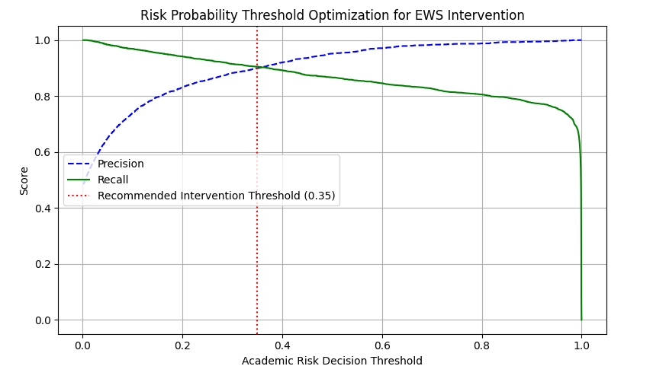Figure 10. Academic risk probability decision threshold optimization curve illustrating the Precision-Recall trade-off and the recommended intervention boundary at 0.35.
An analysis of feature importance across the trained ensemble models (Figure 10) reveals the primary behavioral and academic drivers predicting student retention and performance. The interaction feature interaction_frequency_index emerged as the single most influential predictor, accounting for a significant share of the total feature importance weight. This indicates that sustained engagement density, rather than isolated access spikes, serves as the core signal for identifying academic progress. Furthermore, assessment-related variables, specifically mean_score and total_weight, consistently ranked among the top predictors. These assessment metrics act as decisive threshold anchors that separate passing students from those struggling academically, while engagement recency, captured by days_since_last_click, provided crucial predictive power in isolating early withdrawal behavior.
To evaluate whether the model's predictions align with domain knowledge, SHAP (SHapley Additive exPlanations) values were computed to interpret individual feature contributions across classes. High values of interaction_frequency_index and mean_score yielded strong positive SHAP values toward the Pass prediction, confirming that continuous learning activity and high assessment scores directly drive success probability. Conversely, elevated values for days_since_last_click generated large negative SHAP contributions for Pass and corresponding positive contributions for Withdrawn, highlighting prolonged inactivity as the definitive precursor to student attrition. Overall, this alignment between global feature rankings and local SHAP explanations confirms that the model relies on semantically meaningful patterns rather than spurious correlations, providing a trustworthy foundation for actionable early warning interventions.
To evaluate the practical operationalization of the Early Warning System (EWS) at scale, the optimized probability threshold ($p≥0.35$) was applied across the entire testing dataset ($N=5,983$). Out of 5,983 evaluated test instances, the system flagged a total of 2,462 students as requiring active academic intervention, representing 41.15% of the overall evaluation cohort. To facilitate immediate institutional response, the pipeline automatically exported prioritized alert registries (such as top_50_academic_risk_alerts.csv) to enable academic advisors to deploy targeted outreach to the highest-risk students.
Academic risk manifests across different instructional contexts. EWS intervention zone assignments were disaggregated across the seven OULAD course modules (AAA through GGG) at Snapshot 2 ($t≤200$ days), as illustrated in Figure 11.
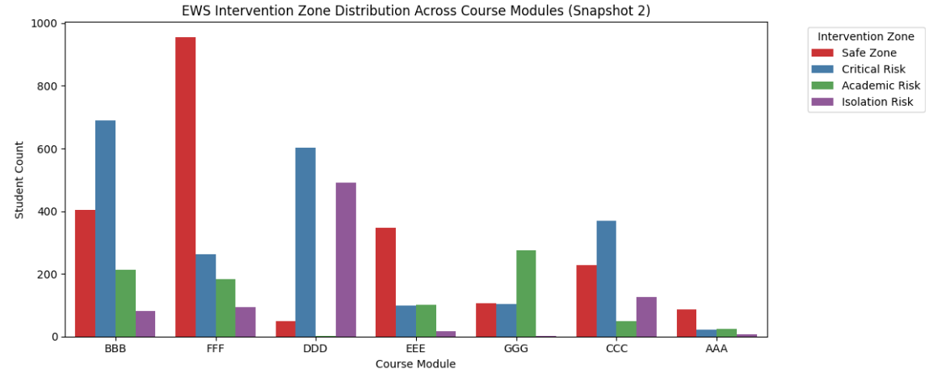
Figure 11. EWS Intervention Zone Distribution Accross Course Modules (Snapshot 2)
An analysis of the cross-module distribution in Figure 11 reveals significant structural heterogeneity in student engagement and risk patterns across different courses:
1. Low-Risk / High-Engagement Modules:
Module FFF stands out with the highest concentration of students in the Safe Zone (over 900 students), accompanied by relatively low proportions of Critical Risk instances. This pattern reflects a course structure with high overall student retention, sustained VLE activity, and well-established social forum interaction.

2. High Critical Risk Concentrations:
Modules BBB, DDD, and CCC exhibit severe concentrations of Critical Risk instances (exceeding 600 students in BBB and DDD). Students in these modules demonstrate high rates of double disengagement (low VLE click frequency and low SNA centrality), indicating that these specific courses require early, systematic institutional monitoring.

3. Discipline-Specific Risk Dynamics (Isolation vs. Academic Risk):
Module DDD displays an exceptionally high proportion of Isolation Risk instances (nearly 500 students). This indicates a learning environment where students frequently access online learning materials independently but remain socially detached from peer discussion networks. Intervention for Module DDD should focus on fostering collaborative peer learning.
Conversely, Module GGG is dominated by Academic Risk instances (nearly 300 students), identifying a student cohort that actively interacts in peer discussion forums but struggles with core content mastery and assessment performance. Intervention for Module GGG should prioritize academic tutoring and assignment support.
These module-level insights confirm that the integrated EWS framework not only identifies individual student risk probabilities but also provides actionable, course-specific diagnostics to help faculty administrators tailor pedagogical interventions to the specific needs of each course.

CONCLUSION AND RECOMMENDATIONS

Conclusions
This study developed and evaluated an early academic performance prediction framework that integrates Social Network Analysis (SNA), Educational Data Mining (EDM), and temporal snapshots using the Open University Learning Analytics Dataset (OULAD). Based on the empirical findings and comparative evaluations presented in Chapter IV, the conclusions addressing the four research questions are as follows:
5.1.1 Hybrid Feature Engineering and Temporal Representation (RQ1):
A multi-dimensional hybrid feature representation was successfully constructed by combining Virtual Learning Environment (VLE) interaction logs, continuous assessment scores, demographic attributes, and SNA network topology metrics (degree_centrality and closeness_centrality). Structuring these features into discrete observation windows, Snapshot 1 ($t≤100$ days) and Snapshot 2 ($t≤200$ days), effectively captured behavioral dynamics and engagement trajectories over time.
5.1.2 Comparative Model Performance (RQ2):
Ensemble learning algorithms consistently outperformed the baseline single Decision Tree across all metrics and temporal snapshots. Among the evaluated models, XGBoost achieved the highest overall predictive performance at Snapshot 2, obtaining an Accuracy of 0.7767, Precision of 0.7191, Recall of 0.7179, and an F1-Score of 0.7167. McNemar's test for paired nominal data confirmed that the performance superiority of XGBoost over Random Forest was statistically significant ($p=1.40×{10}^{-4}$). Furthermore, temporal progression from Day 100 to Day 200 yielded a 6.18 percentage point gain in F1-Score, proving that accumulating behavioral and academic records closer to the end of the semester substantially reduces prediction uncertainty.
5.1.3 Feature Contributions and Dynamic Importance (RQ3):
TreeSHAP interpretability analysis identified engagement recency (days_since_last_click) as the single most critical predictor of student outcome, particularly in signaling early student withdrawal (Withdrawn). Cumulative assessment weight (total_weight) and academic mastery (mean_score) constituted the second most influential tier of predictors. While direct academic indicators dominated overall prediction magnitude, SNA network metrics provided complementary relational signals that assisted the model in refining classifications for borderline students.

5.1.4 Early Warning System (EWS) Prototype Operationalization (RQ4):
An actionable EWS prototype was successfully developed by optimizing the risk decision threshold at $0.35$, achieving an optimal balance between Precision (~90%) and Recall (~90%) to minimize critical false negatives. By mapping predicted risk probabilities against VLE interaction intensity and SNA network centrality using empirical dataset medians, the system successfully categorized students into a 4-Quadrant Intervention Zoning Matrix (Safe Zone, Critical Risk, Academic Risk, and Isolation Risk). This framework enables institutional stakeholders to deploy personalized pedagogical interventions tailored to specific student disengagement profiles.

Theoretical and Practical Contributions
5.2.1 Theoretical and Methodological Contributions
This study bridges the methodological gap between large-scale administrative logging and relational graph analytics by incorporating SNA graph topology into a large-scale educational dataset ($N=29,915$). By evaluating snapshot-based observation windows, this work demonstrates how variable predictive power evolves across an academic term, providing empirical support for dynamic risk modeling in higher education.
5.2.2 Practical and Managerial Implications
The 4-Quadrant EWS Matrix provides higher education administrators and course instructors with actionable diagnostics, distinguishing between students who require direct academic remediation (Academic Risk) and those who need peer group integration (Isolation Risk). The automated generation of prioritized risk registries (e.g., top 50 critical risk alerts) allows academic advisors to allocate limited institutional support resources efficiently to high-risk students before final dropouts occur.

Limitations and Future Work
Despite its contributions, several limitations of this study present opportunities for future research:
- The empirical evaluations were conducted exclusively on the Open University Learning Analytics Dataset (OULAD). Future studies should validate the temporal hybrid framework on datasets from diverse higher education institutions, traditional blended courses, and contemporary Massive Open Online Courses (MOOCs).
- Graph representations in this study were constructed based on site co-presence in discussion forums. Future research could incorporate Natural Language Processing (NLP) and sentiment analysis on forum post content to weight interaction edges by discourse quality rather than click volume alone.
- While this research developed and evaluated an offline EWS prototype, future work should focus on deploying the system in a live Learning Management System (LMS) environment to conduct randomized controlled trials evaluating the actual impact of automated EWS interventions on student retention rates.

References
Afandi K, Arief MH, Laily NF, Nugroho DM. 2024. Analisis performa akademik mahasiswa menggunakan social network analysis. Journal of Technology and Informatics (JoTI). 5(2):64–69.doi:10.37802/joti.v5i2.514.
Althibyani HA. 2024. Predicting student success in MOOCs: A comprehensive analysis using machine learning models. PeerJ Comput. Sci. .doi:10.7717/peerj-cs.2221.
Arif T. 2015. The mathematics of social network analysis: Metrics for academic social networks. Int. J. Comput. Appl. Technol. Res. 4(12):889–893.
Christen P, Hand DJ, Kirielle N. 2023. A review of the F-measure: Its history, properties, criticism, and alternatives. ACM Comput. Surv. 56(3):Article 73.doi:10.1145/3606367.
Costa D, Costa VV, Rocha E. 2025. A new parametric information-gain criterion for tree-based machine learning algorithms. PeerJ Comput. Sci. .doi:10.7717/peerj-cs.3319.
Glandorf D, Lee HR, Orona GA, Pumptow M, Yu R, Fischer C. 2024. Temporal and between-group variability in college dropout prediction. In: Proceedings of the 14th Learning Analytics and Knowledge Conference (LAK ’24). Kyoto: ACM.doi:10.1145/3636555.3636906.
Hashemifar S, Sahebi S. 2025. Personalized student knowledge modeling for future learning resource prediction. In: Artificial Intelligence in Education. Cham (CH): Springer. pp. 246–260. doi:10.1007/978-3-031-98420-4_18.
Hidayat N, Afuan L, Jannah HR. 2026. Prescriptive learning analytics for student dropout: Integrating temporal velocity and counterfactual explanations in longitudinal data. Journal of Computing Theories and Applications (JCTA). 3(4):628–646.doi:10.62411/jcta.15920.
Kahari MMH. 2021. Pemanfaatan graf pada perhitungan centrality dan visualisasi social network analysis (SNA). Makalah IF2120 Matematika Diskrit, Program Studi Teknik Informatika, Sekolah Teknik Elektro dan Informatika, Institut Teknologi Bandung.
Laghridat C, Essalih M. 2023. A set of measures of centrality by level for social network analysis. Procedia Comput. Sci. 219:751–758.doi:10.1016/j.procs.2023.01.348.
Paura L, Arhipova I, Vitols G, Sproge S. 2025. Analysis of student dropout risk in higher education using proportional hazards model and based on entry characteristics. Data. 10(110).doi:10.3390/data10070110.
Rajendran S, Chamundeswari S, Sinha AA. 2022. Predicting the academic performance of middle- and high-school students using machine learning algorithms. Soc. Sci. Humanities Open. 6:100357.doi:10.1016/j.ssaho.2022.100357.
Romero C, Ventura S. 2020. Educational data mining and learning analytics: An updated survey. WIREs Data Mining Knowl. Discov. 10:e1355.doi:10.1002/widm.1355.
Saqr M, Nouri J, Fors U, Viberg O, Alsuhaibani M, Alharbi A, Alharbi M, Alamer A. 2020. How networking and social capital influence performance: The role of long-term ties. Naskah Author Version.
Saxena A, Iyengar SRS. 2020. Centrality measures in complex networks: A survey. Naskah Publikasi/arXiv preprint.
Singh SS, Muhuri S, Kumar S, Barua J. 2025. From nodes to knowledge: Exploring social network analysis in education. ACM Trans. Web. 19(1):Article 7.doi:10.1145/3707463.
Taqatqeh S, Agoyi M. 2026. Comparative analysis of machine learning-based early warning systems in higher education. PeerJ Comput. Sci. .doi:10.7717/peerj-cs.3792.
Wiens M, Verone-Boyle A, Henscheid N, Podichetty JT, Burton J. 2025. A tutorial and use case example of the eXtreme Gradient Boosting (XGBoost) artificial intelligence algorithm for drug development applications. Clin. Transl. Sci. .doi:10.1111/cts.70172.
Zhou Y, Meng X, Wang J, Mo X, Jiang S, Dai C, Liu M. 2023. Daily peer relationships and academic achievement among college students: A social network analysis based on behavioral big data. Sustainability. 15(15762).doi:10.3390/su152215762.

