**Step 1:** Extract the zip file you will see 3 files shown in the zip named tool.ipynb, questionTitle.json and this Docs which you are reading

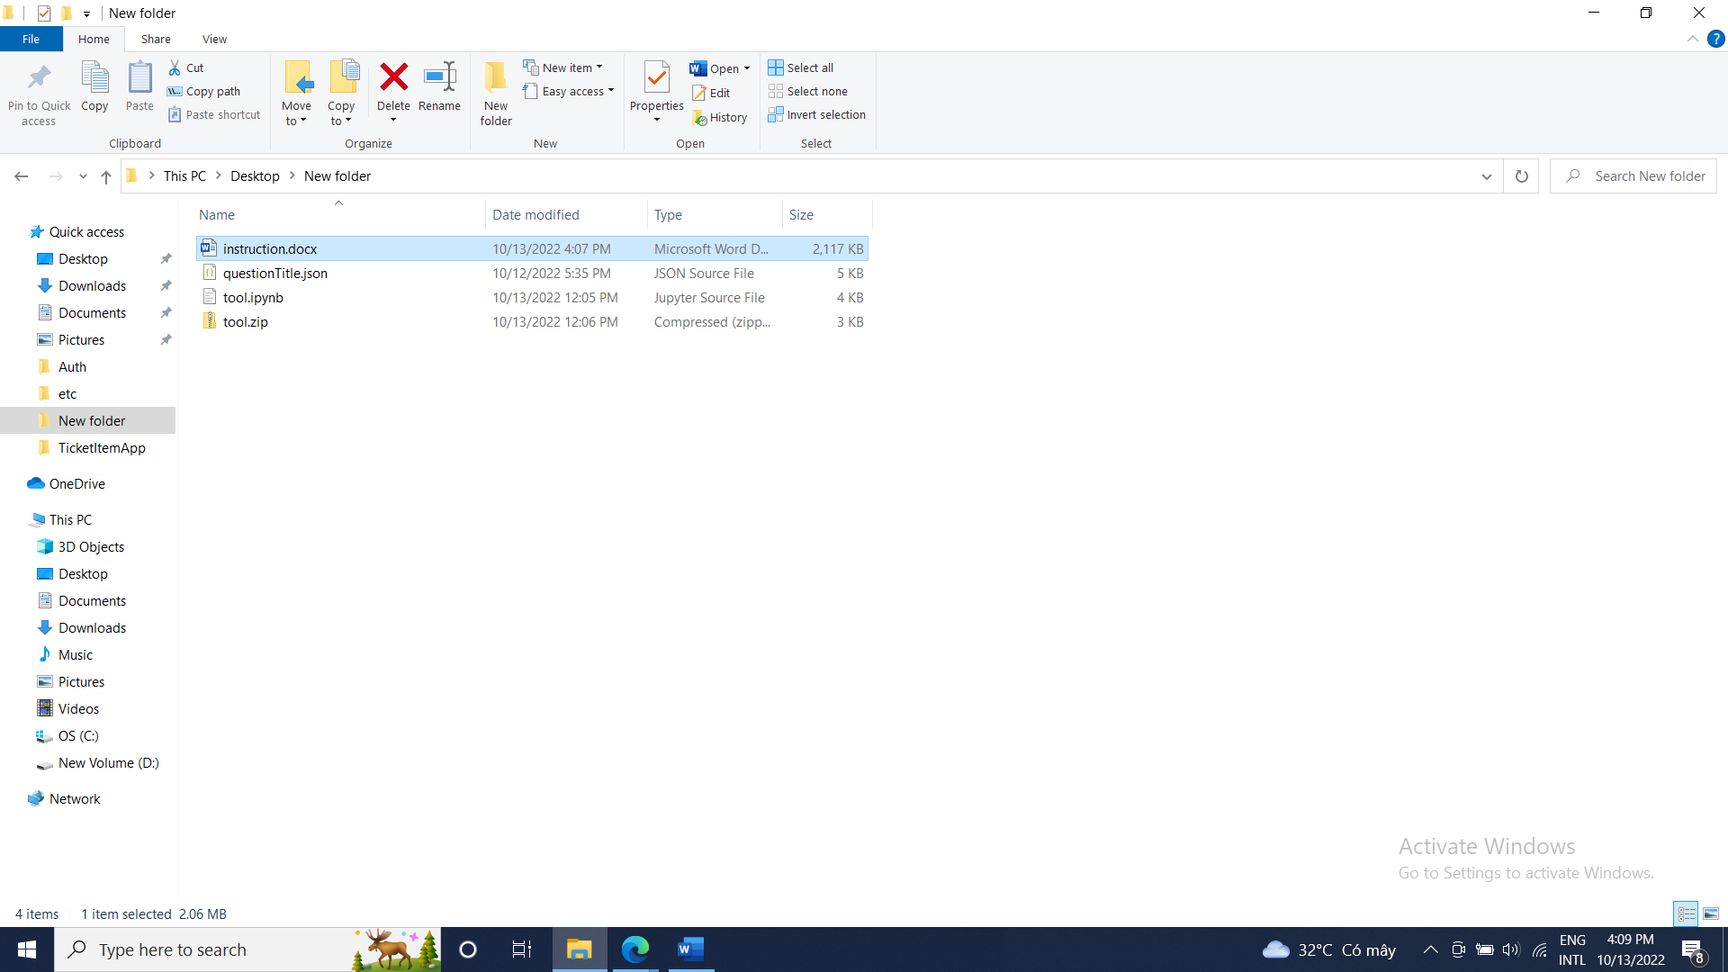

**Step 2**: Access this link [Welcome To Colaboratory - Colaboratory (google.com)](https://colab.research.google.com/)

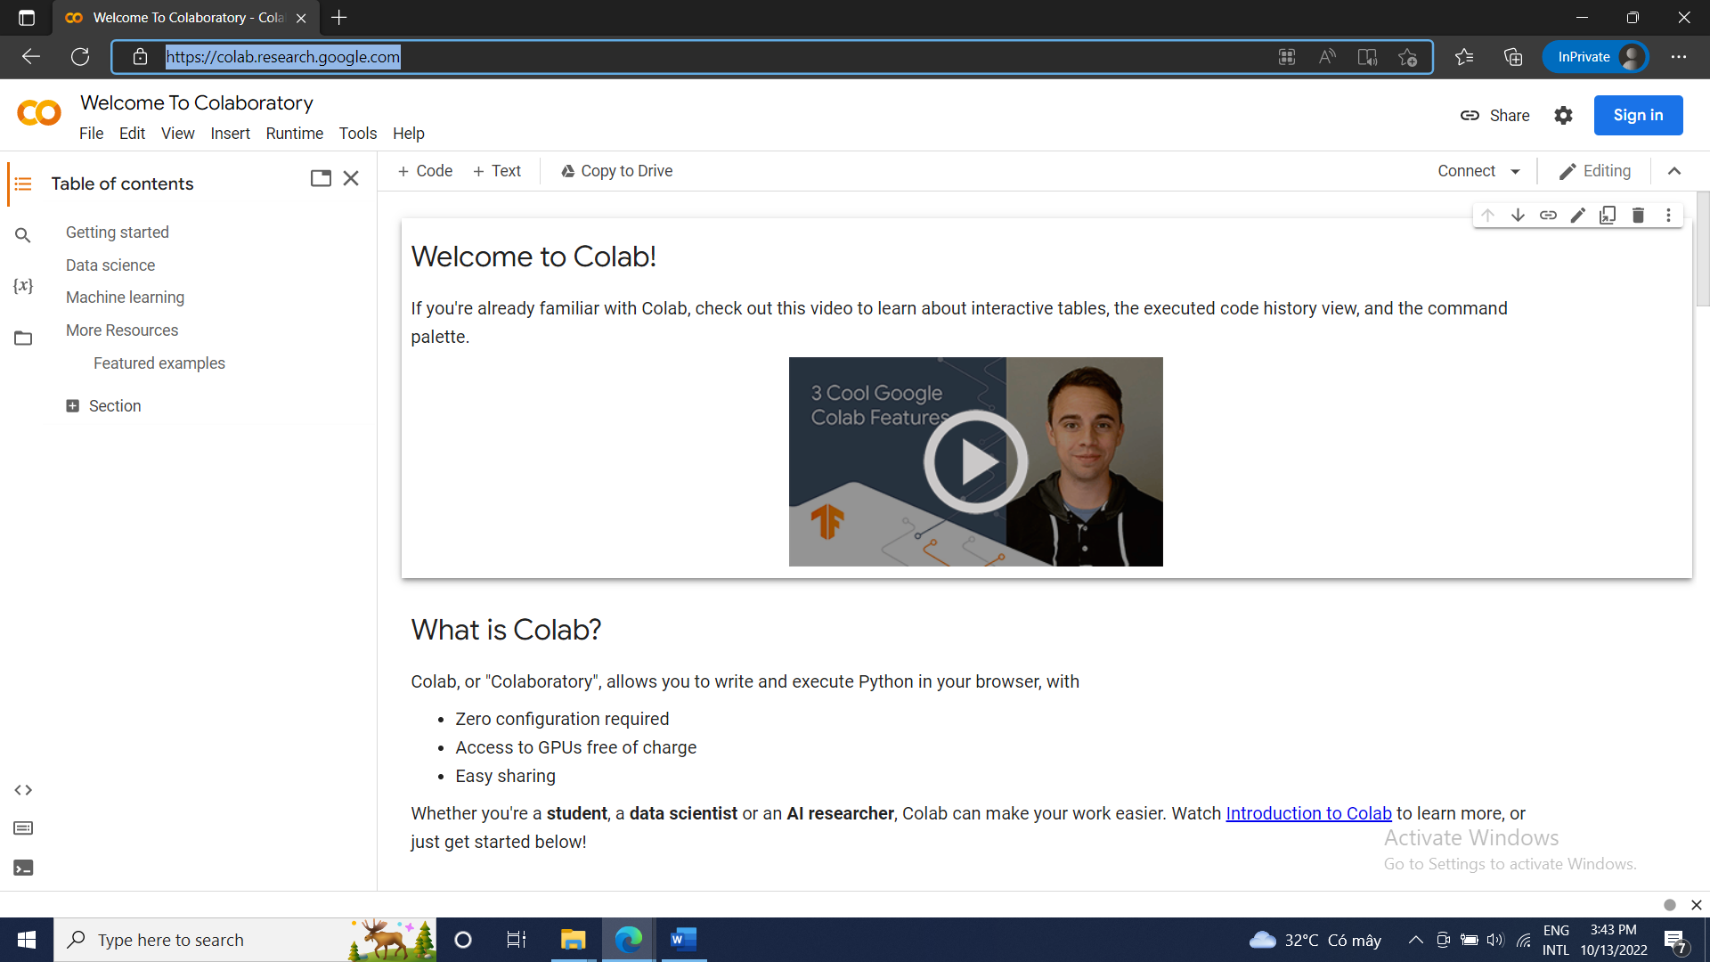

**Step 3**: Sign in with google:

**Step 4**: Click on File, after that Upload Notebook  
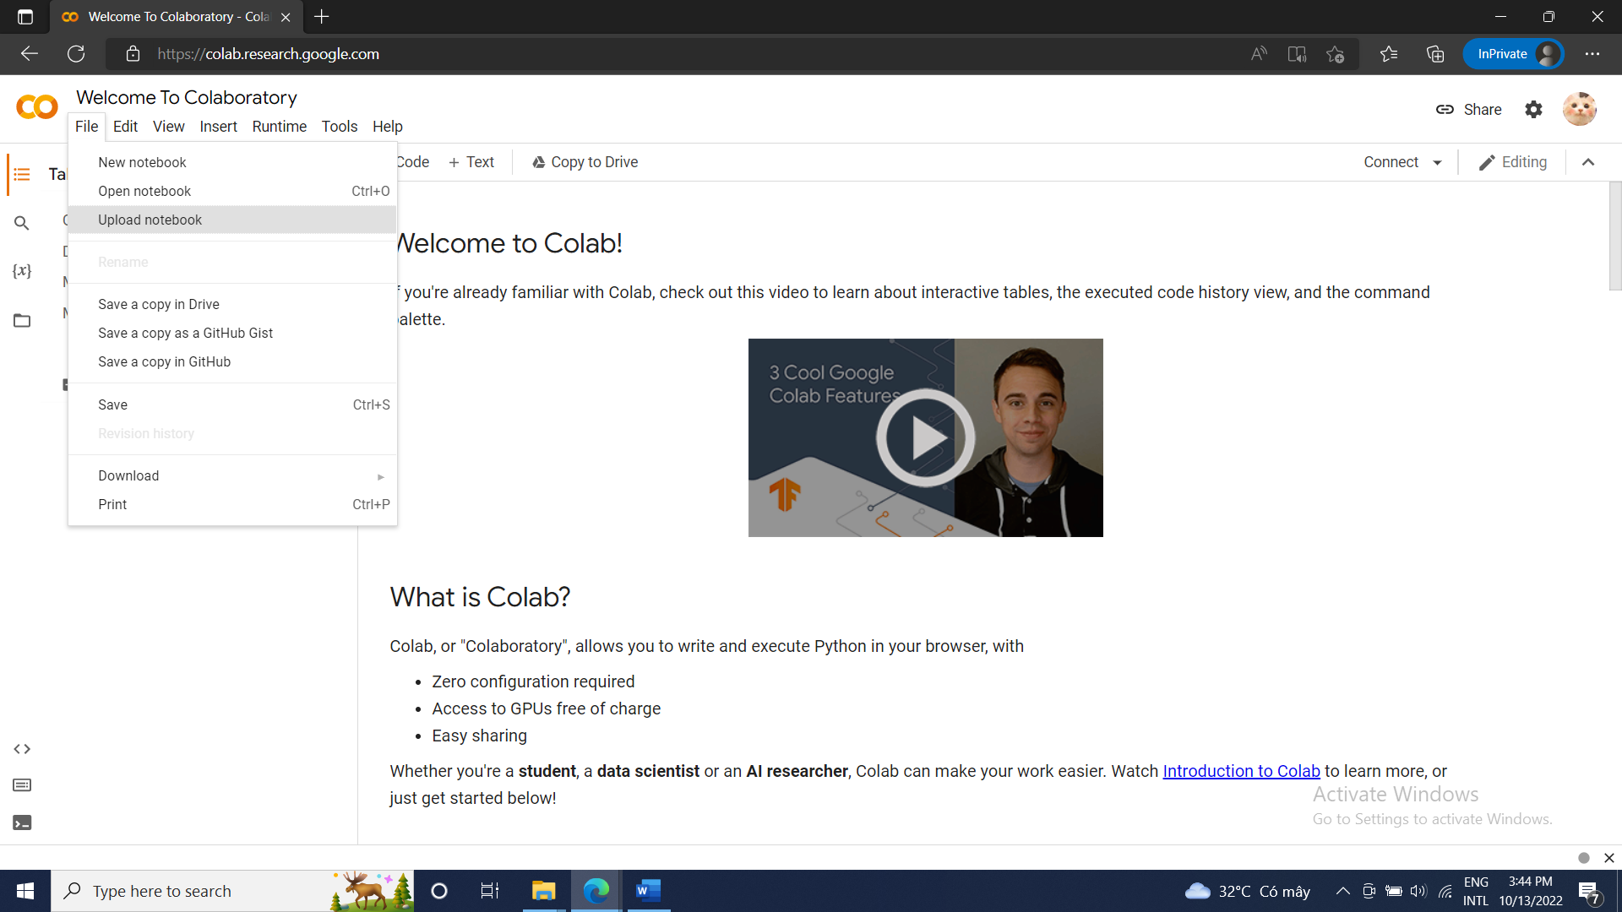

**Step 5**: Choose a file tool.ipynb and click open

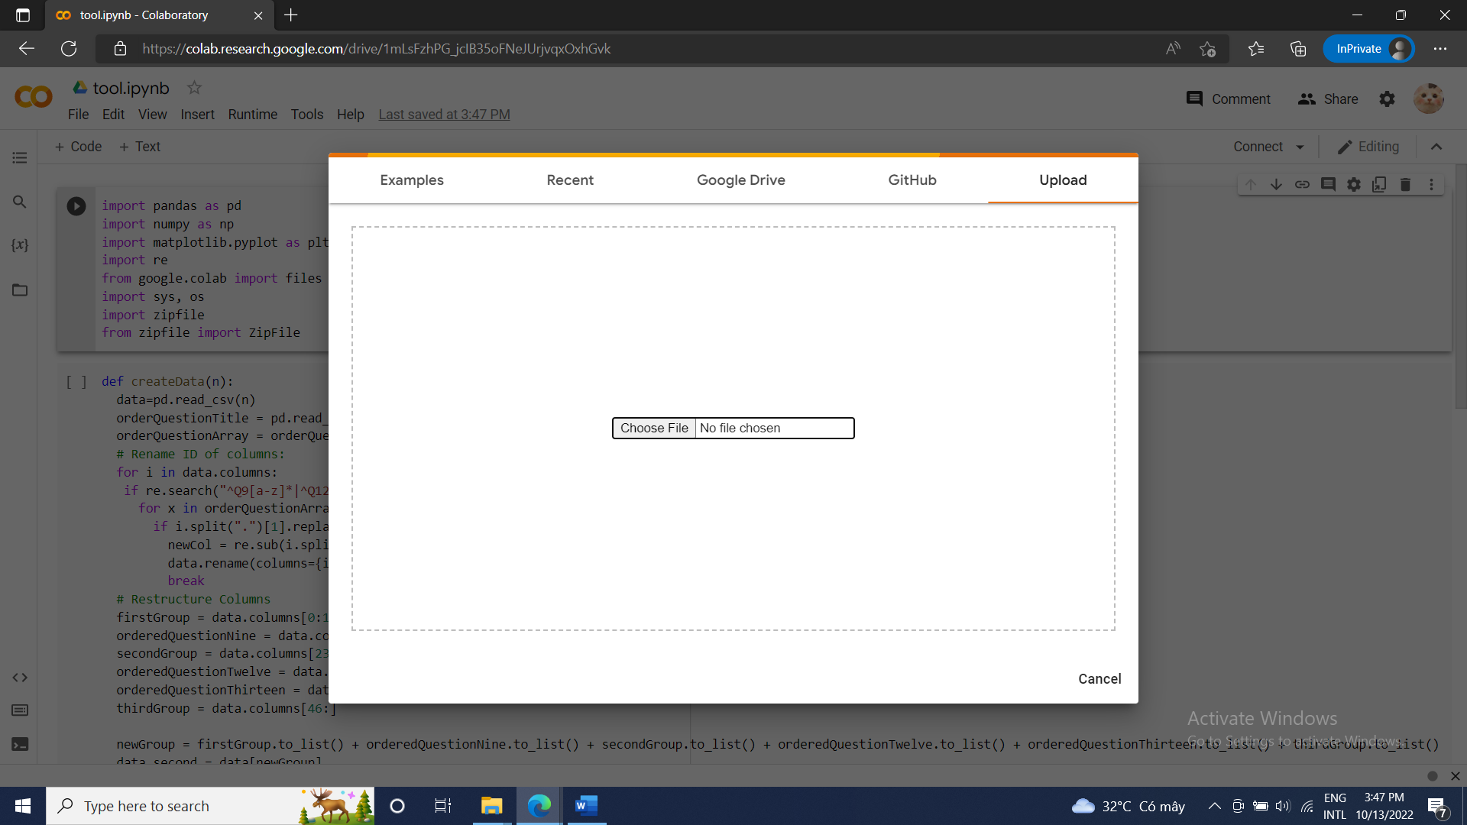

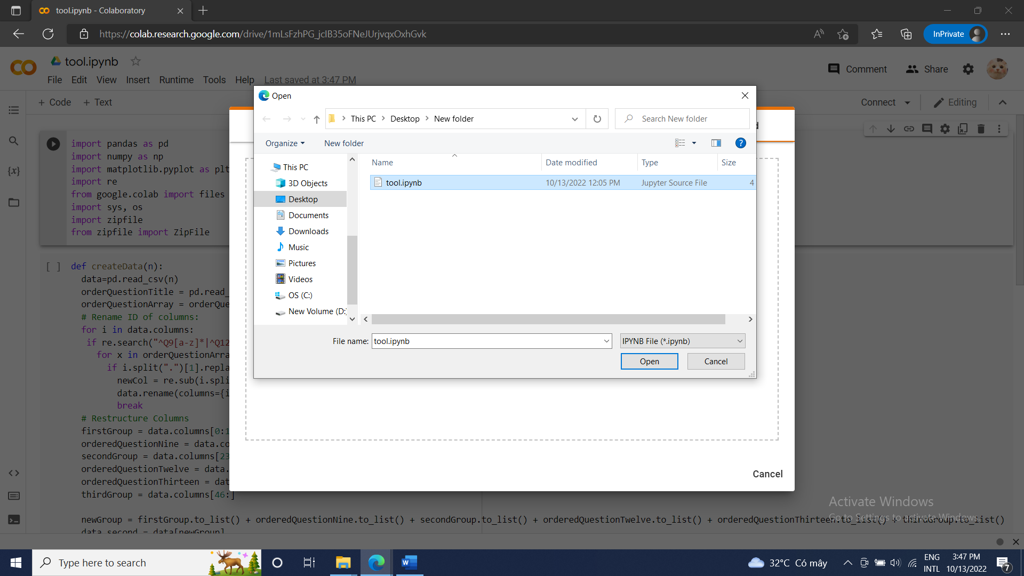

**Step 6**: On the left menu bar you will see a folder button icon, click on that and then select the first icon (upload icon) shown just like in the image below:

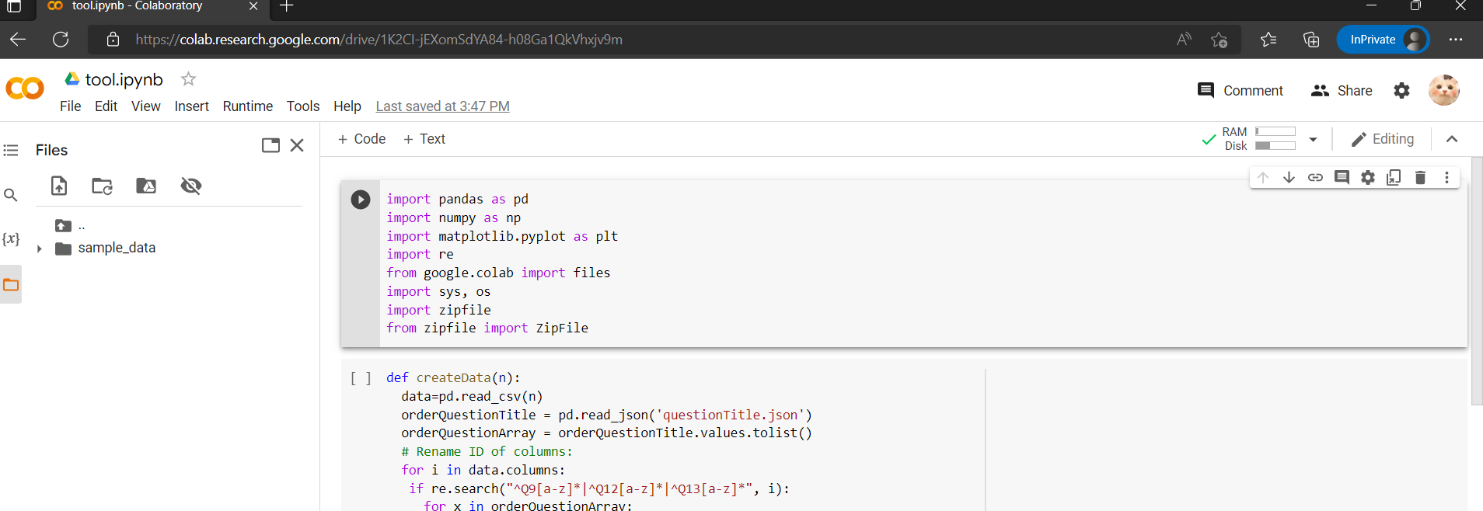

**Step 7**: You can choose one or more excel files but remember to choose a questionTitle.json file which is extracted with a zip file. After that click open :

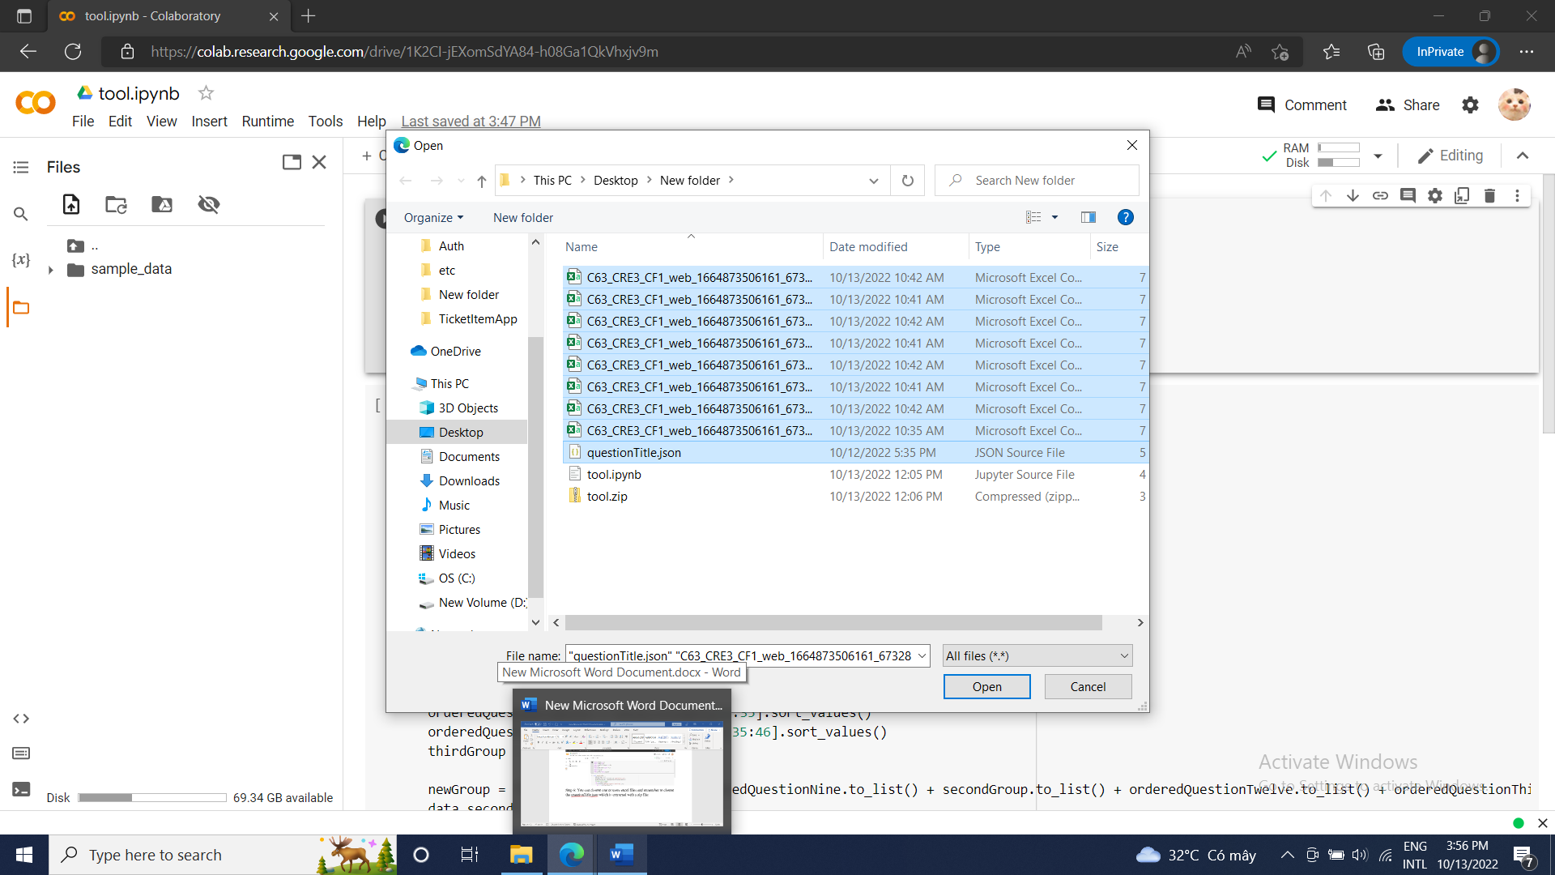

**Step 8**: You will have a new list of data appear in the left menu side while pressing the second button, after that press CTRL + F9 to run the notebook:

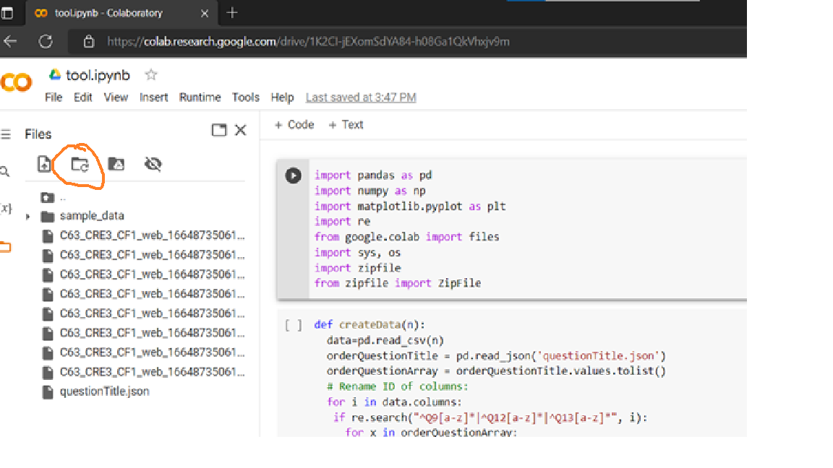

**Step 9** : The zip file has been downloaded then extract it:

