

**32SMILES**

**Supervisor:** Ms. Nguyễn Hạ Vy

**Semester:** 01

**Batch No:** T1.2302.M0

**Group No:** 05

|  |  |  |
| --- | --- | --- |
| **Order:** | **Full name** | **Roll No.** |
| *1.* | *Nguyễn Văn Nghị* | *Student1455770* |
| *2.* | *Đặng Minh Triết* | *Student1455774* |
| *3.* | *Hồ Thiện Nhân* | *Student1455773* |
| *4.* | *Võ Xuân Thịnh* | |  | | --- | | *Student1455759* | |

**Month**: 5 **Year**: 2023

**This report is to certify that four of us:**

* *Nguyễn Văn Nghị*
* *Đặng Minh Triết*
* *Hồ Thiện Nhân*
* *Võ Xuân Thịnh*

**Have successfully Designed and Developed:**

**32SMILES**

**Submitted by:** Ms. Nguyễn Hạ Vy

**Date of Issue:** 5/15/2023

**TABLE OF CONTENT**

Review 1

Review 2

Review 3 ..

Tasksheet ..

**Acknowledgement**

First and foremost, it is hard to say that this is the end of the **32SMILES** project. It was one of the most challenging yet delightful experiences in our educational career. We put lots of effort to make a good project with our full commitment and responsibility.

Even though it has been a long and strenuous project, we have done it with the support and guidance from our lovely teacher Ms. Vy Nguyen Ha so we would like to acknowledge with thanks to her for all the valuable suggestions with this project as well as all FPT Aptech professors who gave us the golden opportunity to design this wonderful project on the topic **32SMILES**, which also helped us in doing a lot of researches and we came to know about so many new things we greatly appreciate them.

Lastly, thanks again to everyone involved in making it happen because without them we would not be here today with an amazing website completed!

Sincerely,

*Nguyễn Văn Nghị*

*Đặng Minh Triết*

*Hồ Thiện Nhân*

*Võ Xuân Thịnh*

T1.2302.M0

# **Synopsis**

## *Abstract:*

Dental diseases are quite common, with consequences on many levels of oral health and general health. Most oral diseases can be prevented and treated with good communication and oral health care activities in the community.

Speaking at the Congress of the Vietnam Odonto-Stomatology Association for the term 2022-2025, Assoc. Prof. Dr. Nguyen Thi Lien Huong - Deputy Minister of Health said that oral diseases are quite common, causing consequences at many levels. dental health and general health, in which tooth decay is classified by the World Health Organization as the third scourge of mankind after cancer and heart disease.

In our country, over 85% of children have tooth decay, over 80% of adults have gingivitis and periodontitis, etc. These diseases are the main causes of early tooth loss, affecting health. Moreover, the foci of infection in the mouth are also the cause of medical diseases such as arthritis, glomerulonephritis, endocarditis, etc., affecting health and quality of life.

"However, most oral diseases can be prevented and treated with good communication and oral health care activities in the community" - Deputy Minister of Health Nguyen Thi Lien Huong emphasize.

According to the Deputy Minister, Vietnam is in the process of well implementing the Global Action Plan on NCDs prevention, achieving 9 out of 19 indicators assessing progress and capacity to respond to the national response to NCDs. infectious diseases, the Vietnam Health Program was announced in February 2019, with non-communicable diseases as a key priority.

Vietnam is actively implementing Resolutions, Action Programs, and Projects on strengthening grassroots health to respond to NCDs. At the same time, to cope with the burden of non-communicable diseases, including oral diseases, the National Strategy for the prevention and control of NCDs in Vietnam for the period 2013-2020 was approved by the Prime Minister. In which, there is a significant contribution of doctors specializing in Odonto-Stomatology in Vietnam.Therefore, we are not only concerned about the outbreak of dental disease, but also have to bring it to our dear customers by providing services and products to help them gradually get better. On the other hand, we understand that online marketing can help establish a strong online presence, making it easier for patients to find our clinic when searching for relevant keywords and phrases. relate to. Social media marketing is more common these days and it can also be used to increase visibility online and allow our clinic to connect with patients on the platforms they spend their share of. Great time to build long term relationship with them all the time. Digital marketing strategies can help our clinic proactively manage its online reputation to maintain a positive image by responding to every review and interacting with patients to resolve any concerns. concerns they may have. Furthermore, when compared to traditional marketing methods, digital marketing is a cost-effective way for our clinic to market its services and products. We can also reach out to potential patients resulting in a higher return on investment for our marketing efforts. Realizing some of the potential of online marketing as outlined above, we launched a website to provide more experience and information about our clinic's products and services to our clients. row.

## *Introduction:*

## We help every client understand more about the importance of dental disease. Besides, we also provide product collections with reasonable cost. Here, we have the best doctors and staff to help restore the roots to regain the patient's confidence.

## Building a website for respective services is one of the most important marketing tasks that need to be completed. While the website itself will not bring new customers to our clinic, it will not be easy to generate new customers online without the right website strategy. Once a properly developed website strategy, advertising and search engine optimization can be used to expand our business for long term success. Therefore, we developed a sample website for any dental clinic that will provide full details of services and products, as well as educational information.

## *Objectives:*

This program's purpose is to give one sampling project to work on real life projects. These applications guide us to build a larger and prosperous application. We are not aiming to study only the HTML/JavaScript/Dreamweaver/HTML5 but to obtain a drill with a real-life scenario and create basic applications using the tools that we have learned through sessions. It is a long path to reach out to this project after the completion of the HTML5's module.

## *Methodology and methods:*

We use the hardware as below:

* Intel Core i3/i5 Processor or higher
* 8 GB RAM or above
* Color SVGA
* 500 GB Hard Disk space
* Mouse
* Keyboard

We use some of the software as below:

* + Technologies to be used:
  + Frontend: HTML5, CSS, Bootstrap, JavaScript, jQuery, AngularJS, XML
  + Data Store: JSON files or TXT files
  + Other Requirements:
  + Operating Portal: Windows
  + Browsers: Edge, Chrome, Mozilla Firefox, Safari

Libraries that we used while coding:

* Google Web Fonts
* Angular
* Bootstrap
* Font Awesome
* Animate
* jQuery

# **Analysis**

*Purpose of using 32SMILES Clinic website:*

In this day and age, dental treatment and care is quite popular and widely applied. With its safety and effectiveness, it has helped millions of people around the world restore their oral health and improve their quality of life. However, not everyone has a clear understanding of what oral protection is and when to apply them. Therefore, 32SMILES decided to design a website to provide information and knowledge for customers to keep in touch with them.

Our website is not only a way to promote our services and products, but also a valuable educational resource. We want to bring information about dental care closer to people, help them understand its benefits and how to apply it to self-care in their daily lives. We believe that by providing complete and detailed knowledge, we can help people make informed decisions about which therapy is best for them.

Not only providing information, we also want to contribute to reducing the burden of disease for everyone and building a happy and healthy community. By encouraging people to use our website, we provide convenient online appointment booking without having to go to the clinic. This saves clients time and effort, and ensures that they receive the best care and treatment from our team of specialists.

In addition, customers can actively call or receive online consultation from our own website whenever they cannot come to the clinic. Our team of experienced professionals will always be happy to listen and answer any questions and support requests from our customers. We understand that recovery and treatment can be difficult at times, so we want to be with our clients and make sure they don't face these challenges alone.

At 32SMILES, we are committed to providing the best care to our customers. Our website will connect us and our customers, providing us with the best information and support possible. We believe that by creating a high-quality online resource, we can contribute to improving people's health and quality of life.

Our website has been designed with a friendly and easy to use interface. We have optimized the operations so that customers can easily find information, book appointments, and interact with our team of experts. By leveraging technology and online communication, we want to ensure that people can approach rehabilitation therapy services in the most convenient and flexible way.

On the website, clients can learn about diseases and problems related to rehabilitation therapy. 32SMILES website provides information on therapeutic methods and techniques, as well as the benefits they provide. Customers can learn about the recovery process, exercises, and techniques, as well as self-care measures at home. We provide educational materials, videos, and articles to help clients have clearer sight about rehabilitation therapy and apply it to their daily lives.

Farther, our website also meets customers' online consulting needs. Customers can interact directly with our experts through online chat or video call. Our team of experts will listen to all the customers’ inquiries and requests of support and provide applicable advice and guidance. We believe this face-to-face interaction will help clients feel more confident and reliable during their recovery and treatment.

Our website also offers the convenience of online appointment scheduling. Customers can choose a suitable date and time for their schedule and book appointments online hands down. This saves time and effort for our customers while ensuring they receive the best care and treatment from our expert team.

In conclusion, not to mention that our website is not just a tool for promoting our services, it brings valuable educational and support resources to all the customers as well. We aim to provide detailed and understandable knowledge and information about functional rehabilitation. Through our website, we hope to accompany customers throughout their recovery journey and bring them a better quality of life.

*Target Customer Segment:*

Regardless of age, we always aim to serve everybody as much as possible. Physical therapy is a treatment method that can be applied to anyone, depending on the regimen and method prescribed by a doctor. Nevertheless, according to elderly population in Vietnam, many people are still unaware of the benefits of physical therapy, and just a few numbers of people are using the internet to look up more information about it. Thus, the primary target group we are focusing on is individuals aged 35 to 50 (middle-aged). This group of people is capable of quickly using the internet and accessing information through the PR and marketing campaigns we deploy. In particular, they tend to seek deeper understanding to improve their own and their family's health.

For each age group, we will provide tailored treatment protocols, combined with one-by-one individual therapy sessions conducted by expert doctors. In this way, we ensure that patients receive dedicated care and recover their health quickly.

At 32SMILES, we are committed to provide quality and attentive services to all customers, especially those in the middle age. We understand that the modern life causes many pressures and challenges to our health. The expert team at the clinic will find optimal solutions to recover their body functions and help customers thrive in their daily lives by combining specialized knowledge and practical experience.

We hope that our website will be a useful and reliable source of information for this target group of customers. By accessing the website, customers can learn about the types of therapies we provide, supportive products, and efficiently schedule appointments online. In addition, we offer telephone consultation services directly from the website, to help our customers get in touch with our employees besides additional support and have the privilege to get their questions answered.

With a mission of sharing the burden of illness and contribute to the development of family happiness and social well-being, we hope to be a reliable partner in everyone's healthcare path, especially the middle-aged group, to build a healthy and prosperous community together. If you look through the feedback section on the website, you will see that we already served people of various ages, from babies and children to the elderly. Therefore, we are confident with our ability to diagnose and treat everyone.

With this principle, we are ready to accompany everyone, not only to provide the best services but also to create a safe and comfortable environment. We hope to have the opportunity to accompany and support you on your journey to health recovery and improving the quality of life.

# **Design**

## Data Flow Diagrams

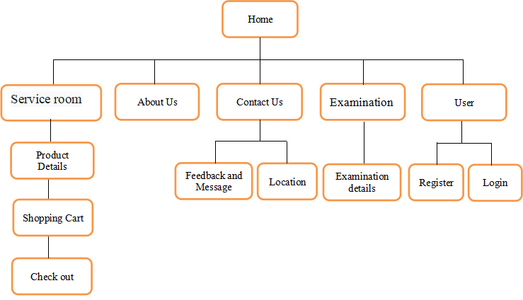

# **User Guide**

**Product name:**

32SMILES website

**Intended use:**

Users can book any appointment or contact our clinic straightforwardly, read more information about our services and products on the website. They can even learn more about the educational information that we daily update on our website and catch up with our news and discount promotions.

**Features:**

We design live chat scenarios for real-time interaction with customers. Besides, we provide hotline contact with hyperlinks to help users connect easily and directly with us. When the user scrolls down anywhere else in the Home page, a back-to-top icon appears which improves the user experience. Furthermore, we create a shopping cart for users to easily check out the products they have selected. In addition, we designed a search bar so that customers can easily search for any type of product in several Product pages. In particular, we write a script to display the number of online users to show the popularity of our site. Last but not least, in the Login or Register section, the user can change the internal password at their convenience..

**Description of the user interface:**

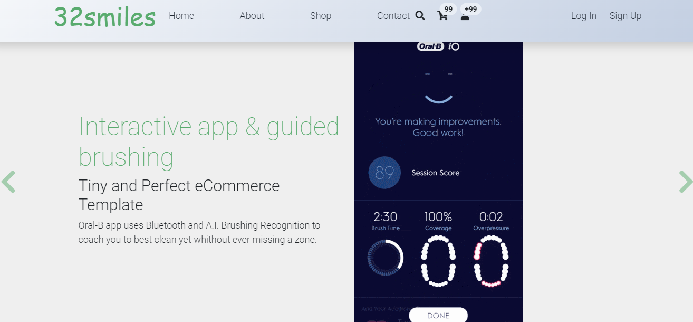As any other clinics, we design 32SMILES is logo and website with three mainstream colors including white, blue, and green that bring comfort for all users’ eyes while reading or searching on the website. We exclusively design the Home page with the font size of 20 for users with 18 font size in order to let the elders read the page easily and clearly other pages.

Our website has simple and easy to manipulate for all age users, particularly elders which are our main customers. There is a real-time connection between customers and our employees, they will reply as soon as possible for the customer as well as contact with customers via the phone numbers.

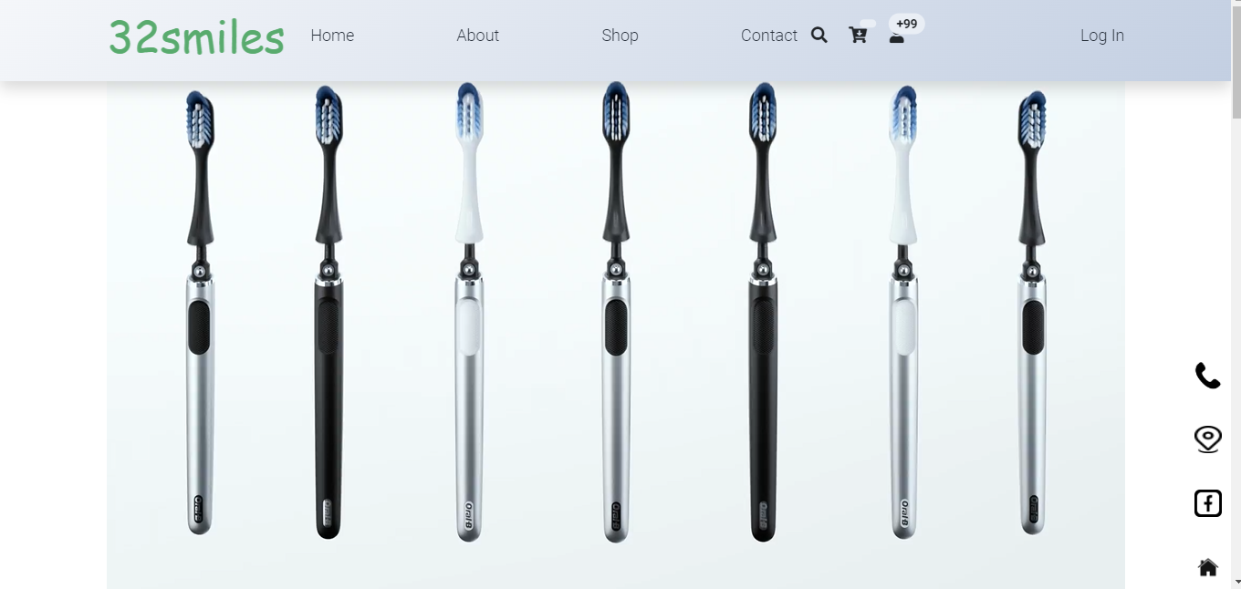

The website also provides some customer testimonials to let other users know more about our therapy clinic.

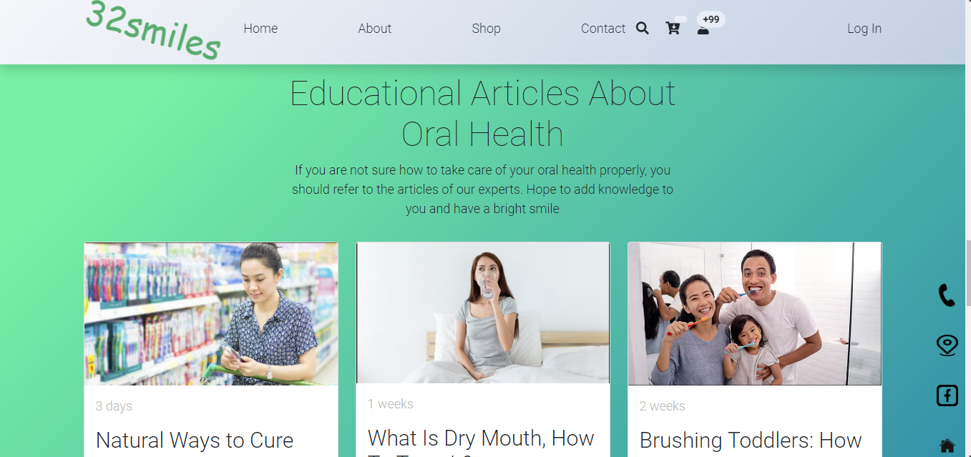

**Description of how to use or operate the product:**

Input:

* + Users can look up information with the search bar.
  + Data of clients reading our clinic’s website.
  + Rating stars and comment on our services or products within the website.
  + Booking any appointments inside our home page.
  + Directly contact us with our branches’ telephone numbers.
  + Customers can adjust the quantity of products on the checkout page whenever they change their minds.

Process:

* Filter the results of what customers are searching for.
* Check and store the data of users reading our website.
* Gather all the rating stars and comment for our products as well as services.
* Accumulate the booking information of our dearest customers.
* When users click any link on our branches’ telephone numbers will directly connect to our online employees.
* Calculate the prices of products based on customers’ changes.

Output:

* Return the result of customers’ searching and display the information on the screen for them.
* Exhibit the data of registered customers.
* Represent customers’ comments and the rating stars of our services and products in the Testimonials site.
* Announcement for the successful booking to let customers know that it was confirmed well.
* Update the product’s final amount depends on customers’ modifications.

**Guidance of using Home page:**



- This navigation bar will quickly lead users to alternate pages including About Us, Service Type, Product Type, Testimonials and Contact Us page.

- The shopping cart will appear on the Home page when the user clicks on the cart icon.

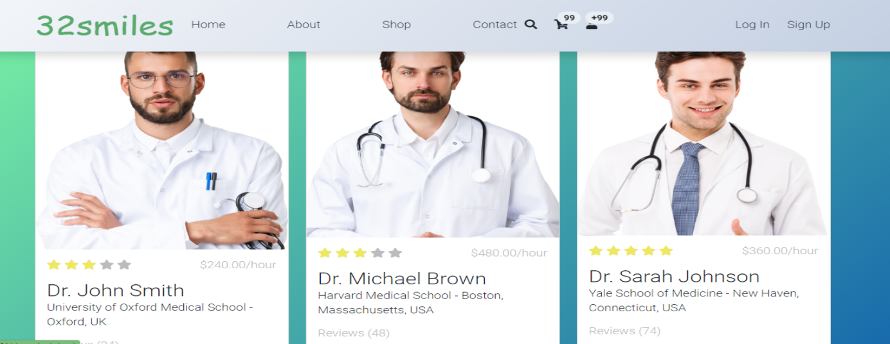- The Login or Register section will also be displayed whenever the customer clicks on the login icon.

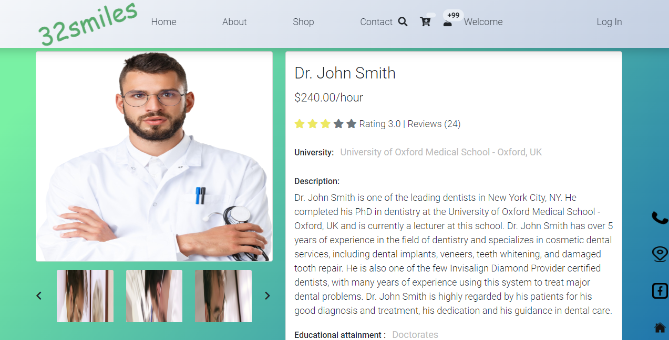--See more instantly navigate to the small pages of dentist information.

- Hover the mouse into each picture, users will see its name of the product come into sight and clicking on those four little pictures will quickly guide them to the detailed products.

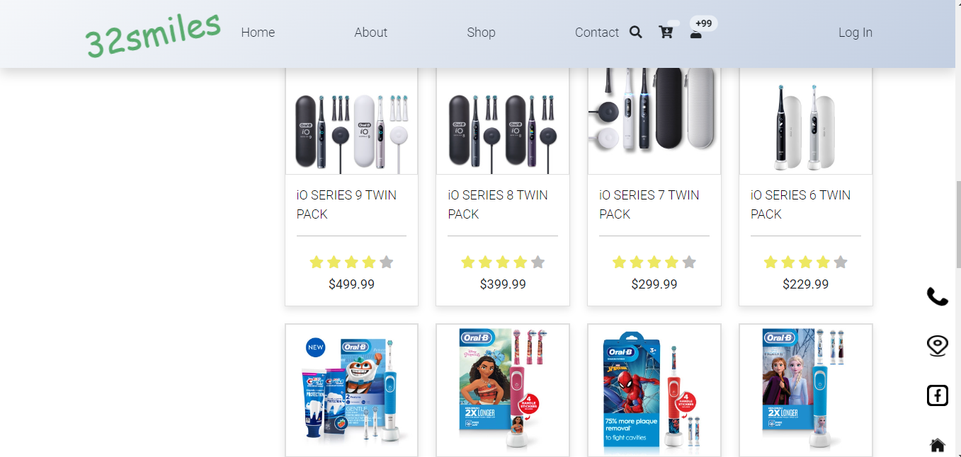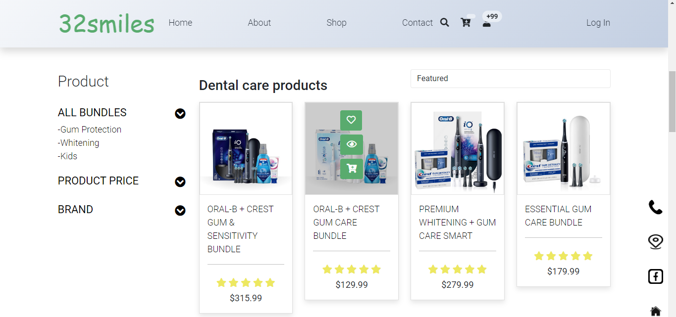- Our clinic requires each client to leave us some basic information to record their booking as well as their stress when coming to our clinic.

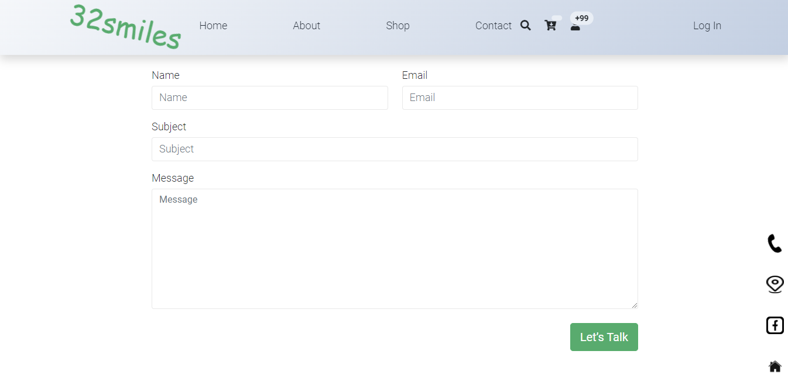

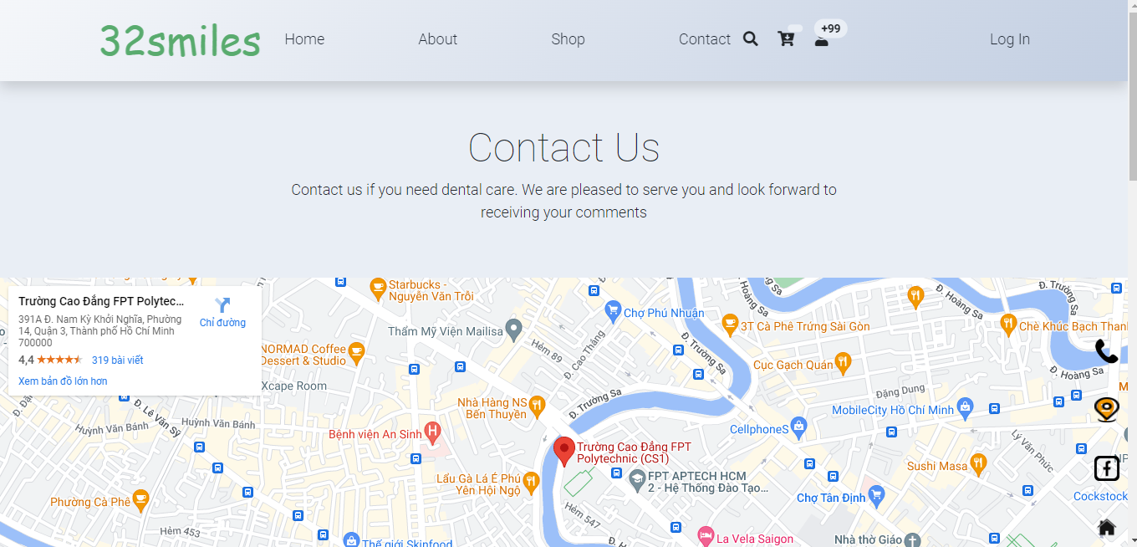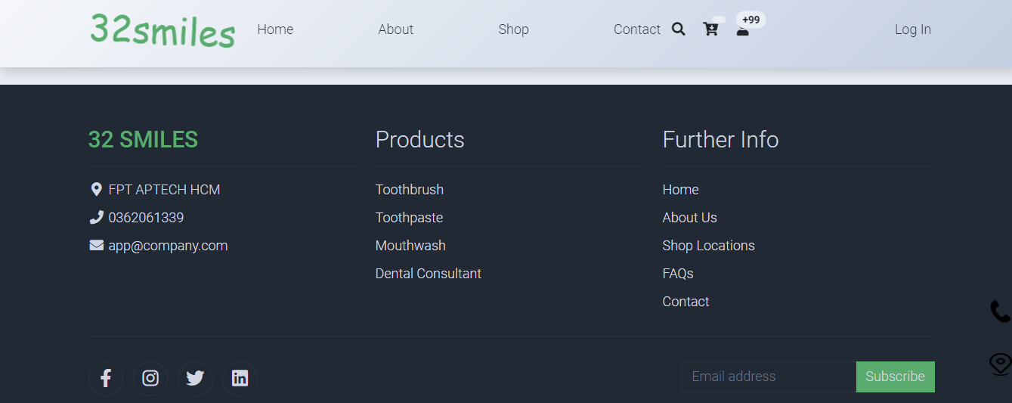

- At the footer, we provide full contact information including address, phone number, email address. In addition, to increase profits, we promote product consumption by always reminding users about our products on the 32SMILES clinic website. Some small information about us is displayed with logos and copyright symbols. Maps are provided for users to check the roads to our clinic.

**Login Page:**

- Login form for sign in.

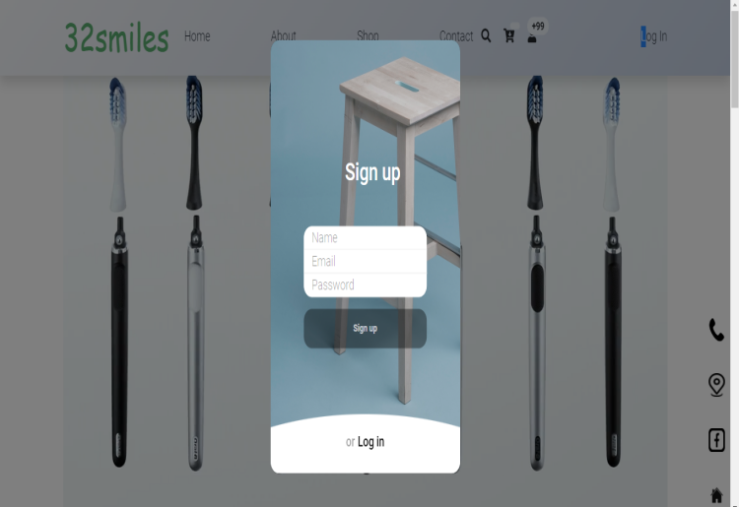- Click create account for signing up and sign-up form will be appearing.

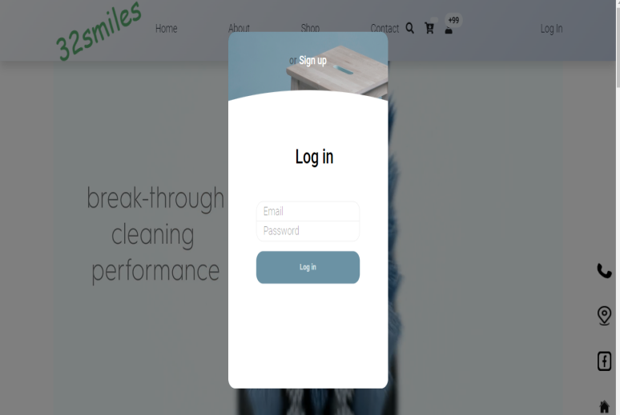

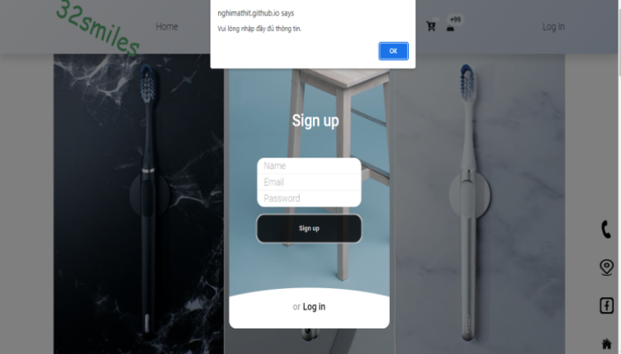-After login or register successfully a pop-up will appear for successful notification.

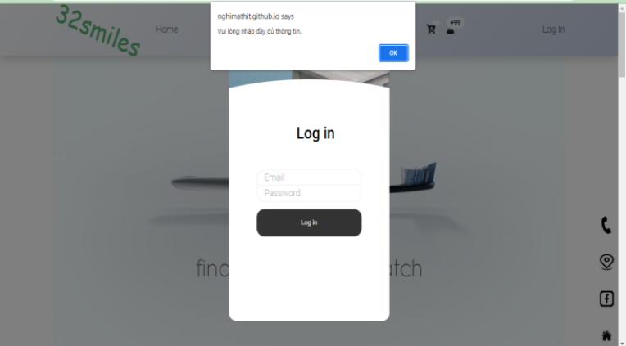

**Task sheet**

|  |  |  |  |  |  |  |  |
| --- | --- | --- | --- | --- | --- | --- | --- |
| No | Member | Contents | Page Name | Activity Plan | Date of Preparation of Activity Plan | | |
| Planed Start Date | **Report I** | **Report II** | Status |
| *1* | *Nguyễn Văn Nghị* | Contact Us | contact.html | 8/5/2023 | 19/5/2023 | 8/6/2023 | 100% |
| Examination details | index.html | 8/5/2023 | 19/5/2023 | 8/6/2023 | 100% |
| Shopping Cart | cart.html | 8/5/2023 | 19/5/2023 | 8/6/2023 | 100% |
| Examination | examination.html | 8/5/2023 | 19/5/2023 | 8/6/2023 | 100% |
| *2* | *Đặng Minh Triết* | Service room | book.html | 8/5/2023 | 19/5/2023 | 8/6/2023 | 70% |
| User | user.html | 8/5/2023 | 19/5/2023 | 8/6/2023 | 70% |
| About | about.html | 8/5/2023 | 19/5/2023 | 8/6/2023 | 70% |
| *3* | *Hồ Thiện Nhân* |  |  | 8/5/2023 | 19/5/2023 | 8/6/2023 |  |
| *4* | *Võ Xuân Thịnh* |  |  | 8/5/2023 | 19/5/2023 | 8/6/2023 |  |