

**<<Project name>>**

**Software Design Specification**

– Hanoi, August 2022 –

Record of changeS

|  |  |  |  |
| --- | --- | --- | --- |
| Date | A* M, D | In charge | Change Description |
| 11/9/22 | A | All member | Add overview |
|  |  |  |  |
|  |  |  |  |
|  |  |  |  |
|  |  |  |  |
|  |  |  |  |
|  |  |  |  |
|  |  |  |  |
|  |  |  |  |
|  |  |  |  |
|  |  |  |  |
|  |  |  |  |
|  |  |  |  |

*A - Added M - Modified D - Deleted

**Table of Contents**

I. Overview 4

1. Code Packages 4

2. Database Design 4

a. Database Schema 4

b. Table Description 4

II. Code Designs 5

1. <Feature/Function Name1> 5

a. Class Diagram 5

b. Class Specifications 5

c. Sequence Diagram(s) 5

d. Database queries 6

2. <Feature/Function Name2> 6

# I. Overview

## 1. Code Packages

*[Provide the package diagram for each sub-system. The content of this section including the overall package diagram, the explanation, package and class naming conventions in each package. Please see the sample & description table format below (****please note: package names don’t follow Java package naming convention yet****)]*

***Package descriptions***

|  |  |  |
| --- | --- | --- |
| **No** | **Package** | **Description** |
| *01* | *mysqlDB* | *Database using in project* |
| *02* | *utils* | *Regex, validate* |
| *03* | *dal* | *Data access layer* |
| *04* | *controller* | *Feature* |
| *05* | *filter* | *Sort, roles, …* |
| *06* | *view* | *Web view* |
| *07* | *…* |  |

## 2. Database Design

### a. Database Schema

*[Provide the tables relationship like example below – following MySQL database naming convention]*

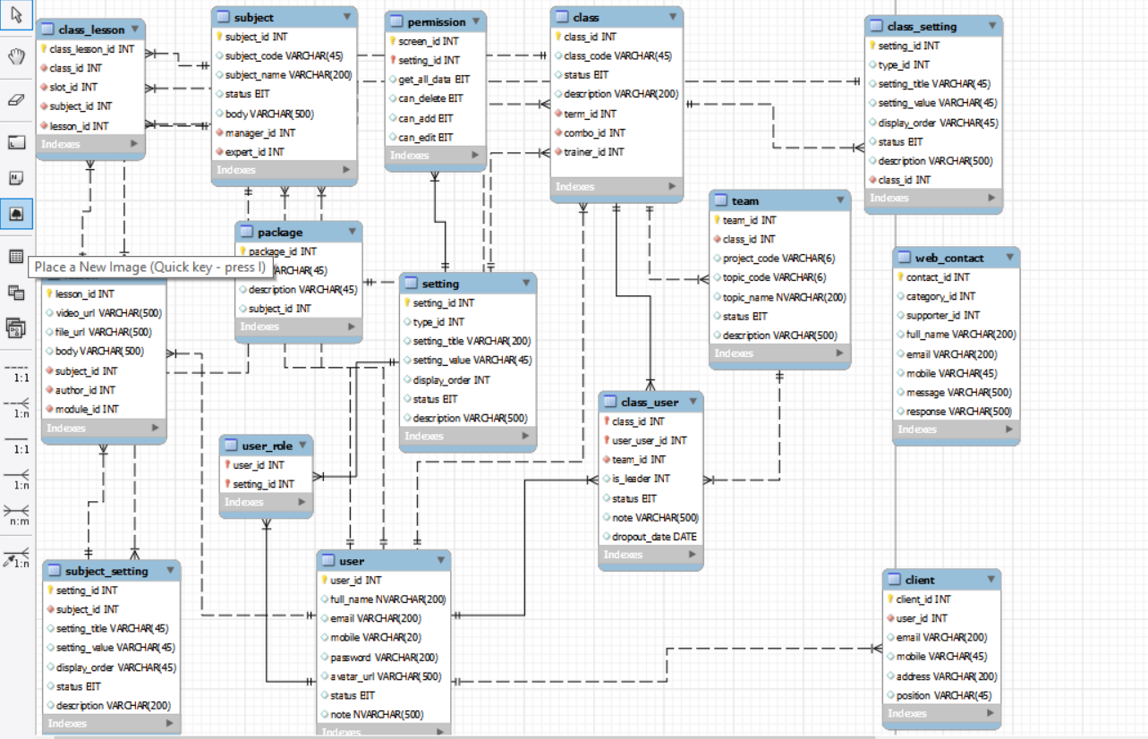

### b. Table Description

|  |  |  |
| --- | --- | --- |
| **No** | **Table** | **Description** |
| *01* | *user* | *User information and status* |
| *02* | *user_role* | *Roles of users* |
| *03* | *setting* | *System setting* |
| *04* | *class_user* | *User information in a class* |
| *05* | *class* | *Class information and status* |
| *06* | *class_setting* | *Setting of class (status, sort,…)* |
| *07* | *lesson* | *Lesson information* |
| *08* | *class_lesson* | *Lesson detail of class (status, sort,…)* |
| *09* | *team* | *Team information* |
| *10* | *permission* | *System permission* |
| *11* | *subject* | *Subject detail* |
| *12* | *package* | *Package detail* |
| *13* | *subject_setting* | *Setting of subject (status, sort,…)* |
| *14* | *client* | *Client information* |
| *15* | *web_contact* | *Contact information* |

# II. Code Designs

## 1. <Feature/Function Name1>

*[Provide the detailed design for the function <Feature/Function Name1>. It include Class Diagram, Class Specifications, and Sequence Diagram(s)]*

### a. Class Diagram

*[This part presents the class diagram for the relevant feature]*

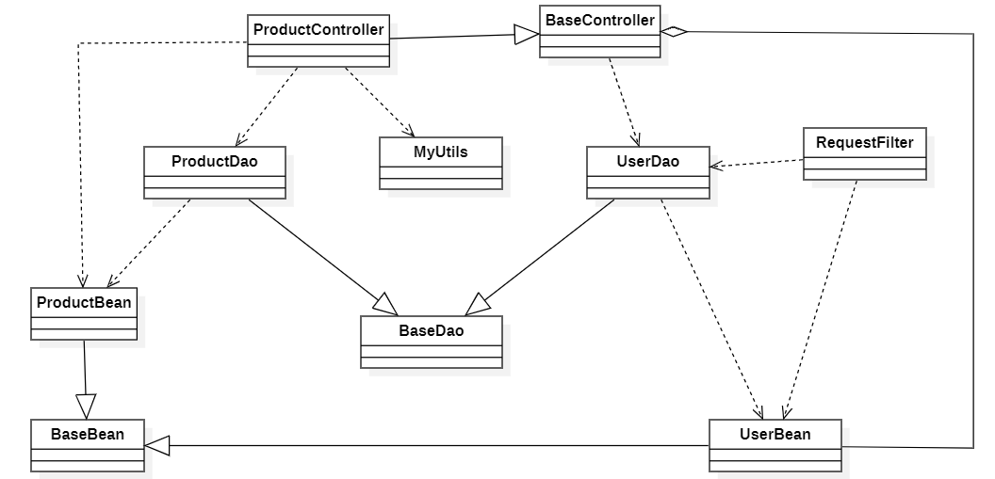

### b. Class Specifications

*[Provide the description for each class and the methods in each class, following the table format as below]*

#### XYZ Class

*[Provide the detailed description for the class methods]*

|  |  |  |
| --- | --- | --- |
| **No** | **Method** | **Description** |
| *01* | *<method name>* | *<Description of the method, including the inputs, outputs & internal method processing>* |
|  |  |  |

#### ABC Class

***Class Methods***

*[Provide the detailed description for the class methods]*

|  |  |  |
| --- | --- | --- |
| **No** | **Method** | **Description** |
| *01* | *<method name>* | *<Description of the method, including the inputs, outputs & internal method processing>* |
|  |  |  |

### c. Sequence Diagram(s)

*[Provide the sequence diagram(s) for the feature, see the sample below]*

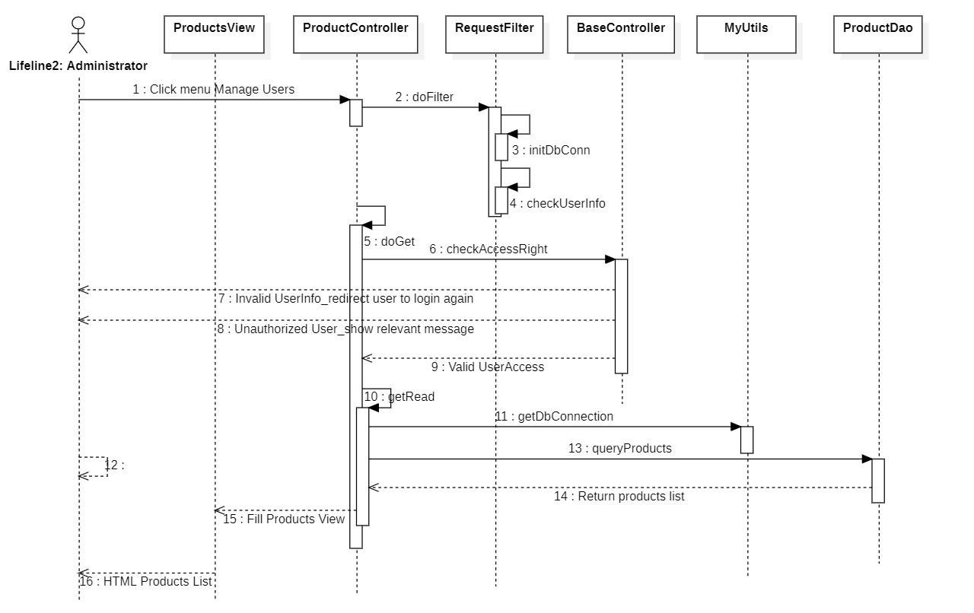

### d. Database Queries

*[Provide the detailed SQL (select, insert, update...) which are used in implementing the function/screen]*

## 2. <Feature/Function Name2>

…